Viewing Data with the TatukGIS Viewer

TatukGIS is a free data viewer which can be downloaded and used to view NAIP imagery and other geospatial files. It will not open the near infrared band (Band 4), in projects acquired with four bands. These images will display only in the natural color version, with the RGB band assignment.

TatukGIS displays vector files (shapefiles) and will allow the user to query the attribute table for an individual feature.

TatukGIS will not reproject on the fly, and all data must be in the same projection and coordinate system in order to display correctly.

Click on the Add Data Button

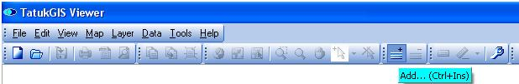

Under the Files of type dropdown menu, select All Files or, as a filter, select a specific file format (such as All pixel files for imagery.).

Navigate to the location of the data.
Select the file(s) to load, and click Open.

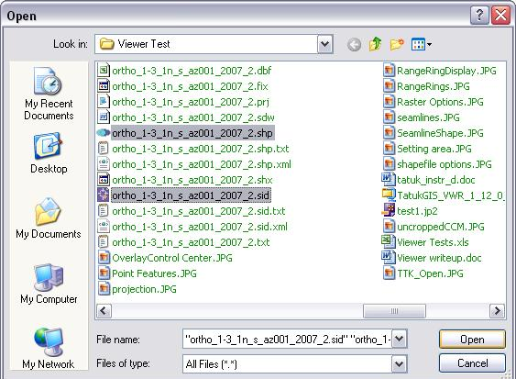

The files will be added to the view in the order they were selected. In this display, the vector layer (shapefile) is above the image. There will be a default fill pattern for the shapefile. The image will display with the RGB band assignment. In this case a Compressed County Mosaic (CCM) and the corresponding Seamline Shapefile have been added into the view.
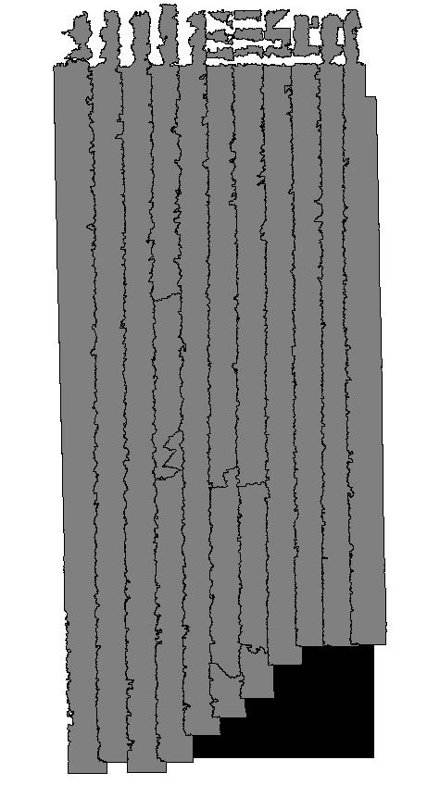

Save or Open a Project

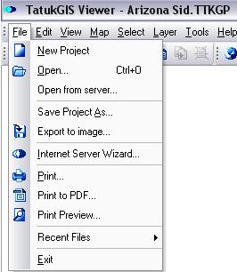

Data in the Display window can be saved as a Project through the File dropdown menu. A saved project can be opened from this menu as well.

Show/Hide a Data Layer

To turn a data layer on or off, check the box next to the layer name in the Legend.

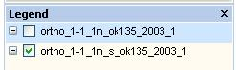

Change the Display Order of Layers

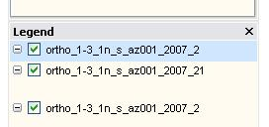

To change the viewing order of the layers, simply select a layer name, and drag it above or below another layer. In this graphic, the shapefile (_2) is being dragged below the image (_21). (The “arrow” cursor did not reproduce in the graphic.)
The order can also be changed by right clicking the file name in the Legend, and selecting Move Up or Move Down from the dropdown menu.

Zoom in and out on the Display

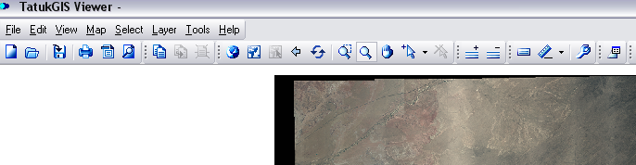

Several icons are used to change the zoom level of the display. The circled pair to the right (yellow) are both zoom tools. The magnifying glass with a small rectangle is for Zoom mode, and it allows the user to select a rectangular area to zoom into. The magnifying glass with no rectangle is called Zoom extended mode, and it zooms in or out continuously as the cursor is moved over the image.

Zooming out would need to be done with the Zoom extended mode icon, or with the backwards arrow, located in the middle circle (green). The pair on the left, circled in blue, will zoom to the layer extent or to the full extent.

Tonal Changes to an Image

TatukGIS offers some tonal adjustment options for the imagery.

- The dialog box can be accessed by right clicking on the image name in the Legend.
- Select the Properties option from the dropdown menu.
- Select the Pixel tab, and experiment with image display options.
- The Raster dialog box offers the option to change Brightness, Contrast, and relative importance of the different bands. It also allows Inversion (where the dark areas are light, and vice versa), Grayscale (gradations of black to white) and Histogram [stretch].

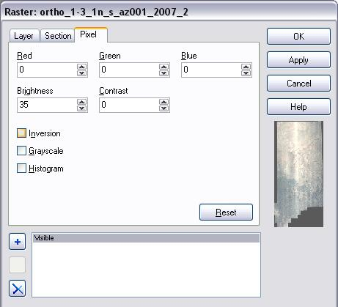
This CCM is displayed with increased brightness.

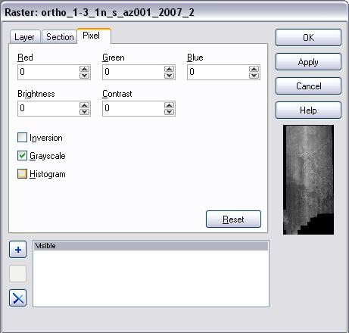
This CCM is displayed as a Grayscale image.
Using the Vector Layer in TatukGIS

The strength of TatukGIS lies in the options for use with vector data. The online Help, or the .pdf manual will explain the possibilities in greater detail.

Edit a Vector Layer Display

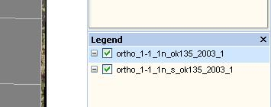

To edit a vector layer (shapefile) double click on the index name. This will make it the active layer, and will open the Theme Properties menu.

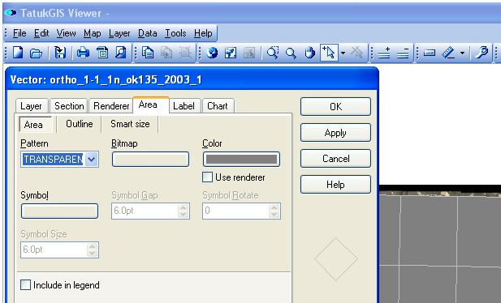

To remove the solid fill, select TRANSPARENT as the Pattern, and click Apply.
Other patterns and colors are available if desired.

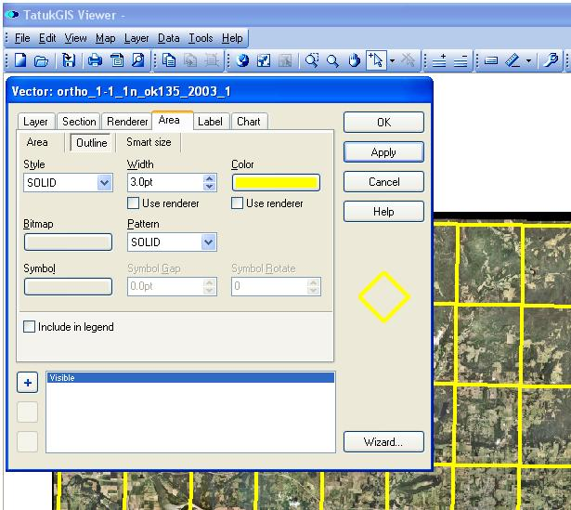

To change the color and size of the index lines select Outline, select a Style, enter a line width (in points) into the Width box, and select a color from the Color box. Click OK.

Labeling the Vector Polygons

The polygons in the vector file (shapefile) can be labeled by right clicking on the name in the Legend and selecting the Properties option from the dropdown menu.

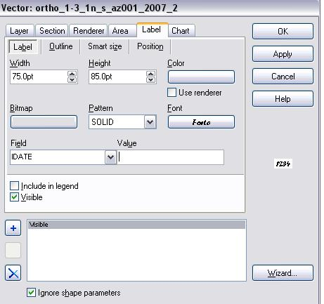
In the Vector properties box, click on the Label tab, and make a selection in the Field
box. This is the attribute which will be displayed as a label.

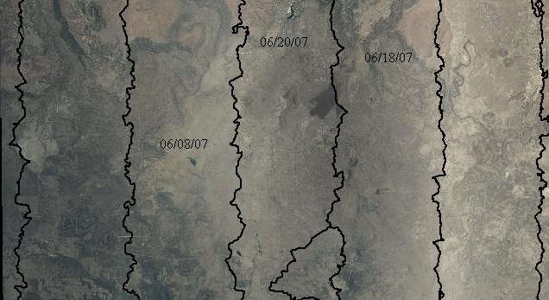

In this close-up, the image dates from the IDATE field are displayed.

View the Attribute Information

There are several methods for accessing attribute information in TatukGIS. Attributes can be displayed for individual polygons or as an entire table.

One of the easiest ways to view attribute information is with the Select Localize icon. This is the arrow with a plus sign. After clicking on a polygon with this tool, it will change color and the attributes will display in the box to the left (see next page).

There are two tabs in this box – one for Attributes and the other for information about the polygon’s Shape.

The arrow icon to the right of the Select Localize icon, with an “X” over it, is Deselect All.
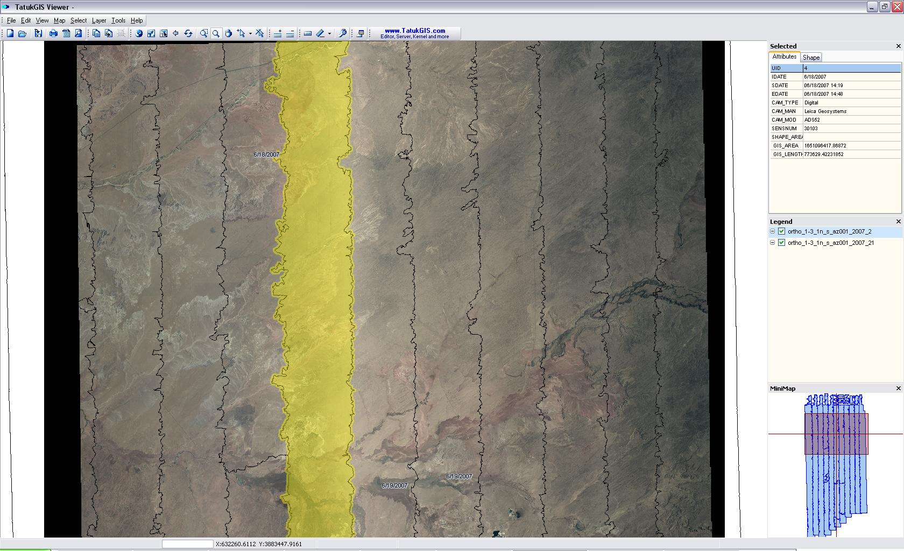

In the examples below, both tabs of information for the selected polygon are displayed.

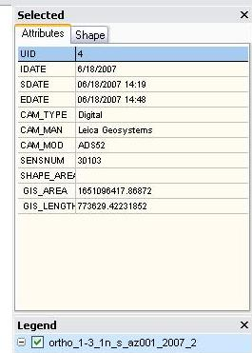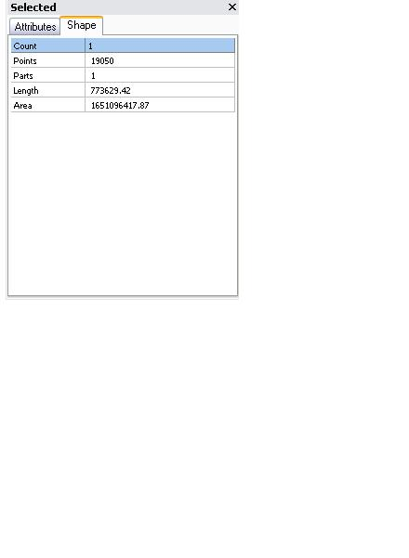

Another method for viewing attribute data is with Map Hints.

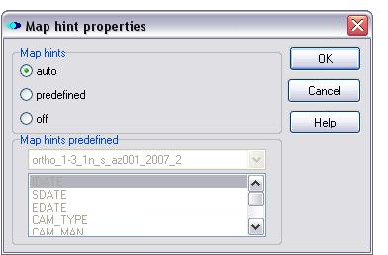

Clicking on the Map Hints icon (circled, above) will open a dialog box with the option to display all of the attributes (auto) or only one (predefined). As the cursor moves over a polygon, the attributes will temporarily appear inside a shaded rectangle.

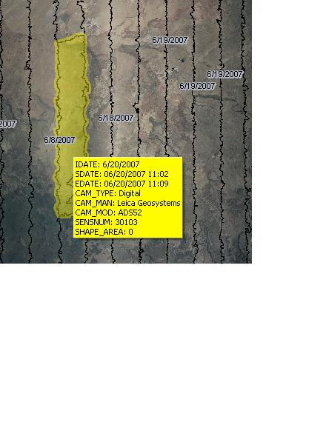

Display the Attribute Table

The attribute data can also be displayed as an entire table.



The table is opened by clicking on the Data icon at the far right of the toolbar. It will display at the bottom of the screen, and can be enlarged. It will move up into the Display screen, and the data displayed will become smaller (see graphic below).

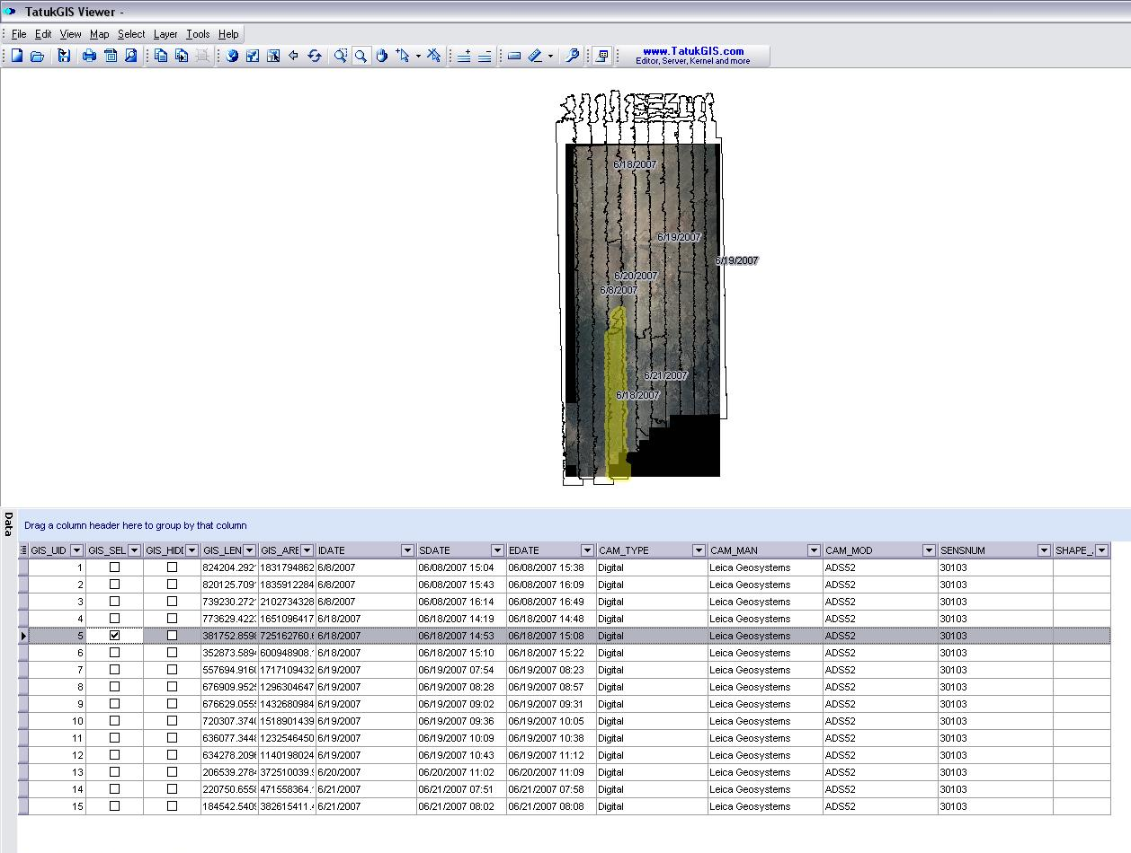

An individual polygon can be selected in the display by clicking the check box in the GIS_SELECTED column.

If a column header is dragged into the blue area, the individual records will be grouped by that header. In the example below, all of the records with the same IDATE (image date) are grouped together. If the boxes are checked, all records in a group will be selected in the display.

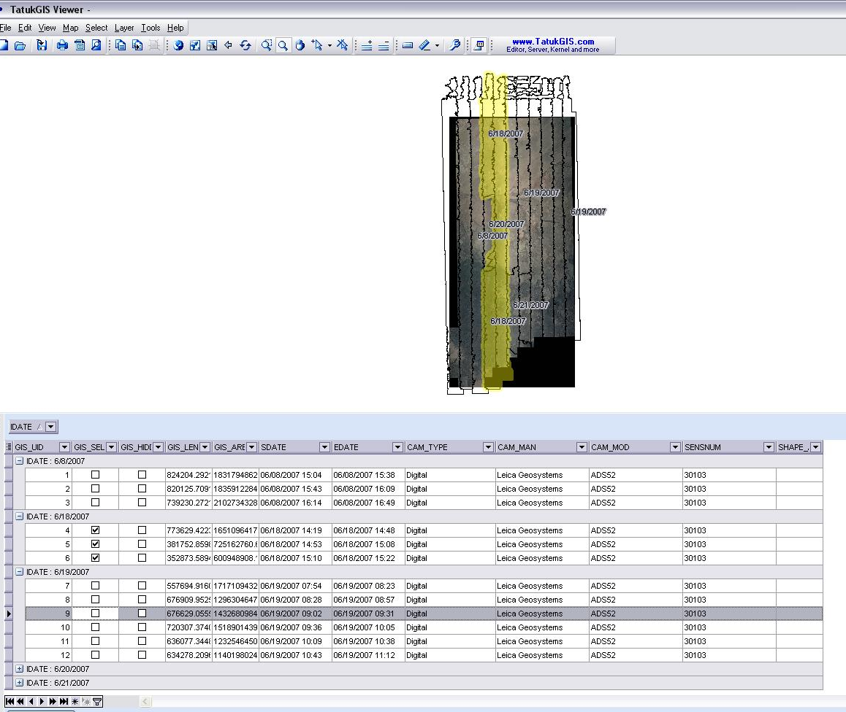

The Query Builder

The icon on the far right of the Toolbar below the Table will open a Query Builder. It will set up very simple SQL type queries.

In the first example below, the query builder opens up a calendar to assist in selecting a field populated with dates. The selection is displayed with Map Hints.

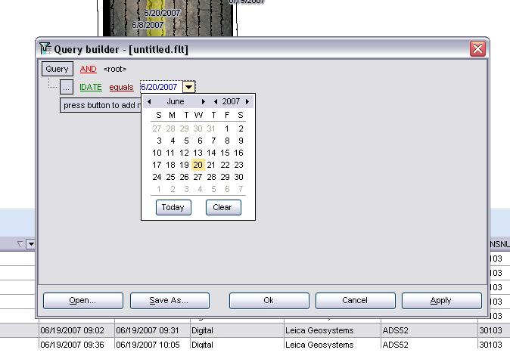

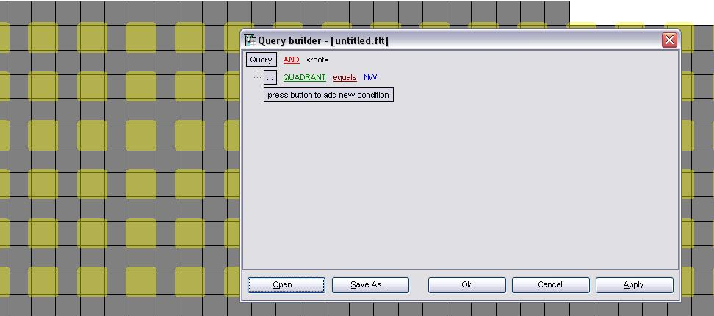

Another query selected all quadrants labeled as NW (northwest).

Removing the Attribute Table

The table can be removed from the view by clicking on the Data icon in the main Toolbar.

Change the Language of the Display Window

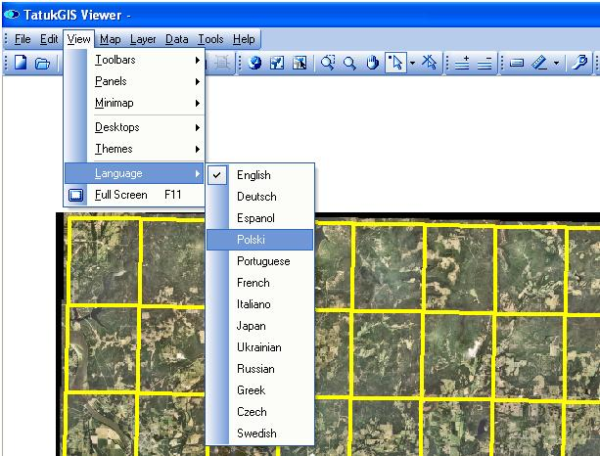

TatukGIS allows the user to select from several different languages in the display. To change the program language, select View, Language, and one of the options. (The data in the tables remains in the original language.)

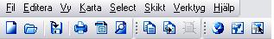

The Toolbar is shown with headings in Swedish.

Printing a Map

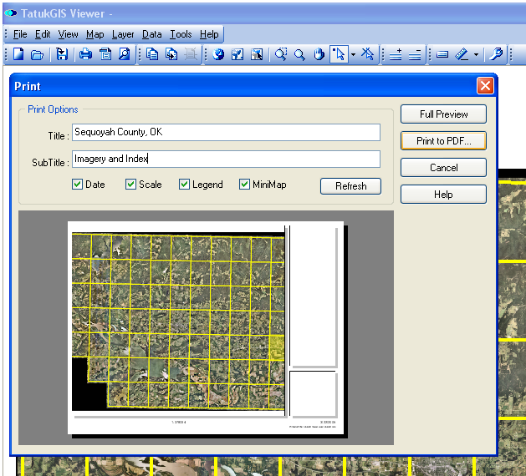

To print a map select the File dropdown menu. There are three options available.
- Print will print what is on the screen to the printer specified.
- Print Preview gives the option of adding a title to the bottom of the page, as well as a text scale and legend before printing.
- Print to PDF will open Adobe Acrobat and create a .pdf file.

For additional instructions on using the software click on Help, Help or Tutorials.
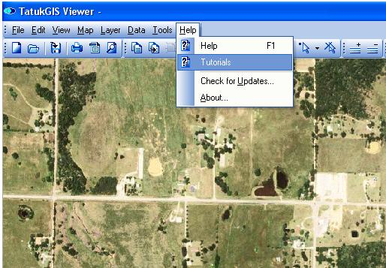

For additional information contact:
USDA-FSA
Aerial Photography Field Office
2222 West 2300 South
Salt Lake City, UT 84119-2020

801-644-2934

TUwww.apfo.usda.govUT


