Tropical Cyclone Report
Tropical Storm Lowell
(EP132008)
6 – 11 September 2008

Robbie Berg
National Hurricane Center
2 December 2008

Lowell was a tropical storm that moved northwestward well off the coast of Mexico before turning northeastward and affecting the southern Baja California peninsula as a tropical depression. The remnants of Lowell caused heavy rainfall and flooding across the Mexican states of Sonora and Sinaloa.

- Synoptic History

Lowell’s formation resulted from a complex interaction of a surface trough off the coast of Mexico and a westward-moving tropical wave. The tropical wave initially moved off the coast of Africa on 19 August and propagated across the Atlantic for the next 10 days. Hurricane Hanna developed from the northern portion of the wave axis on 28 August as it moved north of the Greater Antilles, but the southern portion of the wave continued to move westward across the Caribbean Sea and crossed Central America on 27 and 28 August. By that time, strong southwesterly low-level flow and a surface trough had developed off the coast of southern Mexico. The tropical wave moved very slowly westward through the larger cyclonic circulation associated with the trough and induced a gradual increase in deep convection. As the wave reached the western edge of the gyre, a smaller embedded circulation developed and eventually detached from the larger circulation. It is estimated that the resulting tropical depression formed at 1200 UTC 6 September when it was centered about 255 n mi south of Manzanillo, Mexico. A prominent convective band formed that day, and the depression strengthened into a tropical storm at 0000 UTC 7 September about 225 n mi south-southwest of Manzanillo. The “best track” chart of Lowell’s path is given in Fig. 1, with the wind and pressure histories shown in Figs. 2 and 3, respectively. The best track positions and intensities are listed in Table 1.

A deep-layer anticyclone over Mexico steered Lowell northwestward during the next couple of days. However, strong upper-level winds on the south side of the anticyclone produced about 20 kt of northeasterly to easterly shear over the cyclone for several days, and the low-level center of Lowell remained exposed to the northeast of the deep convection. Lowell reached and then maintained a peak intensity of 45 kt from 1200 UTC 7 September through 0600 UTC 8 September as it moved very close to Socorro Island. Fig. 4 depicts an infrared and microwave image of Lowell near its peak intensity.

Vertical shear lessened over Lowell by 9 September as the cyclone reached the western periphery of the subtropical ridge. However, the tropical storm had already begun ingesting drier, more stable air originating from west of Baja California, and organized deep convection was never able to fully redevelop. The circulation began to slowly spin down, and QuikSCAT data indicate that Lowell weakened to a tropical depression at 0600 UTC 10 September as it was moving north-northeastward about 180 n mi west-southwest of the southern tip of Baja California. The depression produced intermittent thunderstorm activity in a ring around the low-level center and in a burst of deep convection to the north of the center on 10 September. However, the mid-level center and the thunderstorm activity was sheared northeastward across southern Baja California and into northwestern mainland Mexico ahead of an upper-level trough. Lowell then turned to the east-northeast and made landfall near Cabo San Lucas at 0900 UTC 11 September as a 30-kt depression. By 1800 UTC, satellite imagery and surface observations indicate that the circulation of Lowell opened up into an elongated surface trough that extended across the southern Gulf of California. A squall line developed along and to the south of the trough and moved quickly eastward towards the mainland Mexican coast of Sinaloa and Nayarit later that day.

- Meteorological Statistics

Observations in Lowell (Figs. 2 and 3) include satellite-based Dvorak technique intensity estimates from the Tropical Analysis and Forecast Branch (TAFB) and the Satellite Analysis Branch (SAB). Data and imagery from NOAA polar-orbiting satellites, Defense Meteorological Satellite Program (DMSP) satellites, National Aeronautics and Space Administration (NASA) satellites, including the Tropical Rainfall Measuring Mission (TRMM), QuikSCAT, and Aqua, and the U.S. Navy WindSat were also useful in tracking Lowell.

Lowell’s peak intensity of 45 kt is based on a combination of satellite intensity estimates as well as two QuikSCAT passes at 1320 UTC 7 September and 0147 UTC 8 September. Each of the QuikSCAT passes showed a few wind barbs of 50 kt, but these were rain-flagged within deep convection and located well to the southwest of the center of circulation. In addition, objective and subjective satellite intensity estimates at the time supported an intensity between 35 and 45 kt. The landfall intensity of 30 kt on the southern tip of Baja California is based on a 1317 UTC QuikSCAT pass on 11 September and satellite intensity estimates at 1200 UTC.

There were no surface land station or ship reports of winds of tropical storm force associated with Lowell. However, two unofficial stations in Cabo San Lucas reported minimum pressures of 998.5 mb (IBAJACAL9) and 1000.6 mb (IBAJACAL12) at 0915 UTC and 0925 UTC, respectively, as the center of Lowell moved over the area. These were the lowest reported pressures in southern Baja California and agree with geostationary and microwave satellite imagery, indicating that the low-level center moved over the southern tip of the peninsula.

- Casualty and Damage Statistics

Heavy rainfall from the remnants of Lowell caused streams and canals to overflow in the Mexican states of Sonora and Sinaloa, leaving more than 26,500 people homeless. The cities of Navojoa, Benito Juarez, Huatabampo, and Etchojoa were most affected. The government of Sonora has estimated the damage in that state at 200 million pesos (about 15.5 million US dollars).

The remnants of Lowell later merged with a frontal boundary over the central United States and caused heavy rainfall and flooding one to two days before the remnants of Hurricane Ike passed through the region. Fig. 5 shows the swath of heaviest rain, which fell from Kansas to northern Illinois and Indiana. Wichita, Kansas, measured a daily record 10.31 inches of rain on 12 September and broke the 24-hour rainfall record of 7.99 inches that had been held since 1911. Chicago, Illinois, reported 6.64 inches at O’Hare International Airport, the highest one-day total since records began in 1871. This amount broke the previous daily record of 6.49 inches set in 1987. Numerous people were rescued from stranded vehicles as rainfall flooded city streets.

- Forecast and Warning Critique

The genesis of Lowell was not well forecast. The large area of disturbed weather from which Lowell eventually emerged was first mentioned in the Tropical Weather Outlook (TWO) and given a medium chance of development (20-50%) approximately 12 h before the system became a tropical depression. The possibility of formation of a tropical depression was first mentioned in the TWO at 1200 UTC 6 September, but a post-analysis of Lowell’s history suggests that the system had already become a tropical depression by that time.

A verification of official and guidance model track forecasts is given in Table 2. Average official track errors for Lowell were 30, 41, 58, 75, 129, and 278 n mi for the 12, 24, 36, 48, 72, and 96 h forecasts, respectively. The number of forecasts ranged from 17 at 12 h to 3 at 96 h. These errors are lower than the average long-term official track errors through 72 h but are higher than average long-term errors at 96 h (Table 2). However, only three forecasts were made for the 96 h period, and a comprehensive comparison is not valid. Of the individual track models, only the ECMWF model (EMXI) consistently performed better than the official forecast at 36 through 96 h.

Average official intensity errors were 5, 7, 10, 13, 19, and 15 kt for the 12, 24, 36, 48, 72, and 96 h forecasts, respectively (Table 3). For comparison, the average long-term official intensity errors are 6, 10, 14, 16, 19, and 19 kt, respectively. The official forecast intensity errors were lower than the average long-term errors for all forecast times except the 72 h period, when they were nearly equal. Even though the official forecasts showed skill over the long-term averages, they did not show as much skill as most of the available model guidance, especially from 36 through 96 h. In particular, the Florida State Superensemble (FSSE) and Decay SHIPS (DSHP) had lower errors than the official forecast at all forecast times. The intensity consensus (ICON) had lower errors at all forecast times except the 12 h period.

Watches and warnings associated with Lowell are listed in Table 4. A tropical storm watch was issued for a portion of the southwest coast of Baja California despite the fact that the official forecast indicated Lowell would reach the coast as a tropical depression. Wind speed probabilities at the time indicated that there was still a 26% chance that Lowell could reach the coast as a tropical storm.
Table 1. Best track for Tropical Storm Lowell, 6 – 11 September 2008.

Date/Time  (UTC) | Latitude  (°N) | Longitude  (°W) | Pressure  (mb) | Wind Speed  (kt) | Stage
06 / 1200 | 14.9 | 104.3 | 1004 | 25 | tropical depression
06 / 1800 | 15.2 | 105.2 | 1003 | 30 | "
07 / 0000 | 15.7 | 106.0 | 1002 | 35 | tropical storm
07 / 0600 | 16.3 | 106.7 | 1000 | 40 | "
07 / 1200 | 16.9 | 107.5 | 998 | 45 | "
07 / 1800 | 17.4 | 108.4 | 998 | 45 | "
08 / 0000 | 17.8 | 109.2 | 998 | 45 | "
08 / 0600 | 18.3 | 110.0 | 998 | 45 | "
08 / 1200 | 18.8 | 110.6 | 1000 | 40 | "
08 / 1800 | 19.3 | 111.3 | 1000 | 40 | "
09 / 0000 | 19.6 | 112.0 | 1000 | 40 | "
09 / 0600 | 19.9 | 112.6 | 1000 | 40 | "
09 / 1200 | 20.3 | 113.0 | 1000 | 40 | "
09 / 1800 | 20.7 | 113.1 | 1000 | 40 | "
10 / 0000 | 21.1 | 113.1 | 1002 | 35 | "
10 / 0600 | 21.6 | 112.9 | 1002 | 30 | tropical depression
10 / 1200 | 22.0 | 112.6 | 1002 | 30 | "
10 / 1800 | 22.4 | 112.1 | 1002 | 30 | "
11 / 0000 | 22.7 | 111.4 | 1002 | 30 | "
11 / 0600 | 22.9 | 110.6 | 1001 | 30 | "
11 / 1200 | 23.0 | 109.7 | 1000 | 30 | "
11 / 1800 |  |  |  |  | dissipated
07 / 1200 | 16.9 | 107.5 | 998 | 45 | minimum pressure and maximum wind
11 / 0900 | 23.0 | 110.1 | 1000 | 30 | landfall near Cabo San Lucas, Mexico
Table 2. Track forecast evaluation (heterogeneous sample) for Tropical Storm Lowell, 6 – 11 September 2008. Forecast errors (n mi) are followed by the number of forecasts in parentheses. Errors smaller than the NHC official forecast are shown in boldface type.

Forecast Technique | Forecast Period (h)
Forecast Technique | 12 | 24 | 36 | 48 | 72 | 96 | 120
CLP5 | 51 (19) | 93 (17) | 149 (15) | 203 (13) | 258 ( 9) | 285 ( 5)
GFNI | 32 (11) | 62 (11) | 99 (10) | 128 ( 8) | 216 ( 4)
GFDI | 28 (19) | 50 (17) | 78 (15) | 108 (13) | 110 ( 8) | 101 ( 2)
HWFI | 37 (19) | 63 (17) | 94 (15) | 146 (13) | 265 ( 9) | 360 ( 5)
GFSI | 47 (19) | 82 (17) | 110 (15) | 135 (13) | 182 ( 9) | 327 ( 5)
AEMI | 46 (19) | 77 (17) | 100 (15) | 111 (13) | 130 ( 9) | 246 ( 5)
NGPI | 45 (17) | 63 (15) | 73 (13) | 115 (11) | 212 ( 7) | 335 ( 3)
UKMI | 53 (16) | 83 (14) | 123 (12) | 135 (10) | 199 ( 6) | 166 ( 2)
EGRI | 52 (16) | 82 (14) | 123 (12) | 135 (10) | 201 ( 6) | 166 ( 2)
EMXI | 31 (12) | 44 (11) | 48 (10) | 62 ( 9) | 87 ( 6) | 172 ( 3)
BAMD | 53 (19) | 91 (17) | 135 (15) | 177 (13) | 277 ( 9) | 412 ( 5)
BAMM | 42 (19) | 70 (17) | 107 (15) | 148 (13) | 260 ( 9) | 372 ( 5)
BAMS | 32 (18) | 45 (16) | 58 (14) | 86 (12) | 199 ( 9) | 327 ( 5)
LBAR | 46 (18) | 84 (16) | 123 (14) | 169 (12) | 284 ( 9) | 504 ( 5)
TVCN | 28 (19) | 41 (17) | 62 (15) | 84 (13) | 123 ( 9) | 240 ( 5)
GUNA | 29 (14) | 37 (12) | 58 (10) | 88 ( 8) | 133 ( 4)
FSSE | 23 (13) | 41 (13) | 67 (12) | 88 (10) | 75 ( 6) | 103 ( 2)
OFCL | 30 (17) | 41 (15) | 58 (13) | 75 (11) | 129 ( 7) | 278 ( 3)
NHC Official  (2003-2007 mean) | 31.9 (1282) | 55.1 (1129) | 77.4 (979) | 97.9 (849) | 136.2 (620) | 180.1 (439) | 226.1 (293)

Table 3. Intensity forecast evaluation (heterogeneous sample) for Tropical Storm Lowell,
6 – 11 September 2008. Forecast errors (kt) are followed by the number of forecasts in parentheses. Errors smaller than the NHC official forecast are shown in boldface type.

Forecast Technique | Forecast Period (h)
Forecast Technique | 12 | 24 | 36 | 48 | 72 | 96 | 120
OCD5 | 5.3 (19) | 8.0 (17) | 10.0 (15) | 12.1 (13) | 21.0 ( 9) | 24.2 ( 5)
GHMI | 6.3 (19) | 7.9 (17) | 7.9 (15) | 8.2 (13) | 6.6 ( 8) | 2.5 ( 2)
HWFI | 6.3 (19) | 9.5 (17) | 11.3 (15) | 12.6 (13) | 15.1 ( 9) | 15.0 ( 5)
LGEM | 5.7 (19) | 8.1 (17) | 7.7 (15) | 8.6 (13) | 10.8 ( 9) | 7.0 ( 5)
DSHP | 3.8 (19) | 5.8 (17) | 5.4 (15) | 7.8 (13) | 12.2 ( 9) | 11.6 ( 5)
FSSE | 4.6 (13) | 6.2 (13) | 8.2 (12) | 8.8 (10) | 13.3 ( 6) | 2.0 ( 2)
ICON | 5.3 (19) | 7.1 (17) | 6.9 (15) | 6.9 (13) | 9.1 ( 8) | 9.5 ( 2)
OFCL | 4.7 (17) | 7.3 (15) | 10.4 (13) | 12.7 (11) | 18.6 ( 7) | 15.0 ( 3)
NHC Official  (2003-2007 mean) | 6.2 (1282) | 10.4 (1129) | 13.9 (979) | 16.3 (848) | 18.7 (620) | 19.2 (439) | 19.1 (293)

Table 4. Watch and warning summary for Tropical Storm Lowell, 6 – 11 September 2008.

Date/Time (UTC) | Action | Location
9 / 2100 | Tropical Storm Watch issued | Bahia Magdalena to Cabo San Lucas
11 / 0900 | Tropical Storm Watch discontinued | All

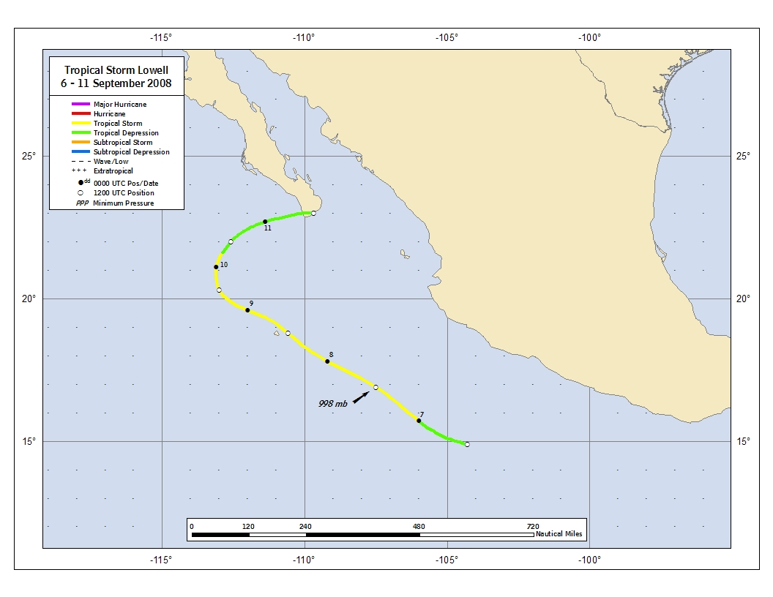
Figure 1. Best track positions for Tropical Storm Lowell, 6 – 11 September 2008.

Figure 2. Selected wind observations and best track maximum sustained surface wind speed curve for Tropical Storm Lowell, 6 – 11 September 2008. Objective Dvorak estimates represent linear averages over a three-hour period centered on the nominal observation time. Dashed vertical lines correspond to 0000 UTC. Thick vertical line depicts landfall.

Figure 3. Selected pressure observations and best track minimum central pressure curve for Tropical Storm Lowell, 6 – 11 September 2008. Objective Dvorak estimates represent linear averages over a three-hour period centered on the nominal observation time. Dashed vertical lines correspond to 0000 UTC. Thick vertical line depicts landfall.

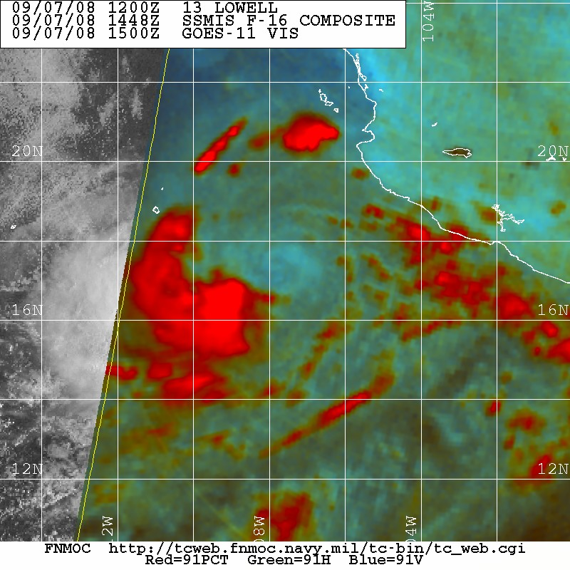
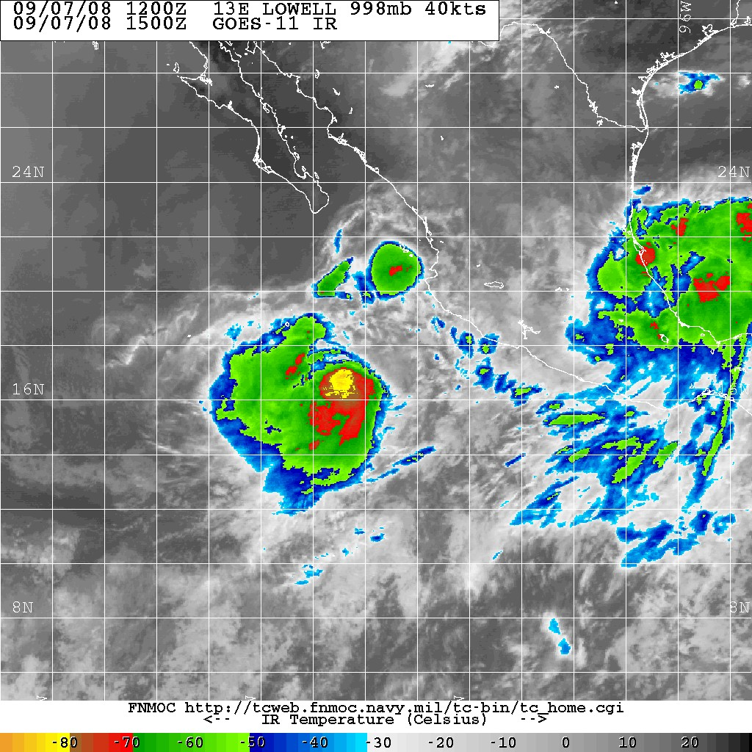
X
X

Figure 4. An infrared satellite image from GOES-W at 1500 UTC 7 September when Lowell was at its peak intensity of 45 kt (left) and a corresponding 91 GHz image from SSMIS at 1448 UTC 7 September (right). Note that the low cloud lines in the SSMIS image indicate that the low-level center (marked by an X) is exposed to the northeast of the deep convection. Images courtesy of the Fleet Numerical Meteorology and Oceanography Center.

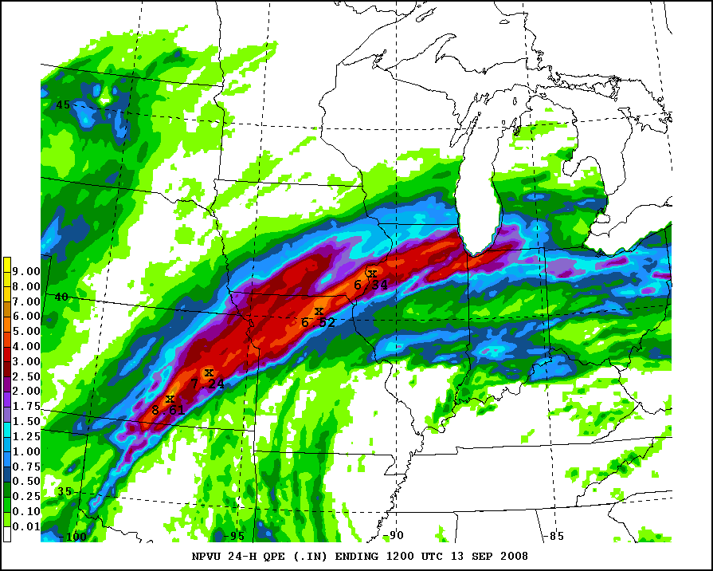

Figure 5. Radar/gauge composite analysis of 24-hour rainfall accumulation between 1200 UTC 12 September and 1200 UTC 13 September, showing the swath of heavy rain that occurred over the U.S. Central Plains when the remnants of Lowell merged with a frontal boundary. Data courtesy of the National Weather Service National Precipitation Verification Unit.

A digital record of the complete best track, including wind radii, can be found on line at ftp://ftp.nhc.noaa.gov/atcf. Data for the current year’s storms are located in the btk directory, while previous years’ data are located in the archive directory.

