Tropical Cyclone Report
Hurricane Genevieve
(EP082008)
21-27 July 2008

Jessica Schauer Clark and Jamie R. Rhome
National Hurricane Center
16 December 2008

Genevieve was a category 1 hurricane (on the Saffir-Simpson Hurricane Scale) that remained over the open waters of the eastern North Pacific Ocean and never affected land as a tropical cyclone.

- Synoptic History

Genevieve formed from a tropical wave that moved across the coast of Africa on 6 July. The wave tracked south of a strong subtropical ridge across the tropical North Atlantic, passing into the Caribbean Sea on 14 July, and spawned a surface low pressure system on 16 July over the western Caribbean Sea. Subjective Dvorak intensity estimates were initiated for this system at 1515 UTC on 17 July but were discontinued after 2345 UTC that day when the system moved onshore into Nicaragua. The wave then crossed Central America, bringing heavy rains to much of the region. The low center moved off the coast of El Salvador into the eastern North Pacific on 19 July with a central pressure of 1008 mb.

Dvorak intensity estimates resumed at 1200 UTC on 19 July. The organization of the deep convection was limited over the next two days as the system moved through a region of moderate easterly vertical wind shear on the southern edge of a strong upper-level high pressure system centered over southwestern Mexico. The wind shear began to relax on 21 July, allowing the associated deep convection to become better organized. It is estimated that a tropical depression formed around 1200 UTC 21 July approximately 220 n mi south-southwest of Acapulco, Mexico. Data obtained later that day from the Advanced Scatterometer (ASCAT) and Dvorak intensity estimates suggest that the depression reached tropical storm strength by 1800 UTC. The “best track” chart of the tropical cyclone’s path is given in Fig. 1, with the wind and pressure histories shown in Figs. 2 and 3, respectively. The best track positions and intensities are listed in Table 1.

While the vertical shear influencing Genevieve continued to decrease, the cyclone began to move over anomalously low sea surface temperatures in the wake of Hurricane Fausto, which had passed through the same region about five days earlier (17-19 July). Hurricane Fausto cooled the sea surface more than 3°C below the Reynolds climatological sea surface temperature values along the eventual path of Genevieve. The passage of Genevieve over this cold pool likely caused the temporary decrease in intensity from 1200 UTC 23 July to 0600 UTC 24 July despite subsiding vertical wind shear.

After Genevieve traversed the cold pool, it intensified from 45 kt to 65 kt in 18 hours, reaching hurricane strength around 1200 UTC 25 July when it was centered 510 n mi southwest of Cabo San Lucas, Mexico. Genevieve’s life as a hurricane was brief, and it weakened to tropical storm status by 0600 UTC 26 July as it encountered increasing southeasterly shear when it moved around the western periphery of the mid- to upper-level ridge over the eastern North Pacific. Genevieve passed over decreasing sea surface temperatures and into a region of increasing northerly shear, further weakening to a tropical depression around 0600 UTC on 27 July. The depression degenerated into a remnant low approximately six hours later. While devoid of deep convection and no longer a tropical cyclone, the remnant low of Genevieve maintained a closed surface wind circulation until around 0600 UTC on 31 July. The winds associated with the remnant of Genevieve finally diminished below 20 kt around 0000 UTC 2 August near 16°N 146°W, approximately 560 n mi east-southeast of Hilo, Hawaii .

- Meteorological Statistics

Observations in Genevieve (Figs. 2 and 3) include satellite-based Dvorak technique intensity estimates from the Tropical Analysis and Forecast Branch (TAFB) and the Satellite Analysis Branch (SAB). Data and imagery from NOAA polar-orbiting satellites, the NASA Tropical Rainfall Measuring Mission (TRMM), the NASA QuikSCAT, the European Space Agency ASCAT, and Defense Meteorological Satellite Program (DMSP) satellites, among others, were also useful in tracking Genevieve. Genevieve’s estimated peak intensity of 65 kt is based on Dvorak estimates from both TAFB and SAB.

There were no land-based surface reports or ship observations of tropical-storm force winds associated with Genevieve.

- Casualty and Damage Statistics

There were no reports of damage or casualties associated with Genevieve.

- Forecast and Warning Critique

Prior to moving into the eastern North Pacific, the antecedent tropical wave and attendant surface low over the western Caribbean Sea were mentioned in the Atlantic Tropical Weather Outlook beginning on 16 July at 1800 UTC with an initial probabilistic genesis forecast in the “medium” category corresponding to 20-50% probability of tropical cyclone formation within 48 hours. The Dvorak estimates for this system on 17 July were as high as 1.5/1.5 from TAFB, but the system was never considered organized enough to classify by SAB during this period. While in the Caribbean, the experimental probabilistic genesis forecast for the system reached the high end of the “medium” category with a 50% probability of genesis at 0600 and 1200 UTC 17 July. Subsequently, the forecast likelihood of genesis decreased rapidly as the system approached land.

Once in the eastern North Pacific, the genesis of Genevieve was very well advertised. The first mention of the system in the eastern Pacific Tropical Weather Outlook occurred at 1200 UTC on 19 July with an associated categorical genesis forecast of “medium”. The experimental genesis forecast increased to the “high” category (probability of genesis over 50%) six hours later, approximately 42 hours prior to the formation of the tropical depression, and remained in this category until tropical cyclone formation occurred.

As a tropical storm, Genevieve encountered the aforementioned anomalously cool sea surface temperatures due to the recent passage of Hurricane Fausto. The sea surface temperature departures from climatology, as measured by the Advanced Microwave Scanning Radiometer - Earth Observing System (AMSR-E) on the NASA Aqua satellite and the Tropical Rainfall Measuring Mission (TRMM) Microwave Imager (TMI), are depicted in Figure 4a. Figure 4b shows the corresponding 0000 UTC 23 July sea surface temperature analysis derived from the optimum interpolation (OI) method using a blend of the TMI and AMSR-E data, indicating that the coolest sea surface temperatures in the path of Genevieve were approximately 23-24°C. However, the Reynolds weekly sea-surface temperature analysis values were approximately
27-28°C in these areas. Therefore, the intensity guidance that utilized this weekly Reynolds sea-surface temperature analysis underestimated the cold anomaly induced by Fausto. For example, the SHIPS model from 0000 UTC 23 July indicated that SSTs along the track of Genevieve would remain above 27°C through 96 hours.

A verification of official and guidance model track forecasts is given in Table 2. Average official track errors for Genevieve were 30, 41, 51, 61, 91, 107, and 104 n mi for the 12, 24, 36, 48, 72, 96, and 120 h forecasts, respectively. The number of forecasts ranged from 21 at 12 h to 3 at 120 h. These errors are lower than the average 5-year official track errors at all forecast times (Table 2). The NHC track forecasts favored a more northwesterly track of the system than the model consensus as Genevieve passed through the cold pool induced by Fausto. As a result, the official track improved upon all track guidance at the 96 and 120 h forecast times. However, the GFDI model forecast was superior to all other track guidance for the 12, 24, 36, and 48 h forecasts, and also bested the official track at those forecast times.

A verification of official and guidance model intensity forecasts is given in Table 3. Average official intensity errors for Genevieve were 6, 11, 10, 9, 7, 9, and 12 kt for the 12, 24, 36, 48, 72, 96, and 120 h forecasts, respectively. For comparison, the average long-term official intensity errors in the eastern North Pacific are 6, 10, 14, 16, 19, 19, and 19 kt, respectively. The NHC average intensity forecast errors were superior to the long-term averages for all forecast times except at 24 h. Accurate track forecasts and assessment of the size and magnitude of the cold pool generated by Hurricane Fausto contributed to the accuracy of the official intensity forecasts. Specifically, by adopting a more northwesterly track forecast than the model consensus after the 0300 UTC advisory package on 23 July, the official forecast kept the path of Genevieve over the cold pool longer than some of the forecast guidance. The official intensity forecast was bested only by the intensity model consensus, ICON, at 48, 72, and 120 h and the FSSE at 72 and 120 h.

Watches and warnings were not required for Genevieve.

Table 1. Best track for Hurricane Genevieve, 21-27 July 2008.

Date/Time  (UTC) | Latitude  (°N) | Longitude  (°W) | Pressure  (mb) | Wind Speed  (kt) | Stage
21 / 1200 | 13.4 | 100.3 | 1006 | 30 | tropical depression
21 / 1800 | 13.8 | 101.9 | 1004 | 35 | tropical storm
22 / 0000 | 14.2 | 103.4 | 1004 | 35 | "
22 / 0600 | 14.3 | 104.6 | 1002 | 40 | "
22 / 1200 | 14.3 | 105.7 | 998 | 50 | "
22 / 1800 | 14.4 | 106.7 | 996 | 50 | "
23 / 0000 | 14.7 | 107.5 | 994 | 55 | "
23 / 0600 | 14.9 | 108.2 | 994 | 55 | "
23 / 1200 | 15.0 | 108.9 | 994 | 55 | "
23 / 1800 | 15.0 | 109.8 | 996 | 50 | "
24 / 0000 | 15.1 | 110.6 | 998 | 50 | "
24 / 0600 | 15.2 | 111.5 | 1000 | 45 | "
24 / 1200 | 15.3 | 112.2 | 1000 | 45 | "
24 / 1800 | 15.5 | 112.8 | 1000 | 45 | "
25 / 0000 | 15.8 | 113.4 | 997 | 50 | "
25 / 0600 | 16.0 | 114.2 | 994 | 55 | "
25 / 1200 | 16.3 | 115.2 | 987 | 65 | hurricane
25 / 1800 | 16.5 | 116.4 | 987 | 65 | "
26 / 0000 | 16.8 | 117.6 | 987 | 65 | "
26 / 0600 | 17.0 | 118.6 | 990 | 60 | tropical storm
26 / 1200 | 17.0 | 119.8 | 997 | 50 | "
26 / 1800 | 17.0 | 120.9 | 1000 | 45 | "
27 / 0000 | 16.9 | 122.0 | 1000 | 35 | "
27 / 0600 | 16.9 | 123.1 | 1004 | 30 | tropical depression
27 / 1200 | 16.9 | 124.4 | 1006 | 25 | low
27 / 1800 | 16.9 | 125.3 | 1008 | 25 | "
28 / 0000 | 17.0 | 126.0 | 1009 | 25 | "
28 / 0600 | 17.0 | 127.0 | 1009 | 25 | "
28 / 1200 | 17.0 | 128.0 | 1010 | 25 | "
28 / 1800 | 17.0 | 129.0 | 1010 | 25 | "
29 / 0000 | 17.3 | 130.0 | 1011 | 25 | "
29 / 0600 | 17.8 | 131.0 | 1012 | 20 | "
29 / 1200 | 18.0 | 132.0 | 1013 | 20 | "
29 / 1800 | 18.0 | 133.0 | 1013 | 20 | "
30 / 0000 | 17.8 | 134.1 | 1014 | 20 | "
30 / 0600 | 17.5 | 135.2 | 1014 | 20 | "
30 / 1200 | 17.1 | 136.4 | 1014 | 20 | "
30 / 1800 | 16.7 | 137.7 | 1014 | 20 | "
31 / 0000 | 16.4 | 138.9 | 1014 | 20 | "
31 / 0600 | 16.6 | 140.0 | 1015 | 20 | "
31 / 1200 |  |  |  |  | dissipated
25 / 1200 | 16.3 | 115.2 | 987 | 65 | minimum pressure

Table 2. Track forecast evaluation (heterogeneous sample) for Hurricane Genevieve, 21-27 July 2008. Forecast errors (n mi) are followed by the number of forecasts in parentheses. Errors smaller than the NHC official forecast are shown in boldface type.

Forecast Technique | Forecast Period (h)
Forecast Technique | 12 | 24 | 36 | 48 | 72 | 96 | 120
CLP5 | 35 (21) | 61 (19) | 86 (17) | 106 (15) | 146 (11) | 170 ( 7) | 223 ( 3)
GFNI | 34 (18) | 67 (16) | 105 (14) | 155 (12) | 245 ( 8) | 469 ( 4)
GFDI | 25 (21) | 36 (19) | 38 (17) | 51 (15) | 119 (11) | 228 ( 7) | 532 ( 3)
HWFI | 36 (21) | 55 (19) | 62 (17) | 76 (15) | 135 (11) | 177 ( 7) | 148 ( 3)
GFSI | 31 (21) | 45 (19) | 69 (17) | 86 (15) | 146 (11) | 208 ( 7) | 152 ( 3)
AEMI | 36 (21) | 57 (19) | 83 (17) | 110 (15) | 185 (11) | 263 ( 6) | 231 ( 3)
NGPI | 40 (20) | 67 (18) | 92 (16) | 128 (14) | 204 (10) | 381 ( 6)
UKMI | 31 (16) | 49 (14) | 71 (12) | 81 ( 8) | 46 ( 4)
BAMD | 38 (21) | 62 (19) | 89 (17) | 123 (15) | 184 (11) | 245 ( 7) | 321 ( 3)
BAMM | 35 (20) | 61 (18) | 90 (16) | 125 (14) | 189 (10) | 241 ( 6) | 295 ( 2)
BAMS | 31 (20) | 46 (18) | 65 (16) | 83 (14) | 134 (10) | 186 ( 6) | 259 ( 2)
TVCN | 31 (21) | 46 (19) | 53 (17) | 62 (15) | 101 (11) | 171 ( 7) | 221 ( 3)
GUNA | 29 (19) | 44 (17) | 56 (15) | 65 (12) | 108 ( 8) | 158 ( 4)
FSSE | 30 (20) | 45 (18) | 55 (16) | 55 (14) | 80 (10) | 134 ( 6) | 127 ( 2)
OFCL | 30 (21) | 41 (19) | 51 (17) | 61 (15) | 91 (11) | 107 ( 7) | 104 ( 3)
NHC Official  (2003-2007 mean) | 31.9 (1282) | 55.1 (1129) | 77.4 (979) | 97.9 (849) | 136.2 (620) | 180.1 (439) | 226.1 (293)

Table 3. Intensity forecast evaluation (heterogeneous sample) for Hurricane Genevieve, 21-27 July 2008. Forecast errors (kt) are followed by the number of forecasts in parentheses. Errors smaller than the NHC official forecast are shown in boldface type.

Forecast Technique | Forecast Period (h)
Forecast Technique | 12 | 24 | 36 | 48 | 72 | 96 | 120
SHF5 | 6.3 (21) | 11.9 (19) | 14.2 (17) | 13.5 (15) | 10.3 (11) | 13.3 ( 7) | 9.3 ( 3)
GHMI | 8.0 (21) | 14.7 (19) | 14.2 (17) | 10.8 (15) | 11.2 (11) | 21.7 ( 7) | 13.7 ( 3)
HWFI | 11.3 (21) | 17.7 (19) | 16.5 (17) | 10.9 (15) | 14.2 (11) | 24.9 ( 7) | 20.7 ( 3)
SHIP | 6.7 (21) | 11.5 (19) | 14.7 (17) | 15.5 (15) | 10.5 (11) | 9.6 ( 7) | 13.0 ( 3)
DSHP | 6.7 (21) | 11.5 (19) | 14.7 (17) | 15.5 (15) | 10.5 (11) | 9.6 ( 7) | 13.0 ( 3)
FSSE | 6.9 (20) | 12.3 (18) | 13.8 (16) | 11.6 (14) | 4.8 (10) | 13.3 ( 6) | 6.0 ( 2)
ICON | 7.6 (21) | 12.8 (19) | 12.1 (17) | 8.5 (15) | 6.2 (11) | 15.0 ( 7) | 6.7 ( 3)
OFCL | 5.7 (21) | 11.3 (19) | 10.0 (17) | 9.0 (15) | 7.3 (11) | 8.6 ( 7) | 11.7 ( 3)
NHC Official  (2003-2007 mean) | 6.2 (1282) | 10.4 (1129) | 13.9 (979) | 16.3 (848) | 18.7 (620) | 19.2 (439) | 19.1 (293)

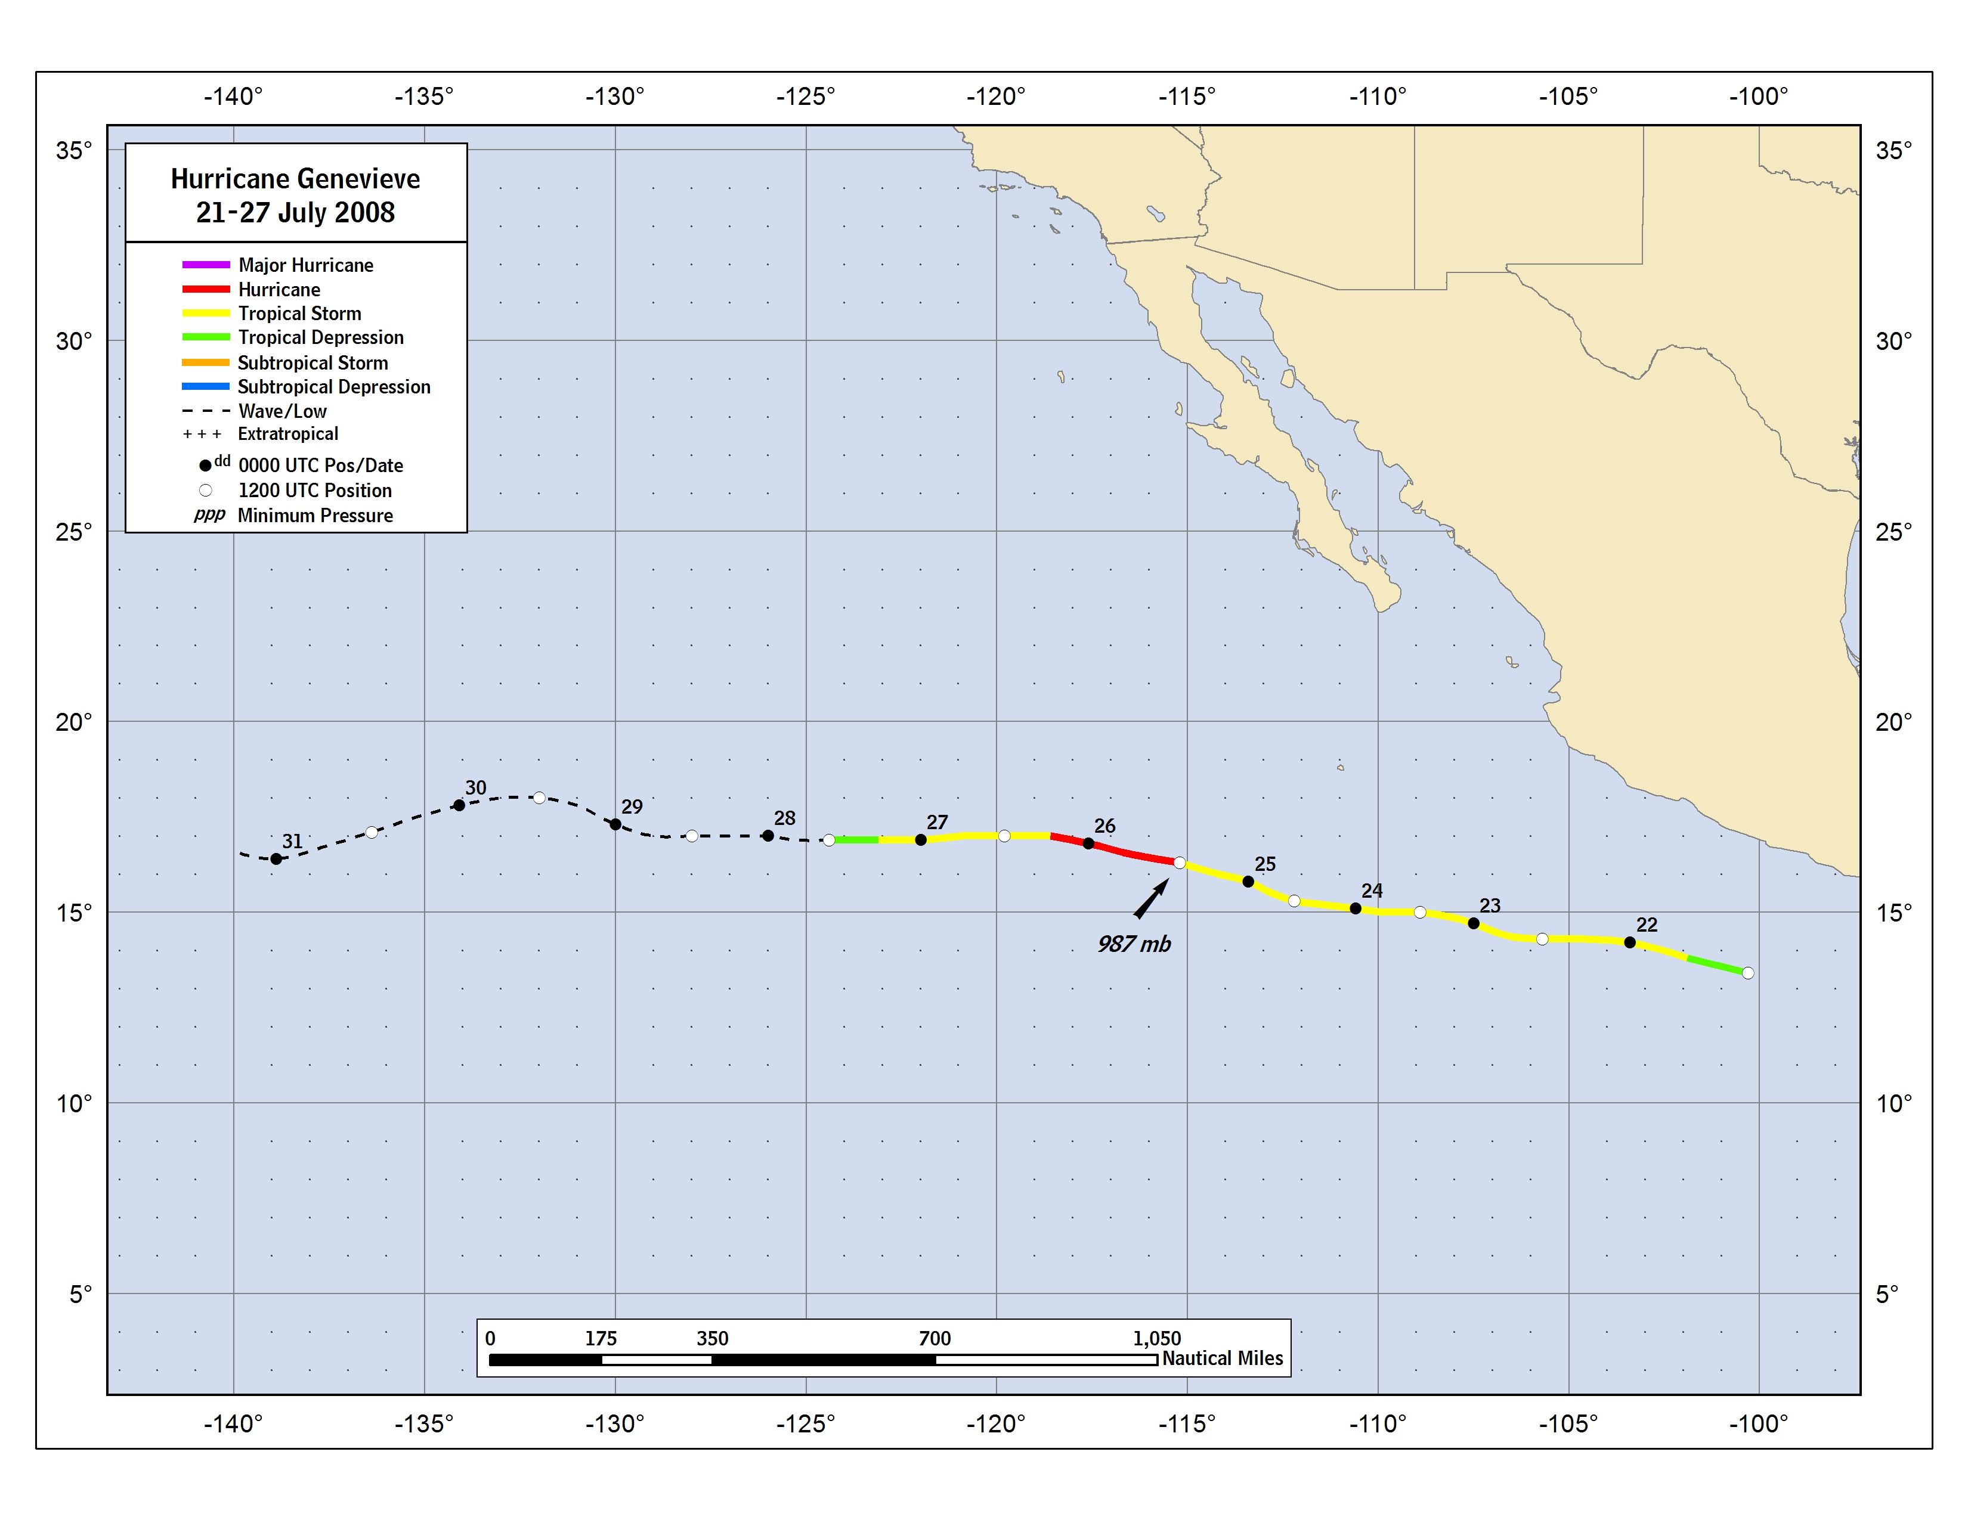

Figure 1. Best track positions for Hurricane Genevieve, 21-27 July 2008.

Figure 2. Selected wind observations and best track maximum sustained surface wind speed curve for Hurricane Genevieve, 21-27 July 2008.

Figure 3. Selected pressure observations and best track minimum central pressure curve for Hurricane Genevieve, 21-27 July 2008.

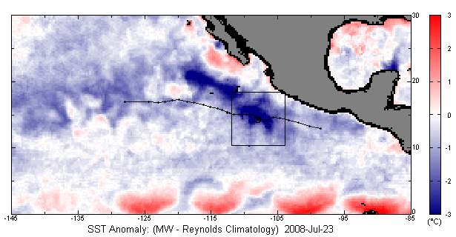

Figure 4a. Daily sea surface temperature anomaly from Reynolds sea surface temperature climatology (°C). The black line represents the track of Genevieve. The black box highlights the intersection of the track of Genevieve and the region of below normal sea surface temperature values associated with Hurricane Fausto. The position of Genevieve at 0000 UTC on 23 July 2008 is represented by the circle. Graphic courtesy of Remote Sensing Systems.

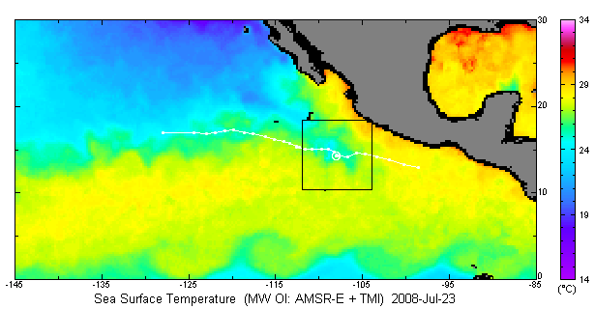

Figure 4b. Sea surface temperature analysis (°C) from the Tropical Rainfall Measuring Mission (TRMM) Microwave Imager (TMI) and the Advanced Microwave Scanning Radiometer - Earth Observing System (AMSR-E) from 0000 UTC on 23 July 2008. The black box represents the region of intersection between the track of Genevieve (white line) and the cooler sea surface temperatures left in the wake of Hurricane Fausto. The position of Genevieve at 0000 UTC on 23 July 2008 is represented by the circle. Graphic courtesy of Remote Sensing Systems.

A digital record of the complete best track, including wind radii, can be found on line at ftp://ftp.nhc.noaa.gov/atcf. Data for the current year’s storms are located in the btk directory, while previous years’ data are located in the archive directory.

