THE TWENTY-NINTH MEETING OF THE
INFORMAL PACIFIC ATC CO-ORDINATING GROUP
(IPACG/29)

(Fukuoka, Japan, 28-31 October 2008)

Agenda Item 5: Air Traffic Management (ATM) issues

DARP combined with UPR Routing in Central Pacific

(Presented by IATA)

SUMMARY

United Airlines conducted a DARP (Dynamic Air Re-route Procedure) on September 21, 2008 between Tokyo and Honolulu of a User Preferred Route (UPR). This information paper is for the information of the members of IPACG/29 and illustrates the potential benefits of both DARP and UPR operations in Pacific airspace.

- Introduction

- Dynamic Air Re-route Procedures provides an operator with the opportunity to improve the efficiency of a flight while en-route utilizing the latest upper air wind data and taking into consideration any improved routings that may become available after departure.

- User Preferred Routes (UPR) trials have been conducted between Japan and Hawaii since August 2008. Combined with the opportunity to DARP while en-route, greater operational efficiency is achieved.

- Combining both UPR routing and DARP operations can have a significant affect on the operational efficiency of a flight as illustrated in the completion of UAL880 from Tokyo to Honolulu on September 21, 2008.

- Discussion

  - On September 21, 2008 United Airlines operated flight UAL880 from Tokyo RJAA to Honolulu PHNL via a UPR. When compared to PACOTS Track 11, the projected savings of the UPR route was one (1) minute and 300 pounds of fuel. This would also save 900 pounds of CO2.

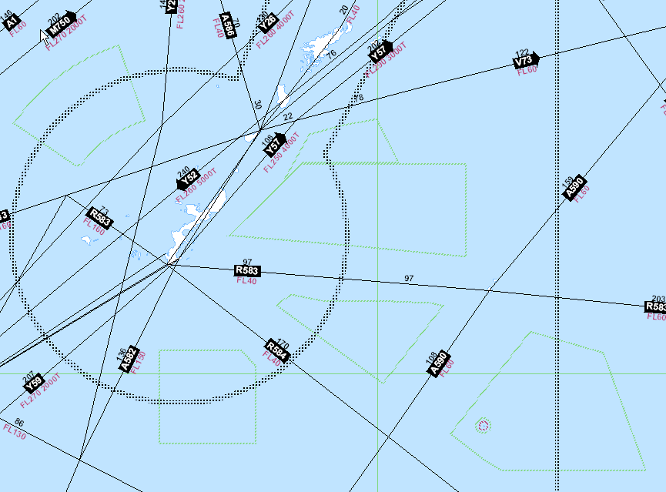
  - The UPR routing was generated by United Airlines Dispatch and included airspace restrictions in the Hawaii region, including the UPR trial requirement to cross a named waypoint on the Honolulu Control facility boundary.

  - The DARP operation was initiated prior to 180E with a routing to 30N170W, which provided the flight with the opportunity to tactically improve the routing into the Honolulu Control Facility. This resulted in a more direct routing and additional fuel savings.

  - Even though the DARP routing indicated zero time savings and only 69 pounds of fuel savings on “paper,” actual saving amounted to 7 minutes less flight time and 2000 pounds of fuel saved.

  - See the attached illustration of route comparisons.

- Recommendation

  - The meeting is invited to:

- Note the information contained within this paper
- ANSPs are asked to consider both the expansion of User Preferred Routes and DARP operations in their airspace.

Attachment A

CITYPAIR COMPARISON

UAL880 -1, 21SEP08, NRT-HNL B777-200ER

RTNG VIA OPTI-PAC11-SEALS-DANNO
F350 DCT GUPPY OTR13 SEALS DCT 36N150E DCT
37N160E DCT 36N170E DCT 33N180E DCT 29N170W DCT DANNO
DCT BOOKE BOOKE8
DIST 3376 TRIPF 101232 EET 6.39
COST FUEL 51605 TIME 5648 OVRFLT 948 TOTAL 58201

RTNG VIA OPTI-UPR-RIPKI W188
F350 DCT GUPPY OTR8 KAGIS OTR11 RIPKI DCT
37N155E DCT 37N160E DCT 36N170E DCT 34N180E DCT 29N170W
DCT ECEDO DCT DANNO DCT LIH V15 BOOKE BOOKE8
DIST 3382 TRIPF 100922 EET 6.38
COST FUEL 51449 TIME 5638 OVRFLT 948 TOTAL 58035

RTNG VIA PROPOSED DARP..DO NOT FILE
F350 DCT GUPPY OTR8 KAGIS OTR11 RIPKI DCT
37N155E DCT 37N160E DCT 36N170E DCT 34N180E DCT 30N170W
DCT DANNO DCT LIH V15 BOOKE BOOKE8
DIST 3382 TRIPF 100853 EET 6.38
COST FUEL 51415 TIME 5634 OVRFLT 948 TOTAL 57997

