The Twentieth Meeting of the Informal South Pacific ATS Coordinating Group
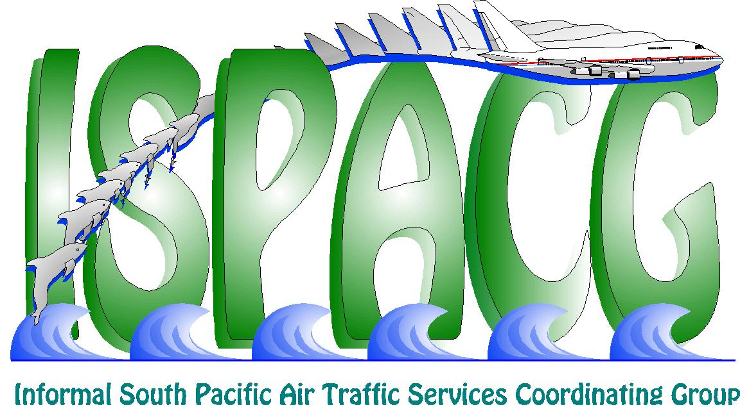
(ISPACG/20)

Honolulu, USA, 30 January – 1 February 2006

Agenda Item 7: Other business

Ground Earth Station Backup Capabilities

(Presented by the Federal Aviation Administration)

SUMMARY

This working paper attempts to generate discussions on Ground Earth Station (GES) and Datalink Service Provider (DSP) backup capabilities and Flight Management System requirements.

1. Background

1.1 During the months of September and October there were numerous outages of the Perth (POR1) GES.

1.2 The outages were frequent enough that several air traffic service units (ATSU) discontinued the use of separation standards based on automatic dependent surveillance (ADS).

1.3 During these outages, Oakland Air Route Traffic Control Center (ARTCC) experienced a complete loss of datalink capabilities. From Oakland ARTCC’s perspective it appeared as if the backup systems did not work.

2. Discussion

2.1 Oakland ARTCC wants to clarify what back up coverage is available when a satellite, GES or service provider incurs an outage.

  - Are aircraft properly configured to utilize backup data-link communication platforms?

  - Are the current outage notification processes sufficient since the separation of aircraft are dependent on these services?

  - Are current GES/DSP capabilities capable of supporting current and future ATM initiatives?

3. Recommendation

3.1 The meeting is invited to discuss/comment on the following:

- Do existing networks support current and future airspace initiatives?

- Determine what backup capabilities exist.

- Ensure that aircraft are properly configured so that they will be able to utilize alternate data-link paths.

- If necessary, revise outage notification procedures with DSP’s.

