The Twentieth Meeting of the Informal South Pacific ATS Coordinating Group (ISPACG/20)
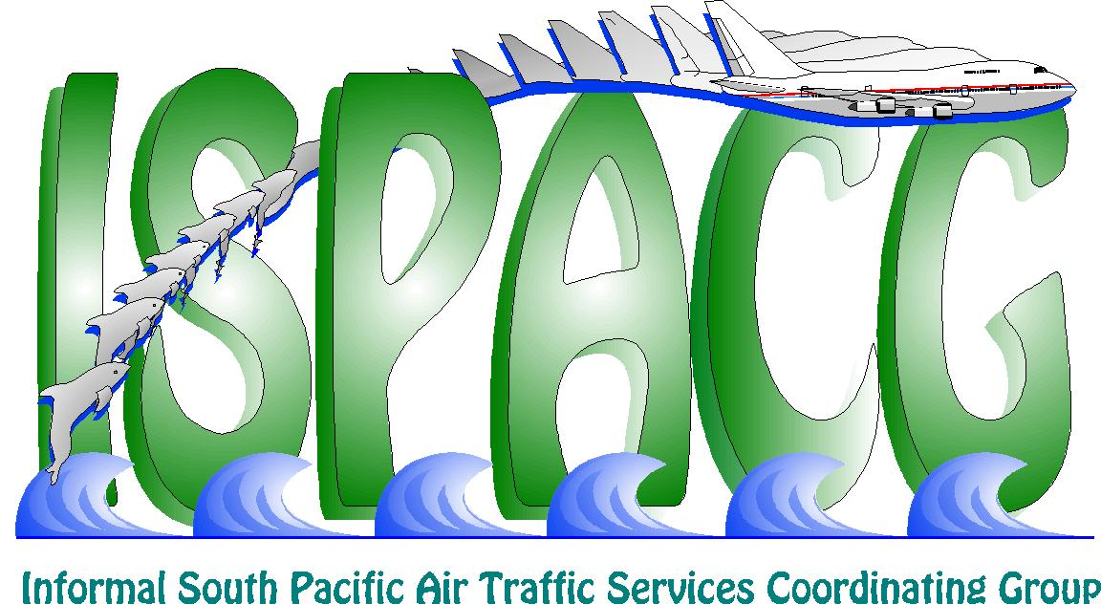

Honolulu, USA, 30 January – 1 February 2006

Agenda Item 3: Progress Report on 30/30 Implementation Task Force

30/30 TASK FORCE PROGRESS INFORMATION PAPER

(Presented by Airservices Australia)

SUMMARY
The 30/30 Separation Standards were safely implemented in January 2005 in the Tasman airspace. The standard has had only minimal use since that date. The drop in SATCOM availability resulted in a moratorium being placed upon its application. Subsequent SATCOM availability improvements have resulted in the standard being considered for reintroduction.

1. INTRODUCTION

1.1 Introduction and Background
  - ISPACG 18 initiated 30/30 Working Group
  - Appointed joint co-chairs from Airways NZ and Airservices Australia
  - 30/30 implemented in TASMAN January 2005
  - SATCOM availability limits use

Overview

1.2 The ICAO ANC Separation and Safety Panel [SASP] has been steadily evaluating the reduction in Lateral and Longitudinal separation standards based upon the introduction of new Communication, Surveillance and Navigation technologies. The advent of Direct Controller Pilot Communications via Controller Pilot Data Link Communication [CPDLC] in the Oceanic airspace, the development of Automatic Dependent Surveillance Contract [ADS-C] capabilities and high integrity RNAV provided the window of opportunity for the Air Navigation Commission to approve the reduction in Lateral and Longitudinal separation to 30NM Laterally and 30NM Longitudinally under strict conditions.

1.3 On 20th June 2004, the ICAO President on behalf of the Council authorised the use of the 30nm lateral/30nm longitudinal separation standard. The Informal South Pacific ATS Coordination Group [ISPACG/18] directed that a working group be established to implement 30nm lateral/30nm longitudinal separation standard within MID ASIA/PAC (Regional Supplementary Procedures – Doc 7030) airspace, provided minimum requirements were met or exceeded. These include but are not limited to communication utilising CPDLC, navigation utilising RNP4 and surveillance utilising ADS-C.

1.4 The 30NM/30NM Implementation Project was established to safely implement and operate the ICAO 30nm lateral/30nm longitudinal separation standard within specified Oceanic airspace. Implementation of this standard in the Australian Oceanic airspace (east of Australia only), Auckland FIR, Honiara FIR, Nauru FIR and the Nadi FIR; in Class A airspace is the precursor to broader implementation throughout the Pacific Oceanic FIRs.

1.5 The 30nm lateral/30nm longitudinal separation standard permits suitably equipped aircraft to operate in closer proximity to each other to effectively utilise the airspace in a more efficient manner.

1.6 The calculated target level of safety associated with the 30nm lateral/30nm longitudinal separation standard has been calculated as 2.38 x 10⁻⁹ Fatal Accidents per Flight Hour and exceeds the target level of safety of 5 x 10⁻⁹ Fatal Accidents per Flight Hour required by ICAO.

1.7 The ISPACG 30NM lateral/30NM longitudinal Implementation Working Group Project Team under the co-chairmanship of Steve Kemp, Airservices Australia and Geoff de Bazin, Airways New Zealand, met every two months in the time period April 2004 until September 2004 to ensure that all identified project hazards were effectively managed, that all project milestones were tracked, and all project team members were continuously apprised of issues, problems and solutions.

1.8 The major activities undertaken for the implementation of the 30NM lateral/30NM longitudinal RNAV separation standard were:

- Creation of the Implementation working group task list
- Conducted Safety Assessment (Hazard Identification workshop)
- Determination of Airborne and Ground system Requirements
- Conducted Rulemaking
- Performed Industry, Defence and Internal coordination
- Conducted International coordination
- Developed Pilot procedures
- Conducted Training Needs Analysis
- Performed Initial System Verification
- Conducted system verification of all NZ and Australian navigation deviation incidents and events (Does not include Fiji due lack of data availability)
- Conducted Target Level of Safety calculations for the airspace
- Established a monitoring procedure of post implementation System Performance
    - AGDP
    - OCS
    - SITA
- Conducted investigation of delayed ADS-C reports
- Established an ongoing monitoring program for navigation deviations
- Established an ongoing monthly reporting of all data link communication delays

1.9 The outcome of these activities ensured that there was a safe implementation of the ICAO Doc 7030 MID/ASIA/PAC 30NM lateral/30NM longitudinal RNAV separation standard in the Tasman and South Pacific.

1.10 The utilisation of this standard since January 20th 2005 has been minimal due to the number of aircraft with the appropriate RNP 4 approvals. However the Australian regulation CASR 91 Sub-part U becomes effective in January 2006 and it is expected that the number of RNP4 approvals will increase significantly as a result.

1.11 A 30/30 post implementation review will be conducted in April 2006. This PIR will be conducted by the co-chairs of the 30/30 Working Group. The results of the PIR will be circulated to the ANB, the ICAO Bangkok Regional office, the various ANSP’s and Regulators in the Pacific.

1.12 Since the implementation of 30nm lateral/30nm longitudinal separation standard on the 20th January 2005 aircraft are now able to obtain optimal flight paths and cruising levels leading to operational, economic and environmental benefits. Australian registered airlines in the TASMAN have already made applications to CASA in advance of the Sub Part 91U effective date and the expectation is that the use of 30/30 will escalate significantly from January 2006.

2. DISCUSSION

2.1 During October and November 2005 the SATCOM availability level dropped to an unacceptable level due to technical issues related to the Ground Earth Stations[GES]. Airports Fiji Limited, Airways New Zealand and Airservices Australia agreed to not apply the 30NM Lateral or 30NM Longitudinal separation standard in their State administered airspace from the third week in October.

2.2 Airports Fiji Limited, Airways New Zealand and Airservices Australia agreed to re-instate the application of the 30NM Lateral or 30NM Longitudinal separation standard in their State administered airspace when the required ADS-C and CPDLC communications achieved 99.7% operational availability. The 99.7% availability is to be the mean value of SATCOM availability achieved over a period of a month.

2.3 The refurbishment of the GES’s has satisfactorily reinstated the availability level and the decision to reinstate the 30/30 Separation Standards was taken by Airservices Australia, Airways NZ and Airports Fiji Limited with effect 1st December 2005.

2.4 This issue reinforced the level of system and safety monitoring that was instigated during the 30/30 Task Forces Project and proves the value of a high level of operational vigilance.

2.5 The application of 30/30 still requires a more robust system of lateral deviation monitoring to be implemented. The current reliance on ANSP Incident report monitoring is adequate but not optimal.

3. RECOMMENDATION

3.1 That ISPACG 20 note the information provided in this paper.

