The Twentieth Meeting of the Informal South Pacific ATS Coordinating Group
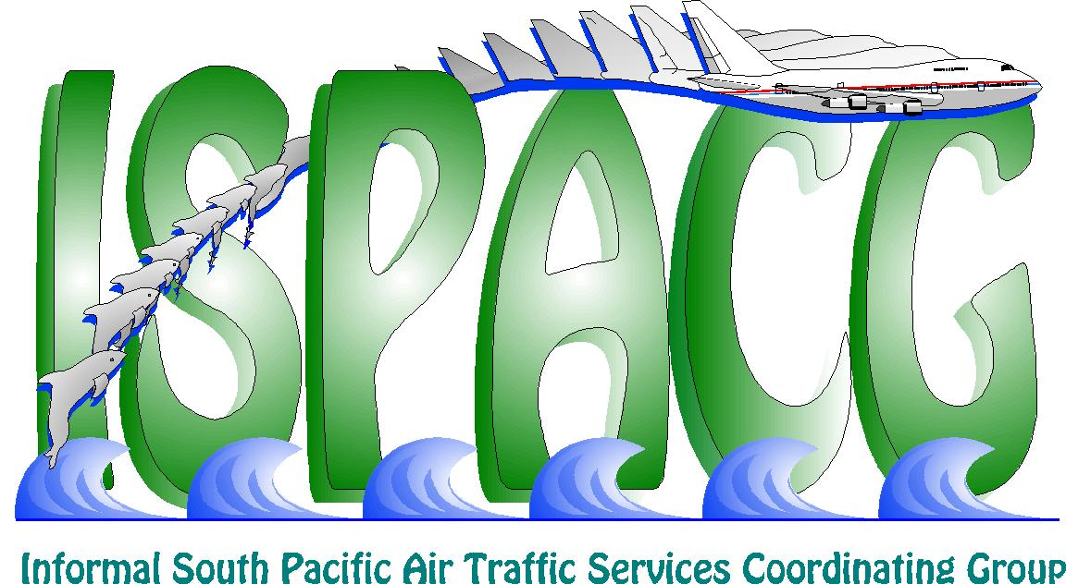
(ISPACG/20)

Honolulu, USA, 30 January – 1 February 2006

Agenda Item 2: Updates from ATS Providers

AUCKLAND OCEANIC UPDATE 2005

(Presented by Airways New Zealand)

SUMMARY

This information paper provides an update on events from Auckland Oceanic for 2005.

1. INTRODUCTION

  - Airways New Zealand made steady progress in 2005 with enhancements to our service delivery and continual improvement to the Oceanic Control System (OCS).

  - Traffic levels have remained relatively constant through 2005 and we continue to run a single OCS sector except for weekend days when two sectors are used.

2. DISCUSSION

AIDC

  - At the beginning of the year Auckland Oceanic was using AIDC with Brisbane and Christchurch for notification, coordination, and transfer of control, and with Oakland for notification. We were also using ICAO Doc 4444 PAC and CDN messages for departure coordination with Samoa, Tonga, and Rarotonga, and EST messages for coordination with Santiago.

  - During 2005 we introduced AIDC with both Nadi and Tahiti. The Nadi interface is compliant with the ICAO ASIA/PAC Interface Control Document Version 1 and is used for notification, coordination, and transfer of control. The Tahiti interface is compliant with ICAO Doc 4444, and is used for notification and coordination. We are currently introducing full AIDC for notification and coordination with the Oakland ATOP platform which is complaint with the ICAO ASIA/PAC ICD Version 1. Oakland testing was completed on 18 January and we are expecting operational use in the next few weeks.

  - Generally, AIDC is working well. We still have some software issues to be resolved in 2006 with flights hemstitching through the Auckland/ Nadi boundary where OCS on occasion will send AIDC messaging to Brisbane for Brisbane bound flights not under OCS control. Incorrect route truncation by controllers, which causes inaccuracy in ABI data, is still seen occasionally. However, the incidence of this problem has reduced. Brisbane’s inability to process more than 10 characters in Field 10 data (equipment) which causes LRM responses to valid ABI data is becoming more of a problem as more airlines file more than 10 characters in this field. Workarounds are in place to overcome this problem until a software solution can be found.

  - Auckland is currently completing final testing of our AIDC Version 2 software for the Oceanic Control System (OCS). Version 2 AIDC enables the coordination of block levels, weather deviations and offsets and will significantly reduce phone coordination and enhance service delivery by reducing coordination times with adjacent ATSU’s. The software will be released on AIRAC date 15 March.

  - The OCS software is a full AIDC Version 2 implementation. However, it has been designed to allow partial AIDC Version 2 implementation with adjacent ATSU’s. OCS adaptation will define what if any AIDC version2 fields are supported by an adjacent ATSU and the OCS controller will be given adequate visibility in the user interface of any limitations requiring manual coordination. The picture below shows the OCS coordination window enhanced for AIDC Version2.

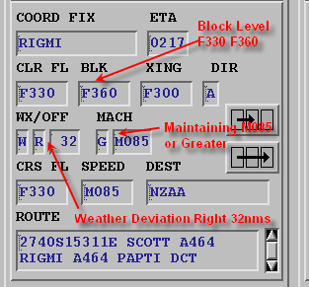

  - The OCS software uses different coloured field backgrounds to differentiate AIDC Version 2 elements that are not supported. Automated coordination is also put on hold when non-supported AIDC Version 2 fields exist. The current interface is depicted below for a non-AIDC Version 2 ATSU where a 25nm left weather deviation is in existence on profile. In this situation automatic coordination is put on hold and the controller is prompted to manually coordinate the data. The coloured fields allow the controller to easily identify for each ATSU what fields are not supported in the AIDC messaging.

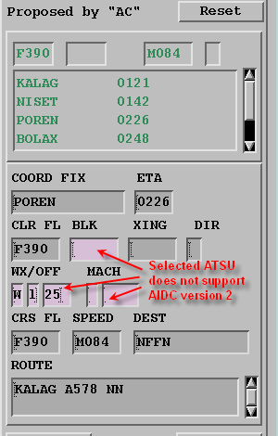

  - Controller visibility of coordinated AIDC Version 2 data on inbound flights is provided by enhancements to the controller electronic strips and situation displays. The current interface for controller strips is depicted below.

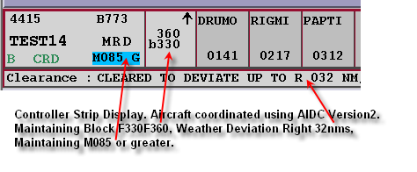
DARP and Flex Tracks

  - Further DARP reroute testing was completed during the year with both Boeing and Airbus test benches to validate the latest ISPACG DARP procedures. With the introduction of AIDC with Nadi, Oakland, and Tahiti, we expect to see significant progress this year towards implementing DARP reroutes in the region.

  - Air Tahiti Nui introduced flex tracks on the Tahiti – Sydney sector in 2005.

30/30 Separation Standard

  - Qantas have now joined Air New Zealand, Emirates, and Singapore Airlines with 30/30 separation approvals in the Auckland Oceanic FIR. Airways New Zealand introduced the standard in the South Pacific in conjunction with Nadi and Brisbane in January 2005.

  - The application of the standard was withdrawn between October 13 and December 1 because of system availability issues caused by problems at the Perth GES.

  - The OCS application of the standard is selected by the controller when required. OCS automation will only set the increased ADS contract rates with an aircraft when the separation is required. Now that Qantas have the required approvals we might even get to apply the standard this year.

Oceanic Control System (OCS) Development

  - The stability of OCS has improved significantly through 2005. In 2006/2007 we will be making architecture changes to the platform to further enhance the system and enable seamless datalink operation from the OCS reserve platform. The OCS reserve platform is used when upgrading software on the main platform, and also in the event of main platform failure. Enhancements to the software (Sync Server) used to transfer operations between the main and reserve platforms now permit controllers to move operations between platforms within a few minutes. The actual transfer of flight records and profile data takes around 20 seconds.

  - We are starting work this year on our next operating system and hardware upgrade for the operational OCS platforms.

  - On the software side we continue to enhance the OCS controller HMI with the emphasis on reducing controller workload. We will also be starting work on the integration of the ATN CPDLC and ADS applications into the OCS system.

  - In 2006 we will also be working with Air New Zealand to develop ACARS FMC Way Point Reporting on the A320. This will assist in reducing HF congestion in the area.

General Operations

  - Traffic levels in the Auckland Oceanic area are not forecast to change significantly over the next year. The monthly daily average was 183 movements in November 2005. Operations expect single sector operation to continue at these traffic levels, however we will maintain dual sector staffing levels on weekend days to cover increased daily maximums at these times.

  - FANS-1/A traffic averaged between 20-25% of total monthly traffic during 2005. Total numbers on FANS traffic/month vary between 1100 and 1500 flights. This variation is caused by changing weather patterns affecting the routing of the Australian-US flex tracks.

  - Auckland Oceanic is placing more emphasis on liaison with our domestic counterparts to improve block to block times and we have a number of initiatives under way in this area.

3. RECOMMENDATION

3.1 The meeting is invited to note the information provided in this paper.

