The Twentieth Meeting of the Informal South Pacific ATS Coordinating Group
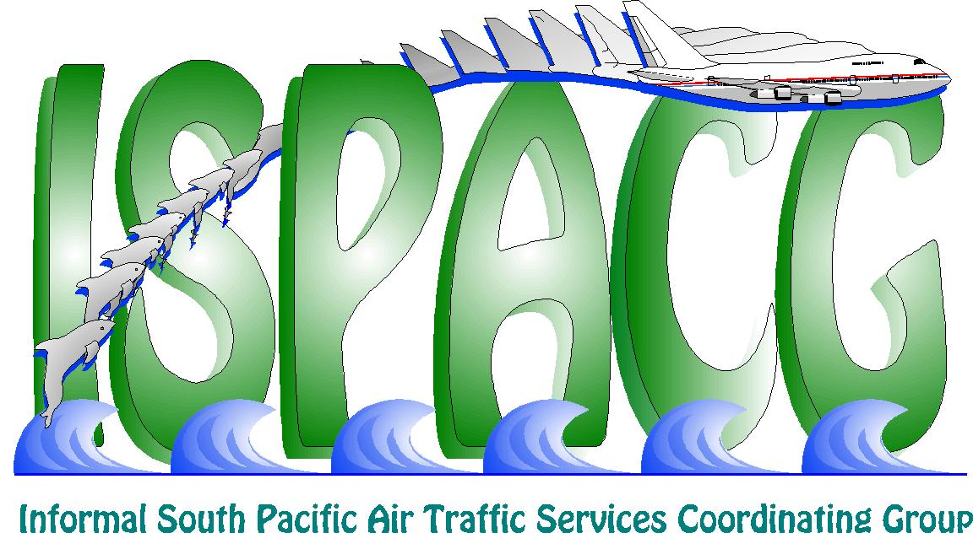
(ISPACG/20)

Honolulu, USA, 30 January – 1 February 2006

Agenda Item 2: Updates from ATS Providers

STATUS OF ADVANCED TECHNOLOGIES AND OCEANIC PROCEDURES
OCEAN21 SYSTEM IMPLEMENTATION

Presented by the Federal Aviation Administration

SUMMARY

This paper provides an overall status on the implementation and deployment of the ATOP Ocean21 system.

1. Background

1.1 The Advanced Technologies & Oceanic Procedures (ATOP) Ocean21 system replaces the current Federal Aviation Administration (FAA) oceanic air traffic control system. It fully integrates flight and radar data processing, detects conflicts between aircraft, provides satellite data link communication and surveillance capabilities, eliminates the need for paper flight strips and automates the manual processes used today. The program provides a fully modernized oceanic air traffic control automation system, which will allow airspace users to take further advantage of investments made in cockpit digital communications.

1.2 With Ocean21, the FAA significantly reduces the intensive manual processes that today limit the ability of controllers to safely handle airspace operator requests for more efficient tracks or altitudes over long oceanic routes. It allows the FAA to meet international commitments of reducing aircraft separation standards thereby dramatically increasing operational efficiency without any loss of safety.

1.3 Ocean21 Benefits

- Increases opportunity for aircraft on long haul oceanic flights to fly preferred fuel saving tracks
- Increases flight profile predictability and reliability, thereby potentially increasing cargo revenues
- Provides greater flexibility and responsiveness to in-flight requests through timely, reliable satellite data communications, providing additional cost savings and benefits
- Streamlines and automates manual processes freeing air traffic controllers to respond to pilot requests
- Improves safety by reducing chances for pilot controller miscommunications due to readback/hearback errors that are more common with voice communications
- Provides FAA benefits through implementation of common systems, procedures, training and support at all three oceanic centers
- Increases airspace efficiency through enabling the implementation of reduced separation standards

1.3 Initial Operational Capability (IOC) of the Ocean21 system was achieved at the New York Air Route Traffic Control Center (ARTCC) on 31 March 2005. This milestone was accomplished within established cost and schedule baselines.

2. Discussion

2.1 New York ARTCC began full operational use of the Ocean21 system on 6 June 2006. Oakland ARTCC began full operational use of the Ocean21 system on 17 October 2006. Anchorage ARTCC is scheduled for Initial Operating Capabilities (IOC) on one sector in March 2006. Anchorage will then work toward implementing Ocean21 in the rest of their flight information region (FIR).

2.2 With the implementation of the Ocean21 system, Oakland began utilizing the 50NM longitudinal separation standard based on automatic dependent surveillance (ADS) throughout the Oakland FIR.

2.3 On 22 October 2006, Oakland ARTCC began operational trials of the 30NM lateral/30NM longitudinal separation standard (30/30) based on ADS in the Oakland Oceanic Sector 3 (OC3). The expansion of the use of 30/30 throughout the Oakland FIR will be based on the outcome of the OC3 trials over the next few months. The FAA is aggressively pursuing this goal and will implement as soon as the data and approval process permit.

3. Recommendation

3.1 The meeting is requested to note the information in this paper.

