The Twentieth Meeting of the Informal South Pacific ATS Coordinating Group
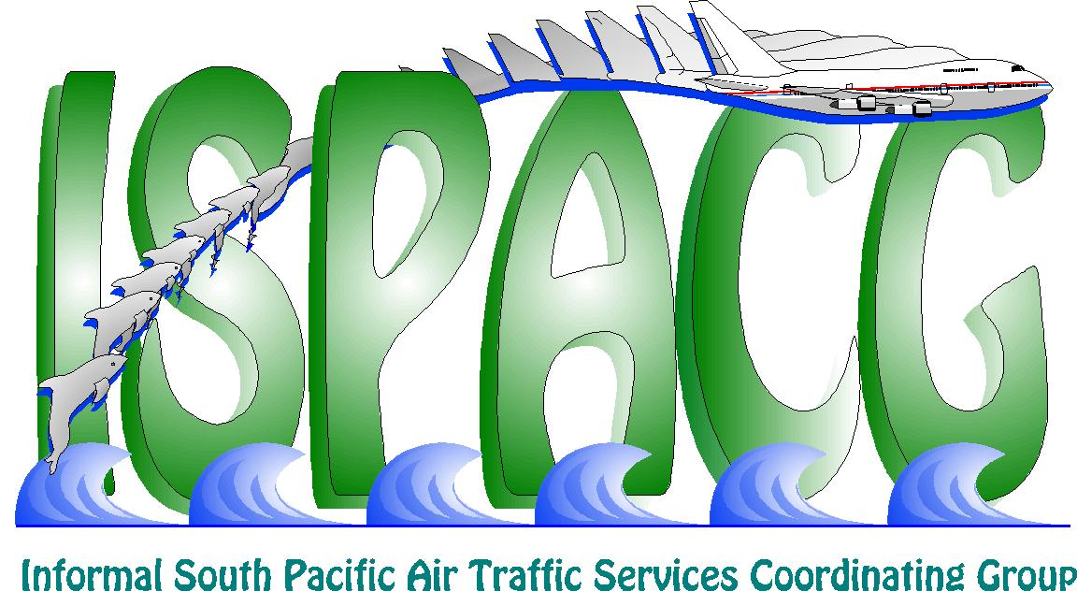
(ISPACG/20)

Honolulu, USA, 30 January – 1 February 2006

Agenda Item 7: Other business

Utilization of Block Altitudes in the Oakland FIR

(Presented by the Federal Aviation Administration)

SUMMARY

This information paper provides information on the application of block altitudes within the Oakland FIR.

1. Introduction

  - In today’s aviation environment, it is critical to provide users with every opportunity possible to save money. One of the ways Oakland Air Route Traffic Control Center (ARTCC) does this is thru the application of Block Altitudes. Block Altitude clearances provide a means for aircraft to cruise climb to the next altitude thereby increasing fuel burn efficiency. Block Altitude clearances are not issued when they will negatively impact another operator.

  - For example, Aircraft A is at F290 and Aircraft B is directly below Aircraft A at F280. Aircraft B is requesting higher altitude but is unable to climb due to traffic, Aircraft A. Aircraft A is issued a Block Altitude of F290B310. This Block Altitude does not negatively impact Aircraft B because they would still be unable to climb if Aircraft A was assigned a single altitude of F290. With the Block Altitude clearance, Aircraft A is able to maximize their fuel efficiency by effectively cruise climbing to F310. When Aircraft A reports F300, the altitude clearance is revised to Block F300B310. Aircraft B would then be assigned F290. Similarly when Aircraft A reports at F310 a new clearance would be issued which allowed Aircraft B to climb to F300. Aircraft A’s block altitude does not impact Aircraft B’s ability to climb.

  - Another example would be two aircraft converging, Aircraft A is assigned F290B310 and Aircraft B is assigned their requested altitude F300. The two aircraft will lose lateral separation at 140 west longitude. In this case Aircraft A would be given the option to cross 140 West at either F290 or F310 so as to insure the Block Altitude does not impact Aircraft B.

2. Conclusion

2.1 Block Altitude clearances when applied correctly provide improved airspace efficiency to the airspace customers.

3. Recommendation

3.1 The meeting is invited to note the information provided in this paper.

