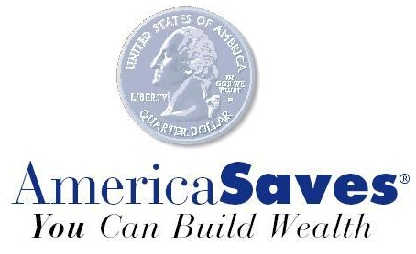

America Saves Week
February 24 – March 2, 2008

A Guide for Extension Educators:
National Evaluation Form

This working paper was prepared by a team of Cooperative Extension professionals and the America Saves team at the Consumer Federation of America. To access the most current version of this document on-line, go to http://www.csrees.usda.gov/nea/economics/fsll/edu_saves.html

July 2007
For further information and questions, contact

Nancy Register, Director, America Saves, nregister@consumerfed.org or
Jane Schuchardt, National Program Leader, CSREES, USDA, jschuchardt@csrees.usda.gov

America Saves Week Extension Leadership Team
Southern Region
Jennifer Abel jabel@vt.edu
Virginia Cooperative Extension, Arlington County
Elaine Courtney ecourtney@co.okaloosa.fl.us
University of Florida Extension, Okaloosa County
June Puett jpuett@utk.edu
University of Tennessee Extension

Northeast Region
Barbara O’Neill oneill@aesop.rutgers.edu
Rutgers Cooperative Extension

Western Region
Patti Wooten-Swanson pwswanson@ucdavis.edu
University of California Extension

Central Region
Caezilia Loibl loibl.3@osu.edu
Ohio State University Extension
Carol Young cyoung@oznet.ksu.edu
Kansas State University Extension

The following pages provide extension educators with the following resources and tools for a successful America Saves Week:

Item Page
National evaluation form for America Saves Week 2008 3

National evaluation form for America Saves Week 2008

Summarized by: June Puett, University of Tennessee Extension

We ask extension educators across the United States to contribute to Extension’s national America Saves Week efforts by collecting the information below. Enter the information on-line between March 2 and March 29 at:

http://www.surveymonkey.com/s.aspx?sm=OgMmjPmaYX_2bxY_2fqq8OJC1A_3d_3d

Please summarize activities used to highlight or promote financial education conducted prior, during or following America Saves Week, not necessarily the total program year efforts.

Evaluation Questions:
- Total number of direct methods used (workshop, class, mail, face-to-face, etc.)- count each time activity was used: ______
- Total people reached with direct methods: ______
- Total number of indirect methods used (media, website, exhibit, publication, flyer, etc.)- count each time method was used): ______
- Total people reached with indirect methods: ______

- Number of America Savers enrolled (paper or on-line): ______
- Total amount of monthly savings goal pledged (available on enrollment form): ______
- Number accounts (savings, investment, retirement, etc.) opened and or contributed to: ______
- Number of collaborating partners and volunteers: ______
- Total amount sponsorship, funding, or in-kind contribution (include donated media space/time): $_____________
- Briefly list or describe other events, activities or successes (proclamations, piggy bank pageant, legislative event, financial institution collaboration, etc) : ______

Thanks for your response! Reports will be summarized for the national Extension America Saves Week report.

