S. American Waterweed: An Invasive Aquatic Plant

Egeria densa
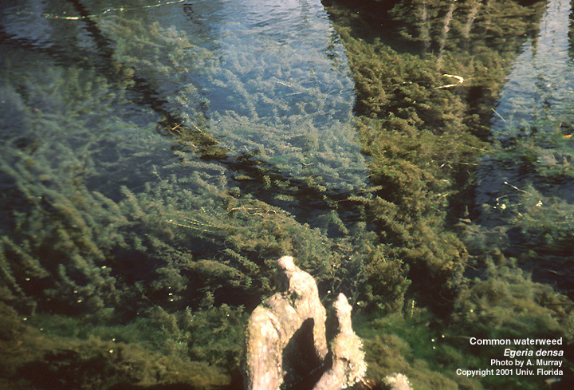

Description
- Egeria densa is a very leafy aggressive non-native invasive aquatic plant. E. densa is a perennial monocot originally from South America and is often called Brazilian Waterweed.
- E. densa is very buoyant and most of its biomass is located near the water’s surface.
- The strap-shaped leaves are bright green, 1” long and ¼” wide, and the tips end in a point. The leaf margins have small serrations that can be seen with a hand lenses, but no teeth are present on the lower midrib of the leaf. Leaves are arranged in whorls of 4-8, but most often occur in whorls of 4.
- The dense stems are bright green with branches sprouting from double nodes on the stem.
- E. densa is dioecious (male and female flowers on separate plants), however, seed germination has not been reported in the United States, and no tubers are produced.

S. American Waterweed
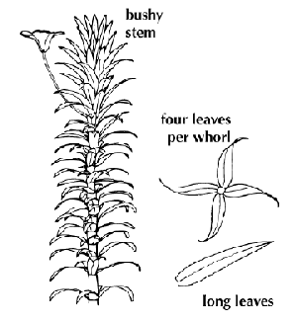
Robust plant with bushy stem

WhoWhorls of four

Long serrated leaves

Habitat
Egeria densa is a very hardy and persistent species that has established itself in a wide range of aquatic habitats.
- Tolerates a variety of habitats and water conditions, including oligotrophic (nutrient poor) and eutrophic (nutrient rich) lakes.
- Prefers slow moving acidic waters and is less tolerant of high temperatures than other invasive species.

Commonwealth of Massachusetts ~ Department of Environmental Management ~ Office of Water Resources ~ Lakes and Ponds Program

Distribution Map

Egeria densa
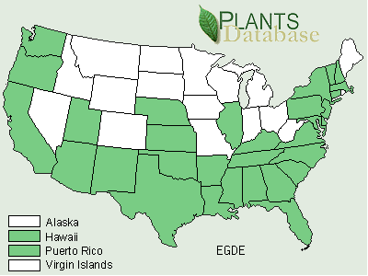

Reproduction
Although seeds are produced, the main method of reproduction for E. densa is vegetative.
- E. densa fragments very easily and fragments can travel to new locations. Where double nodes have formed roots or stems can develop.
- Small white 342” flowers with 3 petals develop on a stalk that can extend 1” above the waters surface.

Impacts and Threats Posed by South American Waterweed
E. densa is a highly competitive plant that is capable of rapid growth and spread. E. densa can displace native species, reduce biodiversity, limit recreation, diminish aesthetic value, and decrease water quality and flow.
- Once established, E. densa can form thick unsightly mats on the water’s surface that may restrict light to the complete exclusion of other native plants.
- The mats formed can hamper fishing, boating, swimming and other activities and the loss of recreational and aesthetic value can cause a decline in surrounding lake property value.
- E. densa may form dense single species stands that often do not provide ideal habitat or food for native wildlife. These native wildlife populations may be forced to relocate or perish, ultimately resulting in a loss of biodiversity and a disruption in the balance of the ecosystem.
- When the large stands of E. densa die, their decomposition can create anoxic (low oxygen) conditions in the water which may result in fish kills.
- Dense stands of E. densa trap sediments, slow water flow in irrigation channels and waterways.
- Both organic and inorganic sediment levels increase with increasing E. densa abundance.
- Dense surface mats may provide a breeding ground for mosquitoes.

Management Methods
Management methods currently include mechanical methods, herbicides, drawdowns and barriers.
- Although harvesting can greatly reduce the E. densa biomass in a water body, harvesting causes fragmentation. E. densa spreads primarily by fragmentation, and fragments created by mechanical harvesting may drift downstream or attach to boats and wildlife and create new infestations elsewhere.
- Treatment with Diquat, Endothall or copper based herbicides have been effective measures of control. However, herbicides require permits, must be applied by a licensed applicator and may impact non-target native plants or animals.
- Drawdowns can be an effective control method if the drawdown is sufficient to allow sediments to freeze. Drawdowns may have downstream impacts and may affect fish, reptiles, amphibians and aquatic organisms.
- Benthic barriers may be used in small areas including swimming beaches, boating lanes and around docks. The barriers restrict light and upward growth but can have a negative impact on benthic organisms, and need to be properly anchored and maintained.
- The only potential biological control, the fungus Fusarium ssp., has shown promising lab results but field trails, have yet to be completed.

Other Information
- Informational websites:
http://aquat1.ifas.ufl.edu/ (Center for Aquatic and Invasive Plants)
http://dnr.metrokc.gov/wlr/waterres/smlakes/weed.htm (Washington State King County)
www.ProtectYourWaters.net (Aquatic Nuisance Species national web site)
- Many pet stores sell South American Waterweed under the name Anacharis.
- E. densa was first documented in Massachusetts in Abington in 1940.
- E. densa may be confused with the native Common Waterweed (Elodea) or non-native Hydrilla (Hydrilla verticillata). Egeria densa is more robust, leafy, and larger than either Hydrilla or Elodea, with leaves in whorls of 4.
- Elodea has leaves that are small and arranged in whorls of three.
- Hydrilla has small leaves arranged in whorls of 4-8 and the leaf margins are distinctly serrated.

S. American Waterweed compared to Elodea and Hydrilla
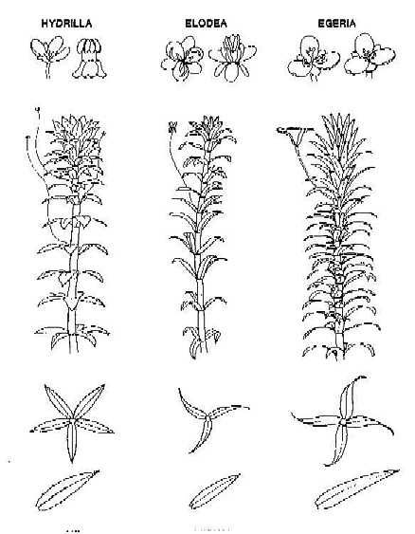

References:
1) Literature References:
http://www.ecy.wa.gov/programs/wq/plants/weeds/aqua002.html (WA State King County site)
www.wapms.org/plants/egeria.html (Western Aquatic Plant Managers Society)
http://webapps.lib.uconn.edu/ipane/browsing.cfm?descriptionid=17 (IPANE site)
2) Photographs were obtained from:
http://plants.ifas.ufl.edu/egdepic.html (cover photo and line drawing)
3) The distribution map was taken from:
http://plants.usda.gov/cgi_bin/topics.cgi (USDA Plant Atlas)

For more information please contact:
D.E.M. Office of Water Resources, Lakes and Ponds Program
Michelle Robinson at: michelle.robinson@state.ma.us
Or visit the Lakes and Ponds web site at: http://www.mass.gov/lakesandponds
Prepared: November 2002

