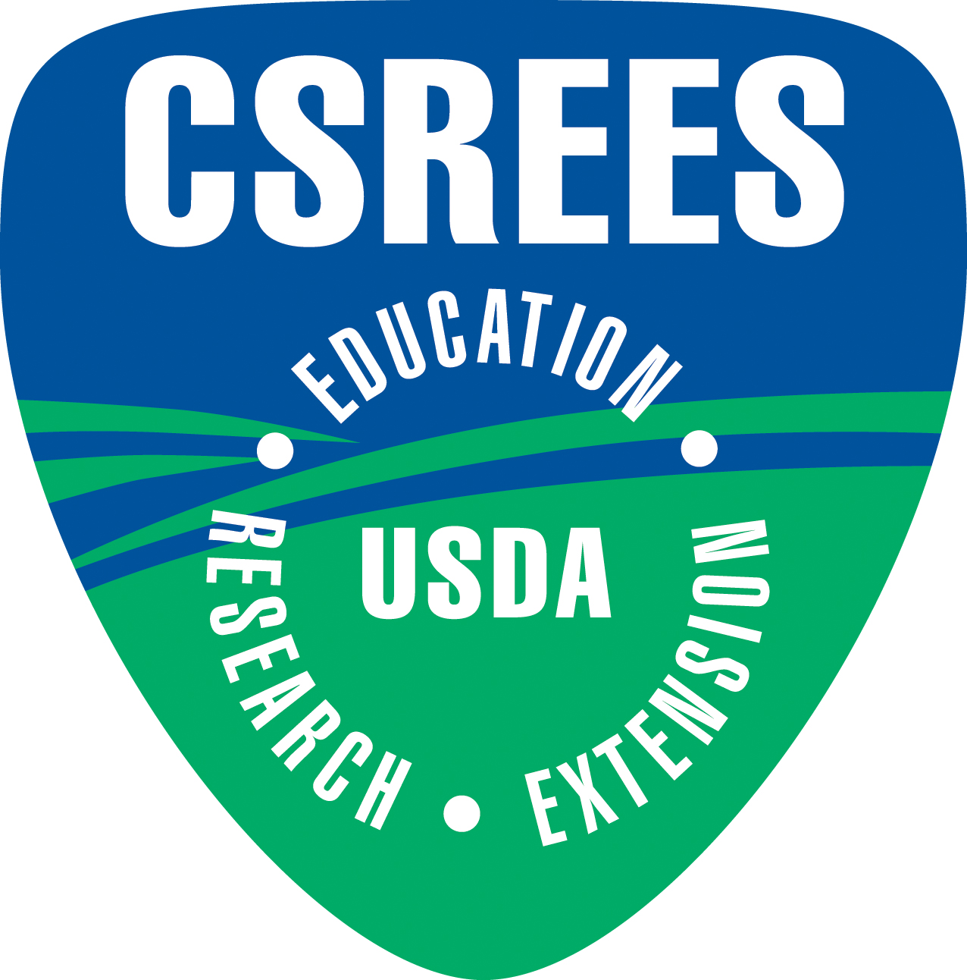
Agricultural Research Service
Cooperative State Research, Education, and Extension Service

Manure and Byproduct Utilization
Customer/Stakeholder Workshop Schedule

Monday, Nov 3, 2008
7:00 p.m. to 8:30 p.m. Gateway Room | Planning and Orientation Meeting for Facilitators  Evert Byington, Moderator
7:00 p.m. to 9:00 p.m. Concourse A Foyer | Early Registration  Ellen Buckley & Colette Wood, Coordinators
Tuesday, Nov 4, 2008
7:00 a.m. to 8:00 a.m. Concourse A Foyer | Registration, Continental Breakfast  Ellen Buckley & Colette Wood, Coordinators
Workshop Opening
8:00 a.m. to 9:10 a.m. Concourse Ballroom A  Mark Walbridge, Chair  ARS National Program Leader, Water Availability & Watershed Management | Introductions and Purpose of Meeting  Evert Byington  ARS National Program Leader, Manure and Byproduct Utilization  Area Office Welcome  Larry Chandler  Director, ARS Midwest Area  ARS Overview  Steven Shafer  ARS Deputy Administrator, Natural Resources and Sustainable Agricultural Systems  CSREES Welcome and Overview  Ralph Otto  CSREES Associate Administrator  Meeting Process and Goals  Evert Byington
CSREES and ARS Activities in Manure and Byproduct Utilization
9:10 a.m. to 10:00 a.m. Concourse Ballroom A | Summary of CSREES Projects and Funding Activities  Richard Hegg  CSREES National Program Leader, Plant & Animal Systems  Current ARS Action Plan and Associated Projects  Evert Byington
10:00 a.m. to 10:20 a.m. Concourse A Foyer | Break
10:20 a.m. to 11:45 a.m. Concourse Ballroom A | External Assessment of ARS Manure and Byproduct Utilization program  Wendy Powers  Animal Ag Environmental Stewardship Director  Michigan State University  Responses to Customer/Stakeholder Questionnaires  Evert Byington  Charge to the Group for First Breakout Session  Evert Byington
11:45 a.m. to 1:00 p.m. Concourse Ballroom A | Workshop Luncheon and Guest Speaker  Paul Martin  Director of Environmental Services  Western United Dairymen
Customer Focus Sessions
1:00 p.m. to 3:00 p.m. | Breakout Session I: Developing a Strategic National Perspective for Research, Tech Transfer and Education  Breakout rooms:  Truman Room  Clayton Room  Ladue Room  Lindbergh Room A  Lindbergh Room B
3:00 p.m. to 3:15 p.m. Concourse A Foyer | Break
3:15 p.m. to 4:00 p.m. | Breakout Session II: Discuss National Perspective/ Define Needs and Priorities  Breakout rooms:  Truman Room— Poultry  Clayton Room— Swine  Ladue Room— Beef Cattle  Lindbergh Room A— Dairy Cattle  Lindbergh Room B— Industrial By-products
4:00 p.m. to 5:15 p.m. Concourse Ballroom A | Breakout Session Reports and Consolidation  Richard Hegg
5:15 p.m. to 6:15 p.m. Penthouse Ballroom | Social Hour
6:00 p.m. to 7:00 p.m. Gateway Room | Facilitators Debriefing

Wednesday Morning, Nov 5, 2008
7:00 a.m. to 8:00 a.m. Concourse A Foyer | Continental Breakfast
8:00 a.m. to 8:15 a.m. Concourse Ballroom A | Charge to Breakout Session III  Evert Byington
8:15 a.m. to 9:45 a.m. | Breakout Session III: Research, Tech Transfer and Educational Needs/Setting Priorities for Next 5 Years and Beyond  Breakout rooms:  Truman Room  Clayton Room  Ladue Room  Lindbergh Room A  Lindbergh Room B
9:45 a.m. to 10:00 a.m. Concourse A Foyer | Break
10:00 a.m. to 11:45 a.m. Concourse Ballroom A | Breakout Session Reports, Discussions, and Prioritization  Mary Ann Rozum  CSREES National Program Leader, Natural Resources & Environment
11:45a.m. to 12:00p.m. Concourse Ballroom A | Next Steps and Customer Adjournment  Evert Byington

We wish you safe travels and thank you for contributing to the future of ARS and CSREES research in Agricultural Waste and Byproduct Utilization!

Wednesday Afternoon, Nov 5, 2008
Research, Tech Transfer and Education Planning Sessions
12:00 p.m. to 1:15 p.m. Concourse A Foyer | Working Luncheon
1:30 p.m. to 2:15 p.m. Concourse Ballroom A | ARS and CSREES: Discuss Workshop Results and Synthesize Customer Problems, Desired Products, and Identify Need for Shifts in Priorities  Chaired by CSREES and ARS NPLs
2:15 p.m. to 3:30 p.m.  , | Breakout Session IV: Identify Research Components and Writing Teams for Action Plan; Begin Identifying Problem Areas  Breakout rooms:  Truman Room  Clayton Room  Ladue Room  Lindbergh Room A  Lindbergh Room B
3:30 p.m. to 3:45 p.m. Concourse A Foyer | Break
3:45 p.m. to 4:30 p.m. Concourse Ballroom A | Identifying Opportunities for Collaboration between ARS, CSREES and Land Grant System on Research, Tech Transfer, and Education  Chaired by CSREES and ARS NPLs
4:30 p.m. to 5:30 p.m. | Breakout Session V: Component Writing Teams Meet and Continue Identifying and Refining Problem Areas  Breakout rooms:  Truman Room  Clayton Room  Ladue Room  Lindbergh Room A  Lindbergh Room B
5:30 p.m. to 6:30 p.m. Concourse Ballroom A | Facilitators Debriefing

Thursday Morning, Nov 6, 2008
NP 206 Research Planning Sessions
7:00 a.m. to 8:00 a.m. Concourse A Foyer | Continental Breakfast
8:00 a.m. to 9:00 a.m. Concourse Ballroom A | Reports from ARS Breakout Sessions--Organizing Research Efforts and Research Approaches  Steven Shafer
9:00 a.m. to 11:30 a.m.  10:30 a.m. to 10:45 a.m. Concourse A Foyer | Breakout Session VI: ARS Writing Teams Finalize Problem Areas; Begin Development of Measures of Research Progress  Breakout rooms:  Truman Room  Clayton Room  Ladue Room  Concourse Ballroom A  Break  Breakout Session VI, cont: Assign Writing Responsibilities and Deadlines
11:30 a.m. to 12:30 p.m. Concourse Ballroom A | Component Writing Teams Report-out & Finalize writing assignments and dates
Adjourn

