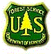
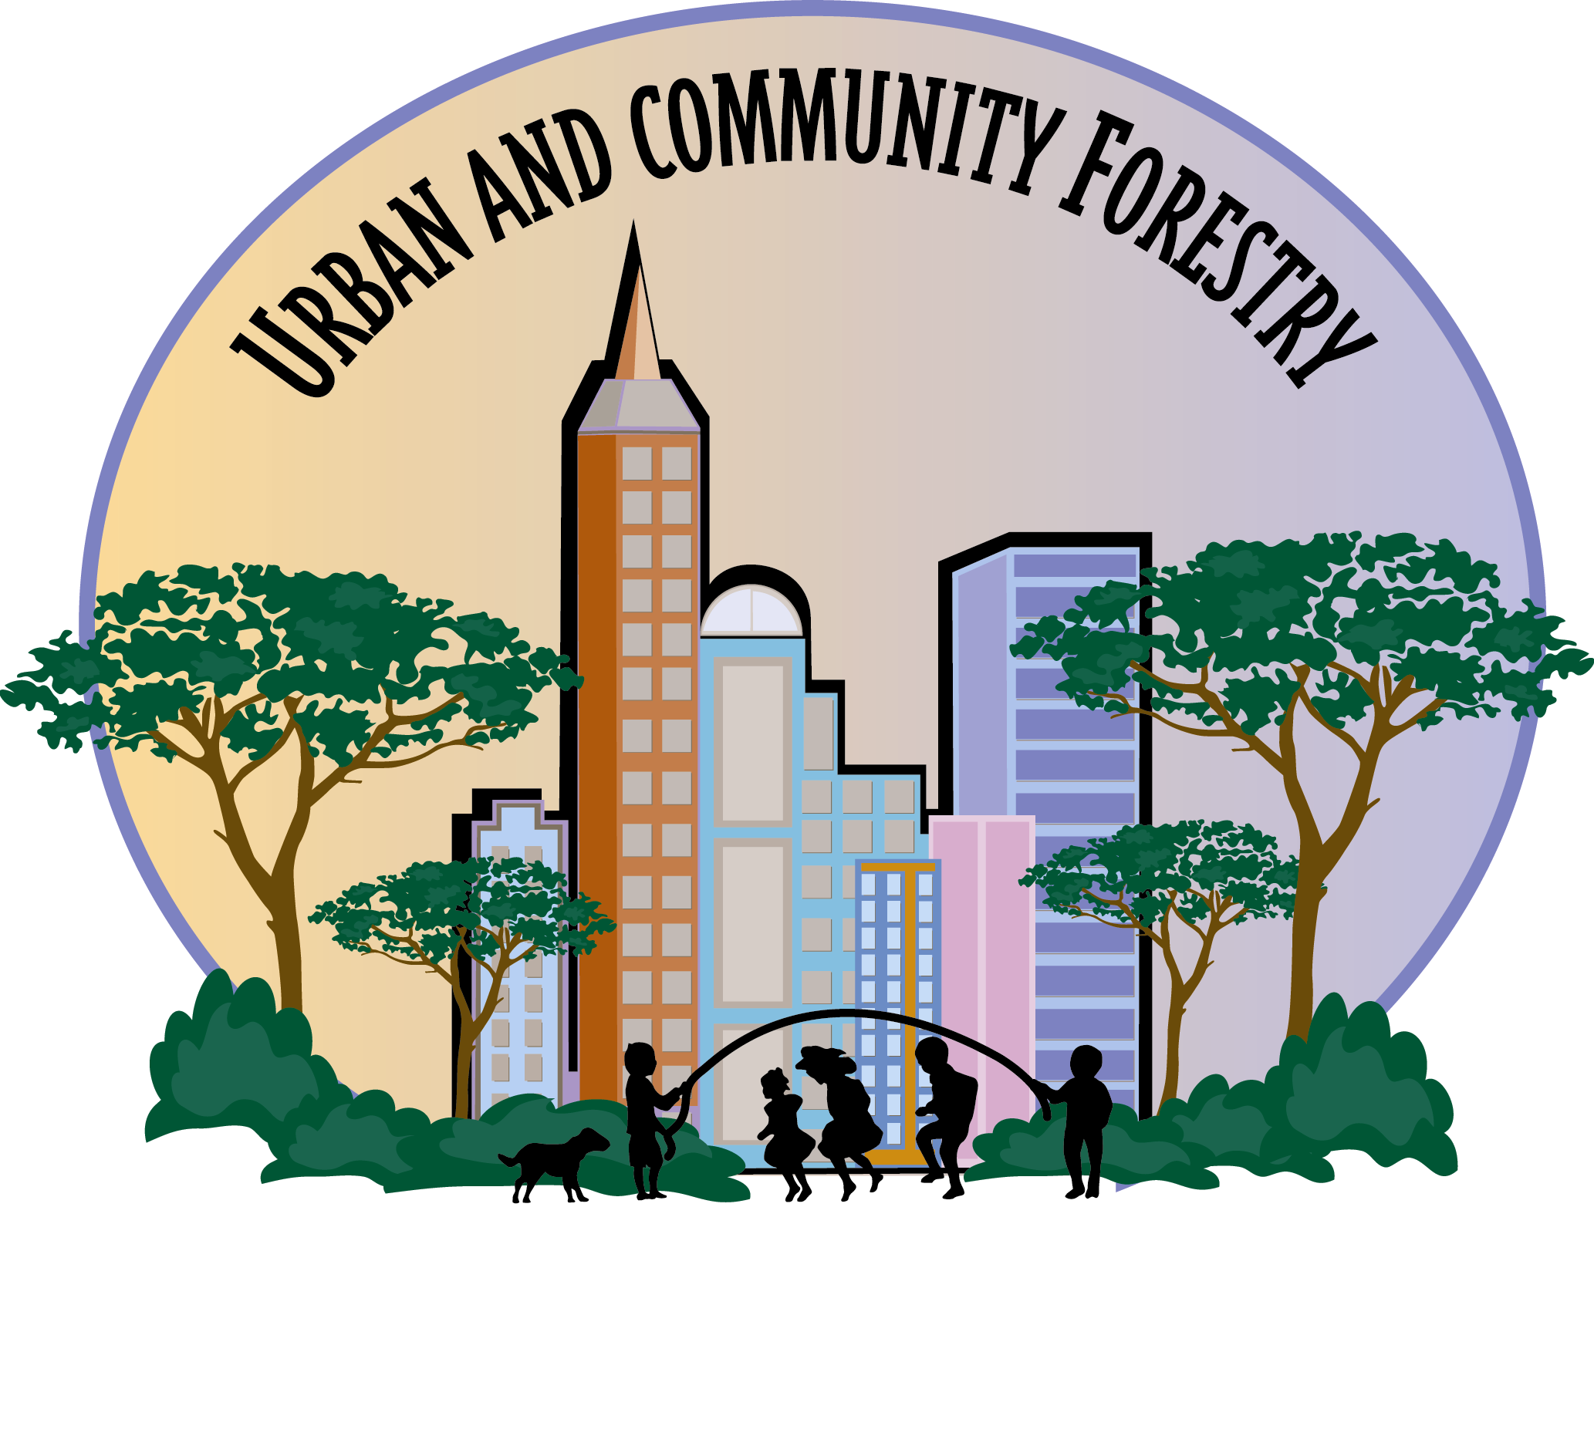

National Urban and Community Forestry Advisory Council

2005 Challenge Cost-Share Grant Program
September 2004

URBAN FOREST PROJECT FUNDING OPPORTUNITY

Request for Pre-Proposals

The National Urban and Community Forestry Advisory Council (Council) serves to advise the Secretary of Agriculture on the status of the nation’s urban and community forests. The Council seeks to establish sustainable urban and community forests by encouraging communities of all sizes to manage and protect their natural resources for this and future generations. Through its competitive Challenge Cost-Share Grant Program, funded by the USDA Forest Service’s Urban and Community Forestry Program, the Council only supports urban and community forestry projects that have national, or widespread, significance in their impact or application. A listing of the previously funded projects can be viewed at http://www.treelink.org/nucfac/.

Definition of Urban and Community Forestry: The art, science, and technology of managing trees, forests, and natural systems in and around urban areas for the health and well being of communities.

PROGRAM OVERVIEW

Available Funding: Approximately $1 million in grant funds will be awarded through the 2005 Challenge Cost-Share Grant Program. Grants of any dollar amount, up to the $1 million dollar limit, will be considered. Up to twenty-five percent (25%) of the 2005 Challenge Cost-Share funding is available for activities that support the Council’s interest in reaching and supporting underserved populations.

Eligible Applicants: Any non-Federal organization, operating within the United States or its territories, may apply for a Challenge Cost-Share grant. Collaboration with Federal agencies is encouraged; however, a Federal agency may not receive funding through this grant program. (Conflict of interest issues will be addressed appropriately.) Individuals are not eligible.

Matching Requirements: All grant funds must be matched at least equally (dollar for dollar) with non-Federal source funds. This match may include in-kind donations, volunteer assistance, and private and public (non-Federal) monetary contributions. All matching funds must be specifically related to the proposed project. The source of matching funds must be identified and grantees must comply with all applicable Federal regulations.

Administration: Upon Forest Service review of the Council’s recommendations for funding, the selected projects will be awarded as Federal Financial Assistance grants by the USDA Forest Service Urban and Community Forestry Program and as such will be subject to the appropriate federal rules, regulations, and reporting requirements.

Application Deadlines: Pre-Proposals must be received (not postmarked) by November 2, 2004, and will be reviewed by January 14, 2005. Finalists who are asked to submit more detailed, full proposals will have until February 15, 2005, to do so. Full proposals will be reviewed and selections made by April 29, 2005. The USDA Forest Service will award the successful projects as Federal Financial Assistance grants no later than September 30, 2005. NOTE: Successful applicants will receive formal notice of their grant award from the USDA Forest Service late in the Federal fiscal year (July 1 - September 30, 2005). Consequently, grantees may not begin their projects prior to official award notification.

Grant Period: Grantees will be given up to three years to complete their projects. The grant period begins when award letters are issued by the USDA Forest Service.

Grant Writing Assistance: There are various internet sites that provide valuable grant writing tips and guidance for developing competitive grant proposals. Two in particular are the Catalog of Federal Domestic Assistance website at http://www.cfda.gov, select “Writing Grant Proposals”; and the TreeLink website at http://www.treelink.org/grants/.

Inquiries: All questions regarding the program should be directed to Suzanne M. del Villar, Executive Assistant to the Council, at (909) 585-9268 from 7:00 a.m. to 5:00 p.m. (Pacific Standard Time).

SELECTING A GRANT CATEGORY
A project may only be submitted in one category and will only be considered in the category indicated on the Pre-Proposal Cover Sheet (page 8) by the applicant.

Category 1 is for proposals that will produce projects/materials focused on, and targeted to, minority and underserved populations and the urban and community forestry issues that specifically relate to these populations. Category 1 is for any applicant that seeks to work with minority or underserved populations, or on those issues that highly impact these populations. The Council specifically seeks proposals from underserved population applicants (minority organizations) in its continuing search for increased diversity in its pool of proposals and applicants. The Council strongly encourages minority applicants to apply under this category and the others. Remember that Category 1 is for proposals targeted to minority or underserved populations and related issues. The applicant can be either minority or non-minority.

If you are a minority organization or institution (i.e. a Historically Black or Native American college or university) that seeks to do urban and community forestry work unrelated to minority populations or issues, then submit your proposal in Category 2, 3, or 4 as appropriate.

GRANT CATEGORIES
Pre-proposals addressing the categories described below will be accepted through the close of business on Tuesday, November 2, 2004. The pre-proposals must have national scope or widespread application, and include a clear, national distribution or outreach plan for the findings. Local tree-planting projects, capital improvements to property or any ownership, and/or projects that have only a local impact and applicability will not be considered for funding. Urban and community forestry projects with a local scope of work should contact their State Urban and Community Forestry Coordinator for assistance in identifying funding alternatives at the local level. The list of State Coordinators may be found at the following website: http://www.fs.fed.us/ucf/Related_Links/UCF_State_coordinators.htm.

CATEGORY 1: Creative and Innovative Urban and Community Forestry for and with
Minority and Underserved Populations
Priority: To develop creative and innovative approaches involving minority and underserved populations in urban and community forestry. To apply new techniques that involve minority and underserved populations in the development and implementation of urban and community forestry at the local level.

Goal: To increase the involvement of minority and underserved populations in urban and community forestry.

Examples include but are not limited to: Projects that encourage and guide underserved and minority populations to careers in arboriculture and urban forestry related disciplines; projects that focus on involving at-risk youth with urban and community forestry; projects that focus on non-typical underserved populations such as the elderly; a national review and guidebook of successful underserved urban and community forestry projects; developing environmental education programs for the underserved; and increasing access to technical and financial assistance.

CATEGORY 2: Creative and Innovative Urban Forest Resource Management
Priority: Successful urban forest resource management programs provide increased benefits of urban trees such as cleaner air and water, energy conservation, safer and healthier communities, greater cost effectiveness and other products that increase the livability of our communities when compared to communities that do not manage or under-manage their urban trees. The examination of new design, evaluation, and management tools are needed to optimize the net benefits of sustainable landscapes in both urban and rural settings.
Goals: To obtain information on the best policies and management systems for the urban forest in general. To advance and promote the current body of knowledge, views, and practice of urban and community forest management from sustaining a healthy population of publicly owned trees to the management of all trees and associated resources within the urban environment. To define and promote the principles of a well-managed urban and community forest and profile those communities with successful programs. To advocate a systems management approach to urban and community forest management. To position the management of the urban and community forest so it is on an equal footing with other municipal infrastructure systems. To establish a national standard of sustainable management of urban and community forest resources.
Examples include but are not limited to: Projects demonstrating how interested individuals and groups interact with policy makers and managers to prioritize the specific urban and community forest benefits they desire to sustain and how to develop budgeting alternatives to obtain these benefits; projects that determine what type of urban and community forest structure is necessary to best address community needs; projects involving regional or comprehensive planning and management involving coordinated activities among different owners and managers across jurisdictions; projects demonstrating the application of comprehensive and adaptive management models in an urban forestry program; and creation of a manual that identifies the rationale for, and details practices of, effectively managing the urban forest.

CATEGORY 3: Creative and Innovative Projects that Communicate the Value of Urban
and Community Forestry
Priority: Communication, marketing, and technology transfer are keys to improving awareness, knowledge, and support for urban forest management and protection. Increasing people’s understanding of the social, cultural, economic, human health, and ecological benefits of urban and community forests is necessary for the development and preservation of our urban and community forests. Targeted, relevant information, education, tools, and skills are needed for people who impact the urban forest resource (i.e. elected officials, city managers, land use planners, engineers, natural resources professionals, design professionals, citizen groups, green industry, developers, utilities, homeowners, non-governmental organizations and others).

Goal: To promote awareness, knowledge, skills, and behavior change within target audiences to positively impact urban and community forests.

Examples include but are not limited to: A qualitative review of existing U&CF communications resources and products most appropriate for national reproduction and dissemination; analyzing and improving technology transfer methodologies in U&CF; communications products, tools, training, or other resources that increase the industry’s effectiveness in promoting the value of U&CF to target audiences; developing public awareness tools for multi-cultural audiences; implementing a national public awareness and education campaign; and creating information on the value of urban and community forestry for leaders to use locally.

CATEGORY 4: Creative and Innovative Urban and Community Forestry Research and Technology Development
Priority: Develop new knowledge about, and transfer understanding of, urban and community forest ecosystems (their components, structure and function), and their relationship with social and environmental needs. There are many gaps in the applications of research findings, thus a high priority is placed on research that has a well-defined plan for communicating the findings to the practitioners and projects that emphasize partnerships between researchers and industry professionals. Projects of an applied nature are preferred.

Goal: To improve our knowledge about the many components and interactions within the urban and community forest ecosystem.

Examples include but are not limited to: Forest fragmentation; urban forest health restoration; development of urban tree valuation; urban forest and water quality; trees and urban development; energy conservation; social benefits of trees and forests; improving tree adaptation and longevity in urban plantings; urban soils; tree biomechanics (e.g. defects, structural failures, mitigation); tree maintenance (e.g. pruning, structural support); ecosystem management (e.g. management of invasive species, watershed management); tree/pest interactions (e.g. influence of cultural practices on tree defenses); invasive insect and disease (e.g. Emerald Ash Borer, Asian Long Horned Beetle, Phytophthora ramorum); worker safety; and tree inventory systems at various levels of sophistication.

APPLICATION PROCEDURE
All application materials should be submitted on white 8.5" x 11" paper. Please do not enclose pre-proposals in folders or binders (staple in the top, left hand corner of each copy) and do not include unsolicited material as it will be removed and destroyed. Pre-proposals are restricted to a pre-proposal cover sheet (page 8) that includes a project summary not to exceed 100 words, a two-page (single spaced, Times New Roman font, 12-point type, 1" margins) narrative (see selection criteria on pages 5 and 6), plus a one-page budget (following sample budget format on page 7).

NOTE: Any narrative over two pages in length or not formatted as noted above will be returned without consideration.

To apply, send ten (10) copies to: Suzanne M. del Villar, Executive Assistant to NUCFAC
U.S. Forest Service
P.O. Box 1003
132 Moreno Avenue
Sugarloaf, CA 92386

*Note: To ensure delivery, use both the P.O. box number and the street address when addressing your package for shipment.

PRE-PROPOSALS MUST BE RECEIVED (NOT POSTMARKED) BY 5:00 P.M. PACIFIC STANDARD TIME ON NOVEMBER 2, 2004. Pre-proposals received after November 2, 2004, will be returned without consideration. Full proposals (if requested) must be received by 5:00 p.m. on February 15, 2005. No facsimiles or e-mail submissions will be accepted.

NOTE: Refer to the enclosed “Application Procedure Check-Off List” (page 7) prior to submitting your pre-proposal. Any pre-proposal that does not meet all the application requirements will be returned without consideration.

SELECTION CRITERIA
Proposals will be evaluated on how well they address each of the following criteria and the priority of each category. Arrange your narrative to correspond with the numbered items listed below. Proposals that do not include all of the requested information will not score well in the evaluation process.

1. Scope and Applicability/Justification
Describe how your project addresses the intent of the category. Identify the project’s objective(s). Identify your national target audience. Identify what specific types of other national organizations may benefit from your project (level of government, private business, non-profits, the green industry, and/or educational institutions) that can utilize your findings/product. Why should the project be done now?

2. Literature Review
Perform a literature search to ensure that the project is original and of direct benefit to the goal of the category. Be sure to include, but not limit to, previous Council grants in your search. Explain how your project is unique and how it differs from everything else pertaining to your topic area. Be specific.
3. Organization/Methodology
Describe the steps that will be performed to reach the desired goal(s). This includes, but is not limited to, the clarity of the proposal and effectiveness and efficiency of the project’s methodology.

4. Product
Provide a detailed description of the deliverable product(s) and identify the recipients. How will they be disseminated? How many will be produced? Will there be a fee to receive a copy of the final product(s)? If so, what will the fee be? If not, how many will be provided free?

5. National Distribution/Technology Transfer of Your Findings
Every successful grant project should have a comprehensive plan to distribute the results to those who will benefit most from the findings. Ask yourself; “Does the distribution plan of your findings reach the target audience?” For example, if your project is on the psychological effects of trees on residents in nursing homes, how will you distribute your findings to nursing home developers and administrators across the country?

6. Project Evaluation
Describe how your project will increase the public’s knowledge of the importance of urban and community forestry. What criteria will you use to judge the success of your project in regard to heightening the public’s awareness of the importance of urban and community forestry?

7. Experience/Personnel/Adequacy of Resources
Describe the experience and training in the fields relating to the project and any other qualifications that pertain to the quality of the product. Provide past experience with similar projects. Are adequate resources (e.g., personnel, facilities, equipment, supplies, and time) available to carry out the project?

8. Budget and Funding
Be sure that costs are reasonable in relationship to the project’s objective and scope. Use the Budget Sample (page 7) to create your budget sheet. NOTE: The Federal dollars requested may not be used to purchase trees, plant materials, equipment with a cost of $5,000 or greater, or capital improvements to property of any ownership. Please confirm that your math is accurate.

NOTE REGARDING INDIRECT COSTS
Although indirect costs are allowable in Federal Financial Assistance Grants, the Council prefers that indirect costs are shared or covered by matching funds.
SAMPLE BUDGET
NOTE: The Federal dollars requested may not be used to purchase trees, plant materials, equipment with a cost of $5,000 or greater, or capital improvements to property of any ownership.

Applicant: L&M Incorporated
Project: Develop and distribute tree care information in Arabic
Total Cost: $20,000
 | Federal Funds  (requested) | Non-federal Match  Cash In-kind |  | Total | Source of Matching Funds
Personnel* |  | 3,000 | 1,200 | 4,200 | L&M Inc.
Brochure layout | 1,000 | 800 | 200 | 2,000 | XYZ Design
Printing costs** | 9,000 | 1,000 |  | 10,000 | L&M Inc.
Distribution costs*** |  | 1,800 | 2,000 | 3,800 | Green Foundation and local volunteers
Total Cost: | 10,000 | 6,600 | 3,400 | 20,000
 |  | Total Match = $10,000
*Personnel: 300 hours @ $14 per hour = $4,200
**Printing: 20,000 copies, 8-pages each, 4 colors
***Distribution: copies will be sent to federal and state urban forestry coordinators and will be
available on request to all callers for at least one year from date of completion.

APPLICATION PROCEDURE CHECK-OFF LIST

Is your pre-proposal:
- In Times New Roman font?
- In 12-point pitch?
- In a format with empty 1-inch margins on the top and bottom of the document and in the left and right margins?

- Have you formatted your narrative to match the numbered Selection Criteria (pages 5 and 6)? Have you addressed all the criteria in your narrative and labeled each selection criteria accordingly?

- Does your budget reflect, as a minimum, a non-Federal match dollar-for-dollar?

- Does your budget follow the format of the sample budget (page 7)? Did you check your
math? Do the columns total down and across?

- Does your pre-proposal contain the Pre-Proposal Cover Sheet (page 8), 2-page maximum
narrative addressing all the Selection Criteria (pages 5 and 6), and a one-page budget using the format given in the Sample Budget (page 7)? Do not attach unsolicited documentation to your pre-proposal as it will be removed and destroyed.

Did you staple each copy of your pre-proposal in the top, left-hand corner? Do not

enclose your pre-proposal in any bindings or folders.

- Did you include ten copies of your pre-proposal?

- Have you arranged for the proper delivery service to insure that your pre-proposal will be

received (not postmarked) by 5:00 p.m. Pacific Standard Time on Tuesday,

November 2, 2004?

NUCFAC use only. Do not write in this box.

Control Number: __________________

NUCFAC 2005 Challenge Cost-Share Program

Pre-Proposal Cover Sheet

CATEGORY: (Select only one)

- __ Creative and Innovative Urban and Community Forestry for and with Minority and
Underserved Populations

2. Creative and Innovative Urban Forest Resource Management

3. Creative and Innovative Projects that Communicate the Value of Urban and Community
Forestry

4. Creative and Innovative Urban and Community Forestry Research and Technology Development

PROJECT TITLE:

NAME OF ORGANIZATION:

MAILING ADDRESS:

PROJECT CONTACT:

PROJECT CONTACT’S: PHONE NO. FAX NO.
E-MAIL

Is this project being developed to reach a minority or underserved population? ___Yes ___No

Is this pre-proposal being submitted by a minority or underserved population (owned/operated/directed) business, organization or college/university? ___Yes ___No
______________________________________________________________________________

REQUESTED: $ + MATCHING: $ = TOTAL PROJECT: $ ______________________________________________________________________________
Summarize the proposed project in 100 words or less.

REMINDER: Submit ten copies of your pre-proposal.

