Strategies to Increase Use of Remotely Sensed Data in Forest Inventory and Analysis Program

Author

Abstract: The Forest Inventory and Analysis (FIA) program produces the only comprehensive and consistent statistical information on the status, changes, and trends in the condition and health of all forest ecosystems in the USA. . . . . . . .

Keywords: Forest, inventory, FIA, remote sensing, efficiency, stratification.

Introduction

The USDA Forest Service Research and Development branch, through its Forest Inventory and Analysis (FIA) program, is committed to the delivery of current, consistent, and credible information about the status, condition, and trends of America’s forests. . . . . . . . . . .

Opportunities to Enhance the FIA Program

FIA has recently identified opportunities to expand its service to the nation (USDA, 2006) after full implementation of the base FIA program, which is described in its 1998 strategic plan (USDA. 1998). . . . . . . . . . .

Remote sensing

One opportunity is more aggressive remote sensing approaches to improve cost effectiveness and data quality. This might shift a portion of the investments in FIA field data towards observations with remotely sensed data. However, verification of remotely sensed data with sufficient field data remains essential. . . . . . . . . . .

Regional Priorities: A shift towards more remotely sensed observations is most compelling in the interior West, interior Alaska, and other regions with forests dominated by open canopies, lower levels of stocking, and lower productivity. . . . . . .

Technologies: FIA envisions use of high-resolution remotely sensed imagery and light detection and ranging (LiDAR) technology. Other sensors include Moderate Resolution Imaging Spectro-radiometer (MODIS) with 250-m pixels (Justice et al.., 2002), Landsat and IKONOS satellites. . . . . . .

Support to the National Forest System

Another opportunity is enhanced support to the National Forest System (NFS) within the USDA Forest Service. FIA could extend its sampling grid of field plots to all NFS lands, not just those that meet the definition of forest. . . . . . . . . .

Rapid Assessment Capacity

A remote sensing component might support other opportunities for FIA service. A rapid assessment capacity could be developed within FIA to provide emergency surveys of resource impacts within days or weeks following a major environmental disturbance, such as wildfires, storms, hurricanes, or sudden insect or disease outbreaks. . . . . . .

Urban Forests

Urban trees and forests affect quality of life of urban populations, which includes approximately 80 percent of the U.S. population. Urban forestry is especially important to States with increasingly populations. However, the FIA system currently does not fully incorporate urban forests. . . . . . .

Non-forest Ecosystems

FIA has the opportunity to help build a national rangeland inventory. The 2002 House Interior Appropriations Committee report included language directing the Secretaries of Agriculture and the Interior to collaborate in implementing a rangeland monitoring system. . . . .

Wildlife Habitat

Another opportunity is strategic monitoring of wildlife habitat to mitigate concerns about management actions on species viability. However, standard FIA indicators, plot size, and measurements protocols can miss important habitat components. The geographic scale of a habitat component might not match the scale of an FIA plot (for example, Figure 1).

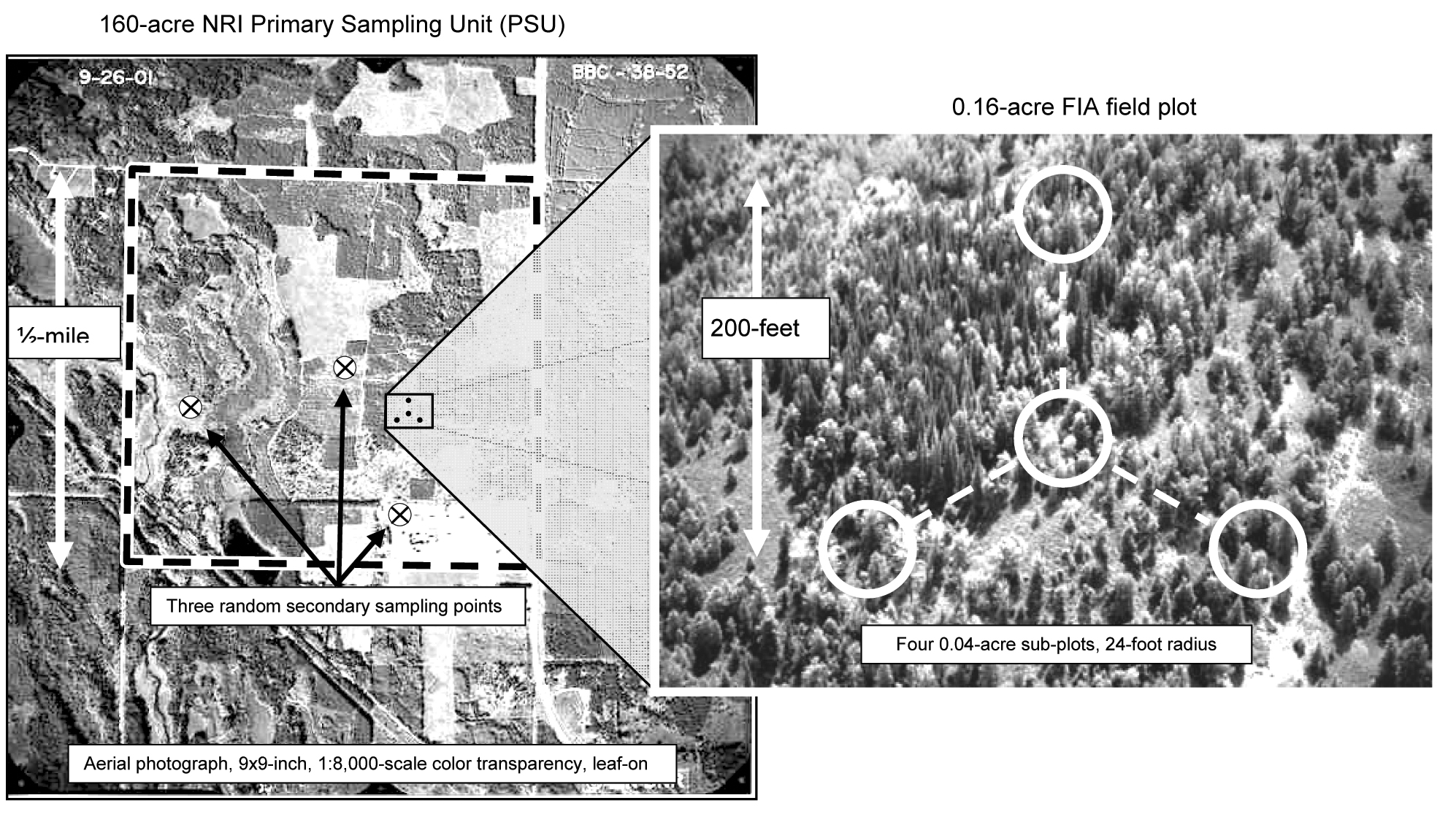

Figure 1: Example of 160-ac photo-plot from the USDA NRCS National Resources Inventory (NRI). The NRI plot, referred to as the Primary Sampling Unit, or PSU, is typically 160-acres. Most NRI plots have three secondary sampling units, or SSUs, at which detailed photo-interpreted measurements are made.

Monitoring

There is an opportunity to conduct strategic-level monitoring of status and trends on all treed land. Indicators could be developed for ecosystem health, biodiversity, carbon sequestration, wildlife corridors and habitat, narrow riparian features, windrows, and agro-forestry stands (Healy et al. in press). Some indicators might be reliably measured with high-resolution remote sensing technologies.

Partnerships

Integrating new technologies is critical to the efficient delivery of the FIA program. One focus of the new FIA strategic plan is to build technology partnerships with other national programs that produce data related to FIA objectives.

Most opportunities for improved technologies involve sharing cost and logistical burdens to more efficiently and effectively use remotely sensed data from satellites and low-altitude aircraft to facilitate broad-scale applications of GIS techniques to improve geospatial analyses. FIA has a preeminent position among all Federal efforts to inventory and monitor forest resource conditions at the regional and national levels and in innovative uses of remotely sensed data to improve the number of products, the quality and timeliness of those products, and the cost-effectiveness of the FIA program. . . . . . . . .

Table 1: Summary of programs and pilot studies that use remotely sensed data to improve extensive sample surveys of natural resources
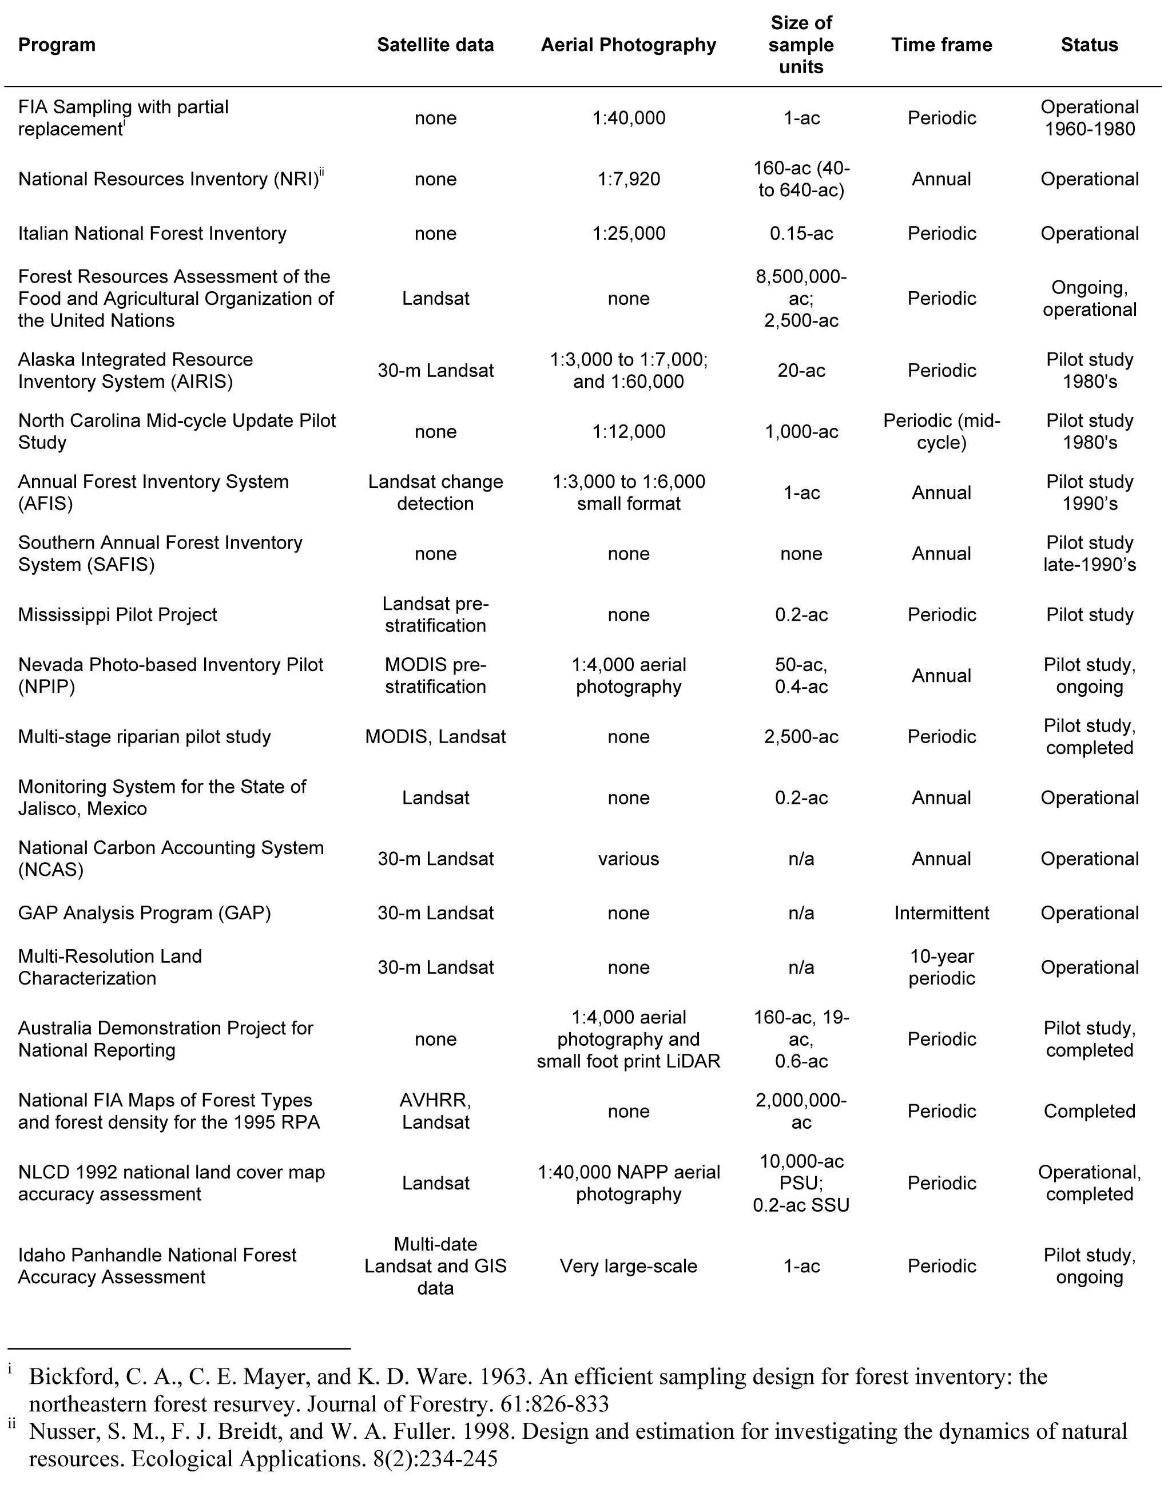

Stratification in FIA

FIA is a pioneer in the use of remotely sensed data for stratification to improve efficiency of its statistical products (Bickford et al. 1963). Currently, FIA primarily uses remotely sensed thematic maps of forest v. nonforest cover produced with wall-to-wall Landsat data (McRoberts et al. 2002, Hoppus and Lister 2003).

Hansen and Wendt (2000) and McRoberts et al. (2002) further stratify based on edge conditions between remotely sensed classifications of forest and non-forest: forest, forest edge, non-forest edge, and non-forest. This separates heterogeneous edge conditions from more homogeneous conditions within the interior of stands, and it helps accommodate mis-registration between FIA plots and their corresponding pixels (Figure 2). . . . . . . . . .
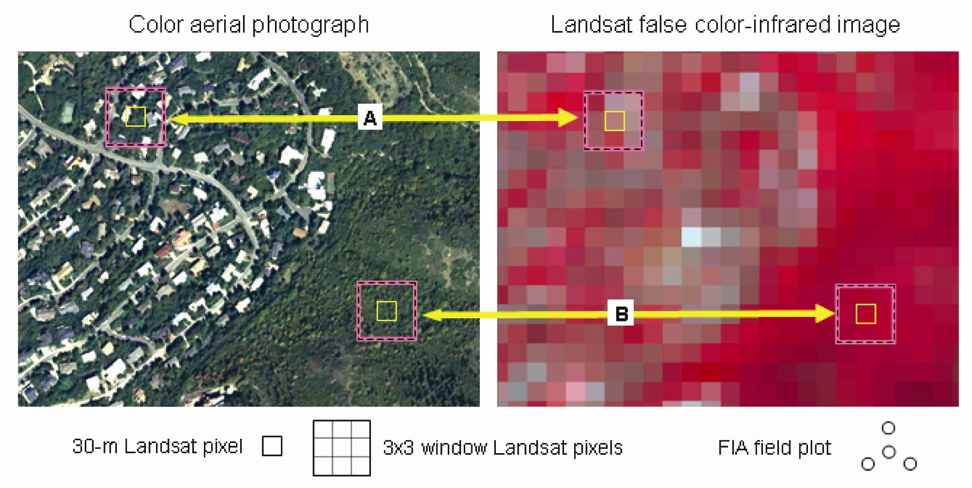
Figure 2: An example of registration of two 30-m pixels in an aerial photography and Landsat data. Each image covers the same identical site, which is about 100-acres in size. Each of the two 30-m pixels (A and B) represent a sampled SSU in the accuracy assessment of the NLCD 1992 land cover map (Yang et al.. 2000; Zhu et al.. 2000). The remotely sensed land cover classifications from NLCD 1992 (not shown, but corresponding to pixels A and B) were compared to the reference classifications from photo-interpretation of the matching pixels in the aerial photograph. For the actual accuracy assessment, NLCD 1992 re-classified the map category for each sampled SSU with most frequent map category within a 3x3 window of nine pixels centered on the SSU pixel, which is represented by the larger boxes in Image A. The FIA field plot measures an area that approximately matches 3x3 window of Landsat pixels.

Further substantive improvements through stratification are unlikely. Stratification reduces the information content in remotely sensed data into a few categorical values, and any remaining information available in those data is lost to the estimators. For example, Stehman et al. (2005) found that the regression estimator is an efficient alternative to stratification, although this estimator, by itself, is incapable of imposing the areal constraints on census statistics. Remotely sensed data can predict continuous variables that are correlated with relevant variables, such as total biomass. Conventional stratification with small sample sizes within strata is not well suited to improve statistical efficiency with continuous ancillary information.
Stratification is best used to reduce variance in sample estimates. However, FIA also uses stratification to impose areal control on its statistical products. This assures that FIA statistics agree with official statistics for the areas within geopolitical boundaries. Areal control does not necessarily provide variance reduction. However, joint stratification on remotely sensed data and geopolitical census areas produces numerous small strata that contain few FIA plots. This causes a loss in degrees of freedom. The estimated variance (for example, Schreuder et al. 1993; McRoberts 2006) of a parameter estimate (for example, wood volume) among strata is:

$\hat{V}\left({\hat{t}}_{h}\right)=N_{h}^{2}\left(\frac{1}{n_{h}−1}\right)\sum_{i∈s_{h}}{\frac{{\left(y_{\text{hi}}−{\bar{y}}_{h}\right)}^{2}}{n_{h}}}$

As a within stratum sample size (n_{h}) becomes smaller, the 1/(n_{h}-1) term in Eq. Error: Reference source not found becomes larger, and the variance (V) grows rapidly. It is common for FIA strata to have sample sizes of four to ten field plots (for example, Scott et al. 2005; McRoberts 2006). Relative to sample sizes of n_{h} = 50 FIA plots in forest v. non-forest strata, sample sizes of 4 ≤ n_{h} ≤ 10 per stratum can increase variances of population-wide areal estimates by 10 to 30 percent based on the 1/(n_{h}-1) term in Eq. . . . . . . . . . .

Conclusion

Accomplishment of FIA’s strategic objectives will likely require statistical estimators that combine time series of field data with an unsynchronized time series of remotely sensed data from different sensors with different resolutions to estimate status, trends, and location by class for land use/land cover/fragmentation change analysis (de Gruijter et al. 2006). Consistency of statistical estimates with GIS summaries from thematic maps will further improve the utility and credibility of FIA products.

Literature Cited

Bickford, C. A., C. E. Mayer, and K. D. Ware. 1963. An efficient sampling design for forest inventory: the northeastern forest resurvey. Journal of Forestry 61:826-833.
Czaplewski, R. 2001 Areal control using generalized least squares as an alternative to stratification , pp. 63-65. In Proceedings of the Second Annual Forest Inventory and Analysis Symposium; 2000 October 17-18; Salt Lake City, UT. Reams, Gregory A.; McRoberts, Ronald E.; Van Deusen, Paul C., eds. General Technical Report SRS–47. Asheville, NC: U.S. Department of Agriculture, Forest Service, Southern Research Station. 143 p.
Czaplewski, Raymond L. and Paul L. Patterson. 2003. Classification accuracy for stratification with remotely sensed data. Forest Science 49(3):402-408
de Gruijter, Jaap; Dick Brus; Marc Bierkens; and Martin Knotters. 2006. Sampling for Natural Resource Monitoring. Springer-Verlag, Berlin, Heidelberg. 332 p.

United States Forest Service; Rocky Mountain Research Station; Inventory, Monitoring, and Analysis Program; 2150 Centre Avenue, Bldg. A; Fort Collins, CO 80526-1891 USA; e-mail; Web site for bio info, etc

