Chapter III

Summary Data Requirements

Introduction
The purpose of this chapter is to explain the HPMS summary data reporting requirements. With the exception of data on the U.S. Territories, summary data are submitted to FHWA as part of the HPMS data file. Data are coded on four summary screens included in the HPMS submittal software package. In general, only data that cannot be generated from the HPMS universe or sample data files are required to be reported via the summary screens. Summary data are primarily limited to pavement and vehicle travel information for the minor collector and local functional systems, population and land area reporting, and supplementary travel information by vehicle type. Territorial data are provided via hard copy form as shown elsewhere in this Chapter. States are not required to maintain metric data; however, data must be reported in metric units to meet FHWA’s statutory metric obligations. If State inventory systems are maintained in English units, the FHWA data software will convert data inputs to the required metric format.

Four summary screens are required for complete summary data reporting. Each summary screen is discussed in the following sections. For additional information, the user is directed to the documentation and help screens in the HPMS Submittal Software.

Travel and Demographic Data
This summary requires the reporting of limited vehicle travel and demographic information not available from the HPMS data set as shown in the following summary screen. The HPMS software will automatically fill the Urban Code, Name and Nonattainment Code, and Name cells shown on the screen. However, the user must code all daily travel, population, and land area value cells shown.
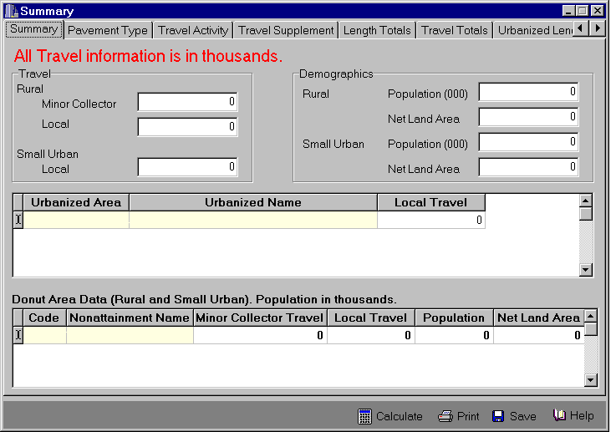
Figure III-1. HPMS Software Summary Screen
Daily vehicle travel is the amount of travel (in thousands) accumulated over a 24-hour day, midnight to midnight, for all days of a calendar year. It should reflect travel occurring on public roads, by motorized vehicles, excluding construction equipment or farm tractors. Exclude vehicle travel not occurring on public roads, such as that occurring on private access roads, parking lots, etc. Report vehicle travel that occurs on public roads for the functional systems and areas shown:

Area Type | Functional Systems
Area Type | Local | Minor Collector
Each Urbanized Area | X
Small Urban Statewide | X
Rural Statewide | X | X
Each NAAQS Nonattainment Donut Area:  Small Urban  Rural | X
Each NAAQS Nonattainment Donut Area:  Small Urban  Rural | X | X

States are encouraged to improve traffic estimating practices on the local and rural minor collector functional systems. Rural areas in or near fast growing communities will require the most attention to determine changes in travel. It can be reasonably assumed that a portion of the rural minor collector and local functional systems, away from the major growth areas of the State, will experience little traffic change, thereby reducing the effort required to update this information. Travel estimates on the rural minor collector and the rural, small urban, and urbanized area local functional systems should be traffic count based. Donut area data need only be reported when HPMS is used to develop travel estimates to meet EPA requirements in NAAQS nonattainment and maintenance areas. Sufficient emphasis should be placed on the development of these travel estimates to assure that they are reasonable and can be consistently generated.

Land area is determined in accordance with the U.S. Bureau of the Census definitions. Land area includes dry land and land temporarily or partially covered by water, such as marshlands, swamps and river flood plains. It also includes systems, sloughs, estuaries, and canals less than 0.2 kilometers (1/8 of a statute mile) in width, and lakes, reservoirs, and ponds less than 0.16 square kilometers (1/16 square mile) in area. [For Alaska, 0.8 kilometers (½ mile) and 2.60 square kilometers (1 square mile) are substituted for these values.] It excludes areas of oceans, bays, sounds, etc., lying within the 4.8-kilometer (3-mile) U.S. jurisdiction as well as inland water areas larger than indicated above. Land area is reported to HPMS for rural, small urban, and urbanized areas based on FHWA-approved, adjusted urban and urbanized area boundaries.

Population is based on the annual Census estimate of State resident population as of July 1st (April 1st in decennial Census years) for the calendar year for which the HPMS data are being reported. The allocation of Census-reported State resident population to rural, urban, or urbanized areas can be accomplished by using growth factors applied to the last official decennial figures, the most recent census estimate if available from the U.S. Bureau of the Census, or from population estimates available from MPOs or other State agencies. All reported population estimates must be adjusted to match the FHWA-approved, adjusted urban and urbanized area boundaries.

Pavement Data
This summary requires the reporting of limited pavement type information not available from the HPMS data set as shown in the following pavement type screen. Enter the paved and unpaved length for the specified functional systems. The Control Total is the length reported in the HPMS database for each functional system. The definitions of paved roads should be consistent with those included in Item 50, Surface/Pavement Type, codes 2 - 6.
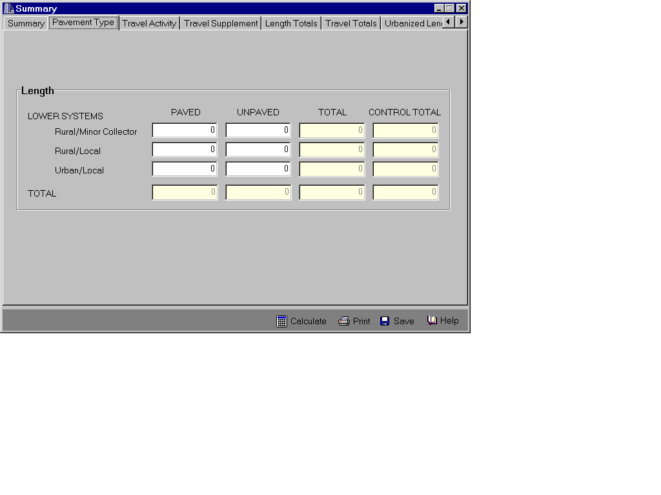 Figure III-2. HPMS Pavement Type Screen

Travel Data By Vehicle Type
This summary requires the reporting of the percentage of travel made by various vehicle types over the various functional systems of highways as shown in the travel activity screen on the following page. The percentage of travel is reported for each vehicle type relative to the total vehicle travel for each functional system or functional system groups by rural and urban areas. The values for each functional system or functional system groups must sum to 1.000 (100 percent). The individual vehicle type data cell values should be entered as a decimal number to the nearest thousandth.

States using equipment that they believe cannot differentiate automobiles from other two-axle, four-tire single-unit vehicles may report these two vehicle types as an aggregate figure. If a State that uses automated equipment normally augments its data with automobile-specific information, that data should be used to complete the summary. States are encouraged to provide automobile information distinct from other two-axle, four-tire single-unit vehicles even if estimates based on limited manual counts serve as the base. When entering aggregate data of two-axle, four-tire vehicles for a functional system, the values should be entered in the passenger car column and the "other two-axle, four-tire" column should be entered as zero.
Travel Activity by Vehicle Type

Basic Data

Shaded cells are reserved for titles and computer software generated values. Enter data in the unshaded cells only. Enter data as a decimal to the nearest thousandth.

FUNCTIONAL  SYSTEM | PERCENT OF TRAVEL
FUNCTIONAL  SYSTEM | MOTOR-  CYCLES  [OP-  TIONAL] | PASSENGER  CARS  [2 AXLE,  4 TIRE] | LIGHT  TRUCKS  [OTHER  2 AXLE,  4 TIRE] | BUSES | SINGLE-UNIT TRUCKS | COMBINATION  TRUCKS | TOTAL
RURAL
INTERSTATE

OTHER ARTERIAL

OTHER RURAL

URBAN
INTERSTATE
OTHER ARTERIAL

OTHER URBAN

Report is in English Units.

Report rural and urban vehicle activity information for interstate system and functional system groups. The Traffic Monitoring Guide (TMG) should be consulted for recommended practices regarding the development of the vehicle classification coverage count program. The procedures are flexible, allow incorporation of existing automated sites, and are sufficient to meet the area wide and standard sample section reporting needs of the HPMS. If the TMG procedures have not been fully implemented, the source and derivation of the cell values should be thoroughly documented (as discussed in Appendix F)

If the standard sample is statistically valid, estimates of percent travel for all vehicle type/functional system cells in the summary are computed as the average of all the classification sample locations within that cell. Example 1 should be used for estimates of percent travel for rural interstate and urban interstate. Example 2 should be used for estimates of percent travel for functional system groups.

Example 1: The percentage of buses on the rural interstate system is the average of the percent of buses of all vehicle classification measurements in the sample taken on the rural interstate system. If the sample consisted of 9 sections and the percent buses measured at each section were 0.9, 0.5, 1.1, 0.8, 0.4, 0.2, 1.3, 0.5, and 0.3 (total = 6.0), then the average of 0.67 would be the estimated percentage of buses and would be entered as .007 for the rural interstate cell of the summary.

Example 2: The percentage of buses on the rural other arterial group is the average of the percent of buses of all vehicle classification measurements in the sample taken on rural other principal arterials (ROPA) and rural minor arterials (RMA). If the sample consisted of 8 sections from ROPA and 7 sections from RMA, and the percent buses measured at each section were 0.8, 0.7, 0.6, 0.9, 0.7, 0.8, 0.6, 1.1 for ROPA and 1.1, 1.2, 0.5, 0.9, 0.7, 0.8, 0.6 for RMA (total = 12.0, then the average of 0.8 would be the estimate percentage of the buses and would be entered as .008 for the rural other arterial group cell of the summary.

In reporting information for the area wide Travel Activity by Vehicle Type Form, the following criteria should be followed:

- Single-Unit Trucks are described by vehicle type 5 – 7 as defined in the TMG, and exclude buses.
- Combination-Unit Trucks are described by vehicle type 8 – 13 as defined in the TMG.
- Truck-tractor units traveling without a trailer should be considered single-unit trucks.
- A truck-tractor unit pulling other such units in a "piggyback" (or "saddle-mount") configuration should be considered as one single-unit truck and be defined only by the axles on the pulling unit.
- Vehicles should be defined based on the number of axles in contact with the roadway. Therefore, "floating" axles are counted only when in the down position.
- The term "trailer" includes both semi- and full-trailers.
- Rural Other Arterial includes rural other principal and rural minor arterial functional systems.
- Other Rural includes major collector, rural minor collector, and rural local functional systems.
- Other Urban Arterial includes urban other freeways & expressways, urban other principal arterials, and urban minor arterials.
- Other Urban includes urban collector and urban local functional systems.

The States collect vehicle classification data annually at continuous permanent installations and portable sites. The site-specific classification and station description data should be sent with the truck Weigh In Motion data to the Office of Highway Policy Information (HPPI-30) using the FHWA data formats by June 15th of the year following the year for which the data are collected. Additional information about FHWA data formats is found in the TMG.

Vehicle Type Codes and Descriptions
Code | Description
1 | Motorcycles (Optional): All two- or three-wheeled motorized vehicles. Typical vehicles in this category have saddle type seats and are steered by handlebars rather than a wheel. This category includes motorcycles, motor scooters, mopeds, motor-powered bicycles, and three-wheeled motorcycles. This vehicle type may be reported at the option of the State, but should not be reported with any other vehicle type.
2 | Passenger Cars: All sedans, coupes, and station wagons manufactured primarily for the purpose of carrying passengers and including those passenger cars pulling recreational or other light trailers. Vehicles registered as passenger cars that are pickups, panels, vans, etc. (described as vehicle type "3") should be reported as vehicle type "3".
3 | Other Two-Axle, Four-Tire, Single-Unit Vehicles: All two-axle, four-tire vehicles, other than passenger cars. Included in this classification are pickups, panels, vans, and other vehicles such as campers, motor homes, ambulances, hearses, and carryalls. Other two-axle, four-tire single-unit vehicles pulling recreational or other light trailers are included in this classification.
4 | Buses: All vehicles manufactured as traditional passenger-carrying buses with two-axles, six-tires and three or more axles. This category includes only traditional buses (including school buses) functioning as passenger-carrying vehicles. All two-axle, four-tire minibuses should be classified as other two-axle, four-tire, single-unit vehicles (type "3"). Modified buses should be considered as trucks and be appropriately classified.
5 | Two-Axle, Six-Tire, Single-Unit Trucks: All vehicles on a single frame including trucks, camping and recreational vehicles, motor homes, etc., having two axles and dual rear wheels.
6 | Three-Axle, Single-Unit Trucks: All vehicles on a single frame including trucks, camping and recreational vehicles, motor homes, etc., having three axles.
7 | Four-or-More Axle, Single-Unit Trucks: All vehicles on a single frame with four or more axles.
8 | Four-or-Less Axle, Single-Trailer Trucks: All vehicles with four or less axles consisting of two units, one of which is a tractor or straight truck power-unit.
9 | Five-Axle, Single-Trailer Trucks: All five-axle vehicles consisting of two units, one of which is a tractor or straight truck power-unit.
10 | Six-or-More Axle, Single-Trailer Trucks: All vehicles with six or more axles consisting of two units, one of which is a tractor or straight truck power-unit.
11 | Five-or-Less Axle, Multi-Trailer Trucks: All vehicles with five or less axles consisting of three or more units, one of which is a tractor or straight truck power-unit.
12 | Six-Axle, Multi-Trailer Trucks: All six-axle vehicles consisting of three or more units, one of which is a tractor or straight truck power-unit.
13 | Seven-or-More Axle, Multi-Trailer Trucks: All vehicles with seven or more axles consisting of three or more units, one of which is a tractor or straight truck power-unit.

Additional information about the means of identifying the vehicle types may be found in the current FHWA Traffic Monitoring Guide.

Continuous Traffic Data
The Heavy Vehicle Travel Information System (OMB 2125-0587) asks that volume and vehicle classification data collected by continuous automatic vehicle classifiers be submitted monthly to FHWA. In addition, traffic volume data collected using permanent automatic traffic recorders (ATR) also should be submitted monthly to FHWA. Both types of data should be submitted within 20 days after the close of the month for which the data were collected.

Continuous vehicle counter data are used by FHWA to assess the quality of AADT estimates included in the annual HPMS submittal. Consequently, States that have not already provided complete continuous count data as part of their monthly submissions to the Heavy Vehicle Travel Information System are requested to provide these data at the same time as they submit their HPMS data in June of each year.

U.S. Territory Information
A paper summary report is required annually from the U.S. Territories of Guam, Northern Marianas Islands, American Samoa, and Virgin Islands as shown in the following form. This summary report contains the totals for population, land area, system length and vehicle travel data.

Population and land area data should be reviewed and updated annually and related to changes in decennial Census estimates. The U.S. Territories should annually submit revised estimates when changes have occurred in either population or land area for rural or small urban areas. Annual updates between decennial Censuses should be based on local trends or Census or territorial estimates.

System length should include all arterial and collector system public roads on the Territorial Highway System and other public roads that are maintained by a public authority. Under 23 U.S.C. 215, each territory must establish, with FHWA approval, a system of arterial and collector highways designated as the Federal-aid Territorial Highway System. Breakdowns by paved and unpaved surface types should be consistent with Item 50, Surface/Pavement Type. The total reported length must be consistent with the public roads mileage certified annually to the FHWA.

Daily vehicle travel should accurately indicate the usage of the public roads by motorized highway vehicles. The U.S. Territories are encouraged to use traffic count-based practices to develop travel estimates by arterial, collector, and local functional systems in rural and small urban areas. Since vehicle use in the U.S. Territories is limited to motorized vehicles maintained on the islands, other procedures, such as annual odometer surveys, could also be used to verify total travel. Procedures used to develop estimates of travel should be thoroughly documented and meet the requirements of Appendix F.

U.S. Territory Information

Territory: _____________________ Territory FIPS Code: ______

Units: [ ] English 1/ [ ] Metric 2/ Data Year: ________ Date: ______________

Category |  |  |  | Rural | Urban | Total
Population (1,000)
Land Area
Federal-Aid Territorial Highway System - Arterial:
 | Paved Length
 | Unpaved Length
 |  | Subtotal
 | Daily Travel (1,000)
Federal-Aid Territorial Highway System - Collector:
 | Paved Length
 | Unpaved Length
 |  | Subtotal
 | Daily Travel (1,000)
Other Public Roads:
 | Paved Length
 | Unpaved Length
 |  | Subtotal
 | Daily Travel (l,000)
All Public Roads:
 | Total Length
 | Total Daily Travel (1,000)
1/ English units for length and travel are miles and daily vehicle-miles (in thousands), respectively.
2/ Metric units for length and travel are kilometers and daily vehicle-kilometers (in thousands),
respectively.

? Additional information about the means of identifying the vehicle types may be found in the current FHWA Traffic Monitoring Guide.

