POLAR Spacecraft Status As of: Tues 5 Dec 06, 14:00 EST
(changes from last week in bold border)
Subsystem/  Component | NOAA-12D  AM 16:59=AN  STIP data only  No IPD processing | NOAA-14J  AM: 21:10=AN  STIP data only  No IPD processing | NOAA-15K  AM: 17:49=AN  GAC data only | NOAA-16L  PM: 15:04=AN  GAC&LAC data | NOAA-17M  AM: 22:23=AN  GAC&LAC data | NOAA-18N  PM 13:49=AN  GAC & LAC data
LAUNCHED | 05/14/91 | 12/30/94 | 05/13/98 | 09/21/00 | 6/24/02 | 5/20/05
CNTL OBP | OBP2  Recursive SCT | OBP2  OBP1 inoperative  Recursive SCT | OBP2 | OBP2 | OBP2 | OBP2
BUS | B-BUS  XSU-1 | B-BUS  XSU2 (XSU1 inop) | B-BUS  XSU-1 | B-BUS  XSU-1: TOAR444 | B-BUS  XSU-1 | B-BUS  XSU-1
BUS VETO | NO | NO | NO | NO | NO | NO
ADACS | Nominal Mode  Autonomous swap to YGC 30 Aug, commanded back to nominal 31 Aug  RGmode=Monitor  Gyro chans=XYZ | YGC Mode  Autonomous swap 1 Dec  Very low N2 gas | Nominal Mode  Rgmode=Monitor  Gyro-3 Off 6/26/00 Gyro chans=AAB  N2 Low PSI invalid | RGYRO Mode  Estimate Y-ROLL  Rgmode=PASSIVE  Gyros-1 & 3 Inop/Off  Gyro chans XA-ZB  Gyro2 safe macro | Nominal Mode  Rgmode=Monitor  Gyro-3 Off 6/10/04  Gyro chans=AAB GAS Enabled Dec 05 | Nominal Mode  Gyro-A MIMU-2  Z-wheel -Pitch  TOAR 447  Z-momentum transition complete  Pitch Torquer again active
RXO | PRI  BU random enables  daily bias+6.5 mS | PRI  BU random enables daily bias–7.0 mS | PRI  daily bias -8 mS  -500 mS 12/31/05 | PRI  Daily Bias –5.5 mS  -1500 mS 31Dec05 | PRI  Daily Bias –3 mS  -1500 mS 31Dec05 | PRI  No daily bias  -1500 mS 31Dec05
CLOCK DIV | 2 | 2 | 2 | 2 | 2 | 2
MIRP | External Synch  Rephase Enabled | External Synch  Macro rephased once per orbit | External Synch Rephase 0730 daily | External Sync  Rephase each orbit | External Sync  Rephase Enabled | External Synch  Rephase Enabled
TIP SIDE | 1 | 2  Since 19 Jul 06 | 2  (since 4/3/03)  3 channels inop | 2  since 4/18/05  (analog drifting?) | 2  Swapped 9/20/06 | 1  Analog telem drifting
Recorders  (DTR, SSR) | DTRs 3A, 4, 5B  Safestate 5B  4b low pressure | DTRs 1, 2B, 5 Safestate- 1B | DTRs 1, 2, 3, 4 Safestate 1B EOT | DTRs 1, 2, 3, 4A  Safestate 3A  4B STIP only | DTR 1,3,4 / SSR 2  Safestate=SSR 2B  4A Pressure leak | SSRs 1,2,3,4,5  Safestate=5B  Current spikes
VTX  (APT data) | #1 ON  137.50 MHZ | OFF (nominal)  Since 8/2/05 | #1 ON  As of 13 Nov | OFF / INOP  since 11/15/00 | #2 ON  137.62 MHZ | #2 ON  137.9125 MHZ
BTX | #1  136.77 MHZ | #2  137.77 MHZ | #1  137.35 MHZ | #2  137.77 MHZ | #2  137.77 MHZ | #1  137.35 MHZ
STX  1 = rcp 1698.0 mhz  2 = lcp 1702.5 mhz  3= rcp 1707.0 mhz  4= rcp 2247.5 mhz | 1 – HRPT;  2,3 - Playback | 3 – HRPT  2, 1 – Playback | 2-Omni HRPT  2 Omni=rcp  Power TOAR 446  4-Playback  1,2,3-Degraded | 2 – HRPT  1– Playback  4 – Playback  & MCM usage  3 low power unused | 3 – HRPT  TOAR424 low power  2 & 4 Playback  1-Standby  STX-1 Power drop | 1 - HRPT  3 - Playback  2-Playback  4-Test & Standby
POWER  (Array offset and CANT angle, charge & V/T rates, eclipse states and sun angle) | ArrayOff +60  since 8/31/06  Full Sun  Sun Angle 16 uptrend to 20 in early Jan 07  Shunt degraded  SA CANT=37 degs  PSSS trigger =18.5 | Array Off -50  Since 22Nov05  Eclipse all year  Sun angle 55 steady  Batts 1-3 LRC  Degraded shunts  SA CANT=22 degs  PSS macro to safe  SAD Motor switching enabled  SAD side =A | Array Off -45  Since 1/25/01  Full Sun  Sun Angle 13  Uptrend to 18 early Jan 07  SA CANT=37 degs | Array Off -40  Since 7/16/02  Eclipse all year  Sun Angle 34  Steady trend  SA CANT=22 degs  Transitioning to full sun S/C in Sept 07 | Array Off. –40  Since 1/29/04  Eclipse all year  Sun Angle at 66  Steady trend  SA CANT=37 degs | Array Off. -40  Since 6/6/05  Eclipse all year  Sun Angle 63 uptrend to 65 on  1 Jan 07  SA CANT=22  BVR Phase Control auton swap 3/29/06
AVHRR | Nominal  HRPT and APT data only | Nominal  HRPT data only Autonomous T/off 9/28 back on 9/30  Occasional SM current spikes. | Nominal  Channel 3B only  Occasional minor scan motor instabilities | Nominal  Recent SM current increases  TCE24 OFF 4/14/04  Channel 3B only | Nominal  3A-B switch enabled  Previous scan motor current mini surges | Nominal  Channel 3B only  Scan motor current drop 29 Aug 06
AMSU-A1 |  |  | Operational  Ch14 inoperative  Ch11 inoperative | Operational  Primary PLLO chans 9-14 bias shift.  Backup PLLO inop.  Channel 9-14 noise | OFF/INOP  Since 10/30/03  Survival heat on. | Nominal  Full Scan mode
AMSU-A2 |  |  | Nominal | Nominal | Nominal | Nominal
AMSU-B |  |  | Operational  Bias in All Chans.  Degraded Chan-3 | Operational  Space Position-3  Chan-8 degradation | Nominal | Replaced by MHS
HIRS | ON/Inop  Turned On 4/30/05  for power balance  Filter Wheel OFF | NOMINAL  IPD no longer processing data  Outgas heater turned ON 13 Nov 14:00z turned OFF 14 Nov 14:00z | NOMINAL  FW Abrupt return to nominal 7/12/05  After years of minor and major current surges  FW mode=Hi Powr | NOMINAL  New all time high filter motor current reached 9/17/06.  Imagery occasionally exhibits high levels of radiometric noise | NOMINAL  1 Pixel cross track misalignment. | Operational  Filter Heat OFF.  LW channel 1-12 noise TOAR 448 Loose LWIR lens.  LW imagery erratic.
MHS/MIU |  |  |  |  |  | Nominal
MSU | OFF/Inop  Turned off for power balance  6/23/05  Turnon considered for power balance | Operational  AMDAHL Process shutdown permanently 10 Oct
SSU |  | OFF/Nominal  Turned off 5 May for power balance
DCS  RFI investigation | Nominal | Nominal  Autonomous turnoff 28 Sept  Autonomous turnon on 30 Sept | Nominal | Nominal  Pseudo message turned on 1/5/06 | Nominal | Nominal  DRU’s 1-7 On  DRU8 inop/off
SARR |  | Nominal  Autonomous turnoff 28 Sept  Commanded back on 29 Sept | Operational  A-Side, AGC Mode  Intermittent failures for 243MHz A&B | Operational  Mode =AA  A-side, AGC Mode  (B-side in FG mode)  243 MHz = INOP. | Nominal  A-side  All AGC Mode | Nominal  A-Side  All AGC Mode  Since 15 Aug 05
SARP |  | OFF  Power Failure | Nominal  RCVR B/W = 2 | Nominal  RCVR B/W = 2 | Nominal | Nominal  A-side 23 May05
SEM | ON/Nominal  Autonomous reset  8 Jun, back to nominal 10 June  Turned on 8/30/04  Elec-CH-HVPS=4  Prot-CH-HVPS=0  TED level=3 | Operational  Elec-CH-HVPS=0  Prot-CH-HVPS=0  1 of 4 Tscopes inop  Autonomous Recursive SCT=no IFC capability | Nominal  E-CDEM-HVPS=2  P-CDEM-HVPS=0 | Nominal  E-CDEM-HVPS=6  P-CDEM-HVPS=5  27 Jun 15:30z | Nominal  E-CDEM-HVPS=2  P-CDEM-HVPS=4  27 June 16:00z | Nominal  Elec-CH-HVPS=1  27 June 17:00z  Prot-CH-HVPS=0
SBUV |  | ON  No longer operational. Used for power balance only since  AMDAHL Process shutdown 10 Oct 06 |  | Operational  Degraded Ozone data  Backup Diffuser inop  Primary Diffuser deployment problem TOAR 426  AMSU EMI causing erratic Behavior in PMT cathod, range 3 | Nominal  Anode Mode  Plan sweep mode  Standard Ops  TOAR 463 sun glint  IBSL test performed 12 Sept  Grating motor investigation | Nominal  Anode mode  since 6 July 13:30z  Electronics turnoff taken out of STESM safestate table  TOAR 462 sun glint
SADPOS |  |  |  | ON  Enabled MFactor50%  Timer = 12 mins | ON  ENABLED  Timer = 12mins | ON  Enabled  Timer =12 mins
THERMAL  Heaters, louvers  TCE’s | Nominal  TCE’s back to nominal configuration following 7/25/04 UVtrip. | Nominal  Power survival safestate macro  Implemented 28 Sept. Most TCE’s off. All TCE’s re-enabled 30 Sept 15:30z  HIRS outgas heater turned on 13Nov, off 14Nov | TCE26 & 15H  Telem invalid  TOAR 432  TCE24L&25L (HIRS & AVHRR) failed 5/13/98  RCE thermostat failed 5/13/98  Spacecraft in thermal uptrend | Nominal  TCE24 OFF 4/14/05  (AVHRR H&L)  HIRS Filter heater turned OFF 1/18/05 | TCE3H Batt 2A heater failed ON, turned off 8/26/03  AMSU-A1 survival heaters on 10/29/03 | All TCE’s active  HIRS filter heater turned OFF 9/28/06  TCE3H displaying invalid readings  TOAR 458  submitted
 | N12 | N14 | N15 | N16 | N17 | N18

COMMENTS/CHANGES:

NOAA-12: EMOSS engineer Carl Gliniak is investigating some recent bus voltage instabilities on N12. Nothing is yet considered
anomalous but some change in performance was detected in recent days and possible reconfigurations may be necessary to compensate for these changes (illustration 1). Presently, a turnon of the MSU is being considered the best way to approach this situation with approval from NOAA management still pending the date for such an operation is TBD.

NOAA-14: N14 was commanded back to nominal mode on 30 Nov at 18:35z with yaw precision improving markedly as a result.
However, almost exactly 24 hours later, as STX-1 was being turned on, the spacecraft again autonomously switched into YGC mode (where it remains today) with yet another degradation of yaw precision resulting. At the time the switch occurred the NESAAI1 value was being dwelled upon (1 second dwell) so additional data is now available for the continuing investigation into this phenomenon. With the main SOCC operational equipment move currently underway, and no complaints from direct readout users being received by NOAA, it was determined that N14 will remain in YGC mode at least for the next couple of weeks. Jim Shepherd is leading the EMOSS side of this investigation. Plans are still in effect to place the ESA in high speed dwell mode for 10 seconds before and 10 seconds after a STX-1 turnon (out of the ground schedule) but the date for this operation is presently TBD.

Other than the YGC mode operations the remainder of the N14 spacecraft performed nominally during the past week with the power subsystem remaining nominal and the AVHRR experiencing no scan motor current spikes during this entire time period (illustration 2).

NOAA-15: There were relatively no changes to the N15 health situation during the past week. Illustrations 3 and 4 depicts primary payloads and ADACS component performance during this time frame.

NOAA-16: There were relatively no changes to the N16 health situation during the past week (except a minor improvement in the
AVHRR scan motor current and a reversal of the AVHRR thermal uptrend, Illustration 5). In general, N16 attitude control was nominal during the past week (illustration 6) although there was a short lived surge in the gyro-2 spin motor current on 2 Dec which was accompanied by a change in IMU block temp and TCA voltage (illustration 7). Given the significant degradation of the N16 ADACS even small performance changes are a matter of concern. Fortunately, these values quickly returned back to their more typical performance ranges.
Starting mid-September 2007, N16 will transition from what had always been a permanently eclipsing spacecraft to a full sun orbit (with eclipse seasons each summer). This orbit-sun profile has been predicted to last at least until 2011 but may last even longer. Carl Gliniak is investigating the implications of this change in order to be proactive about any reconfigurations that might be required when this even begins (see illustrations 17a and B at the end of this report).

NOAA-17: The N17 payloads generally performed nominally during the past week (illustrations 8) and no new concerns or
information has been forthcoming regarding a possible problem with the N17 SBUV (see last weeks report). Otherwise, the N17 ADACS was generally nominal and stable during the past week although the IMU TCA voltage did experience a short lived surge on 29 Nov that was not accompanied by any other changes in ADACS component performance characteristics (illustrations 9 and 10) except perhaps a one count increase in gyro-1 spin motor current. Such surges in TCA voltage may be indicative of a problem within the gyro and concerns with KLM gyro performance are continual. However, everything returned back to nominal values and ranges within a short period of time so at the moment there does not seem to be cause for concern.
NOAA-18: The N18 HIRS remained nominal from an engineering standpoint but degraded from a long wave imagery user perspective during the past week (illustration 11). On the other hand, the N18 AVHRR and AMSU’s performed nominally and stably during this same time period (illustration 12). The MHS was also relatively nominal during the past week except that the flywheel motor abruptly showed an increase of more than 100 mAmps (illustration 13) starting on 29 Nov (within previously observed norms). Analysis of this payload has been difficult in the past week because of the excessive number of noise spikes introduced by the ABE trending system into the engineering data stream.

Otherwise the N18 ADACS performed nominally during the past week (illustration 14 and 15) while the momentum transition (from negative to positive values) addressed in previous Weekly Reports appears to have reached its new equilibrium (illustration 16). Since 29 Nov, the torquer coils have again begun to activate to unload the Rwheels and preliminary analysis has determined that they are all performing nominally.

NOTES: Illustrations 1, 2, 4, 6, 7, 9, 10, 14, 15 and 16 have been omitted for web hosting.

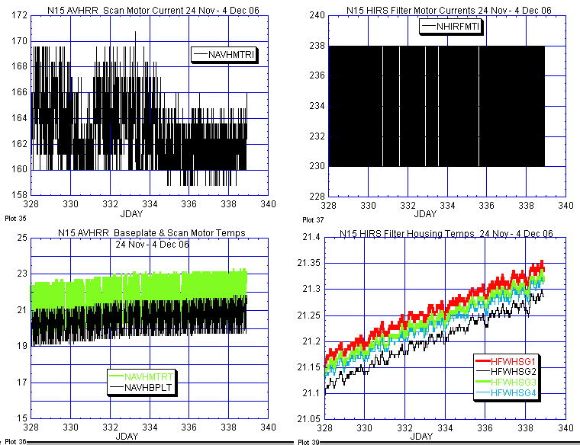

AVHRR HIRS

Illustration 3: N15 AVHRR & HIRS Health Analysis

(Nominal, even improved performance [AVHRR scan motor upper left plot] during this continued thermal uptrend. AMSU’s [not depicted this week] were all nominal although still trending upward thermally.)

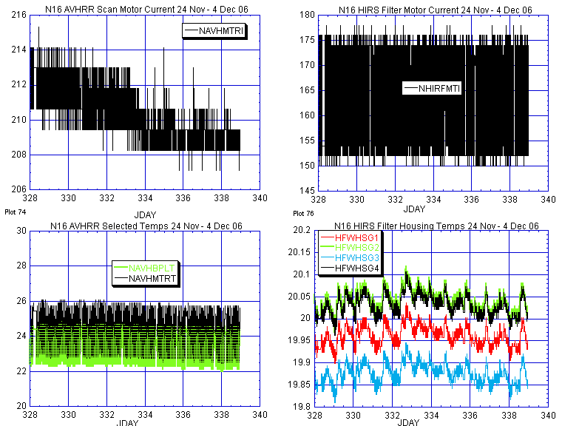

AVHRR HIRS

Illustration 5: N16 AVHRR & HIRS Health Analysis

(AVHRR scan motor current [upper left plot] improved again during the past week. HIRS remained stable during this time.)

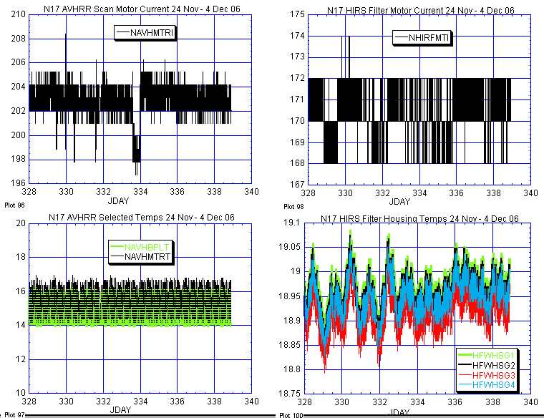
AVHRR HIRS

Illustration 8: N17 AVHRR & HIRS Health Analysis

(Nominal if not perfectly stable [AVHRR scan motor on Jday 333; upper left plot] last week. AMSU’s A2 and B [not depicted this week] were nominal and stable during this same time period.)

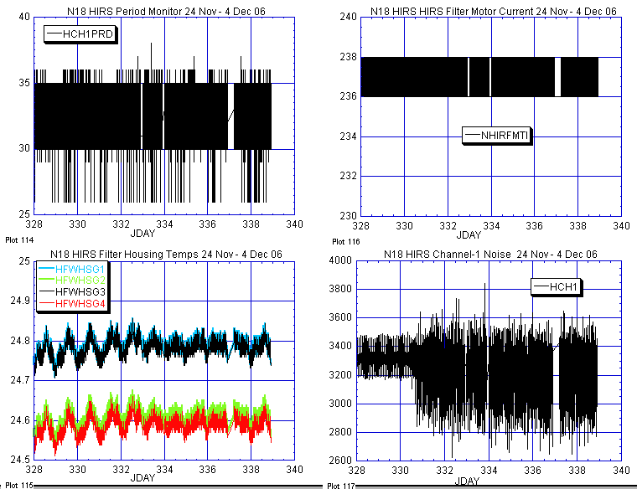

Illustration 11: N18 HIRS Health Analysis

(Generally nominal and stable last week from an engineering perspective but degraded from a long wave products point of view [lower right plot].)

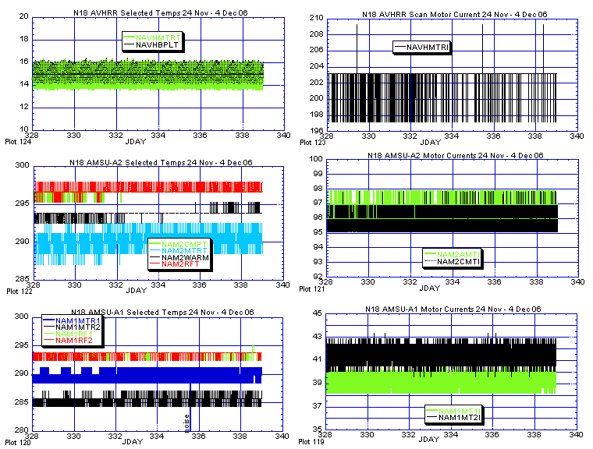

Illustration 12: N18 AMSU’s and AVHRR Health Analysis

(Nominal and stable last week.)

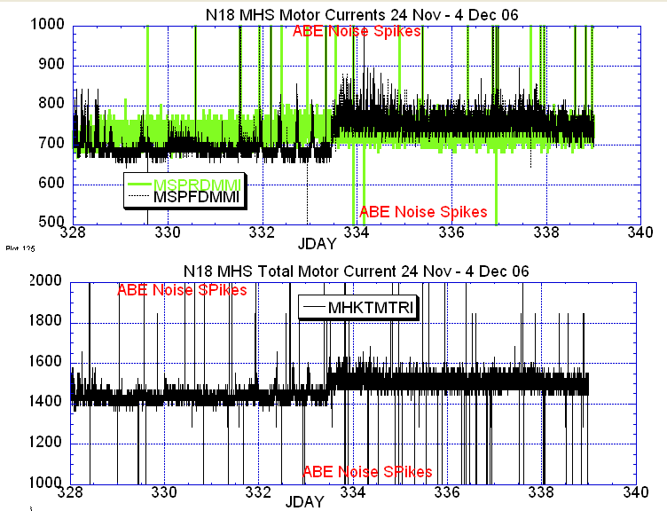

Illustration 13: N18 MHS Motor Health Analysis

(Perhaps the worst noise interjection by ABE since N18 launch significantly reduces the fidelity of these two plots. However, on Jday 333 [again 333] it is noticeable that there was an abrupt increase in the flywheel motor current although the range remains within acceptable norms.)

