POLAR Spacecraft Status As of: Thurs 21 Aug 2008, 12:00 EST
(Changes from last week in bold border)
Subsystem/  Component | NOAA-15K  AM: 17:49=AN  GAC data only | NOAA-16L  PM: 15:04=AN  GAC data | NOAA-17M  AM: 22:23=AN  GAC&LAC data | NOAA-18N  PM 13:49=AN  GAC & LAC data
LAUNCHED | 05/13/98 | 09/21/00 | 6/24/02 | 5/20/05
CNTL OBP | OBP2 | OBP2 | OBP2 | OBP2
BUS | B-BUS  XSU-1 | B-BUS  XSU-2: TOAR472 | B-BUS  XSU-2: TOAR 471  1/15/08 | B-BUS  XSU-1
BUS VETO | NO | NO | NO | NO
ADACS | Nominal Mode  Rgmode=Monitor  Gyro-3 Off 6/26/00 Gyro chans=AAB  N2 Low PSI invalid | RGYRO Mode  Estimate Y-ROLL  Rgmode=PASSIVE  Gyros-1 & 3 Inop/Off  Gyro chans XA-ZB  Pitch wheel bias 2400  *Z gas unload = 145  Gyro2 safe macro | Nominal Mode  Rgmode=Monitor  Gyro-3 Off 6/10/04  Gyro chans=AAB GAS Enabled Dec 05  *Z Gas unload =45 | Nominal Mode  Gyro-A MIMU-2  Z-wheel -Pitch  TOAR 447  Z-momentum transition complete  Pitch Torquer again active  Gas auto unloading enabled 8/18/08
RXO | PRI  daily bias -8 mS  -500 mS 12/31/05 | PRI  Daily Bias –5.5 mS  -1500 mS 31Dec05 | PRI  Daily Bias –3 mS  -1500 mS 31Dec05 | PRI  No daily bias  -1500 mS 31Dec05
CLOCK DIV | 2 | 2 | 2 | 2
MIRP | External Synch Rephase 0730 daily | External Sync  Rephase each orbit | External Sync  Rephase Enabled | External Synch  Rephase Enabled
TIP SIDE | 2  (since 4/3/03)  3 channels inop | 2  since 4/18/05  (analog drifting?) | 2  Swapped 9/20/06 | 1  Analog telem drifting
Recorders  (DTR, SSR) | DTRs 1, 2, 3, 4 Safestate 1B EOT | DTRs 1, 2, 3, 4A  Safestate 3A  4B STIP only | DTR 1,3,4 / SSR 2  Safestate=SSR 2B  4A Pressure leak | SSRs 1,2,3,4,5  Safestate=5B  Current spikes
VTX  (APT data) | #1 ON  As of 19 June 07 | OFF / INOP  since 11/15/00 | #2 ON  137.62 MHZ | #1 ON  137.1 MHZ  As of 16 Aug 07
BTX | #1  137.35 MHZ | #2  137.77 MHZ | #2  137.77 MHZ | #1  137.35 MHZ
STX  1 = rcp 1698.0 mhz  2 = lcp 1702.5 mhz  3= rcp 1707.0 mhz  4= rcp 2247.5 mhz | 2-Omni HRPT  2 Omni=rcp  Power TOAR 446  4-Playback  1,2,3-Degraded | 2 – HRPT  1– Playback  4 Standby  3 low power INOP -10 Aug 2007 | 1 – HRPT  TOAR424 low power  2 & 4 Playback  STX-1 Power drop 2.29W 3/2/08  STX-4 nominal  STX-3 Failed 2/14/08 | 3 - HRPT  1 - Playback  2 - Playback  4-Test & Standby
POWER  (Array offset and CANT angle, eclipse states and sun angle) | Array Off -45  Since 1/25/01  Full Sun  Sun Angle 13  Uptrend to 18 early Jan 07  SA CANT=37 degs | Array Off -20  Since 9/13/07  Eclipse all year  Sun Angle 34  Steady trend  SA CANT=22 degs  Full sun S/C in Sept 07  BVR Phase Control auton swap 7/19/07 | Array Off. –40  Since 1/29/04  Eclipse all year  Sun Angle at 66  Steady trend  SA CANT=37 degs  BVR Phase Control auton swap 9/17/07  Swap back 9/18/07  SADPOS Enabled 2/12/08 | Array Off. -40  Since 6/6/05  Eclipse all year  Sun Angle 63 uptrend to 65 on  1 Jan 07  SA CANT=22  BVR Phase Control auton swap 3/29/06 & 1/4/07
AVHRR | Nominal  Channel 3B only  Occasional minor scan motor instabilities | Nominal  Recent SM current increases  TCE24 OFF 4/14/04  Channel 3B only | Nominal  3A-B switch enabled  Previous scan motor current mini surges | Nominal  Channel 3B only  Scan motor current drop 29 Aug 06
AMSU-A1 | Operational  Ch14 inoperative  Ch11 inoperative | Operational  Primary PLLO chans 9-14 bias shift.  Backup PLLO inop.  Channel 9-14 noise  Channel 4 severely degraded 4 Mar 08 | OFF/INOP  Since 10/30/03  Survival heat on. | Nominal  Full Scan mode
`AMSU-A2 | Nominal | Nominal | Nominal | Non-nominal  DIG-A Temps erratic 2/7/08  Cold Cal Pos 2 2/21/08
AMSU-B | Operational  Bias in All Chans.  Degraded Chan-3 | Operational  Space Position-3  Chan-8 degradation | Nominal | Replaced by MHS
HIRS | NOMINAL  FW Abrupt return to nominal 7/12/05  After years of minor and major current surges  FW mode=Hi Powr | NOMINAL  New all time high filter motor current reached 9/17/06.  Imagery occasionally exhibits high levels of radiometric noise | NOMINAL  1 Pixel cross-track misalignment. | Operational  Filter Heat OFF.  LW channel 1-12 noise TOAR 448 Loose LWIR lens.  LW imagery erratic.  CH 1 Period Monitor event 13 May 08
MHS/MIU |  |  |  | Nominal  Fly Wheel Motor Current Spiking but not alarming since 27 Dec 06  Entered Motor Spin State on 9 May 08  H4 gain increased 9 May 08  H3 gain increased 9 May 08
DCS  RFI investigation | Nominal | Nominal  Pseudo message turned on 1/5/06 | Nominal | Nominal  DRU’s 1-7 On  DRU8 inop/off
SARR | Operational  B-Side, 13 Dec 07  AGC Mode  Intermittent failures for 243MHz A&B | Operational  Mode =AA  A-side, AGC Mode  (B-side in FG mode)  124 & 243 MHz = INOP & OFF as of 29 Jul 08  406 RCVR ATT set to 5dB, PDS ATT set to 0dB | Nominal  A-side  All AGC Mode | Nominal  A-Side  All AGC Mode  Since 15 Aug 05
SARP | Nominal  RCVR B/W = 2 | Nominal  RCVR B/W = 2 | Nominal | Nominal  A-side 23 May05
SEM | Nominal  E-CDEM-HVPS=2  P-CDEM-HVPS=0 | Nominal  E-CDEM-HVPS=7  P-CDEM-HVPS=7  11 Jan 0714:47z | Nominal  E-CDEM-HVPS=2  P-CDEM-HVPS=4  27 June 06 16:00z | Nominal  Elec-CH-HVPS=1  27 June 06 17:00z  Prot-CH-HVPS=1  11 Jan 07 14:15z
SBUV |  | Operational  Degraded Ozone data  Backup Diffuser inop  Primary Diffuser deployment problem TOAR 426  AMSU EMI causing erratic Behavior in PMT cathod, range 3 | Nominal  Anode Mode  Plan sweep mode  Standard Ops  TOAR 463 sun glint  IBSL test performed 12 Sept 06  Grating motor investigation | Partially-Operational  Anode mode  since 6 July 05 13:30z  Electronics turnoff taken out of STESM safestate table  TOAR 462 sun glint  Chop Motor stalled 22 May 08. Currently all motors turned on; not fully operational
SADPOS |  | ON  Enabled MFactor50%  Timer = 12 mins | ON  ENABLED  Timer = 12mins | ON  Enabled  Timer =12 mins
THERMAL  Heaters, louvers  TCE’s | TCE26 & 15H  Telem valid  TOAR 432 closed  TCE24L&25L (HIRS & AVHRR) failed 5/13/98  RCE thermostat failed 5/13/98  Spacecraft in thermal uptrend | Nominal  TCE24 OFF 4/14/05  (AVHRR H&L)  HIRS Filter heater turned OFF 1/18/05 | TCE3H Batt 2A heater failed ON, turned off 8/26/03  AMSU-A1 survival heaters on 10/29/03 | All TCE’s active  HIRS filter heater turned OFF 9/28/06

COMMENTS/CHANGES:

MISC:

NOAA-15: There were relatively no changes to the NOAA-15 bus or payload health situation during the past week.

The #2 gyro is still relatively quiet. Daily monitoring continues.

Summer eclipse season ended on 17 August 08 as expected. Slight battery temperature increase and patch current of about 250 mamps (about pre-summer value). Bus voltage min and max variation have settled into average bus voltage. The load current has decreased due to reduced TCS demand and no charging of batteries required.

NOAA-16: There was relatively no change in the performance of the NOAA-16 bus & payload subsystems during the past week.

Summer eclipse season ended on 16 August 08 as expected. Batteries 1 and 2 have had typical temperature increases that have settled in at 12 deg C and 9.5 deg C, battery 3 had a very slight increase in temperature. The patch current is about 210 mamps which is about pre-summer value. Bus voltage min and max variation have settled into average bus voltage. The load current has decreased due to reduced TCS demand and no charging of batteries required.

Per request by USMCC/SARSAT, NOAA-16's SARR 406 MHz receiver attenuators will be set to 5 DB and its PDS channel attenuators to 0 DB on 20 August 08 (08/233) at 18:10z. CTEC confirmed that they saw the change in the attenuator settings.

NOAA-17: There was relatively no change in the performance of the NOAA-17 payload subsystem during the past week.

NOAA-17 continues to have occasional bus voltage spikes. It appears the shunts are responding to a small change in the load current that causes a large swing in the bus voltage and then a large swing in the shunt drive voltage. This could be a result of the solar array current versus voltage curve operating near the knee. See Figures 1 & 2.

NOAA-18: There were relatively no changes to the NOAA-18 health situation during the past week.

The Air Force informed NOAA of a possible close approach with a piece of debris from the FENGUYN Chinese satellite that was destroyed January 2007 on 18 August at 10:16z. Auto Thruster Firing (Gas) was enabled on NOAA-18, and no other configuration change was done to the spacecraft based on the analysis of the size of the object. The spacecraft was over the South Pole at the time of the predicted close approach. No effects were seen on the spacecraft.

As a result of the Automatic Thruster Unloading Enable commanding for the close approach, the automatic momentum unloading system (ATMUL) was turned on for this encounter and left enabled to guard against future close encounters. The pitch thruster firing that occurred at 18:14 UT was determined to be due to nominal operational conditions and not the result of outside forces i.e. impact from debris or foreign object. During normal spacecraft operations the momentum carried by the Z (pitch) RWA ranges from -25 to about -40 inch pound seconds (see Figure 3). The automatic thruster unloading threshold for the pitch axis is set at ±40 in. lb sec, which is too close to operational levels to avoid inadvertent thruster firings when automatic thruster momentum unloading is enabled. ATMUL was disabled to avoid additional inadvertent thruster firings. The threshold for the Z axis should be increased to 45 in. lb sec if ATMUL is to be enabled for future close encounters. Once the investigation is complete and the thresholds are increased, auto thruster unloading will be re-enabled and remain enabled. During the + pitch thruster firing the ROLL reasonableness test failed on the NON control side, which caused the MIMU to switch from MIMU 2 to MIMU 1, and set MIMU switching to INHIBIT.

The N18 MHS Channel 5 signal has been slowly drifting downward. This is an anticipated condition resulting from seasonal effects (cyclical temperatures) and aging hardware. The signal levels in the space view are near the lower 5% level, 3276 counts. When the signal is below 5%, the MHS raises flags to indicate the sensor may need adjustment to keep the signal from saturating. Figure 4 depicts the daily and orbital cycles in which the signal dips below the 5% level. The plan is to perform a DC Offset correction that will move the signal level back towards the center of its range. There are no current concerns of data loss/degradation or instrument health.

MetOp-A: There were relatively no changes to the health and safety of the NOAA instruments on MetOp-A this past week.

The slightly increasing trend identified last week in the SARR 121.5 MHz Rx-A AGC Voltage (mean values) did not continue this week and can therefore be considered insignificant.
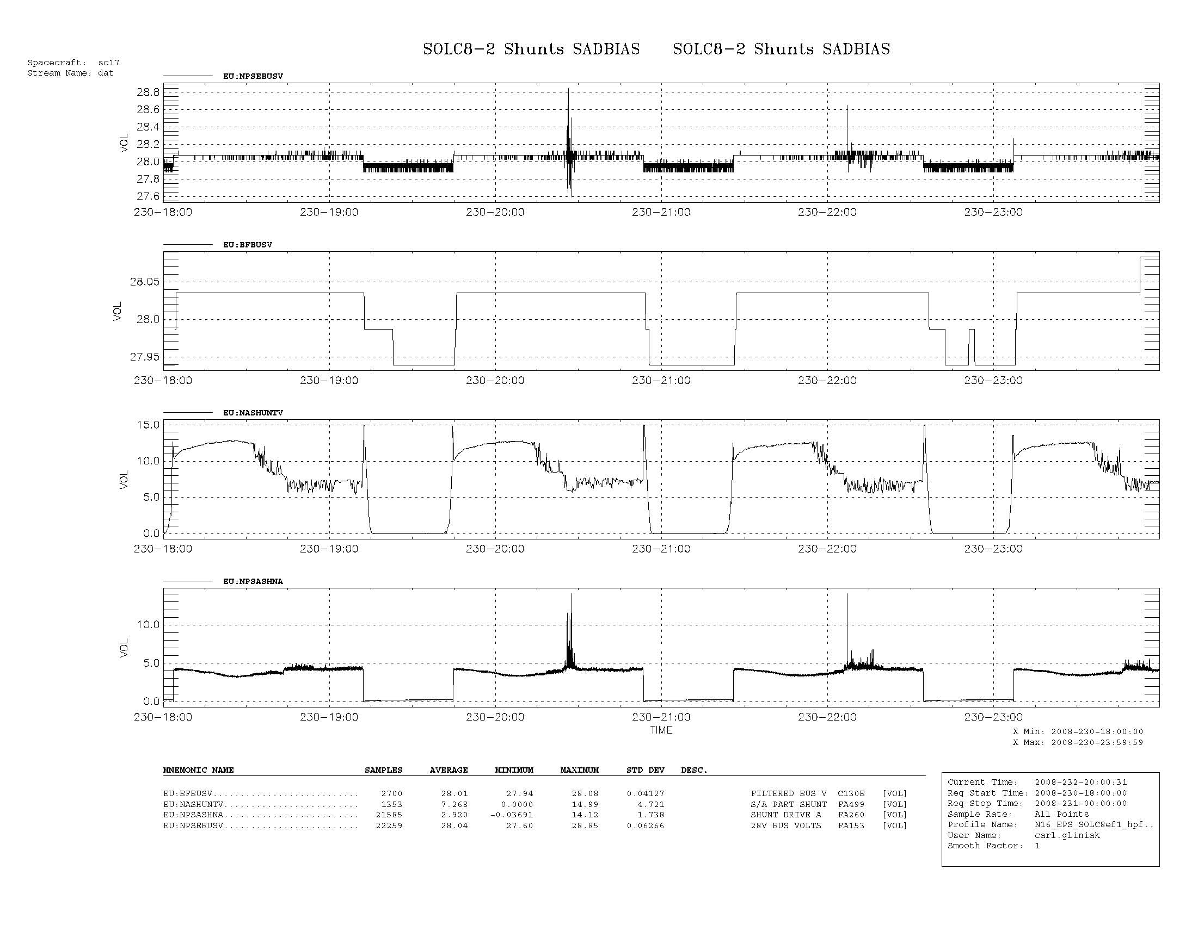
Figure 1 NOAA-17 Shunts (2008/230-231)
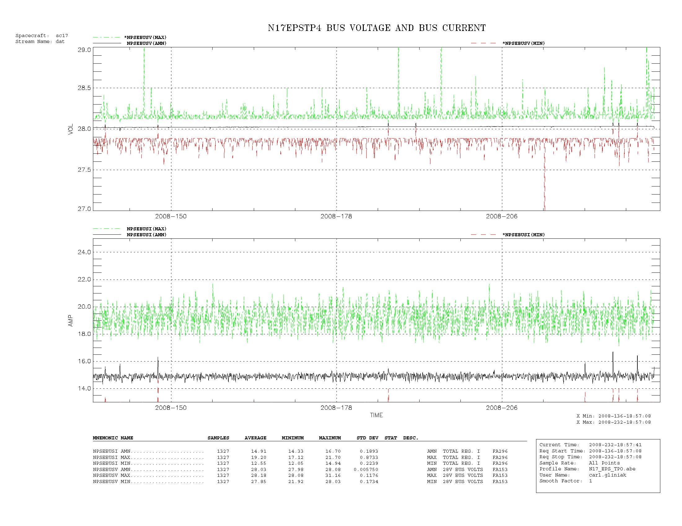
Figure 2 NOAA-15 RWA Speeds (2008/136-232)
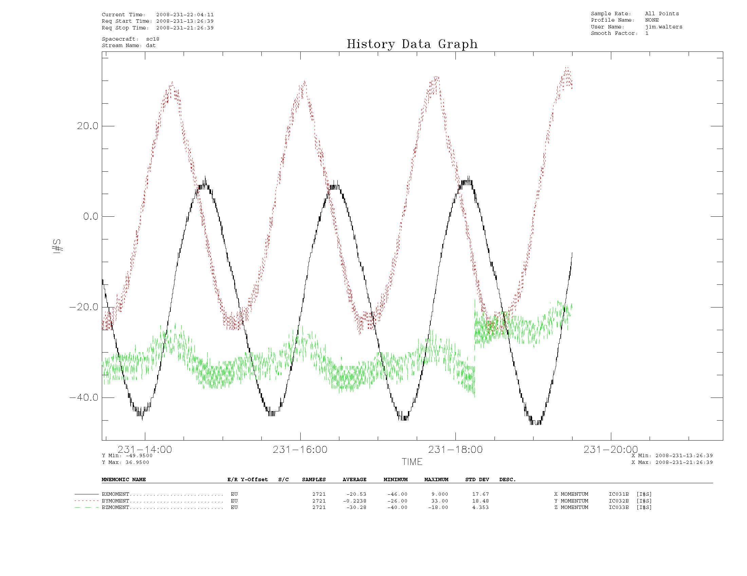
Figure 3 NOAA-18 X,Y,Z Momentum (2008/231)
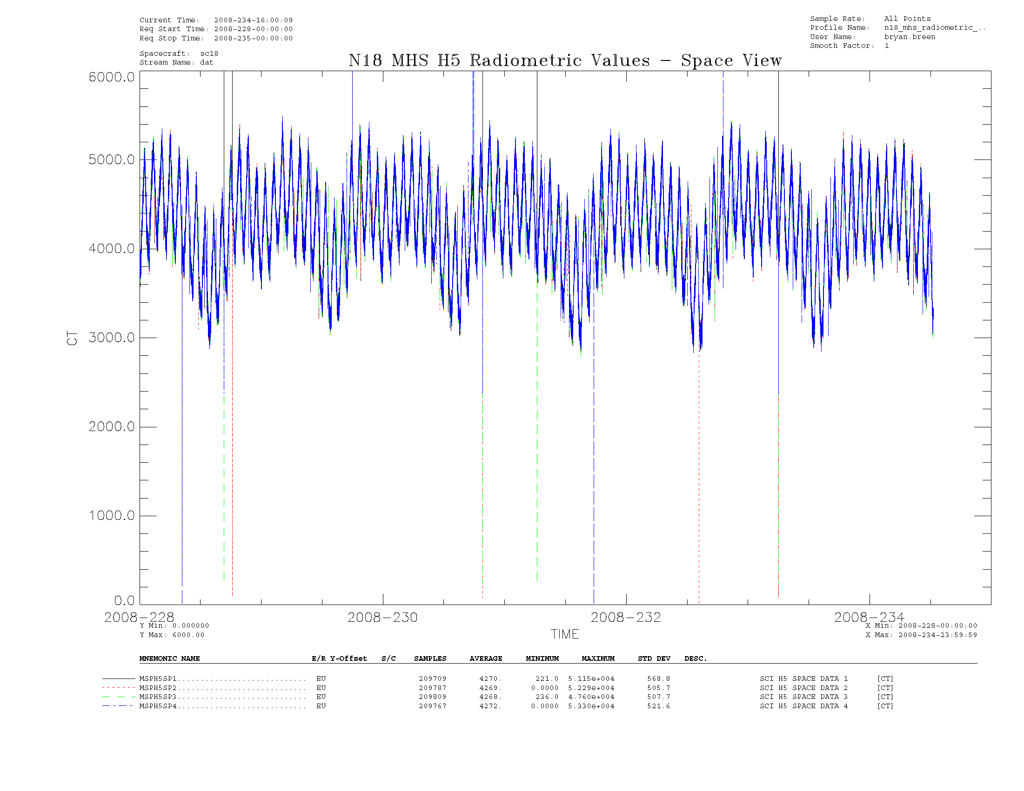

Figure 3 NOAA-18 MHS Channel 5 (2008/228-234)

