POLAR Spacecraft Status As of: Thurs 31 July 2008, 16:00 EST
(Changes from last week in bold border)
Subsystem/  Component | NOAA-15K  AM: 17:49=AN  GAC data only | NOAA-16L  PM: 15:04=AN  GAC data | NOAA-17M  AM: 22:23=AN  GAC&LAC data | NOAA-18N  PM 13:49=AN  GAC & LAC data
LAUNCHED | 05/13/98 | 09/21/00 | 6/24/02 | 5/20/05
CNTL OBP | OBP2 | OBP2 | OBP2 | OBP2
BUS | B-BUS  XSU-1 | B-BUS  XSU-2: TOAR472 | B-BUS  XSU-2: TOAR 471  1/15/08 | B-BUS  XSU-1
BUS VETO | NO | NO | NO | NO
ADACS | Nominal Mode  Rgmode=Monitor  Gyro-3 Off 6/26/00 Gyro chans=AAB  N2 Low PSI invalid | RGYRO Mode  Estimate Y-ROLL  Rgmode=PASSIVE  Gyros-1 & 3 Inop/Off  Gyro chans XA-ZB  Pitch wheel bias 2400  *Z gas unload = 145  Gyro2 safe macro | Nominal Mode  Rgmode=Monitor  Gyro-3 Off 6/10/04  Gyro chans=AAB GAS Enabled Dec 05  *Z Gas unload =45 | Nominal Mode  Gyro-A MIMU-2  Z-wheel -Pitch  TOAR 447  Z-momentum transition complete  Pitch Torquer again active
RXO | PRI  daily bias -8 mS  -500 mS 12/31/05 | PRI  Daily Bias –5.5 mS  -1500 mS 31Dec05 | PRI  Daily Bias –3 mS  -1500 mS 31Dec05 | PRI  No daily bias  -1500 mS 31Dec05
CLOCK DIV | 2 | 2 | 2 | 2
MIRP | External Synch Rephase 0730 daily | External Sync  Rephase each orbit | External Sync  Rephase Enabled | External Synch  Rephase Enabled
TIP SIDE | 2  (since 4/3/03)  3 channels inop | 2  since 4/18/05  (analog drifting?) | 2  Swapped 9/20/06 | 1  Analog telem drifting
Recorders  (DTR, SSR) | DTRs 1, 2, 3, 4 Safestate 1B EOT | DTRs 1, 2, 3, 4A  Safestate 3A  4B STIP only | DTR 1,3,4 / SSR 2  Safestate=SSR 2B  4A Pressure leak | SSRs 1,2,3,4,5  Safestate=5B  Current spikes
VTX  (APT data) | #1 ON  As of 19 June 07 | OFF / INOP  since 11/15/00 | #2 ON  137.62 MHZ | #1 ON  137.1 MHZ  As of 16 Aug 07
BTX | #1  137.35 MHZ | #2  137.77 MHZ | #2  137.77 MHZ | #1  137.35 MHZ
STX  1 = rcp 1698.0 mhz  2 = lcp 1702.5 mhz  3= rcp 1707.0 mhz  4= rcp 2247.5 mhz | 2-Omni HRPT  2 Omni=rcp  Power TOAR 446  4-Playback  1,2,3-Degraded | 2 – HRPT  1– Playback  4 Standby  3 low power INOP -10 Aug 2007 | 1 – HRPT  TOAR424 low power  2 & 4 Playback  STX-1 Power drop 2.29W 3/2/08  STX-4 nominal  STX-3 Failed 2/14/08 | 3 - HRPT  1 - Playback  2 - Playback  4-Test & Standby
POWER  (Array offset and CANT angle, eclipse states and sun angle) | Array Off -45  Since 1/25/01  Full Sun  Sun Angle 13  Uptrend to 18 early Jan 07  SA CANT=37 degs | Array Off -20  Since 9/13/07  Eclipse all year  Sun Angle 34  Steady trend  SA CANT=22 degs  Full sun S/C in Sept 07  BVR Phase Control auton swap 7/19/07 | Array Off. –40  Since 1/29/04  Eclipse all year  Sun Angle at 66  Steady trend  SA CANT=37 degs  BVR Phase Control auton swap 9/17/07  Swap back 9/18/07  SADPOS Enabled 2/12/08 | Array Off. -40  Since 6/6/05  Eclipse all year  Sun Angle 63 uptrend to 65 on  1 Jan 07  SA CANT=22  BVR Phase Control auton swap 3/29/06 & 1/4/07
AVHRR | Nominal  Channel 3B only  Occasional minor scan motor instabilities | Nominal  Recent SM current increases  TCE24 OFF 4/14/04  Channel 3B only | Nominal  3A-B switch enabled  Previous scan motor current mini surges | Nominal  Channel 3B only  Scan motor current drop 29 Aug 06
AMSU-A1 | Operational  Ch14 inoperative  Ch11 inoperative | Operational  Primary PLLO chans 9-14 bias shift.  Backup PLLO inop.  Channel 9-14 noise  Channel 4 severely degraded 4 Mar 08 | OFF/INOP  Since 10/30/03  Survival heat on. | Nominal  Full Scan mode
`AMSU-A2 | Nominal | Nominal | Nominal | Non-nominal  DIG-A Temps erratic 2/7/08  Cold Cal Pos 2 2/21/08
AMSU-B | Operational  Bias in All Chans.  Degraded Chan-3 | Operational  Space Position-3  Chan-8 degradation | Nominal | Replaced by MHS
HIRS | NOMINAL  FW Abrupt return to nominal 7/12/05  After years of minor and major current surges  FW mode=Hi Powr | NOMINAL  New all time high filter motor current reached 9/17/06.  Imagery occasionally exhibits high levels of radiometric noise | NOMINAL  1 Pixel cross-track misalignment. | Operational  Filter Heat OFF.  LW channel 1-12 noise TOAR 448 Loose LWIR lens.  LW imagery erratic.  CH 1 Period Monitor event 13 May 08
MHS/MIU |  |  |  | Nominal  Fly Wheel Motor Current Spiking but not alarming since 27 Dec 06  Entered Motor Spin State on 9 May 08  H4 gain increased 9 May 08  H3 gain increased 9 May 08
DCS  RFI investigation | Nominal | Nominal  Pseudo message turned on 1/5/06 | Nominal | Nominal  DRU’s 1-7 On  DRU8 inop/off
SARR | Operational  B-Side, 13 Dec 07  AGC Mode  Intermittent failures for 243MHz A&B | Operational  Mode =AA  A-side, AGC Mode  (B-side in FG mode)  124 & 243 MHz = INOP & OFF as of 29 Jul 08 | Nominal  A-side  All AGC Mode | Nominal  A-Side  All AGC Mode  Since 15 Aug 05
SARP | Nominal  RCVR B/W = 2 | Nominal  RCVR B/W = 2 | Nominal | Nominal  A-side 23 May05
SEM | Nominal  E-CDEM-HVPS=2  P-CDEM-HVPS=0 | Nominal  E-CDEM-HVPS=7  P-CDEM-HVPS=7  11 Jan 0714:47z | Nominal  E-CDEM-HVPS=2  P-CDEM-HVPS=4  27 June 06 16:00z | Nominal  Elec-CH-HVPS=1  27 June 06 17:00z  Prot-CH-HVPS=1  11 Jan 07 14:15z
SBUV |  | Operational  Degraded Ozone data  Backup Diffuser inop  Primary Diffuser deployment problem TOAR 426  AMSU EMI causing erratic Behavior in PMT cathod, range 3 | Nominal  Anode Mode  Plan sweep mode  Standard Ops  TOAR 463 sun glint  IBSL test performed 12 Sept 06  Grating motor investigation | Partially-Operational  Anode mode  since 6 July 05 13:30z  Electronics turnoff taken out of STESM safestate table  TOAR 462 sun glint  Chop Motor stalled 22 May 08. Currently all motors turned on; not fully operational
SADPOS |  | ON  Enabled MFactor50%  Timer = 12 mins | ON  ENABLED  Timer = 12mins | ON  Enabled  Timer =12 mins
THERMAL  Heaters, louvers  TCE’s | TCE26 & 15H  Telem valid  TOAR 432 closed  TCE24L&25L (HIRS & AVHRR) failed 5/13/98  RCE thermostat failed 5/13/98  Spacecraft in thermal uptrend | Nominal  TCE24 OFF 4/14/05  (AVHRR H&L)  HIRS Filter heater turned OFF 1/18/05 | TCE3H Batt 2A heater failed ON, turned off 8/26/03  AMSU-A1 survival heaters on 10/29/03 | All TCE’s active  HIRS filter heater turned OFF 9/28/06

COMMENTS/CHANGES:
MISC: On 30 July 2008 (08/212) a minor FSW change to correct a flaw in the CTCES table was executed. The set point for the HIRS TCE was not using the correct temperature point. This was done for

There is a solar eclipse on 1 August 2008 (08/214) for spacecrafts.

Since Jason-2’s launch data gaps has been noticed on NOAA-16.

NOAA-15: There were relatively no changes to the NOAA-15 bus or payload health situation during the past week.

The #2 gyro is still relatively quiet. Daily monitoring continues.

Summer eclipse season will be ending in mid August.

NOAA-16: There was relatively no change in the performance of the NOAA-16 bus & payload subsystems during the past week.

Summer eclipse season will be ending in mid August.

The NOAA-16 121 and 243 MHz SARR were turned off on 29 July 2008.

NOAA-17: There was relatively no change in the performance of the NOAA-17 payload subsystem during the past week.

NOAA-18: There were relatively no changes to the NOAA-18 health situation during the past week.

The NOAA-18 SBUV is still functioning properly. The plan is to return the instrument to normal operations in the next few weeks.

The NOAA-18 HIRS Scan Mirror Temperature telemetry point erratic readings from 2008/205 (July 23) have not returned.

On 2008/211 at 13:03:03 UTC, the SOCC AET observed the following telemetry bi-level points flagging in and out of their yellow limits: MHKDCOFE = 1 - (HK5:5) DC Offset Error Flag MSPDCOFE = 1 - (SD5:5) DC Offset Error Flag MSPDCOFV = 0 - (SD9:1) DC Offset Valid Flag MSPH5VAL = 0 - (SD10:10) H5 Data Validity Flag. Additionally, the two composite ground software points that monitor the above points (QHKPRFLT and QSPPRFLT) were flagging in and out of yellow limits.

This signature of telemetry indicates that the Channel H5 data is triggering warning flags from the internal MHS Software. Upon investigation of the MHS Science Data, it appears that the H5 signal is dipping below the 5% of signal lower threshold for a few orbits each day. The minimum signal level, seen during the Space View pixels, has been near the 5% level for a while. Figure 2 depicts the lowest level observed (Space View) over the last 17 days for H5. There have been occasional crossings of the 5% boundary in recent days with a very slow downward trend of approximately 1% of the signal range in the time period observed.

Figure 3 is a plot of the 15 telemetered pixels for Channel H5 on DOY 2008/211. Channel H5 is using approximately 69% of its range. Performing a DC Offset Initialization (MHS FOM Procedure P330) would shift it back to the center of its range as it drifts below the 5% threshold. This is the recommended procedure (TOAR 482) to deal with the anticipated drift/shift expected in the more problematic Channels H3 and H4. It is an appropriate response in this situation as well.

At the current drift rate, the data is still usable and should remain so for several weeks. This will give us a little time to continue monitoring the Channel H5 signal levels and to prepare to implement the corrective actions recommended in the related Channel H3 and H4 TOAR 482.

MetOp-A: There were relatively no changes to the health and safety of the NOAA instruments on MetOp-A this past week.

Based on the CVF Digital A daily, weekly and long term trend reports, all parameters are nominal and stable. All performance parameters are well within specification (e.g. NEdT, NEdN, NEdA and SNR). Note: AMSU-A1 Channel 7 NEdT is still increasing and following the same curve as mentioned in previous weekly reports.

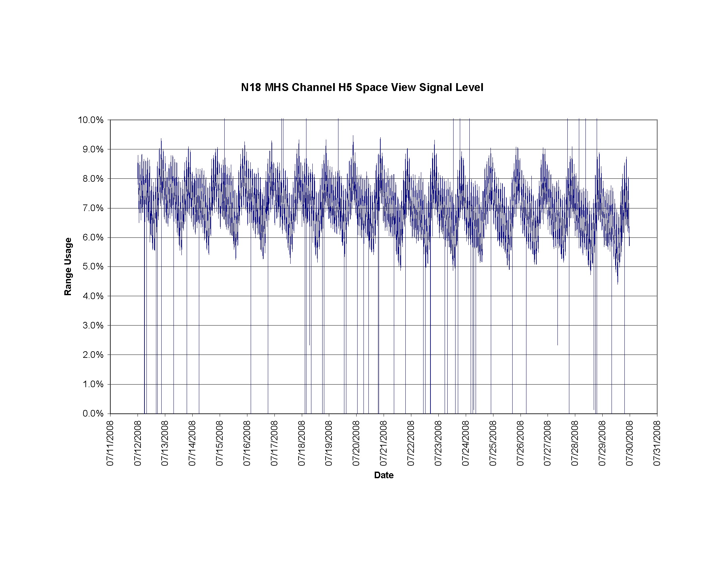
Figure 2 NOAA-18 MHS (2008/193-212)
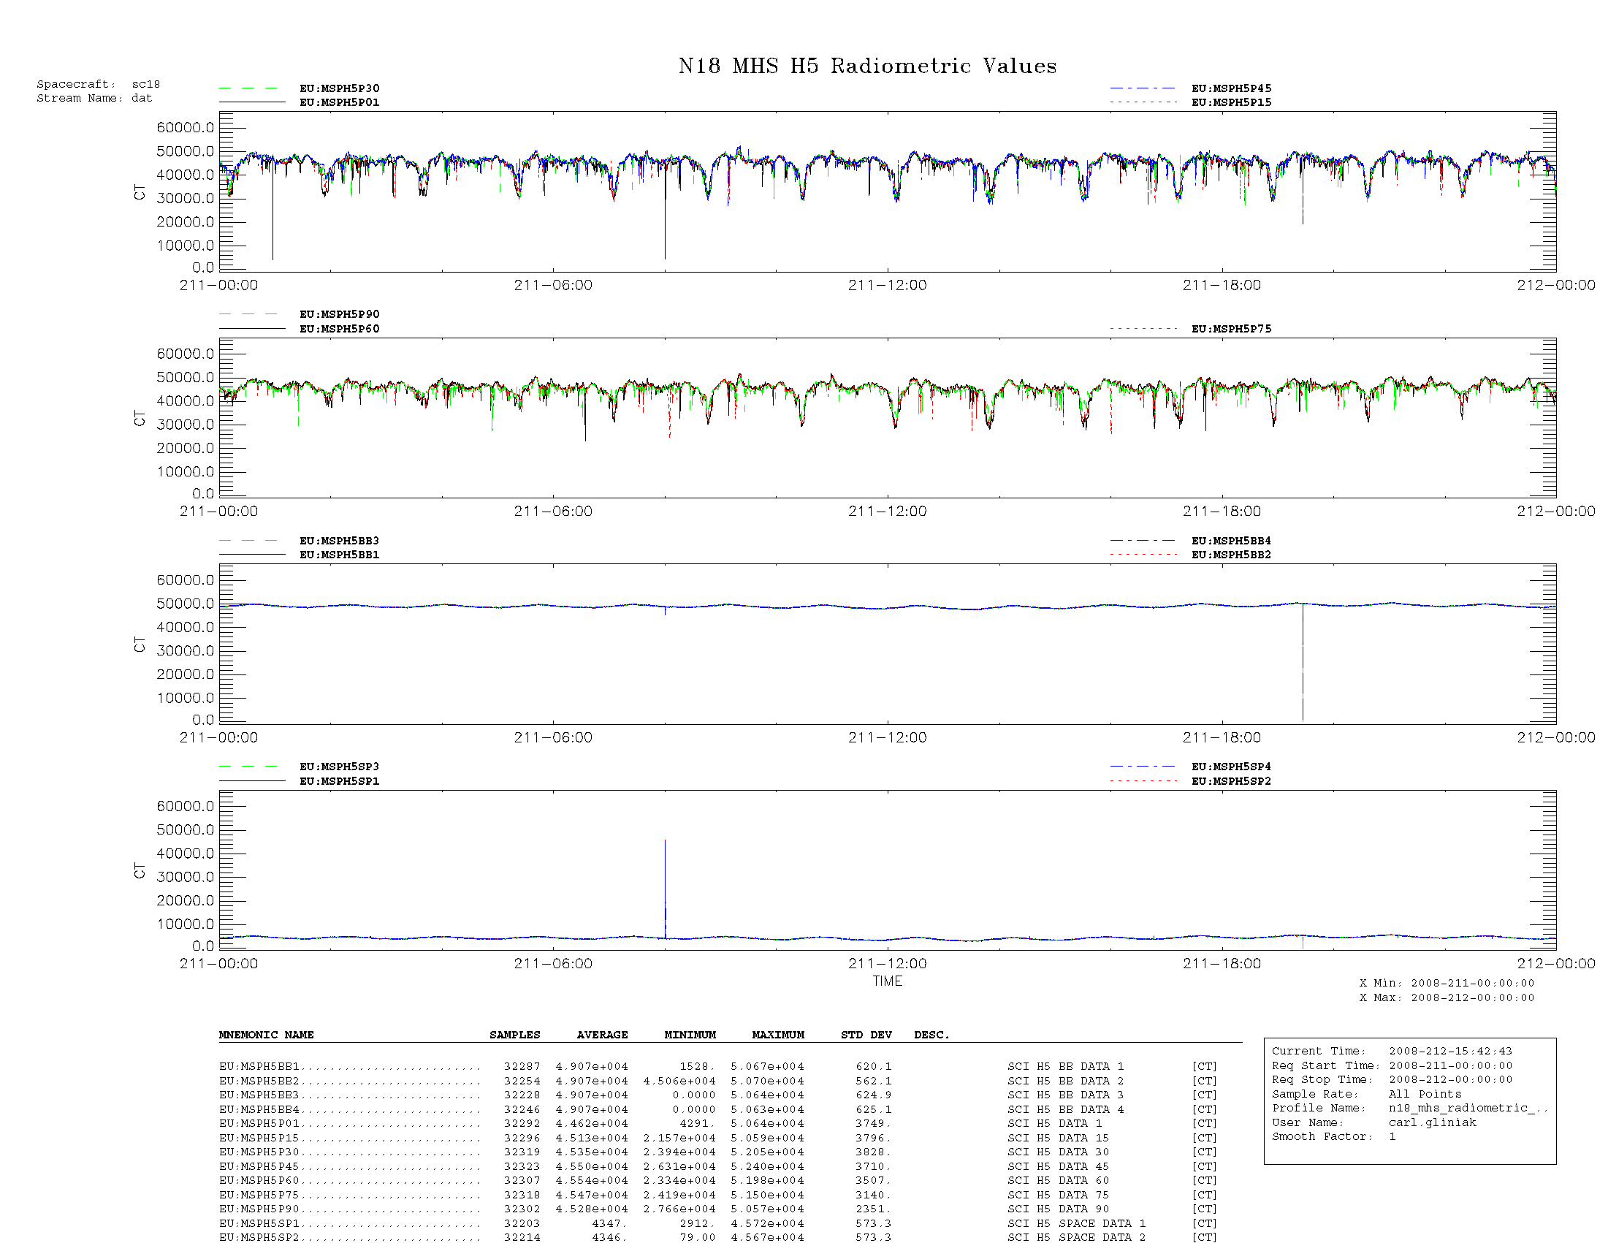

Figure 3 NOAA-18 MHS (2008/211-212)

