POLAR Spacecraft Status As of: Tues, 14 Mar 06, 16:00 EST
(changes from last week in bold border)
Subsystem/  Component | NOAA-12D  AM 16:59=AN  STIP data only | NOAA-14J  AM: 21:10=AN  STIP data only | NOAA-15K  AM: 17:49=AN  GAC data only | NOAA-16L  PM: 15:04=AN  GAC&LAC data | NOAA-17M  AM: 22:23=AN  GAC&LAC data | NOAA-18N  PM 13:49=AN  GAC & LAC data
LAUNCHED | 05/14/91 | 12/30/94 | 05/13/98 | 09/21/00 | 6/24/02 | 5/20/05
CNTL OBP | OBP2  Recursive SCT | OBP2  OBP1 inoperative | OBP2 | OBP2 | OBP2 | OBP2
BUS | B-BUS  XSU-1 | B-BUS  XSU2 (XSU1 inop) | B-BUS  XSU-1 | B-BUS  XSU-1: TOAR444 | B-BUS  XSU-1 | B-BUS  XSU-1
BUS VETO | NO | NO | NO | NO | NO | NO
ADACS | Nominal Mode  RGmode=Monitor  Gyro chans=XYZ | Nominal Mode  Rgmode=Disabled  Gyro chans=XYZ | Nominal Mode  Rgmode=Monitor  Gyro-3 Off 6/26/00 Gyro chans=AAB | RGYRO Mode  Estimate ROLL  Rgmode=PASSIVE  Gyros-1 & 3 Inop/Off  Gyro chans XA-ZB  Gyro-2 motor current surge 13 Mar | Nominal Mode  Rgmode=Monitor  Gyro-3 Off 6/10/04  Gyro chans=AAB  Gyro-2 TOAR 451 | Nominal Mode  Gyro-A MIMU-2  Z-wheel -Pitch  TOAR 447
RXO | PRI  BU random enables  daily bias+6.5 mS | PRI  BU random enables daily bias–7.0 mS | PRI  daily bias -8 mS  -500 mS 12/31/05 | PRI  Daily Bias –5.5 mS  -1500 mS 31Dec05 | PRI  Daily Bias –3 mS  -1500 mS 31Dec05 | PRI  No daily bias  -1500 mS 31Dec05
CLOCK DIV | 2 | 2 | 2 | 2 | 2 | 2
MIRP | External Synch  Rephase Enabled | External Synch  Rephase each orbit | External Synch Rephase 0730 daily | External Sync  Rephase each orbit | External Sync  Rephase Enabled | External Synch  Rephase Enabled
TIP SIDE | 1 | 1 | 2 (since 4/3/03)  #2 has 3 chans inop | 2  since 4/18/05 | 1  Analog telem drifting | 1  Analog telem drift?
Recorders  (DTR, SSR) | DTRs 3A, 4, 5B  Safestate 5B | DTRs 1, 2B, 5 Safestate- 1B | DTRs 1, 2, 3, 4 Safestate 1B EOT | DTRs 1, 2, 3, 4A  Safestate 3A  4B STIP only | DTR 1,3,4 / SSR 2  Safestate=SSR 2B | SSRs 1,2,3,4,5  Safestate=5B  Current spikes  TOAR 450
VTX  (APT data) | #1 ON  137.50 MHZ  Conflict with N15 | OFF (nominal)  Since 8/2/05 | OFF  Conflict with N12  Back on 2 Apr | INOP/Off  OFF since 11/15/00 | #2 ON  137.62 MHZ | #1 ON  137.10 MHZ  Swapped 1/4/06
BTX | #1  136.77 MHZ | #2  137.77 MHZ | #1  137.35 MHZ | #2  137.77 MHZ | #2  137.77 MHZ | #1  137.35 MHZ
STX  1 = rcp 1698.0 mhz  2 = lcp 1702.5 mhz  3= rcp 1707.0 mhz  4= rcp 2247.5 mhz | 1 – HRPT;  2,3 - Playback | 3 – HRPT  2, 1 – Playback | 2-Omni HRPT  2 omni=rcp  Power Drop  TOAR 446  4-Playback  1,2,3-Degraded | 2 – HRPT  1– Playback  4 – Playback  & MCM usage  3 low power unused | 3 – HRPT  TOAR424 low power  2 & 4 Playback  1-Standby  STX-1 Power drop TOAR 443. | 1 - HRPT  3 - Playback  2-Playback  4-Test & Standby
POWER  (Array offset and CANT angle, charge & V/T rates, eclipse states and sun angle)  Sun Moon eclipse  Predicted for  29 Mar, all spacecraft experience | ArrayOff +60  since 6/23/05  Full Sun  Sun Angle 18 steady trend  Batts 1&2=LRC  Batt 1&2 V/T=4  Shunt degraded  SA CANT=37 degs | Array Off -50  Batts 1&3V/T=6/9  Batt2 VT=7/9  Since 11/22/05  Eclipse all year  Sun angle 46  Up trend to 60 in mid-June  Batts 1-3= LRC  Degraded shunts  SA CANT=22 degs  PSSS change plan | Array Off -45  Since 1/25/01  Full Sun  Sun Angle 8  New uptrend to 32 in mid-June  Batts 1-3= LRC  V/T=7/9  SA CANT=37 degs | Array Off -40  Since 7/16/02  Eclipse all year  Sun Angle 56  Steady Trend  Batts 1-3= LRC  V/T=4/8  SA CANT=22 degs | Array Off. –40  Since 1/29/04  Eclipse all year  Sun Angle at 63  New uptrend to 71 at end of May  Batts 1-3= LRC  V/T= 4/8  SA CANT=37 degs | Array Off. -40  Since 6/6/05  Eclipse all year  Sun Angle 66 up trend to 72 mid-Jul  TOAR 453 on  Batt C/D ratio  Batts 1-3=LRC  Batts 1-3 V/T=4/8  SA CANT=22
AVHRR | Nominal | Variable  Status upgraded to Yellow 20 Dec  Occasional scan motor current surge  and bar codes  Channels 2&4 APT | Nominal  Rare major scan motor surges. Last  Incident 11/18/04  Channel 3B only  Recent scan motor current rise | Nominal  Nominal scan motor currents & imagery since mid Oct 05  TCE24 OFF 4/14/04  Channel 3B only. | Nominal  3A-B switch enabled  Occasional scan motor current “mini surges” observed | Nominal  3A-B switch Disabled 8/05/05  Channel 3B only
AMSU-A1 |  |  | Operational  Ch14 inoperative  Ch11 inoperative | Operational  Primary PLLO chans 9-14 bias shift.  Backup PLLO inop.  Channel 9-14 noise | OFF/INOP  Since 10/30/03  Survival heat on. | Nominal  Full Scan mode
AMSU-A2 |  |  | Nominal | Nominal  Space Position-2 | Nominal | Nominal  Full scan mode
AMSU-B |  |  | Operational  Bias in All Chans.  Motor surges most recent 11/14/04  Degraded Chan-3 since 4/30/05 | Operational  Space Position-3  IPD reports channel 8 degradation | Nominal | Replaced by MHS
HIRS | OFF/Inop  Turned off 6/23/05  For power balance  Filter Wheel turned OFF 10/17/02. | NOMINAL  Operational  Occasional loss of Fwheel synch | NOMINAL  FW Abrupt return to nominal 7/12/05  After years of minor and major current surges  FW mode=Hi Powr | Operational  Imagery high levels radiometric noise  TOAR 441 CLOSED  Recent momentary FW synch dropouts  Occasional major FM surges, most recent  12/9/04 | NOMINAL  1 Pixel cross track misalignment. | Operational  LW channel 1-12 noise TOAR 448 Problem isolated to loose LWIR lens.  Out of spec longwave noise started anew 5 Feb  Status DOWNGRADED to Yellow 14 Mar 06
MHS/MIU |  |  |  |  |  | Nominal  Space View=0  Turbo anomalies  16 Dec & 6 Jan TOAR 456 Closed 14 Mar 06  Caused by proton hits over SAA
MSU | OFF/Inop  Turned off for power balance  6/23/05 | Operational  Scan motor and antenna problems  EOL test planned
SSU |  | Nominal
DCS  RFI under investigation | Nominal | Nominal | Nominal | Nominal  Pseudo message turned on 1/5/06 | Nominal | Nominal  DRU’s 1-7 On  DRU8 off  TOAR 449 Closed 6 no fix possible
SARR |  | Nominal | Operational  A-Side, AGC Mode  Intermittent failures for 243MHz A&B | Operational  Mode =AA  A-side, AGC Mode  (B-side in FG mode)  243 MHz = INOP. | Nominal  A-side  All AGC Mode | Nominal  A-Side  All AGC Mode  Since 15 Aug 05
SARP |  | OFF  Power Failure | Nominal  RCVR B/W = 2 | Nominal  RCVR B/W = 2 | Nominal | Nominal  A-side 23 May05
SEM | ON/Nominal  Turned on 8/30/04  Elec-CH-HVPS=4  Prot-CH-HVPS=0  TED level=3 as of 27 Sept | Operational  Elec-CH-HVPS=0  Prot-CH-HVPS=0  1 of 4 Tscopes inop  Autonomous TED shutdown 24 Sept | Nominal  E-CDEM-HVPS=2  P-CDEM-HVPS=0 | Nominal  E-CDEM-HVPS=5  P-CDEM-HVPS=4 | Nominal  E-CDEM-HVPS=2  P-CDEM-HVPS=3 | Nominal  Elec-CH-HVPS=0  Prot-CH-HVPS=0
SBUV |  | Degraded  Grate motor sticks  Flex memory 3 (giant step) ops suspended 12/2/03  Reduced operations  Transient anomaly  1 Sept 05 |  | Operational  Degraded Ozone data  Backup Diffuser inop  Primary Diffuser deployment problem TOAR 426  AMSU EMI causing erratic Behavior in PMT cathod, range 3 | Nominal  Anode Mode  Plan sweep mode  Standard Ops Procedure changes  forthcoming | Nominal  Anode mode  since 6 July 13:30z  Electronics turnoff taken out of STESM safestate table
SADPOS |  |  | N/A | ON  Enabled MFactor50%  Timer = 12 mins | ON  ENABLED  Timer = 12mins | ON  Enabled  Timer =12 mins
THERMAL  Heaters, louvers  TCE’s | Nominal  TCE’s back to nominal configuration following 7/25/04 UVtrip. | Nominal | TCE26 & 15H  Telem invalid  TOAR 432  TCE24L&25L (HIRS & AVHRR) failed 5/13/98  RCE thermostat failed 5/13/98 | Nominal  TCE24 OFF 4/14 (AVHRR H&L)  HIRS Filter heater turned OFF 1/18/05 | TCE3H Batt 2A heater failed ON, turned off 8/26/03  AMSU-A1 survival heaters on 10/29/03 | All TCE’s active
 | N12 | N14 | N15 | N16 | N17 | N18

COMMENTS/CHANGES:

NOAA-12: There were no changes to N12 during the past reporting period.

NOAA-14: There were no AVHRR scan motor current spikes during the past week and the Power subsystem was nominal as well
(illustration 1) as were all other N14 subsystems.

NOAA-15: There were no changes in performance characteristics during the past week. The N15 payload suite was generally
nominal (illustration 2) with the AMSU’s thermal trend reversing to the upside in conjunction with the reversal of the sun angle downtrend that bottomed out last week (illustration 2). The N15 Attitude Control Subsystem was also nominal and stable last week (illustration 3). However, VTX-1 remains off until 2 Apr because of an RF conflict with N12.

NOAA-16: The N16 payload suite was also generally nominal and stable during the past week (illustration 4) with the AVHRR
reaching its lowest ever scan motor current (which is considered a positive situation).
Gyro #2 showed a motor current surge by 10mA. This also corresponded to an increase in the TCA voltage. The TCA voltage and motor current both settled down but at a slightly higher than previous value. There as been increase monitoring of the gyro and IMU parameters.
There was no change to the DCS configuration on N16 during the past week with pseudo messaging remaining on and now expected to remain on indefinitely as it has proven highly beneficial to European (IJPS) engineers investigating noise and interference events on N18.

NOAA-17: There were no changes to N17 during the past reporting period. The payload suite was nominal and stable (illustration
8) during this time as was the ADACS (illustration 9 and 10) with no new orbit or attitude perturbations observed.

NOAA-18: There were no changes to N18 during the past reporting period. HIRS hardware continued to perform nominally while
the payload continued to produce significant noise on a variety of channels (illustrations 11 and 12). EMOSS engineers were informed that because of this noise, the Products personnel are no longer using data from this payload. Accordingly, NOAA management re-downgraded the N18 HIRS operational status to YELLOW on 14 Mar. Otherwise, the remainder of the N18 payload suite was nominal with no new MHS spin mode anomalies observed (illustration 13). On 14 Mar, at the POES TOAR Board meeting, TOAR 456, MHS Spin Mode Anomaly, was officially closed. The problem was determined to have been caused by high level protons hitting the MHS at a very specific angle while over the South Atlantic Anomaly. There is no fix for preventing this from happening again but the COPS now in place are deemed an acceptable workaround as long as the problem continues to occur infrequently.

Finally, the N18 ADACS was nominal during the past week (illustrations 15 and 16).

MISC: All POES spacecraft will experience a sun-moon eclipse situation on 29 Mar between 07:30 and 14:00z. No
reconfigurations to any spacecraft will be necessary in anticipation of this event. Refer to the last 6 pages of this report for an in-depth analysis of how this event will affect each POES spacecraft

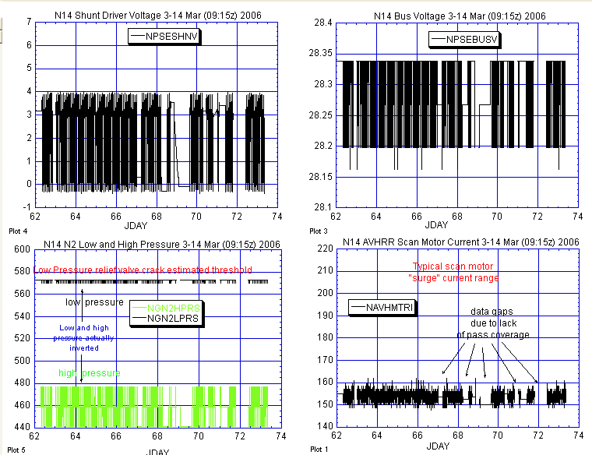

Illustration 1: NOAA-14 Attitude, Power & AVHRR Health Analysis

(An apparent good week for AVHRR scan motor although there is a possibility that scan motor current surges may have occurred in some of the large data gaps caused mostly by reduced pass support. Power subsystem remained nominal and N2 low pressure value did not increase which are both positive.)

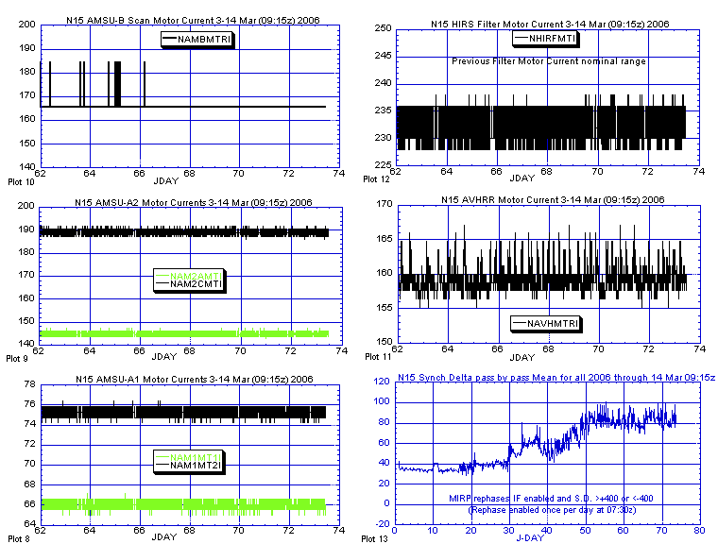

Illustration 2: N15 Primary Payload Health Analysis

(All generally nominal and stable last week. Thermally [not shown here] most components have recently started a new uptrend in conjunction with the uptrend that recently began on the spacecraft sun angle.)

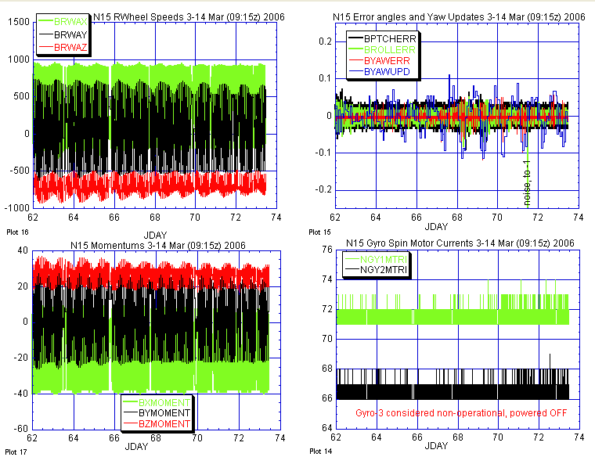

Illustration 3: N15 ADACS Health Analysis
(Nominal and stable last week.)

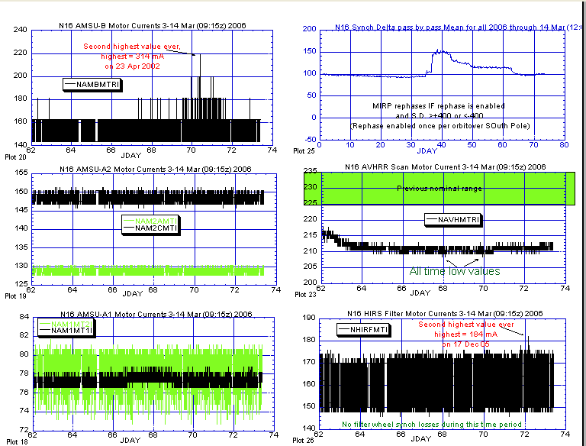

Illustration 4: N16 Primary Payload Health Analysis
(Notwithstanding small motor current surges in AMSU-B and HIRS Filter motor, it was a relatively stable and nominal week for the N16 payload suite.)

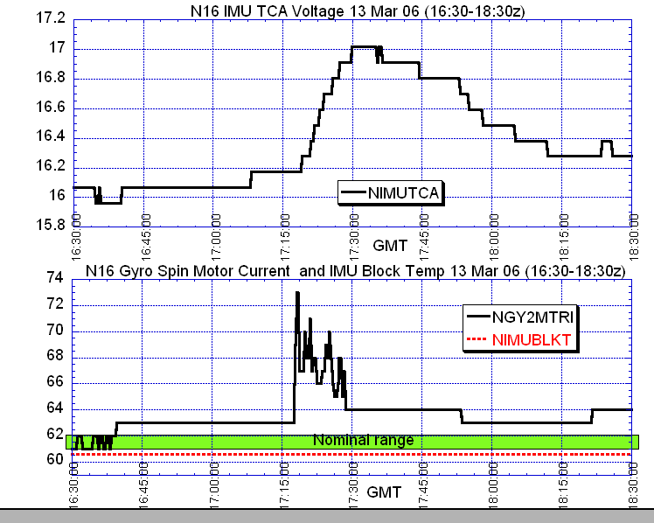

Illustration 5a: N16 Gyro-2 and TCA Anomaly

(Before, during and after the anomaly. Green box in lower plot indicates the range that gyro-2 )

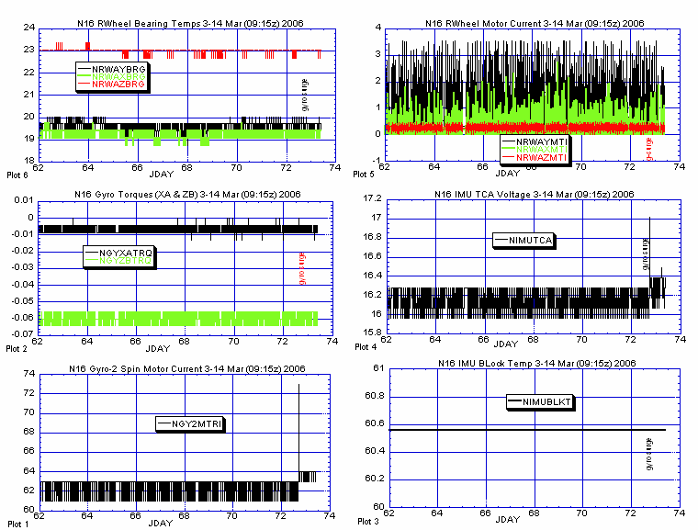

Illustration 5b: N16 ADACS Performance Analysis (in perspective)

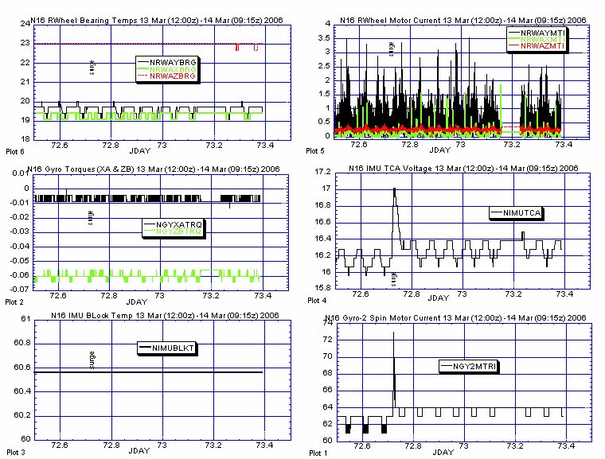

Illustration 5c: N16 ADACS Performance Analysis (in perspective)

(The short view of the previous illustration. The most recent 24 hour period just prior to and following the gyro-2 spin motor current surge.)

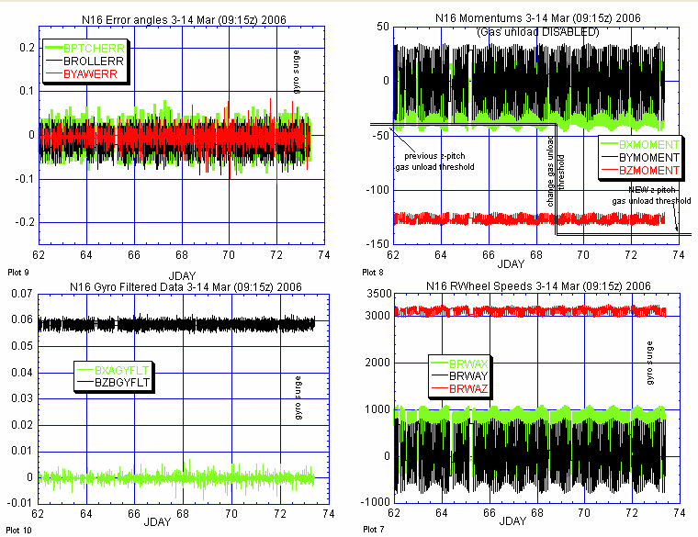

ILLUSTRATION 6a: N16 ADACS Control Analysis (cont)

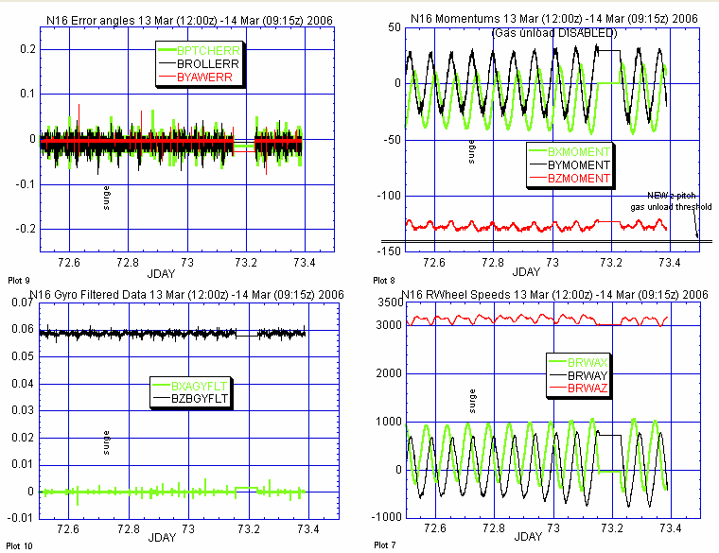

Illustration 7: N16 Attitude Control Analysis
(Nominal and stable last week, within the confines of its severely degraded capabilities.)

ILLUSTRATION 6b: N16 ADACS Control Analysis (cont)

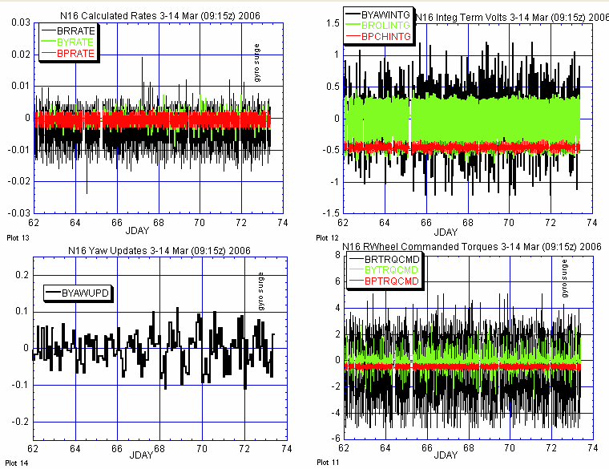

ILLUSTRATION 7a: N16 Attitude Control Analysis (cont)

(The long view, analyzing the effects of the gyro-2 spin motor current surge on other attitude control components of which none are readily apparent, from this long perspective.)

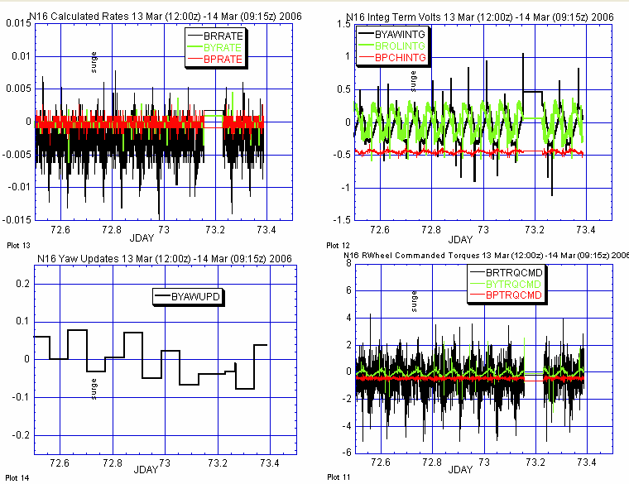

ILLUSTRATION 7b: N16 Attitude Control Analysis

(The short view of the previous illustration, analyzing the effects of the gyro-2 spin motor current surge on other attitude control components. Nothing readily apparent from this perspective either. )

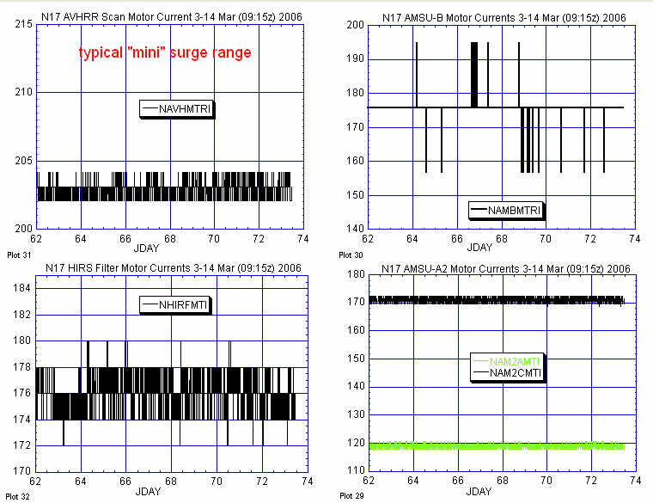

ILLUSTRATION 8: N17 Primary Payload Health Analysis

(A good week, nominal and stable: K.O.W.)

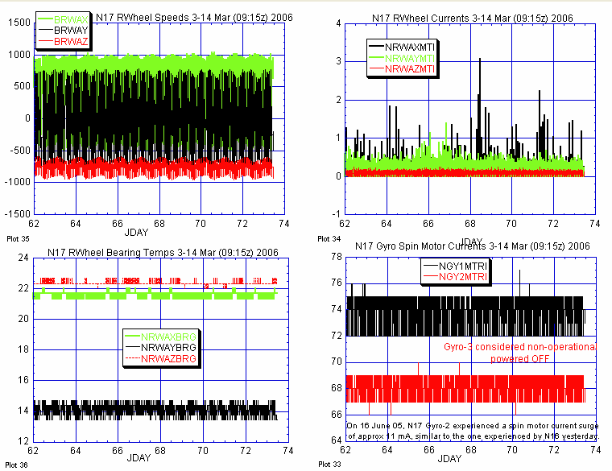

ILLUSTRATION 9: N17 ADACS Health Analysis

(Nominal and stable last week. No new attitude perturbations.)

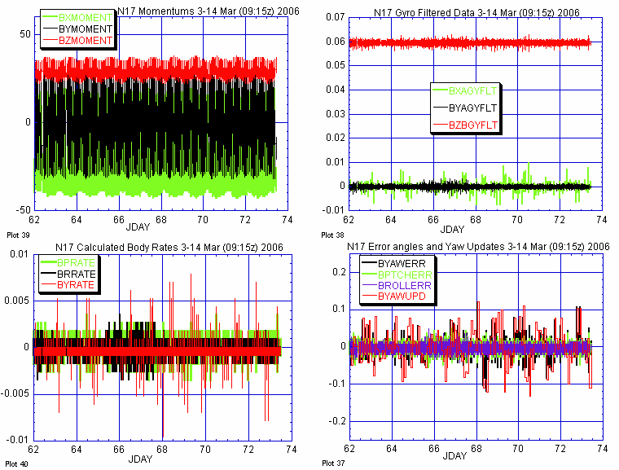

ILLUSTRATION 10: N18 ADACS Health Analysis (cont)

(Again, nominal and stable last week.)

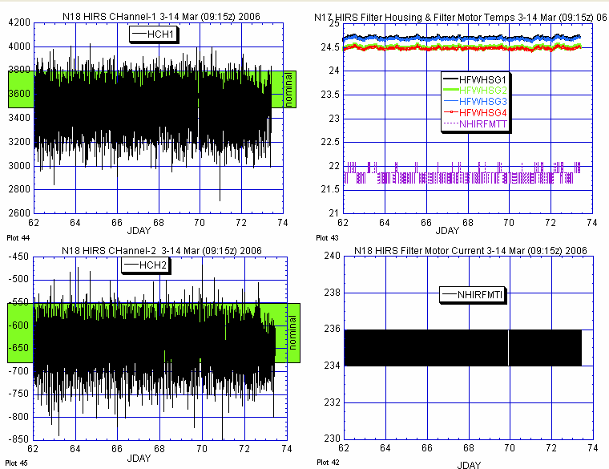

ILLUSTRATION 11: N18 HIRS Health Analysis

(No change from last week; hardware nominal, long wave channels noisy.)

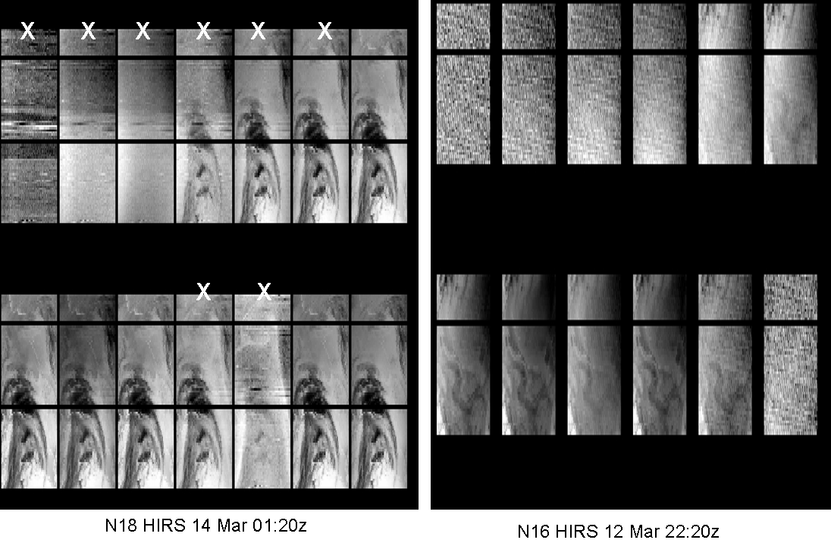

(Channels 1-14) (Channels 1-12)

ILLUSTRATION 12: N18 vs. N16 HIRS Imagery Analysis Comparison.

(Using N16 as a baseline nominal standard HIRS image, you can readily see numerous N18 HIRS channels that appear corrupted [X].)

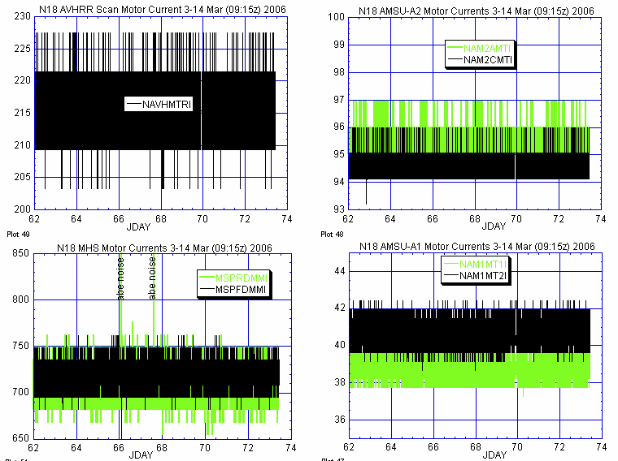

ILLUSTRATION 13: N18 Primary Payload Health History Analysis
(Nominal and stable across the board.)

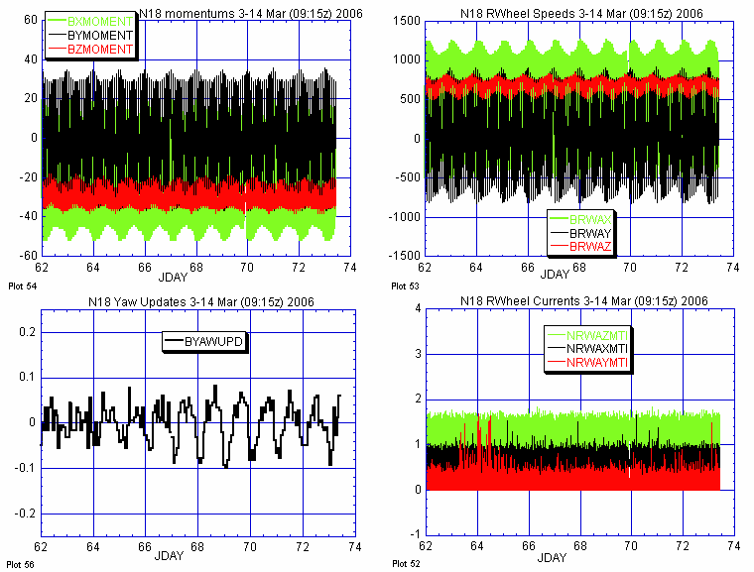

ILLUSTRATION 14: N18 ADACS Health Analysis
(Nominal and stable last week. )

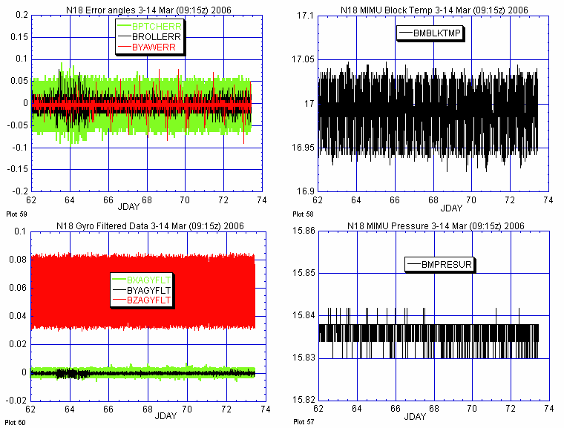

ILLUSTRATION 15: N18 ADACS Health Analysis (cont)

(Also nominal and stable last week.)

POLAR SPACECRAFT TIP CLOCK ERROR

WEEK ENDING March 10, 2006
DAY/DATE | NOAA-12 | NOAA-14 | NOAA-15 | NOAA-16 | NOAA-17 | NOAA-18
FRI. 03/03 | -034 msec | -159 msec | +073 msec | -065 msec | -207 msec | -236 msec
SAT. 03/04 | -035 msec | -163 msec | +071 msec | -064 msec | -206 msec | -234 msec
SUN. 03/05 | N/A | -163 msec | +068 msec | -063 msec | -204 msec | -231 msec
MON. 03/06 | -040 msec | -162 msec | +071 msec | -063 msec | -203 msec | -229 msec
TUE. 03/-7 | -046 msec | -162 msec | +068 msec | -063 msec | -202 msec | -227 msec
WED. 03/08 | -042 msec | -162 msec | +070 msec | -062 msec | -201 msec | -228 msec
THU. 03/09 | -043 msec | -161 msec | +069 msec | -062 msec | -200 msec | -224 msec

NOAA-14: As of 12/23/03 the TIP clock is corrected daily by –7.0 msec to compensate for drift.
NOAA-15: As of 04/22/03 the TIP clock is corrected daily by –8.0 msec to compensate for drift.
NOAA-16: As of 12/23/03 the TIP clock is corrected daily by -5.5 msec to compensate for drift.
NOAA-17: As of 12/23/03 the TIP clock is corrected daily by –3.0 msec to compensate for drift.
NOAA-12: As of 12/10/03 the TIP clock is corrected daily by +6.5 msec to compensate for drift.
* A clock jump of +500 milliseconds on 11/30/05 due to fractional second daily ETCUP. A clock
jump of -500 milliseconds on 02/14/06 due to fractional second daily ETCUP. Alternating +/-
500 millisecond clock jumps will ccur at 76-day intervals as long as fractional second daily
ETCUP is utilized to manage clock drift. The next +500 millisecond jump is expected on 05/01/06.
** TIP Clock corrections were made to compensate for the positive leap second introduced on 12/31/05.

POES CONSTELLATION SUN-MOON ECLIPSE ANALYSIS FOR 29 MAR 06
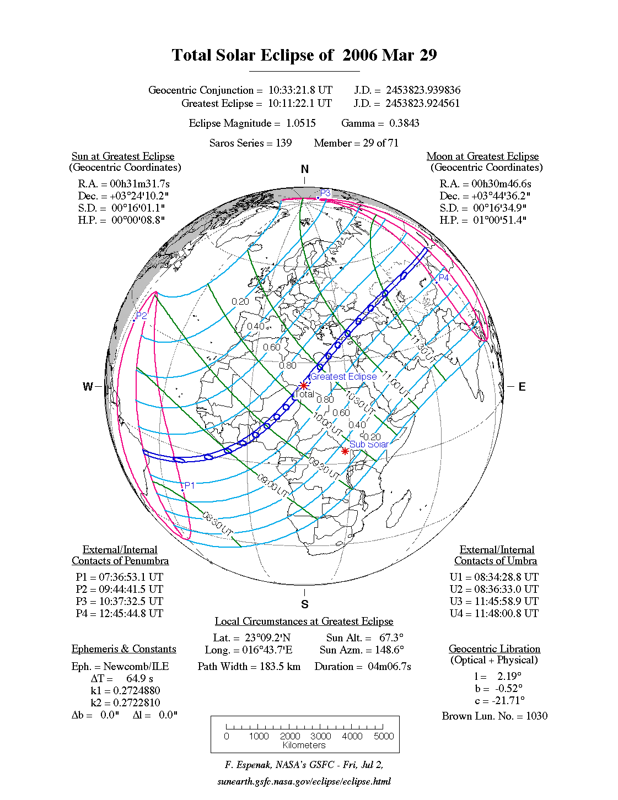

http://sunearth.gsfc.nasa.gov/eclipse/SEmono/TSE2006/TSE2006.html

On Wednesday, 2006 March 29, a total eclipse of the Sun will be visible from within a narrow corridor which traverses half the Earth. The path of the Moon's umbral shadow begins in Brazil and extends across the Atlantic, northern Africa, and central Asia where it ends at sunset in western Mongolia. A partial eclipse will be seen within the much broader path of the Moon's penumbral shadow, which includes the northern two thirds of Africa, Europe, and central Asia.

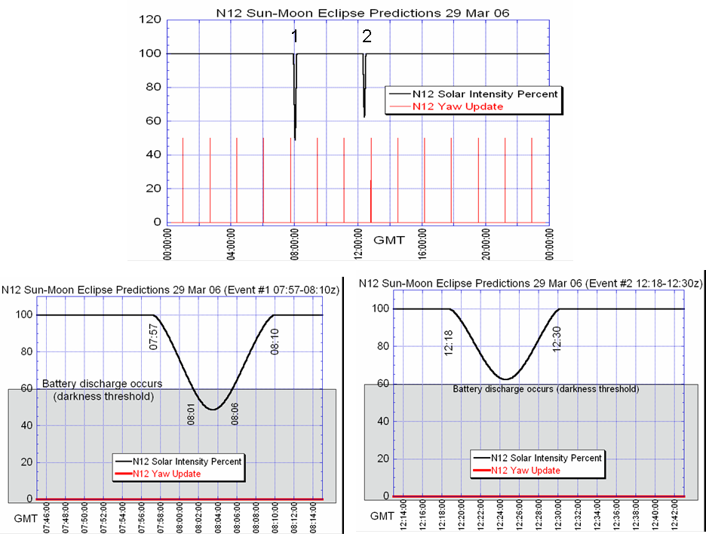

N12 Eclipse Analysis
(Spacecraft is in full sun season)

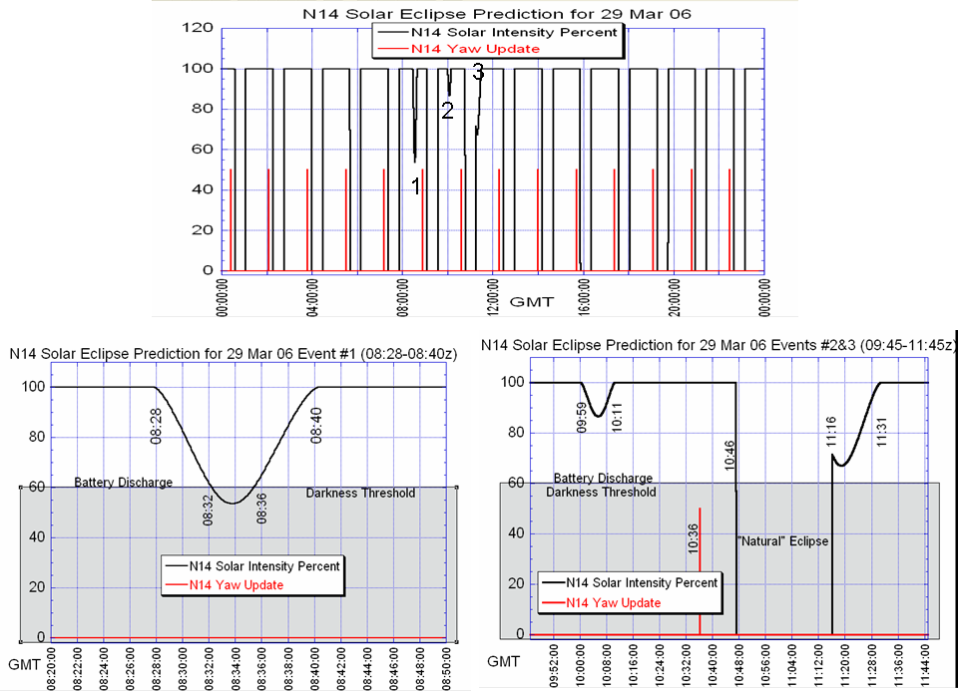

N14 Eclipse Analysis
(Spacecraft is permanently eclipsing.)

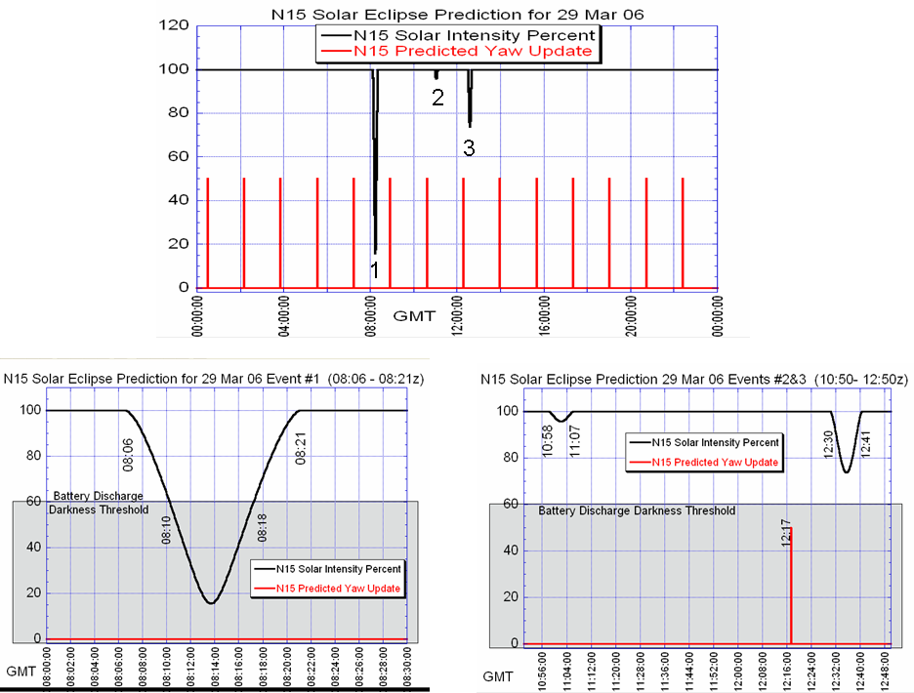

N15 Eclipse Analysis
(Spacecraft is currently in full sun orbit.)

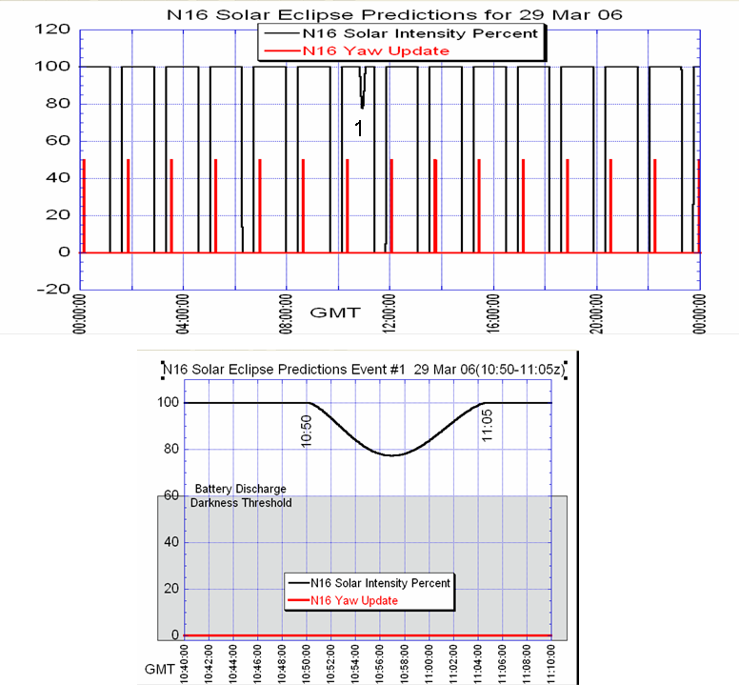

N16 Eclipse Analysis
(Spacecraft is permanently eclipsing.)

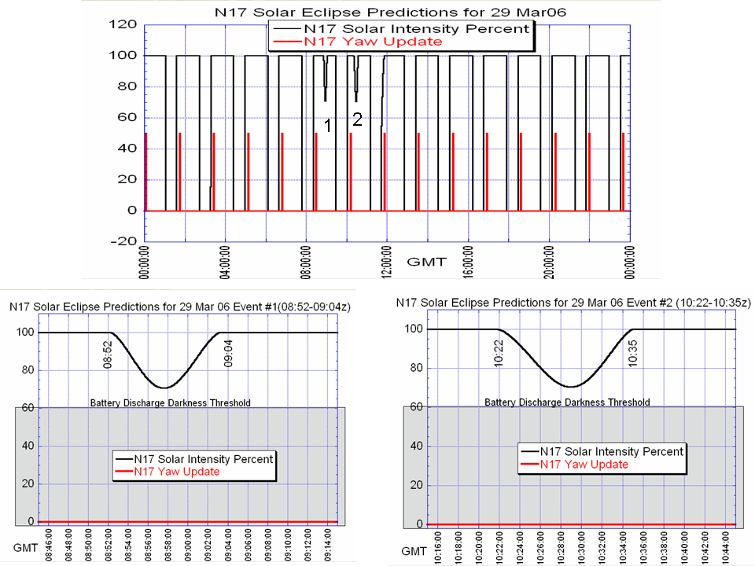

N17 Eclipse Analysis
(Spacecraft is permanently eclipsing.)

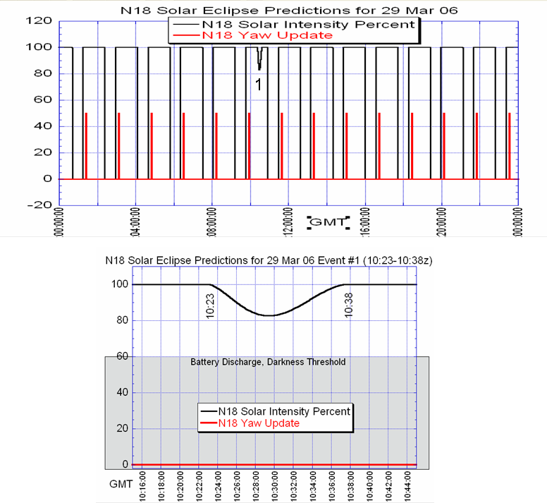

N18 Eclipse Analysis
(Spacecraft is permanently eclipsing.)

