  U.S. Department  of Transportation  Federal Aviation  Administration | Advisory  Circular

Subject: FAA SPECIFICATION FOR WIND CONE ASSEMBLIES | Date: 6/2/04  Initiated by: AAS-100 | AC No: 150/5345-27D  Change:
______________________________________

1. PURPOSE. This advisory circular (AC) contains a specification for wind cone assemblies to be used to provide wind information to pilots of aircraft.

2. PRINCIPAL CHANGES. The principal changes in this AC are:

- The equipment qualification requirements to be furnished under the Federal grant assistance program for airports has been revised.
- The new specifications for internally lighted wind cones have been added.
- Editorial changes have been made.

3. CANCELLATION. AC 150/5345-27C, Specification For Wind Cone Assemblies, dated July 19, 1985, is canceled.

4. APPLICATION. The standards contained in this advisory circular are recommended by the Federal Aviation Administration (FAA) in all applications involving airport development of this nature. The specification is an acceptable means for compliance with Federal Aviation Regulation (FAR) Part 139 where such facilities may be required. For airport projects receiving Federal grant-in-aid assistance, the use of these standards is mandatory.

5. METRIC UNITS. To promote an orderly transition to metric units, this specification includes both English and metric dimensions. The metric conversions may not be exact equivalents and until there is an official changeover to the metric system the English dimensions will govern.

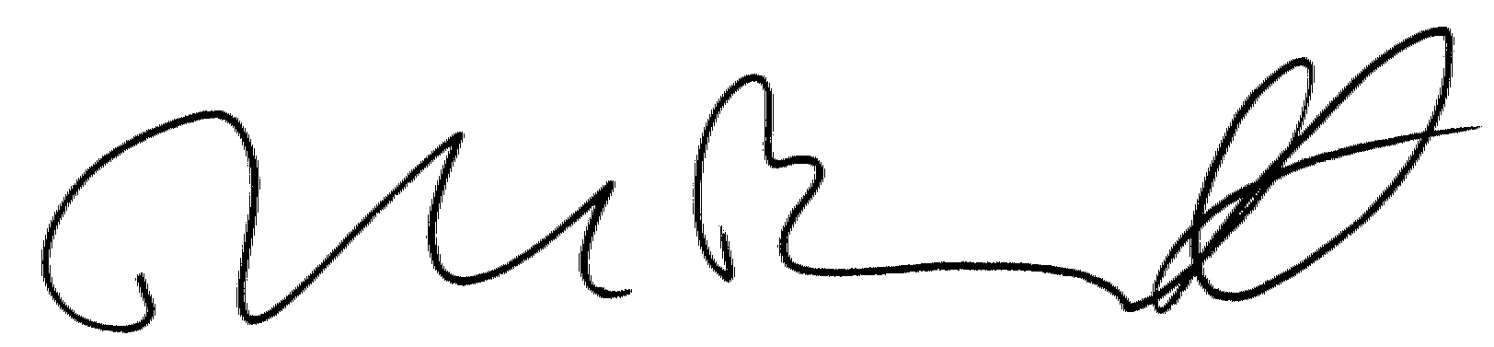

DAVID L. BENNETT
Director, Office of Airport Safety and Standards

FAA SPECIFICATION FOR WIND CONE ASSEMBLIES

1. SCOPE AND CLASSIFICATION.

1.1 Scope. This specification covers fabric windsocks and their supporting structures used at airports and heliports to indicate surface wind conditions.

1.2 Wind Cone Assemblies Classification.

1.2.1 Types.

L-806 - those mounted on low mass supporting structures
(typical assemblies are shown in figure 1)

L-807 - those mounted on rigid supporting structures
(typical assemblies are shown in figure 2)

1.2.2 Styles.

Style I-A – externally lighted

Style I-B - internally lighted (typical internally lighted wind cone is shown in figure 3)

Style II – unlighted

1.2.3 Sizes.

Size 1 - 8 feet (2.5 m), for use with Type L-806 and L-807 assemblies.

Size 2 - 12 feet (3.75 m), for use with Type L-807 assemblies.

2. REFERENCED DOCUMENTS.

2.1 General. The following is a list of documents referenced in this advisory circular.

2.2 Federal Aviation Administration (FAA) Advisory Circulars.

AC 150/5345-43 Specification for Obstruction Lighting Equipment

AC 150/5345-45 Lightweight Approach Light Structure

AC 150/5345-53 Airport Lighting Equipment Certification Program

2.3 Federal Standard.

FED-STD 191A Textile Test Methods, or current version

(Copies of FAA advisory circulars may be downloaded from http://www.faa.gov/arp/150acs.cfm)

3. EQUIPMENT REQUIREMENTS

3.1 Environmental Conditions. The wind cone assemblies must be designed to operate under the following environmental conditions:

a. Temperature. Any ambient temperature between -67°F (-55°C) and 131°F (+55°C.)

b. Wind. Wind speed up to 75 knots (140 km/hr or 86 mph).

3.2 Fabric Windsocks.

3.2.1 Fabrication. The fabric windsock must be made so it takes the shape of a truncated cone when it is filled with air; be reinforced at all points that are subject to abrasion by flexing against the metal framework; and be designed to allow removal and replacement without the use or special tools or stitching. The fabric windsock must be constructed to allow water drainage out of the area of the basket assembly.

3.2.2 Dimensions. The minimum effective length and the throat end opening diameter of the fabric windsock are as follows:

a. Size 1 - Eight feet (2.5 m) in length and 18 inches (0.45 m) in throat diameter.

b. Size 2 - Twelve feet (3.75 m) in length and 36 inches (0.9 m) in throat diameter.

The taper or the fabric windsock from the throat to the trailing end must be designed to cause the windsock to fully extend when exposed to a wind of 15 knots (28 km/hr or 17 mph).

3.2.3 Fabric. Fabric for the windsock may be made of cotton, a synthetic material, or a blend of the two, and may be coated. If the fabric is not naturally immune to water absorption, it must be treated to become water repellent. Color of the windsock fabric may be natural (white), yellow, or orange. Color will be specified by the purchaser. The manufacturer must certify that the fabric meets the following requirements:

a. Minimum breaking strength: Warp - 150 pounds (667 N); Filling - 150 pounds (667 N). The method 5102 of FED-STD-191A can be used to determine the minimum breaking strength.

b. Good or better colorfastness as determined by Method 5671 of FED-STD-191A.

3.3 Framework. A framework must be provided to hold the throat of the fabric windsock fully open under no wind conditions and to provide an interface with the support. It must be of low-mass design so as to offer minimum resistance to an inadvertent strike by aircraft. The framework may be made of metallic or nonmetallic material. Ferrous materials must be hot-dipped galvanized, zinc plated, or epoxy-resin coated to provide protection against corrosion. The framework is to be constructed so as to deter the accumulation of water in the windsock. The framework must support the fabric windsock in a rigid position for three-eighths of its length. When the fabric windsock is attached to the framework the combination must perform as a wind vane. Bearings, bushings, or like devices must be either permanently lubricated or provided with fittings to allow periodic lubrication.

3.4 Supporting Structures. Typical supporting structures are shown in figures 1 through 3. Although the illustrations are typical, the dimensions shown are to be complied with.

3.4.1 Type L-806. The type L-806 support must be of low-mass, and designed for easy installation and maintenance. When firmly anchored, the frangible support must withstand a moment of 350 pound-feet (475 N m) without damage and fail before a moment of 700 pound-feet (950 N m) is reached by a force applied parallel to and 6 feet (1.8 m) above the surface to which the support is attached. Alternatively, a support meeting the requirements of AC 150/5345-45, Lightweight Approach Light Structure, may be used.

3.4.2 Type L-807. The type L-807 support may be hinged at its base or near its middle so the wind cone and light fixture can be serviced from the ground. When the support is mounted in place, it must withstand, without damage, a moment of not less than 3200 pound-feet (4340 N m) when the force is applied parallel to and 16 feet (4.8-m) above the surface to which the support is attached. This support may be used only where allowed by airport design standards published in AC 150/5300-13, Airport Design.

3.5 Windsock Movement. The windsock must move freely about the vertical shaft it is attached to and when subjected to wind of 3 knots (5.6 km/hr or 3.5 mph) or more and indicate the true wind direction within +/- 5 degrees.

3.6 Photometric requirements. Light fixtures must be placed and aimed to minimize objectionable glare to aircraft pilots. Wiring from the base of the supporting structure to the light fixture must be housed in the structure or in electrical conduit. Electrical cable must be of proper type and size for its application.

3.6.1 Style I-A, externally lighted wind cone assemblies must be supplied with sufficient light fixtures to provide a minimum of 2 foot-candles (fc)(21.5 lux) illumination on any point of the horizontal plane described by the complete rotation of the upper surface of a fully extended cone.

3.6.2 Style I-B, internally lighted wind cone assemblies must be size 2 and must have at least two (2) spotlights mounted internally within the windsock throat section. Two separate lamps are used in the assembly so that failure of a single lamp will not render the unit ineffective at night. The power supply arrangement must be in such a way that when transferring electrical power to the lamps the wind cone assembly is allowed to rotate freely with the existing wind. The top and lateral surfaces of the fabric windsock of style I-B wind cone assemblies must have an average luminance of 10 to 30 ft-lamberts (fL) and a minimum luminance at any point of 2 ft-lamberts (fL).

3.7 Obstruction Light. When required, an L-810 obstruction light conforming to AC 150/5345-43, Specification for Obstruction Lighting Equipment, must be supplied. The obstruction light is to be mounted at the highest point of the wind cone assembly to avoid being obscured by any other part when viewed from above.

3.8 Painting. All exposed metal parts of the wind cone assembly, except reflecting surfaces of light fixtures, must be given one prime, one body, and one finish coat of paint. The prime coat must be appropriate for the particular metal being painted. The finish coat must consist of a colorfast orange color paint.

3.9 Equipment Parts and Instructional Manual. A manual must be supplied with each wind cone assembly containing, as a minimum, the following information:

a. Complete wiring diagram for lighted wind cones.

b. Complete parts list with the name and part number of the original manufacturer.

c. Assembly and installation instructions, including mounting foundation and anchor bolt requirements.

d. Maintenance instructions.

4. EQUIPMENT QUALIFICATION REQUIREMENTS.

4.1 Qualification Procedures. Procedures for qualifying equipment to be furnished under the federal grant assistance program for airports are contained in Advisory Circular 150/5345-53, Airport Lighting Equipment Certification Program.

4.2 Qualification Tests.

4.2.1 General. Each type, style, and size of wind cone assembly for which approval is requested must be tested.

4.2.2 Windsock Cone Attachment. Test the attachment of the fabric windsock to the metal framework by applying the following tension to the free end of the wind cone:

a. Size 1 - 45 pounds (200 N)

b. Size 2 - 100 pounds (450 N)

Any distress noted in the fabric windsock or the means of attachment will be cause for rejection.

4.2.3 Support Rigidity. Mount the support on a surface to simulate its normal field installation and apply the following forces to the support. The force must be applied parallel to and at the specified distance from the surface:

Type | Force |  | Distance
 | Hold | Fail by
L-806 | 58 lb. (264 N) | 117 lb. (530 N) 1/ | 6 ft. (1.8 m)
L-807 | 200 lb. (890 N) | - | 16 ft. (4.9 m)

1/ Low mass structures must cause minimal damage when struck by aircraft. The structure must not wrap around the aircraft but must crumple or collapse on impact.

4.2.4 Windsock Movement. Test the windsock movement around the vertical axis. The windsock must move freely and align with a 3-knot (5.6 km/hr or 3.5 mph) wind as specified in paragraph 3.5. The wind test must be run at no less than 6 equally spaced points about the vertical axis.

4.2.5 Photometric Test

4.2.5.1 Style I-A, Externally Lighted Wind Cone. The illumination must be tested at the throat, trailing end, and center points of the upper surface of the extended fabric wind cone at 30-degree intervals throughout a complete horizontal rotation of the wind cone. The illumination at the test points must not be less than 2 foot-candles as noted in paragraph 3.6.1.

4.2.5.2 Style I-B, Internally Lighted Wind Cone. The internally lighted wind cone must be tested for luminance while fully extended. Luminance measurements must be taken from 1 foot away from the throat to 11 feet away from the throat at 1-foot intervals and 45-degree increments around the circumference of the wind cone. The spot-size for the luminance measurement must be 1.5 inches in diameter. The average luminance on the top and lateral surfaces of the windsock must be between 10 and 30 foot-lamberts as noted in paragraph 3.6.2.

    - Windsock Extension. Test the windsock to assure that it extends fully when subjected to a wind of 15 (+2,-1) knots (+3.7, -1.8) km/hr or (+2.3, -1.2 mph) ).

    - Windsock Fabric. Supply a certification from the fabric manufacturer that the fabric meets the requirements in paragraph 3.2.3. The manufacturer must retain on file written letters of conformance from the fabric manufacturer for all fabric used in the wind cone manufacture.

5. PRODUCTION TEST REQUIREMENTS

5.1 Production Tests. A certified copy of test reports on the tests specified in paragraph 4.2.5, must be made available by the manufacturer upon written request by the FAA.

6/2/04 AC 150/5345-27D

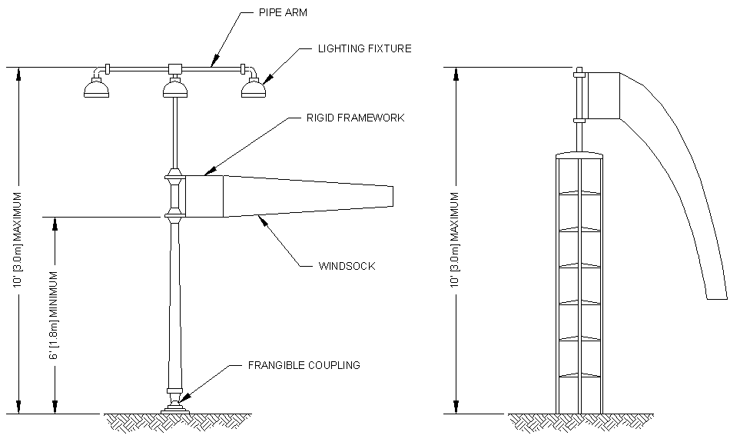

Figure 1. Typical Type L-806 supports

8
6/2/04 AC 150/5345-27D

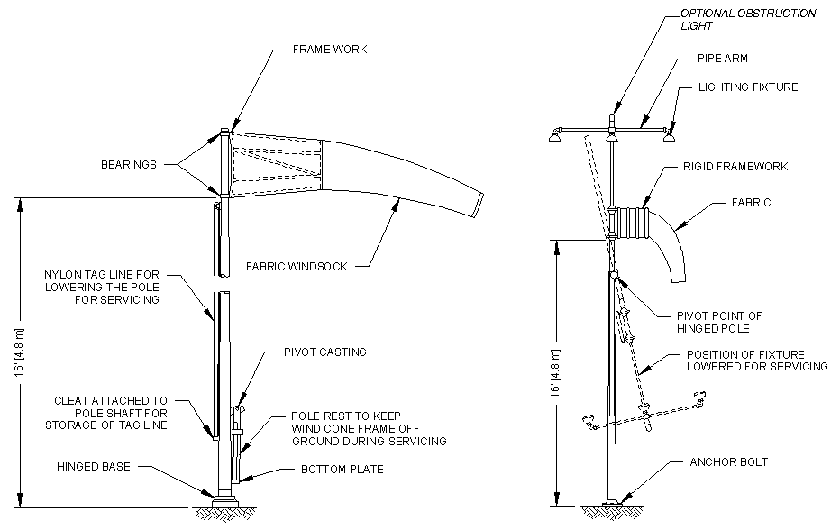

Figure 2. Typical Type L-807 supports

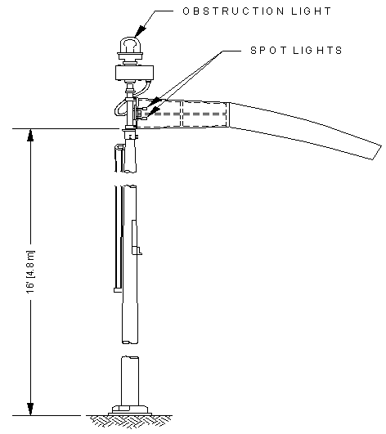

Figure 3. Typical Internally Lighted Wind Cone.

