U.S. Department  of Transportation  Federal Aviation  Administration | Advisory  Circular

Subject: Change 3 to MEASUREMENT, CONSTRUCTION, AND MAINTENANCE OF SKID-RESISTANT AIRPORT PAVEMENT SURFACES | Date: 8/25/04  Initiated by: AAS-100 | AC No: 150/5320-12C  Change: 3

- PURPOSE. This change updates information regarding FAA qualified Continuous Friction Measuring Equipment.

2. PRINCIPAL CHANGES. The following editorial changes have been made:

a. Appendix 4. Changes have been made to reflect updated information for manufacturers.

PAGE CONTROL CHART
Remove Pages | Dated | Insert Pages | Dated
Appendix 4  pg. 1 (and 2) | 4/16/04 | Appendix 4  pg. 1 (and 2) | 8/25/04

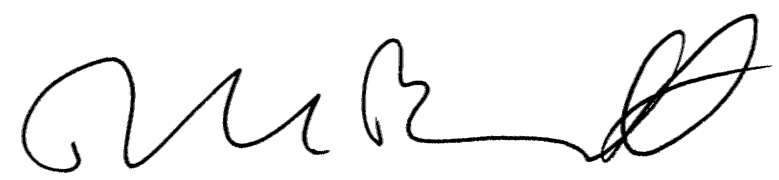

DAVID L. BENNETT
Director, Office of Airport Safety
and Standards
8/25/04 AC 150/5320-12C
Appendix 4
Change 3

APPENDIX 4. FAA-APPROVED CFME

AIRPORT SURFACE FRICTION TESTER INDUSTRIES AB AIRPORT SURFACE FRICTION TESTER
Metallgatan 7 +46 0 411 651 00
271 39 Ystad, Sweden FAX +46 0 411 190 12
SWEDEN Email: sales@ asft.se

AIRPORT TECHNOLOGY USA SAFEGATE FRICTION TESTER
NO LONGER AVAILABLE
DYNATEST CONSULTING, INC., RUNWAY FRICTION TESTER (M6800)
(FORMERLY K.J. LAW ENGINEERS, INC.) (904) 964-3777
13952 US Highway 301 South FAX (904) 964-3749
Starke, FL 32091
FINDLAY, IRVINE, LTD. GRIPTESTER FRICTION TESTER
42-44 Bog Road, Penicuik +44 1968 672111
Midlothian EH 26 9 BU FAX +44 1968 671237
SCOTLAND www.findlayirvine.com
INTERTECH ENGINEERING TATRA FRICTION TESTER
NO LONGER AVAILABLE
NEUBERT AERO CORP. MU METER
4105 West DeLeon Street (727) 538-8744
Tampa, FL 33609 FAX (727) 538-8765
Email: info@airportnac.com
NORSEMETER RUNAR RUNWAY ANALYSER AND RECORDER
P.O. Box 125 +47 23 20 1270
Bogstadvien FAX + 47 23 20 1271
0323 0310
NORWAY
PATRIA VAMMAS AEC BV-11 SKIDDOMETER
P.O. Box 18 Vammaksentie + 358 20 4694041
FIN-38201 Vammala FAX +358 20 4694250
FINLAND www.patria.fi

