  U.S. Department  of Transportation  Federal Aviation  Administration | Advisory  Circular

Subject: General Guidance and Specifications for Aeronautical Survey Airport Imagery Acquisition and Submission to the National Geodetic Survey | Date: 9/29/08  Initiated by: AAS-100 | AC No: 150/5300-17B Change:

Purpose.
This AC provides the specifications for Airport Imagery acquisition and how to submit the imagery for review and approval in support of aeronautical information and airport engineering surveys.

Application.
The Federal Aviation Administration (FAA) recommends the guidance and specifications in this Advisory Circular for Aeronautical Survey Airport Imagery. In general, use of this AC is not mandatory. However, use of this AC is mandatory for all projects funded with federal grant monies through the Airport Improvement Program (AIP) and with revenue from the Passenger Facility Charges (PFC) Program. See Grant Assistance No. 34, “Policies, Standards, and Specifications,” and PFC Assurance No.9, “Standards and Specifications.”

Cancellation.
This AC cancels AC 150/5300-17A, General Guidance and Specifications for Aeronautical Survey Airport Imagery Acquisition and Submission to the National Geodetic Survey, dated September 15, 2007.

Principal Changes.
- Reformatted entire document for readability, usability, and to provide clarification of some criteria.
- Added requirement for submission and approval of an imagery plan prior to imagery acquisition.
- Clarified requirement of flying height to consider the use of the imagery of further endeavors such as future engineering or planning activities.
- Eliminated requirement for a final report except under most conditions unless there is a change from the provided plan or an unusual circumstance was encountered during the collection effort.
- Add requirement for development and delivery to FAA of digital orthoimagery.
- Added a requirement for the use of the Airports GIS to submit and track project requirements such as the plan and deliverables.
- Changes the exterior orientation reporting units for omega, phi, kappa, from radians to decimal degrees.
- Allows the use of state plane coordinates, reported in meters.



Michael J. O’Donnell
Director, Office of Airport Safety and Standards
TABLE OF CONTENTS

1. Purpose. 1
2. Application. 1
3. Cancellation. 1
4. Principal Changes 1
GENERAL INFORMATION AND REQUIREMENTS 3
IMAGERY PLAN 3
5. Imagery Plan Requirements. 3
6. Image Control Points. 4
7. Accuracy and Datums. 6
8. Equipment and Materials. 7
9. Flying Height 7
FLIGHT LINE NAVIGATION AND GUIDANCE 8
10. General. 8
11. Tilt. 8
12. Crab. 8
13. Overlap and Sidelap. 8
IMAGE QUALITY 8
WEATHER, SOLAR ANGLE, AND TIME OF YEAR 9
14. Clouds. 9
15. Tree Leaves. 9
16. Well-Defined Images. 9
17. Visibility. 9
18. Sun Angle. 9
REQUIRED DELIVERABLES 9
19. Submission of Required Information. 9
20. Deliverables required for NGS Review. 9
21. NGS Review Process. 13
22. FAA Deliverables. 14
POINTS OF CONTACT 15

GENERAL INFORMATION AND REQUIREMENTS

This AC provides the guidance and specifications for contractors to acquire and submit airport imagery in support of FAA airport surveys. The FAA has tasked the Aeronautical Survey Program (ASP) at NGS to perform quality assurance on all airport surveys contracted by State aviation agencies and local airport authorities. NGS administers the ASP in accordance with an Interagency Agreement with the FAA. NGS will perform a photogrammetric analysis using this airport imagery to ensure the survey data adheres to the most current edition of the appropriate FAA ACs and program objectives.

Provide complete written justification to exceed or deviate from this specification to NGS and the FAA through the airport sponsor. Requests to exceed or deviate from these specifications will be considered when written justification is provided to the FAA Airport Surveying-GIS Program Manager and NGS in advance.

IMAGERY PLAN

Imagery Plan Requirements.
The contractor will submit in an non-editable format, such as Adobe Portable Document format ™ an imagery plan to the FAA through the Airports GIS (http://airports-gis.faa.gov) web site for review and approval prior to beginning the collection of the imagery. The plan will detail the following information

a. Airport Name

b. Airport Identifier

c. Submitting Organization
- Name
- Street Address
- City
- State
- Zip Code
- Telephone Number
- Facsimile Number
- Organization’s Contact Person Name
- Email Address

d. Briefly describe the purpose of the aerial photography acquired in support of the survey. Identify the flying height(s) proposed and the large mapping scale expected. In this section discuss how the proposed flying height(s) will achieve the required accuracy for the purpose of the survey.

e. Describe in detail the collection methodology the contractor proposes for imagery acquisition. This section must discuss the following items:

- The number of proposed flight lines. Provide as part of the plan an imagery (ground) control network diagram and flightline layout as illustrated in Figure 2.

- Describe in detail what method the contractor proposes to geo-reference the imagery within acceptable accuracies.

- Provide an ASCII text file of the proposed imagery control stations the contractor proposes to use in the project. Use the format as shown in Table 2.

- Describe in detail how the contractor proposes to extract airport feature from the imagery within the required accuracies.

- Describe in detail the remote sensing method proposed for use to identify, locate, and observe the required objects within the required accuracies.

f. Quality Assurance: Describe in detail the quality control procedures and practices proposed for use during and following data collection. Detail how the submitting organization will ensure the traceability and adherence to the requirements of the General Specifications standard. At a minimum, the plan will include the following:

- Briefly summarize the methods used to ensure high-quality data.

- Describe the quality control measures the contractor uses to ensure the data is checked, complete, reliable, and meets the accuracy requirements (including error analysis) in these general specifications.

- Describe the evidence the submitting organization will provide to demonstrate how methods used to collect the various types of features met the desired accuracies.

- Describe the procedure and policies the contractor uses to backup and archive the collected data.

- Detail the procedures and methods used by the contractor to ensure the original data is not modified once collected.

- Describe and explain the method used to check all file formats and a summary of the file-naming convention for all electronic files.

g. Provide a complete listing of the equipment the contractor proposes to use in the survey, including model and serial numbers, specifications, calibration reports, and equipment maintenance reports for the field (aerial) and office equipment and software used. The contractor must provide the appropriate Calibration Certificate for the aerial camera(s) proposed for use in the project. This calibration certificate must be dated within 3 years of the estimated completion of the collection. If using a digital camera, provide the calibration report and/or the manufacturer’s recommended equivalent procedure. If a manufacturer recommended procedure is provided, a Statement of Compliance on company letterhead will be submitted. The statement of compliance will—

- Certify that the manufacturer’s recommended procedure was completed at the recommended intervals as required.

- Identify the date the procedure was last accomplished before the imagery was flown.

- Be signed by an authorized representative of the company submitting the Statement of Compliance.

h. Provide a generalized schedule identifying anticipated imagery acquisition dates, delivery of required data and information to NGS (see paragraph 20), and expected delivery of orthoimagery to the FAA.

Image Control Points.
a. Image Control Points

Provide the image control points used to geo-reference the imagery. The proposed number and location of ground image control points must be in the Imagery Plan. The number and placement of the image control points must be sufficient to geo-reference the imagery within the accuracy requirement of the proposed survey to be conducted.

In addition to ground image control points, a minimum five check points are required in the project area. Check points must meet the same standards as control points. Note, check points shall not be used in controlling the imagery. A position determined through the NGS OPUS program is required for each check point. Submit a copy of the OPUS solution for each check point. See Figure 2 for an example pattern for check point placement.

b. Image Control Point Documentation

Document each image control station using the FAA Station Location and Visibility form (available at http://airports-gis.faa.gov). Include on the form a sketch of the area surrounding the control point and a digital image of the control point and the surrounding area. In the sketch area of the form, list the file name used to identify the appropriate digital image for the station being described on the form. Complete a separate form for each control point.
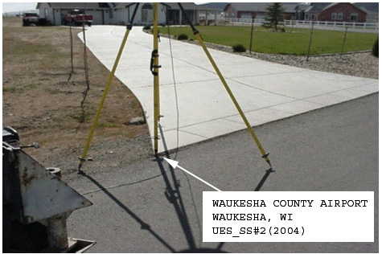
Figure 1 shows a sample digital photograph of an imagery control point with the antenna located over the point. Note the caption has been added to the photo to aid in identification of the point.

- Selection of Image Control Points

The ideal type of point for control identification is one that produces a very small, recognizable, and symmetrical photographic image that has a distinct boundary of a relatively high to a lower contrast. Some examples of “well defined” control points are—

(1) A point at well-defined junctions of intersecting features (sidewalks, abutments, and roads)
(2) Corner points of any clear, well–defined feature (a parking lot, a tennis court, a road intersection)
(3) The center of a small isolated bush.
(4) A pre-marked or paneled point that can be identified on the imagery

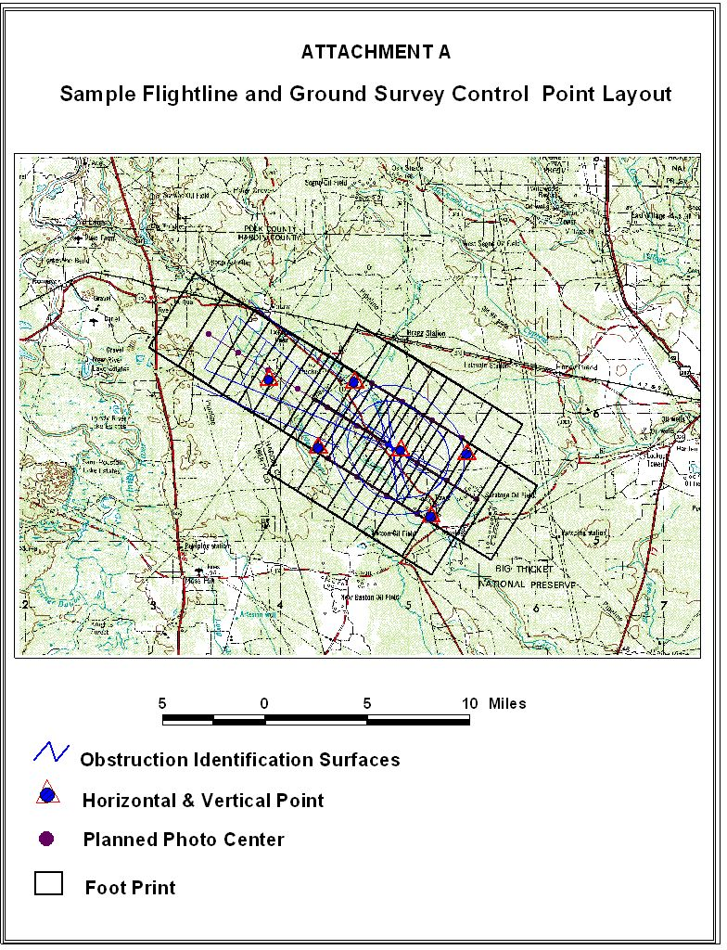

Figure 2 illustrates the combined Network Control Diagram and associated fligthlines for the project.

Accuracy and Datums.
Determine the horizontal position for each image control point. The minimum horizontal accuracy requirement for image control points shall be within 0.3 meters (1 foot) relative to the National Spatial Reference System (NSRS) North American Datum of 1983 (NAD 83). Determine orthometric elevations for each image control point. The minimum orthometric accuracy shall be 0.3 meters relative to the National Spatial Reference System (NSRS) North American Vertical Datum of 1988 (NAVD 88). In Alaska and other areas outside the continental United States where NAVD 88 benchmarks are not available, contact NGS for further guidance.

Equipment and Materials.
a. Camera

The aerial camera used to collect imagery under these specifications and guidance must have equivalent manufacturer specifications to those specified below.

(1) Single lens metric camera with quality equivalent to or better than a Wild RC 30 or Zeiss RMK-TOP, with forward motion compensation.
(2) Digital mapping sensors such as the Zeiss DMC, Ultracam, DDS, or equivalent system are permitted and will be approved by NGS on a case by case basis. The Imagery Plan shall contained detailed information on how imagery from these sensors will be geo-referenced.; the collection bands to be used; and proposed imagery format.

The sensor must be a geometrically stable and calibrated system suitable to use for high-accuracy photogrammetric mapping; the sensor must be of a high enough resolution and have a large enough Field of View (FOV) to meet the review requirements as listed in paragraph 4b. The sensor must record in the red, green, and blue (RGB) spectral bands and produce an image replicating natural color. If the sensor records in the near IR band, it must be provided also.

- Film

If film is used to obtain images, it must be a high-resolution aerial film. Film emulsions must be color negative (such as Kodak 2444 or AGFA X-100). The low-contrast target resolution of color negative emulsions must be rated at greater than or equal to 80 line pairs per millimeter (lp/mm). Emulsion and filter combinations selected must be sensitive to and record on the film the green, yellow, orange, and red hues of the tree leaf canopy.

- Scanner

Provide the name and model number of the film scanner used to create digital images

Flying Height
The target flying height must not exceed 12,000 feet above ground level (AGL) for film-based systems with a 6-inch focal length camera. Choose the flying height for a digital camera system to produce an image resolution and quality greater than or equal to the resolution and quality obtained from filmed based systems. Providers should select and identify in the imagery plan a flying height allowing the use of the imagery in future projects. Flying at lower altitudes is highly recommended to increase the usability of the imagery for other purposes, such as mapping, engineering and planning activities of the airport. Select these heights based on the standards of the Federal Geographic Data Committee (FGDC) and the American Society of Photogrammetry and Remote Sensing (ASPRS). The flying height must not exceed 2 percent below or 5 percent above the target level identified in the imagery plan. The following table is excerpted from the ASPRS standards and is provided as general guidance in selecting an appropriate flying height.
Table 1. Federal Geographic Data Committee Spatial Data Accuracy Standards (ASPRS) Class II Mapping accuracy for large scale maps) Map Accuracies as a function of Photo/Map Scale

Map Scale  1” = -ft. | Photo Scale  1” = -ft. | Minimum Contour Interval in feet | Accuracy XY  RMSE in feet | Accuracy Z  RMSE in feet
20 | 200 | 0.5 | 0.4 | 0.33
40 | 320 | 1.0 | 0.8 | 0.66
50 | 400 | 1.0 | 1.0 | 0.66
100 | 800 | 2.0 | 2.0 | 1.32
200 | 1600 | 4.0 | 4.0 | 2.64
250 | 2000 | 5.0 | 5.0 | 3.30
400 | 3200 | 8.0 | 8.0 | 5.28
500 | 4000 | 10.0 | 10.0 | 6.60
800 | 6400 | 16.0 | 16.0 | 10.56
1000 | 8000 | 20.0 | 20.0 | 13.20
1667 | 12800 | 32.0 | 33.3 | 21.12

FLIGHT LINE NAVIGATION AND GUIDANCE

General.
All flight lines should be continuous and not be broken or patched. If a line requires a second flight, it must have the original flight line number.

Tilt.
Ensure the tilt (departure from the vertical) of the camera is kept to a minimum. Tilt must not exceed +/- 3° for any photographic frame. The average tilt for the entire project must not exceed +/- 1°.

Crab.
Ensure the imaging system is compensated for crab of the aircraft, with a resultant error not exceeding +/- 5°, as measured from the average line of flight with a differential between any two successive exposures not exceeding +/- 5°.

Overlap and Sidelap.
For frame imaging systems, forward overlap must average 60 percent between consecutive exposures, while forward overlap must not be greater than 68 percent or less than 55 percent in any pair of consecutive images. The flight must be planned to minimize imagery sidelap. Planning for the appropriate sidelap normally equates to 50 percent overlap for a film-based system with the acceptable range being 30 to 60 percent. A sidelap of 50 percent is recommended to ensure that objects may be seen in stereo from multiple views. Fifty percent side lap is critical in forested areas.

IMAGE QUALITY

Image quality must meet the highest professional standards. Dark areas must not bleed together and individual objects must be readily discernable. Detail must be sufficiently sharp to allow photogrammetric measurement of tree heights, compilation of runway/taxiway edges and other fine map features, and accomplishment of other intended uses for the imagery. Image products must be free of abrasions, blemishes, scratches, tears, and irregularities. Fiducial marks must be clearly visible and sharp on every image.

WEATHER, SOLAR ANGLE, AND TIME OF YEAR

Clouds.
Clouds or cloud shadows must not appear on the imagery. High, thin overcast is permitted above the flying altitude if it does not cause ground mottling or a discernable reduction in light levels and/or ground object shadows.

Tree Leaves.
Collect imagery to show full tree leaf coverage. This facilitates photogrammetric tree height determination. This requirement limits the acquisition window depending on season and geographic location.

Well-Defined Images.
Collect imagery to obtain well-defined images. Do not attempt imagery acquisition where the ground is obscured by haze, smoke, smog, dust, or falling snow, sleet, rain, or other obscuring phenomena. Do not collect imagery when the airport ground area is covered by water (flood), snow, or ice obscuring airport features.

Visibility.
The minimum visibility at the time of exposure must be 10 miles or greater. Determine the visibility by looking at objects on the ground toward the sun. The distance at which the detail of ground objects is clearly defined is the visibility. If the visibility is satisfactory, details of ground objects will be clearly defined at the edge of the view through the drift sight.

Sun Angle.
Do not collect imagery when the sun angle is less than 30 degrees above the horizon. Ideally, the sun angle should be between 40 and 60 degrees above the horizon because of the intermediate-size shadows produced. In mountainous areas with steep terrain and/or areas with tall trees, increase the minimum sun to horizon angle. Extreme shadowing could result in imagery rejection. Determine the sun angle for a given day from either a “Solar Altitude Diagram” or appropriate computer software. The U.S. Naval Observatory’s web site, http://aa.usno.navy.mil/data/docs/AltAz.php, can be used to compute sun altitudes and sun azimuths for U.S. locations and world-wide positions.

REQUIRED DELIVERABLES

Submission of Required Information.
Use the Airports GIS web site to submit the imagery plan for review and approval. The Airports GIS system must also be used to track when deliverable submissions are made directly to NGS.

Deliverables required for NGS Review.
  - Digital Stereo Imagery

The airport sponsor must provide NGS ASP with digital stereo imagery of the area of analysis. The dimensions of this area depend on the type of survey the contractor is requested to perform. Acquire the imagery within at most 6 months prior to the ground survey (AC 150/5300-18 survey). Submit the imagery well in advance of the survey deliverables for NGS review and approval. Upon imagery approval, the final survey deliverables may be submitted. Submit the imagery and associated deliverables directly to NGS for review at the following address.

Image Review Coordinator
National Geodetic Survey, NOAA
ATTN: N/NGS33; SSMC3, Sta. 5359
1315 East-West Highway
Silver Spring MD 20910
(1) The directory structure for imagery deliverables must conform to the following requirements:

Establish the directory structure (see Figure 3) so each directory contains pertinent information about each item. Name the root directory using the assigned FAA airport location identifier, for example, BOS AP Acquisition Report. Develop and include a table of contents for each submission and store it in the root directory. The use of this standardized format assists in NGS verification.

(2) The imagery deliverables must conform to the following requirements:

- Delivery medium— USB compatible external medium, such as an external hard drive. DVD may be used for data sets 40GB or less
- Flight Line Diagram—See Figure 2
- File Format—TIFF (Tagged Image File Format) or VITec Scanner Raster Format
- Scanner (for imagery collected with film)—Must use metric quality scanner
- Pixel Ground Sample Distance (GSD) of Scanned Pixels—10–30 cm
- Resolution—must be of sufficient quality to allow photogrammetric measurement and analysis of airport features such as buildings, obstructions, equipment, edges of paved areas and pavement markings
- Image Quality—must meet the highest professional standards, free from blemishes, such as from dust or lint. Individual airport features must be readily discernable.
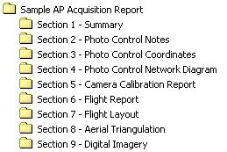

Figure 3 provides an example directory structure.

  - Imagery Control Points

Provide an ASCII text file of the final imagery control point values identifying any changes from the imagery plan (as illustrated in Table 2). Describe each imagery control point used in the project on the FAA Station Location Sketch and Visibility Diagram form. Submit a digital image of the station as depicted in Figure 1 and a sketch of the site.

Imagery Control Point Coordinates—Sample
Airport Name:
Coordinate System:
UTM Zone: (The state plane coordinate system in which the Airport Reference Point is located may also be used)
Reference Ellipsoid:
Horizontal and Vertical Datum:
All heights are in meters

Station Name Northing Easting Orthometric Height Ellipsoidal Height
P01 2086849.62 3579322.68 115.48 83.34
P02 2086905.37 3583818.97 78.47 46.29
P03 2092134.98 3584776.85 93.59 61.45
P04 2093245.00 3586869.35 97.09 64.94
P05 2089958.84 3591583.70 88.78 56.53
P06 2084575.11 3596417.02 51.81 19.39
P07 2080281.03 3598531.32 12.47 -20.02
P08 2075655.30 3602180.66 3.04 -29.52
P09 2075499.76 3599408.29 11.76 -20.77

Table 2 depicting a sample ASCII Imagery Control Points File.

c. Geo-Referencing

Provided imagery must be geo-referenced (such as by aero-triangulation, direct Global Positioning System (GPS)/Inertial Measurement Unit (IMU) observation, or both). For frame imagery, the contractor must provide an ASCII file (as in the Table 3 below), containing camera focal length and the X, Y, Z, omega, phi, kappa, of each image. Provide the information in either the Universal Transverse Mercator (UTM) or State Plane Coordinate System, NAD-83. Specify the Zone used and include with the submitted file the information enumerated below.

(1) Strip Number
(2) Image Number
(3) Easting specified in meters to the hundredth
(4) Northing specified in meters to the hundredth
(5) Orthometric Height specified in meters to the hundredth
(6) Omega specified in decimal degrees to six (6) decimal places
(7) Phi specified in decimal degrees to six (6) decimal places
(8) Kappa specified in decimal degrees to six (6) decimal places

ASCII Image File (Results of the Geo-referencing) — Sample

GEO-REFERENCING RESULTS
Header Information:
Airport Name:
UTM Coordinate Zone: (Must match the system and zone used to report ground image control points)
Reference Ellipsoid:
Horizontal and Vertical Datum:
Camera Focal Length:

Strip# Image# Easting Northing Ortho Height Omega Phi Kappa
(Meters) (Meters) (NAVD 88) (Angles are decimal degrees; ground to photo)

1 1 3579254.35 2089643.60 3824.12 -1.201358 1.010730 -68.873243
1 2 3580688.07 2087953.67 3823.95 -1.162651 2.000519 -68.884133
1 3 3582126.18 2086260.81 3829.93 -1.004605 1.100225 -68.882666
2 1 3582017.30 2092108.36 3821.09 -0.006452 0.003406 112.853920
2 2 3583490.60 2090446.64 3833.50 0.009585 1.006764 112.852786
2 3 3584965.37 2088806.15 3825.61 -1.219045 -1.003069 112.846104

Table 3 shows the proper formatting for submission to NGS of the geo-referencing information for the imagery.

d. Flight Report

Submit an Imagery Flight Report using the Photographic Flight Report form available at http://airports-gis.faa.gov.

Instructions for Completing the Photographic Flight Report for Airport Photography

DATE—Film is first loaded into the cassette of Magazine, Print “LOADED” and Date
ROLL NUMBER—Year, Camera System Designator, Film Type (CN = Color Negative), and Sequential Roll Number for that Calendar Year.
EMULSION NUMBER—Taken directly from the film can upon loading.
EXPIRATION DATE—Taken from film can upon loading.
SHEET NUMBER— X of Y sheets = 1 of 4, 2 of 4, etc.
FILM TYPE—Color, Color Negative, etc.
ISO INDEX—Film speed actually used (not EAFS from film can).
FILTER—Wavelength of filter used, in Nanometers.
CASSETTE/MAGAZINE—Feed and take-up cassettes or magazine identification number.
CAMERA/DRIVE UNIT NUMBERS—Camera identification number or lens serial number/drive unit number.
MISSION NUMBER —Aircraft Type (Cessna Citation II).
AIRCRAFT—Aircraft Tail Number (N52RF)
PILOT—Printed Surname.
COPILOT—Printed Surname.
PHOTOGRAPHER—Printed Surname.
DATE and LINE NUMBER—Date of photography (Month, Day, Year), flight line number (30-002, indicating a scale of 1:30,000 and Line No. 2). Add note “NEW DAY” to indicate a date change. Place near the date entry.
GMT/LOCAL—Time (Coordinated Universal Time or GMT) in Hours and Minutes and associated local time.
COMP HEAD/DRIFT—Enter the magnetic heading in degrees/variances in degrees left or right of the path of the aircraft and ground tracking over the planned flight line.
ADD NUMBERS—Enter the first and last frame numbers of the line.
NUMBER OF EXPOSURES—To remain blank.
VISIBILITY—Distance in statute miles out from the aircraft, in the direction of the sun, at which tree crowns are still separately discernable.
CLOUDS—Enter an estimate of cloud-cover from choices at the end of the photographic flight report.
TEMPERATURE—Enter the temperature in degrees Celsius at the time of the photography.
ALTITUDE—Feet above ground level (AGL) over Airports.
VACUUM—Enter vacuum reading from gauge or from camera display panel (600 mmws, or nominally 64 mb standard).
SHUTTER—Enter speed of shutter during line of photography. Enter, if in automatic mode, variances in shutter speeds (450-550).
APERTURE—Enter the actual aperture used. Final adjustment from camera indicator, not base exposure from an automatic light meter.
RHEOSTAT—Enter the rheostat setting as a function of the ISO (“per xxx ISO”).
ENDLAP—Enter the planned percentage of endlap as a whole number (60, 80, etc.).
NUMBER OF BLANKS TO START OF ROLL— “6" is standard.
METER READINGS— Record the automatic light meter readings (4 @ 1000)
CRAB — Provide the crab angle of the aircraft during acquisition
TILT — Provide the camera tilt (departure from vertical) during acquisition
SUN ANGLE — record the sun angle at the time of acquisition
OVERLAP/SIDELAP — Enter the planned percentage of overlap and sidelap as a whole number (60, 80, etc.).
REMARKS—A description of the terrain, local ambient conditions, and remarks concerning abnormalities.

e. Final Report
A formal final report is not required, however, the contractor should provide any supplemental information they consider useful or explanatory for use by NGS in reviewing the usability of the imagery. Comments are required when the project is completed differently than identified in the imagery plan due to unusual circumstances or problems, equipment malfunctions, changes to proposed methodologies/equipment or any deviations from these specifications.

NGS Review Process.
a. Receipt Acknowledgment

The NGS ASP will acknowledge the date the imagery and associated deliverables were received in the Airports GIS project file within 2 working days of receipt. They will include a note in the comments section of the project when they expect to start and finish the review for the information of the FAA, contractor and airport sponsor.

- Imagery Acceptance Review

The NGS ASP will formally accept the imagery by providing an imagery usability report in the project file of Airport GIS. This review typically is completed within five days of the start date but could take longer depending on workload. Once a favorable usability determination is made by NGS the contractor may then submit the airport ground survey data. If NGS determines the imagery is unacceptable, the contractor must re-submit new imagery as soon as possible for review. This is the primary reason for submitting the imagery well in advance of the airport ground survey portion.

- NGS Imagery Acceptance Criteria

The imagery will be evaluated by the criteria listed below:

(1) Ground Sample Distance (GSD)—GSD is between 10 and 30 cm.
(2) Stereo Coverage—Imagery must have sufficient overlap to permit stereo coverage of the entire area for analysis.
(3) Geometric Fidelity—Collection and processing of the image data will maintain, within accuracy requirements, the relationship between measurements made in the image model and real world coordinates.
(4) Geo-Referencing—The imagery is geo-referenced and the source data used for completing the geo-referencing is provided.
(5) Positional Accuracy—Positions of well-defined points determined from the stereo imagery must be within 1 meter relative to the National Spatial Reference System (NSRS) referenced to North American Datum of 1983 (NAD83) and the North American Vertical Datum of 1988 (NAVD88) at the 95 percent confidence level for Easting, Northing and Orthometric Height.
(6) Resolution—Imagery must be sufficiently sharp to allow identification, analysis, and measurement of airport features and obstructions.
(7) Image Quality—the imagery must be clear, sharp, and evenly exposed across the format. The imagery must be free from clouds, cloud shadows, smoke, haze, scratches, and other blemishes interfering with the intended use of the imagery.
(8) Acquisition Date—the imagery should be acquired within the 6 month period prior to the airport ground survey.
(9) Foliage – Imagery collected at time of full leaf foliage.

FAA Deliverables.
Provide the FAA with digital orthoimagery of the area(s) flown. Develop the orthoimagery using the specifications defined by the Federal Geographic Data Committee in FGDC-STD-008-1999, except the imagery should not be resampled, they should be developed at the resolution of the original imagery used for analysis. Provide metadata for the orthoimagery as described in the FGDC standard. Submit the digital orthoimagery to the FAA on similar media as hat uses to provide the imagery to NGS. Include on the delivery media FGDC compliant metadata for the orthoimagery.

Address for orthoimagery submission
Federal Aviation Administration
Airport Engineering Division (AAS-100)
Airport Surveying-GIS Program Manager
800 Independence Ave. SW
Suite 621
Washington DC 20591

POINTS OF CONTACT

Contact the following offices for additional information or clarification regarding their respective areas.

- For questions regarding these specifications, the Airport Surveying/GIS Program or Airports GIS, contact:

FAA Airport Surveying-GIS Program Manager
Email: 9-AWA-ARP-AirportSurveyingGIS@faa.gov

- For questions regarding imagery review, usability, or review times contact the following NGS personnel.

Manager Aeronautical Survey Program
National Geodetic Survey, NOAA
ATTN: N/NGS, SSMC3, Sta. 8753
1315 East-West Highway
Silver Spring MD 20910
301-713-3198 x-100
FAX 301-713-4572

This page intentionally blank.

