Registry Background for Michigan

Ages: | 0 - 20 years
Geographic Area: | statewide
Years In Operation: | 8 years
Reporting Mandate: | yes
Annual Birth Cohort: | 135,000
Number of Records: | 2.8 million
Number of Immunizations: | 37.8 million
Number of Providers Contributing Data: | 2823
% Provider Participation | 76%
Type of Registry | Oracle Database
Pending: | Open MCIR over 20, integrate MCIR with other health data

Michigan received from CDC the Grow and Protect award at the National Immunization Conference in Atlanta Georgia in 2003

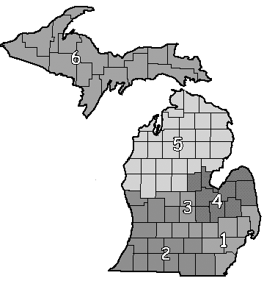
Regions | # of Counties | # of Providers | Provider Participation Rate | Coverage Levels
1 | 7 | 1100 | 62% | 47
2 | 15 | 540 | 93% | 66
3 | 6 | 345 | 95% | 63
4 | 9 | 344 | 93% | 63
5 | 31 | 254 | 80% | 72
6 | 15 | 240 | 95% | 72
Sentinel | 76 | 1179 | 91.6%
91% of children under the age of 6 have two or more shots in MCIR.

