Washington, DC Sentinel Site Project Summary
October 2004

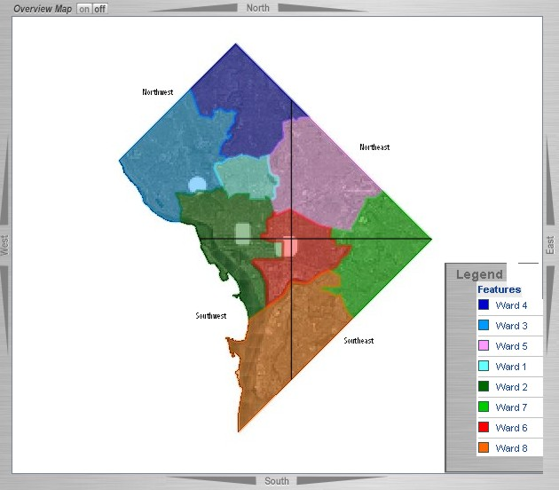
Sentinel Site Population
The District of Columbia is an independent city of 63 square miles (source: 2000 US Census). It has a median household income of $41,000. It functions as the center of the federal government and a self-ruling city-state. It is governed by an elected Mayor and City Council but is overseen by the US Congress. It houses its 572,059 residents, the White House, the Capitol, the Supreme Court, the Embassies of various nations, military bases and offices, federal administrations, museums and parks, and private businesses. In addition, it hosts 20,000,000 annual visitors and approximately 500,000-1,000,000 daily “commuting” workers. The population of the District is made up of 60% black, 30% white, 3% Asian, and 7% other or mixed race residents. Approximately 8% of the residents are of Hispanic ethnicity. (Source: 2000 US Census.)
As designed by Pierre L’Enfant, the District of Columbia is divided into four quadrants with the US Capitol as the center. It is also divided politically into eight Wards (see map). It shares borders with the neighboring states of Maryland and Virginia. Amongst the four quadrants – Northeast, Northwest, Southwest, and Southeast – the diversity of the District can be seen. The District stretches from Northwest with a population 90% white and 4% black, to Southeast with a population 90% black and 8% white. (Source: State Center for Health Statistics, 1999.)
The geographical region chosen for the District’s Sentinel Site is Southeast Washington (2000-2004 Sentinel Site population was Medicaid children). It is a medically underserved area of higher than average poverty. Approximately 25% of its households live at or below the poverty line (DC average: 15%); and the unemployment rate is approximately 15% (DC average: 8%). Children 0-5-years in the District have a poverty rate of 53.9% (Source: CDC/Urban Institute, 1999 Report, “Health Care for Low-Income People in the District of Columbia”). From 1990 to 1998, the Southeast area experienced a 15% reduction in its population. (Source: 1998 District Indices.) Its population is 90% black, 8% white, and 2% other/mixed; 2% of its residents are of Hispanic ethnicity. It has the city’s highest infant mortality rate at 27.5 (US average: 7.1); 16% of its live births are for low birthweight infants; 82% of its births are to single mothers (US average: 33%).
Approximately 11,596 0-6-year-olds live in Southeast Washington (source: extrapolation of 2000 0-18-year-old census data). Of the 11,596 sentinel children, 11,126 (96%) have a record in the DC Immunization-EPSDT Tracking System; 9,573 of the children have two or more immunizations recorded in the system (source: children with southeast addresses reported by clinic, WIC, Headstart, or childcare, in the tracking system as of May 2004). For the sentinel children, 57% of their immunizations are reported to the tracking system within 30 days of vaccine administration.
As of December 31, 2003, the sentinel site children (Southeast Washington) 19-35 months of age had the following vaccination series levels in the DC Immunization-EPSDT Tracking System: 4:3:1 = 56.69% (NIS Range: 69.9% - 81.1%); 4:3:1:3 = 56.27% (NIS Range: 68.6% - 79.8%).
There are 17 pediatricians, 15 family practitioners, and 6 clinics in Southeast Washington for a total of 38 immunization providers. Thirty-six (36) of the providers (95%) participate with the DC Immunization-EPSDT Tracking System and are enrolled in the VFC Program (17 pediatricians, 13 family practitioners and 6 clinics).
Also within Southeast Washington, there are 6 WIC Clinics with 2,802 enrolled children in the tracking system, 47 Headstart Centers with 1,005 enrolled children in the tracking system, and 68 licensed child-care centers. There are also 73 schools (7 chartered, 49 public, 7 parochial, and 10 private) with 24,410 students in the tracking system. All of these centers are linked to the DC Immunization-EPSDT Tracking System via electronic or paper means as their infrastructure permits. All centers have immunization rates reported monthly and annually.

Project Description: Capacity Building Grant

Data Quality Improvement
The Immunization-EPSDT Tracking System staff planned and developed a Data Quality Improvement Plan addressing the Sentinel Site data quality functional standards in April 2003. The plan included steps to enhance
- data entry to include vaccine manufacturer, lot number, and other NVAC-approved core elements (see functional standard #1)
- provider enrollment via on-site training sessions and other contacts to increase base reporting (see functional standard #4)
- provider training including timeliness and completeness of immunization reporting, with particular emphasis on children’s past immunization histories (see functional standard #4)
- current quality assurance procedures to include written data quality protocol and testing of deduplication methods with the CDC de-duplication test cases (see functional standard #12)

Quarterly and Ad-hoc Reports
The Immunization-EPSDT Tracking System staff have completed Sentinel Site Quarterly Reports since joining the Sentinel Site network in 2000. Staff will generate the requested quarterly and ad-hoc Sentinel Site reports and submit them by the deadline.

