Isaac Dickson Elementary School Asheville, NC

Originally, the 17.3 acre campus of the Isaac Dickson Elementary, half a mile from downtown Asheville, North Carolina, contained fields and wetlands. With the help of community members and other partners, the campus today hosts not only playgrounds but a nature reserve including a pond and wetlands area, a bird sanctuary, and several gardens, including a sound garden and numerous perennial and vegetable gardens. The school has devoted so much effort to its environment because, in a very real sense, the larger world is the school’s curriculum. Originally the Asheville Alternative School, Isaac Dickson was founded in 1989 by dedicated parents and teachers. Their collaboration continues to support the school’s vision, which is that “children learn best by doing.” Alida Woods, a teacher when the school was founded, assumed the principalship in 2002. The school seeks, says Woods, to invite and nurture diversity, create a climate of kindness, and encourage students to reach their learning potential in a community of lifelong learners.
Isaac Dickson Elementary School
Asheville, NC

420 K-5 students

Students qualifying for free or reduced price lunch 46%

Special education students 10%

Student ethnicity:
White 58%
African American 28%
Multi-racial 11%
Other 3%
A Curriculum Rooted in the Community
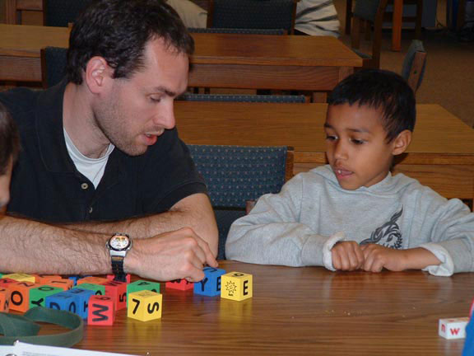
Isaac Dickson is based on the principles of the Foxfire organization, a non-profit, educational and literary organization in northeastern Georgia. Ensuring that “the connections between the classroom work, the surrounding communities, and the world beyond the community are clear” is a core Foxfire principle. At Isaac Dickson, this philosophy translates into student investigations of nature, the local community, and places as far from campus such as the coast of North Carolina.
For example, when asked, “What does local government look like?” fourth grade students at Isaac Dickson tackled the question with vigor. Working with University of North Carolina Asheville (UNCA), they formulated questions—such as, “What are three of the most important issues in our community? and How do public officials demonstrate moral courage and civic responsibility?”—for county commissioners and city council members. Practicing their interviewing techniques with the college students, they interviewed and produced slide shows on each council member. Students not only learned about their community, they learned how to act in it: subsequently, a playground in one of the neighboring public housing projects was repaired with 48 hours due to the class discussion with a city council member.
“With a Canjo on My Knee”
A student captures the force of first-hand learning: “I see things through my own eyes.” When students explored Appalachian history and culture, they became intrigued by “canjos,” a low-cost musical instrument devised by European settlers to the region to play music of the old country. A canjo is a banjo—made from a can. Isaac Dickson students built their own canjos, learned some of the old ballads, wrote about they had learned, and presented their findings and music at a community concert. Students performed for other classes and produced PowerPoint presentations of their projects.
As teachers and learners seek practical applications of classroom content outside the school walls, the community becomes a learning laboratory. When fifth grade students and their explored the history of their own campus, unearthing a chimney and other artifacts of human life, they discovered their school occupied the former “Stumptown,” the segregated, African American part of town dating to the turn of the last century. This occasioned extended discussion of their community’s own past.
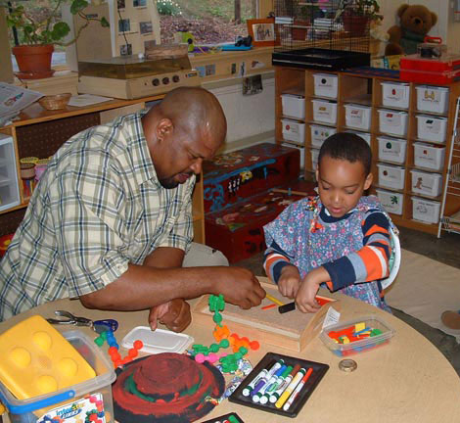
Making Decisions Together
In addition to Foxfire, the school uses the Comer model of comprehensive school reform, which builds consensus through dialogue and shared decision-making and taps adults to support students’ learning and healthy development. Principal Woods believes that collaborative leadership is the key for success in schools: joint decision-making creates a dynamic cohesion of staff, child, and family. Collaboration must include teachers, parents, and students in partnership with system-wide initiatives, she said.
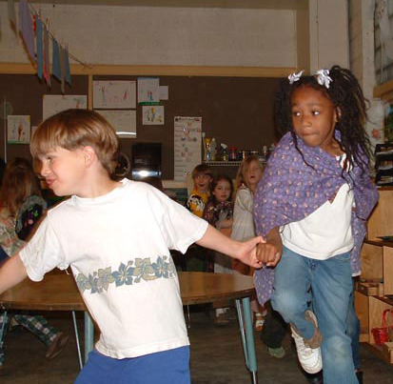
Three teams, each including staff members, parents, and community members, shape the school’s operation: the School Planning and Management Team (SPMT), the Student and Staff Support Team (SSST), and the Parent Team (PT). The SPMT develops the school’s Comprehensive School Plan, sets academic, social, and community goals, and coordinates all school activities, including staff development programs. The SSST concerns itself with the school’s culture, social conditions, and personal relationships, and works in collaboration with a larger support staff to provide academic and community resources for students and families.
The PT engages parents in the life of the school and its students. Parent involvement is strong at Isaac Dickson; they have been involved in designing and putting the playgrounds in place, tutoring, hosting classes on field trips and “most anything you can think of,” Principal Woods said. The school takes steps to include all parents, ensuring their voices are heard even if they can’t make it to the school. Once a month, Isaac Dickson conducts “Family Nights”—dinner and information sessions—at local housing projects to reach out to underrepresented families.
Students are involved in many decisions, including writing class rules, choosing class projects, and taking part in both class and school-wide governance. An active Student Council follows a structured protocol with well defined roles for timekeeper, facilitator, chairperson, and recorder. Students believe they have a voice and influence school decisions. Placing students at the center benefits achievement, too. In 2004, fifth grade students scored 100% in reading and 98% in math.
Letting the World Into School

The school forms a range of partnerships, both within the school and with the larger community. With the aim of helping students do their best work, learn life skills, and celebrate their diversity, students, staff, and community partners flow back and forth between the school and community. Parents and grandparents, foster parents and foster grandparents, mentors, tutors, university faculty as well as pre-service educators from Western Carolina University, UNCA, Warren Wilson College, and Mars Hills College, and partners in grant-funded projects all contribute to the school’s vitality. A visitor remarked on the absence of walkie-talkies and student identification badges as a sign of the sense of community in the school.
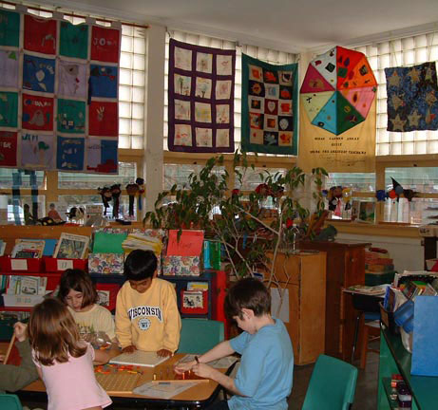
Tutors, mentors, and other assistants work with students based on needs identified by adult “teams” that support each child. An SSST team arranges meetings when a student has a specific concern. The SASSY ( Service All Stars Serving Youth) team’s support staff—social workers, nurse, school based therapist, speech therapist, counselor, and administration work with families in greatest need and coordinate the school’s Wrap-Around Service. Other school-community partnerships include the Family Room, housed at Isaac Dickson and funded by a non-profit agency (Children First), that offers family education programs as well as a clothing closet and referral system for families in crisis. A representative of a community agency said, “Isaac Dickson welcomes people and welcomes new experiences.”
Learning by Giving

The school serves the community in other ways. Through a garden program funded in part by Learn and Serve America and Title I, an outdoor educator helps students learn about nutrition not only by studying food, but by growing it in the school garden. Student-grown foods are shared with local social service organizations. In partnership with Learn and Serve America, the school began a system-wide recycling effort. Other service learning projects include work with the local food bank, a Classroom without Walls career shadowing program, and a community project on African American Heritage, Literacy Through Photography. Working with a professional photographer funded through Learn and Serve and carried out in partnership with the local art museum; students in this project studied photographers and photography, learned to use a point-and-shoot camera, photograph family, and develop writing projects from the photographs. A monthly Street Clean Up (in partnership with the Local Quality Forward environmental group) brings school members out to the community. The school’s Read to Feed Program raises money for Heifer International, an international charity, through student-driven reading and discussion projects.
Students also work at the MANNA Food Bank in Asheville, stacking and packaging food for needy families. Because they were “nervous” the first time they volunteered at MANNA, Isaac Dickson students created a brochure for students from other schools, letting them know what to expect when they volunteer at MANNA.
The Foxfire Philosophy
The school’s curriculum is based on the North Carolina Standard Course of Study, as realized through the Foxfire approach. The Foxfire Core Practices are:
- The work that teachers and learners do together is infused from the beginning with learner choice, design, and revision.
- The role of the teacher is that of facilitator and collaborator.
- The academic integrity of the work teachers and learners do together is clear.
- The work is characterized by active learning.
- Peer teaching, small group work, and teamwork are all consistent features of classroom activities.
- Connections between the classroom work, the surrounding communities, and the world beyond the community are clear.
- There is an audience beyond the teacher for learner work.
- New activities spiral gracefully out of the old, incorporating lessons learned from past experiences, building on skills and understandings that can now be amplified.
- Imagination and creativity are encouraged in the completion of learning activities.
- Reflection is an essential activity that takes place at key points throughout the work.
- The work teachers and learners do together includes rigorous, ongoing assessment and evaluation
Teachers and students work together to decide how they will learn, how they will assess and evaluate what they learn, and how they will use what they know in meaningful ways. In the classroom, students learn to work collaboratively and assume responsibility for their own learning processes. They are expected to be involved, active learners who solve problems creatively and apply what they learn beyond the classroom. Where possible, the school encourages multidisciplinary collaboration although, as a teacher noted, “Collaboration takes time and we are still working on making time.”
The other strong influence on the school is the Comer model, which looks at the whole child through a complement of developmental pathways—physical, language, psychological, ethical, social, and cognitive. Explains a teacher, “We look at all the pathways one child at a time.” Children are not viewed as broken or imperfect but as persons with possibilities. “We don’t give up on any child. We work together to get a plan and implement. . . . different ways of learning are honored and supported.” Adds another, “With the Foxfire approach we don’t miss any types of learning—tactile, visual, etc.” Staff make an effort to keep classes small, which not only allows teachers to differentiate instruction according to students’ needs, it lets teachers get to know their students individually. Following extensive study by the Parent Team and SPMT, planning has begun to move from multiage primary classes to a combination of looping and multiage classes as key to the school’s overall mission and driving philosophy.
Learning to Learn
As teachers and students seek practical applications of classroom content outside the school walls, the community becomes a learning laboratory. Principal Woods has worked hard to bring in grants, particularly for Landscapes for Learning and the school’s outdoor education program. In constantly tying skills and concepts to purposes that can be seen and understood in learners’ lives both today and in preparation for their futures, teachers appear to inspire their students to learn. One parent, drawn to the school because of its focus on experiential learning, noted with pride, “My daughter is learning how to learn and knows how to find out about things.” Through partnerships with Western Carolina University and UNCA, the school welcomes educators in a two-way process that helps university programs stay up to date with what works in actual schools.
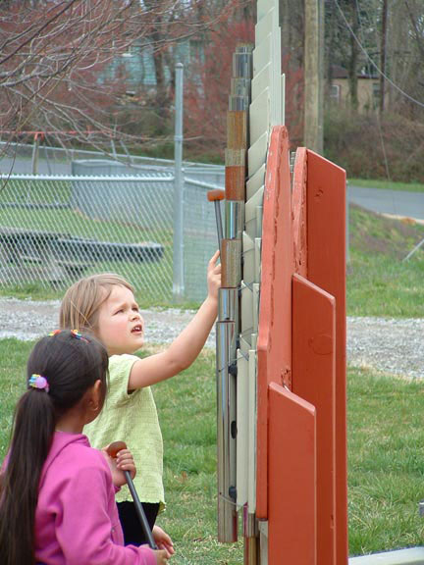
Tutors, all certified teachers funded through Title I, work with regular classroom teachers to support small group instruction. Tutors plan their work with the teachers and submit weekly lesson plans that support classroom learning goals. Classroom assistants work as co-teachers and are trained to teach literacy, math, and writing. This year all 3-5th grade classes had either an assistant or a tutor for a two-hour block in the morning. Teachers maintain contact with parents to reinforce classroom practices through homework. “I talk to my daughter’s teacher every day,” a parent reported. “A letter comes home every week telling me about what they are doing in school so I can ask her about it.” Teachers also visit students’ families at home to make communication easier for parents. A parent remarked, “You do not need to wait for an official conference.”
At Isaac Dickson, the boundaries between school and world are permeable: the world enters the school, and the students and teachers go out into the world. Surrounded by nature and gardens, it is deeply rooted in its local setting, but faces out to embrace the world.

www.foxfire.org/teachi.html Accessed June 15, 2005.

