Dr. Jessie Hayden Elementary School Midway City, California

Dr. Jessie Hayden Elementary School
Midway City, California

690 students, K-5

Asian60%
Hispanic32%
White 6%
African American1%
Students receiving free/ reduced price lunch67%
Students receiving SPED services 3%
Limited English proficient students69%
Student teacher ratio:21%
Student turnover rate 3%
Student: Teacher ratiovaries by grade

“Little Saigon”
Southern California’s Midway City in Orange County is home to the largest Vietnamese population in the United States. Of the 690 students Hayden Elementary School currently serves in grades K–5, 60% are Vietnamese, 32% are Hispanic, and 6% are White. Two-thirds of Hayden’s students are English language learners and a nearly equal number are eligible for free or reduced-price meals.
Despite these challenges, Hayden has consistently exceeded academic growth targets as measured by California’s Standardized Testing and Reporting (STAR) system. The state’s Academic Performance Index (API) uses STAR results in reading and mathematics to calculate a score ranging from 200 to 1,000 for each school. The API target for all schools is 800; Hayden achieved an API of 813 in 2004 and 831 in 2005, placing it in the top 10% of similar schools in the state.
High Expectations and Focus on Standards

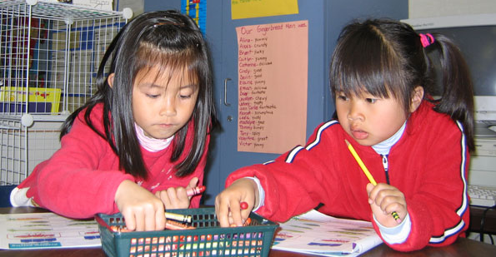
Both teachers and administrators cite high expectations for teacher and student success as key factors in Hayden’s success. “Some teachers in the district think they can’t teach students because the students don’t speak English very well,” says Principal Linda Reed. “Our teachers believe the students can learn and so they just teach the curriculum.” Hayden’s standards-aligned reading materials were selected and recommended to the school board by a committee of parents, teachers, and curriculum experts.
Instruction in K-2 ELA is through Open Court, a research-based, systematic, explicit phonics program that also engages students in high quality literature selections. Kindergarten students have 90 minutes of reading daily, while upper grades students receive up to 150 minutes in language arts instruction daily. Primary grade students also spend half an hour a day at a Writing to Read computer lab.
Students take “little” books (controlled readers) home for practice and track themselves on the Accelerated Reader computer program. Upper grades use the Houghton Mifflin Reading Program, emphasizing reading, word work, and writing and language.
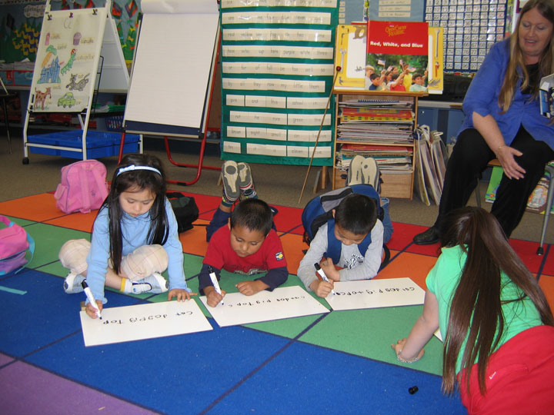
Math instruction is through the Harcourt Brace math programs, linked closely to the state standards. Review sections are designed so students frequently revisit concepts covered in earlier lessons.
Through a contribution from the Beckman@Science Foundation, the Westminster Elementary district has established a ScienceWorks Consortium to stimulate, preserve, and inspire children’s natural curiosity to achieve scientific literacy. Teachers receive extensive support in using these hands-on science kits, including training in lesson delivery, student assessment, and materials replenishment. Data collected through the consortium suggest that skills acquired through hands-on, inquiry-based science study transfer to other curriculum areas.
Students also participate in “Art Masters,” a docent-led study of the great artists of the world, for which teachers also receive extensive training. Upper-grade level students receive vocal and instrumental music lessons.
Curriculum Supplements and English Language Development

Teachers at Hayden Elementary go above and beyond faithful replication of the curriculum and find ways to supplement it to “make it more alive” and fill in “gaps.” For example, the principal and vice principal note, because “teachers feel that they are held accountable for test scores,” teachers bought materials to supplement the science kits in order to bring science instruction into alignment with state standards. Teachers supplement the curriculum through teacher-created worksheets, information from the Internet, workbooks, the computer lab, the library, and Writing to Read lab.
Because so many Hayden students are English language learners, the school has a strong English language development focus. Staff members have been trained in the Moving Into English program for all new students, and struggling fourth and fifth grade students are pulled out to participate in the Language! program. Students also use computers in the Writing to Read lab, which is separate from the regular computer lab. All teachers are required to obtain a California Language Acquisition and Development (CLAD) certificate before they can teach at Hayden.
Differentiated instruction for English language learners, below grade-level readers, and advanced students takes place through small groups, center activities, and the use of Title I teachers. The student-teacher ratio in kindergarten through second grade is 20:1, the result of a statewide class size reduction program.
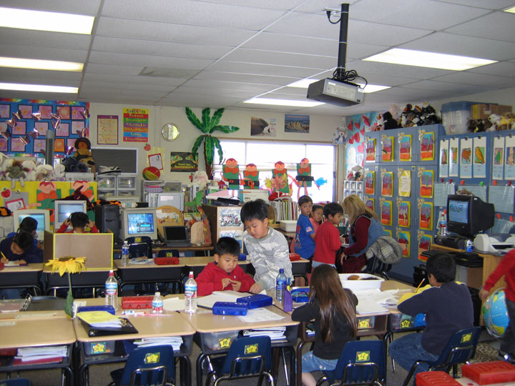
English language learners find the science program especially appealing, filled as it is with hands-on experiences with wood, bugs, rocks, and plants. The school receives professional development and other support through the Beckman@Science foundation and the collaboration of community agencies and two neighboring school districts.
Other student supports include upper and primary grade “Big/ Little Buddies” partnerships that meet regularly to practice science, reading, and writing as cross-age tutors. Community Science Nights bring students and parents together with educators, letting parents experience first-hand how scientific study facilitates critical thinking, problem solving, reading, and writing.

Grade-level teams use “backwards planning”—looking at where students need to be in each curriculum area by the end of the year, and lay out a plan to ensure that all the curriculum goals and standards are covered by then. Grade-level teachers communicate frequently to ensure that they are all maintaining the pace needed to cover the standards by the end of the school year, and teachers from adjacent grade levels communicate often to ensure that they are preparing students to meet expectations at the next grade level. Ongoing program evaluation takes place through best practice roundtables where lead teachers meet to solve problems, identify areas of need, and share successes.
“Backwards” Planning
Teachers offer regular small-group after-school tutorials; students identified as needing additional assistance attend tutorials with their classroom teachers. Other interventions include differentiated instruction in small groups with a reading teacher and a Title I teacher, Proficiency Summer School, the use of alternative curricula, computer programs that target specific skills practice, peer tutoring, and the cross-age tutoring program. Comprehensive homework engages parents in learning. Hayden has established strong relationships with The Midway City Community Center, the local police, sheriff’s office, the Westminster Community Collaborative and boys and girls clubs. Through a special project, first and second graders receive free tutoring from seniors at the community center, where families can also access self-help skills.
The district has broken the state standards down into quarterly benchmarks; widely posted, they remind both students and teachers of learning expectations during the school year. Student planners further reinforce high expectations: students record their assignments and must get them signed by parents to indicate they have completed the required homework.
Use of Technology

In addition to having at least five computers in every classroom plus a computer lab, most Hayden classrooms include Smart Boards and streaming video, which are heavily used. Teachers also have access to software that allows them to develop classroom assessments using item banks tied to California state standards. The software also produces item analyses so teachers can see which standards students have mastered and which standards need to be re-taught. Increases in student achievement are also attributed to integrating technology—Internet, “smart” boards, and classroom computers—with intensive professional development in technology for teachers.
Differentiating Instruction
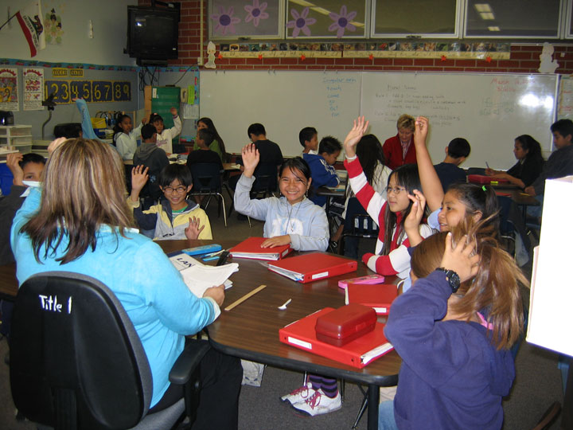
The Westminster Elementary School District releases teachers for five days each year to meet in grade-level teams to plan instruction. Different grade levels are released on different days so that the Student Achievement Teacher (SAT) can meet with each team to discuss interventions and groupings for students who need additional assistance. During these meetings, teachers use the state achievement tests (STAR), the district’s quarterly benchmark tests (aligned with state standards), curriculum-embedded tests, and other assessments to evaluate student learning. Students are assigned to groups for after-school tutoring with their classroom teachers, supplemental assistance in language development, small groups within their classrooms, or regroupings for selected subjects at some grade levels.
Teachers also use these planning days to discuss gaps in the curriculum and strategies for filling in those gaps, and to assess their own strategies for teaching students. One teacher observed that the data “makes me evaluate myself. If the majority of the class didn’t do well on a test then the problem is me; if there were just a few students who didn’t do well then I can pull them aside and work with them. Looking at student data lets us know which kids need more challenge and which kids need to back up.”
Classroom teachers provide after-school tutoring to students from their own classrooms, an intensive intervention delivered three to four times weekly. Homogeneous groups of 6-8 students benefit from the “pre-teach, re-teach model,” which emphasizes modeled reading, shared reading, and guided reading. Cross-curricular opportunities to build reading skills occur as students create science journals, compile math dictionaries, and conduct social science research. Even though some teachers resist having to put in extra hours, they are willing to do so, says one, because “it is beneficial, and you see so much growth out of those kids.”

Teachers at Hayden pride themselves on their ability to work together toward the common goal of student education. As one teacher says, “It’s not a competition; we want all children to be successful.” Teachers explain that frequent communication and collaboration among teachers began because teachers “discovered that the best resources were each other.”
Teacher Communication and Collaboration
Teachers meet daily (before school, during lunch, after school) and weekly during grade-level meetings. The principal notes, “They are so collaborative that everyone from the grade level comes to grade-level meetings, rather than one teacher from each grade.” When a child moves to the next grade the benefits of this collaboration continue because teachers convey information about students’ strengths assessment to the students’ next year teacher.
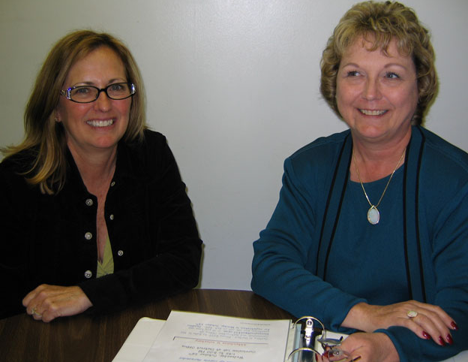
Because teachers communicate so often, all classes in the same grade level are at the same place in the curriculum. To keep pace with each other, teachers talk often: “We are interested in finding out how we are doing,” says one. This consistency in delivering the curriculum to all students in the same grade level creates a community of teachers who can compare notes, strengthen lesson plans, and offer support, all in real time. It helps students gauge themselves as well; because they know that all teachers are doing the same things, students will ask, “Are we behind?” And parents notice too, as a parent who volunteers in different classes observed. Even the two Special Day Classes at the school try to mirror the curriculum that is taught at their students’ grade levels.
The school staff members at Hayden Elementary are dedicated and committed to doing what they think is the right thing to do for children. One parent described her child’s teacher as “[having] lots of patience and using lots of strategies; if children can’t do something they will go over it and over it.” Among strategies teachers use are hands-on learning, historical simulations, dramatizations, speeches, chants, singing, performances, and team-teaching; teachers also use reciprocal teaching, graphic organizers, cross-age buddies, and small group instruction. Writing and word processing are taught at all grade levels.

Teachers report that their administrators foster a positive school learning community by making the teachers feel important, valued, and supported; they see their administrators as very accessible and dedicated, and working hard to get teachers the materials they need and help them improve. At staff meetings, held every Thursday, most issues are voted on. “It’s very time-consuming,” a teacher observes, “But all of our voices are heard!”
Administrative Support

During the five collaborative planning days, teachers by grade level examine student assessment data, review pacing calendars, and determine student intervention groups.
Student Achievement Teachers (SATs) lead quarterly Student Achievement Collaboration Sessions (SACs), and SATs collaborate monthly at the district level to share ideas and strategies to increase student achievement. Hayden has been recognized as a Title I Achieving School four years in a row, and is the frequent recipient of visits of grade-level teams from other district schools.
Professional Development

The district offers many opportunities for staff learning; in addition to three mandatory professional development days each year, the district provides weekly modified days and student-free days for teacher collaborations and professional development. Teachers can use their Wednesday afternoon time to attend workshops of interest or to plan with other staff members. Teachers are also able to attend professional conferences of their choice. The Westminster district is part of a larger collaborate, the West Orange County Professional Development Center, that offers interactive opportunities to refine instructional practices and develop strategies for improving student achievement.
First and fourth grade teams have taken part in the district technology program, which offered teachers a summer institute on technology use and aligning curricula with state standards. The district goal of expanding the use of technology beyond math and science classes has brought technology into other content areas. Teachers across all grades are trained in use of the “smart” boards.
Resources such as BTSA (Beginning Teacher Support and Assessment), new teacher workshops, the Westminster School District Staff Development Days, the West Orange County Professional Development Center, Orange County Department of Education, and UCI trainings are used to gain knowledge in identified areas of student need. Teachers self-select staff development opportunities based on their interest in the identified area of focus.

Home-school communication takes many forms: back-to-school night, twice-yearly parent-teacher conferences, quarterly progress reports, tests and homework for parents to see and sign, monthly newsletters, communication logs, formal IEPs for special education students, and daily contact with parents when teachers walk the students out to the front of the school at the end of day.
Home-School Communication
Because of the multilingual nature of the school population at Hayden, the school sends all correspondence between the school and parents home in Vietnamese, Spanish, and English. The school also employs two part-time school-community liaisons—one who speaks Spanish and one who speaks Vietnamese. When parent-teacher conferences are scheduled, parents are asked whether they would like the school to provide a translator for the meeting.
Parents regularly volunteer in the classroom and participate in field trips. Each year the school holds a back to school night and provides parents with packets of information on what they should expect their students to learn during the year. For the Kindergarten orientation this year, parents were given ideas for what they should be doing with their children at home to assist with learning. Students at the school orientation session were given backpacks filled with manipulatives and other materials their parents could use at home with them.
The district sponsors a District Parent Academy, Parents in Education nights, and special interest meetings such as “Positive Strategies for Managing Behavior” offered by the district Prevention Intervention coordinator. The district’s ongoing training for administrators is designed to build capacity in school leaders.
The active PTA at Hayden not only organizes fundraisers for the school, but provides gift baskets for needy children at Christmas and produces a school yearbook. The PTA also sponsors popular family events at school. Parents raved about family movie night, where families watch movies together at school, with low-priced popcorn and drinks for sale by the PTA. Parents reported that they felt very welcome at the school, and they appreciate the high academic standards and the dedication of the school staff to meeting student needs.
Parents were also happy with the responsiveness of school staff members to their needs, noting that the school sent out a survey asking whether there were additional resources the school could provide or whether there were things that parents would like to see changed. Parents asked for English classes for the non-English speaking parents, and now the school currently offers these classes.
Hayden has shown itself to be successful, responsive,and resilient—the very qualities it is nurturing in its students.
Hayden Elementary School State Criterion-Referenced Tests
% proficient and above: 5th grade ELA
 | 2001 | 2002 | 2003 | 2004
All | 37 | 41 | 50 | 53
Low income | 25 | 41 | 43 | 48
State average | 28 | 31 | 36 | 40
% proficient and above: 5th grade Math
 | 2001 | 2002 | 2003 | 2004
All | NA | 46 | 60 | 59
Low income | NA | 48 | 61 | 56
State average | NA | 29 | 35 | 38

