Good Nutrition Is Essential

Nutrition is important at every stage of life. Eating well provides us with the energy needed for daily living and is a key part of achieving good health. For older adults, consuming a variety of nutrient-packed foods has been linked to reduced risks for developing chronic health conditions, such as osteoporosis, arthritis, obesity, high blood pressure, diabetes, heart disease, and certain types of cancer. Studies also show that a healthy diet during the later years contributes to a higher quality of life, enabling older people to remain independent and fit for every day activities like hobbies or visiting with family and friends.

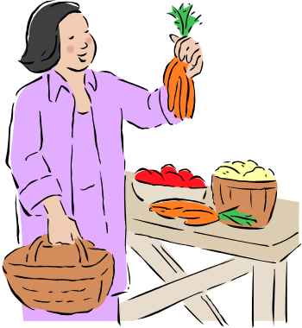
Nutrition Recommendations for Older Adults
Middle-aged and older adults can select nutritious foods and still treat their taste buds. The U.S. Administration on Aging (AoA) has developed practical recommendations from the Dietary Guidelines for Americans 2005 with older adults in mind. Getting Older. Living Healthier. Feeling Better. offers guidance on making choices from the major food groups and striking the right balance between calories eaten and calories burned. In general, the adapted guidelines recommend the following:

- Eat a variety of fruits and vegetables.

- Go easy on sugars and incorporate whole grains and fat-free or low-fat milk and milk products into meals.

- Choose lean proteins such as poultry, fish, beans, and nuts, and try to keep total fat to between 20 to 35 percent of daily calorie consumption.

- Limit sodium to no more than 1,500 milligrams per day—the equivalent 3/4 teaspoon of salt.

- Eat foods that are fortified with vitamins D and B12.

Older adults should read “Nutrition Facts” and other labels when selecting packaged foods to ensure they are receiving the right nutrients. And to burn calories adequately, older adults are encouraged to engage in at least 30 minutes of physical activity (above usual activity) on most days of the week.

Older adults who have difficulty preparing nutritious meals may want to consult a qualified professional. Others may find help from either family and friends or programs supported by the Older Americans Act (OAA). Available for more than 30 years, the OAA Nutrition Program serves approximately 250 million congregate and home-delivered meals (“meals on wheels”) per year. It also provides nutrition screening and assessment, education and recreational activities, and other services. Nutrition Program services ensure older Americans get at least one meal a day that includes a minimum of one-third of the Recommended Dietary Allowances. They also provide opportunities for older adults to gather, socialize, and address their health and nutrition needs. Some programs also include special health assessments for diseases such as hypertension and diabetes.

Eating balanced meals, finding time to be physically active, and taking advantage of the assistance programs can go a long way toward helping older adults fully enjoy their later years. For more information about nutrition and physical activity, visit www.healthierus.gov/dietaryguidelines. To find a local nutrition program, visit the Eldercare Locator at www.eldercare.gov or call the service at 1–800–677–1116, Monday through Friday, 9:00 a.m. to 8:00 p.m. e.s.t.

