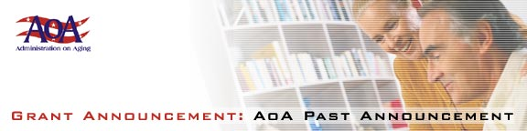

Statewide Senior Legal Hotlines

[Federal Register: June 18, 2001 (Volume 66, Number 117)] [Notices][Page 32825]
From the Federal Register Online via GPO Access [wais.access.gpo.gov]
[DOCID:fr18jn01-98]
-----------------------------------------------------------------------
DEPARTMENT OF HEALTH AND HUMAN SERVICES
Administration on Aging
[Program Announcement No. AoA-01-06]
Fiscal Year 2001 Program Announcement: Availability of Funds and
Notice Regarding Applications

AGENCY: Administration on Aging, HHS.

ACTION: Announcement of availability of funds and request for applications to establish, or expand and improve, Statewide Senior Legal Hotlines whose purpose is to advance the quality and accessibility of the legal assistance provided to older people.

-----------------------------------------------------------------------

SUMMARY: The Administration on Aging announces that under this program announcement it will hold a competition for grant awards for four (4) to (5) projects that establish, or expand and improve, Statewide Senior Legal Hotlines aimed at advancing the quality and accessibility of the legal assistance provided to older people.

The deadline date for the submission of applications is August 3,
2001. Eligibility for grant awards is limited to public and/or nonprofit agencies, organizations, and institutions experienced in providing legal assistance to older persons.

Application kits are available by writing to the Department of
Health and Human Services, Administration on Aging, Office of Program
Development, 330 Independence Avenue, SW., Room 4264, Washington, DC
20201, by calling 202/619-2987, or on the web at http://www.aoa.gov/t4/
fy2001.

Dated: June 12, 2001.
Norman L. Thompson,
Acting Principal Deputy Assistant Secretary for Aging.
[FR Doc. 01-15203 Filed 6-15-01; 8:45 am]
BILLING CODE 4154-01-P

