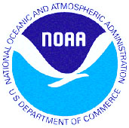
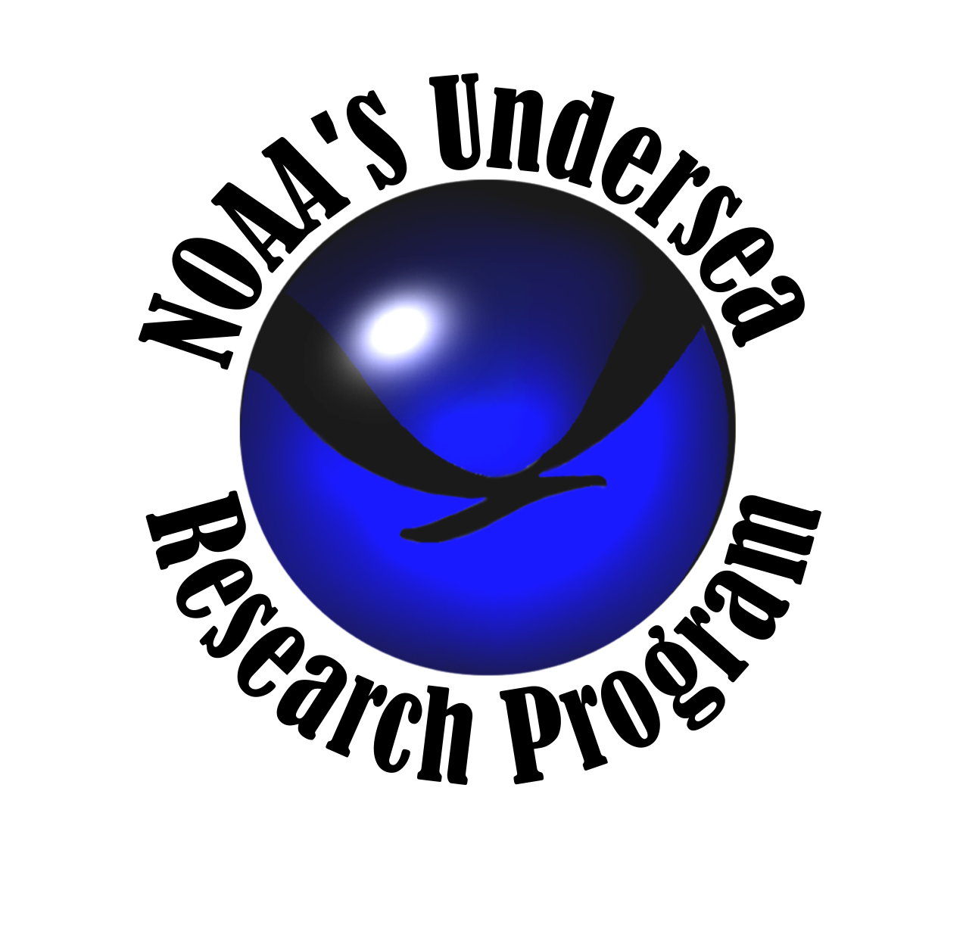

NURP – NOAA’s Undersea Research Program

FY 2005 SCIENCE GUIDANCE

This document outlines NURP’s Science Guidance to the NURP Centers and NIUST for FY 2005.

INTRODUCTION

NOAA’s Undersea Research Program (NURP) is a comprehensive underwater research program that supports NOAA’s mission by providing scientists with the tools and expertise they need to conduct scientific research of regional, national, and global importance. Of special interest to NURP is research focused on NOAA’s management responsibilities – corals, fisheries, and ecosystems – and on advancing underwater technologies to conduct this research. Additionally, NURP is keenly interested in furthering the field of marine biotechnology research through its National Institute for Undersea Science and Technology’s (NIUST) National Repository of marine natural products. This repository represents the first intensive survey/sampling of U.S. coral reef organisms that are screened in-house for biomedical and agrochemical potential; and are available to qualified researchers for further biotechnology studies.

ABOUT NURP

NURP is part of NOAA Research and is headquartered in Silver Spring, MD. NURP consists of six regional NURP Centers and one Institute that maintain responsibility for soliciting and supporting research and technology development.

- North Atlantic and Great Lakes NURP Center
at the University of Connecticut, Avery Point
- Mid-Atlantic Bight NURP Center
at Rutgers University
- Southeast and Gulf of Mexico NURP Center
at the University of North Carolina at Wilmington
- Caribbean NURP Center
at the Caribbean Marine Research Center
- West Coast and Polar Regions NURP Center
at the University of Alaska Fairbanks
- Hawai‘i and the Western Pacific NURP Center
at the University of Hawai‘i, Manoa
- NIUST – National Institute for
Undersea Science and Technology
at the University of Mississippi and
The University of Southern Mississippi

See Table 1 for NURP Contact Information.

NURP works with scientists to use advanced underwater technologies and methods including: scuba diving, mixed-gas diving, advanced technical diving, human-occupied submersibles, remotely operated vehicles (ROVs), autonomous underwater vehicles (AUVs), sea floor observatories, Aquarius – the world’s only underwater laboratory, and other cutting edge technologies. By using advanced underwater technologies, NURP helps scientists make observations, collect samples, and conduct experiments that would otherwise be unobtainable.

About 90 percent of the funding appropriated to NURP by the U.S. Congress is spent extramurally (outside NOAA) on undersea research. NURP supports high-quality, peer-reviewed research through 6 regional NURP Centers and NIUST. The quality of NURP-supported research is ensured through a competitive process with high standards of peer-review patterned after the National Science Foundation.

The following research directions constitute the NURP FY 2005 Science Guidance. These guidelines are based upon the NOAA Strategic Plan for FY 2003-2008 and research needs as defined by NOAA resource managers. Undoubtedly, additional research directions could be added. However, these directions are meant to serve as an initial guide to the NURP Centers and NIUST in forming their approach to FY 2005. The NURP Centers and NIUST should continue to consider their individual capabilities, expertise, and unique regional priorities in developing their scientific and programmatic approaches.

STRATEGIES

In response to the changing needs of society and the environment, NOAA has adopted a new strategic plan for FY 2003-2008. The new plan responds to changes in climate, demographics, globalization, economies, and stressors to the environment. NOAA’s Strategic Plan is located at www.osp.noaa.gov.

NOAA’s Mission:

To understand and predict changes in the Earth’s environment and conserve and manage coastal and marine resources to meet the Nation’s economic, social, and environmental needs.

NURP responds to NOAA’s mission by using its expertise in undersea in situ research and technology.

NURP’s Mission:

To support NOAA’s mission through advanced undersea research, sampling, observation, experimentation, and education.

NURP’s mission directly supports NOAA by providing an improved understanding of the Nation’s underwater resources to enable effective ecosystem-based management. NURP supports targeted research that enables NOAA to achieve its Ecosystem Mission Goal to “protect, restore, and manage the use of coastal and ocean resources through ecosystem-based management”.

The NOAA Strategic Plan identifies five strategies by which the Ecosystem Goal can be met:

- Monitor and observe the land, sea, atmosphere, and space and create a data collection network to track Earth’s changing systems.
- Understand and describe how natural systems work together through investigation and interpretation of information.
- Assess and predict changes in natural systems and provide information about the future.
- Engage, advise, and inform individuals, partners, communities and industries to facilitate information flow, assure coordination and cooperation, and provide assistance in the use, evaluation, and application of information.
- Manage coastal and ocean resources to optimize benefits to the environment, the economy, and public safety.

NURP supports primarily the strategy to Understand and Describe; and also contributes information to support the strategies to Monitor and Observe, Assess and Predict, Engage, Advise, and Inform, and Manage.

REGIONS OF INTEREST FOR FY 2005

Highest priority is given to proposals for studies within the U.S. Exclusive Economic Zone and waters under U.S. jurisdiction including, the Great Lakes, territorial seas, and adjacent waters of the United States; U.S. Territories; and the Freely-Associated States.

Habitats of Interest

NURP encourages research to be conducted in specific habitats including:
- Coral reefs
- Deep coral reefs (e.g., insular slope reefs at the edge of scuba limits)
- Deep-sea coral communities
- Essential Fish Habitat
- Seamounts and other hard bottom structures (pinnacles, outcrops, etc.)
- Hydrothermal vents and cold seeps

Marine Managed Areas

NURP encourages and supports research in areas that are managed for specific uses. The development and evaluation of management strategies is also encouraged. These marine managed areas include:
- Marine Protected Areas
- Habitat Areas of Particular Concern
- National Marine Sanctuaries
- National Estuarine Research Reserves
- National Wildlife Refuges
- National Parks

RESEARCH PRIORITIES FOR FY 2005

NOTE: For organizational purposes, research directions are divided into five categories – Corals, Fisheries, Ecosystems, Management Strategies, and Technology Development. These categories are for reporting convenience and are not meant to be mutually exclusive. Additionally, some research directions are repeated because of their applicability to multiple categories.

These priorities were established through discussion with NOAA resource managers.

Corals
.
- Define the roll of keystone species within coral communities and determine how they sustain such roles through studies of their trophic and behavioral webs, physiological metrics in comparison to other guild members (including reproductive physiology), recruitment dynamics, and population dynamics.
- Study the life histories of economically important marine organisms associated with shallow and/or deep-sea coral ecosystems.
- Conduct research to better understand how ecosystems function, including interrelationships between environments, populations, species, and individual organisms to predict how such systems will react to change.
- Conduct research to better understand the threats faced by shallow coral reefs, including, but not limited to, coral bleaching, coral diseases, land-based pollution, and invasive species.
- Conduct research to develop methods for restoration of damaged coral reefs.
- Conduct studies to increase the understanding of deep-sea corals, including knowledge of the corals themselves, the factors that influence their growth, reproduction, distribution, recruitment, and how communities of corals may function as habitat for fish and invertebrates.
- Model and predict future environmental changes (e.g. shifts in major water masses) on decadal and centennial time scales using past environmental conditions as recorded in fossil and living deep-sea coral skeletons.
- Develop models to accurately predict the effects of environmental changes (including natural events) on habitats of interest and marine managed areas (See the section entitled Regions of Interest for more information on critical habitats and marine managed areas).
- Evaluate, model, and predict the effects of anthropogenic stressors on shallow and deep-sea coral habitats and/or ecosystems and estimate rates of impact recovery.

Fisheries

NOTE: Fisheries includes commercially important fish and invertebrates (e.g., Queen Conch, Spiny Lobster, American Lobster, King Crab, Tanner Crab, etc.)

- Determine how spatial and temporal patterns of diversity are regulated and relate spatial patterns to phenotypic and genetic variation in key taxa in critical habitats and marine managed areas. (See the section entitled Regions of Interest for more information on critical habitats and marine managed areas).
- Conduct research to better understand how ecosystems function, including interrelationships between environments, populations, species, and individual organisms to predict how such systems will react to change.
- Conduct studies to assess the effectiveness of management strategies for conserving fish stocks, essential fish habitat, biological diversity, and productivity.
- Use advanced underwater technology to develop improved techniques for stock assessment of fish populations, and to determine the effectiveness of stock enhancement efforts.
- Develop improved methods/models to assess the abundance and condition of fishery populations or affected ecosystems, and the effectiveness of stock or habitat enhancements.
- Model and predict the effects of anthropogenic stressors on fish populations, habitats or ecosystems, and estimate rates of impact recovery.
- Identify, characterize, and understand essential fish habitat to determine requirements for healthy fish populations.
- Assess long-term changes in oceanographic or climatic parameters that may affect the abundance of fish populations.
- Determine the relationships of oceanographic and climatic parameters to the abundance and diversity of economically important fishery populations.
- Conduct research on life histories of commercially or ecologically important fish and invertebrate stocks.
- Develop models to accurately predict the effects of environmental changes (including natural events) on habitats of interest and marine managed areas (See the section entitled Regions of Interest for more information on critical habitats and marine managed areas).
- Assess the influence of trophic interactions and oceanographic conditions on recruitment success.
- Document and assess the effects of fishing on trophic structures.

Ecosystems

- Develop models to predict the succession of hydrothermal vent/cold seep communities as a response to changes in chemical flux.
- Seek out, recover, and culture novel organisms from unique, extreme environments, such as deep-sea vents and cold seeps, for the purpose of identifying unique bioactive compounds with commercial potential.
- Investigate the relationships between vent or seep geochemistry and the associated vent and seep communities.
- Understand the role that methane hydrate degassing plays in the carbon cycle.
- Characterize, assess, and analyze the spread of alien and invasive species.
- Collect, analyze, and archive marine samples for biomedical and commercial applications.
- Evaluate, model, and predict the effects of anthropogenic stressors and/or environmental changes hydrothermal vent and cold seep ecosystems, and estimate rates of impact recovery.

Management Strategies

- Conduct studies to assess the effectiveness of management strategies for conserving fish stocks, essential fish habitat, biological diversity, and productivity.
- Conduct research to assess the effectiveness of marine managed areas.
- Conduct research to develop new management strategies or improve strategies in current use.

Technology Development

- Develop new technologies/methods to improve NOAA’s ability to assess fish and invertebrate populations.
- Develop new technologies/methods for monitoring the dynamics and status of ecosystems and communities, including chemical, physical, and biological sensors.
- Develop new technologies for in situ long-term research and observations, including underwater vehicles for long-term immersion and remote control including, AUVs, ROVs, and chemical, physical, and biological sensors.
- Develop new technologies/methods to support technical diving and use of closed-circuit rebreathers.
GENERAL GUIDELINES

Eligibility

Eligible applicants are U.S. institutions of higher education, not-for-profit institutions, and federal, state, and local governments. Federal agencies may not charge salary or overhead.

Regions

Highest priority is given to proposals for studies within the U.S. Exclusive Economic Zone and waters under U.S. jurisdiction including, the Great Lakes, territorial seas, and adjacent waters of the United States; U.S. Territories; and the Freely-Associated States.

Proposal Guidelines

Proposals for funding from NURP through its 6 regional NURP Centers and NIUST must meet rigorous scientific guidelines, including:

- Research subjects must support NOAA’s and NURP’s strategic goals.
- Research questions should be hypothesis-driven, and formulated in a way that is answerable by the proposed methodology. “Look-and-see” explorations are generally not supported.
- Hypotheses and methods should be economic - efficiently addressing the research problem with the least use of resources. “Shotgun” approaches to problem solving are discouraged.
- Proposed methodology must be adequate to address the problem, appropriate to the situation, and must be the most cost-effective. Alternative methods must be effectively eliminated.
- Research should address processes or relationships that will lead to explanatory knowledge that can be extrapolated to the larger world.
- Research should be innovative, and must produce new knowledge.
- Proposals to develop models to predict the impacts of environmental change, anthropogenic stressors, etc. should contain a field component that utilizes the assets and/or expertise of the NURP Centers and/or NIUST.
- Proposals for technology testing should utilize the new technology in novel scientific research.
- Principal Investigators must demonstrate that they have background knowledge and familiarity with the research subject and methodology proposed. Previous publications in related subjects are beneficial.
Table 1. NOAA’s Undersea Research Program Contacts
Program | Director  Contact Information | Address
NOAA’s Undersea Research Program  Headquarters  www.nurp.noaa.gov | Barbara Moore  Barbara.Moore@noaa.gov  Tel: (301) 713-2427 x127  Fax: (301) 713-1967 | NOAA’s Undersea Research Program  1315 East-West Hwy, R/NURP  Silver Spring, MD 20910
North Atlantic and Great Lakes  NURP Center at the  University of Connecticut at Avery Point  www.nurc.uconn.edu | Ivar Babb  babb@uconn.edu  Tel: (860) 405-9121  Fax: (860) 445-2969 | North Atlantic Great Lakes  National Undersea Research Center  University of Connecticut – Avery Point  1084 Shennecossett Road  Groton, CT 06340
Mid-Atlantic Bight  NURP Center at  Rutgers University  http://marine.rutgers.edu/nurp/mabnurc.html | Michael DeLuca  deluca@imcs.rutgers.edu  Tel: (732) 932-6555 x512  Fax: (732) 932-8578 | Mid-Atlantic Bight  National Undersea Research Center  Institute of Marine & Coastal Sciences  Rutgers University  71 Dudley Road  New Brunswick, NJ 08901-8521
Southeast U.S. and Gulf of Mexico  NURP Center at the  University of North Carolina at Wilmington  www.uncwil.edu/nurc | Steven Miller  smiller@gate.net  Tel: (910) 962-2440  Tel: (305) 451-0233  Fax: (910) 962-2410 | Southeastern U.S. and Gulf of Mexico  National Undersea Research Center  University of North Carolina at Wilmington  5600 Marvin K. Moss Lane  Wilmington, NC 28049
Caribbean  NURP Center  Caribbean Marine Research Center  www.cmrc.org | John Marr  jmarr@cmrc.org  Tel: (561) 741-0192  Fax: (561) 741-0193 | Caribbean Marine Research Center  100 North U.S. Highway 1  Jupiter, FL 33477
West Coast and Polar Regions  NURP Center  University of Alaska Fairbanks  www.westnurc.uaf.edu | Ray Highsmith  westnurc@guru.uaf.edu  Tel: (907) 474-5870  Fax: (907) 474-5804 | West Coast and Polar Regions  Undersea Research Center  University of Alaska Fairbanks  P.O. Box 757220  213 O’Neill Building  Fairbanks, AK 99775-7220
Hawai‘i and the Western Pacific  NURP Center  Hawai‘i Undersea Research Laboratory  University of Hawai‘i Manoa  http://www.soest.hawaii.edu/HURL/ | John Wiltshire, Acting  johnw@soest.hawaii.edu  Tel: (808) 956-6802  Fax: (808) 956-2136 | Hawai‘i Undersea Research Laboratory  University of Hawai‘i Manoa  1000 Pope Road, MSB 303  Honolulu, HI 96822
National Institute for  Science and Technology  University of Mississippi and the  University of Southern Mississippi  www.usm.edu/niust/ | Marc Slattery  eniust@olemiss.edu  Tel: (662) 915-1053  Fax: (662) 915-7026 | National Institute for Undersea Science and Technology  Department of Pharmacognosy  University of Mississippi  University, MS 38677-1848

WHY WE DO THE RESEARCH?

NURP conducts hypothesis-driven research, through both the academic and federal research communities, directed at meeting the needs of NOAA resource managers responsible for managing corals, fisheries, and ecosystems. NURP also conducts research to: (1) develop and evaluate management strategies; (2) advance underwater technologies and tools to conduct state-of-the-art research– such as ROVs, AUVs, human-occupied submersibles, undersea laboratories, advanced technical diving, and biological and chemical sensors; and (3) develop marine natural products.

NURP research is intended to provide NOAA managers with the necessary information to make well-informed decisions. NOAA’s management responsibilities and research authorities for corals, fisheries, and ecosystems are derived in part from:

- Coral Reef Conservation Act of 2000
(16 U.S.C. §6401 et seq.)
- Magnuson-Stevens Fishery Conservation and Management Act
(as amended by the Sustainable Fisheries Act)
(16 U.S.C. §1801 et seq.)
- National Marine Sanctuaries Act
(16 U.S.C. §1440)
- Methane Hydrate Research and Development Act of 2000
(30 U.S.C. §1902)
- National Materials and Minerals Policy Research and Development Act of 1980
(30 U.S.C. §1601)
- Outer Continental Shelf Lands Act (1978)
(43 U.S.C. §1347)
- Executive Order 13158: Marine Protected Areas (2000)
- Executive Order 13089: Coral Reef Protection

