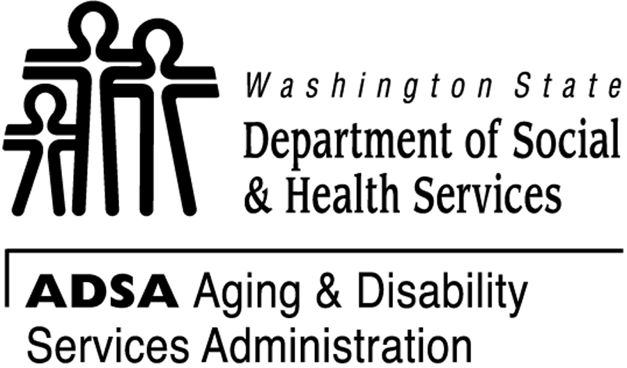AoA Older Americans Month 2008 Program Champion

Project: Washington State Chronic Disease Self-Management Program

Organizations: Washington State Department of Social and Health Services, Aging and Disability Services Administration and Washington State Department of Health, Chronic Disease Prevention Unit/Division of Community and Family Health

Description

The Washington State Aging and Disability Services Administration in collaboration with the Washington State Department of Health, three Area Agencies on Aging and three community-based aging service providers are providing Stanford University’s Chronic Disease Self Management Program (CDSMP). The work with our community providers is expanding the CDSMP to three racially diverse and high risk elder communities, and by doing so, strengthening our capacity at the state and community levels to disseminate, replicate, and sustain the CDSMP in Washington State. The sponsors are providing CDSMP through our partner organizations to:

- The elders of two tribal nations -- the Nooksack and Shoalwater -- through collaboration with their tribal health clinics in Western Washington
- Hispanic seniors, through collaboration with the Yakima Valley Farm Workers Clinic (YVFWC), in Eastern Washington.

As a result of this work, the project will:

- Improve access to the evidence based practice of CDSMP for hard to reach, aging populations on both sides of Washington state that experience a disproportionate burden of chronic diseases. The project expects to serve over 300 clients in three communities.
- Develop a state database of CDSMP participants, increase our state pool of CDSMP trainers and leaders, and build a sustainable web-based resource for CDSMP,
- Assure sustained efforts through expanding partnerships, networking our grant project sites and Area Agencies on Aging with other interested providers and funding sources.

Highlights

- Since the inception of the grant classes have been provided to Hispanic elders at a Catholic church in Yakima Washington. Participants are receiving the Spanish version of CDSMP and have been encouraged to participate in better management of their health by their physicians, families, and friends. Elders are feeling more connected, and more confident in their ability to control their own lives.
- Project partners on the Washington coast with the Shoalwater Tribe are collaborating with other coastal tribes to share and network their health resources.
- The Washington State Department of Health is funding the week-long Master Trainer training in eastern Washington for both English and Spanish versions of CDSMP. We are training 26 trainers. Health care providers in Washington State are excited to provide evidence based services to their elder consumers, improve healthy aging and improve the health of our communities.

For more information on this project contact Candace Goehring, MN RN at (360) 725-2562 or via e-mail at goehrcs@dshs.wa.gov. You may also contact Samantha Barker at
360-725-2572 or via e-mail barkesj@dshs.wa.gov

