
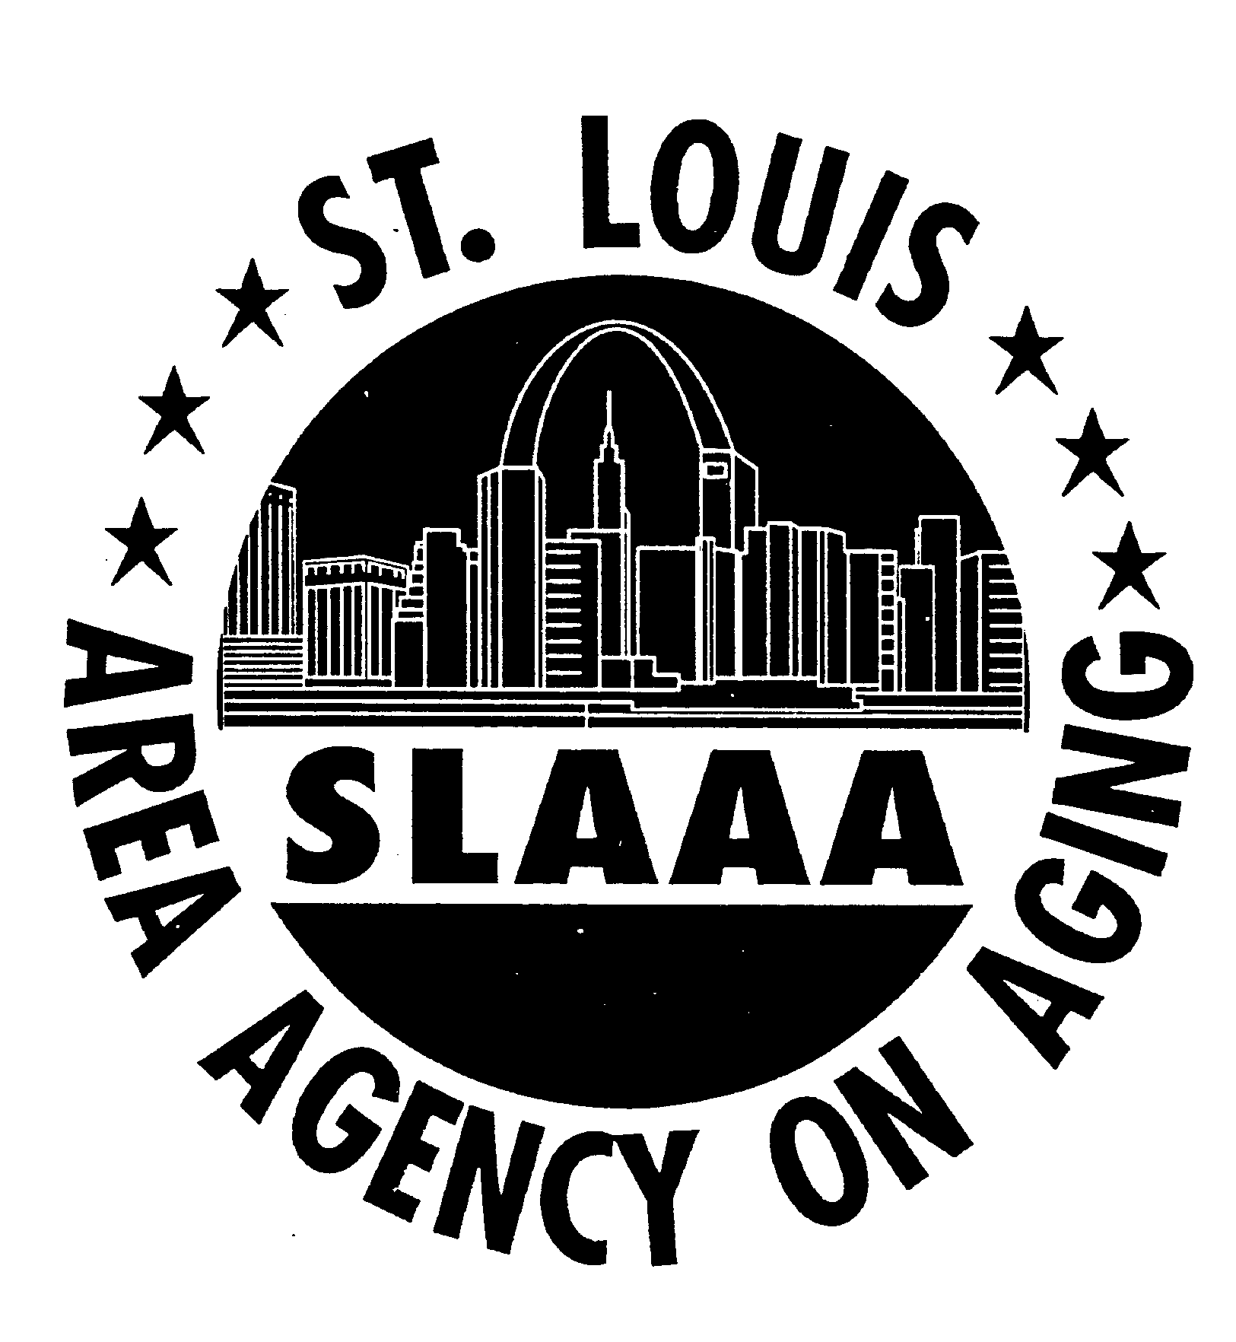
AoA Older Americans Month 2008 Program Champion

Project: Community Based Enrollment Campaign for the Low-Income Subsidy

Organization: St. Louis Area Agency on Aging

Project Description:

In partnership with the National Association of Area Agencies on Aging (n4a), the U.S. Administration on Aging and the Centers for Medicare and Medicaid Services, St. Louis Area Agency on Aging (SLAAA) has been developing innovative and targeted outreach strategies for the potentially eligible Low-Income Subsidy (LIS) population within Medicare Part D. Through a thorough understanding of community resources and partnerships and developing a monthly focus and media calendar to promote prescription drug assistance awareness, SLAAA is helping seniors and their caregivers obtain the tools and education they need to make better informed decisions about their prescription drug access in the City of St. Louis. The goal of the program is to identify as many beneficiaries as possible who are potentially eligible for LIS, providing group education and individual personalize counseling and to assist in applying for the subsidy.

SLAAA was able to work with Care Improvement Plus in providing education and information about LIS to clients enrolled in Care Improvement Plus Special Needs Programs. They also worked with WellCare in providing information about LIS to clients in senior housing facilities. SLAAA presented training information to a group of Psychiatric Geriatric Fellows at the St. Louis University School of Medicine about how they can assist their patients in getting help with prescription drug costs.

During the month of February, SLAAA worked with the International Institute in helping their older adult immigrant clients sign up for LIS at the local Social Security Office. The Social Security offices were opened on two consecutive Saturdays to accommodate this population. A total of about 25 Vietnamese older adult immigrants were helped. SLAAA is planning to assist them with the older Bosnian population at a later date.

SLAAA participated in a Community Health Fair sponsored by Community Health in Partnership Services (CHIPs) and provided LIS information to about 50 residents living at the Sullivan Place Apartments. To date in this campaign SLAAA has provided 32 group education events with over 800 participating individuals. They have performed 260 individual counseling sessions about LIS and have helped to submit 96 LIS applications to Social Security.

For more information contact David Sykora at (314) 612-5900 or via e-mail at
sykorad@stlouiscity.com.

