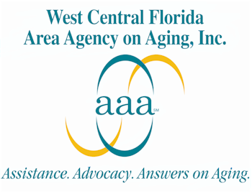

Program Name: Living Healthy: A Chronic Disease Self-Management Program

Organization Name: West Central Florida Area Agency on Aging

In early 2007, the West Central Florida Area Agency on Aging (WCFAAA) adopted the Stanford University’s “Chronic Disease Self-Management Program,” known in Florida as the “Living Healthy” program, as its main evidence-based health promotion program.

The WCFAAA chose to implement the Living Healthy program because of its proven success in teaching the aging population the behavior change skills necessary to manage their chronic conditions and develop a healthy lifestyle. The goal of the Living Healthy program is to improve the physical and emotional health of participants, while reducing health care costs. By learning key behavior change techniques and having a weekly opportunity to practice those techniques, participants acquire the additional skills needed to manage their conditions, reduce the risk of disease, and improve overall health.

Through an ongoing partnership with the Florida Department of Elder Affairs, the Florida Department of Health Bureau of Chronic Disease Prevention and Health Promotion, and various community partnerships, the Living Healthy program is now available to low income, minority and medically underserved seniors in our five-county planning and service area (PSA). In an effort to reach a diverse group of individuals with chronic conditions, courses are held free of charge at local senior centers, meal sites, HUD housing facilities, and faith-based organizations. Classes meet for two and a half hours, once a week, for six weeks and can be delivered to individuals no matter the level of frailty, disease progression or functional impairment. Additionally, interested caregivers are encouraged to enroll in the course along with their loved ones.

Throughout the year, the WCFAAA focused on educating aging service providers regarding the benefits of evidence-based programming in an effort to build the infrastructure to support further implementation of the program in our PSA. This was done through regular communication with community leaders, presentations to local health coalitions, and by providing information about the program to the target audience. Potential instructors were recruited from within the community, and then asked to assist in planning courses and recruiting participants.

In 2008, the team fully implemented the Living Healthy program and expects to reach approximately 200 seniors during the course of the year, with special focus on the Hispanic population. They anticipate the following outcomes: reducing the frequency of physician visits, reducing hospital utilization rates, and reducing emergency room visits among those completing the six-week course. Additionally, participants will demonstrate improved self-efficacy for disease management, improved cognitive function, improved communication with family, caregivers and health professionals, and enhanced connection to other resources within the Aging Network.

As a result of these various partnerships, continued success of the Living Healthy program should be evident in the coming year. For more information, contact
Maureen Kelly (813) 740-3888 Ext. 5572 or Kellym@elderaffairs.org
The website for the West Central Florida Area Agency on Aging is http://www.wcfaaa.org

