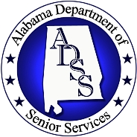

Name of Program: ALABAMA SAFE CENTER FOR SENIOR CITIZENS

Name of Organization: Alabama Department of Senior Services

Program Description:

Effective April 21st, 2008, the State of Alabama opened the doors to the nation’s first “Safe Center for Senior Citizens.” The Safe Center combines a senior center that will be used daily with a safe center area that will provide a place of respite for elders in the event of a disaster.

The Safe Center concept was developed in response to needs identified for special populations after recent hurricanes and tornados. Before the storms there was no identified safe shelter and after the storms, seniors did not have a safe place they could go to regain a since of normalcy and reconnect with friends. Breaking ground on this Safe Center was a landmark event toward ensuring the safety of Alabama’s seniors and demonstrates commitment to their well-being.

The Guin Safe Center serves as a model for other communities as Alabama works to ensure that senior citizens have a place of daily respite and safety before, during and after disasters such as the hurricanes and tornadoes that have devastated parts of our country in recent years.

The Safe Center is equipped with generator power and extra wall outlets that can be used to operate light medical equipment such as portable oxygen machines. The center has an area for seniors in the early stages of Alzheimer’s or dementia. Each Safe Center will have a satellite telephone to ensure communication before, during and after storms and other natural disasters. The building is designed according to Federal Emergency Management Agency (FEMA) standards to withstand hurricane and tornado force winds, floods and other hazardous conditions.

The Safe Center is a wise use of public resources because it serves the dual purpose of a place for daily senior activities and a place of respite after a disaster. The Safe Center concept will serve as a model as Alabama continues to build new senior centers and renovate existing ones.

All Safe Centers will have similar architecture and the same light blue roof color for recognition. If a senior from south Alabama is visiting family in north Alabama, they can look for the blue roof and know the Safe Center is there to serve them after a disaster.

Trained staff and volunteers operate the Safe Center which is stocked with appropriate supplies and shelf-staple meals. The center has full showering and laundry facilities in the event seniors need to stay for an extended period of time.

The Safe Center was developed through a partnership between the Alabama Department of Senior Services, U.S. Administration on Aging, Alabama Emergency Management Agency, Alabama Department of Economic and Community Affairs and the City of Guin. For more information, contact Irene B. Collins at (334) 242-5743 or by email at
irene.collins@adss.alabama.gov

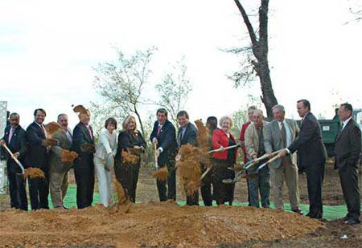
Assistant Secretary Carbonell, Irene Collins, Executive Director of the Alabama Department of Senior Services and other Federal, State and local leaders at the groundbreaking for the Safe Center.

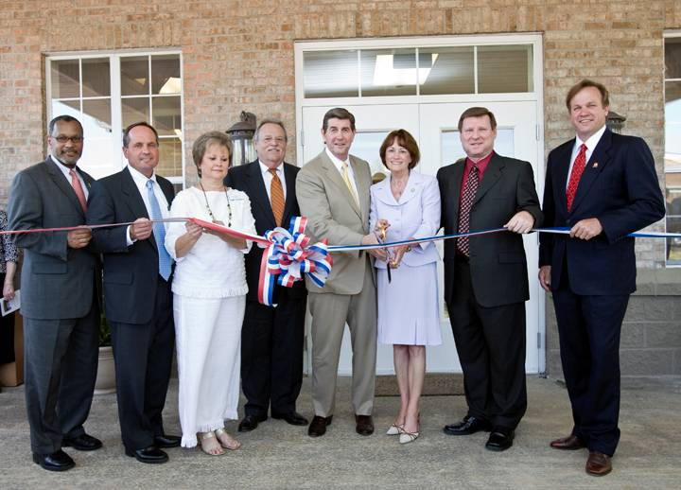
Edwin Walker, Administration on Aging Deputy Assistant Secretary for Policy and Programs, Irene Collins, Executive Director of the Alabama Department of Senior Services, and other State and local leaders at the opening of the Safe Center.

