Modernizing Older Americans Act Programs

U.S. Administration on Aging

2006
Table of Contents

Message From the Assistant Secretary for Aging………………………….3

I. Introduction………………………………………………………………4

II. Empowering Individuals to Make Informed Choices…………………...6

III. Enabling Seniors to Remain in Their Own Homes……………………11

IV. Empowering Older People to Stay Active and Healthy……………….15

V. Ensuring the Rights of Older People…………………………………...19

FY2006 Financial Report………………………………………………….28

Message From the Assistant Secretary for Aging

I’m pleased to present to you Modernizing Older Americans Act Programs, a document that chronicles the partnerships between the U.S. Administration on Aging (AoA) and the National Aging Services Network (the Network) to respond to the increasingly diverse needs of today’s aging population. We have made great strides throughout the past year working in step with other Federal agencies that provide services to our Nation’s older adults, their families and caregivers, and populations with disabilities.

A landmark event in particular helped make 2006 an exciting time to serve older adults: the reauthorization of the Older Americans Act (OAA). On October 17, President Bush signed amendments to the OAA, endorsing continued Federal support to ensure the dignity and independence of our older citizens. The legislation incorporates a number of significant changes designed to modernize the delivery of aging services and long-term care for the 21st Century, including new provisions that reflect the core principles of Choices for Independence.

The new provisions in the OAA establish a unifying strategy for advancing long-term care systems change in three key areas: easing consumers’ access to existing services and supports; making it easier for seniors to make use of low-cost, evidence-based prevention programs; and using flexible service models to help consumers who are at high-risk of nursing home placement—but not yet eligible for Medicaid—to remain in their own homes and communities. The provisions build on and strengthen the unique mission, capacity, and success of the Network in advancing systemic changes at the State and local levels.

In December, AoA hosted its Choices Summit, a unique gathering of nearly 1,300 Network representatives from all corners of the Nation, as well as AoA staff, Federal policymakers, and other professionals serving older adults. The Choices Summit provided a substantive introduction to the new provisions in the OAA, and it afforded attendees an opportunity to engage in extraordinary peer-to-peer exchanges of best practices that State and local representatives can use to enhance quality of life for the older adults they serve, rebalance our system of health and long-term care, and position the Network for the future.

This is a time of sweeping change and opportunity in the field of aging, health, and long-term care. Significant progress in the technology available to improve health care, increased focus on prevention strategies, and the growing importance of home and community-based care are just three key factors transforming the landscape of health and long-term care delivery. Embracing these and other changes provides great opportunities for AoA and the Network to advance our common mission: to ensure that these changes occur in ways that respond to the needs and preferences of the people we serve. AoA remains committed to modernizing our programs and services and providing the best possible service to the Nation’s older adults.

Josefina G. Carbonell, Assistant Secretary for Aging
I. Introduction

Our Mission

The mission of the Administration on Aging, as embodied in the OAA of 1965, is to help elderly individuals maintain their dignity and independence in their homes and communities through comprehensive, coordinated, and cost-effective systems of long-term care, and livable communities across the United States. AoA does this by serving as the Federal agency responsible for advancing the concerns and interests of older people and by providing national leadership, funding, technical support, and oversight to the Network, which is charged under the OAA with responsibility for promoting the development of a comprehensive and coordinated system of home and community-based long-term care that is responsive to the needs and preferences of older people and their family caregivers.

Our Priorities

The OAA has played an important role for many years in shaping our Nation’s health and long-term care system to help older adults learn about and access opportunities for maintaining their health and well-being in the community. However, the aging of America is creating new challenges and opportunities for our Nation’s system of care for older adults. The number of older people is increasing rapidly, and those reaching age 65 are living longer than ever before. By 2030, the population age 65 and over will almost double, as will the 85-plus population—the group most in need of long-term support. These demographic shifts have profound implications for the Nation’s system of long-term care.

To help our Nation respond to these challenges, AoA continues to work with its partners at the Federal, State, and community levels to help strengthen the Nation’s capacity to promote the dignity and independence of older people. AoA will do this by collaborating our efforts that aim to transform our Nation’s system of health and long-term care to be more responsive to the needs and preferences of older people and their family caregivers; providing more support for community living; promoting consumer choice, control, and independence; encouraging people to take positive steps to maintain their health; and assisting people while they are still healthy and able to plan ahead for their care. In support of these priorities, AoA has developed the following five programmatic priorities to guide and focus our investment of effort and resources over the next five years:

1. Empower older people, their families, and other consumers to make informed decisions about, and to be able to easily access, existing health and long-term care options.

2. Enable seniors to remain in their own homes with high quality of life for as long as possible through the provision of home and community-based services, including supports for family caregivers.

3. Empower older people to stay active and healthy through OAA services and the new prevention benefits under Medicare, including evidence-based disease and disability prevention programs.

4. Ensure the rights of older people and prevent their abuse, neglect, and exploitation.

5. Maintain effective and responsive management.

Our Overall Approach

AoA’s overall approach for achieving its goals and objectives is to support initiatives, in partnership with other Federal agencies and national organizations, that strengthen the capacity of the Network at the State and local levels to advance systemic changes in the Nation’s system of care in a manner that will make our system of long-term care more consumer-directed and supportive of community-living. AoA continues to focus on initiatives that build on the latest research and best practices from the field and capitalize on the unique assets and core programs inherent in the OAA. We believe that investment in such initiatives as the Aging and Disability Resource Center grants program, the Own Your Future campaign, the Evidence-Based Disease and Disability Prevention grants program, and the Cash and Counseling program add significant value to our Nation’s evolving health and long-term care system.

ADMINISTRATION ON AGING

Modernizing Older Americans Act Programs

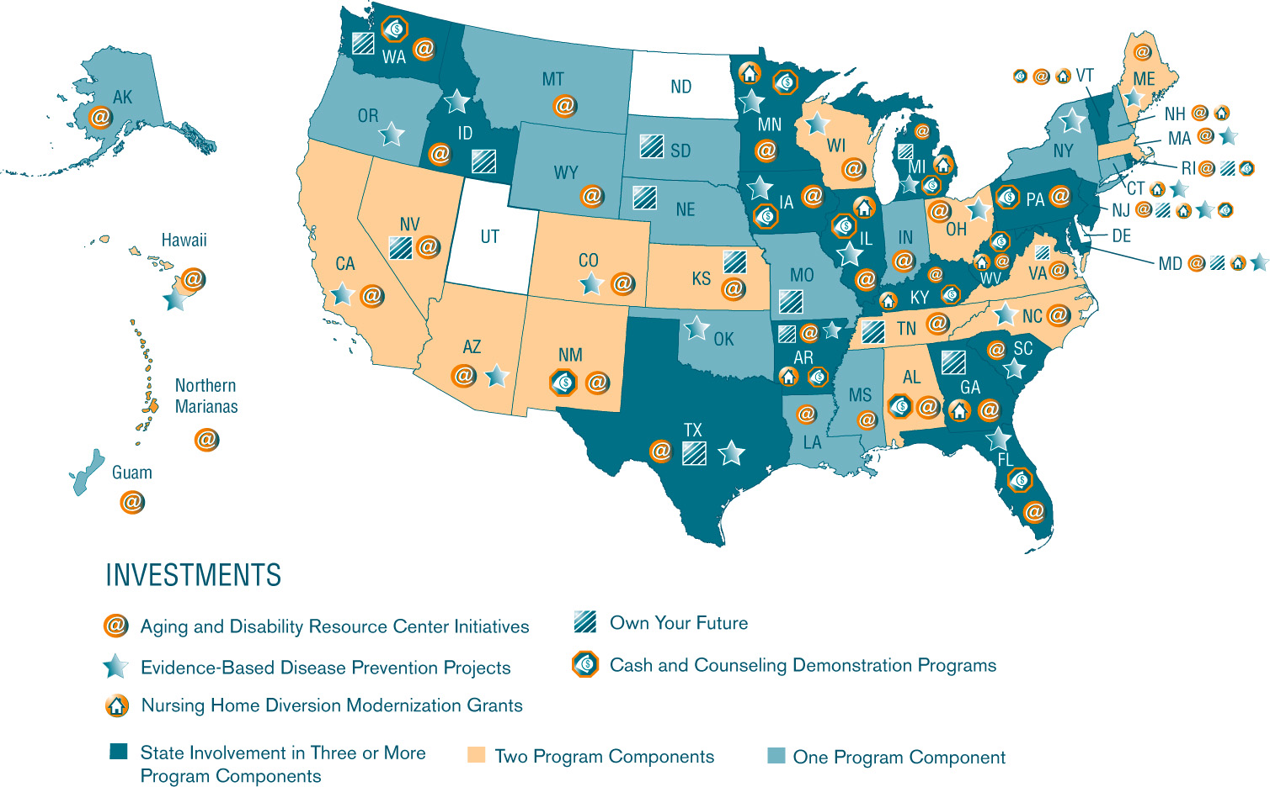

II. Empowering Individuals to Make Informed Choices

The Network is the premier system for providing information and assistance on the broadest range of topics for the greatest number of older adults. Since the passage of the OAA in 1965, the Network has developed a wide range of programs that provide information, counseling, education, and advocacy services of benefit to older adults. Through various access, community-based, in-home, and advocacy service programs, the Network provides outreach, information, education, and counseling; empowers older persons to act on their own behalf; advocates on behalf of frail and vulnerable older individuals; and advocates for systems change.

Network services have empowered seniors and their families to make informed choices about their care and provided more than 13 million information and referral contacts on programs and services. More than 20 million people received information on available caregiver resources.

The efforts outlined in this section build on the fact that the Network is viewed by older people and their families as a “trusted source of information.” AoA is working with Federal, State, and local partners to make it easier for consumers to learn about and access existing services and supports in their communities. AoA continues to advance single-entry-point models to the long-term care system; support efforts to educate and counsel on a variety of topics including Medicare and emergency preparedness; and champion public awareness about the need to plan ahead for long-term care.

Aging and Disability Resource Centers

In 2006, AoA, in partnership with the Centers for Medicare and Medicaid Services (CMS), continued the historic national rollout of the Aging and Disability Resource Center (ADRC) grant program. The ADRC program is a critical element of AoA strategy for modernizing the Network, and the new OAA provisions direct AoA to work with CMS to implement ADRCs in all States. To support this directive, AoA provided continuation and supplemental grant award opportunities in 2006 to extend the current activities of the 2003 and 2004 grantees. To date, 43 States have received grants to support their efforts in developing one-stop centers where consumers have the opportunity to receive information and access to long-term supports, which range from in-home services to nursing facility care. These grants continue to assist States in their efforts to streamline access to multiple public and private programs. Additionally, the grants ensure that families can find the assistance they need through a single point of entry into the long-term care support system.

The ADRC program is part of the President’s New Freedom Initiative, which works to overcome barriers to community living for people with disabilities of all ages. This initiative provides States with an opportunity to effectively integrate their long-term support resources for consumers into a single, coordinated system. The development of
ADRCs is serving as a cornerstone for States pursuing significant long-term care reform efforts.

AoA recognizes that consumer expectations about human services are continually changing and should influence how we market, design, and implement our services. In response, funded ADRC States have made considerable progress in providing information on services for multiple populations, streamlining access to services, and increasing community partnerships and collaboration.

The ADRC initiative has demonstrated a number of outcomes. By fall 2006, 104 ADRC pilot sites were operational. More than half the States participating in the grants program have enacted laws, issued executive orders or invested State revenue in support of ADRCs. A survey of ADRC grantees indicated that 55 percent of referrals to ADRCs were from critical pathways to long-term supports, such as hospital discharge planners or physicians. Nine out of 10 ADRC clients surveyed indicated that they would recommend the ADRC to others. In addition, preliminary data indicates that ADRCs continue to receive increases in the number of contacts, repeat customers, and referrals among professionals. The ADRC Interim Outcomes Report is available at www.adrc-tae.org.

AGING AND DISABILITY RESOURCE CENTER AWARDEES

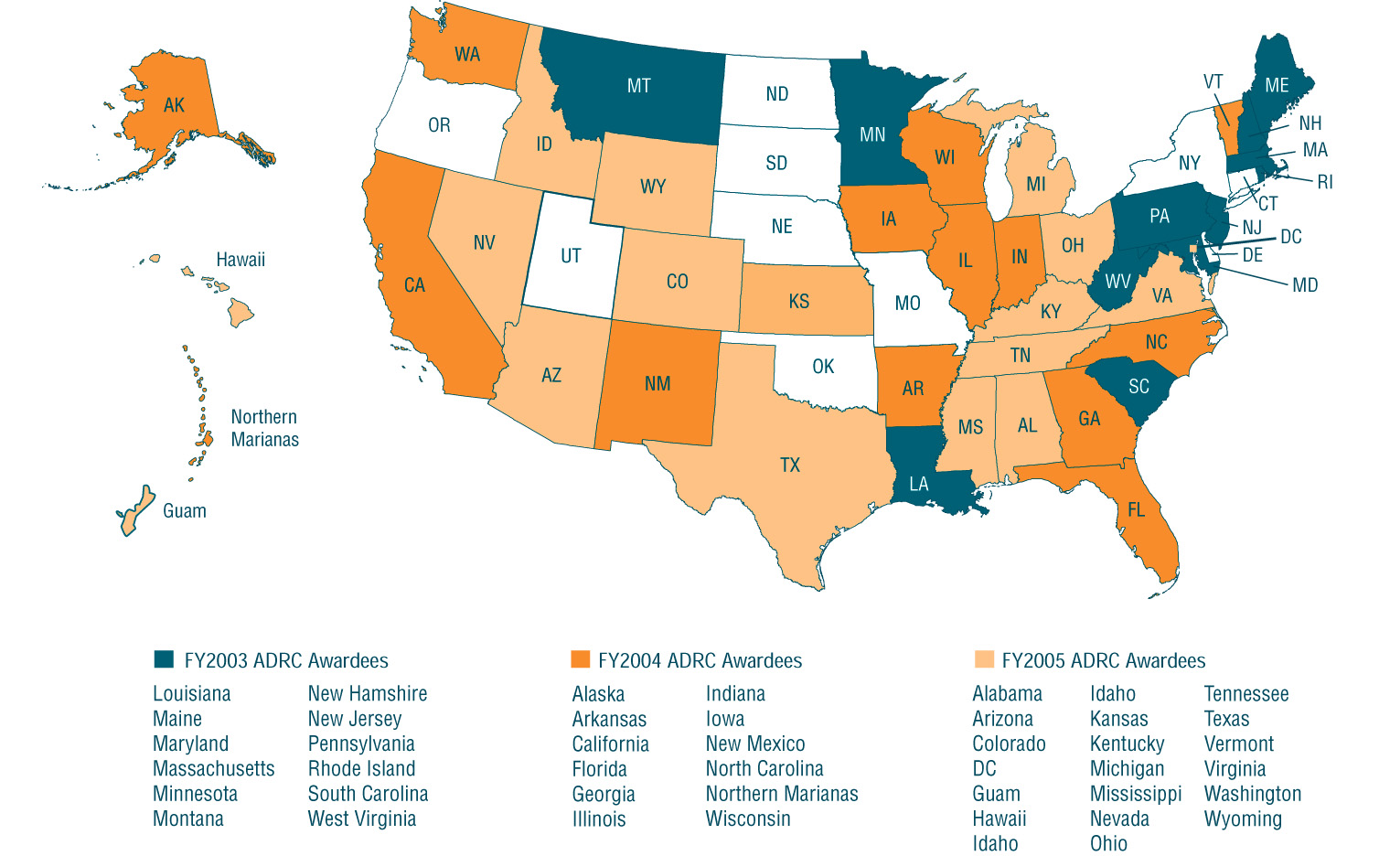

Implementing the Medicare Modernization Act

The year 2006 was a landmark for older people and younger people with disabilities. Through President George W. Bush’s Medicare Modernization and Improvement Act (MMA) of 2003, seniors are now offered greater choices, better access to prescription drugs and preventive care. For people with Medicare and limited incomes, the MMA helped pay for Medicare’s monthly premiums and the cost-sharing responsibilities associated with prescription drug coverage.

In 2006, AoA continued to actively partner with CMS and the Social Security Administration (SSA) to ensure that all older Americans take full advantage of the MMA, including assisting them to obtain the information needed to enroll in the new prescription drug benefit. Special efforts have been taken to reach older members of minority, limited-income, limited English-speaking, and other underserved populations.

AoA and the Network were the “foot soldiers” on the ground and provided an overall average of 1,000 educational sessions weekly, and approximately 40,000 beneficiaries received one-on-one enrollment assistance weekly. Through December 31, 2006, more than 39 million Americans—over 90 percent of people with Medicare—had prescription drug coverage.

The Network worked tirelessly to meet the needs of Medicare beneficiaries. Recognizing the strength of the Network, CMS and AoA continued to partner to provide specialized, targeted outreach. AoA, with cooperation from CMS, provided funding to the National Association of Area Agencies on Aging (n4a) to assist with the mobilization of the Network. This funding helped the Network provide training and financial support to national and community-based organizations so that they can provide enrollment beneficiaries with assistance and counseling. In addition, n4a worked with the National Council on Aging to provide technology assistance and tracking of beneficiary enrollment, and with the National Association of State Units on Aging to provide training and technical assistance on providing enrollment support.

National and Community-Based Organizations Making a Difference

The national organizations receiving funding exceeded expectations by achieving overwhelming success with beneficiary enrollment events, as well as with the number of beneficiaries that received enrollment assistance. A total of 81,270 Medicare beneficiaries received one-on-one assistance with enrolling in a Part D Prescription Drug Plan.

Planned Vs. Actual Number of Enrollment
Events of National Organizations
0
500
1000
1,500
2,000
Planned
Actual
Number of Events
# of Enrollment
Events

In addition to the national organizations, funding was provided to 144 community-based organizations (CBOs) selected by CMS and AoA within the Network. Financial assistance was based on need for additional support and a gap analysis. Funding was also awarded to State and Area Agencies on Aging (AAAs), who then partnered with local, traditional, and nontraditional partners in order to achieve their goals. The CBOs had an overall goal of providing one-on-one assistance to 50,806 beneficiaries. In the end, these CBOs provided enrollment assistance to 217,738 beneficiaries through 17,222 events, 400 percent over the goal.

CBO Expected Vs. Actual Enrollment Assistance

Own Your Future and the National Clearinghouse for Long-Term Care Information
AoA, in partnership with CMS and the U.S. Department of Health and Human Services (HHS) Assistant Secretary for Planning and Evaluation (ASPE), is exploring new ways to reach older adults and other key audiences about long-term care financing. Included in this effort is the Own Your Future campaign, a unique partnership between the Federal Government and States to offer a consistent message about the importance of planning ahead for long-term care. Such planning can help increase overall quality of life for adults as they age while helping to reduce public financing of health care costs.
Own Your Future began in 2005 in Arkansas, Idaho, Nevada, New Jersey, and Virginia. In 2006, AoA and its Federal partners expanded their successful work in educating older adults and other key audiences about long-term care planning and financing and launched State campaigns in Kansas, Maryland, Rhode Island, and Washington. Through campaigns in these nine States, Governors have sent letters to more than 3.5 million households with adults age 50 to 70. Late in 2006, additional State campaigns were funded in Georgia, Massachusetts, Michigan, Nebraska, South Dakota, and Texas—these campaigns will continue throughout 2007.
The success of the Own Your Future campaign resulted in support for both additional State campaigns and the new National Clearinghouse for Long-Term Care Information through the Deficit Reduction Act of 2005. Under the Act, Congress appropriated $15 million for the Clearinghouse and State awareness campaigns over five years.
The National Clearinghouse for Long-Term Care Information is now available at www.longtermcare.gov. This important new resource recognizes that while no one likes to think about needing long-term care services—such as help with bathing, dressing, or using the bathroom—about 60 percent of people over age 65 will require some long-term care at some point in their lives. As mandated by Congress, the Clearinghouse includes objective information to assist consumers with decision making regarding public and private long-term care financing options, provides contact information for objective resources for planning, educates consumers about Medicaid coverage and limitations, and provides information on State Long-Term Care Partnership Programs under Medicaid.

Emergency Preparedness

In today’s world, an emergency situation can occur in any location at any time. Emergency preparedness needs to be a priority for everyone, including older adults and caregivers. AoA and Caresource Healthcare Communications of Seattle, WA, jointly produced a toolkit for family caregivers titled Just In Case: Emergency Readiness for Older Adults and Caregivers. This resource addresses the important issues specific to older adults and caregivers for emergency preparation, including:
- Making a personal plan.
- Medications, medical equipment, mobility, and support services.
- Risks in your community.
- Preparing to stay at home and evacuate.
- Essential emergency supplies.

This toolkit consists of a fact sheet, checklist, and video that are available in English and Spanish. The fact sheet and checklist are accessible at www.aoa.gov.

III. Enabling Seniors to Remain in Their Own Homes

The Network is a consumer-driven, locally designed network that is supported by multiple funding streams and reaches into every community across the Nation, serving over 9 million seniors and over one million family caregivers each year. It is capable of reaching people with low-cost interventions long before they need intensive services. The home and community-based supportive services provided by the Network offers an array of supports that help older adults remain independent and at home. Services provided for seniors and their caregivers include access to such services as home delivered meals, transportation and case management; in-home services, such as personal care, chore, and homemaker assistance; and center-based services, such as congregate meals, adult day care, and respite care.
In FY2005, the Network provided the following vital home and community-based services to older adults:
- 36 million rides to doctor offices and other critical daily activities.
- 20 million hours of in-home services (personal care, homemaker, chore).
- 7 million hours of adult day care and day health services.
- 4 million hours of case management services.

In addition, nearly 70,000 caregivers were provided with respite care and an additional 150,000 received counseling and training services.

In addition to providing vital core home and community-based services, the Network has been a leader in advancing changes in the larger long-term system of care. At AoA, we are pleased to be working with the Network to give States more flexibility to help seniors at high risk of nursing home placement avoid or delay institutionalization. This section of the report will focus on our efforts to test new approaches to home and community-based services for older adults and caregivers, including efforts to support consumer-directed care; identifying and supporting innovations in aging services that involve the use of partnerships with managed care organizations or MMA demonstrations; and providing assistance to persons with Alzheimer’s disease and their caregivers.

Cash and Counseling

Cash and Counseling is a new approach to delivering home and community-based services that allows participants receiving supportive services to live more independently by directing their own care needs. Cash and Counseling gives people control over the types of services they receive and the manner in which services are delivered. This includes the option of hiring a family member, friend, or neighbor. The model was tested with a randomized control sample of elderly and younger people with disabilities who were eligible for Medicaid home and community-based services in Arkansas, New Jersey, and Florida. Compared to the traditional model, Cash and Counseling produced higher client satisfaction and better quality care. AoA continued to partner with ASPE and the Robert Wood Johnson Foundation to fund and support the replication of the Cash and Counseling model in the Medicaid program in 11 States: Alabama, Iowa, Kentucky, Michigan, Minnesota, New Mexico, Pennsylvania, Rhode Island, Vermont, Washington, and West Virginia. Illinois, funded by the Retirement Research Foundation, was added as an additional expansion State.
As of fall 2006, the Cash and Counseling expansion States were moving forward with program implementation. All States are expected to be fully functioning and enrolling consumers before the end of 2007.
The outcomes for participants in Cash and Counseling, including increased independence and improved quality of life, mirror the goals of the OAA, and the Network is playing a leadership role in its replication. State Units on Aging are responsible for the grant program in eight of the 12 replication States. For example, the Illinois Department of Aging is the lead agency for that State’s demonstration, and AAAs will be the fiscal intermediaries for the program when it is fully launched. Minnesota is using supplemental funding to work with AAAs and providers to make consumer-directed respite services available to family caregivers. The Cash and Counseling model was incorporated into the OAA as part of the 2006 Reauthorization, and AoA plans to actively promote its use in OAA programs over the coming years.
Integrated Care Management

As new options for older people are emerging in health and long-term care, managed care is playing an increasingly important role. Over 20 percent of Medicare beneficiaries are now enrolled in managed care plans. AoA’s Integrated Care Management Grants Program provided small grants to AAAs and Aging Services Provider Organizations to support partnerships between the Network and managed care plans to improve the delivery of services to older adults, enhance the integration of health and social supports, and help position the Network in the evolving health and long-term care system. Ten grants were awarded to the following organizations:
- Alzheimer’s Disease & Related Disorders Association, Los Angeles, CA
- Area Agency on Aging 10B, Inc., Uniontown, OH
- Atlanta Regional Commission, Atlanta, GA
- Benjamin Rose Institute, Cleveland, OH
- Chinese American Service League, Chicago, IL
- City of Inglewood, Inglewood, CA
- Gulf Coast Jewish Family Services, Inc., Clearwater, FL
- Kenosha County Department of Human Services, Kenosha, WI
- San Mateo County, San Mateo, CA
- Senior Services of Seattle/King County, Seattle, WA

A variety of partnership models were supported under the program, reaching a broad range of populations including people with dementia, beneficiaries duly eligible for Medicare and Medicaid, patients with end-stage renal disease, older adults with chronic diseases, and others. For example, in Los Angeles, the Alzheimer’s Association partnered with HealthCare Partners Medical Group, a mixed staff/preferred provider organization and model Medicare managed care organization, to create an evaluation-based intervention to reduce expenses while improving quality of care given to people with dementia and their caregivers. As a result of the project, a new care management protocol was developed and implemented within the Medical Group, along with new consumer educational materials for caregivers who are served by the Group.

The Access Atlanta project in Atlanta, GA, focused largely on home monitoring of patients, communication between partners for care plan development, status updates and referrals, and promotion of chronic disease self-management. The project targeted all shared patients (those enrolled in the Evercare managed care organization and receiving services through the Network) with one or more chronic conditions. The project resulted in improved referral processes between the participating agencies. The Buffalo, NY, project focused on reducing falls and hip fractures among high-risk elderly. That partnership between the AAA and the Independent Health Association (an Individual Practice Association-Health Maintenance Organization or IPA/HMO) resulted in the AAA incorporating a “Fall Risk Assessment Tool” that was developed by the IPA/HMO and incorporated into its screening and assessment software. In this way the AAA case managers can use it to identify persons likely to benefit from fall prevention measures. Overall, the program demonstrated the value of partnerships that leverage and coordinate the unique capacities, experiences, and shared interests of the Network and managed care organizations to improve the quality of life for older Americans.

Alzheimer’s Disease Initiatives

The Alzheimer’s Disease Demonstration Grants to States (ADDGS) program is designed to test innovative approaches to providing diagnostic and support services to persons with Alzheimer’s disease, their families, and their caregivers, and to incorporate proven approaches into statewide systems of home and community-based services so that those systems become more responsive to the needs of persons with dementia and their family caregivers. The program focuses on serving hard-to-reach and underserved people with Alzheimer’s disease or related disorders.

AoA awarded grants to 38 State governmental agencies in 2006 to demonstrate how existing public and private resources within States can be more effectively coordinated and utilized to enhance educational needs and service delivery systems for persons with Alzheimer’s disease, their families, and caregivers. Grantees are required to focus on using the ADDGS program as a vehicle for advancing changes in their State’s overall system of home and community-based care, and they are supported by the AoA-funded ADDGS National Resource Center. For more information, go to www.aoa.gov/alz.

AoA continued support of the Alzheimer’s Association Nationwide Contact Center, which serves people with memory loss and their caregivers, health care professionals, and the public. The Contact Center offers around-the-clock information and referral and care consultation services; focuses on expanding service to traditionally underserved populations, in particular Hispanic/Latino communities; provides an online communication forum through the use of message boards and chat rooms, available in both English and Spanish; and shares best practices and lessons learned to assist the Network in developing, improving, or expanding telephone or Web-based assistance to the elderly and their caregivers. For more information, call 1–800–272–3900.

IV. Empowering Older People to Stay Active and Healthy

AoA is pleased to be supporting HHS Secretary Mike Leavitt’s priorities as we work toward achieving President Bush’s vision of a healthier, safer, and more hopeful America. Prevention is a focus and an underlying principle of the core AoA services provided by the Network. Our nutrition programs ensure that millions of older adults have access to the nutritious food they need to stay healthy and decrease their risk of disability. Approximately 911,000 homebound seniors received 140 million meals in FY2005, while an additional 1.7 million seniors received meals in a group setting.

Over the past several years, AoA has been partnering with the Centers for Disease Control and Prevention, the National Institute on Aging, the Agency for Healthcare Research and Quality, CMS, and a variety of national and community foundations to implement programs that can empower older individuals to make lifestyle changes to reduce their risk of disease, disability, and injury. We began an initiative in 2003 to put the best available science into the hands of older people who are at risk of chronic disease so they can take more control of their own health. We also continue to support programs that focus on eliminating health disparities among minority populations. This section of the report will highlight these important efforts to support the health of older adults.

Evidence-Based Disease Prevention Programs

Since 2003, AoA has invested discretionary funds to promote the adoption of evidence-based disease and disability prevention programs through community-based service providers for older adults. The programs target older Americans who are disproportionately affected by chronic diseases and conditions, such as arthritis, diabetes, and heart disease, as well as disabilities from such injuries as falls.

The 2003 initiative used research results from the HHS science and health agencies with the goal of developing the knowledge, experience, and infrastructure to facilitate the implementation of evidence-based disease prevention programs at the community level. Twelve community-based projects were funded that focused on strategies to improve participant outcomes in chronic disease self-management, fall prevention, nutrition, physical activity, depression, and medication management. The success of this initiative led AoA to expand the program in 2006, in partnership with Atlantic Philanthropies, to help 24 States mobilize public/private partnerships to implement and to sustain the delivery of evidence-based disease prevention programs through nonprofit service providers for the aging. Additionally, during the 2006 Reauthorization, Congress embedded the Network’s use of evidence-based prevention programs into the OAA.

Following are summaries of some of the recently funded State projects.

Ohio: The Ohio Departments of Aging and Health, AAAs, and community-based health care and service organizations for the aging are proposing to implement and evaluate evidence-based programs on chronic disease self-care, physical activity, and fall prevention in multiple regions of the State. The goal is to implement the Stanford Chronic Disease Self-Management Program in AAA 4 (Toledo), AAA 6 (Columbus), AAA 8 (Appalachian Southeast Ohio), and AAA 10B (Akron); sustain and expand the Active Living Every Day program (a.k.a. Active for Life) in Southwestern Ohio (Cincinnati); and implement the A Matter of Balance: Managing Concerns About Falls Volunteer Lay Leader Model in Cuyahoga County (Cleveland).

South Carolina: The South Carolina Lieutenant Governor’s Office on Aging, the South Carolina Department of Health and Environmental Control, and their partners plan to implement evidence-based disease prevention programs. Goals are to increase the quality and years of life for seniors with chronic diseases or who have fears of falling, and to develop and sustain an infrastructure of partnerships to embed the Stanford Chronic Disease Self-Management Program and the A Matter of Balance program in State health and long-term care systems.

Florida: The Florida Department of Health, in collaboration with the Florida Department of Elder Affairs, proposes to implement the Stanford Chronic Disease Self-Management Program and the Spanish Arthritis Self-Management Program and other evidence-based self-management programs. The project’s goal is to provide evidence-based interventions for arthritis and other chronic conditions to the maximum number of people, age 60 and older, that are at risk for and can benefit from the interventions.

Hawaii: Hawaii’s Executive Office on Aging and its key partners, the State Department of Health and three of Hawaii’s four AAAs, proposes to implement its Healthy Aging Partnership—Empowering Elders initiative. Its statewide goals are to continue building the Network’s capacity in evidence-based programming and effectively embed two evidence-based programs, the Stanford Chronic Disease Self-Management Program and the Enhance Fitness Program, in its network for the aging.

Eliminating Health Disparities

AoA provided funding to four organizations to reduce or eliminate racial and ethnic disparities in health among older adults. Funded projects developed, tailored, and translated culturally competent health promotion and disease prevention information. The projects also tested strategies designed to encourage healthy behaviors among older individuals in each of the four major racial and ethnic minority groups: African American, Asian and Pacific Islander (API), Hispanic, and American Indians and Alaska Natives.

Asociaciòn Nacional Pro Personas Mayores

Salud a la Vida

Older Individuals of Hispanic Decent: Asociaciòn Nacional Pro Personas Mayores, using the fotonovela format, developed bilingual health promotion interventions in the areas of cardiovascular disease (one fotonovela each for older men and older women), prostate cancer for older men, diabetes and its impact on Hispanics, and good nutrition as it affects these conditions. To accompany the fotonovela on prostate cancer, a bilingual DVD that approaches the sensitive subject from an Hispanic man’s point of view was developed for use by health educators. PowerPoint presentations for use by health educators complemented each fotonovela.

Additionally, the project developed and disseminated a bilingual immunization campaign package targeting the Hispanic community. The campaign theme is “Chispa a La Viva! Vacunate!/Get a Spark of Life! Get Immunized!” A logo, poster, and 60-minute radio spot using a soccer game as the background, along with a 30-minute televison spot, have been distributed throughout Hispanic markets in the United States.

National Caucus and Center on the Black Aged

The Healing Zone: Community Health Action and Advocacy Training Project

African-American Seniors: The National Caucus and Center on the Black Aged conducted this faith-based community health leadership program in collaboration with its network and the Network. The program aims to reduce obesity as a leading risk factor for chronic disease. Through 35 churches in five cities, faith-based community health and action coalitions worked to increase awareness about the negative impacts of physical inactivity and unhealthy eating practices. The coalitions also stressed the positive impact of reducing obesity as a risk factor for chronic conditions, such as diabetes, cardiovascular disease, and kidney failure. Over the course of the three-year project, Healing Zone coalitions responded to the critical impact of obesity and associated health conditions by integrating health promotion efforts with the blend of mind, body, and spirit often reflected in African-American churches. Using this strategy, the program maximized partnerships and services, cultivated expertise, and reached more than 600 older African Americans with critical information.

National Indian Council on Aging

Preventing Diabetes: Healthy Living for American-Indian Elders

American-Indian Elders: The National Indian Council on Aging (NICOA) offered culturally competent and linguistically appropriate health promotion and disease prevention strategies for American-Indian and Alaska-Native elders through its Five a Day, the Indian Way project. The project promotes positive, healthy behaviors that will strengthen the elders’ capacity to maintain active, independent lifestyles within their communities and to prevent or better control type 2 diabetes. To accomplish this, NICOA partnered with Hunger Grow Away, a national nonprofit focusing on addressing hunger and malnutrition one family at a time.

The goal of Five a Day, the Indian Way is to assist elders in preventing or controlling type 2 diabetes by maintaining a healthy diet and low-impact physical activity through family and community gardening. The project makes use of Hunger Grow Away’s “Abundant Harvest Garden” model. It is expected that elders will have a healthy diet and remain more active to prevent or better control type 2 diabetes; increase their consumption of fresh fruits and vegetables; revitalize the family garden; and increase intergenerational activities that promote healthy Native communities.

National Asian Pacific Center on Aging

Addressing Health Disparities Among Asian and Pacific Islander Elders

Asian and Pacific Islander Elders: The National Asian Pacific Center on Aging (NAPCA) focused on designing and translating materials that would assist older APIs to access health promotion and disease prevention information. Activities focused on diabetes included translating paper risk tests into API languages for participation in the HHS Diabetes Detection Initiative. NAPCA participated in the roll-out of the MMA by translating forms and other materials, conducting outreach, and establishing a Bilingual Helpline that provided information on MMA enrollment and low-income subsidies in Cantonese, Mandarin, Korean, Vietnamese, and English.

V. Ensuring the Rights of Older People

AoA’s commitment to improving long-term care, especially the systems directing information and access to long-term care, will also benefit national efforts to protect older Americans from threats to their independence and well-being. Ensuring the rights of older adults and preventing their abuse, neglect, and exploitation is one of AoA’s key strategic priorities. AoA’s elder rights programs strive to protect seniors from known abuses to which they are vulnerable, while providing support to enhance older individuals’ right to make choices about their future, to live independently, and to participate fully in community life.

OAA Vulnerable Elder Rights Programs protect and enhance the basic rights and benefits of vulnerable older people, and empower them to make informed choices that enhance their ability to remain in the community. The programs provide a range of services, including training, systems development, and public education, that help to protect the rights and safety of vulnerable older people.

Prevention of Elder Abuse, Neglect, and Exploitation

The OAA Amendments of 2006 provide AoA further opportunities for Federal leadership in strengthening elder justice strategic planning and direction for programs, activities, and research related to elder abuse awareness and prevention. The following illustrates how programs to prevent elder abuse, neglect, and exploitation are serving older adults at the local level:
- In Sonoma County, CA, the Elder Abuse Prevention Council created a Court Advocacy Workgroup made up of senior volunteers. The workgroup follows cases of elder abuse and exploitation to help raise their visibility within the judicial system.
- The Florida Department of Elder Affairs’ Senior Companion Program trains volunteers and local Adult Protective Services staff in abuse, neglect, and exploitation to work with self-neglecting elders to improve their outcomes.
- The Washington, DC, Office on Aging supports an Adult Abuse Prevention Committee, which develops work plans each year that include initiatives such as consumer fraud prevention conferences, roundtables with different agencies and organizations to collaborate efforts, and training for bank security personnel to identify financial exploitation.

The National Center on Elder Abuse (NCEA) disseminates information related to the prevention of elder abuse and neglect to professionals and the public, and also provides technical assistance and training to States and community-based organizations. In recognition of the call for greater leadership in the 2006 reauthorization of the OAA, AoA committed to examine how the NCEA could be better positioned to assist AoA in implementing some of the provisions in the OAA in FY2007.

The NCEA has always operated as a multi-disciplinary consortium of equal partners with expertise in elder abuse, neglect, and exploitation. The following highlights NCEA’s 2006 activities. For more information, please visit www.ncea.aoa.gov:
- NCEA E-Newsletter: More than 1,700 subscribers worldwide receive this newsletter.
- Clearinghouse on Abuse and Neglect of the Elderly (CANE): Wth more than 6,000 holdings, the CANE database catalogs the largest collection of peer-reviewed and scholarly publications on all aspects of elder abuse.
- NCEA Elder Abuse Listserv: The listserv includes 1,670 members worldwide.
- National APS/Elder Abuse Training Library: The library’s holdings include 170 subject matter-specific resources gathered from around the Nation.
- NCEA Web Site: In 2006 alone, there were 3.7 million page requests.
- Webcast Forums: To date, 700 professionals have participated in our national Webcasts to gain new insights and hear how others are dealing with the issues.
- NCEA Promising Practices Database: The online database includes 400 promising local models and practices and can easily be searched by State or topic.

The Long-Term Care Ombudsman Program

Long-term care ombudsmen are advocates for residents of long-term care facilities. They work to resolve individuals’ concerns with care and quality of life and to bring about changes at the local, State, and Federal levels to improve conditions for all facility residents. Established under Section 712 of the OAA, ombudsman programs in every State and 569 local or regional areas carry out a variety of activities to assist residents to maintain a good quality of life and care in nursing facilities, assisted living facilities, and other types of long-term care settings. Thousands of trained paid and volunteer ombudsmen provide an ongoing presence in long-term care facilities, monitoring care and residents’ rights and providing a voice for residents and their families.

Ombudsman responsibilities as outlined in Title VII of the OAA include the following:
- Identify, investigate, and resolve complaints made by or on behalf of residents.
- Provide information to residents about long-term care services.
- Represent the interests of residents before governmental agencies and seek administrative, legal, and other remedies to protect residents.
- Analyze, comment on, and recommend changes in laws and regulations pertaining to the health, safety, welfare, and rights of residents.
- Educate and inform consumers and the general public regarding issues and concerns related to long-term care and facilitate public comment on laws, regulations, policies and actions.
- Promote the development of citizen organizations to participate in the program.
- Provide technical support for the development of resident and family councils to protect the well-being and rights of residents.

The National Long-Term Care Ombudsman Resource Center, operated by the National Citizens’ Coalition for Nursing Home Reform in conjunction with the National Association of State Units on Aging, provides on-call technical assistance and intensive training to assist ombudsmen in their demanding work. The Center is supported with funds appropriated by Congress and awarded by AoA.
States provide annual reports to AoA through the National Ombudsman Reporting System (NORS). The following sections provide data for FY2006 from all State ombudsman programs on the activities of the Ombudsman Program at the State and local levels and analyze changes in the data since FY1996, the first year of full NORS data compilation.

Ombudsman Presence in Facilities and Empowerment of Families and Residents

- Ombudsman staff and volunteers visited almost 80 percent of nursing facilities on a regular basis, defined as at least quarterly and not in response to a complaint. In 19 States, ombudsmen regularly visited 100 percent of nursing facilities; in another 10 States, ombudsmen regularly visited 90 or more percent of the nursing facilities in their State.

- Nationwide, ombudsman staff and volunteers visited almost 42 percent of board and care and similar homes on a regular basis. In 11 States, ombudsmen regularly visited 100 percent of these types of homes; in another four States, ombudsmen regularly visited 80 or more percent of these types of homes in their State.

- Ombudsmen provided over 317,000 consultations to individuals in 2006. These consultations have more than doubled since FY1996. Consultations most frequently addressed such topics as alternatives to institutional care, how to select and pay for a nursing facility, residents’ rights, and Federal and State facility rules and policies.

- Ombudsman consultations to long-term care facilities provide useful information to facility managers and staff. Ombudsmen provided almost 122,000 consultations to facility staff in FY2006. Consultations address a wide range of issues, including residents’ rights, observations about care, working with behavioral issues, and transfer and discharge issues.

- Nationwide, ombudsmen also:
- Met with resident councils (20,620 sessions) and family councils (5,379 sessions).
- Provided 6,743 training sessions to facility staff.
- Facilitated or conducted 11,656 community education sessions.
- Participated in 13,878 facility surveys.

Services to Individuals (Complaint Investigation and Resolution)

- In FY2006, ombudsmen resolved or partially resolved over 79 percent of nursing facility complaints and over 74 percent of board and care complaints to the satisfaction of the resident or complainant. Since 2000, complaint resolution has exceeded three quarters of complaints in all facilities (over 78 percent in 2006).

- Ombudsmen nationwide opened 190,354 cases and closed 182,599 cases involving 285,659 individual complaints in FY2006.

- Of the cases handled, 143,616 were associated with nursing facility settings. Of the remaining cases, 36,671 were related to board and care, assisted living, residential care, and other facilities, and 2,312 were associated with other settings.

- Most cases were initiated by residents or friends and relatives of residents, with residents initiating over 37 percent of cases in nursing facilities and over 30 percent in board and care, assisted living, residential care, and other similar facilities.

- The five most frequent nursing facility complaints were unanswered requests for assistance; inadequate or no discharge/eviction notice or planning; lack of respect for residents, poor staff attitudes; problems with care planning and resident assessment; and accidents and improper handling. These five complaints constituted 21 percent of all complaints in 2006; four have consistently been the same since 2000, and the only new one, inadequate or no discharge/eviction notice or planning, was ranked second nationally in 2006.

- The five most frequent board and care and similar facilities complaints were medications—administration, organization; quality, quantity, variation, and choice of food; inadequate or no discharge/eviction notice or planning; equipment or building hazards; and lack of respect for residents, poor staff attitudes. These complaints have been the five most frequent since 1999 and constitute 21 percent of all complaints.

Staffing, Providing Support to Volunteers, and Local Programs

- The number of paid ombudsman staff increased to 1,301 full-time equivalents (FTEs) in FY2006.

- In 2006, there were 9,183 ombudsman volunteers certified to investigate complaints, almost all of them serving in the 569 local programs throughout the Nation.

- Providing technical assistance and training to paid and volunteer ombudsmen is a significant function of State-level ombudsman program staff. In 32 State entities, the program staff spent 30 percent or more of their time providing technical assistance to volunteers and local programs. In another eight of the remaining State entities, program staff used 20 percent or more of their time supporting and training ombudsmen.

- In FY2006, ombudsman program staff provided or arranged for over 11,000 training sessions, totaling 48,621 hours, to their volunteers and staff.

Senior Legal Services

The OAA is one of the top funding sources for low-income senior legal assistance. There are approximately 1,000 OAA-funded legal services providers nationwide, which help to ensure that older Americans receive legal assistance and critical information. AoA’s legal programs help older Americans and their caregivers address threats to home ownership (such as predatory lending and consumer scams), obtain financial powers of attorney or guardianships that can prevent or stop financial exploitation, and apply for public benefits that promote health and independence.

The following are examples of how AoA legal services help seniors:
- A caller to the ElderAccessLine in Nebraska received a writ of execution directing the sheriff to sell her house in order to satisfy a judgment lien filed against the property. Since the senior had never received notice of the underlying lawsuit, helpline staff were able to halt the judgment and give her time to obtain a reverse mortgage. The debt has been paid off, and the caller remains in her home.
- As a result of a focused outreach campaign, the Michigan senior legal helpline helped more than 500 seniors complete the Michigan Durable Power of Attorney for Health Care Form.
- The Pennsylvania SeniorLAW Helpline translated its outreach materials into six languages (Spanish, Chinese, Russian, Korean, Vietnamese, and Cambodian) and, as a result, saw an increase in the number of language-, ethnic-, and cultural-minority seniors served grow from nine to 16 percent within a six-month period.

In addition, AoA currently funds eight Grants to Enhance Access to Senior Legal Services and six new Model Approaches to Statewide Legal Assistance Systems, which provide States with cost-effective ways to increase the number of seniors who receive this type of assistance. The purpose of the Model Approaches grants is to develop models for statewide legal services development and delivery systems that coordinate the efforts of senior legal helplines, Title III-B legal resources, private bar pro bono activities, law school clinics and self-help sites to ensure maximum impact from limited resources. Upon completion of the three-year grant period, grantees are expected to present cost-effective examples of integrated State legal services delivery systems that increase overall access to legal services within their States. These grants are intended to enhance statewide consistency and efficiency in senior legal services program delivery through incorporating the use of low-cost legal services mechanisms into the State legal services planning and development process.

AoA also funds five national legal resource centers that work to improve the quality and accessibility of the legal assistance provided to older people across the United States.

In 2006, these resource centers carried out the following activities:
- Initiated a legal training project entitled “Reach Out to Indian Country” to meet the needs of Indian tribes.
- Conducted numerous trainings on elder law topics, such as guardianship, SSI and other public benefits, elder abuse and financial exploitation, housing issues, and predatory lending.
- Disseminated consumer education brochures and factsheets on topics such as telemarketing fraud, medical debt, and identity theft.
- Responded to more than 2,000 requests for technical assistance and in-depth case consultation, including information and resources on State laws and tools for health care decision making and surrogate decision making.
- Provided direct onsite technical assistance in the implementation of Model Approaches to Statewide Legal Assistance Systems.

SMP Projects (formerly Senior Medicare Patrol)

Since the mid-1990s, AoA has partnered with CMS, the HHS Office of the Inspector General, and the U.S. Department of Justice in a Government-led effort to fight fraud, error, and abuse in the Medicare and Medicaid programs through implementation of a health care integrity program designed to coordinate Federal, State, and local resources to target areas most plagued by program abuses. Today, there are 57 SMP projects covering every State, the District of Columbia, Guam, Puerto Rico, and the U.S. Virgin Islands.

SMP volunteers educate Medicare and Medicaid beneficiaries, family members, and caregivers about the importance of reviewing their Medicare notices to identify billing errors and potentially fraudulent activity. Program volunteers also encourage seniors to make inquiries to the SMP Program when such issues are identified, so that the project may ensure appropriate resolution or referral.

The National Consumer Protection Technical Resource Center provides technical assistance and support to SMP grantees. In 2006, the Center took the lead in educating SMP project staff on integrity issues related to Medicare Part D, targeting hard-to-reach populations, and numerous other subjects through teleconferences, training Webinars, a biweekly news clipping service, and timely consumer information alerts via the SMP network listserv. The Center’s mentoring program provided peer training and support to new SMP projects and project directors, and the Products and Practices of Distinction program recognized and shared SMP projects’ innovative approaches and products. The Center maintains a current, comprehensive Web site and information library for SMPs, seniors, and the general public at www.smpresource.org.

In 2006, 15 SMP Integration Projects were funded to enhance SMPs’ capacities to more effectively reach seniors with the message of health care fraud prevention. The Integration Projects seek to improve SMP beneficiary education in two areas:
- Grantees may focus on developing outreach strategies to address specific, targeted health care areas, including Medicaid, the Medicare Part D Prescription Drug Benefit, durable medical equipment, or home health care.
- Grantees may develop strategies and materials to reach specific hard-to-reach population groups previously underserved by the SMP program. These groups include tribal populations, non-English speaking, minority, ethnically or culturally diverse populations, as well as others not traditionally reached, such as homebound or long-term care residents.
Integration grantees will develop model approaches that will be shared with SMPs nationally in 2008.

In December, the SMP Program held the seventh national SMP conference, A New Era in Consumer Protection, in coordination with the AoA Choices Summit. The conference kicked off the program’s official adoption of a new program identity. It was announced that the Senior Medicare Patrol Program is now officially referred to as the “SMP Program.” Also new are its logo and the official tagline “Empowering Seniors to Prevent Healthcare Fraud.”
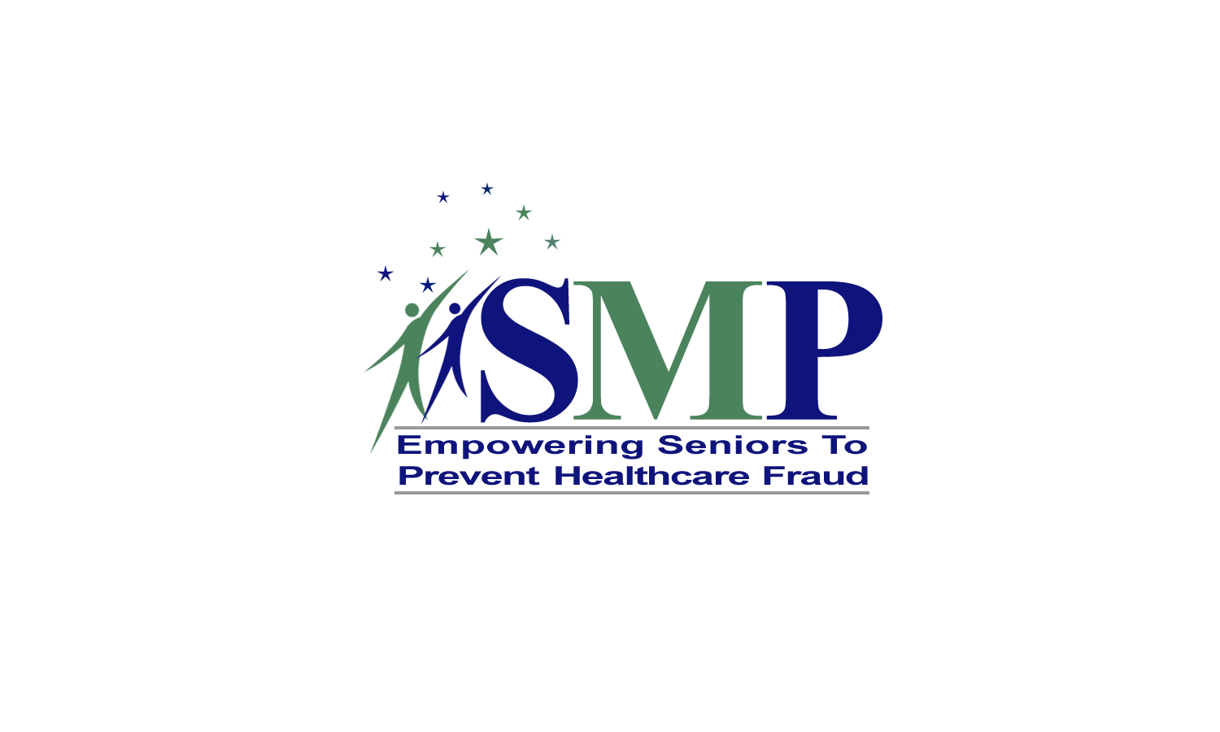

[Caption under the logo:
The adoption of a new national identity is a promising new direction for the
SMP Program, which will help unify best efforts in preventing health care fraud. Our new program tagline, “Empowering Seniors to Prevent Healthcare Fraud,” better captures the current mission, role, and activities of our program.]

New SMP fraud prevention media campaign materials were also introduced at the national conference. Materials include a newly designed SMP brochure, focused on the theme “Don’t Be a Target of Health Care Fraud,” which shares tips to “Protect, Detect, and Report” potential Medicare and other health care errors, fraud, and abuse. In addition, a newly designed Personal Health Care Journal, two new SMP educational videos, and two Public Service Announcements were included in the conference kickoff. All materials will be translated into Chinese, Korean, Vietnamese, Spanish, and Russian.

In 2006, AoA introduced a new Web-based SMP complaint management, tracking, and reporting system dubbed “SMART FACTS.” SMP project stakeholders have played an important role in providing feedback and testing at key points. SMART FACTS’ core function is capturing information on consumer inquiries received by SMP projects—both simple queries and more complex issues or complaints—as well as actions taken by the SMP to resolve or refer these matters. In addition, modules have been designed to allow SMPs to capture project activities, including outreach and education activities and volunteer management. Guidance to SMP users will help ensure linkage of SMP Program actions and results to SMP Program Strategic Objectives; enable greater consistency in decisions made on investigations or referrals; and improve the quality, depth, and consistency of data collected for semiannual OIG performance reporting.
Since inception, AoA’s SMP projects have:
- Trained more than 58,400 senior olunteers to serve as community resources and educators. (These volunteers in turn conducted more than 40,000 community education events.)
- Held more than 150,000 media events.
- Helped secure $104.5 million in savings to the trust fund or beneficiaries.

Pension Counseling and Retirement Planning

Thousands of individuals reach retirement age each year, only to be told that they cannot receive the benefits that they expected. Since 1993, the AoA Pension Counseling projects have helped older adults access information about their retirement benefits and negotiate with former employers and pension plan administrators for due compensation. Monetary recoveries have helped people achieve and maintain financial security, which has increased their independence and decision making.

AoA currently funds 6 regional counseling projects covering 25 States, and a National Pension Assistance Resource Center, which strengthens the pension counseling skills and capacities of the AoA Pension Counseling projects, SUAs, and AAAs. Data for the program shows that:

- Since 1993, Pension Counseling projects have successfully obtained well over $70 million in retirement benefits. During a six-month reporting period in FY2006, a single project (the Great Lakes Pension Rights Project) was able to recover $1,884,906 in benefits, representing a return of over $25 for each Federal dollar invested in the program.
- Projects have directly served more than 30,000 individuals by providing hands-on assistance in pursuing claims through administrative appeals processes, helping seniors locate pension plans “lost” as a result of mergers and acquisitions, answering queries about complex plan provisions, and making targeted referrals to other professionals for assistance.

By producing fact sheets and other publications, hosting Web sites, and conducting outreach, education, and awareness efforts, Pension Counseling projects also provide indirect services to tens of thousands of seniors and their families. Even when Pension Counseling projects are unable to secure benefits for clients, the information and assistance the projects provide can bring peace of mind to vulnerable elderly individuals, often after months or years of searching for answers.

Recognizing the critical components of economic security for older women, AoA provides funding to the Women’s Institute for a Secure Retirement (WISER) to support the National Education and Resource Center on Women and Retirement. WISER established a one-stop gateway that provides traditionally hard to reach women with “user friendly” retirement planning and financial education tools. Especially targeted are disadvantaged, hard-to-reach women, such as average- and low-income women, women of color, and women with limited English proficiency.

FY2006 Financial Report

The AoA budget totaled approximately $1.4 billion in FY2006. Of the FY2006 total, $1.26 billion provided formula grants to States to support a wide range of home and community-based services, including supportive and transportation services, caregiver services, nutrition, health promotion, and elder rights activities. Another $32.4 million provided grants to Indian Tribes and Native Hawaiian organizations for nutrition, supportive, and caregiver services.

Complementing these core formula grants, the FY2006 budget included $49.4 million for discretionary grant programs. These discretionary funds served as a catalyst for developing new approaches and techniques that States and communities used to help seniors: stay healthy, active, and independent; remain in their own homes and communities for as long as possible; prevent or delay nursing home placement; and avoid unnecessary spend-down of their resources. These funds also maintained support for a number of ongoing projects that provided information and technical assistance to older Americans and the Network. The AoA budget also included $17.7 million for program support, which paid for the salaries of approximately 113 Federal staff and other related administrative expenses.
The Network successfully leverages Federal funding to build coordinated service systems at the State and local levels. In FY2005, the most recent year for which data are available, States and local communities leveraged approximately $3 from other sources for every $1 of Federal funding. Funds are flexible and States and communities can tailor their programs to address the needs of consumers at the local level.

AoA is committed to being a good steward of taxpayer resources and to ensuring accountability in the use of its resources. Starting in FY2003, AoA’s financial Statements, policies, and procedures have been reviewed as part of the HHS consolidated “top-down” audit. In each year since then, HHS received a clean audit opinion.

U.S. Department of Health and Human Services
U.S. Administration on Aging
Washington, DC 20201
Phone: 202.619.0724
Fax: 202.357.3560
E-mail: aoainfo@aoa.gov
Internet: www.aoa.gov

