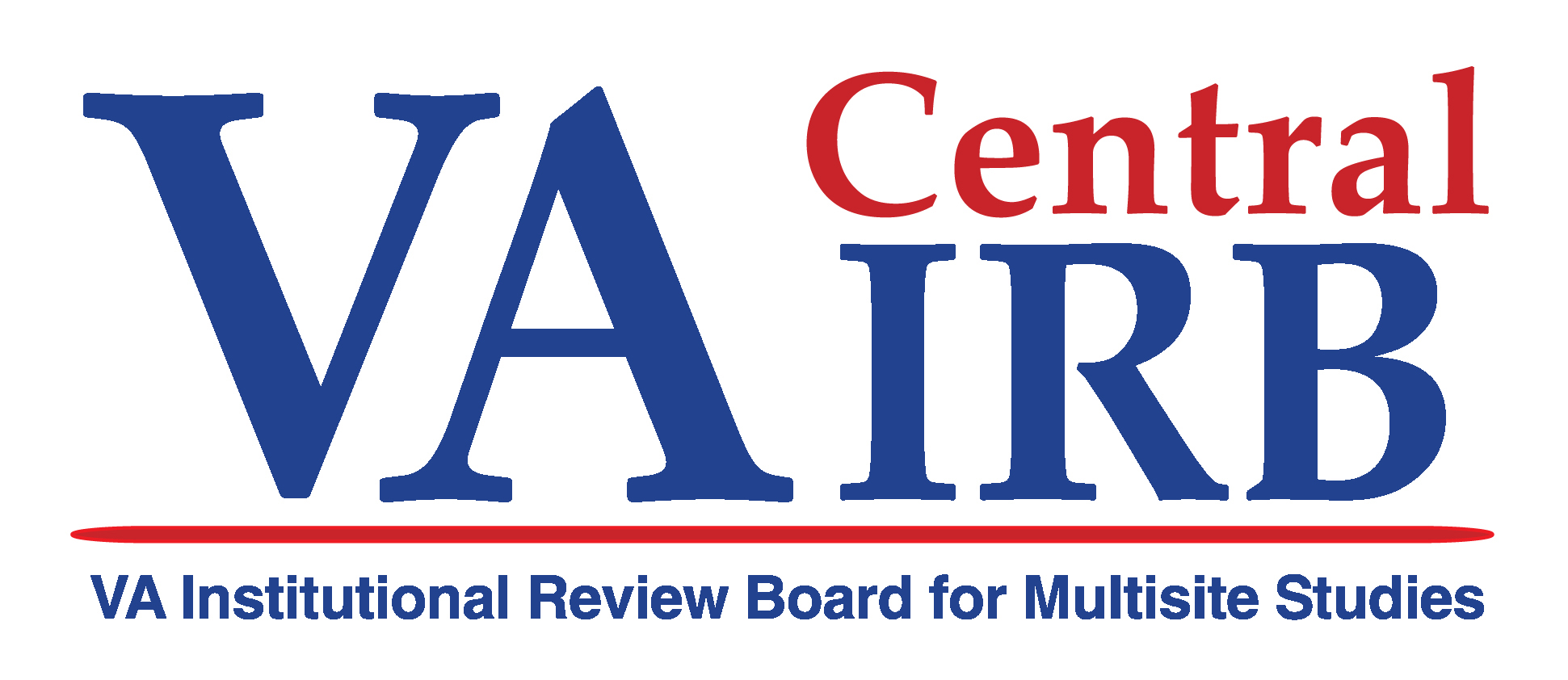
Guidance for Local SOPs for VA Facilities using the VA Central IRB as an IRB of Record

RESPONSIBILITIES

1. Retain ultimate responsibility for oversight of its local HRPP that includes:

a. Ensuring that all research approved or determined exempt by the VA Central IRB is submitted to the local site R&D Committee for review. | This should not require a change in current SOPs. However, you may want to have in your R&D Policy how the facility will communicate with the VA Central IRB.
b. Safeguarding the rights and welfare of human subjects of all research approved by its R&D Committee. | This should already be in your local policy.
c. Educating the members of its research community to establish and maintain a culture of compliance with all VA and other Federal requirements, as well as all {Name of Local VA Facility} requirements relevant to the protection of human subjects. | This should already be in your local policy.
d. Instituting appropriate local oversight mechanisms to ensure compliance with the determinations of VA Central IRB. This includes performing routine audits and monitoring of locally conducted VA Central IRB-approved projects and reporting results of these activities to VA Central IRB. | This may require a change in your auditing policy. Facilities may or may not have a separate auditing policy outside the IRB SOP, but probably should have. You will want to include dual reporting to the VA Central IRB and to the R&D Committee for those studies overseen by the VA Central IRB.
e. Promptly informing VA Central IRB of any complaints from subjects or others; unanticipated problems involving risks to subjects or others; serious adverse events that are unanticipated and related to the research; suspension or termination of research activities; or serious or continuing noncompliance encountered in VA human subjects research projects approved by VA Central IRB. The {Name of Local VA Facility} will work with VA Central IRB to ensure all VA and other Federal reporting requirements are met including, but not limited to, those specified in VHA Handbook 1058.1, Reporting Adverse Events in Research to the Office of Research Oversight (ORO). | First, the investigators must comply with the VA Central IRB requirements for reporting all events to the VA Central IRB. (see VA Central IRB SOPs #114, 118, and 126) Second, if the local VA discovers a problem or receives a complaint, this should be communicated to the VA Central IRB. This should be added to the appropriate local policies on complaints, unanticipated problems and adverse events, noncompliance, and suspension or termination where this is done by the R&D Committee or by an institutional official. Reporting to ORO and other Federal agencies should be coordinated with the VA Central IRB on those studies overseen by the VA Central IRB. (see SOP #125)

2. Modify its existing FWA, through ORO per VHA Handbook 1058.03, to designate VA Central IRB as an IRB of record.

If the {Name of Local VA Facility} uses one or more of its local academic affiliate’s IRBs as an IRB of record, the {Name of Local VA Facility} will review the relevant MOU {Name of Local VA Facility} holds with its academic affiliate and, if necessary, modify the MOU between {Name of Local VA Facility} and its academic affiliate to permit the {Name of Local VA Facility} to use VA Central IRB. | Not all facilities have in their SOPs how the FWA is handled or have MOUs with their academic affiliate. If you do, add a section that states which studies will be overseen by the VA Central IRB (i.e., multi-site VA studies) and that all others will be overseen by their affiliate IRB. Be sure that in the MOU with the affiliate it does not say that all VA studies must be reviewed by the affiliate IRB.
If the {Name of Local VA Facility} uses the services of another VA facility’s R&D Committee, then {Name of Local VA Facility} will review the relevant MOU with the other VA facility and, if necessary, modify the MOU to permit {Name of Local VA Facility} to use VA Central IRB. | If you use both the R&D and IRB of another VA, the MOU may reflect both committees. Add to that MOU that you will use the VA Central IRB for review and oversight of multi-site VA studies that are requested to be overseen by the VA Central IRB.

3. Maintain documentation that all required training, credentialing and privileging is up to date for all local HRPP staff and for all local research team members of VA Central IRB-approved projects. | This should already be in your SOPs and will require no change.
4. Work with the Local Site Investigator in preparing the Local Site Application to participate in any research project that has been designated for review by VA Central IRB. The Local Site Investigator will submit the Local Site Application to the PI and VA Central IRB through the local Associate Chief of Staff (ACOS) for R&D (or equivalent). | If you have an HRPP Policy, include that the VA Central IRB will be the IRB of record for multi-site VA studies that are requested by ORD to be reviewed and overseen by the VA Central IRB. For these studies, the Local Site Investigator must complete the VA Central IRB LSI application and have it signed by the ACOS/R&D or the Chief of Staff. A copy of the form and attachments should be filed with the local VA R&D Committee. You may want to have the investigator also complete your R&D application at this same time. You may put it on the R&D agenda at this time, or wait until you receive the review by the VA Central IRB. R&D approval will be required prior to initiating the study at your facility.
5. Provide comments and/or suggestions to VA Central IRB about VA Central IRB’s initial review considerations in a timely manner, not to exceed 30 calendar days, from the date of receipt of the initial review considerations. | There are a variety of ways that you may handle this. Determine which entity you want to do this review. Some facilities may choose to have the R&D Committee review the entire application along with the initial review considerations of the VA Central IRB. Others may want the IRB Chair or experienced reviewer to review the considerations and provide input to the VA Central IRB. Small sites may have the Chief of Staff do the review. Thus, depending on which entity does the review will affect which policy this needs to be added to.
6. Notify the Local Site Investigator and VA Central IRB in a timely manner, not to exceed 10 calendar days after receipt of VA Central IRB’s final approval of a project, whether or not the local site chooses to participate or declines to participate in the project. | This is related to the above procedures and depends on who you have indicated to provide this decision to the VA Central IRB.
7. Ensure the project is reviewed at the next regularly scheduled meeting of its R&D Committee after it agrees to participate in a given VA Central IRB-approved project. | Add to the R&D SOPs.
8. Ensure that the project is not started until it has been approved by both VA Central IRB and the local R&D Committee. | This should already be in your policies.
9. Forward any Freedom of Information Act (FOIA) requests received by {Name of Local VA Facility} for any records concerning VA Central IRB documents to the VHA Central Office FOIA Officer for review and release as applicable. | This does not need to be in a local policy.

10. Agree not to independently modify any VA Central IRB-approved protocol except where necessary to eliminate apparent immediate hazards to the human subjects in accordance with 21 CFR 56.108(a) and 38 CFR 16.103(b)(4).

a. VA Central IRB must be notified within 5 working days if such an action is taken. | This is an investigator responsibility.
b. VA Central IRB will not review emergency use of test articles. Such use must be reviewed at the local level in accordance with the {Name of Local VA Facility}’s policies and procedures. | You should already have a local policy on emergency use of a test article.

11. Notify VA Central IRB immediately of potential research impropriety, misconduct, suspension, debarment, or restriction of any local research team member associated with a VA Central IRB-approved project. | Include in the discussion with 1.e. above.
12. Provide VA Central IRB access to the research subjects’ clinical records and/or case files if required as part of any VA Central IRB oversight or monitoring activity. This includes providing access to any VA Central IRB member, administrative staff, or designee. | Include in the auditing plan in 1.d.
13. Participate in the annual review of the VHA Central Office HRPP, including an evaluation of VA Central IRB composition and operations, in accordance with VA Central IRB SOPs and as required by VHA Handbook 1200.1, the R&D Committee Handbook. | Include in the R&D SOP in the same way you review your local IRB of record.
14. Maintain compliance with any additional state, local, or institutional requirements related to the protection of human subjects. {Name of Local VA Facility} should consult its VA Regional Counsel Office or Office of General Counsel as needed. | This should already be in your policies.
15. Promptly notify VA Central IRB and the PI of any changes in the local study team on active projects. | The local site investigator is responsible for this. Your policy on multi-site studies should already reflect that it is the local investigator’s responsibility to notify the IRB of record and the PI of the study of any changes in personnel.
16. Provide procedures for coordinating approval of local committees, including but not limited to the R&D Committee, Radiation Safety Committee, Biosafety Committee, Institutional Animal Care and Use Committee (IACUC), and/or any other relevant local committees in accordance with local SOPs. Copies of such approvals must be submitted to VA Central IRB. | This should not be any different than what you are already doing to coordinate approvals from local committees. Although you may need to add the VA Central IRB in these policies if you refer to a specific IRB of record.
17. Conduct routine compliance audits and monitoring and report findings to appropriate regulatory authorities and VA Central IRB. This includes any audits or monitoring plan included in VA Central IRB final approval of the project. | Same as 1.d. above.
18. Maintain a file on each VA Central IRB-approved project that will include the PI’s Initial Application, the {Name of Local VA Facility}’s Local Site Application, VA Central IRB-approved consent form that will be used locally, other documents associated with the initial application, VA Central IRB final approval documents, {Name of Local VA Facility} R&D Committee approvals, local audits and monitoring reports, and any subsequent correspondence, amendments, continuing review reports and approvals, and any other pertinent documents. | This should be made part of the R&D protocol file unless you use an R&D committee of another VA. If you use the R&D of another VA, you should still have an office that is charged with oversight of the conduct of the research at your facility. This office should have a protocol file with all IRB and R&D information and correspondence.
19. Provide information as requested to the {Name of Local VA Facility} Local Site Investigator and the project’s PI as part of the continuing review process. | This should be in your multi-site study policy regarding communication with the IRB of record and the project PI.
20. Maintain current written SOPs that incorporate {Name of Local VA Facility}’s specific responsibilities as outlined in this MOU. | If you have a policy on SOPs, add mention of keeping your policies updated to reflect the interaction with the VA Central IRB. Not everyone will have such a policy.
21. Comply with all VA Central IRB SOPs as applicable. | This does not require a policy change.

22. The {Name of the Local VA Facility} will not:

a. Submit a Local Site Application for a specific project to VA Central IRB if another IRB of record for {Name of Local VA Facility} has already disapproved that VA facility’s participation in the project. | This is tied to #4 above. Add a statement that the ACOS/R&D may not sign off on the application if it has already been disapproved.
b. Submit an application to another IRB of record for review if VA Central IRB has determined that the {Name of Local VA Facility} should not participate in a specific project. | As with 22.a., add that the local IRB of record may not review a project that has been disapproved by the VA Central IRB.

