U.S. Department of Health and Human Services Administration on Aging

Challenges of Global Aging


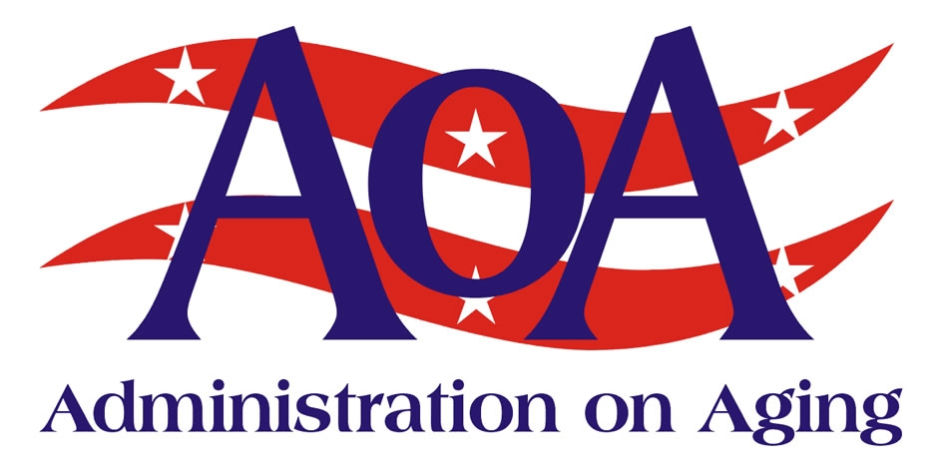

The Administration on Aging
The Administration on Aging (AoA), an agency in the U.S. Department of Health and Human Services, is one of the nation's largest providers of home- and community-based care for older persons and their caregivers. Our mission is to promote the dignity and independence of older people, and to help society prepare for an aging population.

Global Aging
The United States is faced with profound challenges associated with dramatic increases in the numbers of people living to an advanced old age.
This 21st Century phenomenon, shared by many nations, can be attributed to advances in science, technology and medicine leading to reductions in infant and maternal mortality, infectious and parasitic diseases, occupational safety measures, and improvements in nutrition and education.
Rapidly expanding numbers of very old people represent a social phenomenon without historical precedent. In 2000, the number of persons aged 60 years or older was estimated at 605 million. That number is projected to grow to almost 2 billion by 2050, when the population of older persons will be larger than the population of children (0-14 years) for the first time in human history.
Fifty-four percent, the largest share of the world's older persons, live in Asia. Europe has the next largest share, with 24 percent. [Sources: An Aging World 2001, U.S. Department of Commerce, UN Department of Public Information, DP/2264, March 2002.]
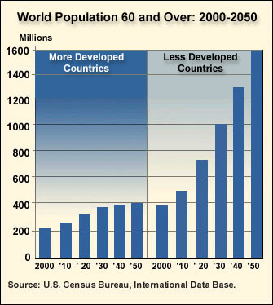
Population ageing will affect every man, woman and child anywhere in the world. The steady increase of older age groups will have a direct bearing on relationships within families, equity across generations, lifestyles, and the family solidarity that is the foundation of society. [Source: UN Department of Public Information, DP/2264, March 2002.]

U.S. Administration on Aging International Activities
As the federal focal point for older Americans and their caregivers, the Administration on Aging (AoA) plays a vital role in information exchange with other nations concerning aging issues. The AoA participates in a number of collaborative efforts with foreign governments and with international organizations, such as the United Nations, to enhance aging programs and policies worldwide.

We respond to requests for information from international organizations, foreign governments, and non-profit agencies. We host international scholars, officials and practitioners who come to the United States to learn first-hand about America’s response to population aging.

People’s Republic of China Agreement
The AoA and the China National Committee on Ageing of the People’s Republic of China have agreed to share information and to develop collaborative activities.
The U.S.-Mexico Binational Commission
The AoA is especially committed to working with neighboring countries. In 1996, a Health Working Group was established under the auspices of the U.S.-Mexico Binational Commission, which promotes exchanges at the Cabinet level on a wide range of issues critical to U.S.-Mexico relations.
The Aging Core Group, led in the U.S. by the Assistant Secretary for Aging, is one of six areas of collaboration between the U.S. Department of Health and Human Services and the Mexican Ministry of Health.
Ongoing exchanges of information, and shared training and technical assistance will help both countries to better address the special health needs of older people.
Examples of such treatable medical conditions are depression, nutritional deficiencies, adverse drug interactions, and metabolic changes.

Specific areas of collaboration include:
- Models of care for the elderly;
- Nutrition and the elderly; and
- Prevention and control of chronic disease in the elderly

Implementation of the International Plan of Action on Ageing
On April 12, 2002, the World Assembly on Ageing adopted the International Plan of Action on Ageing 2002 (the “Plan”). This Plan seeks to ensure that people everywhere will age with security and dignity, and continue to participate in their societies as citizens with full rights.
The top priorities include involving older persons in the development process; advancing health and well being into old age; and ensuring supportive environments that enable older persons to have choices.
Core themes included the recognition of the needs of older women; the desire of older people to stay active and engaged; and the need to create intergenerational solidarity. These themes demonstrate how the international community shares a common vision of a better future for older persons.
Leading the U.S. delegation, the Assistant Secretary for Aging, Josefina G. Carbonell, affirmed the U.S. commitment to these themes. The AoA, working in concert with other nations, will play a key role in implementing the Plan.

Working to Build
the Future of
Long-Term Care

Empowering adults as they age with reliable information and access to the care they need
Enabling individuals who are at high risk of nursing home placement to remain at home
Building disease prevention into community living through the use of low-cost, evidence-based programs

We respond to requests for information from international organizations, foreign governments, and non-profit agencies. We host international scholars, officials and practitioners who come to the United States to learn first-hand about America’s response to population aging.
People’s Republic of China Agreement
The AoA and the China National Committee on Ageing of the People’s Republic of China have agreed to share information and to develop collaborative activities.
The U.S.-Mexico Binational Commission

The AoA is especially committed to working with neighboring countries. In 1996, a Health Working Group was established under the auspices of the U.S.-Mexico Binational Commission, which promotes exchanges at the Cabinet level on a wide range of issues critical to U.S.-Mexico relations.

The Aging Core Group, led in the U.S. by the Assistant Secretary for Aging, is one of six areas of collaboration between the U.S. Department of Health and Human Services and the Mexican Ministry of Health.
Ongoing exchanges of information, and shared training and technical assistance will help both countries to better address the special health needs of older people.
Examples of such treatable medical conditions are depression, nutritional deficiencies, adverse drug interactions, and metabolic changes.
Specific areas of collaboration include:
Models of care for the elderly;
Nutrition and the elderly; and
Page 2 Working to Build the Future of Long Term Care
Administration on Aging | Fact Sheet
For More Information

AoA recognizes the importance of making information readily available to consumers, professionals, researchers, and students. Our website provides information for and about older persons, their families, and professionals involved in aging programs and services. For more information about AoA, please contact: US Dept of Health and Human Services, Administration on Aging, Washington, DC 20201; phone (202) 619-0724; fax (202) 357-3523; Email: aoainfo@aoa.gov or contact our website at www.aoa.gov

October 2008

