U.S. Department of Health and Human Services Administration on Aging

Alzheimer’s Disease Demonstration Grants to States (ADDGS)

Program of the Administration on Aging


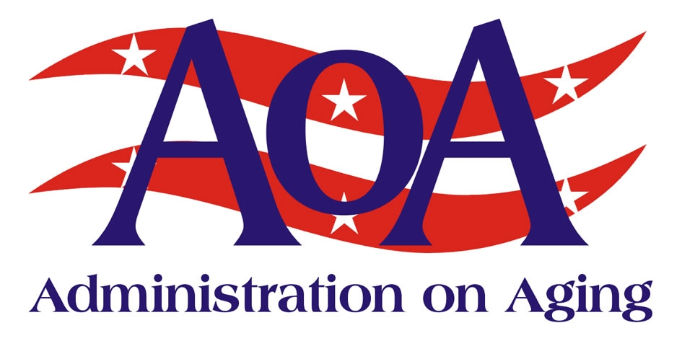

BACKGROUND
Congress created the Alzheimer’s Disease Demonstration Grants to States (ADDGS) program in 1991 to encourage states to develop models of assistance for persons with Alzheimer’s disease, and to encourage close coordination and incorporation of those services into the broader home and community-based care system. In 1998, Congress transferred the administration of the program to Administration on Aging (AoA) in an effort to ensure coordination with other programs for older Americans. To date, the ADDGS program has proven successful in targeting service and system development to traditionally underserved populations, including ethnic minorities, low-income, and rural families coping with Alzheimer’s disease.

There is no cure for Alzheimer’s disease and related forms of dementia (ADRD), however, there are effective strategies to help maintain cognitive function, reduce behavioral symptoms, prevent acute care crises and excess disability, and delay functional decline as well as nursing home placement. ADRD exists on a continuum that begins before diagnosis, and lasts through cognitive and functional decline to eventual total disability and death.

Although not a normal part of aging, one in 10 persons over 65 and nearly half of those over 85 may have ADRD. At least 10 million baby boomers will develop Alzheimer’s disease in their lifetimes – twice as many people as the number estimated to have the disease today. An additional 4 million baby boomers will develop a related dementia. Although ADRD eventually results in death, the disease can progress for years. A person with ADRD lives an average of 5 years, but can live as many as 20 years or more from the onset of symptoms.
PROGRAM MISSION

The mission of the ADDGS program is to expand the availability of diagnostic and support services for persons with Alzheimer’s disease, their families, and their caregivers, as well as to improve the responsiveness of the home and community based care system to persons with dementia. The program focuses on serving hard-to-reach and underserved people with ADRD.

The ADDGS program improves the responsiveness of states to closely coordinate and incorporate services to persons with dementia and their caregivers into the broader home and community-based long-term care services and supports system. The ADDGS Program supports the goals of the President’s New Freedom Initiative, which calls on federal Departments to support state efforts to make their systems of care more consumer-centered and more supportive of home and community-based care.

Under the 2008 ADDGS program announcement, states were able to apply for two types of grants: Evidence-Based Program Grants and Innovation Grants. The Evidence-Based Grants will demonstrate how existing science-based interventions are effective at helping people with ADRD to continue living in the community. These programs can be effectively implemented in other communities across the country by HHS’ national network of aging services provider organizations and their partners. Innovation grants will demonstrate innovative approaches to delivering services and supports to people with ADRD and their family caregivers with an emphasis on approaches that will serve those victims who are at highest risk of nursing home placement or who are in the early stages of ADRD.
ADDGS ACTIVITIES

AoA is assisting states to plan, implement, and evaluate ADDGS programs that:
• Incorporate and/or translate evidence-based research in the formulation of project proposals;
• Improve access of individuals with ADRD and their caregivers to home-based or community-based long-term care services, particularly for individuals who are members of racial or ethnic minority groups, who have limited proficiency in speaking the English language, or who live in rural areas;
• Advance systemic changes in how state’s home and community-based long-term care direct care service workforces assess, coordinate, incorporate and provide services to persons with ADRD and their caregivers; and,
• Provide individualized and public information, education, and referrals about diagnosis, treatment, and related services; sources of assistance for services; and legal rights of people affected by ADRD.

ADDGS GRANTEES

In FY08, HHS is providing $11 million to support the initiative from the Alzheimer’s disease Demonstration Grants to States (ADDGS) program which is administered by AoA. States are contributing $6.2 million to the effort. Of the grants awarded in 2008, 9 are evidence-based grants and 19 are innovation grants.

ADDITIONAL INFORMATION

For additional information on the ADDGS program initiative, including summary information on current and past grantees, please visit the AoA Alzheimer’s Resource Room at: http://www.aoa.gov/alz. You may also contact Donald Grantt, the ADDGS Project Officer, via email: donald.grantt@aoa.hhs.gov.

Working to Build
the Future of
Long-Term Care

Empowering adults as they age with reliable information and access to the care they need
Enabling individuals who are at high risk of nursing home placement to remain at home
Building disease prevention into community living through the use of low-cost, evidence-based programs

ADDGS GRANTEES

In FY08, HHS is providing $11 million to support the initiative from the Alzheimer’s disease Demonstration Grants to States (ADDGS) program which is administered by AoA. States are contributing $6.2 million to the effort. Of the grants awarded in 2008, 9 are evidence-based grants and 19 are innovation grants.

ADDITIONAL INFORMATION

For additional information on the ADDGS program initiative, including summary information on current and past grantees, please visit the AoA Alzheimer’s Resource Room at: http://www.aoa.gov/alz. You may also contact Donald Grantt, the ADDGS Project Officer, via email: donald.grantt@aoa.hhs.gov.

ADDGS ACTIVITIES

AoA is assisting states to plan, implement, and evaluate ADDGS programs that:
• Incorporate and/or translate evidence-based research in the formulation of project proposals;
• Improve access of individuals with ADRD and their caregivers to home-based or community-based long-term care services, particularly for individuals who are members of racial or ethnic minority groups, who have limited proficiency in speaking the English language, or who live in rural areas;
• Advance systemic changes in how state’s home and community-based long-term care direct care service workforces assess, coordinate, incorporate and provide services to persons with ADRD and their caregivers; and,
• Provide individualized and public information, education, and referrals about diagnosis, treatment, and related services; sources of assistance for services; and legal rights of people affected by ADRD.

Alzheimer’s Disease Demonstration Grants to States Awards for 2008Alabama ²Missouri ²Arizona ¹Nevada ²California ^{1,2,3}North Carolina ^{1,2}Florida ¹Ohio ^{1,2}Georgia ^{1,2}Oklahoma ²Indiana ²Rhode Island ²Louisiana ²South Carolina ²Maine ^{1,2}Tennessee ²Massachusetts ²Utah ²Michigan ¹Virginia ²Minnesota ^{1,2,3}Washington ²
¹ Evidence-Based ADDGS Grant
² Innovation ADDGS Grant
³ Also received a 2007 Evidence-Based ADDGS Grant

Page 2 Working to Build the Future of Long Term Care
Administration on Aging | Fact Sheet
For More Information
AoA recognizes the importance of making information readily available to consumers, professionals, researchers, and students. Our website provides information for and about older persons, their families, and professionals involved in aging programs and services. For more information about AoA, please contact: US Dept of Health and Human Services, Administration on Aging, Washington, DC 20201; phone (202) 619-0724; fax (202) 357-3523; Email: aoainfo@aoa.gov or contact our website at www.aoa.gov

October 2008

