U.S. Department of Health and Human Services Administration on Aging

Elder Rights:

Safeguards for the Most Vulnerable Among Us


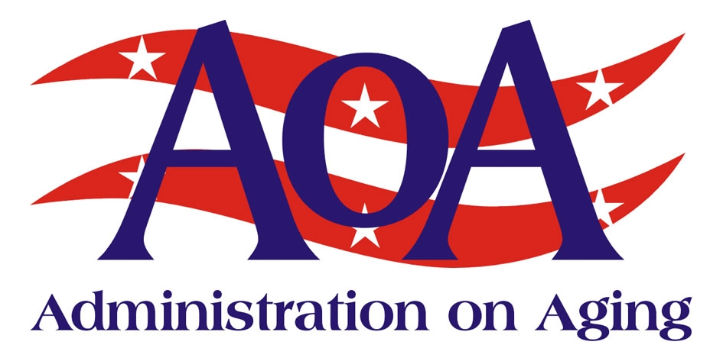

Elder Rights Protect and affect us all: Safeguards for the most vulnerable among us

More and more Americans are being confronted with the challenge of protecting themselves or their loved ones from the threats of elder abuse, neglect and exploitation. According to the 1998 National Elder Abuse Incidence Study, nearly half a million seniors suffer from abuse in domestic settings each year. This study also found that only one out of five cases of abuse are reported to the authorities.

A former police officer recently confronted this growing problem firsthand. “After my father died, my brother agreed to care for my mother who was diagnosed with Alzheimer’s disease. However, he began to neglect her, overmedicating her, leaving her in soiled underclothing, un-bathed and hungry.”

Because of his background, the former officer knew where to turn. “Our family had to do something about it, and we sought advice on handling it. If we hadn’t, who knows what would have happened.” These challenges are extremely
difficult – and yet until 1965, most older Americans had to rely mostly on themselves and were often subject to mistreatment and unfair practices that inhibited dignity and respect for older age.
To provide protection of vulnerable older adults, the Older Americans Act (OAA) was established into law to decree that older Americans were entitled to certain basic rights and benefits.

The law provides for the coordination and funding of a vast network of state and area agencies on aging and local providers that would implement programs and to protect the rights of older persons.

The U.S. Administration on Aging (AoA) was established at the federal level within the Department of Health Human Services in 1965 to oversee the development of the programs called for in the OAA. Today AoA’s aging network includes over 29,000 national, state, local and tribal organizations that work to keep older Americans healthy and in their homes, protect their rights, and assure their access to benefits and services.

The OAA has been amended several times. In 1992, Congress approved amendments that created Title VII – Allotments for Vulnerable Elder Rights Protection Activities. Title VII brought together the advocacy programs of the OAA and authorized development of a system of services, programs and personnel designed to help older persons understand their rights, exercise choice through informed decision-making and benefit from the support and opportunities promised by law.
Core themes included the recognition of the needs of older women; the desire of older people to stay active and engaged; and the need to create intergenerational solidarity. These themes demonstrate how the international community shares a common vision of a better future for older persons.
Leading the U.S. delegation, the Assistant Secretary for Aging, Josefina G. Carbonell, affirmed the U.S. commitment to these themes. The AoA, working in concert with other nations, will play a key role in implementing the Plan.

Working to Build
the Future of
Long-Term Care

Empowering adults as they age with reliable information and access to the care they need
Enabling individuals who are at high risk of nursing home placement to remain at home
Building disease prevention into community living through the use of low-cost, evidence-based programs

Page 2 Working to Build the Future of Long Term Care
As the effective and visible advocate for older Americans and their concerns, AoA is committed to protecting the rights of older Americans. “One of my top priorities is to ensure the rights of older people and prevent their abuse, neglect and exploitation. We are working to heighten awareness among other federal agencies, organizations, groups and the public about the needs of vulnerable older people,” said Josefina G. Carbonell, Assistant Secretary for Aging.

Specific Programs to Protect Elder Rights

AoA administers nutrition and community-based long-term care programs that allow millions of seniors to age in place with dignity. The agency also supports three Title VII programs that specifically promote the rights of seniors and protect them from abuse, neglect and exploitation. Each program is organized and coordinated on the national level by AoA and implemented at the state and local level by members of the aging network.

The goal of the Prevent Elder Abuse, Neglect, and Exploitation program is to develop and strengthen prevention efforts at the state and local level. This includes funding for state and local public awareness campaigns, training programs and multi-disciplinary teams. For example, OAA funding is used to support Orange County, California’s Fiduciary Abuse Specialist Team. This team meets monthly to discuss cases, and last year the program coordinator offered 38 community and law enforcement education sessions to nearly 1,800 people.

To support and enhance these activities, AoA funds the National Center on Elder Abuse (www.elderabusecenter.org). NCEA disseminates information to professionals and the public, and it provides technical assistance and training to states and to community-based organizations.

Under the OAA, older residents in nursing homes, assisted living and other residential settings are protected through the National Long-Term Care Ombudsman program. Every state has a Long-Term Care Ombudsman. This dedicated professional helps citizens obtain the assistance they need to voice concerns and correct conditions affecting the quality of care in long-term care facilities.

Working through hundreds of grassroots programs, ombudsmen and ombudsman volunteers serve the residents of long-term care facilities by educating consumers, family members and providers about residents’ rights and good care practices, including alternatives to chemical and physical restraints.

AoA also supports the National Long-Term Care Ombudsman Resource Center (www.ltcombudsman.org), where state and local “Long term care ombudsmen make a difference everyday by being a voice for residents who are often frail, isolated and vulnerable,” said Alice Hedt, Director of the Ombudsman Resource Center. “With more than 8,000 certified ombudsman, we handle more than 250,000 complaints a year, and try to assist in resolving these problems.”

In addition to funding abuse prevention programs and providing Ombudsman

Elder Right | Fact Sheet
October 20008
What is Elder Abuse?

Elder abuse is an umbrella term used to describe one or more of the following:

Physical abuse is the willful infliction of physical pain or injury, e.g., slapping, bruising, sexually molesting, or restraining.

Sexual abuse is the infliction of non-consensual sexual contact of any kind.

Emotional or psychological abuse is the infliction of mental or emotional anguish, e.g., humiliating, intimidating, or threatening.

Financial or material exploitation is the improper act or process of an individual, using the resources of an older person, without his/her consent, for someone else's benefit.

Neglect is the failure of a caretaker to provide goods or services necessary to avoid physical harm, mental anguish or mental illness, e.g., abandonment, denial of food or health related services.

Self-neglect is characterized as the behavior of an elderly person that threatens his/her own health or safety.

October 2008
For More Information

AoA recognizes the importance of making information readily available to consumers, professionals, researchers, and students. Our website provides information for and about older persons, their families, and professionals involved in aging programs and services. For more information about AoA, please contact: US Dept of Health and Human Services, Administration on Aging, Washington, DC 20201; phone (202) 619-0724; fax (202) 357-3523; Email: aoainfo@aoa.gov or contact our website at www.aoa.gov

Elder Right | Fact Sheet
services, the OAA provides for legal assistance services as another essential element in protecting elder rights through the State Legal Assistance Development program.

The OAA is one of the top funding sources for low-income senior legal assistance. There are approximately 1,000 OAA legal services providers nationwide – which provide over one million hours of assistance to seniors per year on a range of legal issues. The State Legal Assistance Development program coordinates the availability of legal representation and advice to elders, especially those in the greatest social or economic need.

Predatory lending, home repair scams and other types of financial exploitation continue to be a major problem for older Americans. Many victimized older adults lose their life savings or their homes and then require nursing homes. AoA’s legal providers and hotlines protect seniors from these threats to home ownership by providing them with prevention information and help seeking restitution. For example, in Georgia an elderly couple was charged nearly $11,000 for minor home repairs that were never completed. Senior legal services assisted the couple in canceling the contract.

Today too many older Americans are confronted by the threats of abuse, neglect and exploitation. AoA’s Title VII programs attempt to ensure the rights of seniors and protect them from these threats to their well-being. Monthly to discuss cases, and last year the program coordinator offered 38 community and law enforcement education sessions to nearly 1,800 people.

Page 3 Working to Build the Future of Long Term Care

