U.S. Department of Health and Human Services Administration on Aging

Choices for Independence
The Older Americans Act Amendments of 2006


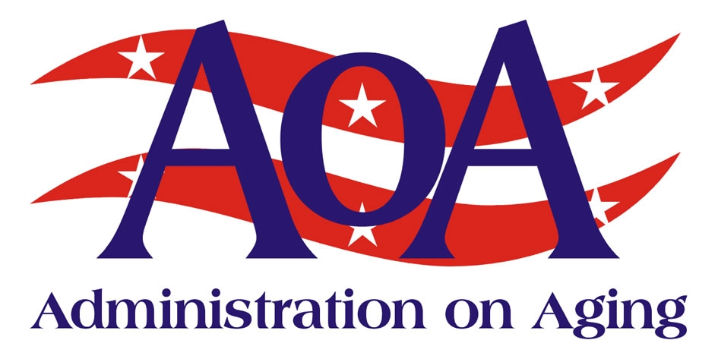

Background

On October 17, 2006, President Bush signed the “Older Americans Act Amendments of 2006” (P.L. 109-365) into law. The reauthorized Older Americans Act (OAA) includes a number of significant changes designed to modernize the delivery of aging services and long term care for the 21st Century. The amendments include new provisions that reflect the core principles of the Administration’s Choices for Independence (Choices) Initiative.
Choices for Independence is an integrated set of strategies and tactics that are ideally suited for use by the Aging Services Network (the Network) in advancing meaningful and important changes in our health and long-term care systems at the federal, state and local level – changes that will improve the quality of life for older Americans, their family caregivers, as well as other populations with disabilities, and result in a more cost-effective system of care. Choices builds on the mission and core values of the OAA and the Network made up of state and area agencies on aging, tribal organizations, community service providers, volunteers and caregivers. It also builds on the latest research and best practice in the field and several grant programs AoA launched over the past four years in partnership with other HHS agencies and a number of private foundations – programs that were strategically designed to promote a “value-added” role for the Network in health and long-term care, and complement the transformations occurring in Medicare and Medicaid.

Streamlining Access

The first strategy Choices advances is to make it easier for consumers to learn about and access the existing services and supports that are available in their communities. Today, when families turn to the formal system for help, they often find themselves dealing with a bewildering maze of programs and bureaucracies. This fragmentation in our current system creates major barriers to access and informed decision-making. To help states eliminate these bureaucratic barriers, the Administration on Aging (AoA) and the Centers for Medicare & Medicaid Services (CMS) launched the Aging and Disability Resource Center (ADRC) grants program in 2003. Under this historic partnership – the first time that AoA and CMS have pooled funding to advance systems change in long-term care we are providing federal leadership, financial support and technical assistance to help states and communities deploy a specific operational tactic (ADRCs) to re-engineer their systems of access for consumers through the establishment of “one stop-shop” entry points. Another important partnership on which this strategy builds is the “Own Your Future” campaign, part of an ongoing public/private effort to increase awareness about the importance of planning ahead for one’s long-term care.

Offering More Choices for High Risk Individuals – Putting Consumers in the Driver’s Seat

The second strategy Choices advances involves the use of flexible service models, including consumer-directed models of care, to help consumers who are at high-risk of nursing home placement - but not yet eligible for Medicaid - to remain in their own homes and communities. While only about 12 percent of the elderly are eligible for Medicaid at any point in time, seniors account for a significant portion of state Medicaid long-term care expenditures. This is because older people often end up on Medicaid after they have exhausted their own personal income and assets on long-term care, usually in a nursing home facility. Once a person enters a nursing home for a long stay, they are more than likely to end up on Medicaid by the end of the first year. By helping high-risk individuals to remain at home through the use of low-cost alternatives, we can assist them in extending the use of their own resources, improve the quality of their lives, and save Medicaid dollars. By using flexible service models, including consumer-directed models, the Network can give consumers more control over the types of services they receive, and better respond to the particular needs and circumstances facing our vulnerable seniors and their families. The new OAA encourages the Network at all levels to promote the use of consumer-directed models of care for high-risk individuals and other seniors who need services and supports in the community.

Building Prevention into Community Living

The third strategy Choices advances is to make it easier for seniors to learn about and take advantage of low-cost evidence-based prevention programs that can empower older individuals to take more control of their own health. There is a growing body of research that has been funded by HHS-science agencies including the National.

Institute on Aging (NIA), the Centers for Disease Control and Prevention (CDC), the Agency for Healthcare Research and Quality (AHRQ), and others that documents the efficacy of low-cost programs that can help seniors to better manage their chronic conditions, reduce their risk of falling, and improve their nutrition and their physical and mental health. The new OAA highlights the critical role the Network, especially our aging services provider organizations, can play in helping seniors to learn about and take advantage of evidence-based programs. The tactic AoA is using to advance this strategy is its highly successful Evidence-Based Prevention Grants Program. This program, launched in 2003 in partnership with the NIA, CDC, AHRQ and the John A. Hartford and Robert Wood Johnson Foundations and others, was significantly expanded in 2006 in partnership with the Atlantic Philanthropies to encourage states to get involved in the initiative. This strategy and tactic gives the Network an important role in health that complements the increasing emphasis on prevention under Medicare. It holds great potential for improving the quality of life for millions of seniors and reducing health care costs. The new OAA authorizes the Assistant Secretary for Aging to establish criteria for states and communities to use in implementing evidence-based programs for seniors, and it encourages the Network at all levels to promote their deployment at the community level through our aging services provider organizations.

National Alliance for Caregiving – www.caregiving.org

Working to Build
the Future of
Long-Term Care

Empowering adults as they age with reliable information and access to the care they need
Enabling individuals who are at high risk of nursing home placement to remain at home
Building disease prevention into community living through the use of low-cost, evidence-based programs

Offering More Choices for High Risk Individuals – Putting Consumers in the Driver’s Seat

The second strategy Choices advances involves the use of flexible service models, including consumer-directed models of care, to help consumers who are at high-risk of nursing home placement - but not yet eligible for Medicaid - to remain in their own homes and communities. While only about 12 percent of the elderly are eligible for Medicaid at any point in time, seniors account for a significant portion of state Medicaid long-term care expenditures. This is because older people often end up on Medicaid after they have exhausted their own personal income and assets on long-term care, usually in a nursing home facility. Once a person enters a nursing home for a long stay, they are more than likely to end up on Medicaid by the end of the first year. By helping high-risk individuals to remain at home through the use of low-cost alternatives, we can assist them in extending the use of their own resources, improve the quality of their lives, and save Medicaid dollars. By using flexible service models, including consumer-directed models, the Network can give consumers more control over the types of services they receive, and better respond to the particular needs and circumstances facing our vulnerable seniors and their families. The new OAA encourages the Network at all levels to promote the use of consumer-directed models of care for high-risk individuals and other seniors who need services and supports in the community.

Page 2 Working to Build the Future of Long Term Care
Administration on Aging | Fact Sheet
For More Information

AoA recognizes the importance of making information readily available to consumers, professionals, researchers, and students. Our website provides information for and about older persons, their families, and professionals involved in aging programs and services. For more information about AoA, please contact: US Dept of Health and Human Services, Administration on Aging, Washington, DC 20201; phone (202) 619-0724; fax (202) 357-3523; Email: aoainfo@aoa.gov or contact our website at www.aoa.gov

October 2008

