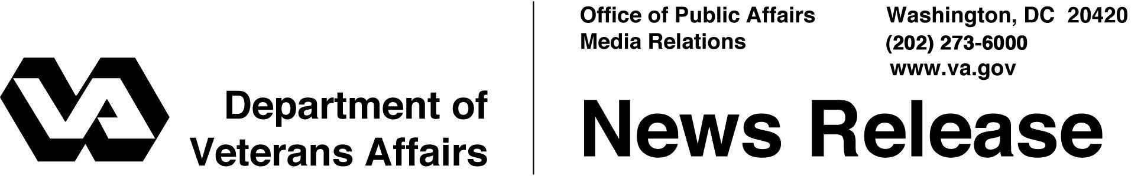
November 8, 2007
Washington, D.C.

Setting the Record Straight…
VA Delivering for Our Homeless Veterans

Reducing Homelessness
- VA is the largest federal provider of direct assistance to the homeless. Services provided include health care, outreach and case management, employment, rehabilitation, transitional residential care, therapeutic work and assistance with permanent housing.

- There has been a 22 percent reduction in the number of homeless veterans in comparison to estimates as recent as five years ago. The estimated number of homeless veterans fell from 250,000 to today’s 195,000 on any given night.

- Only about 30 percent of homeless veterans are chronically homeless, which are the hardest to reach among the homeless population. VA’s programs are designed to directly serve this important group.

- VA supports more than 15,000 beds in transitional housing facilities and VA residential treatment programs.

Providing Our Homeless Veterans with Health Care
- 100,000 veterans – more than half the number of homeless veterans - receive VA health care each year. VA expects to spend $1.6 billion for medical treatment and $287 million for homeless specific programs in FY 08.

- 346 program clinicians are working nationwide who contact homeless veterans as part of their dedication to the homeless health care outreach effort.

Collaborating with Local Homeless Providers
- More than $300 million in grants have been provided to local partners for homeless programs.

- VA also partners with hundreds of communities on Stand Downs across the nation. Stand Downs give homeless veterans a temporary refuge where they can obtain food, shelter, clothing and a range of community and VA assistance. Providers can contact VA’s Homeless Veterans Programs Office at http://www1.va.gov/homeless/, (202) 273-5764, or e-mail VA at homelessvets@mail.va.gov.

# # #

