U.S. Department of
Transportation

FEDERAL AVIATION

ADMINISTRATION

Washington, DC 20591

FINAL REGULATORY EVALUATION,
REGULATORY FLEXIBILITY DETERMINATION, INTERNATIONAL TRADE IMPACT ASSESSMENT, AND UNFUNDED MANDATES ASSESSMENT

FINAL RULE

TITLE 14 CFR PARTS 121, 139

CERTIFICATION OF AIRPORTS

Office of Aviation Policy and Plans,
George A. Euring, Jr.
November 21, 2001

TABLE OF CONTENTS

Executive Summary 1
- Introduction 4
- Background 8
- Summary of the Final Rule 14
- Benefits of the Proposed and Final Rule 23
- Cost Estimates for the Proposed and Final Rules 35
- Benefits and Costs Comparison 64
- Final Regulatory Flexibility Determination 66
- International Trade Impact Assessment 73
- Unfunded Mandates Assessment 73

Appendices 75

III-1 Final Rule Class I Airports, March 2001
III-2 Final Rule Class II Airports, March 2001
III-3 Final Rule Class III Airports, March 2001
III-4 Final Rule Class IV Airports, March 2001

EXECUTIVE SUMMARY
On June 6, 2000, the FAA published a Notice of Proposed Rule Making (NPRM), entitled Certification of Airports, Docket No. FAA-2000-7479. The NPRM proposed to revise of Chapter 14 Code of Federal Regulations (CFR) part 139 and part 121. The original comment period was for 120 days, but was extended at the request of commenters to November 3, 2000.
The NPRM was accompanied by the economic analysis that was entitled:
INITIAL REGULATORY EVALUATION, REGULATORY FLEXIBILITY DETERMINATION, INTERNATIONAL TRADE IMPACT ASSESSMENT, AND UNFUNDED MANDATES ASSESSMENT, FOR NOTICE OF PROPOSED RULEMAKING, TITLE 14 CFR PARTS 121, 139, CERTIFICATION OF AIRPORTS.
March 9, 2000
This document updates the draft Regulatory Evaluation on the basis of the comments received and modifications to the rule made by the FAA. With the exception of Chapter V, the format of this Final Regulatory Evaluation is largely the same as the Initial Regulatory Evaluation. Chapter V discusses the cost estimates that are based upon those in the original draft evaluation and in response to the comments received.
This regulatory evaluation examines the economic impacts of this rule that will affect all civilian airports currently certificated under part 139 (approximately 560 airports), those currently not certificated airports that serve scheduled air carrier operations conducted in 10 – 30 passenger seat aircraft (about 40 airports), and approximately 90 Department of Defense airports currently certificated under part 139.
In addition the final rule addresses National Transportation Board (NTSB) recommendations and petitions for rulemaking noted in the NPRM.
A section of 14 CFR part 121 will also be amended to conform with final changes to airport certification requirements as proposed in the NPRM.
Changes in the final rule principally involve the revision of existing Airport Certification Manuals (ACM’s), the preparation of new ACM’s, or the conversion of existing Airport Certification Specifications into ACM’s as well as the addition of a new class of airports (Class III) and a reorganization of existing certificated airports into Classes I, II, and IV. Most of the cost of this final rule is associated with the final improvements to safety and operational requirements, one of which is the expansion of aircraft rescue and firefighting (ARFF) services. These services are expected to mitigate accidents at airports receiving 10 to 30 seat aircraft scheduled service at airports not currently certificated and at other airports where ARFF coverage is currently not required for this size of aircraft.
The present value of the total cost of the final rule over a ten year period is approximately $74.5 million which includes training, additional emergency response protection, wild life management, and an updated Airport Certification Manual that better reflects current-best practices.
The expected benefit of this final rule is enhanced aviation safety, particularly with respect to airports serving scheduled passenger service in aircraft with 10 to 30 seats. The cost of two accidents of a 30-seat scheduled passenger aircraft could more than cover the total cost of this final rule. Other benefits of this final rule include multiple provisions for snow and ice control, wildlife management, and training, to name a few, that are included in the revision of part 139.

I. Introduction
Prior to the changes to this rule, airports that desired to serve large air carrier aircraft (more than 30 seats) had to obtain an Airport Operating Certificate (AOC) by complying with certain safety requirements. The AOC permitted an airport to serve large air carriers. These requirements covered a broad range of airport operations, including the maintenance of runway pavement, markings and lighting; notification of air carriers of unsafe or changed conditions; and preparedness for aircraft accidents and other emergencies. The FAA periodically inspects these airports to ensure continued compliance with part 139 requirements.
The FAA previously issued two types of AOC's depending on the type of air carrier operations an airport served. Airports that served scheduled operations of large air carrier aircraft (more than 30 seats) were issued an AOC, commonly referred to as a “Full Certificate." As these airports regularly served large air carrier operations, they had to fully comply with all part 139 requirements. Of the approximately 560 certificated civil airports, approximately 430 airports held a Full Certificate. Airports serving only unscheduled operations of large air carrier aircraft required a Limited Airport Operating Certificate (LAOC), known as a “Limited Certificate.” Approximately 130 airports held a Limited Certificate. Air carrier operations in large aircraft were so infrequent at these facilities that consequently they were only required to comply with portions of part 139. For example, existing § 139.213 required airports with a Limited Certificate to comply with only certain pavement, lighting, marking, and emergency response requirements. Airports that had a Limited Certificate were typically located in remote communities or supported seasonal activities, such as skiing during winter months.
This final rule comprehensively revises the airport certification process by establishing four new classes of airports including airports serving scheduled air carrier operations in aircraft with no less than 9 seats but no more than 30 seats (small air carrier aircraft) in the airport certification program to ensure that these airports meet a minimum level of safety. Airports serving small air carrier aircraft and desiring to be certificated under part 139 will be required to develop and implement an Airport Certification Manual (ACM), and to comply with certain safety and operational requirements as determined by the FAA and the airport operator. Variations in airport layout, operations, and air carrier service will require FAA to tailor compliance procedures for each airport through the ACM to ensure that they are the least costly and burdensome but still provide an improved level of safety. While airport operators that choose to be certificated under part 139 will be required to document procedures for complying with part 139 and to comply with certain safety and operational requirements, the tailoring process will permit them some flexibility in complying with the more burdensome requirements.
In addition to serving large, unscheduled air carrier aircraft, approximately 120 of the 130 airports that held a LAOC, proposed Class II airports, also served scheduled small air carrier aircraft. To address these additional operations, this final rule will require these 120 airports, if they desire an AOC, to extend coverage of existing safety measures and comply with additional safety requirements.
This final rule will further require the approximately 560 civilian airports that currently hold a Full or Limited Certificate (proposed Class I, II, and IV airports) to continue to comply with the revised part 139 requirements including their certification manuals. Approximately 45 of these airports (Proposed Class I and II airports) also could be required to implement certain safety measures on a more frequent basis to cover any small air carrier operations that do not occur concurrently with large air carrier aircraft operations.
This final rule clarifies that airports operated by the United States government, including the Department of Defense (DOD), are not subject to part 139. Consequently, approximately 90 DOD airports currently certificated under part 139 will no longer need to be certificated under part 139.
As proposed, the final rule will provide for only one type of certificate, an AOC, and will no longer require two types of certification manuals. Instead, airport certificate holders will be required to adopt and implement an ACM, regardless of the size and type of air carrier operations.
All airports certificated under this final rule will be issued a new AOC. This will not require currently certificated airports to reapply for an Airport-Operating Certificate, but submit a revised ACM as appropriate. The FAA will convert existing certificates. However, airports that will be classified as Class III airports will need to apply for an AOC, as specified in § 139.103.
The FAA has revised the current part 139 to clarify and update several requirements to better reflect current industry practices and technology. The FAA believes these revisions will generally require an already certificated airport to only take administrative action.
Final changes to the existing regulation include updates or clarifications of:
- Recordkeeping requirements;
- Personnel training requirements;
- Hazardous material storage requirements, specifically fuel dispensing and storage safety procedures;
- Aircraft rescue and firefighting (ARFF) training and hazardous material response requirements; and
- Emergency plan requirements.
II. BACKGROUND
A. Introduction
Since 1970, the FAA Administrator has had the statutory authority to issue Airport Operating Certificates to airports who desired to be certificated to serve certain air carriers and who met minimum safety standards for the operation of those airports. This authority is found in Title 49, United States Code (USC) Section 44706, (49 USC 44706) Airport Operating Certificates. The FAA has used this authority to issue regulations for the certification and operation of certain land airports. These requirements are contained in Title 14, Code of Federal Regulations, part 139 (14 CFR part 139), Certification and Operations: Land Airports Serving Certain Air Carriers, as amended.
Until 1996, the FAA’s authority to certificate airports was limited to airports serving air carrier operations with more than 30 seat aircraft. However, a number of studies and accidents suggested that airport safety could be improved if the FAA's authority to certificate airports was extended to those airports that served scheduled operations of small air carrier aircraft. The following sections describe these studies. The current rulemaking is partially in response to these studies.

B. General Accounting Office Report (1987)
In 1987, the General Accounting Office (GAO) issued a safety report on the certification of small airports. The report concluded that airport safety would be enhanced if all airports serving scheduled air carriers were certificated and recommended that the FAA include such facilities in its airport certification program.
The FAA concurred with the GAO's findings, but determined that its statutory authority was limited to airports that serve scheduled and unscheduled passenger operations of air carrier aircraft with more than 30 seats. A proposed amendment to broaden this authority was submitted to Congress, but the measure was not enacted.

C. National Transportation Safety Board Study (1994)
In November 1994, the National Transportation Safety Board (NTSB) released its findings resulting from a study of commuter airline safety. (Note: The term commuter, when it appears in this study, refers to the use of this term before March 20, 1997. As of March 20, 1997, the term commuter refers to an aircraft or operations conducted in an aircraft, which has 9, or less, passenger seats.) This study identified several safety improvements that the NTSB felt would improve the commuter airline safety record.
While this study, and subsequent recommendations, focused on airline and aircraft operations, it was also critical of the FAA for not requiring airports serving small air carrier operations to maintain their facilities in the same manner as airports serving major air carriers.

D. DOT/FAA Initiatives
As discussed above, until recently the FAA’s statutory authority was limited to those airports serving air carrier operations using aircraft with more than 30 passenger seats. However, this authority was broadened by the Federal Aviation Administration Reauthorization Act of 1996. Title 49, U.S.C. 44706 was amended to allow the FAA to certificate airports, with the exception of those located in the State of Alaska, that serve any scheduled passenger operation of an air carrier operating aircraft designed for more than 9 passenger seats but less than 31 passenger seats. FAA's existing authority to certificate airports serving air carrier operations conducted in aircraft with more than 30 seats remained unchanged.
This amendment was proposed by the Secretary of Transportation in response to a recommendation made by the 1994 NTSB study described above that the FAA seek authority from Congress to issue certificates to airports serving small air carrier airlines.
The 1996 amendment to the statute did not mandate the issuance of airport certificates to airports serving small air carriers. It only provided general authority pursuant to which the FAA may promulgate appropriate regulatory standards. With this rule the FAA intends to extend airport regulatory standards to airports now being served by air carriers with scheduled passenger operations with 10 to 30 seat aircraft.
Furthermore, in response to a series of early 1990’s NTSB accident findings, the FAA took steps to ensure safety in aviation commerce, by comprehensively revising regulations pertaining to air carrier operations, specifically 14 CFR parts 121 and 135, to ensure similar safety standards among air carriers of different size.
Lastly, this final rule will revise and clarify several safety and operational requirements that have become outdated. The last major revision of part 139 occurred in November 1987, and since then, industry practices and technology have changed. In the subsequent years, the FAA has gathered data on the effectiveness of part 139 requirements, (primarily through joint industry/FAA working groups, field research and periodic airport certification inspections), and proposes to use this rulemaking to update part 139 requirements.

E. The Aviation Rulemaking Advisory Committee
The FAA approached the question of the certification of airports that serve scheduled air carrier operations using small air carrier aircraft by requesting the assistance of the Aviation Rulemaking Advisory Committee (ARAC). The ARAC was established by the FAA to provide advice and recommendations to the FAA Administrator concerning a range of the FAA's rulemaking activity, including air carrier operations, airman certification, aircraft certification, airports, security, and noise.
To assist in the certification of airports serving small air carrier operations, the FAA requested the ARAC's advice and recommendations on what requirements should be applicable to airports that have scheduled service with aircraft having a seating capacity of 10-30 seats [60 FR 21582, May 2, 1995]. In developing these recommendations, the FAA asked the ARAC to consider alternatives to minimize the operational burden on smaller facilities, including options for aircraft rescue and firefighting services. The FAA also suggested the ARAC conduct a survey of affected airports to gauge the impact of any proposed requirement. At the time of this request, the FAA did not have the statutory authority to regulate airports with scheduled service by aircraft having 10-30 seats.
The ARAC accepted this task and established a Commuter Airport Certification Working Group to develop recommendations on this issue. Comprised of members of the main committee, the working group's membership included representatives from the following organizations:
- Air Line Pilots Association
- Aircraft Owners and Pilots Association
- American Association of Airport Executives
- National Air Transportation Association
- National Association of State Aviation Officials
- Regional Airline Association
The FAA and Landrum and Brown, an airport planning and engineering consulting firm also provided technical support.
Over the course of a year, the Commuter Airport Certification Working Group met five times to research the issue and develop recommendations for the ARAC. The working group initially endeavored to establish a voluntary industry standard consistent with the FAA's lack of authority to regulate airports serving commuter operations. However, after the passage of Public Law 104-264, the FAA requested the working group to immediately finish its report and to take a regulatory approach to the certification of airports serving smaller air carrier aircraft. This action was based on the FAA's decision to exercise its new authority to regulate airports serving small air carrier operations.
While the working group agreed on many issues, a minority disagreed with several of the group's recommendations. This minority differed on six regulatory requirements, including marking and lighting; aircraft rescue and firefighting; and handling of hazardous substances and materials. Subsequently, the working group developed both a majority and minority position at the FAA's request. Individual working group members also provided comments on issues when their respective organizations differed from the position taken by the working group.
In February 1997, both the majority and minority views of the working group, and those of individual group members, were presented to the FAA. Overall, the working group majority recommended that a non-regulatory approach to improve small air carrier airport safety could accomplish the same level of safety as regulating these airports. In light of the proposed rulemaking, the majority suggested that such a regulation should focus on accident prevention rather than accident mitigation, particularly in light of the limited public funds available to these small airports.
As requested by the FAA, the working group also conducted a survey of airports that might be affected to determine what safety practices are already being conducted and the potential operational and economic impact if these airports were to comply with existing part 139 requirements. This survey requested information on rescue and firefighting capabilities, airport staff, certification status, annual enplanements, existing marking, lighting and signs, and capital and recurring costs of certain equipment and procedures. The results of this survey are included with the ARAC final recommendations on commuter airport certification, filed in the public docket. These survey results are also are discussed in this economic analysis associated with this rulemaking.

III. SUMMARY OF THE FINAL RULE

A. Introduction
This final rule will affect all airports currently certificated under part 139 (approximately 560 civil airports) and those currently non-certificated airports serving scheduled, small air carrier aircraft operations (approximately 40 airports).
This final rule will comprehensively revise the airport certification process and will include airports serving small air carrier aircraft to ensure safety at all certificated airports. Airports serving scheduled small air carrier aircraft with 10 or more passenger seats (proposed Class III airports) and currently not regulated under part 139, who desire a certificate, will be required to develop and implement a Airport Certification Manual (ACM), and to comply with certain safety and operational requirements. All airports, however, may request relaxation of requirements of the final rule. Variations in airport layout, operations, and air carrier service will require FAA to tailor compliance procedures for each airport through the ACM to ensure that they are the least costly and burdensome but still provide an improved level of safety. While airport operators that choose to be certificated under part 139 will be required to document procedures for complying with part 139 and to comply with certain safety and operational requirements, the tailoring process will permit them some flexibility in complying with the more burdensome requirements.
As noted above, in addition to serving large, unscheduled air carrier aircraft, approximately 120 of the 130 airports holding a LAOC (Proposed Class II airports) also serve scheduled small air carrier aircraft. To address these additional operations, this final rule will require these 120 airports to implement existing safety measures (such as aircraft rescue and firefighting) on a more frequent basis and comply with additional safety requirements.
This final rule will require the remaining 430 certificated civilian airports (Proposed Class I airports) to continue to comply with all existing part 139 requirements. In addition, these airports will be required to revise their certification manuals and comply with final modifications to existing requirements. Approximately 45 of these airports also could be required to implement certain safety measures on a more frequent basis to cover any small air carrier operations that do not occur concurrently with large air carrier aircraft operations.
Also, this final rule will clarify that airports operated by the United States government, including DOD, are not subject to part 139.
The FAA believes the current classification of Airport Operating Certificates and manuals should be simplified. Instead of differentiating between an AOC and a LAOC and creating additional types of Airport Operating Certificates, this final rule will provide for only one type of certificate, an AOC, and no longer make a distinction between ACM or ACS. All airport certificate holders will be required to adopt and implement an ACM, regardless of size and type of air carrier operations. But all certificated airports will be divided into classes, as described below.
Consequently, all airports certificated under this final rule will be issued new Airport Operating Certificates. This will not require currently certificated airports to reapply for an Airport Operating Certificate. When this final rule is adopted, the FAA will convert existing certificates, as appropriate.

B. Airport Certification Classification
This change to the certification process will still distinguish between airports that serve different sizes or types of air carriers, and establish requirements appropriate for each type of airport. Under this final rule, similar airports will be grouped together into four new categories, Classes I-IV, and a separate set of requirements is required for each new airport class, as follows:
1. Class I Airport Airports serving all types of scheduled operations of large air carrier aircraft, and any other type of air carrier operations, will be known as Class I airports. Essentially, all airports with an existing AOC will become Class I airports.
2. Class II Airports Class II airports will be those airports that serve scheduled operations of small air carrier aircraft (10-30 seats) and unscheduled operations of larger air carrier aircraft (more than 30 seats). Airports that will be classified as Class II will be airports with an existing LAOC that serve scheduled operations by small air carrier aircraft.
3. Class III Airports Class III airports will be those airports that serve only scheduled operations of air carrier aircraft with 10-30 seats. Class III airports will be those facilities newly certificated as the result of this rulemaking.
4. Class IV Airports Class IV airports will be those airports currently with a LAOC that serve only unscheduled air carrier operations in aircraft with more than 30 seats.

C. Airport Certification Manual (ACM) Requirements By Class
The FAA currently requires airports to develop an ACM or ACS, depending on the type of certification, to detail how the airport will comply with the requirements of part 139. As every airport is unique, the final requirements have sufficient flexibility to allow the tailoring of the final requirements to the unique circumstances of each airport. The FAA sets forth performance-based standards that airports implement, through the ACM, in the manner best suited to their facilities. In this manner, the FAA can vary and tailor airport requirements to accommodate local conditions.
Under this final rule, the requirements for manual content will vary among the categories, with the most comprehensive manual being required of Class I airports. Class I airports will have to comply with more safety requirements than Class II, III, and IV airports as they serve more complex and varied air carrier operations.

D. Airports Affected
All currently certificated airports will be affected by the final rule. In addition, an estimated 37 currently uncertificated airports that serve scheduled operations of small air carrier aircraft, will be affected. In the future, any airport operator wishing to serve scheduled air carrier service conducted in small air carrier aircraft , or both scheduled and unscheduled service of large air carrier aircraft, must be certificated.
An estimated total of approximately 600 civil airports will be affected by the final rule. The total number of certificated airports varies during the course of the year due to seasonal activities or fluctuations in air carrier service.
A list of certificated airports by new airport classes, is shown in Appendices III-1 through III-4. These appendices categorize airports that currently hold an Airport Operating Certificate, or will be newly certificated under this final rule, as follows.
- Appendix III-1 shows a list of the Class I airports by state. There is an estimated total of 436 proposed Class I airports.
- Appendix III-2 shows a list of the Class II airports by state. There are an estimated total of 112 proposed Class II airports.
- Appendix III-3 shows a list of the Class III airports by state. There are an estimated total of 37 Class III airports.
- Appendix III-4 shows a list of the Class IV airports by state. There are an estimated total of 18 proposed Class IV airports.

E. Comparison of Existing and Final Airport Requirements
Tables III-1 through III-4 show the existing and final airport certification requirements for each final airport class.

Table III-1 Current and Final Requirements for Proposed Class I Airports
Class I Airports are existing certificated airports holding an Airport Operating Certificate that serve scheduled operations of large air carrier aircraft (more than 30 seats), and any other type of air carrier operation.
 | Current Requirements | Final Additional Requirements
 | Personnel provisions | A recordkeeping system and new personnel training standards
 | Paved and unpaved surfaces
 | Safety areas
 | Marking, lighting and signs
 | Snow and ice control plan
 | ARFF | New recurrency training, fire extinguishing agent and HAZMAT response standards, and increase in frequency of ARFF coverage (where ARFF is not provided for small air carrier operations)
 | HAZMAT handling/  Storage | Air carrier fueling operations, and new fuel safety and personnel training standards
 | Traffic/wind indicators | New supplemental wind cone/segmented circle standards
 | Airport emergency plan (AEP) | New requirement to plan for fuel storage fires
 | Self-inspections | New training requirements for inspection personnel
 | Ground vehicle operations
 | Obstructions
 | Navaids
 | Public protection
 | Wildlife hazard management | New wildlife strike reporting, hazard assessment and management plan standards
 | Airport condition reporting | New notification standard
 | Construction/unserviceable areas

Table III-2 Current and Final Requirements for Proposed Class II Airports
Class II Airports are existing certificated airports holding a Limited Airport Operating Certificate that serve scheduled operations using small air carrier aircraft (10-30 seat), in addition to serving unscheduled large air carrier aircraft (more than 30 passenger seats).
 | Current Requirements | Final Additional Requirements
 | Personnel provisions | New requirement for recordkeeping system and personnel training
 | Paved and unpaved surfaces
 | Safety areas
 | Marking, lighting and signs
 |  | New requirement for snow and ice control plan
 | ARFF | New ARFF standards (per § 139.315-.319)
 | HAZMAT handling/storage | New HAZMAT handling/storage standard (per § 139.321)
 | Traffic/wind indicators | New traffic/wind indicators standard(per § 139.323)
 |  | New requirement for AEP (no triennial exercise required)
 | Self-inspections | New self-inspection standard (per § 139.327)
 |  | New requirement for ground vehicle operations
 |  | New requirement for obstructions
 |  | New requirement for Navaids
 |  | New requirement for public protection
 |  | New requirement for wildlife hazard management
 | Airport condition reporting | New notification standard  (per § 139.339)
 |  | New requirement for construction/ unserviceable areas

Table III-3 Current and Final Requirements for Class III Airports
Class III Airports will be newly certificated under this rule, and will serve scheduled operations of small air carrier aircraft (10-30 seats). These airports can not serve scheduled or unscheduled operations of large air carrier aircraft (more than 30 seats).
 | Current Requirements | Final Additional Requirements
 |  | A recordkeeping system and personnel training
 |  | Paved and unpaved surfaces
 |  | Safety areas
 |  | Marking, lighting and signs
 |  | Snow and ice control plan
 |  | ARFF
 |  | HAZMAT handling/storage
 |  | Traffic/wind indicators
 |  | AEP (no triennial exercise required)
 |  | Self-inspections
 |  | Ground vehicle operations
 |  | Obstructions
 |  | Navaids
 |  | Public protection
 |  | Wildlife hazard management
 |  | Airport condition reporting
 |  | Construction/unserviceable areas

Table III-4 Current and Final Requirements for Class IV Airports
Final Class IV Airports are existing certificated airports holding a Limited Airport Operating Certificate that serve unscheduled operations of large air carrier aircraft (more than 30 seats). These airports can not serve scheduled large, or scheduled small (10-30 seats) air carrier aircraft.
 | Current Requirements | Final Additional Requirements
 |  | New requirement for a recordkeeping system and personnel training
 | Paved and unpaved surfaces
 | Safety areas
 | Marking, lighting and signs
 | ARFF (negotiated standard) | New requirement to comply with ARFF per Subpart D
 | HAZMAT handling/storage | New HAZMAT handling/storage standard (per § 139.321)
 | Traffic/wind indicators | New traffic/wind indicators standard (per § 139.323)
 |  | New requirement for an AEP (triennial exercise not required)
 | Self-inspections (Negotiated standard) | New self-inspection standard (per § 139.327)
 | Airport condition reporting | New notification standard (per § 139.339)

IV. Benefits of the Final Rule

A. Introduction
The expected benefit of this final rule is improved aviation safety resulting in reduced fatalities, injuries, and property damage at airports with scheduled air carrier operations, particularly operations in aircraft designed for10 to 30 passenger seats.
In 1995, the FAA issued regulations aimed at ensuring safety in scheduled air carrier operations in aircraft with 10 or more passenger seats. Since then, Congress has authorized the FAA to regulate airports serving 10 to 30 seat aircraft to further help ensure safety at airports certificated by the FAA. The FAA has now established standards for these airports. The agency has made these standards sufficiently flexible to be tailored to each airport, while providing the maximum possible safety improvements.
B. General Discussion Of Expected Benefits
This final rule affects all currently certificated airports and the estimated 37 additional airports that may choose to obtain certificates. Accordingly, benefits are expected to accrue at all four final classes of certificated airports. Several different types of safety improvements are expected. These involve:
- Prevention of accidents or collisions because of non-standard and/or inadequate signs and traffic and wind direction indicators;
- Mitigation of accidents by improvements to runway safety areas at certain airports;
- Mitigation of accidents by extending ARFF services to additional air carrier operations;
- Prevention and mitigation of fires at airport fuel farms;
- Prevention and mitigation of accidents caused by snow and ice accumulation, and
- Prevention and mitigation of wildlife hazards.
As will be discussed in the following section, while airport accidents that the rule is intended to prevent or mitigate do occur, they have been rare and random events. This was particularly true of small air carrier aircraft, in large part, because they have comprised a small portion of commercial air passenger activity. However, small air carrier airline activity is growing and is projected to continue to grow at much higher rates than major airlines. For example, small-air-carrier revenue passenger miles are projected to increase an average of 7.5 percent per year, for the next several years, compared to 4 percent for major airlines. As a result, prior history may not be predictive of the future. If provisions of the rule prevent or mitigate the consequences of one catastrophic accident involving an aircraft with 30 passenger seats, the potential benefit of lives saved and property damage avoided is as much as $99 million. If it prevents an accident associated with the collision of two such aircraft, the benefit will double to as much as $198 million. Potential safety improvements are not limited to situations involving small air carrier aircraft, but encompass larger aircraft and facilities at the airports that also use smaller aircraft.
Therefore, the FAA concludes that the expected benefits of the rule justify the costs as described in the succeeding sections.
C. Specific Discussion of Expected Benefits

1. Markings, Signs and Lighting, and Traffic and Wind Indicators
Increased safety will result from the requirement of this final rule for uniform standards of installations of runway and taxiway markings, signs and lighting, and for traffic and wind direction indicators. All classes of certificated airports will need to comply with these requirements. Although most airports affected by the rule currently meet these standards, a few (approximately 9) will need to be upgraded. The FAA believes this will make a significant contribution to safety, for example, by helping to reduce the persistent problem of runway incursions.

Runway Safety Areas
A second example of a safety benefit expected as a result of this final rule relates to runway safety areas. On May 8, 1999, a SAAB 340 overran a runway at New York’s John F. Kennedy International Airport. However, the airport had recently installed arresting material in order to comply with part 139 safety area requirements and the airplane stopped 50 feet short of Thurston Bay. The incident resulted in very little damage to the aircraft and one minor passenger injury. A previous incident on the same runway in 1984, before the new safety area was installed, resulted in an SAS DC-10 running into the bay, resulting in passenger injuries and extensive airplane damage.
This final rule will impose the safety areas requirements of part 139 on Class III airports for the first time. These airports have been encouraged to install safety areas for over 10 years, and many have done so. Although the final rule will not mandate immediate installation of these safety facilities at any class of airports, the FAA believes that, over time, the eventual installation or improvement of safety areas at certificated airports will result in safer airports.
- Emergency Response Services and Equipment
Another important safety benefit of this final rule is more widespread availability of emergency response services and equipment. There is evidence that such equipment can save lives and reduce injuries. Perhaps the clearest example of that was an accident that occurred at Los Angeles International Airport on February 1, 1991. This tragedy involved the collision of a US AIR 737-300 and a Skywest Metro on runway 24L. The crew and 10 passengers on the Metro were killed as were some of the crew and 20 passengers on the 737-300. However, the part 139-required emergency response equipment was credited in the NTSB investigation for saving lives.
The following are other examples where the actions of emergency response services and equipment mitigated accident damage:
- Lawton – Ft Sill Regional Airport (5/24/1988). An Embraer Bandeirante in air carrier service lost an engine on takeoff. Immediately after takeoff, the aircraft began losing altitude, struck the ground, and came to rest 1,600 feet from the runway. Passengers and rescue personnel removed the pilot and one passenger from the airplane, and ARFF personnel extinguished the post crash fire.
- Miami International Airport (12/1/1998). A fire broke out while a Boeing 747-200F was being refueled. Responding ARFF personnel extinguished the fire.
- Bradley International Airport (1/21/1998). An ATR 42-300 experienced an engine fire during the landing rollout. Responding ARFF personnel extinguished the fire.
- Nashville International Airport 7/8/1996. A Boeing 737-200 aborted takeoff after the left engine ingested a bird, and came to rest beyond the runway. Responding ARFF personnel extinguished a fire that erupted in the right brake assembly.
- Miami International Airport (10/23/1995). A Boeing 747-121 experienced an uncontained failure of No. 4 engine during takeoff roll. The takeoff was rejected and the airplane was stopped on the remaining runway. Responding ARFF personnel extinguished a fire that subsequently erupted in the failed engine.
- Philadelphia International Airport (8/17/1995). A SAAB SF-340-A experienced a fire near the left engine while waiting to take off. Responding ARFF personnel extinguished the fire.
- Greater Peoria Memorial Airport (7/17/1991). An ATR-42-300 experienced a failure of the left engine followed by engine fire while on final approach. The pilot made a normal landing and conducted an evacuation on the runway. Responding ARFF personnel extinguished the fire.
These examples may give the impression that ARFF personnel and equipment are the only emergency response provided by the certificate holder. However, this is not the case. Although ARFF services are the most immediate help available, they are but one element of required accident mitigation measures. These measures provide a comprehensive response to aircraft accidents, and other emergencies, and are dependent on one another. For example, required alarm and communication systems ensure that both ARFF and airport personnel are notified promptly of an accident, and alert other necessary emergency service providers in the local community (i.e., paramedic, police, ambulance service and hospitals.) Similarly, accident mitigation measures ensure other needed emergency services are provided, including security and crowd control, removal of disabled aircraft and other debris from movement areas, transportation and facilities for uninjured and injured persons, and storage of deceased persons. All of these measures ensure that a certificate holder provides for a comprehensive emergency response that mitigates the loss of passenger lives and property, prevents injury to responding personnel, and protects air carrier aircraft and the public from unsafe conditions.
A major safety provision of the final rule is that it will require the availability of emergency response services and equipment, including ARFF equipment at every landing and takeoff of scheduled air carrier aircraft with 10 to 30 seats. This capability is required now for air carrier operators with more than 30 seats, and, as discussed earlier, there is evidence that lives have been saved and injuries prevented or reduced as a result. In some cases, this protection may not currently be available for small aircraft operations at airports served by large aircraft. For example, the accident that occurred at Quincy, Illinois (A proposed Class I Airport) on November 19, 1996 might have been mitigated had ARFF been on site at the arrival of a small air carrier aircraft.
This accident involved the collision of a United Express Beech 1900C (a small air carrier aircraft) and a Beech King Air (a general aviation aircraft) during the ground operations of the two aircraft -- mistakenly operating simultaneously on the same runway. At the time of the accident, there were no large air carrier aircraft operations in progress or imminent, and, consequently, the airport operator was not required to provide emergency response services, and they were not on the site. When required, emergency response services, including ARFF, were provided by the Quincy Fire Department, whose personnel would come to the airport from an offsite location to staff emergency equipment during the operations of large air carrier aircraft. All 10 passengers and 2 crew members aboard the United Express Beech 1900C and the two occupants aboard the King Air were killed as a result of post crash fires. The NTSB found that the speed with which the fire enveloped the King Air, and the intensity of the fire, precluded the survivability of the occupants. However, the occupants of the Beech 1900C did have the opportunity to escape, but could not open external doors that might have been damaged. The NTSB concluded that…”if on-airport ARFF protection had been required for this operation at Quincy Airport, lives might have been saved.” (NTSB Aircraft Accident Report—Runway Collision United Express Flight 5925 and Beechcraft King Air A90-Quincy Municipal Airport, Illinois-November 19, 1996 –NTSB AAR-97/04, P.51.)
The U.S. air carrier transportation system is very safe, and accidents requiring emergency response action are rare. The risk of death or injury to a passenger, based on current emergency response requirements, is very small; however, many incidents occur where the perceived risk of an accident was great enough that ARFF units were alerted. The FAA has tracked those incidents at currently certificated airports, and notes that over 1,200 such occurrences took place during an 18-month period.
These incidents, of course, took place at airports where emergency response services and equipment are currently available and usually involved large aircraft. Nevertheless, the FAA concludes that a proportionate number of similar incidents occur involving small air carrier aircraft when and where ARFF is not available. Thus, the FAA concludes that the provision of ARFF at all certificated airports is necessary to ensure safety in air transportation.
An important aspect of this final rule is that the amount of additional ARFF protection that will be required at each Class I, II, or III airport will be individually evaluated and determined for each airport. This evaluation will take all relevant factors into account, such as the number of air carrier operations, available nearby fire fighting services, cost to airport operators, affordability, etc. The goal is, however, to ensure that an appropriate level of ARFF service is available for each airport operation by small air carrier aircraft with 10 to 30 passenger seats.

4. Fuel Storage Fires
An expected benefit of the final rule is the prevention/mitigation of fuel storage fires. The final rule requires all classes of airports to address such fires in their disaster plans. This will better prepare airports to prevent and/or extinguish the kind of fire that occurred at Stapleton International Airport, Denver, Colorado, on November 25, 1990. That fire erupted in a fuel farm fire about 1.8 miles from the main terminal and burned for 48 hours, destroying about 3 million gallons of fuel. Flight operations of a major air carrier were disrupted for lack of fuel and the carrier estimated total damage to have reached between $15 and $20 million.
Airport firefighters and the Denver Fire Department promptly responded to the fire and attacked it immediately. However, because the firefighters were unable to maintain a continuous flow of foam on the fire, it reignited and quickly intensified. Airport and local firefighters did not have, nor could they have been expected to have, a sufficient supply of foam concentrate to fight a full fire of such magnitude. The Denver fire burned for about 48 hours before being extinguished by a coordinated attack using resources and materials brought in from long distances.
The National Transportation Safety Board (NTSB) concluded that the City and County of Denver (the airport certificate holder), and the fire department in particular, apparently had not considered the possibility of a fire of this type since no procedures or contingency plans were in place for dealing with one. The FAA believes that a requirement to have effective contingency plans could have resulted in the fire being extinguished much sooner, resulting in considerably less damage.
This final rule will require several improvements to the already existing requirement for airport emergency plans. Final Class II, III, and IV certificated airports will be required to develop and implement such plans, and all classes will be required to include provisions for responding to fuel farm fires. The costs of this final rule requirement are low—a few hundred dollars, annually, total for all airports. Although the risk of fire is always present at fuel facilities, required precautions make the probability of a fire very low. The probability is not zero, however, as demonstrated by the 1990 Denver fire. The FAA concludes that this low-cost provision of the final rule has a high probability of significantly mitigating damage if a fire comparable to Denver’s occurs in the future.
5. Snow and Ice Control
Another safety benefit is expected from improved snow and ice control, which will reduce the potential for the following kind of accidents. On March 17, 1993, a BAC-BA-Jetstream 3101 was making a night instrument approach to the Raleigh County Memorial Airport in Beckley, West Virginia, a proposed Class II airport. Because the runway was not properly plowed, and berms of snow concealed the runway lights at ground level, the captain lost control after touchdown, and the airplane sustained substantial damage.
This final rule will require Class II and III airports to develop snow and ice control plans. Although some of these airports already have individually-developed procedures for snow and ice removal, this final rule will formalize consistent plans across all airports with scheduled air carrier services. The FAA concludes that this low-cost requirement to standardize response to snow and ice will significantly help prevent the kind of accident discussed above.

6. Wildlife Hazard Management
Finally, benefits are expected at all classes of certificated airports as a result of final actions to reduce wildlife hazards (bird strikes and other damaging collisions with wildlife). A FAA study of civil aircraft wildlife strikes in the US (“Wildlife Strikes to Civil Aircraft in the United States, 1990 – 1999”) found a significant and growing hazard of wildlife contact with aircraft in the vicinity of airports. The study determined that 92 percent of all wildlife strikes occur while arriving or departing from an airport. Birds were involved in 97 percent of the reported strikes, mammals (primarily deer and coyotes) in 3 percent and reptiles, such as turtles, in less than 1 percent. The number of annual reported strikes increased 181 percent from 1990 to in 1999, and, according to the FAA report, is now causing about $391 million per year in direct costs.
The report further found that there were 4,528 wildlife-aircraft strikes reported during the period 1991-1997 that had an adverse effect on the aircraft and/or flight. The report estimated that the report rate was about 20 percent of what actually occurred. Based on its findings, the report concludes that airport managers need to be aware of the wildlife hazards on their airports and take appropriate actions, under the guidance of professional biologists trained in wildlife damage management, to minimize the problems.
The expected benefit of this section of this final rule is that wildlife strikes will be reduced in air carrier operations. Some operators of proposed Class II and III airports will be required to conduct wildlife hazard assessments, as well as formulate and implement wildlife hazard management plans for their airports. This final requirement will be responsive to the findings of the FAA study and will bring consistency across all airports with scheduled air carrier operations with aircraft having 10 or more passenger seats. It is intended to make airport certificate holders more aware of effective measures that can be taken to reduce the risk of wildlife strikes. Ultimately, it is expected to actually reduce the number of strikes that will otherwise occur.
The FAA is unable to quantify the annual benefit that may result from this component of the final rule. The FAA report does estimate that wildlife strikes, at the present time, result in 471,867 hours per year of aircraft down time, $255 million per year in direct monetary losses, and $136 million per year in associated costs. The FAA believes that this final rule will significantly reduce these losses.
Two examples of problems related to wildlife were an Embraer 120RT, that hit two deer while landing at Yeager Airport (CRW) (a proposed Class I Airport) at Charleston, WV and the crash of a Learjet owned by Jerry Jones that hit two deer on a runway at Troy, AL (a general aviation airport).
According to the NTSB Aviation/Incident Database Report (NYC01LA054, 12/06/2000):
On December 6, 2000, at 2038 Eastern Standard Time, an Embraer 120RT, N504AS, operating as Atlantic Southeast Airways flight 71, was substantially damaged when it collided with deer, just after landing at Yeager Airport (CRW), Charleston, West Virginia. The 3-person crew and 15 passengers were uninjured, and 1 passenger received serious injuries. The accident occurred at night, while visual meteorological conditions prevailed. An instrument flight rules flight plan was filed for the flight, between The William B. Hartsfield Atlanta International Airport (ATL), Atlanta, Georgia, and Yeager Airport. The scheduled passenger flight was conducted under 14 CFR Part 121. According to the captain, within seconds of landing on Runway 23, the airplane struck two deer. The flight attendant then contacted the cockpit crew, and informed them that there was an injured passenger. After parking at the gate, a walk-around inspection revealed that the tip of a propeller blade from the number 2 engine had separated, and had punctured the airplane's fuselage. According to a Federal Aviation Administration (FAA) inspector, one of the deer was hit by the nose landing gear, and the other deer was hit by the right engine propeller. The separated blade tip was about 4 inches long and 3 inches wide. It had entered the cabin just aft of frame 21, between stringers 14R and 15R. The passenger was sitting in seat 3C.
According to the Avweb News Wire of 18-January-2001 and NTSB ATL01FA021:
Two pilots employed by Dallas Cowboys owner Jerry Jones were seriously hurt Sunday (January 14, 2001) when their Learjet crashed after hitting two deer on a runway in Troy, AL. The jet’s thrust reversers apparently were damaged by the impact with the deer, and it overran the 5,000-foot runway, flipped, and burst into flames on an embankment. The pilots, who were alone on board, were pulled out of the burning wreckage by witnesses who rushed to their aid. The two pilots, Max McVicker, 31 of Irving, Texas, and Eddie Collins, 51, of Jacksonville, AR, remain hospitalized.
These two accidents illustrate the fact that a serious wildlife accident can occur in any type of airplane at any type of airport. Therefore, it is important to prevent this type of accident.

CHAPTER V – COST ESTIMATES FOR THE FINAL RULE

A. Introduction
The cost estimates for the final rule are based on those presented in the initial regulatory evaluation (IRE) for the NPRM adjusted for the changes resulting from an updated count of airports and from comments received on the NPRM. The documentation of the earlier cost estimates, data sources, and methodology per section of the NPRM are fully discussed in the IRE. This section presents the changes in the IRE cost estimates, the reason for those changes, and the resulting total cost estimate for the final rule.
While changes were made throughout part 139, most costs are the result of changes to ARFF requirements. These changes require all certificated airports to provide ARFF coverage. In addition, the final rule clarifies the procedures that airports must follow to apply for an ARFF exemption beyond the tailoring through the ACM and, if granted, what the exemption would probably require. The cost-estimation approach taken herein assumes that all airports fully comply with the rule requirement and does not assume that exemptions are granted. The FAA also extended the time period required to submit a new or revised ACM. A time extension does not change the cost of the requirement and since the extension does not extend beyond a year, the time extension does not effect the present value cost of future compliance. Thus while both these changes, in addition to the tailoring of requirements through the ACM, are likely to reduce the compliance burden, the FAA takes the conservative position that neither change reduces the expected cost of the rule.
The IRE cost estimates updated for the final rule reflect the different count of effected airports. For every airport class the estimated number of airports in that class changed from that specified in the IRE. The criterion that Class III airports provide scheduled passenger service only for aircraft with 10 to 30 seats and the fluid nature of this service to communities resulted in airports added to and deleted from this Class.
The IRE estimated the average cost of compliance per requirement for each of the proposed four airport classes. The reason the FAA used an average cost per rule provision by airport class is that each of the approximately 700 affected airports is unique in geography, facilities, and service provided. Based on the few comments received regarding the IRE, the average cost methodology apparently provided reasonable estimates for nearly all airports with the notable exception of the proposed Class III airports.
In contrast to the average cost estimates for the NPRM, most of the regulatory-evaluation comments received were airport specific. The FAA followed two approaches to modifying the estimated cost for the final rule whenever the FAA agreed with a commenter’s cost estimate. Given the limited number of comments received from Class I and II airports, especially considering the total number of Class I and II airports, the FAA largely accepted and adjusted the estimated costs only for the individual airport referenced in these comments. After reviewing the comments received regarding Class III airports, the FAA generally accepted and revised the estimated compliance cost for all of these airports. Some comments were received from airports that might want to qualify as a Class III airport. The FAA did not incorporate these commenters’ estimates because the airports currently do not have the necessary scheduled service and the estimates were generally substantially higher than the other estimates received.
While the cost estimate changes were relatively minor for Class I, II, and IV airports, the cost estimates changed significantly for Class III airports. Nearly all of the change to Class III airports can be attributed to the FAA assumption regarding existing airport personnel availability to implement the rule requirements. For Class III airports, the FAA response to comments and a minor adjustment in the count of airports resulted in an increase of the initial/capital mitigation costs for all Class III airports from $1,236,928 to $2,098,360 and a significant increase in annual recurring mitigation costs for all Class III airports of $971,842 to $4,153,005. This significant change, plus the other cost adjustments result in an increase in the ten-year present-value total cost of the final rule from $45,351,102 to $74,467,688.
The remainder of this chapter discusses the changes to the NPRM cost estimates by risk-reduction and mitigation cost categories for Class I, II, and IV airports and by Class III airports. Tables V-I and V-II completely account for all of the changes in costs for Class I, II, and IV airports and provide final cost estimates for each of these airport classes. Both tables have two column entries identifying initial and recurring costs for Class I, II, and IV airports. In addition the rows identify significant elements of the NPRM, cost adjustments, and final rule total costs. For Class III airports, the FAA not only changed the cost estimates, but also attempted to provide airport specific cost estimates based on limited available data. The FAA believes these cost estimates provide a reasonable overall cost picture for these airports. Class III airport specific cost estimates are required to provide a transparent set of accounts which could then be an input into a separate analysis of the potential impact of this rule on air service to Class III airports.
B. Risk Reduction Costs by Class I, II, and IV Airports
1. Derivation of Class I Airports Risk Reduction Costs – Final Rule
Introduction
The FAA identified 432 Class I airports in the IRE. These airports ranged in size from the very largest airports, such as Hartsfield International in Atlanta, Georgia; O’Hare International in Chicago, Illinois; and Los Angeles International in Los Angeles, California, to much smaller airports such as, Cortez Municipal in Cortez, Colorado; Hulman Regional in Terre Haute, Indiana; and Pierre Regional in Pierre, South Dakota.
FAA used an average cost per requirement per airport to develop the estimated compliance cost of the proposed rule for class I airports. Of the four classes of airports, the FAA expected that Class I airports would have the widest variation around the average cost estimate. Variation in expected average compliance cost is natural given the large number of Class I airports, the many different sizes and facilities of these airports, the different geographic locations, and air carrier service provided.
From the estimated 432Class I airports, FAA received just five comments regarding the economic evaluation and only three of these comments provided alternative estimates. Given the limited number of comments, the FAA takes the position that the estimated compliance costs for Class I airports are reasonably accurate. However, FAA also accepts reasonable airport compliance estimates and replaced the IRE average cost estimate with the commenter’s estimate where appropriate.
The derivation of risk reduction costs for Class I airports is fully accounted for in Table V-1. While the estimated average cost per airport is considered generically accurate for Class I airports, two adjustments were made to the cost estimates published in the IRE. First, the IRE total cost estimate is adjusted for the change in the number of Class I airports. Second, the cost estimate is then adjusted to reflect quantified estimates from comments received. Finally Table V - 1 provides the resulting risk reduction cost estimates of the final rule for Class I Airports. These adjustments are explained in the following discussion.
NPRM
The left-hand column on Table V-1 details the items that were used to adjust the IRE costs to obtain the cost estimates for the final rule. In Table V–1, the first row under NPRM, the number of Class I airports (432) from the IRE is reproduced. The second row identifies the total risk-reduction initial cost estimate of $225,677 and the total recurring cost estimate of $996,192 for Class I airports reported in the IRE for the proposed rule. Dividing the total costs by the number of Class I airports results in an average per airport cost of $522 for initial costs and $2,306 for annual recurring costs.
Adjustments:
1. For the Number of Airports
As the number of Class I airports increased from 432 airports in the IRD to 436 airports in the final rule, the estimated initial and recurring costs are increased accordingly. Multiplying the final count of airports (436) by the average costs per airport of $522 (initial cost) and $2,306 (recurring cost) resulted in this interim adjustment. The change in the number of Class I airports resulted in a cost adjusted for the additional Class I Airports of $227,767 for initial Costs and $1,005,416 for recurring costs.
2. For Comments
The NPRM cost adjusted for additional airports was then further refined to account for comments received. Only one Class I airport provided a comment with an alternative risk reduction cost estimate and this estimate was airport specific. For this airport, the estimate contained in the comments was substituted in place of the average cost estimate.

Final Rule Total Cost
The adjustments for the change in the number of Class I airports and for the incorporation of the commenter’s estimates result in an estimated final rule total cost for risk reduction costs for Class I Airports of $232,244 for initial costs and $1,008,110 for recurring costs.
2. Derivation of Class II Airports Risk Reduction Costs – Final Rule
Introduction
The FAA identified 121 Class II airports in the IRE. While the differences in Class II airports are not as broad as those for Class I Airports, there still remains a wide size range of the Class II airports. The FAA received two economic comments from the 121 Class II airports. Just as in the case of Class I airports, given the limited number of comments, the FAA takes the position that the estimated compliance costs for Class II airports are relatively accurate. However, the FAA also accepts reasonable airport compliance estimates and replaced the IRE average cost estimate with the commenter’s estimate where appropriate. The same process to adjust the IRE estimates used above for Class I airports is repeated and discussed below.
The derivation of risk reduction costs for Class II airports is fully accounted for in Table V-1. While the average cost per airport is considered generically accurate for these airports, two adjustments were made to the cost estimates published in the initial economic evaluation. First, the total cost estimate is adjusted for the change in the number of Class II airports. Second, the cost estimate is adjusted to reflect quantified estimates from comments received. Finally Table V - 1 provides the resulting risk reduction costs estimates of the final rule for Class II airports. These adjustments are explained as follows.
NPRM
The left-hand column on Table V-1 details the items that were used to adjust the IRE costs of the NPRM to obtain the cost estimates for the final rule. In the first row under the column entitled NPRM, the IRE number of Class II airports (121) is reproduced. The second row identifies total risk-reduction initial cost estimate of $331,377 and total recurring cost estimate of $184,053 for Class II airports as reported in the IRE for the proposed rule. Dividing these total costs by the number of Class II airports results in an average per airport cost of $2,739 for initial costs and $1,521 for annual recurring costs.
Adjustments:
1. For the Number of Airports
As the estimated number of Class II airports decreased from 121 to 113 airports, the estimated initial and recurring costs are decreased accordingly. This interim adjustment was done by multiplying the final count of Class II airports (113) by the average costs per airport of $2,739 (initial cost) and $1,521 (recurring cost). The reduction in the number of Class II airports reduced the cost adjusted for additional Class II airports to $309,468 for initial costs and $171,884 for recurring costs.
2. For Comments
The NPRM cost adjusted for additional airports was then further refined to account for comments received. Only one Class II airport provided a comment with an alternative risk reduction cost estimate and this estimate was airport specific. For this airport, the estimated contained in the comments was substituted for the average cost estimate.
Final Rule Total Cost
The adjustments for the change in the number of Class II airports and for the incorporation of the commenter’s estimates result in an estimated risk reduction cost for Class II Airports of $325,729 for initial costs and $198,920 for recurring costs.
3. Derivation of Class IV Airports Risk Reduction Costs – Final Rule
Only one comment was received from a Class IV airport which supported the proposal. As in the case of Class I and II airports, FAA takes the position that the estimated compliance costs for Class IV Airports are relatively accurate. FAA did adjust the estimated risk reduction costs for Class IV airports because the number of these airports increased from 15 to 18. Both the initial capital cost and the recurring cost increased by the addition of three airports multiplied by the associated average cost.
The estimated final rule cost for Class IV airports risk reduction for initial capital cost increased from $13,422 to $16,106 and for recurring costs from $5,595 to $6,714 (see Table V-1).
C. Mitigation Costs Class I, II, and IV Airports
The methodology to estimate the mitigation costs of the rule for Class I, II, and IV airports follows that discussed above for Risk Assessment Costs. As noted above, given the limited number of comments regarding the IRE estimates, the FAA takes the position that the IRE mitigation cost estimates are reasonably accurate. The mitigation cost estimate for the final rule begins with the IRE estimated mitigation costs. The FAA made two general adjustments to the IRE costs. First, the IRE mitigation cost estimates for each class of airports is adjusted to account for a different number of airports in each class. Secondly, the FAA incorporates commenters’ airport specific mitigation cost estimates. While the FAA accepts and incorporates the five Class I and II Airport mitigation cost estimates, the FAA believes that the IRE average cost is reasonably accurate and thus, changes the mitigation cost to fully reflect the Class I and II comments only for these five airports. As a result of the adjustments to the IRE mitigation cost estimates, the mitigation costs for the final rule are increased by slightly less than 15 percent above that of the IRE.
Table V - 2 fully accounts for the derivation of the final rule mitigation costs. The table format is identical with Table V -1.
1. Mitigation Costs - Class I Airports
Introduction
In the IRE, FAA used an average cost per requirement per airport to develop mitigation costs estimates for the proposed Class I airports. Of the four airport classes FAA expected that Class I airports mitigation cost would have the widest deviation around the average cost estimate. With only three comments providing alternative estimates from the estimated 432 airports, FAA takes the position that the IRE estimates are reasonably accurate. Despite reasonably accurate IRE estimates, FAA cost-adjustment approach taken herein increases the Class I mitigation costs by nearly 25 percent. Thus FAA believes that the resulting Class I mitigation costs may overstate the actual compliance cost.
The derivation of mitigation costs for Class I airports is fully accounted for in Table V-2. While the average cost per airport is considered reasonably accurate for Class I Airports, two adjustments were made to the IRE mitigation cost estimates. First, the IRE cost estimate is adjusted for the change in the number of Class I airports. Second the cost estimate is then adjusted to reflect the quantified alternative estimates based on the comments received. Lastly Table V-2 provides the resulting mitigation cost estimate for the final rule.
NPRM
The left-hand column on Table V-2 details the items that were used to adjust the IRE costs of the NPRM to obtain the mitigation cost estimates for the final rule. In the first row under NPRM, the IRE number of Class I airports (432) is reproduced. The second row identifies Class I Airports initial mitigation cost estimate of $290,040 and total recurring cost estimate of $2,172,500 as reported in the IRE. Dividing these total costs by the number of Class I airports results in an average per airport cost of $671 for initial costs and $5,029 for recurring costs.
Adjustments:
1. For the Number of Airports
The estimated number of Class I airports increased from 432 to 436 airports; the estimated initial and recurring costs are increased accordingly. Multiplying the final count of 436 Class I airports by the average costs per airport of $671 (initial cost) and $5,029 (recurring cost) performed this interim adjustment. This adjustment increased the NPRM cost adjusted for additional Class I airports to $292,726 for initial costs and $2,192,616 for recurring costs.
2. For Comments
The NPRM cost adjusted for additional airports was then further refined to account for comments received. Only three Class I airports provided a comment with an alternative risk reduction cost estimate and these estimates were airport specific. A two step procedure removes the average cost estimate for these airports and then adds the specific costs identified in the comments to the total. The average cost for three Class I airports were first subtracted from the NPRM cost adjusted for additional Class I airports discussed above. Finally, the total alternative estimates for the three airports of $70,000 for the initial costs and $511,316 for recurring costs of the final Rule is added.
Final Rule Total Cost
The adjustments for the change in the number of Class I airports and for the incorporation of the commenters’ alternative estimates result in an estimated final rule total cost for mitigation costs for Class I airports of $360,711 for initial costs and $2,688,847 for recurring costs.
2. Mitigation Costs - Class II Airports

Introduction
The FAA identified 121 Class II airports in the IRE. While the differences in Class II airports are not as broad as those for Class I Airports, there still remains a wide size range of the Class II Airports. The FAA received two economic comments from the 121 Class II Airports. Just as in the case of Class I Airports, given the limited number of comments, the FAA takes the position that the estimated compliance costs for Class II Airports are relatively accurate. However, the FAA also accepts reasonable airport compliance estimates and replaced the IRE average cost estimate with the commenters’ estimate where appropriate. The same process to adjust the IRE estimates used above for Class I airports is repeated and discussed below.
The derivation of risk reduction costs for Class II airports is fully accounted for in Table V-2. While the average cost per airport is considered reasonably accurate for these airports, two adjustments were made to the cost estimates published in the initial economic evaluation. First, the total cost estimate is adjusted for the change in the number of Class II airports. Second, the cost estimate is adjusted to reflect quantified estimates from comments received. Finally Table V-2 provides the resulting risk reduction costs estimates of the final rule for Class II airports. These adjustments are explained as follows.
NPRM
The left-hand column on Table V-2 details the items that were used to adjust the IRE costs of the NPRM to obtain the mitigation cost estimates for the final rule. In the first row under NPRM, the IRE number of Class II airports (121 airports) are reproduced. The second row identifies IRE mitigation initial cost estimate of $707,520 and recurring cost estimate of $1,448,512 for Class II airports. Dividing these costs by the number of Class II airports results in an average per airport cost of $5,847 for initial costs and $11,971 for recurring costs.
Adjustments:
1. For the Number of Airports
As the estimated number of Class II airports decreased from 121 airports to 113 airports, the estimated initial and recurring costs are decreased accordingly. This interim adjustment multiplies the final count of Class II of (113 airports) airports by the average costs per airport of $5,847 (initial cost) and $11,971 (recurring cost). The reduction in the number of Class II airports reduced the NPRM Cost Adjusted for the number of airports to $660,742 for initial mitigation costs and $1,352,743 for recurring mitigation costs.
2. For Comments
No Class II airports provided comments on the IRE initial mitigation costs. Therefore, the initial costs as adjusted for the number of airports of $660,742 is the estimated Class II mitigation cost for the rule.
Two Class II airports provided comments on recurring mitigation costs. A two step procedure removes the average cost estimate for these airports and then adds the specific comments to the total. The average cost for two Class II airports were first subtracted from the NPRM cost adjusted for the reduced number of Class II airports as discussed above. Finally, the total of the two alternative estimates of $224,760 for recurring costs of the final rule is added.
Final Rule Total Cost
The adjustments for the change in the number of Class II airports and for the incorporation of the commenters’ alternative estimates result in an estimated final rule total cost for mitigation costs for Class II airports of $660,742 for initial costs and $1,553,560 for recurring costs.
1.3 Mitigation Costs - Class IV Airports
Only one comment was received from a Class IV airport and this airport operator supported the proposal. As in the case of Class I and II Airports, the FAA takes the position that the estimated compliance costs for Class IV Airports are relatively accurate. The FAA did adjust the estimated mitigation costs for Class IV airports because the number of these airports increased from 15 to 18. Both the initial capital cost and the recurring cost increased by the addition of three airports multiplied by the associated average cost.
The estimated final rule cost for Class IV airports initial mitigation cost increased from $13,440 to $16,128 and for annual recurring costs from $8,064 to $9,677 (see Table V - 2).
D. Class III Airports Costs
Introduction
For the final rule the compliance costs for Class III airports are presented on a per airport basis. The estimated compliance cost of this rule for Class III airports are the basis for a separate FAA study to be submitted separately as a Report to Congress as required by 49 USC 44706(c) on the expected economic impact of the rule on air service to Class III airports. The FAA did not have sufficient data to accurately estimate costs at each Class III airport, but combined average airport costs and commenters’ cost estimates to provide a modified generic cost for each Class III airport. Thus, every requirement of the rule is expected to result in additional costs for Class III airports. These costs are conservative (i.e. on the high side) because they do not take into account alternative means of compliance which are designed to accommodate local conditions. Nor do these costs include assistance that may be provided to the airport by airport grant programs such as the Airport Improvement Program (AIP) or air carrier subsidy programs such as the Essential Air Service Program (EAS).
The methodology to develop the expected additional cost resulting from the requirements of this rule is explained in the IRE. The FAA requested comments, but received comments from only nine Class III airports. Without comments to the contrary, the FAA believes the estimates provided in the IRE are reasonably accurate. Except for the cases where the FAA has prior knowledge, or an airport provided an alternative estimate, these are generic cost estimates, not onsite estimates.
Comments Received
Despite the relatively small number of proposed Class III airports, the FAA received the most comments regarding the IRE analysis regarding these airports. Of the estimated NPRM total of 38 Class III airports, nine Class III airports commented on economic aspects of the NPRM. Of these responses, five provided numerical estimates accepted by FAA. In addition, the States of Maine, Michigan, Montana, and Vermont commented in support of airports in their states. Vermont commented on a proposed Class II airport, however, this airport may eventually become a Class III airport.
The most common theme of these comments was that the airports and or the air carriers utilizing the airport could not afford the costs of the proposed ARFF requirements. A related common theme was that the airports personnel were all fully employed with their existing duties and could not assume additional ARFF duties. Therefore, even though the rule allows cross utilization of employees, these comments indicate that it would not be possible for the airport to spare an existing employee for additional ARFF duties. Since FAA had assumed that one airport person could assist in providing ARFF duties, the IRE estimated ARFF mitigation costs were substantially below the expected compliance costs as provided by these commenters.
Tables V - 3, V - 4, and V- 5 account for the estimated Class III airports incremental risk reduction and mitigation costs as a result of full compliance with the rule. Each column identifies the section of the rule that will result in additional cost for Class III airports. The row entries identify individual Class III airports. Thus reading across each airport row, each expected incremental cost per part 139 requirements specified for that airport. The total expected cost per airport for each part 139 requirement identified in each table is listed in the far right column. Lastly, the totals per part 139 requirement are listed in the bottom row of each table. A more detailed discussion of Class III airport expected compliance cost is discussed below.
Risk Reduction Costs
Table V-3 shows the estimated one-time/capital risk reduction costs and Table V-4 shows the recurring risk reduction cost estimates. For both tables, the column entries are broadly divided by Certification, Airport Certification Manual, and Operations Subparts. For each of these subparts, the section of part 139 which may require additional compliance cost is specified. Thus, the structure of these tables permits easy reference for the estimated airport cost of each section of the final rule.
Generally, the cost estimates for the final rule are the IRE average cost estimate adjusted to be Class III airport specific. When available, FAA substituted the estimated costs for an individual airport as provided in the comments provided by that airport. FAA expects that some of the cost estimates provided will exceed the actual compliance cost. For instance, FAA accepted the Bar Harbor Airport (BHB) snow and ice control operational expense of $5,000, even though FAA estimated this expense to be no more than $180 per airport (Table V - 4). FAA estimate is for the preparation of a snow plan, which generally will start as a documentation of what the airport is currently doing in terms of snow removal. The results of the snow plan may require expense, possibly considerable expense, however, it is not possible to determine this amount until the snow plan is prepared. BHB’s estimate assumed that the snow plan was completed and provided an estimate for supplies and equipment that would be needed for actually providing snow and ice control. Thus, FAA incorporated some high, but not unreasonable, alternative estimates so as not to under-estimate the cost of the rule.
The one significant change from the IRE risk-reduction cost estimates was for the increase in preparation cost of the Airport Certification Manual (ACM). While FAA has an advisory circular explaining how to prepare the manual and is willing to work with airports in the manual preparation, several commenters indicated that they would have a consultant prepare the manual. FAA used the consulting estimate provided in the comments for the referenced individual airports. For each of the remaining Class III airports, the FAA used a median of the commenters’ estimates of $12,500 for a consultant to assist in the preparation of the ACM, even though FAA believes this estimated cost will far exceed actual.
The total cost of the one-time/capital costs of the Class III airport risk reduction items is estimated to be $1,514,108, an increase of $811,560 over the IRE estimate. This increase reflects cost estimates provided by Class III airport commenters. The total annual recurring costs of the Class III airport risk reduction items is estimated to be $240,147, a decrease of $3,395 over the NPRM estimate. This decrease is due to a reduction of the number of Class III airports from 38 to 37 airports.
Mitigation Costs
Most of the increased estimated compliance cost of the final rule is the result of an increase in mitigation costs for Class III airports. (See Table V-5). While there are modest adjustments to the estimated initial capital cost requirements and to ARFF maintenance and supply costs, the single largest adjustment to the IRE estimated cost is the increase in ARFF personnel expense.
At Class III airports, the final rule will require ARFF personnel and equipment appropriate for the type of aircraft served for scheduled air carrier operations conducted in 10 to 30 passenger seat aircraft. Class III airports are expected to be able to afford the capital purchase costs of the necessary truck and equipment, especially in light of the availability of state and federal grants to assist with these capital expenses. The larger expense is that of providing the necessary staffing and training to comply with ARFF requirements. Most Commenters disagreed with the assumption in the IRE regarding Class III airport ARFF personnel. FAA had assumed that existing airport personnel could provide the equivalent of one ARFF staff person. Commenters responded that all staff is fully employed with their existing duties. The FAA accepts those comments and increased the number of additional ARFF personnel required by the rule from one to two for the purposes of estimating costs.
One additional ARFF staff person, per Class III airport, will increase annual compliance costs by nearly a million dollars. There were several exceptions to the general condition of two ARFF staff persons per Class III Airport. Three Class III Airports (IMP, CGX and VEL) have been identified as having sufficient ARFF resources to meet the final rule requirements. FAA recognizes that these commenters estimates are likely to be high and expects that actual circumstances, including the tailoring of the ACM, to result in actual costs that are lower than are estimated in this document.
Five Class III airports provided estimates of ARFF personnel costs. These airports were Show Low Airport (SOW), Augusta State Airport (AUG), Bar Harbor Airport (BHB), Alamagordo Airport (ALM), and Silver City Airport (SVC).
SOW estimated that to provide two ARFF shifts per day with one person per crew, including training, would cost $207,500 per year. The FAA accepted this estimate because it was based on a one-person crew.
AUG provided estimates that were designed to provide 18 hours per day ARFF coverage and cover staff vacation time, sick time, etc. The airport estimated that this would require four, two person crews. The concept of two person firefighting crews is entirely reasonable and may be required by some State and local laws. However, the final rule does not specify the number of ARFF personnel required, only the type of equipment and vessels to be used. Therefore, the AUG estimate for ARFF personnel was adjusted by dividing the Airport’s estimate of crewmembers salaries and benefits in half. FAA believes that this approximates the costs of four one-person crews.
BHB estimated that it would need to provide ARFF/EMS (Note: this is from their comment) services from 0500 to 2200 hours daily with provisions for late arrivals. (FAA note: This is, essentially, a 24-hour operation.) The airport estimated that this would require 4 Full-Time and 1 Part-Time ARFF/EMT persons and one Captain. The airport estimated that the annual costs, including training for these personnel, would be $239,450. In this case, because the airport appeared to be using one-person crews, the Airport’s cost estimate was accepted without adjustment. FAA accepts estimates, based on the assumption that all Class III airports will only need one ARFF person per shift.
ALM provided a total cost estimate for recurring annual expenses of $250,000. The estimate was not broken down and no information was provided about the hours of coverage to be provided, etc. The FAA accepted this estimate because it is in line with the estimates provided by the other similar airports that provided comments.
SVC estimated that it would cost $113,400 per year for ARFF personnel and training. This included the hiring of three people to provide ARFF coverage for seven days per week. Based on the assumption that all Class III airports will only need one ARFF person per shift, FAA accepted this estimate without adjustment because it seemed reasonable compared to FAA’s basic estimate of two people per airport.
Even though FAA expects that grants will significantly reduce the initial and capital mitigation expenses, FAA accepts the, in some cases, substantially higher alternative estimates provided by specific Class III airports. For most of the Class III airports, the IRE average mitigation cost estimates are the expected compliance cost for each airport.
The estimated total initial/capital cost for Class III Airports Mitigation Costs is $2,098,360 (see Table V-5). The estimated annual recurring mitigating expenses are estimated to be $4,135,005 (see Table V-5).
E. Estimated Total Present Value Cost of the NPRM and Final Rules
The FAA estimates that the ten-year, present value of the total compliance cost of this final rule is $74,467,688. The changes to the IRE cost estimate changes were relatively minor for initial/capital costs for both the risk reduction and mitigation cost requirements of the rule. Nearly all of the increase in the estimated compliance costs can be attributed to the expense of needed ARFF personnel for Class III airports. The FAA had assumed that the existing Class III airport personnel would provide the equivalent of one ARFF staff person. After reviewing the comments, the FAA re-estimated Class III compliance cost under the assumption that all existing personnel are fully occupied with existing duties.
Table V–6, Estimated Total Incremental Costs of the NPRM and Final Rules, documents, by airport class, the NPRM and final rule compliance costs by the two subcategories, Risk Reduction and Mitigation Costs. Just as in the IRE FAA recognizes that the average cost estimates methodology only approximates the compliance cost of the rule. FAA provided a 25 percent upper and lower bound for the IRE cost estimates. Even with the significant cost increase for the final rule cost estimate, applying the same range estimate to the final rule costs results in a lower bound estimate below the high estimate of the IRE.
With the exception of Class III airports, the ten-year present value cost of the rule by airport class is proportionate with the number of airports in each class. The approximate present value cost for Class I airports is $26,560,000, for Class II airports the cost is $13,290,000 and for Class IV airports the cost is $150,000. For Class III airports, the approximate present value cost is $34,470,000. The reason the estimated costs are much higher for Class III airports is that with this rule, for the first time, these airports are subject to all of part 139 regulations. (See Table V-7 for the Present Value Cost by Airport Class by One-Time and Recurring Costs).

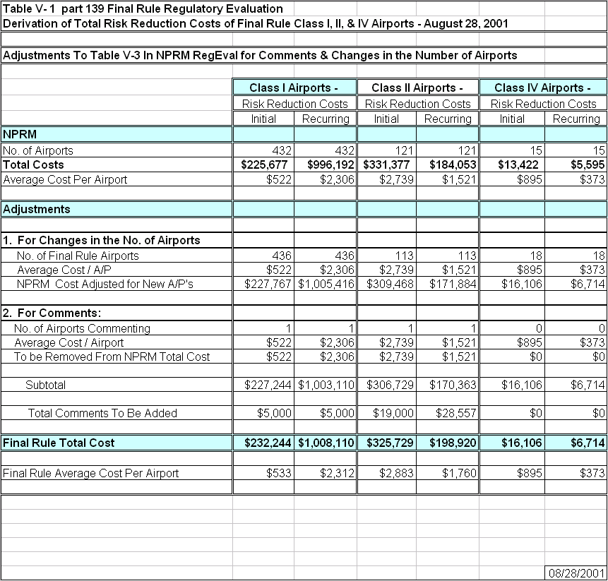

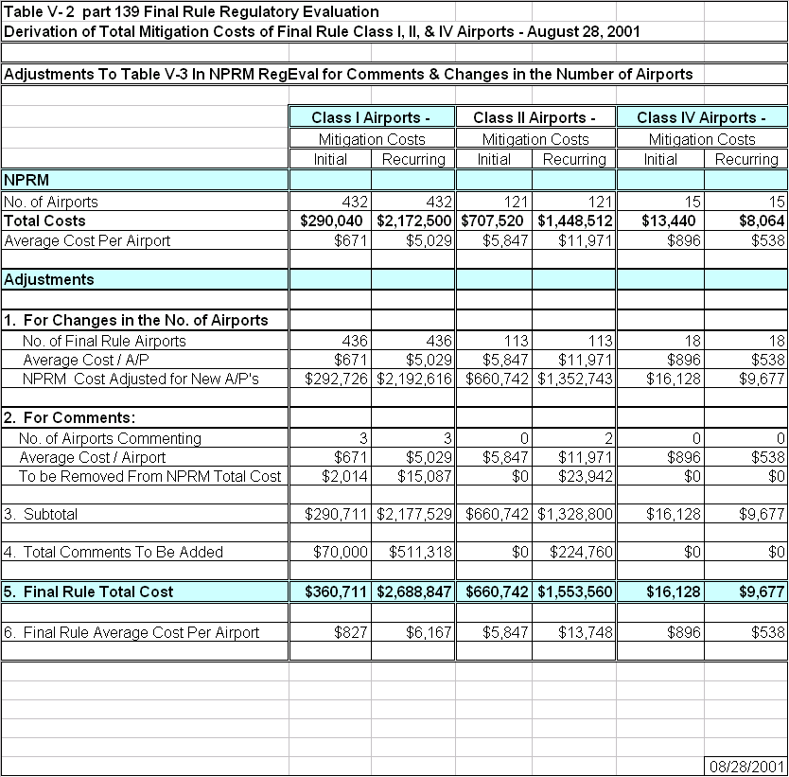

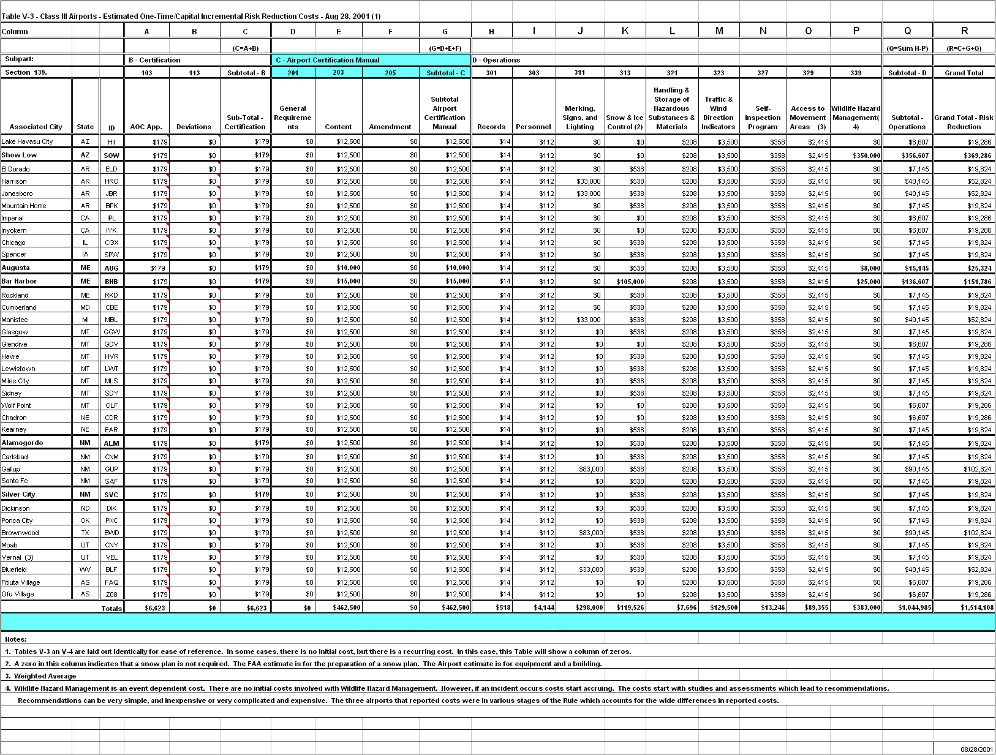
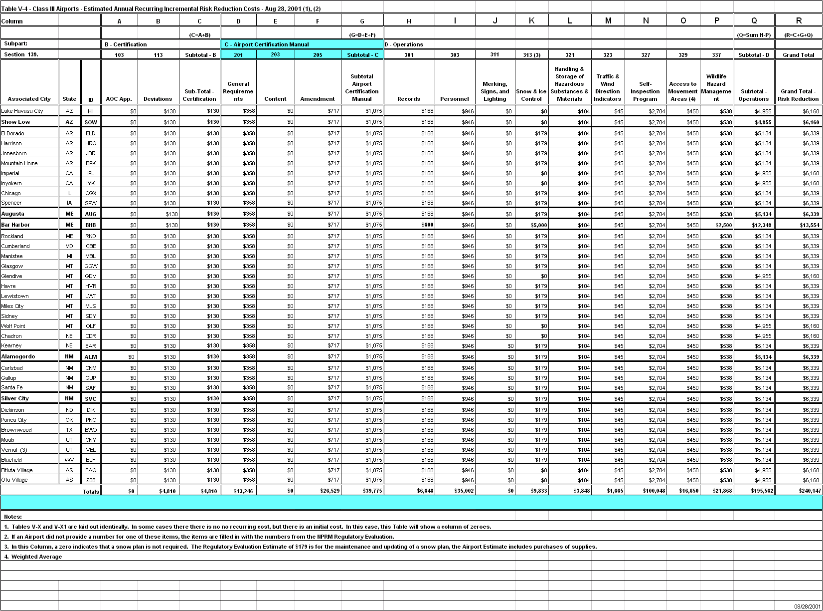

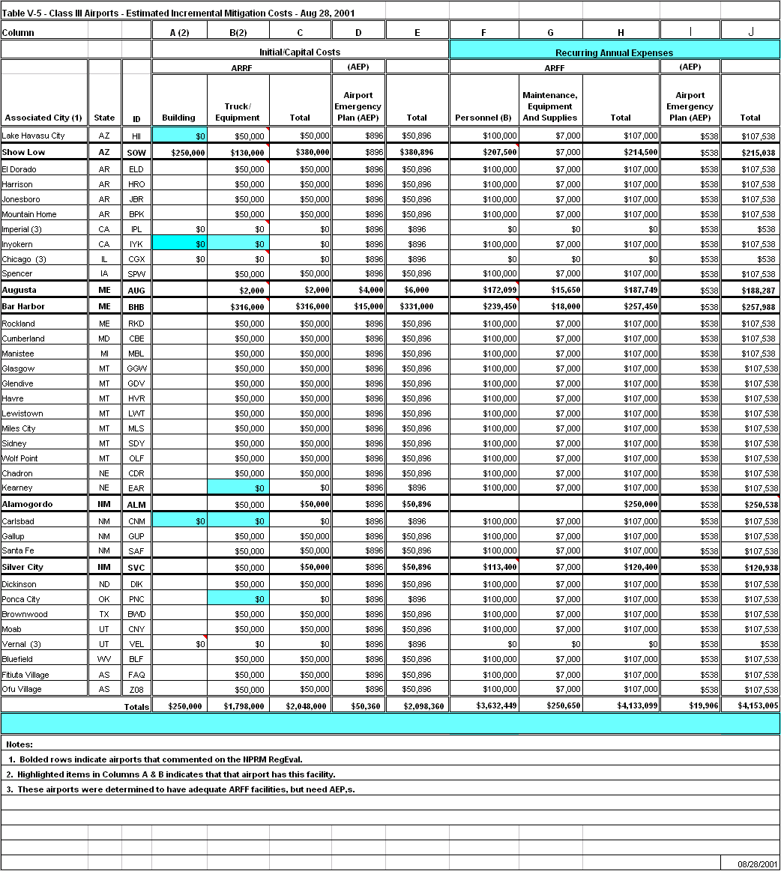

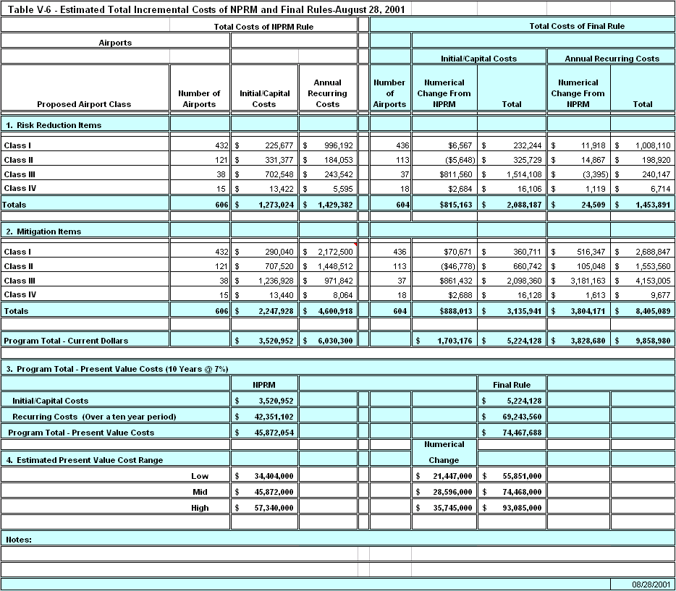

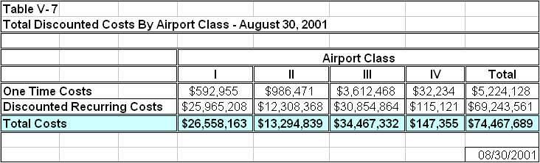

VI. BENEFIT-COST COMPARISON
Some of the requirements of this final rule that will impose costs, such as improved snow and ice control, marking, signing and lighting, and wildlife hazard management are intended to prevent accidents. Others, such as emergency planning and improved emergency response capability are intended to mitigate accidents should they occur. In both cases, the final rule is expected to save lives and reduce injuries and property damage. Without this rule FAA believes that some of the accidents and many near accidents that have occurred in the past are likely to be repeated in the future.
FAA estimates that the present value of the 10-year cost of this final rule is about $74.5 million. This estimate is likely to be high because it is based on assumed average costs across all airports in each airport class. In the application of this rule, each airport (particularly Class III airports) may already be in compliance with this rule, or may receive relief from certain aspects of the rule through alternate means of compliance or the exemption process.
Although FAA did not quantify the benefits of this final rule, for the reasons discussed earlier, some useful observations can be made. First, a single accident could easily equal, or exceed the estimated total cost of this final rule. A single accident involving two 30-seat airplanes with an industry standard load factor could result in a loss of as much as $108 million (using $3.0 million to represent a fatality avoided). With modern yield management techniques, a fully loaded airplane is not uncommon. An accident with a single, fully loaded 30-passenger airplane, and a crew of three could result in a loss of as much as $99 million. For example, the accident at the Quincy, Illinois Airport is estimated to have had a cost of as much as $44 million. In addition, the final rule should reduce the risk of, as well as mitigate, fuel storage fires, wildlife strikes, runway incursions, and snow /ice related accidents.
Thus, FAA believes that numerous safety benefits will occur from the multiple provisions in the final rule. One of these benefits is the reduction of the risk of and the mitigation of another accident, such as the one at Quincy, Illinois, where potential survivors might have been helped. The FAA believes it is necessary to take action that could reduce the potential for such an accident or mitigate a reoccurrence of such an accident. Consequently, and in view of the moderate costs and potential benefits, the FAA concludes that this final rule is cost justified.

VII FINAL REGULATORY FLEXIBILITY ANALYSIS (FRFA)
The Regulatory Flexibility Act of 1980 (RFA) establishes “as a principle of regulatory issuance that agencies shall endeavor, consistent with the objective of the rule and of applicable statutes, to fit regulatory and informational requirements to the scale of the business, organizations, and governmental jurisdictions subject to regulation.” To achieve that principle, the RFA requires agencies to solicit and consider flexible regulatory proposals, and to consider the rationale for their actions. The RFA covers a wide range of small entities, including small businesses, not-for-profit organizations and small governmental jurisdictions.
Agencies must perform a review to determine whether a proposed or final rule will have a significant economic impact on a substantial number of small entities (SEIOSNSE). If the determination is that it will have such an impact, the agency must prepare a regulatory flexibility analysis as described in the RFA. However, if an agency determines that a proposed, or final, rule is not expected to have a significant economic impact on a substantial number of small entities, section 605(b) of the RFA provides that the head of the agency may so certify and a regulatory flexibility analysis is not required. The certification must include a statement providing the factual basis for this determination, and the reasoning should be clear.
This final rule will affect publicly owned airports. When the population of a public airport-owning entity is less than 50,000, it is considered a small entity. Based upon the above review, FAA concludes that the final rule will have a significant economic impact on a substantial number of small entities. Accordingly, the following final regulatory flexibility assessment was prepared, as required by the RFA.

Issues To Be Addressed In A Final Regulatory Flexibility Analysis
The central focus of a final regulatory flexibility analysis (FRFA), like the initial regulatory flexibility analysis (IRFA), is the requirement that agencies evaluate the impact of a rule on small entities and analyze regulatory alternatives that minimize the impact when there will be a significant economic impact on a substantial number of small entities.

The requirements, outlined in section 604(a)(1- 5), are listed and discussed below:
1) A succinct statement of the need for, and objectives of, the rule;
Prior to 1996, the FAA’s statutory authority to certificate airports was limited to those airports serving air carrier operations using aircraft with more than 30 passenger seats. However, this authority was broadened by the Federal Aviation Administration Reauthorization Act of 1996. Title 49 USC 44706 was amended to allow the FAA to certificate airports, with the exception of those located in the State of Alaska, that serve any scheduled passenger operation of an air carrier operating aircraft designed for more than 9 passenger seats but less than 31 passenger seats. FAA's existing authority to certificate airports serving air carrier operations conducted in aircraft with more than 30 seats remained unchanged.
With this rule, the FAA intends to extend airport regulatory standards to airports now being served by air carriers with scheduled passenger operations in aircraft designed for at least nine seats but no more than 30 seats.
The primary objective of this final rule is to ensure safety in air transportation by regulating the operation and maintenance of airports serving certain scheduled air carrier operations. The rule is necessary to reduce the risk of future accidents similar to those that have recently occurred, and to mitigate fatalities and injuries if those accidents do occur.
2) A summary of the significant issues raised by the public comments in response to the IRFA, a summary of the assessment of the agency of such issues, and a statement of any changes made in the proposed rule as a result of such comments;
There were a substantial number of comments from small airports concerned about the financial burden that the proposed rule would place on them, particularly the personnel costs associated with ARFF requirements.
In response to public comments, FAA made the following changes to the proposed rule in developing the final rule:
One of the changes is that the sections of the proposed rule that dealt with obtaining an exemption from the ARFF requirements have been clarified for the final rule. The final rule is more explicit in describing how to apply for an exemption. FAA believes that allowing alternate means of compliance to accommodate local conditions through the exemption process will result in actual compliance costs that are substantially less than those estimated in the final regulatory evaluation because both these processes will vary from airport to airport. FAA was not able to quantify the resulting reduction in compliance cost.
The time period to accomplish some requirements, such as the preparation of the ACM, was extended, especially for the smaller airports.
3) A description of, and an estimate of the number of, small entities to which the rule will apply or an explanation of why no such estimate is available;
The Small Business Administration (SBA) classifies all airports that are operated under the airport ownership of a public entity with 50,000 or less population as small entities.
Using the SBA’s definition of a “small” public entity, there are approximately 200 small entity airports that will be affected by this rule. Most of the small entities are expected to be proposed Class 1 airports (approximately 100 proposed Class I airports), with the largest economic impact expected to occur to the proposed Class III airports (approximately 25 proposed Class III airports).
4) A description of the projected reporting, record-keeping, and other compliance requirements of the rule, including an estimate of the classes of small entities which will be subject to the requirement and the type of professional skills necessary for preparation of the report or record; and
The final rule will create additional reporting or recordkeeping beyond those already specified in existing part 139. For each airport, the preparation of this documentation may involve the airport manager, operation and maintenance personnel, and clerical staff. The FAA estimates the average initial hours to set up a record-keeping system per small entity will be approximately 70 hours, and expects a continuing additional paperwork requirement of about 90 hours annually.
5) A description of the steps the agency has taken to minimize the significant economic impact on small entities consistent with the stated objectives of applicable statutes, including a statement of the factual, policy, and legal reasons for selecting the alternative adopted in the final rule and why each one of the other significant alternatives to the rule considered by the agency which affect the impact on small entities was rejected.
The FAA extensively considered several alternatives, described in the Initial Regulatory Flexibility Analysis (IRFA), and determined that the alternative chosen for the NPRM was the only alternative that was relatively affordable and also achieved the safety objectives of the proposed rule. This initial alternative was subjected to public scrutiny during the comment period of the NPRM process. The comments received were responded to, as described above, and this initial alternative, as modified into the final rule is the selected alternative.
Extended Discussion Of The Rule, Comments On Affordability And Safety
The last major revision of part 139 occurred in November 1987, and since then, industry practices and technology have changed significantly. Subsequently the FAA has monitored the effectiveness of part 139 and has taken this opportunity to update part 139 requirements.
The FAA initiated this rulemaking to improve safety at airports serving small air carrier operations, fully appreciating the financial limitations of these airports. In 1996, Congress authorized FAA to certificate airports serving scheduled air carrier operations conducted in 10 to 30 seat aircraft to further ensure safety in air transportation. This was the same year that all occupants died in a collision of a United Express Beech 1900C (under 30 seat air carrier aircraft) and a Beech King Air aircraft (a general aviation aircraft). The National Transportation Safety Board concluded that…”if on-airport ARFF protection had been required for this operation at Quincy Airport, lives might have been saved.”
An industry/FAA evaluation of possible regulatory alternatives for the certification of airports serving small air carrier aircraft concluded that there exists a need to require at least some minimum level of both risk reduction and accident mitigation measures at airports during operations of smaller air carrier airplanes. However, FAA recognizes the need to provide some flexibility in the implementation of certain safety measures at airports with infrequent air carrier service or where local resources are severely limited. Airports in smaller communities do not always have the resources to support their airports at the same level as large metropolitan areas without adversely affecting other community services and infrastructure.
A final mitigating factor is the FAA’s statutory authority to exempt certain airports from part 139 requirements. In some instances, the cost to comply with certain part 139 requirements could be too burdensome for some airport operators serving small air carrier operations. In such cases, FAA will work with the airport operator in developing and tailoring an Airport Certification Manual to achieve safety in air transportation at that airport, and will assist the airport operator to obtain Federal funds, as appropriate. Also, FAA has the statutory authority to grant exemptions from part 139 requirements that would be too costly, burdensome, or impractical, including ARFF requirements.
There are several avenues available to small-entity airports to mitigate the economic impact of this rule. One is that the Airport Improvement Program (AIP) funding (often supplemented by state grants) is available for certain capital expenditures that may be required by the rule such as fire fighting equipment, airport marking and signs, to name two. Another avenue is the Essential Air Service (EAS) program. For Class III airports that are owned by small communities, serve a limited number of passengers, and operate at a loss, it is likely that much of the final actual costs to the airport would be passed through to the air carriers. At airports where carriers receive EAS subsidies, approximately two-thirds of all Class III airports – the Federal government will probably absorb most, if not all of the cost of the rule through increased subsidies.

Summary
After considering the alternatives for the certification of airports serving small air carrier operations and alternatives for updating part 139 (as specified in the IFRA), the FAA determined that this rule amending part 139 is necessary to ensure safety in air transportation. However, to accommodate variations in airport size and operations, FAA may allow alternative means of compliance with part 139 requirements. This will allow the most cost effective and flexible method of ensuring safety to be employed at all covered airports while providing for the special needs of small entities.
- INTERNATIONAL TRADE IMPACT ASSESSMENT
The Trade Agreement Act of 1979 prohibits Federal agencies from engaging in any standards or related activities that create unnecessary obstacles to the foreign commerce of the United States. Legitimate domestic objectives, such as safety, are not considered unnecessary obstacles. The statute also requires consideration of international standards and where appropriate, that they be the basis for U.S. standards.
In accordance with the above statute, the FAA has assessed the potential effect of this final rule and determined that the rule’s airport certification requirements will have little or no impact on trade for U.S. firms doing business in foreign countries and for foreign firms doing business in the United States.
- UNFUNDED MANDATES REFORM ACT
The Unfunded Mandates Reform Act of 1995 (the Act), enacted as Pub. L. 104-4 on March 22, 1995, is intended, among other things, to curb the practice of imposing unfunded Federal mandates on State, local, and tribal governments.
Title II of the Act requires each Federal agency to prepare a written statement assessing the effects of any Federal mandate in a proposed or final agency rule that may result in a $100 million or more expenditure (adjusted annually for inflation) in any one year by State, local, and tribal governments, in the aggregate, or by the private sector; such a mandate is deemed to be a “significant regulatory action.”
This final rule does not contain such a mandate. Therefore, the requirements of Title II of the Unfunded Mandates Reform Act of 1995 do not apply.

Appendices

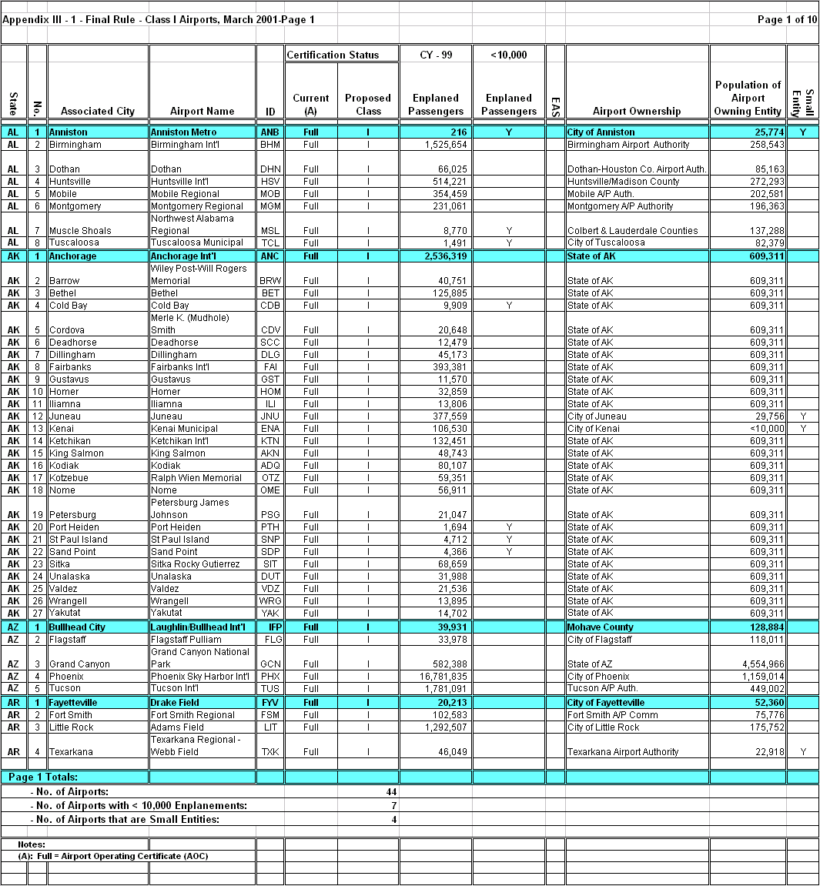

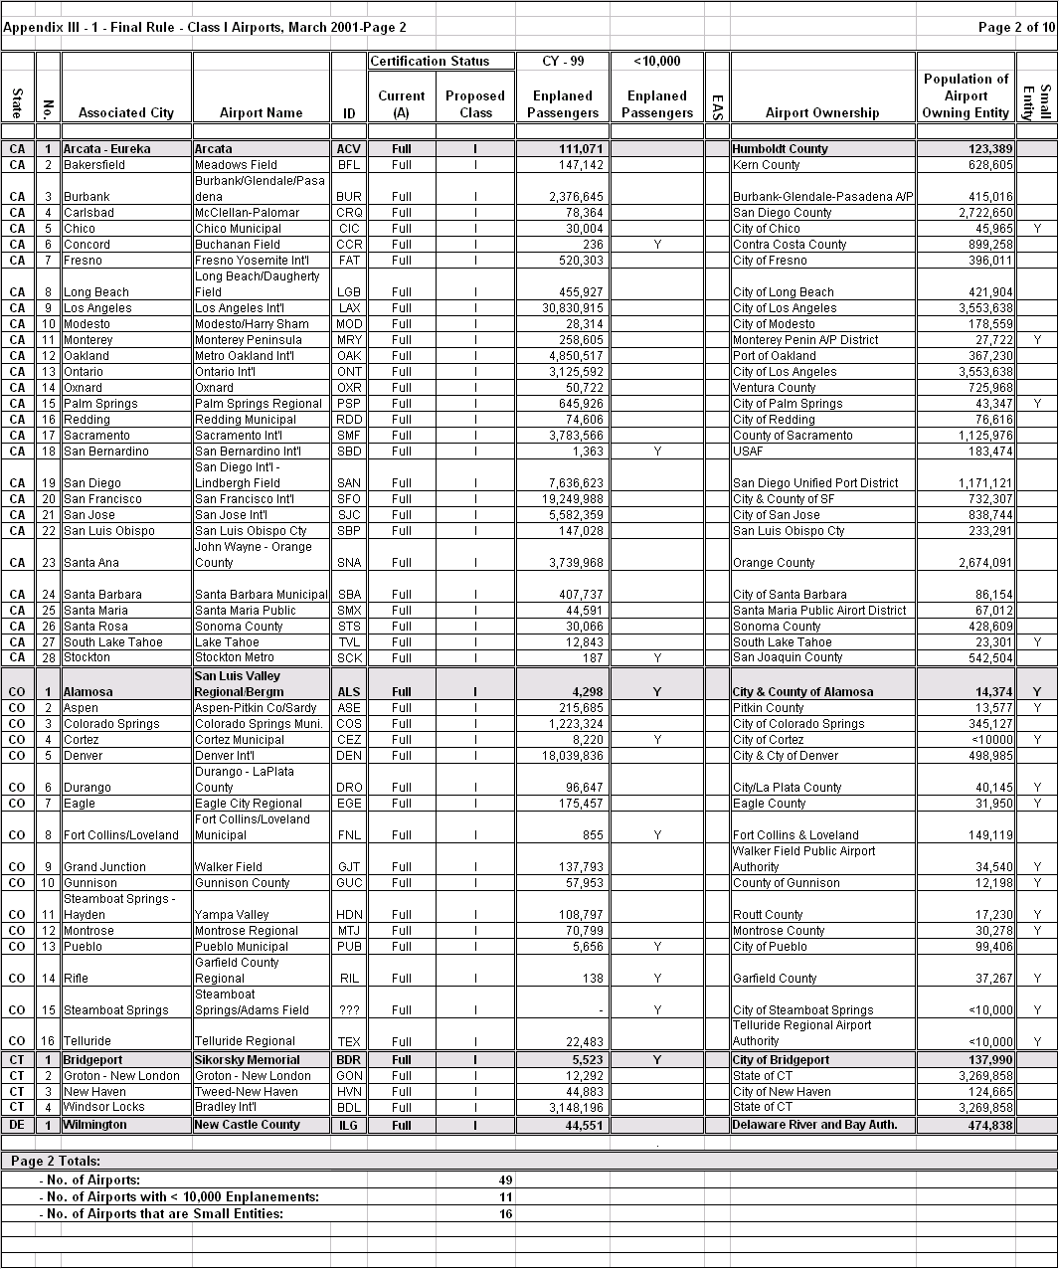

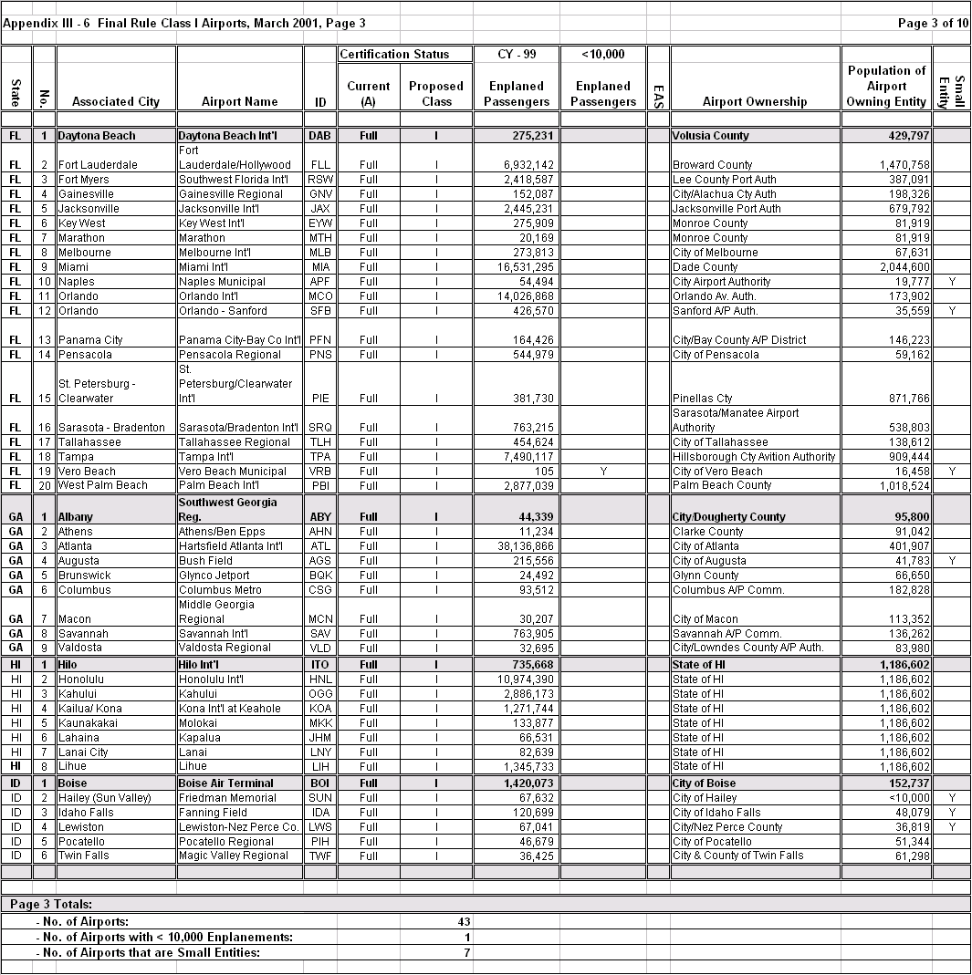

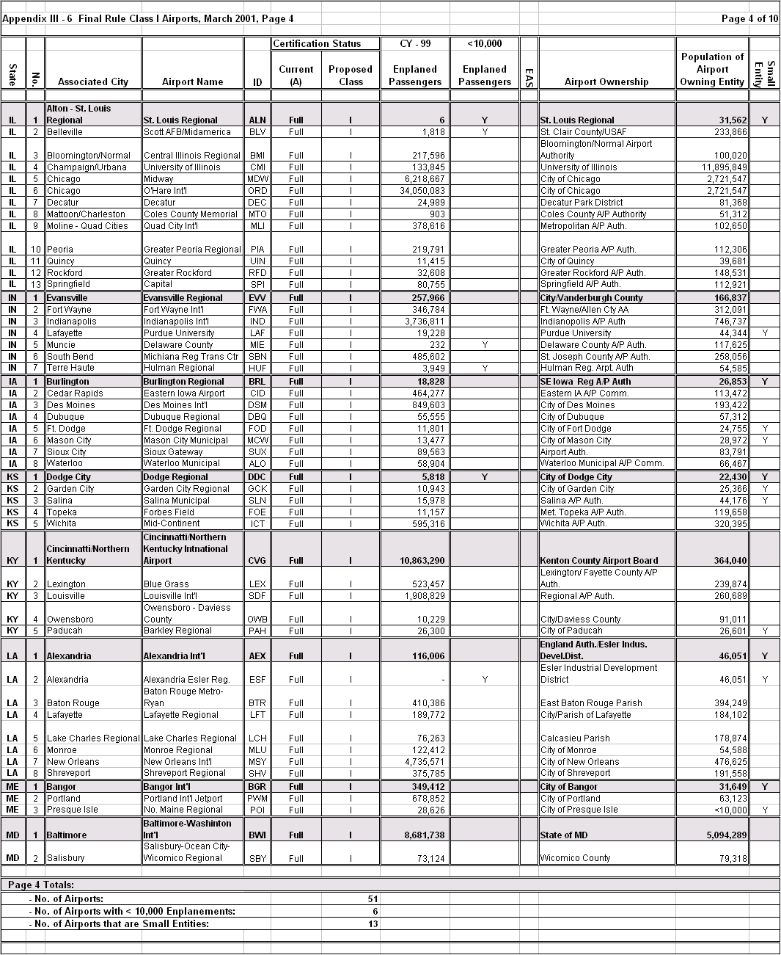

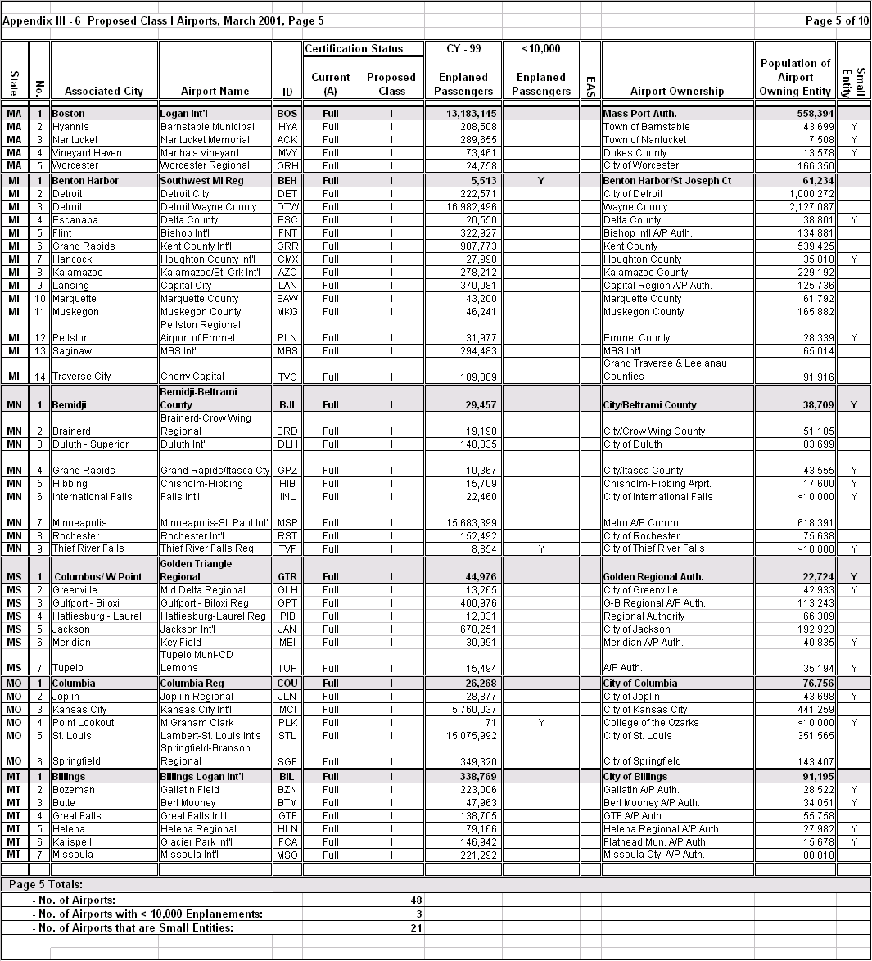

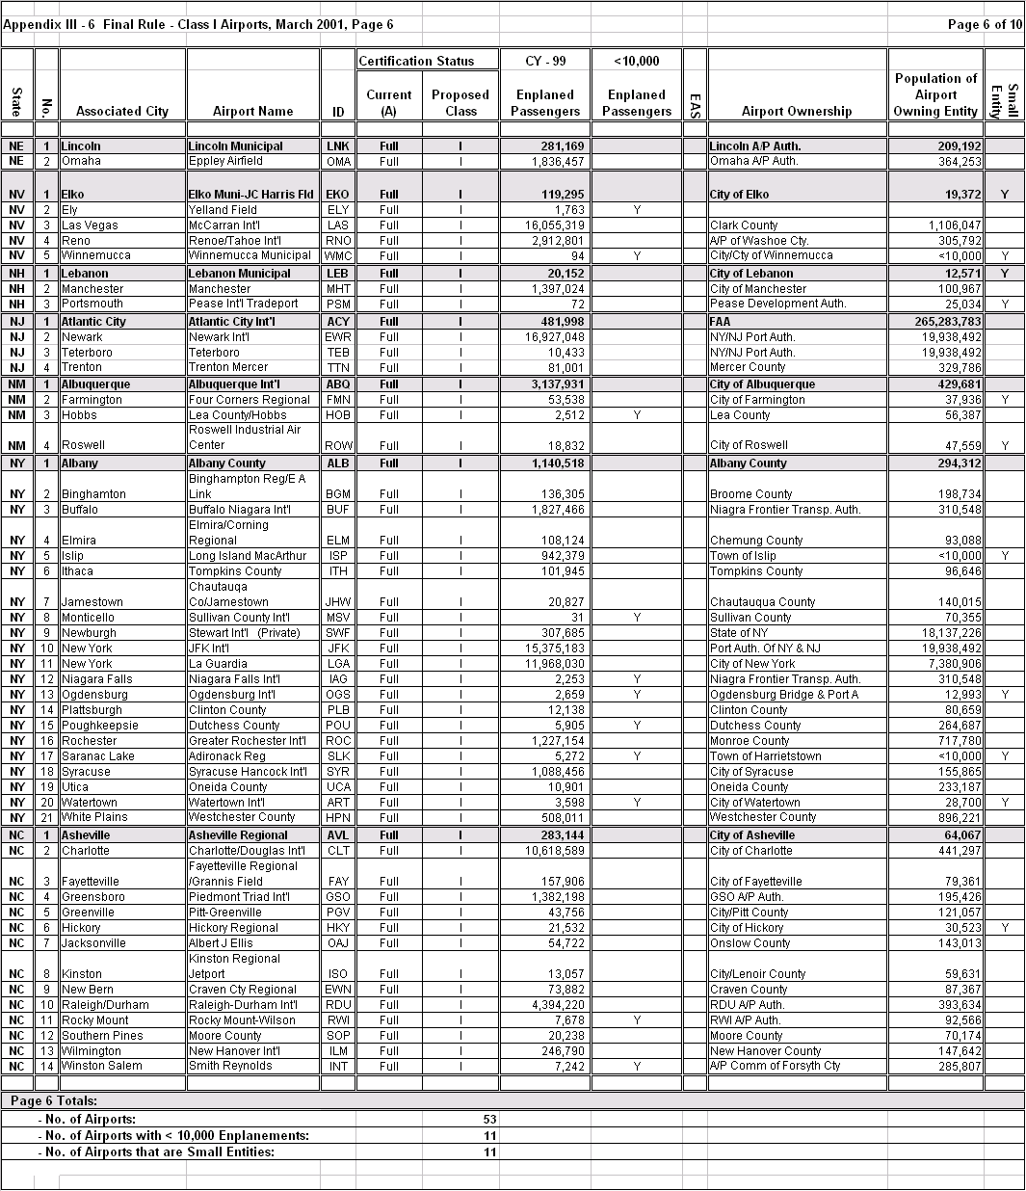

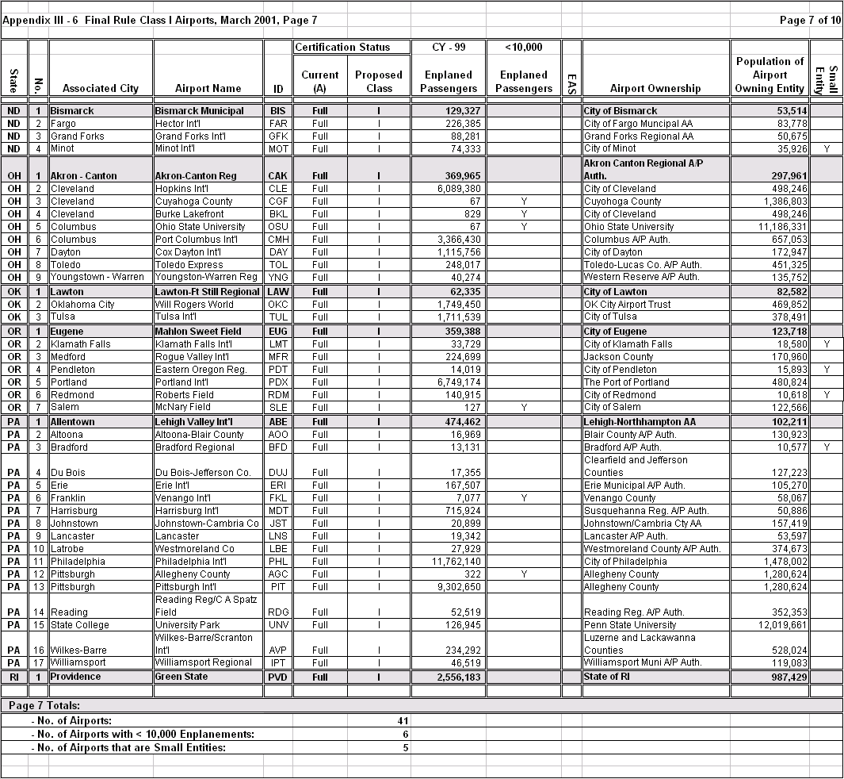

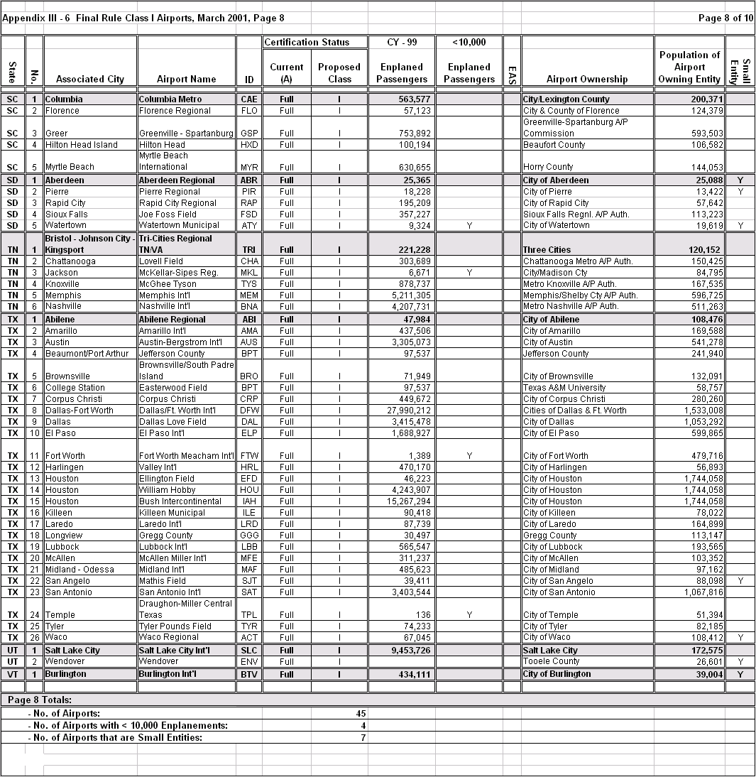

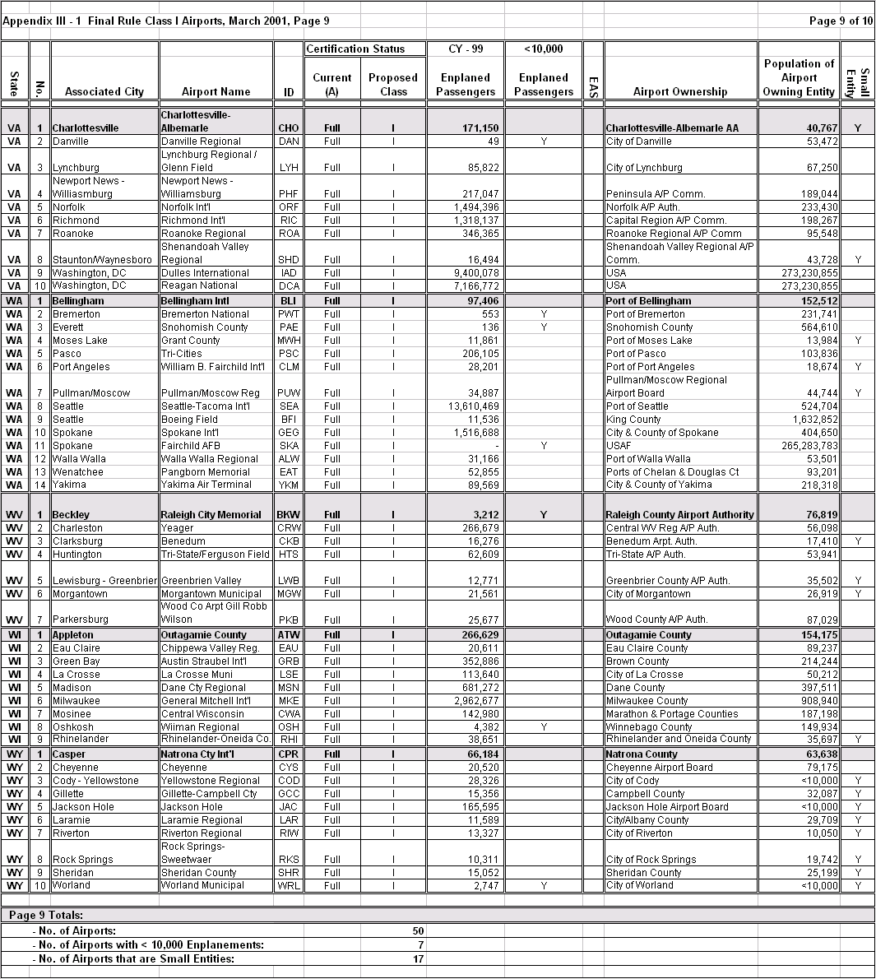

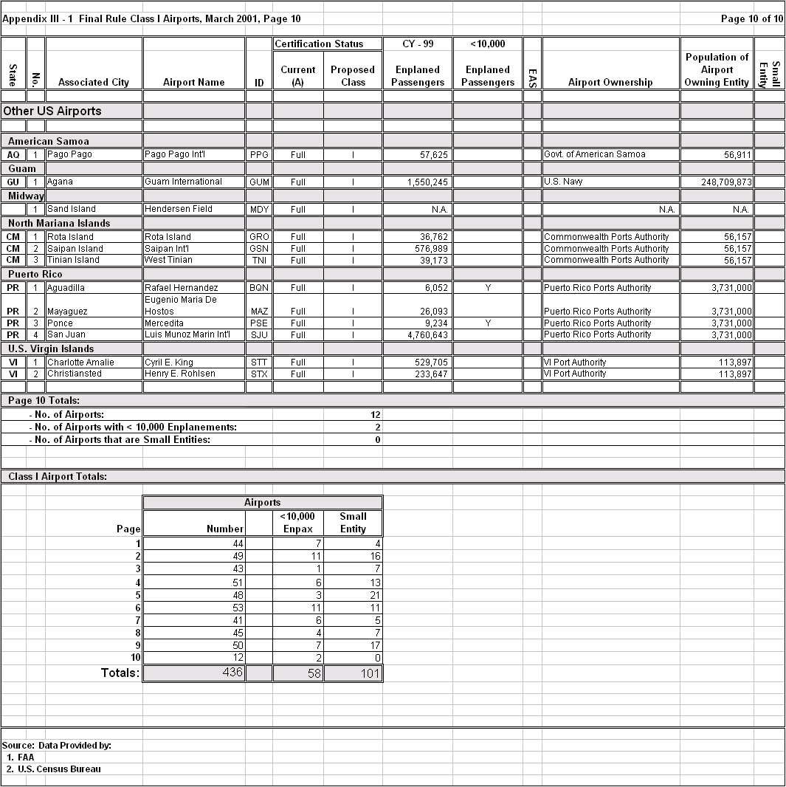

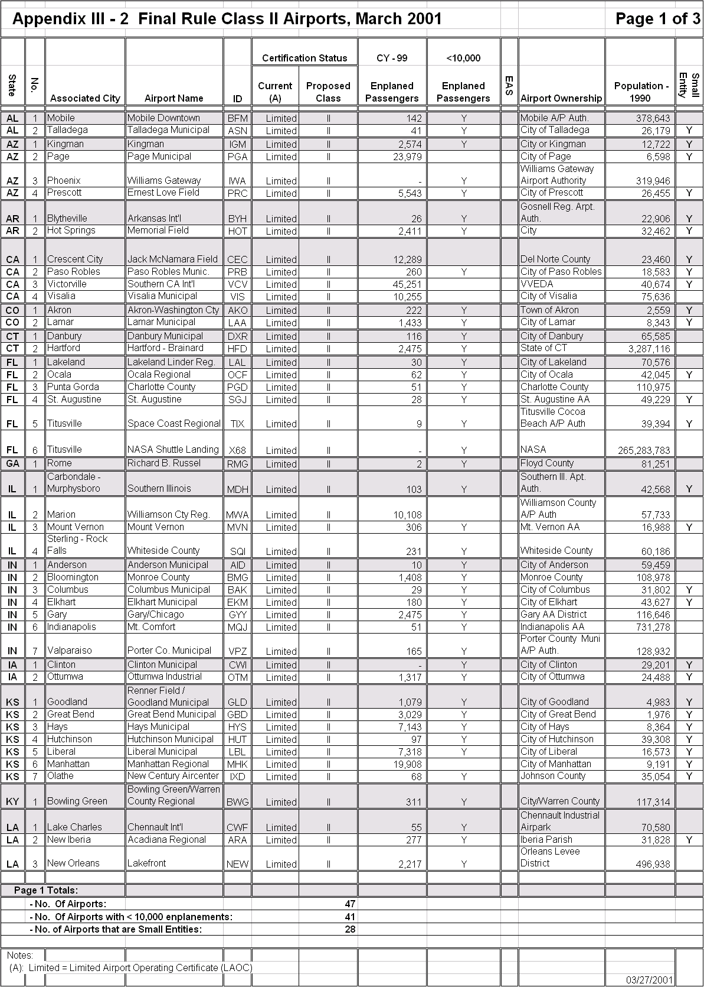

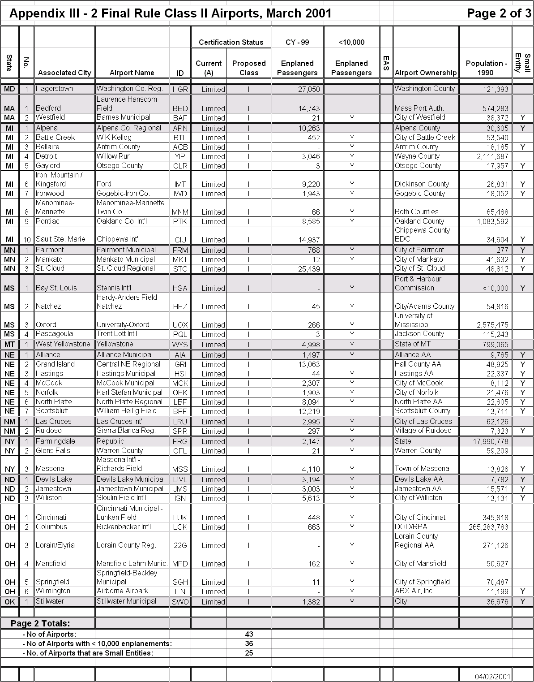

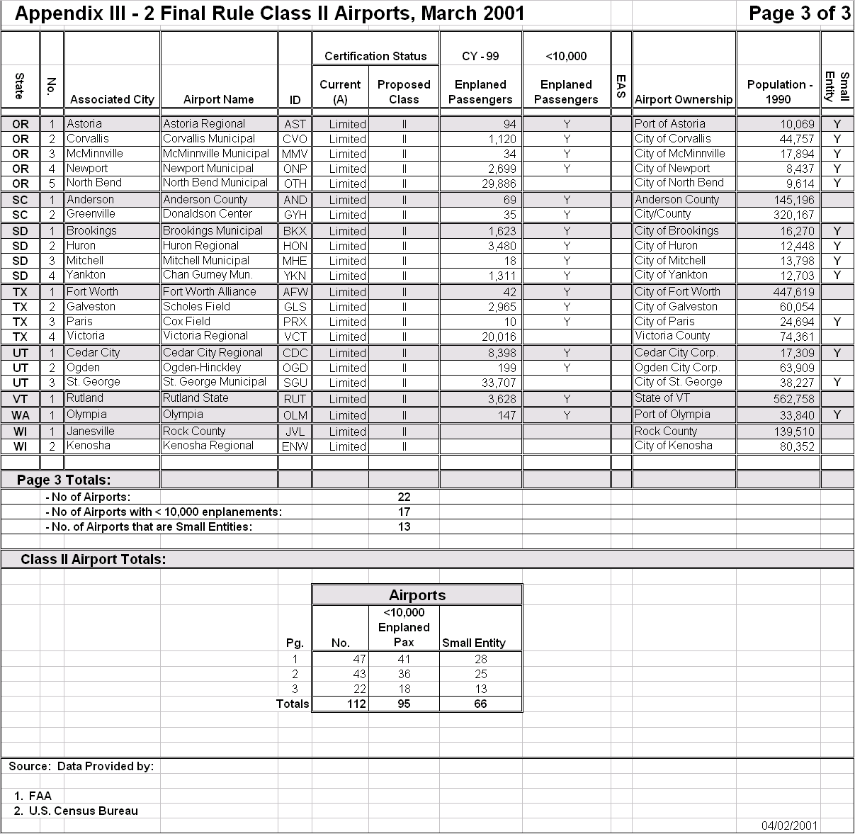

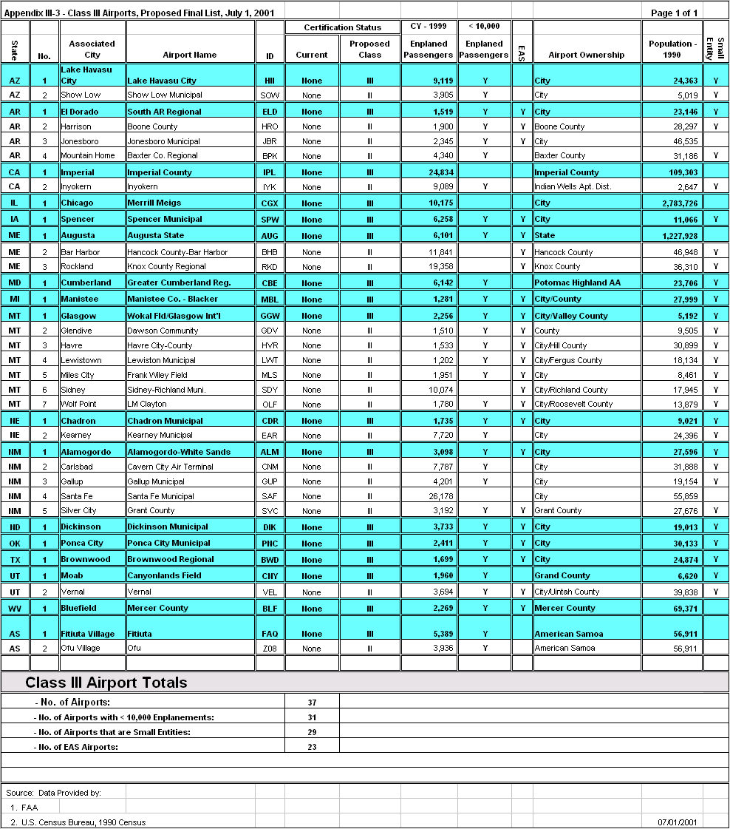

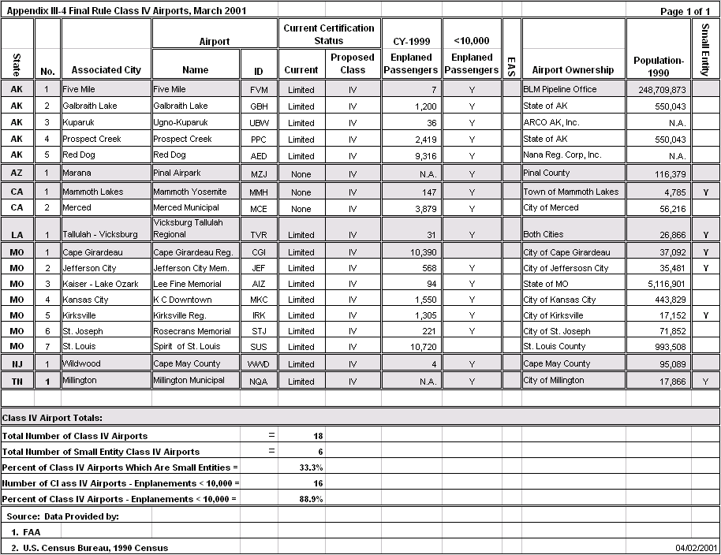

Aviation Safety: Commuter Airports Should Participate in the Airport Certification Program, US General Accounting Office, GAO/RCED-88-41, November 1987.
Safety Study: Commuter Airline Safety, National Transportation Safety Board, NTSB/SS-94/02, November, 1994.

