Hazard Abatement Plan - Thirtymile Fire

Enclosure # 7

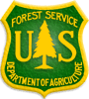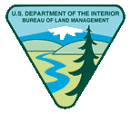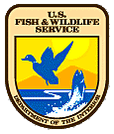

NATIONAL INTERAGENCY FIRE CENTER
3833 S. Development Avenue
Boise, Idaho 83705-5354

April 1, 2002

To: Agency Personnel

From: Fire and Aviation Directors; BLM, FS and FWS

Subject: 2002 Standards for Fire and Aviation Operations

The original “Standards for Fire and Aviation Operations” was created as a
result of the South Canyon fire in 1994, and was first published in 1996.
Completion of the 2002 version satisfies Action Item 17 of the Thirty-Mile
Prevention Action Plan. Most of the standards apply across interagency lines
and users will find either (USFS) or (FWS) wording that will guide them to
agency-specific direction, located at the end of each chapter.

For the USFS and FWS, the 2002 Standards for Fire and Aviation Operations is
now direction that will supplement existing agency manual or handbook
direction. The five federal agencies have additional work to complete in order
to eliminate or reduce supplemental agency specific direction, which is required
by the Federal Fire Policies of 1995 and 2001.

The 2002 version of Standards for Fire and Aviation Operations is an
outstanding example of the interagency effort to continually improve efficiency
in fire and aviation operations.

Signed By: Signed By: Signed By:
Larry Hamilton Dennis W. Pendleton Roger Spaulding
Director F&AM Assistant Director Acting Director
BLM F&AM FS F&AM FWS

