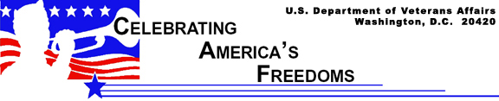

The Seal of the Department of Veterans Affairs

You know them when you see them, those familiar shapes and symbols — corporate America calls them logos –that automatically identify a business in the public mind. They are closely guarded and protected. They are worth millions. Symbols are just as important to government agencies. A federal agency’s official seal, for example, carries the full weight and impact of the laws, resources and responsibilities vested in it by the American people.

VA’s current seal dates back to 1989 when the then-Veterans Administration, an independent agency of the federal government, was made the Department of Veterans Affairs – a Cabinet member agency – by Congress. This brought many changes to VA, including a new VA seal.

The reproduction and use of the VA seal is specified by law (38 CFR 1.9). It is reserved for limited use as the symbol of governmental authority invested by the Department. The seal identifies all official documents, certifications, awards, publications, regulations and reports. Variation and modifications of the seal are prohibited. It is VA’s legally sanctioned official signature.

VA turned to its employees in its search for a new seal representing the newest Cabinet member. A contest was held among more than 225,000 VA employees to design the new seal.

A design submitted by David Gregory, a medical media production specialist working at the Indianapolis VA Medical Center won. He focused on traditional American symbols and his own innovative symbolism to visually convey VA’s special mission.

The five stars represent Army, Navy, Air Force, Marines, Coast Guard.  The flags represent the span of America’s history from 13 colonies to present 50 states. | 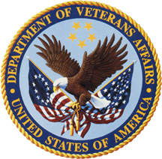 | The eagle holds the cord to perpetuate the memory of all slain Americans and their sacrifices  The golden cord symbolizes those who have fallen in defense of this country.

The VA seal features five key elements. The primary element is the bald eagle, the official symbol of the United States since 1789. The mature eagle is a powerful representation of the United States symbolizing both the American people and the freedoms they enjoy. The circle of five stars above the eagle represent the five branches of the U.S. military; Army, Navy, Air Force, Marine Corps and Coast Guard, which produce the veterans VA serves.

The two flags in the eagle’s talons symbolize America’s history from the thirteen colonies to the present fifty states. A golden cord symbolic of those Americans who have fallen in service to their country binds the flags. The cord is also held by the eagle to perpetuate the memory of those veterans who have sacrificed for the nation. The seal’s colors are derived from the American flag and the natural colors of the earth, representing the Nation’s commitment to its veterans.

In order to maintain the appreciation and respect of the Seal, VA has specific guidelines for use of the Seal. The Seal may only be used in an official capacity. You will never see the official Seal on souvenir or novelty items, toys, gifts, matchbook covers or calendars. These unauthorized uses of the Seal may result in criminal prosecution.

Just as a logo is synonymous with a specific company, the Seal is synonymous with the Department of Veterans Affairs. Any time you see the Seal, you can bet VA is close by.

