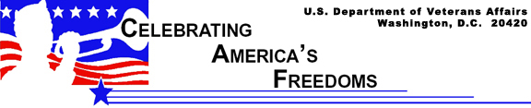

Military Songs Inspire Troops, Preserve Tradition

Each branch of the U.S. Armed Forces maintains its own military marching band to inspire troops and preserve tradition. Though they now serve ceremonial functions, these bands were once an integral element on the battlefield. To increase the morale
and courage of the men, bands would march in front of formations as they entered battle. Yet, as the number of musicians dwindled, commanders delegated marching bands to the rear of the formation, behind the combat-ready troops. Today, bands are no longer involved in armed conflict, but continue to inspire troops through song or hymn that represent the individual histories and traditions of America’s Armed Forces.

“The Army Goes Rolling Along”
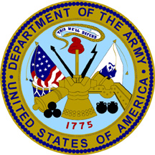
Before “The Caisson Song” was adopted as the official tune of the U.S. Army, it was the proud anthem of the U.S. Field Artillery Corps. During a long march in the Philippines, Lieutenant Edmund L. “Snitz” Gruber overheard an officer roar “Come on! Keep ‘em Rolling!” Gruber, whose relative, Franz, composed the Christmas Song “Silent Night,” was suddenly inspired and that night wrote the now-famous melody. Fellow soldiers helped with the lyrics and in almost no time, all six regiments of the U.S. Field Artillery had adopted “The Caisson Song” as a popular marching tune.

During the last days of World War I, senior artillery leaders wanted to make “The Caisson Song” official, and mistaking the piece as composed during the Civil War, allowed bandmaster John Phillip Sousa to incorporate most of the song into his own composition “The U.S. Field Artillery March.” The song became a chart-topper during World War I, selling 750,000 copies. Discovering Gruber actually wrote the melody, an embarrassed but innocent Sousa made certain Gruber received his royalties. In 1948, the Army held a nationwide contest to find an official song. After four years of unsuccessful results and nearly 800 submitted scores, the Adjunct General’s office decided to recycle “The Caisson Song.” H.W. Arberg arranged the U.S. Army song, naming it “The Army Goes Rolling Along.” The Army copyrighted the song in 1956.
The “Marines’ Hymn”

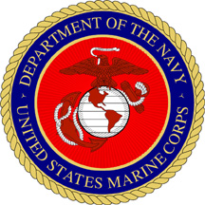
An unlikely venue hosted the debut of a tune many now associate with the Marines’ Hymn. In the city of Paris, France, Jacques Offenbach (1819-1880) wrote and conducted opera and opera-bouffe (comic and farcical opera). Most believe the melody of the Marines’ Hymn was, in fact, taken from an aria in “Genevieve de Brabant” composed by Offenbach. This tune was morphed to fit the now famous lines “From the Halls of Montezuma, To the Shores of Tripoli.”

According to tradition, an officer wrote the first verse of the Hymn on duty in the Mexican War (1846-1848). Meant to highlight the various campaigns of the Marines, the unknown author edited the words from the Marines’ colors and added them to Offenbach’s melody. Continuing the custom, every campaign the Marines participate in gives birth to a new, unofficial verse. Copyright ownership of the Marines’ Hymn was vested to the U.S. Marine Corps in 1991, although its first use as the Marines’ official anthem was in 1929.

U.S. Navy “Anchors Aweigh”

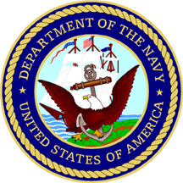
In an attempt to write a catchy tune to rally the Naval Academy’s football team, “Anchors Aweigh” was born. Lieutenant Charles A. Zimmerman, the U.S. Navy bandmaster from 1887 to 1916, started the practice of composing a march for each graduating class. However, none of these tunes really caught on. In 1906, Zimmerman was approached by Midshipman Alfred Hart Miles to write a “piece of music that would be inspiring, one with swing to it so it could be used as a football marching song, and one that would live forever.”

Together, Zimmerman and Hart composed the tune and lyrics that became “Anchors Aweigh,” dedicated to the class of 1907. The new fight song indeed propelled Navy to a win that year over Army. The march was subsequently adopted as the official Navy song and continues to inspire classes of Naval Academy Midshipmen.
“The U.S. Air Force”

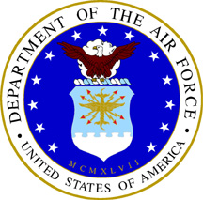
In 1938, the Army Air Corps decided they needed an official song. Liberty Magazine sponsored a contest whereby 757 scores were submitted. Of those, one written by Robert Crawford was selected by a committee of Air Corps wives and officially introduced at the Cleveland Air Races in 1939. Crawford himself sang it in its first public performance. When the Army Air Corps became a separate branch of the military in 1947, Crawford’s march changed names from “The Army Air Corps” to the “U.S. Air Force.”

Since that time, the first line of “Nothing’ll Stop the U.S. Air Force” became a motto and tradition. On July 30, 1971, the original first page submitted by Robert Crawford in 1939 was carried into space in the Apollo 15 “Falcon” and broadcast to the world by Major Alfred W. Worden, who had a tape recorder aboard the “Endeavor” command module. The “All-Air Force” crew arranged to take the sheet music with them as a tribute to Crawford and the U.S. Air Force.

The U.S. Coast Guard and “Semper Paratus”

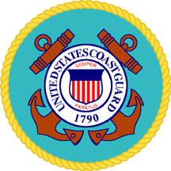
The Coast Guard’s motto of Semper Paratus or “always ready” was officially recognized in 1910, and thenceforth appeared on the ensign. However, no one really knows how Semper Paratus was chosen as the Coast Guard’s “phrase” and watchword prior to its formal acceptance.

Whatever the case, in 1922, Captain Francis S. Van Boskerck was inspired to write an official U.S. Coast Guard song that would rival “Anchor’s Aweigh” or “The Caisson Song.” While in the cabin of his cutter Yamacraw, which was stationed in Savannah, Ga., Boskerck put pen to paper and the lyrics for “Semper Paratus” were born. Five years later, while stationed in the Aleutian Islands, Boskerck composed the accompanying music on a dilapidated old piano in Unalaska, Alaska. The geographically diverse origins of this piece are fittingly illustrated in the song’s first line “From Aztec shore to Arctic Zone, To Europe and Far East…” Semper Paratus remains the proud standard and song of the United States Coast Guard.

