

Flying the American Flag at Half Staff

When should the flag be flown at half-staff?

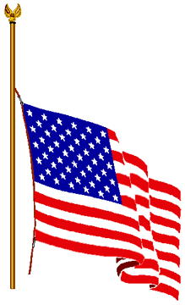An easy way to remember when to fly the United States flag at half-staff is to consider when the whole nation is in mourning. These periods of mourning are proclaimed either by the president of the United States, for national remembrance, or the governor of a state or territory, for local remembrance, in the event of a death of a member or former member of the federal, state or territorial government or judiciary. The heads of departments and agencies of the federal government may also order that the flag be flown at half-staff on buildings, grounds and naval vessels under their jurisdiction.
On Memorial Day the flag should be flown at half-staff from sunrise until noon only, then raised briskly to the top of the staff until sunset, in honor of the nation’s battle heroes.

In the early days of our country, no regulations existed for flying the flag at half-staff and, as a result, there were many conflicting policies. But on March 1, 1954, President Dwight Eisenhower issued a proclamation on the proper times.

The flag should fly at half-staff for 30 days at all federal buildings, grounds, and naval vessels throughout the United States and its territories and possessions after the death of the president or a former president. It is to fly 10 days at half-staff after the death of the vice president, the chief justice or a retired chief justice of the United States Supreme Court, or the speaker of the House of Representatives. For an associate justice of the Supreme Court, a member of the Cabinet, a former vice president, the president pro tempore of the Senate, the majority leader of the Senate, the minority leader of the Senate, the majority leader of the House of Representatives, or the minority leader of the House of Representatives the flag is to be displayed at half-staff from the day of death until interment.

The flag is to be flown at half-staff at all federal buildings, grounds and naval vessels in the Washington, D.C., area on the day and day after the death of a United States senator, representative, territorial delegate, or the resident commissioner from the Commonwealth of Puerto Rico. It should also be flown at half-staff on all federal facilities in the state, congressional district, territory, or commonwealth of these officials.

Upon the death of the governor of a state, territory or possession, the flag should be flown at half-staff on all federal facilities in that governor’s state, territory or possession from the day of death until interment.

The president may order the flag to be flown at half-staff to mark the death of other officials, former officials, or foreign dignitaries. In addition to these occasions, the president may order half-staff display of the flag after other tragic events.

The flag should be briskly run up to the top of the staff before being lowered slowly to the half-staff position.

