

Correct Method of Folding the United States Flag

Start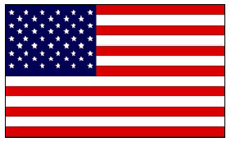Step 1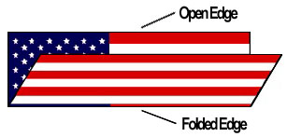

Fold the lower striped section of the flag over the blue field.Step 2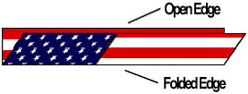

Folded edge is then folded over to meet the open edge.Step 3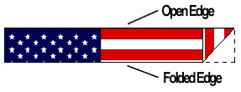
A triangular fold is then started by bringing the striped corner of the folded edge to the open edge.Step 4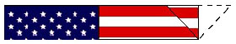Outer point is then turned inward parallel with the open edge to form a second triangle.Step 5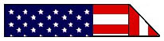Triangular folding is continued until the entire length of the flag is folded in the triangular shape with only the blue field visible.Completed

