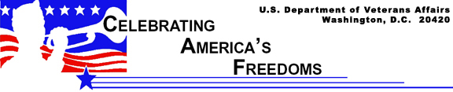

Arlington National Cemetery

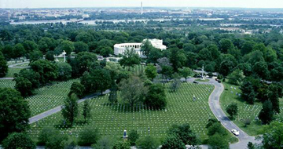

Almost four million people a year visit the national cemetery across the Potomac River from Washington, D.C., where a constant vigil is maintained at the Tomb of the Unknowns. Arlington National Cemetery is the site of the changing of a military guard around the clock daily. On Veterans Day 1921, a coffin bearing the body of an unidentified soldier of World War I was entombed adjacent to the Memorial Amphitheater and a monument weighing more than 100 tons placed atop it in 1932. Nearby crypts bear the remains of unknown American service members of World War II and the Korean War. The remains of a previously unknown Vietnam service member were exhumed on May 14, 1998, identified as Air Force 1st Lt. Michael Joseph Blassie, and removed for burial.

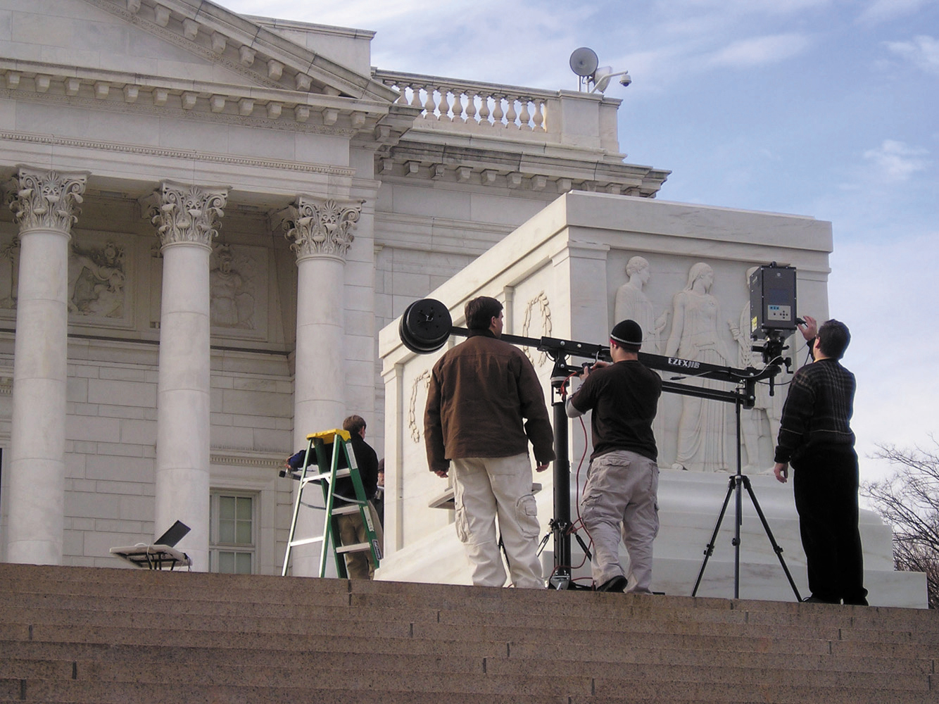 | Currently, the main part of the Tomb of the Unknowns’ above ground monument is being replaced because of two large cracks that have appeared in the marble. A detailed description of the tomb replacement project can be found on page 24 of the March/April edition of VA's magazine, VAnguard (1.1 MB PDF).

Each Memorial Day and Veterans Day, a presidential wreath is placed at the tomb. This may explain why Arlington is America’s most well-known national cemetery, even though it is not the largest or the oldest. Some 230,000 veterans and dependents are buried on the cemetery’s 612 acres. From Pierre L’Enfant, George Washington’s aide during the American Revolution, to American service members killed during Operation Desert Storm, Arlington holds the remains of veterans representing every military action the United States has fought.

Union Seized Lee’s Property

The cemetery’s origins go back to just before the Civil War. George Washington Parke Custis, adopted son of the first president, owned a 1,100-acre plantation and constructed on it a memorial to Washington named Arlington House, which held the world’s largest collection of memorabilia related to the president. Ownership of his estate passed to Custis’ daughter, who had married Robert E. Lee, and they lived in Arlington House for more than 30 years. The Lee family fled when the Civil War was imminent. The Union seized the property because of its strategic location overlooking Washington. Because of the bitter grudge against the South that Union Brig. Gen. Montgomery Meigs bore, and the need for burial space for the Union dead, this commander of forces at Arlington urged the federal government to convert 200 acres of Lee’s property to a cemetery. Meigs ordered burials near the house to make the grounds uninhabitable after the war.

The first soldier was buried in Arlington in May 1864. By war’s end, 16,000 graves filled the spaces close to Arlington House. Though the Supreme Court ruled finally in favor of the heir to the property, the eldest Lee son ceded title to the government for $150,000 and renounced any thought of living in Arlington House. From the portico of the mansion, the first official Memorial Day was proclaimed in 1868.

Burials Restricted

Whereas after the Civil War, only the poor or unidentified were entombed at Arlington, now it is a burial site particularly coveted by veterans and their families. Space for in-ground burials is restricted to those who die on active duty, have had 20 years of service, or earned certain military decorations, and their spouses and dependents. Any honorably discharged veterans and dependents may have their cremated remains inurned in Arlington’s columbarium. Honors are rendered daily by military units bearing a flag-draped coffin, firing a rifle volley and performing taps.

Numerous veterans and civic groups hold memorial services in the cemetery’s marble amphitheater. Monuments have been erected from time to time to memorialize specific groups of military members or veterans buried there.

Prominent Americans buried at Arlington include: Presidents John F. Kennedy and William H. Taft; World War I General of the Armies John J. Pershing; Generals Omar Bradley and George C. Marshall of World War II; and Generals Daniel “Chappie” James and Maxwell Taylor of the Vietnam War.

