 | NLM® Training: PubMed®

MEDLARS Management Section
U.S. National Library of Medicine®
National Institutes of Health
Department of Health and Human Services
Bethesda, Maryland
July 2008 Revision

N O T E S
Table of Contents
Table of Contents i
Agenda iii
Goals and Objectives iv
Introduction to the U.S. National Library of Medicine 5
The National Network of Libraries of Medicine® 5
Document Delivery 6
NLM Technical Bulletin 6
Consumer Information 7
NLM Customer Service 8
Subscribe to NLM-Announces Mailing List 9
Introduction to PubMed® (pubmed.gov) 11
What’s in PubMed 13
MEDLINE Citations 13
Medical Subject Headings (MeSH® Vocabulary) 23
Subheadings 29
Pharmacologic Action Terms 31
Other Types of MeSH Vocabulary 32
Building the Search 37
Search Results Screen 38
Automatic Term Mapping (ATM) 40
Citation Sensor 45
Practice Exercises: Basic Search and ATM 47
Related Articles 50
Limits 51
Phrase Searching 58
Truncation (finding all terms that begin with a given text string) 59
Stopword List 59
Spell Check Feature 59
Practice Exercises: Limits and Phrase Searching 61
Boolean Logical Operators 65
History 67
Practice Exercises: Boolean Operators and History 69
Searching with MeSH and the MeSH Database 71
Practice Exercises: Searching with MeSH 79
Single Citation Matcher 83
Journals Database 87
Using the Search Indexes and Search Tags 91
Practice Exercises: Search Tags 103
Managing the Results 105
Display Options 105
Show… 110
Sort by… 110
Send to… 111
My NCBI Collections 115
Saving the Search 118
Saving Searches with My NCBI 118
Send to RSS Feed 122
Practice Exercises: Managing the Results and Saving the Search 123
Getting the Articles 125
LinkOut 125
Send to Order 127
Additional Tools 129
Filters 129
My NCBI User Preferences 135
Clinical Queries 136
Special Queries – Health Services Research (HSR) Queries 138
Linking to PubMed 139
E-Utilities 143
Review Exercises 145

NLM Training: PubMed
Agenda

8:30 – 8:45 | Welcome
8:45 – 9:00 | Introduction to NLM and PubMed
9:00 – 9:15 | What’s in PubMed
9:15 – 10:15 | Medical Subject Headings (MeSH)
10:15 – 10:30 | BREAK
10:30 – 12:00 | Building the Search (part I)
12:00 – 1:00 | LUNCH
1:00 – 2:30 | Building the Search (part II)
2:30 – 2:45 | BREAK
2:45 – 3:15 | Managing the Results
3:15 – 3:30 | Saving the Search
3:30 – 3:45 | Viewing the Articles
3:45 – 4:15 | Additional Tools
4:15 – 4:45 | Review Exercises
4:45 – 5:00 | Closing

Goals and Objectives

By the end of this course, you should be able to:

- Understand PubMed's scope and content.
- Understand how the MeSH vocabulary is used to describe and retrieve citations.
- Build a search using MeSH and PubMed search tools (Details, Limits, History, etc.)
- Manage your results using display, sort, the Clipboard, save, print, e-mail and order features.
- Save your search strategies.
- Link to full-text articles and other resources.
- Use filters and special queries, and other PubMed/NCBI tools.

Introduction to the U.S. National Library of Medicine

The United States National Library of Medicine (NLM), part of the National Institutes of Health (NIH), is the world's largest medical library. The collections of the National Library of Medicine include more than seven million books, journals, technical reports, manuscripts, microfilms, photographs, and images on medicine and related sciences, including some of the world's oldest and rarest works.
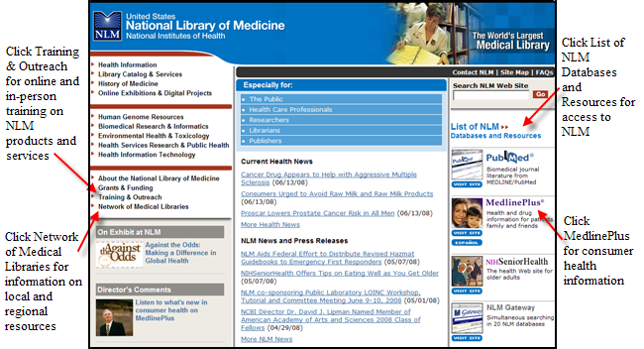

 | The National Network of Libraries of Medicine®

Medical libraries throughout the United States are joined together in a network. The purpose of the National Network of Libraries of Medicine (NN/LM®) is to provide health science practitioners, investigators, educators, and administrators in the United States with timely, convenient access to biomedical and health care information resources.

- The network is administered by the National Library of Medicine.
- It consists of eight Regional Medical Libraries (major institutions under contract to NLM), more than 159 Resource Libraries (primarily at medical schools), and some 4,762 Primary Access Libraries (primarily at hospitals).
- The Regional Medical Libraries administer and coordinate services in the network's eight geographical regions.
 | NN/LM Web site: http://nnlm.gov  Toll free phone number: 1-800-338-7657

Document Delivery

- Loansome Doc® offers full-text document ordering. This feature is part of PubMed and the NLM Gateway.

- DOCLINE® is the computerized interlibrary loan system that is the foundation for Loansome Doc.

More information on Loansome Doc and DOCLINE may be found on factsheets found at the NLM Web site:

Loansome Doc – http://www.nlm.nih.gov/pubs/factsheets/loansome_doc.html

DOCLINE - http://www.nlm.nih.gov/pubs/factsheets/docline.html

NLM Technical Bulletin
- A bi-monthly newsletter published for NLM online searchers.
- The NLM Technical Bulletin keeps searchers apprised of:
  - changes and enhancements to NLM retrieval systems
  - changes to MeSH vocabulary
  - tips for searching
- The Technical Bulletin is published electronically on the NLM Web site. The URL is:

http://www.nlm.nih.gov/pubs/techbull/tb.html

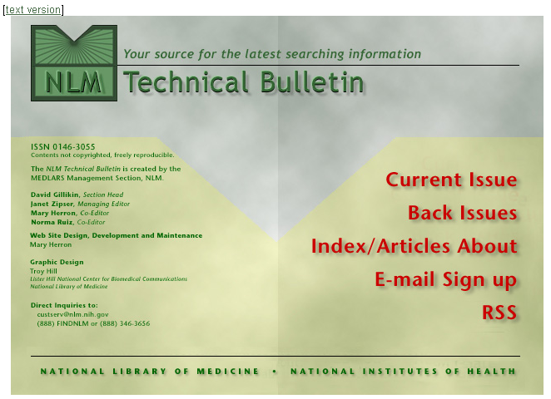
Sign up for an RSS feed to be notified each time an article is published. Alternatively, click on E-mail Sign up to subscribe to the NLM mailing list to receive a weekly e-mail listing newly added items to the NLM web site. See details on Page 9.

Consumer Information

- On October 22, 1998 NLM launched a consumer health Web page called MedlinePlus® (medlineplus.gov)
- Designed to direct consumers to resources containing information that will assist in researching their health questions.
- The pages are designed for educational use only and are not intended to replace advice from a health professional.
- These pages provide a carefully selected list of resources, not a comprehensive catalog.

Click on the MedlinePlus image on the right-hand side of the NLM home page: | 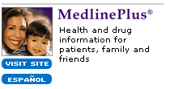

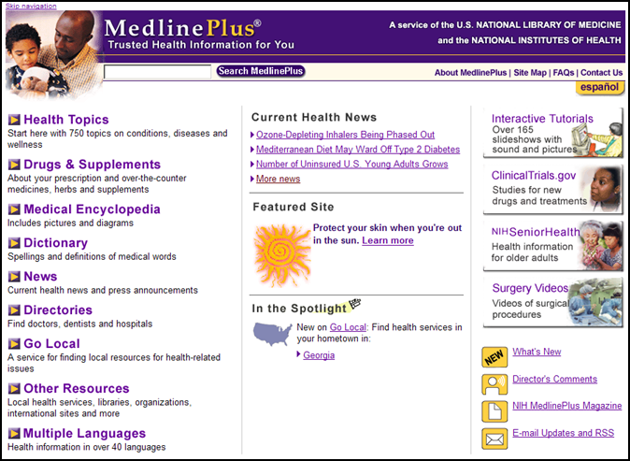

NLM Customer Service

Contact NLM if you need assistance or have questions about NLM’s products or services.
E-mail custserv@nlm.nih.gov
Toll-Free Phone 1-888-FINDNLM (1-888-346-3656)

On the NLM home page, Contact NLM on black bar:
You will be taken to this screen:
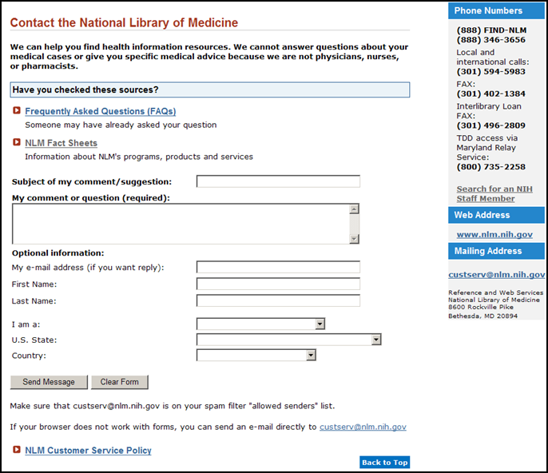

For assistance with PubMed, you may also use the Write to the Help Desk link at the bottom of any PubMed screen.

Subscribe to NLM-Announces Mailing List

This mailing list will alert you when new information has been added to the NLM Web site.
For example:

- When articles have been added to the NLM Technical Bulletin Web site
- When the training manuals have been revised
- Other important NLM announcements and events

Go to https://list.nih.gov/archives/nlm-announces.html
Click on Join or leave the list (or change settings)

or

Click on About the National Library of Medicine from the NLM home page.
Click on News and Events.
Scroll down to New on this Site. Click on Subscribe to the NLM-Announces mailing list.
Click on NLM-Announces.
Click on Join or leave the list (or change settings).

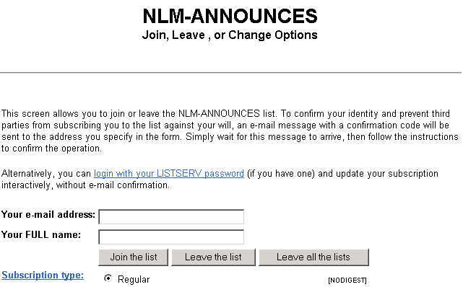 | Fill in this information.  Click Join the list button.

NOTES



Introduction to PubMed® (pubmed.gov)

- NLM has been indexing the biomedical literature since 1879, to help provide health professionals access to information necessary for research, health care, and education.
- What was once a printed index to articles, the Index Medicus, became a database now known as MEDLINE. MEDLINE contains journal citations and abstracts for biomedical literature from around the world.
- Since 1996, free access to MEDLINE has been available to the public online via PubMed.

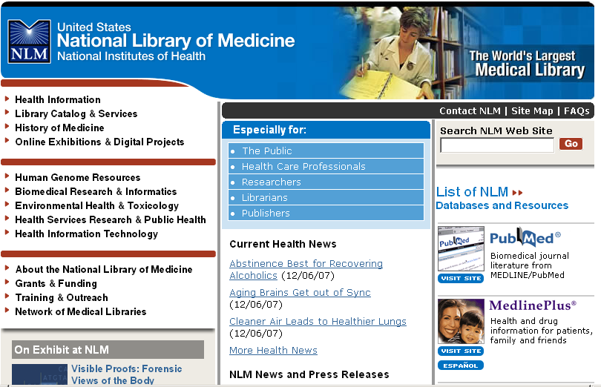  Figure 1: NLM Home Page http://www.nlm.nih.gov | Click here.

- PubMed is a database developed by the National Center for Biotechnology Information (NCBI) at the National Library of Medicine (NLM) available on the Web.
- PubMed is one of several databases under NCBI’s Entrez retrieval system.
- PubMed currently includes over 18 million bibliographic citations.
- PubMed also has links to the full-text of articles at participating publishers’ Web sites, as well as biological data, sequence data, and more from other Entrez Databases and from third parties.

Interrelationships between Entrez Databases

- PubMed provides links to the integrated molecular biology databases maintained by NCBI. These databases contain: DNA and protein sequences, genome mapping data, and 3-D protein structures, aligned sequences from populations, and the Online Mendelian Inheritance in Man (OMIM). Links between MEDLINE records and sequence records make it easy to find MEDLINE abstracts associated with sequence records and vice versa.

- PubMed also provides links to chemical information in PubChem Substance, PubChem Compound and PubChem Bioassay databases.

- The following diagram illustrates the relationships between some of the information resources in Entrez:

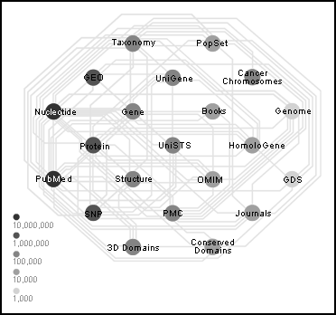
See an interactive view of Entrez links at http://www.ncbi.nlm.nih.gov/Database/

What’s in PubMed

- Most PubMed records are MEDLINE citations.
- Other records include those in different stages of processing (including records provided directly from the journal publisher) but destined to be MEDLINE citations.
- A relatively small number of records that are included in PubMed but not selected for MEDLINE.

MEDLINE Citations

PubMed provides access to MEDLINE®, the National Library of Medicine’s premier bibliographic database containing citations and author abstracts from approximately 5,200 biomedical journals published in the United States and in other countries.

The scope of MEDLINE includes such diverse topics as microbiology, delivery of health care, nutrition, pharmacology and environmental health. The categories covered in MEDLINE include everything from anatomy, organisms, diseases, psychiatry, and psychology to the physical sciences.

- MEDLINE currently contains over 16 million references dating back to 1949.
- New material is added Tuesday through Saturday.
- Coverage is worldwide, but most records (about 90%) are from English-language sources or have English abstracts.
- Approximately 79% of the citations are included with the published abstract.

MEDLINE Journal Selection

- The Literature Selection Technical Review Committee (LSTRC) meets three times a year and considers approximately 140 titles for MEDLINE at each meeting.
- Final approval is made by the Director of the National Library of Medicine.
- Titles are considered for scope and coverage, quality of content, quality of editorial work, production quality, audience, and type of content.
- For more details, see the NLM Fact Sheet, MEDLINE Journal Selection, at http://www.nlm.nih.gov/pubs/factsheets/jsel.html.

MEDLINE® – Basic Bibliographic Citation

One MEDLINE citation represents one journal article and is composed of fields that provide specific information (Title, Author, Language, etc.) about the journal article. The following information is generally provided:

- Title of the journal article

- Names of the Authors

- Abstract published with the article

- Controlled Vocabulary search terms (Medical Subject Headings)

- Journal Source Information

- First Author Affiliation

- Language in which the article was published

- Publication Type (description of the type of article, e.g., Review, Letter, etc.)

A sample MEDLINE citation from PubMed follows.

PubMed MEDLINE citation
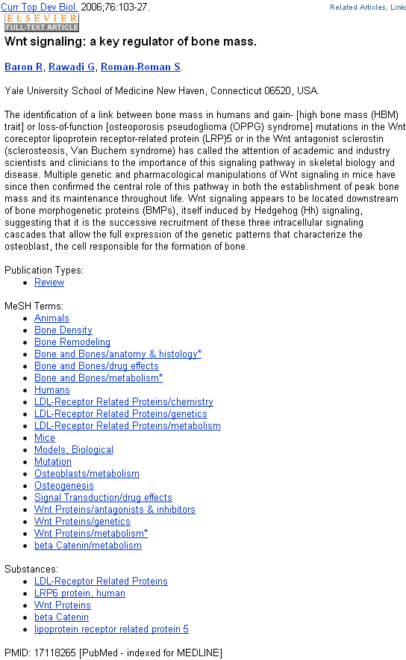

How Citations Get Into PubMed

- Records are either supplied electronically by publishers or created using scanning and Optical Character Recognition (OCR) at NLM.
- Citations are immediately made available via PubMed. All citations go through a quality control process, and citations from MEDLINE journals are indexed.
- All citations display a status tag, which indicates their stage of processing. See the Summary table on page 21.

Publisher Supplied Citations

- These are citations that are supplied electronically by publishers directly to PubMed. The citations are then forwarded to NLM’s Index Section to be processed. (Not all citations are supplied electronically).

- Citations received electronically have the status tag: [PubMed - as supplied by publisher].

Sample PubMed citation that was submitted electronically but processing has not yet begun:

Notice the  [PubMed – as supplied by publisher] status tag. | 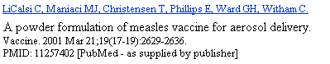

In Process

- These citations are being reviewed for inclusion in MEDLINE and, if in scope, subsequently are indexed with MeSH® vocabulary. In addition the bibliographic data in these records is being checked for accuracy.

- In process records carry the status tag: [PubMed – in process].

- In process records are added to PubMed Tuesday-Saturday.

Sample In Process citation in PubMed:

Notice the  [PubMed – in process]  status tag. | 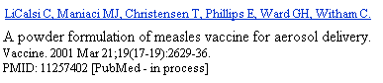

MEDLINE Citations

- This is NLM’s premier bibliographic database

- MEDLINE has over 16 million records from 1949 to the present.

- MEDLINE records are added to PubMed Tuesday-Saturday.

- After Medical Subject Headings (NLM’s controlled vocabulary terms) and other indexing terms are added, the in process citations graduate to MEDLINE records. These “completed” records have also been checked for bibliographic accuracy.

- Fully indexed MEDLINE records carry the status tag [PubMed – indexed for MEDLINE].

Sample MEDLINE citation in PubMed:

Notice the  [PubMed – indexed for MEDLINE]  status tag. | 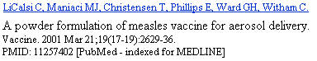

OLDMEDLINE Citations

- About 1.8 million citations (most with no abstracts) are to journal article citations from two printed indexes: Cumulated Index Medicus (CIM) and the Current List of Medical Literature (CLML) published from 1949 to 1965.

- The citations are from international biomedical journals covering the fields of medicine, preclinical sciences, and allied health sciences.

- OLDMEDLINE citations have been created using standards that are different from the data entry standards for MEDLINE records. There are also variations among OLDMEDLINE citations in the data fields present as well as in their format, depending on the original source from which the citations were obtained.

- Beginning in 2005, the original subject terms applied to the citations in the printed indexes are being mapped to current Medical Subject Headings (MeSH).

- OLDMEDLINE records carry the status tag [PubMed – OLDMEDLINE] until all original subject terms are mapped to current MeSH. Once all terms are mapped, the records are promoted to status [PubMed – indexed for MEDLINE].

Sample OLDMEDLINE citations in PubMed:
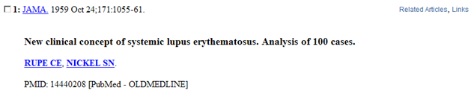
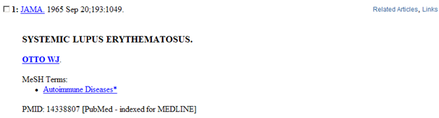

Non-MeSH Indexed Citations

- Some citations received electronically from publishers never become MEDLINE citations.
- These records are not indexed with MeSH terms.
- These records have either the status tag [PubMed] or [PubMed – as supplied by publisher] and remain in PubMed but are not MEDLINE citations.

There are three sources of these types of records:

1. Out-of-scope articles from selectively indexed MEDLINE journals

This may occur when a particular article in a selectively indexed journal is out-of-scope for MEDLINE (such as a geology article in a general scientific journal like Science or Nature).
These citations have been reviewed for accurate bibliographic data.
The status tag [PubMed] appears on these citations.

Sample citation for an article that is out of scope for MEDLINE:
Notice the [PubMed] status tag. | 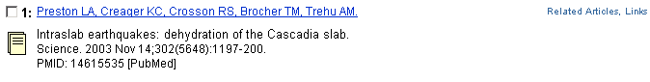

Sample citation for an article from the same journal issue that is indexed for MEDLINE:
Notice the  [PubMed- indexed for MEDLINE]  status tag. | 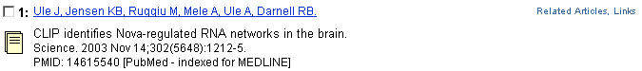

2. Articles from issues of journals published prior to selection for MEDLINE indexing

These earlier citations will not be indexed with MeSH headings.
- Prior to late 2003:
► the citations were not reviewed for accurate bibliographic data
► the status tag of [PubMed – as supplied by publisher] appears
- Beginning in late 2003:
► the citations have been reviewed for accurate bibliographic data
► the status tag of [PubMed] appears.

Example: NLM began indexing the journal, The Neurologist with v. 9, no. 1, 2003. However, the publisher electronically supplied NLM with citations from earlier volumes. The citations from back volumes were entered into PubMed but will not be indexed with MeSH.

Notice the [PubMed] status tag from an item from vol. 8, 2003. | 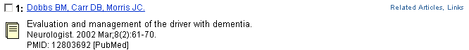

Notice the [PubMed – indexed for MEDLINE] status tag on an item from volume 9, 2003. | 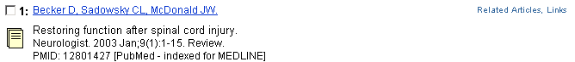

Indexing information for a particular journal can be found in the “Indexed In” field in the NLM Catalog. Use PubMed’s Journals Database to link to this information.

3. Articles from non-MEDLINE journals

- Beginning in July 2005:
► the citations have been reviewed for accurate bibliographic data
► the status tag of [PubMed] appears

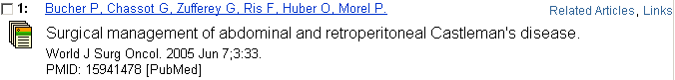

See next page for a Citation Status Tags Summary Table.

PubMed Citation Status Tags Summary Table
Citation Status Tag Value | Condition(s) | MeSH-indexed? | Biblio-graphic data checked? | How to search
[PubMed - as supplied by publisher]
 | - Citations supplied electronically when first received.  - Citations from issues of journals published before journal selected for MEDLINE indexing (records received prior to late 2003).  - Citations from non-MEDLINE journals (records received prior to June 2005). | No | No | publisher [sb]
[PubMed - in process]
 | - Citations in review for inclusion in MEDLINE. | No | No | in process [sb]
[PubMed - indexed for MEDLINE]
 | - Fully indexed citations. | Yes | Yes | medline [sb]
[PubMed - OLDMEDLINE]
 | - Citations originally printed in hardcopy indexes published from 1949 through 1965 that have not had all of their original subject terms mapped to current MeSH. | Partial | In progress | oldmedline [sb]
[PubMed]
 | - Out-of-scope articles from selectively indexed MEDLINE journals.  - Since late 2003, citations from issues of journals published prior to selection for MEDLINE indexing.  - Since June 2005, citations from non-MEDLINE journals. | No | Yes | pubmednotmedline [sb]
[PubMed - author manuscript in PMC]
 | - Citations for articles in PubMed Central (PMC) that would not normally be in PubMed. | No | No | pubstatusnihms

NOTES
Medical Subject Headings (MeSH® Vocabulary)

For a video introduction to MeSH, see Branching Out: The MeSH Vocabulary at http://www.nlm.nih.gov/bsd/disted/video/

What is MeSH?

- Acronym for Medical Subject Headings
- Similar to key words on other systems
- Used for indexing journal articles for MEDLINE and also used for cataloging books and audiovisuals
- Used by searchers
- Revised annually
- Gives uniformity and consistency to the indexing of the biomedical literature and is a distinctive feature of MEDLINE

MeSH Vocabulary includes four types of terms:

- Headings
- Publication Types
- Subheadings
- Supplementary Concept Records

MeSH Headings

- MeSH headings represent concepts found in the biomedical literature
- MeSH headings and Publication Types are arranged in a hierarchical manner called the MeSH Tree Structure

Examples of MeSH Headings:

- Body Weight  - Kidney | - Dental Cavity Preparation  - Self Medication | - Radioactive Waste  - Brain Edema

MeSH Tree Structure

- MeSH vocabulary is organized by 16 main branches:

- Anatomy
- Organisms
- Diseases
- Chemical and Drugs
- Analytical, Diagnostic and Therapeutic Techniques and Equipment
- Psychiatry and Psychology
- Biological Sciences
- Natural Sciences
- Anthropology, Education, Sociology and Social Phenomena
- Technology, Industry, Agriculture
- Humanities
- Information Science
- Named Groups
- Health Care
V. Publication Characteristics
Z. Geographic Locations

- Each Descriptor has a tree number that positions the term in the hierarchy.

Eye [A01.456.505.420]
Eyebrows [A01.456.505.420.338]
Eyelids [A01.456.505.420.504]
Eyelashes [A01.456.505.420.504.421]

- Some terms have multiple tree numbers because they appear in more than one place in the hierarchy.

- By having narrower terms indented under broader terms, a search of a broad term can automatically include the narrower terms. This is known as an EXPLODE.

MeSH Database

- MeSH is the name of an Entrez database that assists PubMed users in locating appropriate terms for searches. This database provides information about MeSH terms including:

  - Definitions
  - Synonyms for the concept
  - Related terms
  - The position of the headings in the MeSH hierarchy

- We can use the MeSH database to look at the type of information associated with each MeSH term:
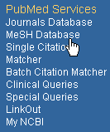  Click on MeSH Database on the sidebar: | 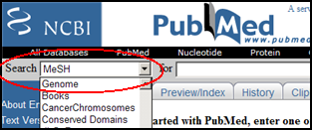  or select MeSH from the database selection box and click Go:

Enter cell count and click on Go:
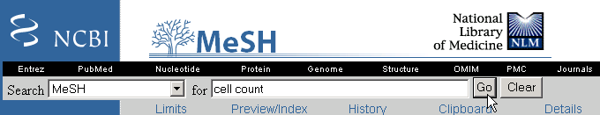

In the retrieval, click on Cell Count:
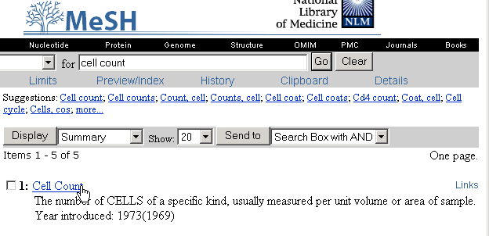
This displays the full record for Cell Count:

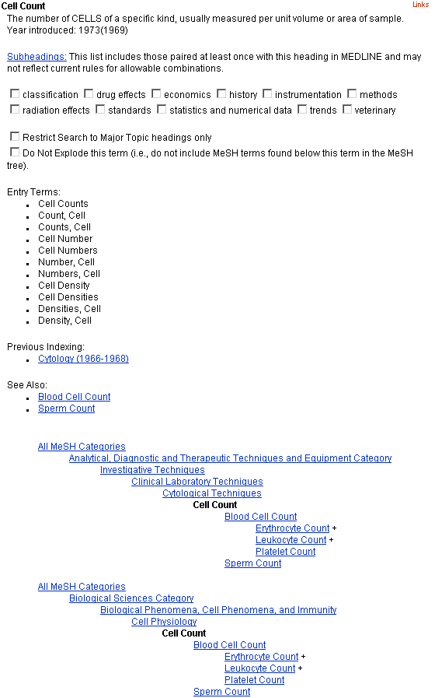
MeSH Term, definition, and year (searchable by earliest year.)
Major topic & Do Not Explode
Select Subheadings
“Synonyms” for this term
Before 1969…
Related terms of possible interest
Position of this term in the MeSH hierarchy

This term has been placed in 2 branches

Use the Links menu to go to the NLM MeSH Browser for additional information:

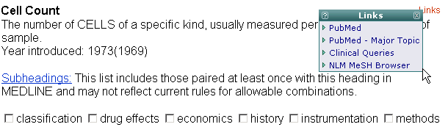

The NLM MeSH Browser is the tool used by MEDLINE indexers and catalogers.

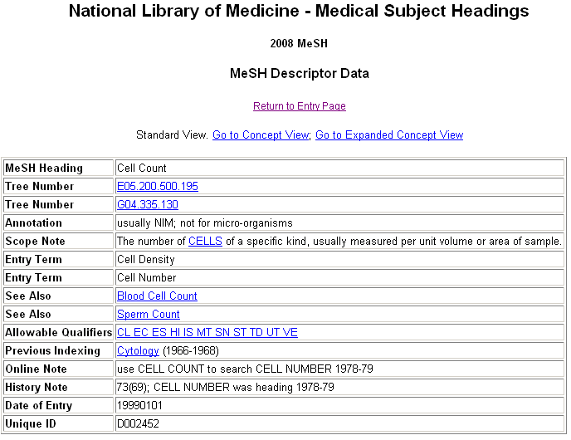

Indexing with MeSH Headings

- NLM’s MEDLINE indexers examine articles and assign the most specific MeSH heading(s) appropriate to describe the main concepts discussed.
- When there is no single specific MeSH heading for a concept, the indexer will use the closest, more general MeSH heading available.
- The indexer will assign as many MeSH headings as appropriate to cover the topics of the article (generally 5 to 15).
- The MeSH terms that reflect the major points of the article are marked with an asterisk (*) by indexers.
- Information the indexer provides includes:
topic of article
age group of population studied
human vs. animal studies
male vs. female studies
type of article (e.g., review article)

Article Title:
Hormone therapy in perimenopausal and postmenopausal women: examining the evidence on cardiovascular disease risks.

Abstract:
Women may live for 30 years or longer after menopause with cardiovascular disease as their highest mortality risk. Menopause may correspond to health alterations for women, yet the use of estrogen during and after this transition has been controversial for the past four decades. The evidence from recent scientific studies does not support the use of hormone therapy for the prevention or treatment of cardiovascular disease, which has resulted in its removal from national guideline recommendations. However, because of concerns related to specific aspects of the research, there are gaps in the evidence. Studies are under way to evaluate alternate methods for hormone delivery, low-dose hormone therapy, and selective estrogen receptor modulators (SERMs) in reducing cardiovascular risks in perimenopausal and postmenopausal women. Implications for clinical nursing practice include education as well as assessment and counseling related to individual risk factors.

Publication Types:
Review

MeSH Terms:
Child
Aged
Cardiovascular Diseases/chemically induced*
Estrogen Replacement Therapy/adverse effects*
Evidence-Based Medicine
Female
Humans
Middle Aged
Perimenopause*
Postmenopause*
Risk Factors

Subheadings

- Subheadings further describe a particular aspect of a MeSH heading.

The entire list of subheadings follows:
Abnormalities | ab | Isolation & purification | ip
Administration & dosage | ad | Legislation & jurisprudence | lj
Adverse effects | ae | Manpower | ma
Agonists | ag | Metabolism | me
Analogs & derivatives | aa | Methods | my
Analysis | an | Microbiology | mi
Anatomy & histology | ah | Mortality | mo
Antagonists & inhibitors | ai | Nursing | nu
Biosynthesis | bi | Organization & administration | og
Blood | bl | Parasitology | ps
Blood supply | bs | Pathogenicity | py
Cerebrospinal fluid | cf | Pathology | pa
Chemical synthesis | cs | Pharmacokinetics | pk
Chemically induced | ci | Pharmacology | pd
Chemistry | ch | Physiology | ph
Classification | cl | Physiopathology | pp
Complications | co | Poisoning | po
Congenital | cn | Prevention & control | pc
Contraindications | ct | Psychology | px
Cytology | cy | Radiation effects | re
Deficiency | df | Radiography | ra
Diagnosis | di | Radionuclide imaging | ri
Diagnostic use | du | Radiotherapy | rt
Diet therapy | dh | Rehabilitation | rh
Drug effects | de | Secondary | sc
Drug therapy | dt | Secretion | se
Economics | ec | Standards | st
Education | ed | Statistics & numerical data | sn
Embryology | em | Supply & distribution | sd
Enzymology | en | Surgery | su
Epidemiology | ep | Therapeutic use | tu
Ethics | es | Therapy | th
Ethnology | eh | Toxicity | to
Etiology | et | Transmission | tm
Genetics | ge | Transplantation | tr
Growth & development | gd | Trends | td
History | hi | Ultrasonography | us
Immunology | im | Ultrastructure | ul
Injuries | in | Urine | ur
Innervation | ir | Utilization | ut
Instrumentation | is | Veterinary | ve
 |  | Virology | vi

Subheading Groupings

- Related subheadings have been grouped to allow for additional, relevant retrieval.
- Not all subheadings have been placed in these groupings – some do not logically fit.
Families of Subheading Explosions

adverse effects | etiology | physiology
poisoning | chemically induced | genetics
toxicity | complications | growth & development
 | secondary | immunology
analysis | congenital | metabolism
blood | embryology | biosynthesis
cerebrospinal fluid | genetics | blood
isolation & purification | immunology | cerebrospinal fluid
urine | microbiology | deficiency
 | virology | enzymology
anatomy & histology | parasitology | pharmacokinetics
blood supply | transmission | urine
cytology |  | physiopathology
pathology | metabolism | secretion
ultrastructure | biosynthesis
embryology | blood | statistics & numer data
abnormalities | cerebrospinal fluid | epidemiology
innervation | deficiency | ethnology
 | enzymology | mortality
chemistry | pharmacokinetics | supply & distribution
agonists | urine | utilization
analogs & derivatives
antagonists & inhibitors | microbiology | surgery
chemical synthesis | virology | transplantation
complications | organization & admin | therapeutic use
secondary | economics | administration & dosage
 | legislation & jurisprudence | adverse effects
cytology | manpower | contraindications
pathology | standards | poisoning
ultrastructure | supply & distribution
 | trends | therapy
diagnosis | utilization | diet therapy
pathology |  | drug therapy
radiography | pharmacology | nursing
radionuclide imaging | administration & dosage | prevention & control
ultrasonography | adverse effects | radiotherapy
 | poisoning | rehabilitation
embryology | toxicity | surgery
abnormalities | agonists | transplantation
 | antagonists & inhibitors
epidemiology | contraindications
ethnology | diagnostic use
mortality | pharmacokinetics

Pharmacologic Action Terms

Every drug and chemical MeSH heading has been assigned one or more headings that describe known pharmacological actions (PA).

- Since 1996, NLM indexers add the appropriate pharmacological action MeSH heading as well as the specific chemical MeSH heading to a citation when the action of the chemical is discussed in the article.

Example:

The pharmacological actions established for the MeSH Heading, Aspirin:
Pharmacological Action  Pharmacological Action  Pharmacological Action  Pharmacological Action | Anti-Inflammatory Agents, Non-Steroidal  Cyclooxygenase Inhibitors  Fibrinolytic Agents  Platelet Aggregation Inhibitors

- A citation to an article that discusses aspirin used as an anti-inflammatory agent will be assigned:

Aspirin
Anti-Inflammatory Agents, Non-Steroidal

- A citation to an article that discusses aspirin used to inhibit blood clotting will be assigned:

Aspirin
Platelet Aggregation Inhibitors

See “The Basics of MeSH” (http://www.nlm.nih.gov/bsd/disted/mesh/), linked from Tutorials on the PubMed home page for information on searching with pharmacologic action terms.

Other Types of MeSH Vocabulary

Supplementary Concepts
- Over 170,000 terms.
- Display in RN field on MEDLINE record.

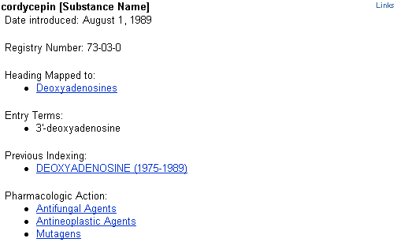

The data in a Supplemental Concept MeSH Database record may include:
- Name of substance: For example: cordycepin
- Date Introduced: The date the record was added to the vocabulary
- Registry Number: For example: 73-03-0. A unique number assigned to chemicals by the Chemical Abstract Service, or a code for enzymes assigned by the Commission on Biological Nomenclature. May display as zero (0), generally for terms for a group or class of compounds.
- Heading Mapped to: The MeSH term used for indexing this chemical in MEDLINE
- Entry Term: Synonyms that can be used for searching this concept
- Previous Indexing: MeSH terms used before the current term became available
- Pharmacologic Action: An action of a drug or chemical as reported in the literature, e.g., Antifungal Agents or Antineoplastic Agents

Age Group MeSH Headings

These are MeSH headings which indicate the age of human subjects discussed in the article:

Infant, Newborn Birth to 1 month
Infant 1 to 23 months
Child, Preschool 2 to 5 years
Child 6 to 12 years
Adolescent 13 to 18 years
Adult 19 to 44 years
Middle aged 45 to 64 years
Aged 65 to 79 years
80 and over 80+

Publication Types

- Publication Types describe the type of material being indexed.
- The most common type is Journal Article. Other Publication Types include:

Clinical Trial | Retraction of Publication
Comment | Review
Practice Guideline | Twin Study
Retracted Publication

- Publication Types may be searched in the MeSH Database. Definitions are provided.
- They are part of the MeSH hierarchy (V category).

NOTES

Practice Exercises – Introduction to MeSH

Use the MeSH Database to find the answers to these questions:

1. What terms are indented under Fever?

2. How far back can you search with the MeSH term, “Recombinant DNA?”

3. What ages are included by the term, “Child, Preschool?”

4. What is the preferred MeSH term for “drooling?”

Suggested Answers – Introduction to MeSH

Use the MeSH Database to find the answers to these questions:

1. What terms are indented under Fever?

Fever of Unknown Origin
Sweating Sickness

2. How far back can you search with the MeSH term, “Recombinant DNA?”

1977

3. What ages are included by the term, “Child, Preschool?”

A child between the ages of 2 and 5.

4. What is the preferred MeSH term for “drooling?

Sialorrhea

Building the Search

PubMed’s Home Page

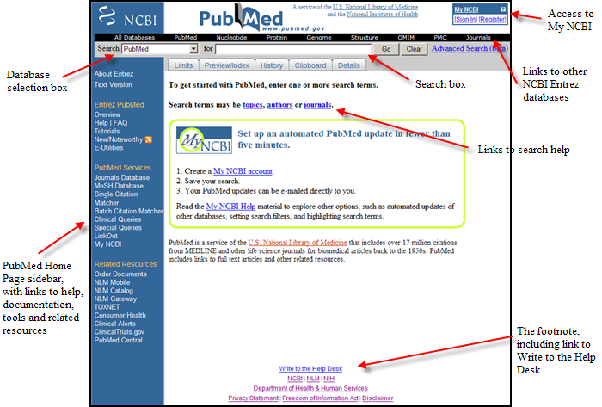

Basic Searching

Search: Find citations to articles about having a rash and a fever.

Entering Search Terms
- Enter significant terms in the query box (e.g., rash fever).
- Click on the Go button.
- Click on Details to check PubMed’s translation.
- Use the Clear button to erase the contents of the query box.

Search Results Screen

Once you click on Go or press the Enter key, PubMed will automatically:

- Run the search
- Retrieve and display citations
- Provide the option to Save Search via My NCBI feature

Results screen returned by PubMed for rash fever search.

Active query box displaying current search  Save Search option via My NCBI | 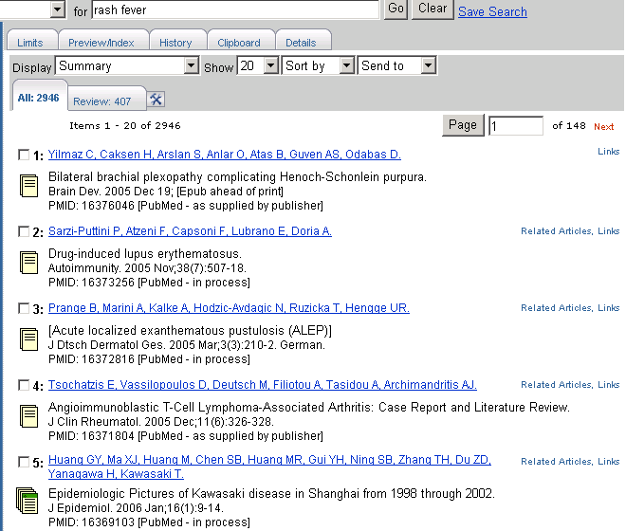
Display options:
Show pull-down Sort options
Send to options
All results tab
Review articles tab
Page options
Citations are displayed in Summary format

Icons indicating
presence of abstract and/or availability of free full text (see page 105).

Retrieval Summary
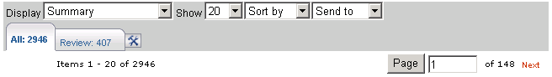

The retrieval summary line displays:
- Total number of citations retrieved by the search (All tab)
- Total number of citations from search results that have been assigned the Publication Type, Review (Review filter tab)
- Tool symbol (hammer and wrench) to the right of the filter tabs links you to My NCBI where users who are signed in can add or modify their Filter selections. (See My NCBI section of workbook for further information.)
- How many pages of citations there are, given the selected number of citations per page (see Action Bar Selections, below)

Page Selection
- Use links for Previous and Next to navigate through search results.
- To move to a non-adjacent page, enter the desired page number and then press the Page button.
- The current page number is displayed in the Page box.

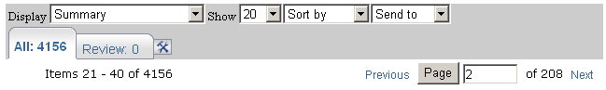

Action Bar Selections
- These options are available both at the top and bottom of the Results screens.

In general, to perform an action on the entire results set, choose the action from the action bar. To perform an action on particular records, select the records using the checkbox to the left of the records. You can select items from any page of your results, then perform the action.

More about results will be covered in the Managing Your Results section beginning on page 105.
Automatic Term Mapping (ATM)

You can see how PubMed processes your search by clicking on the Details tab.
See page 65 for explanation of Boolean logical operators (AND, OR)  Translations are shown in the grey box towards the bottom of the screen. | 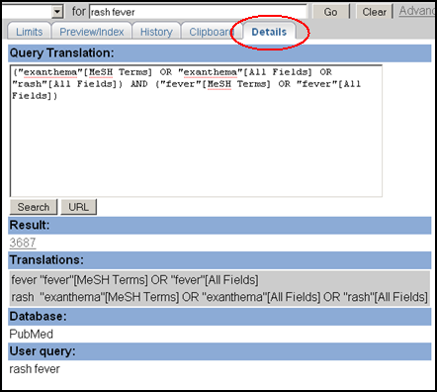

Unqualified terms that are entered in the query box are matched against:

- Subjects, using the
  - MeSH (Medical Subject Headings) Translation Table
- Journals, using the
  - Journals Translation Table
- Authors and Investigators, using the
  - Full Author Translation Table
  - Author Index
  - Full Investigator Translation Table
  - Investigator Index

1. MeSH Translation Table contains:

- MeSH Headings
- Subheadings
- Publication Types
- Entry Term mappings (also known as synonyms) for MeSH terms
- Mappings derived from the Unified Medical Language System (UMLS)
- Supplementary Concepts and synonyms to the Supplementary Concepts

If a match is found in this translation table:
- the term will be mapped to the appropriate MeSH term and searched as MeSH
- the searcher’s term and the mapped MeSH term will be searched in All Fields

Example:

PubMed’s Translation:
"vision"[MeSH Terms] OR "vision"[All Fields] OR "sight"[All Fields]

- Sight is an Entry Term for the MeSH term, Vision.

When a term is searched as a MeSH Heading, PubMed automatically searches that heading and the more specific headings underneath in the hierarchy. This is called exploding a term.

For example, when searched as a MeSH Term, PubMed will search the heading Vision as well as the more specific term(s) in the hierarchy:
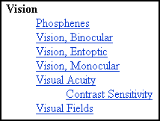

Matching phrases are searched in All Fields as a phrase and broken into individual words, with the exception of phrases mapping to Supplementary Concepts (substances) or MeSH Headings that include a standalone number or single character. These are searched only as phrases in All Fields.

Example:

PubMed’s Translation:
"muscular atrophy"[MeSH Terms] OR ("muscular"[All Fields] AND "atrophy"[All Fields]) OR "muscular atrophy"[All Fields] OR ("muscle"[All Fields] AND "atrophy"[All Fields]) OR "muscle atrophy"[All Fields]

Example:

PubMed’s Translation:
"protein c"[MeSH Terms] OR "protein c"[All Fields]

2. Journals Translation Table contains:

- Full journal title
- MEDLINE abbreviation
- International Standard Serial Number (ISSN)

Example:

PubMed Translation: "J Cell Biol"[Journal] OR "the journal of cell biology"[All Fields]

If a name of a journal also happens to be a MeSH term or a one-word title, PubMed will search the term as a MeSH heading and in All Fields. For example, the search for Science untagged will search: "science"[MeSH Terms] OR "science"[All Fields]. To limit your search to a journal title, use the Limits page or use the tag [ta], e.g., science [ta]

3. Full Author Translation Table includes:

- Full author names for articles published from 2002 forward and to journals that publish using the full names of authors.

- Full author searching can be entered in natural or inverted order:

julia s wong
wong julia s

- When searching a full name using the inverted order, a comma following the last name is generally optional, omit periods after initials, and put all suffixes, e.g., Jr, at the end. For example, to search for the author Bruce J. Herron, you may use any of the following formats:

herron, bruce j
herron bruce j
bruce j herron

- For some names, however, it is necessary to distinguish which name is the last name by using the comma following the last name:

ryan, james
james, ryan

- Full author name searching allows for automatic truncation of the forename. If you don't know the middle initial, enter only the last and first names:

herron bruce

4. Author Index

- Author’s names, for all years of publication, are included in the form of Last Name (space) Initials. Use this format for searching.

Examples: o’brien jm
adams sh
pogonka t

- If only the first initial is used, PubMed automatically truncates the author’s name to account for varying initials.

Example:

This search retrieves citations to articles written by o’brien j, o’brien ja, o’brien jz, etc.

If only an author’s last name is entered, PubMed will search that name in All Fields (Author field plus all other searchable fields). It will not default to the Author Index because the last name is not followed by an initial. When the last name is the same as a MeSH term, PubMed will search the term in MeSH as well as in All Fields. To limit a search to an author’s name, use Limits or use the tag [au], e.g., o’brien [au].

5. Full Investigator Translation Table and Investigator Index

- Investigators are individuals who contributed to the research, but may not have participated in writing the article.

- The names in the Full Investigator Translation Table and the Investigator Index are formatted and searchable in the same way as the Full Author Name Table and Author Index (see above).

If no match is found?

- PubMed breaks apart the phrase and repeats the automatic term mapping process until a match is found.

- Terms that don’t make a match will be searched in “All Fields.” Individual terms will be combined (ANDed) together.

Example:

PubMed Translation:

(“pressure” [MeSH Terms] OR “pressure”[All Fields]) AND point[All Fields])

- PubMed breaks apart a long phrase from right to left:

Example:

Searches for: | Results: | Action:
head lice shampoo | No match found | Removes term on right to re-run Automatic Term Mapping process.
head lice | Match found in MeSH Translation Table | head lice will be searched as "pediculus"[MeSH Terms] OR "pediculus"[All Fields] OR ("head"[All Fields] AND "lice"[All Fields]) OR "head lice"[All Fields]
shampoo | No match found in Translation Tables | shampoo will be searched as  shampoo[All Fields]

PubMed then combines (ANDs) the terms to produce a single search strategy:

"pediculus"[MeSH Terms] OR "pediculus"[All Fields] OR ("head"[All Fields] AND "lice"[All Fields]) OR "head lice"[All Fields]
AND
shampoo[All Fields]

Citation Sensor

The Citation Sensor is a feature that assists searchers looking for a specific article.

- It looks for combinations of search terms that are characteristic of citation searching, e.g., volume/issue numbers, author names, journal titles, publication dates.

- Whenever possible the Citation Sensor matches the search with citations in PubMed.

- If your search invokes the Citation Sensor, you will see a yellow area above the default retrieval with links to one or more citations for your consideration:

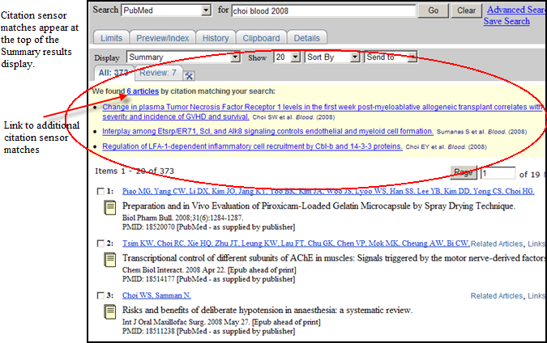

NOTES
Practice Exercises: Basic Search and ATM

- Find references about shingles and facial paralysis. To what MeSH Heading does shingles map? (Hint: Use the Details tab)

- Find references about hypertension and a nosebleed. How does PubMed map the term, nosebleed?

Suggested Answers: Basic Search and ATM

- Find references about shingles and facial paralysis. To what MeSH Heading does shingles map? (Hint: Use the Details tab)

Enter shingles facial paralysis in the query box, click Go. Click on Details to see that the term shingles maps to the MeSH heading Herpes Zoster.

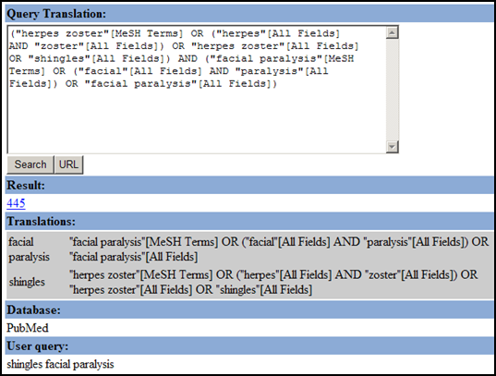

- Find references about hypertension and a nosebleed. How does PubMed map the term, nosebleed?

Enter hypertension nosebleed in the search box and click Go. Click on Details.

Details:

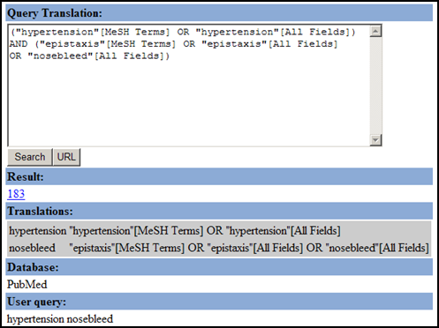

The term, nosebleed, maps to the MeSH heading, epistaxis.

Related Articles

- Citations in PubMed have a Related Articles link. Clicking on this link will access the citations in PubMed that are most closely related to the original citation.

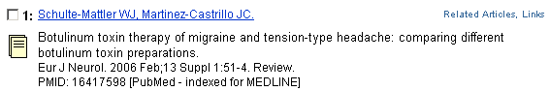
- To create this list of Related Articles PubMed compares words from the Title and Abstract of each citation, as well as the MeSH headings assigned, using a powerful word-weighted algorithm.

- The Related Articles citations display is in rank order from most to least relevant. The citation you linked from is displayed first.

A detailed explanation of the Related Articles algorithm is available in the PubMed Help (Search Related Articles; then click on “Finding articles related to a citation”; then click on the “algorithm” link.)

Example: Find citations to articles about wrestling and crash diets.
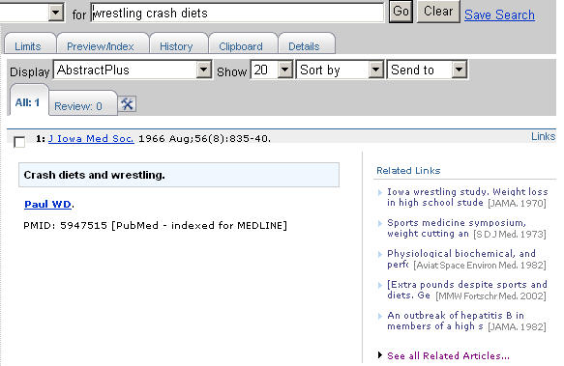  The AbstractPlus display of a single record. | The first five Related Articles are  displayed in the  AbstractPlus format  Click here to display the complete set of Related Articles.

Limits

- Click on Limits from the Feature tabs to bring up the Limits page.  - Go and Clear All Limits buttons are available at the bottom of the Limits page.  - Go button function at the top and bottom of the page is equivalent. | 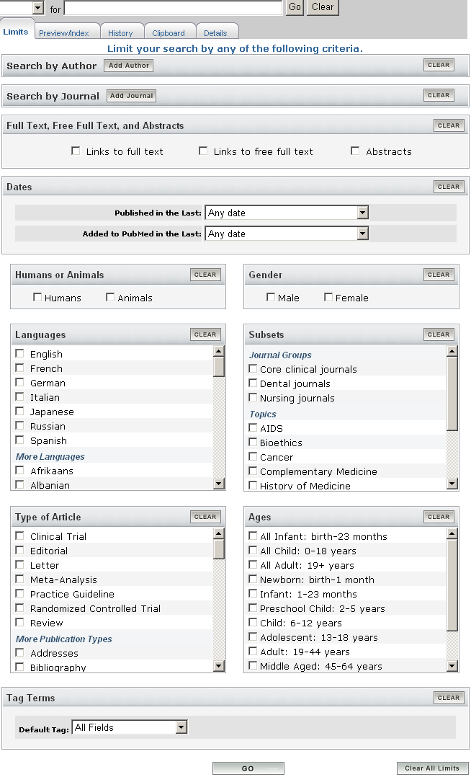

Limit by Author

- To search by author, click Add Author. An author search box will display.  - The author search box includes an autocomplete feature.  - As soon as you see the author name you are looking for, you may select that name.  - Click the Go button. | 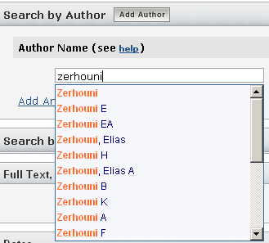

Adding Additional Authors

To add additional authors, click the Add Another Author link to open another author search box.  Click the remove link to delete an author search box. | 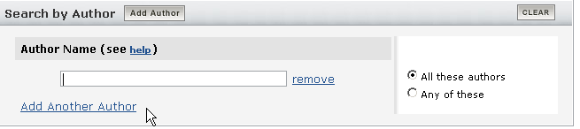

- The default author search is to include all author names in your search (Boolean AND).
- To change this to search for any authors (Boolean OR) click the radio button adjacent to Any of these.

Limit by Journal

- To limit your search to a journal, click Add Journal.  - A journal search box will display. The journal search box includes an autocomplete feature.  - To add additional journals, click the Add Another Journal link. | 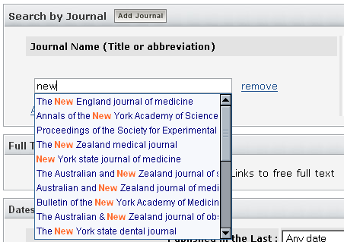

- Author names and Journals will automatically move to the PubMed search box when you click Go.

- Author and journal selections will only be included in subsequent searches if they are not cleared from the PubMed search box.

Limit to Full Text, Free Full Text, and Abstracts

Click the appropriate checkboxes. | 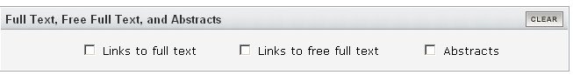

Dates

- PubMed contains citations published back to 1949.
- New citations are added Tuesday-Saturday.
- You may restrict to two date fields from the Limits screen:
  - Published in the Last searches Publication Date, the date the article was published.
  - Added to PubMed in the Last searches Entrez Date, the date the citation was initially added to PubMed.
- When PubMed displays your search results, the citations are displayed in Entrez Date
order – last in, first out.

Limiting by Dates

Limit your search to articles published or added to PubMed by a pre-set date range. | 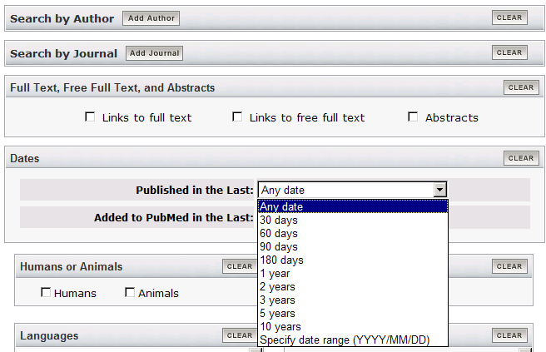

OR

Specify a date range using  yyyy/mm/dd format. Month and days are optional. | 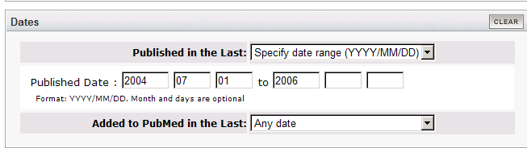

Limiting to Humans or Animals

- Use to limit to a specific group.  - If both options are checked, they are ANDed together. | 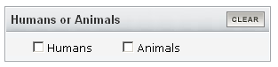

Limiting to Gender

- Use to limit to gender.  - If both options are checked, they are ANDed together. | 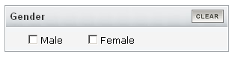

Limiting to Languages
- Journals published in approximately forty languages are indexed.  - The selections at the top are frequently searched languages.  - Scroll down to find a complete alphabetic list of more languages.  - Multiple selections are allowed (ORed together). | 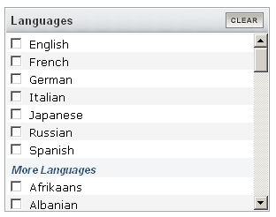

Subset Limits
Allows you to limit your retrieval to 3 types of groupings of records:  1. Journal Groups:  - Core clinical journals: 120 English-language journals from the formerly published Abridged Index Medicus  - Dental  - Nursing  2. Topics:  - AIDS  - Bioethics  - Cancer  - Complementary Medicine  - History of Medicine  - Space Life Sciences  - Systematic Reviews  - Toxicology | 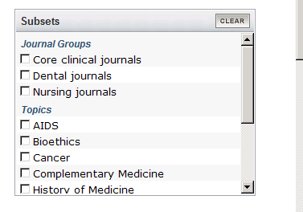
3. More Subsets:
- MEDLINE: completed citations with MeSH headings and other indexing terms that have also been checked for accuracy
- PubMed Central: citations for articles available free in NLM’s archive of life sciences journal literature
  - Multiple selections are allowed (ORed together).

Each Subject Subset uses its own specialized search strategy to aid in the retrieval of citations on these topics. You may view these strategies at http://www.nlm.nih.gov/bsd/pubmed_subsets.html.
Limiting by Type of Article (Publication Type)

- Use to limit your retrieval based on the type of material the citation represents.  - The selections at the top are frequently searched publication types.  - Scroll down to find an alphabetic list of more publication types.  - Multiple selections are allowed (ORed together). | 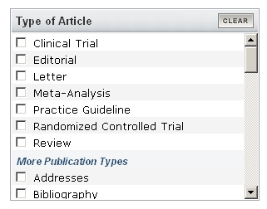

Limiting to Ages

- Use to search for a specific age group or multiple age groups (ORed together). | 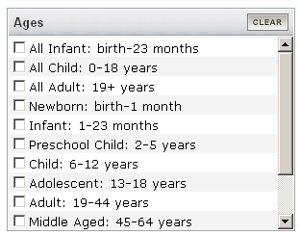

Tag Terms

- You may limit your search term(s) to a specific search field.  - Click the All Fields pull-down menu and select a search field. Enter multiple terms separated by Boolean operators.  - Example: Select MeSH Terms from the pull-down, enter bed rest AND pain in the query box, click Go. | 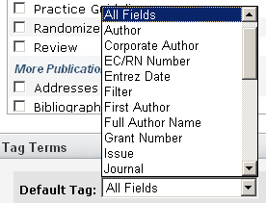

Limits Indicator

- Once you have selected Limits, a check box appears next to the Limits on the Feature tabs.
- If you run a search, the limits in effect will appear in the yellow bar above the Display button:

To turn off all of the limits before you run your next search, click on the check box next to Limits on the Feature tabs to remove the check and turn off the limits OR click the Clear All Limits button at the bottom of the Limits page.

Phrase Searching

PubMed searches for phrases under these conditions:

- The phrase is found in the MeSH, journal, author or investigator tables or indexes during the automatic term mapping process
- The phrase is entered with a search tag:
kidney allograft [tw]
- The phrase is enclosed in double quotes: (The absence of a search tag indicates the search should be conducted in All Fields.)
“kidney allograft”
- The term is hyphenated:
first-line
- The term is truncated:
kidney allograft*

Example:

PubMed Translation: "pressure point"[All Fields]

- The above formats for phrase searching instruct PubMed to bypass automatic term mapping. Instead PubMed looks for the phrase in its Index of searchable terms. If the phrase is in the Index, PubMed will retrieve citations that contain the phrase.

- PubMed may fail to find a phrase because it is not in the Index.

When you enclose a phrase in double quotes, PubMed will not perform automatic term mapping which includes explosions of MeSH terms. For example, “health planning ” will include citations that have the MeSH heading, Health Planning, but will not include the more specific indentations (e.g., Health Care Rationing, Health Care Reform) that are included with automatic MeSH mapping and explosion.

Truncation (finding all terms that begin with a given text string)

- Place an asterisk (*) at the end of a string of characters to search for all terms that begin with that string. The asterisk may only be used at the end of a string of characters.

Example: mimic* will find all terms that begin with the letters m-i-m-i-c-; e.g., mimic, mimics, mimicing.

- PubMed searches the first 600 variations of a truncated term. If a truncated term, e.g., tox*, produces more than 600 variations, PubMed displays the following warning message on the Results screen in pink near the top of the screen:

Truncation turns off automatic term mapping. For example, heart attack* will not map to the MeSH term, Myocardial Infarction or include any of its more specific terms, e.g., Myocardial Stunning.

Stopword List

- PubMed also compares each search to a list of commonly found terms that are referred to as “stopwords.” Stopwords may be ignored. This list is available in PubMed’s Help.

Spell Check Feature

- Suggests alternative spellings for search terms that include misspellings.
- Terms entered with a search tag (e.g., [mh]; [majr]; [tw]) will not generate alternative spellings.

Example:
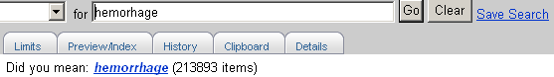 | Click on the hyperlinked alternative spelling to generate that search.

- The alternative spellings are not based on a dictionary but rather the frequency with which a term appears in PubMed.
- The spell checking function will not display an alternative spelling for misspellings that have a high frequency of occurrence in PubMed or for terms with numbers or fewer than five characters.

NOTES

Practice Exercises: Limits and Phrase Searching

- Using only the query box, find some information about using a living donor for a liver transplantation. Using Limits, further restrict the search to the publication type, Clinical Trial.

- Compare the searches “wisdom teeth” and wisdom teeth (with and without quotes), using the Details tab. What accounts for the difference?

- Find references about tuberculosis from the AIDS literature published between 2000 and 2008.

Suggested Answers: Limits and Phrase Searching

- Using only the query box, find some information about using a living donor for a liver transplantation. Using Limits, further restrict the search to the publication type, Clinical Trial.
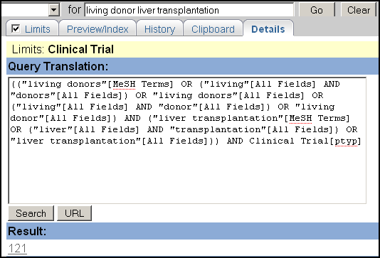

Details screen showing living donor liver transplantation, with Clinical Trial limit activated

- Compare the searches “wisdom teeth” and wisdom teeth (with and without quotes), using the Details tab. What accounts for the difference?

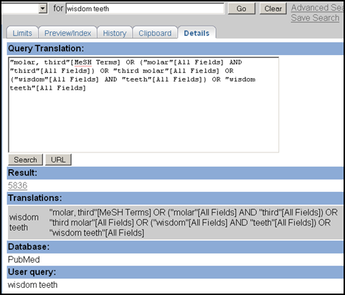

Using quotes bypasses ATM and misses many records which were indexed with the MeSH term, Molar, Third.

- Find references about tuberculosis from the AIDS literature published between 2000 and 2008.

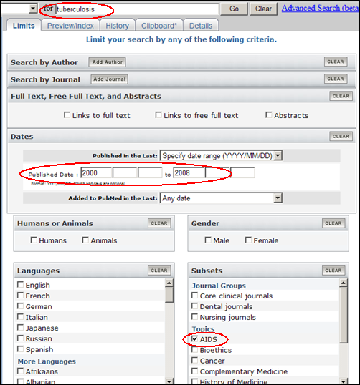

Boolean Logical Operators

In the context of database searching, Boolean logic refers to the logical relationships among search terms.

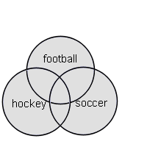
- The Boolean operators AND, OR, NOT can be used to combine search terms in PubMed. They must be entered in uppercase letters.

Logical Operator OR:
- Used to retrieve a set in which each citation contains at least one of the search terms.
- Use OR when you want to pull together articles on similar topics.

Example: football OR hockey OR soccer

Each circle in the diagram to the right represents the retrieval for each term. The grey areas represent the retrieval for this example – all records that include any one of these terms.

The table below represents sample results for each term, then for the terms combined with OR.

Search terms | Results
football | 4819
hockey | 1058
soccer | 2517
football OR hockey OR soccer | 6090

Logical Operator NOT:
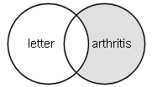
- Retrieves a set from which citations to articles containing specified search terms following the NOT operator are eliminated.
- Use the NOT operator with caution; you might eliminate relevant articles.

Example: arthritis NOT letter

Note in the diagram to the right and in the sample search results below that the retrieval is a portion of the total retrieval for arthritis – that portion not including the term letter.

Search terms | Results
arthritis | 167933
letter | 617646
arthritis NOT letter | 159681

Logical Operator AND:
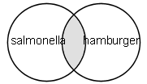
- Used to retrieve a set in which each citation contains all search terms.

Example: salmonella AND hamburger

Note in the diagram to the right and in the sample search results below that the retrieval is only the overlap of the results for each term – those records in which both terms appear.

Search terms | Results
salmonella | 64810
hamburger | 2494
salmonella AND hamburger | 12

- AND is the default operator used in PubMed. If you do not include Boolean operators in your search, PubMed will automatically use AND between terms.

Example: diabetes mellitus phototherapy
PubMed searches as: diabetes mellitus AND phototherapy

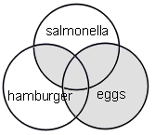
Nesting

- When using multiple Boolean operators in PubMed, they are processed left to right.

Example: salmonella AND hamburger OR eggs
This will retrieve records that include both terms salmonella AND hamburger as well as all records with the term eggs, whether or not they contain the other two terms.

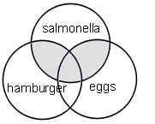
- To change the order in which terms are processed, enclose the terms(s) in parentheses. The terms inside the set of parentheses will be processed as a unit and then incorporated into the overall strategy. This is called nesting.

Example: salmonella AND (hamburger OR eggs)
This will retrieve records that contain the term salmonella, as well as one or both of the terms hamburger OR eggs.

History
- History temporarily holds up to 100 searches and links to results.
- The History screen displays:
  - Your search query
  - The time of the search
  - The number of citations in your search results
  - Search statement numbers menu for combining searches

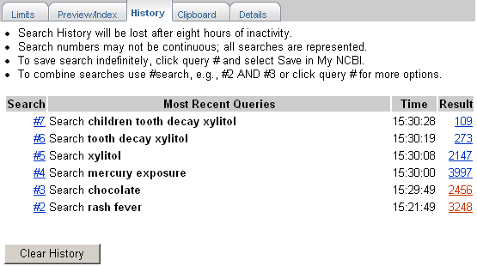

Using History

- You can use the search statement numbers shown in History in search strategies.

Example:

 | Type Boolean operators in all caps as shown in the example above.

Other examples: #8 AND #10
#7 OR #14

Search Statement Number Menu

- Click on the search statement number to open an Options menu:

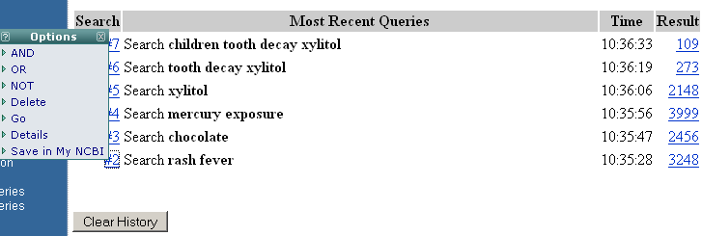

Options Menu includes:
- Boolean operators AND, OR or NOT to add the search to the query box
- Delete the individual search from History
- Re-run the search using the Go option
- Display the search details
- Save in My NCBI

History Tips:

- Maximum number of searches that can be held in History is 100.
- The search history will be deleted after 8 hours of inactivity.
- If a search is repeated, its original number is moved to the top.
- A separate Search History will be kept for each of the Entrez databases although the search statement numbers will be assigned sequentially for all databases.

Click on the Clear History button available at the bottom of the History screen to remove all searches from the History.

Practice Exercises: Boolean Operators and History

- Find references about the relationships between circadian rhythms and either cortisol or melatonin in humans.

- Find references about heart surgery (notice how the term is mapped using Details). Using History, combine this search with the previous search to find references about heart surgery, circadian rhythms and cortisol or melatonin in humans.

Suggested Answers: Boolean Operators and History

- Find references about the relationships between circadian rhythms and either cortisol or melatonin in humans.

circadian rhythms AND (cortisol OR melatonin) AND humans

[You may also use the Humans checkbox on the Limits screen. These terms can be in any order but the OR phrase must be in parentheses.]

- Find references about heart surgery (notice how the term is mapped using Details). Using History, combine this search with the previous search to find references about heart surgery, circadian rhythms and cortisol or melatonin in humans.

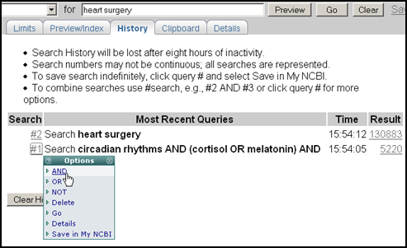

After running a search for heart surgery, go to History, click on the search number link for your circadian rhythm search and select AND. Click Go.

OR

Combine the two searches by typing in the search box:
#1 AND #2
(substituting the numbers of the appropriate searches).

Searching with MeSH and the MeSH Database

Limits screen:
Two selections are available for MeSH Heading searching from the field selection pull-down menu in Limits:  MeSH Terms  MeSH Major Topic | 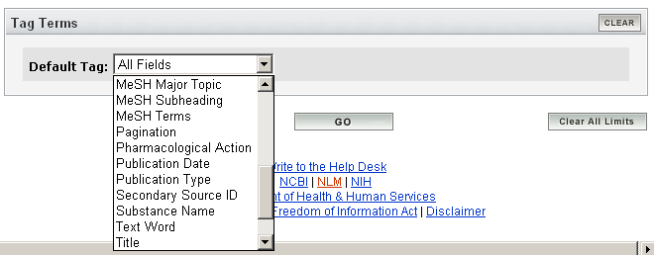

- MeSH Terms - Use when you want to specify that a term is searched only as a MeSH heading not also in All Fields.
When a term is searched as a MeSH Heading, PubMed automatically searches that heading and the more specific headings underneath in the hierarchy. This is called exploding a term.

For example, the MeSH term Face when searched as MeSH Term in PubMed would search the heading Face as well as all the more specific terms below the term in the hierarchy:
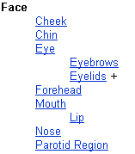
Searching with MeSH terms will exclude in process citations and publisher-supplied citations as they have not been indexed with MeSH headings.
- MeSH Major Topic - Use when you wish to limit to articles where the topic is the main point of the article.

MeSH Database

The MeSH Database allows you to:
- Locate and select MeSH terms (Headings, Subheadings, & Publication Types); Supplementary Concept terms (Substance Names) and Pharmacological Action terms.
- See the definition and other helpful information for a MeSH term.
- Build a PubMed search strategy.
- Display MeSH terms in the hierarchy.
- Limit MeSH terms to a major concept for a search.
- Attach subheadings for a search.
- Link to the NLM MeSH Section’s MeSH Browser.

How to Get There

- Click on MeSH Database on the sidebar or use the database selection menu on the search bar.

Let’s use the MeSH Database to find the proper MeSH term for condition of double vision and then search PubMed for relevant citations.

Enter the term, double vision, in the query box and click the Go button. | 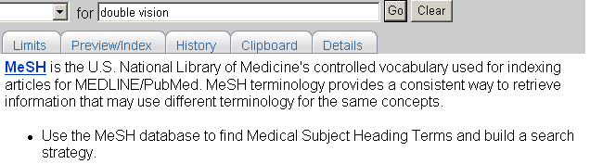

Summary format:
- Select PubMed from the Links pull-down menu to run a PubMed search with that term.
Suggestions are MeSH or Entry terms generated by an algorithm that compares letter combinations.  Scope Note (meaning for this concept is displayed.)  Links allows you to use the term in a PubMed search, use it as a major topic, link to the MeSH Section MeSH Browser or Clinical Queries. | 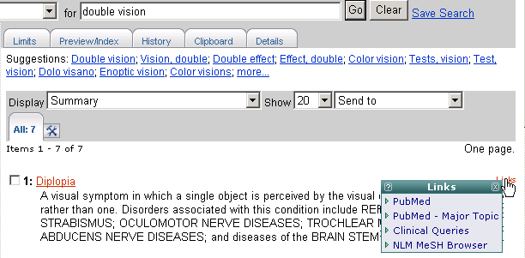

Let’s search for the supplementary concept term: 1,4-bis(chloromethyl)benzene

Some substance names are long and "complicated." Please note also that when searching any Entrez database for a term with parentheses, e.g., 1,4-bis(chloromethyl)benzene, do not enter the parentheses.

These terms will display in search retrieval with the label [Substance Name].  To see additional information for any term, use the link to the NLM MeSH Browser from the Links menu | 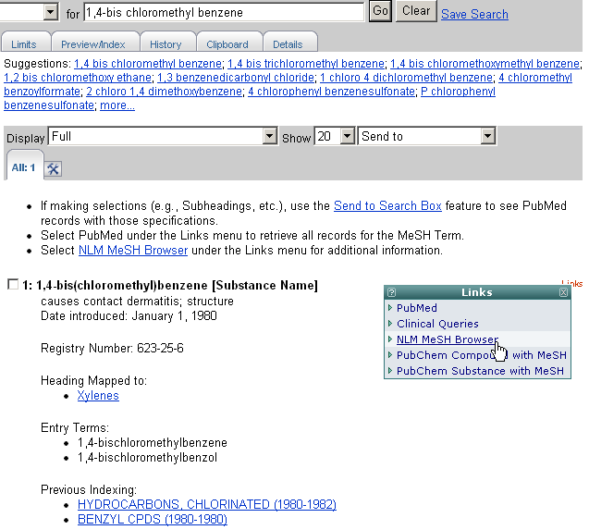

The Feature tabs (Limits, History, etc.) from the MeSH Database deal specifically with the MeSH Database not the PubMed database.

Now, let’s use the MeSH Database to build a search strategy for a search for citations about the diagnosis of bursitis which requires the use of a subheading.

Enter the term, bursitis, in the query box and click the Go button. | 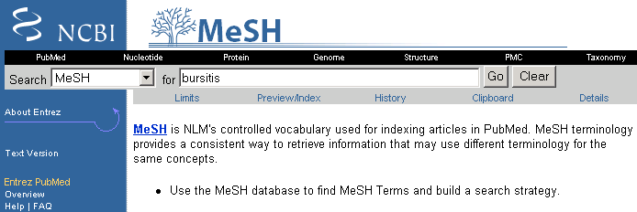

The single record retrieved is displayed in the Full format:
Use the check boxes to select subheadings. Click on the Subheadings link to see a list of subheading definitions.  Use these checkboxes to restrict to major topic or to not explode a term.  Entry Terms (synonyms) are provided.  MeSH hierarchy is displayed with searched term in boldface. | 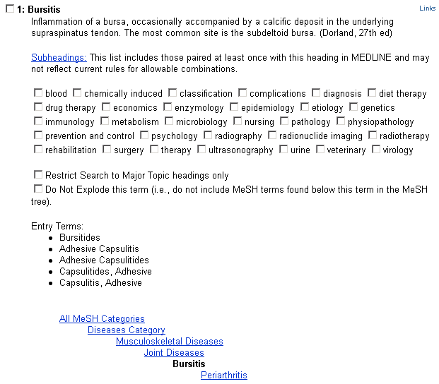

Send to Search Box

To specify a search for: Citations about the diagnosis of bursitis

- Select the diagnosis subheading from the Full display screen.
- Select Search Box with AND from the Send to pull-down menu.

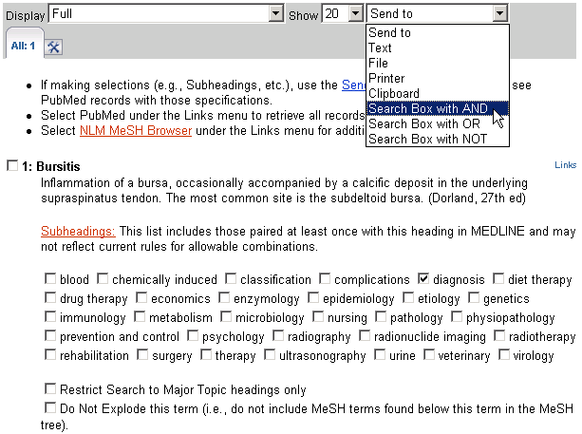

The term with any specifications will appear in the Search Box:

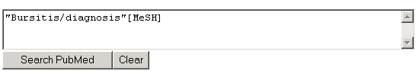

To add additional terms to this strategy, continue searching the database and add terms to the Search Box using the Send to Search Box feature.

Now, let’s adjust our search to specifically look for articles discussing the diagnosis of bursitis in the knee joint. Restrict to citations where the major focus of the article is knee joints and then add this term to the strategy we are building:

Searching on the next term. Click Go.  Here’s the  strategy being  built. | 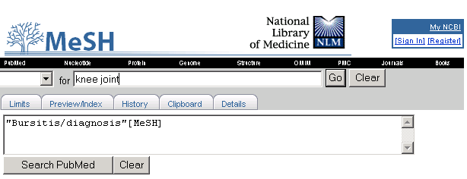
This brings you to the Full display for Knee Joint.  1. Click in the check box for:  Restrict Search to Major Topic headings only.  2. Select Search Box with AND from the Send to pull-down menu. |  | 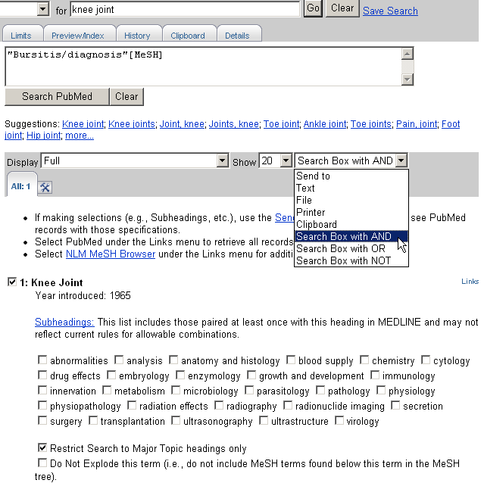

Now, the search is built and is ready to be run in PubMed. Click the Search PubMed button below the Search box:

Click Search PubMed button. | 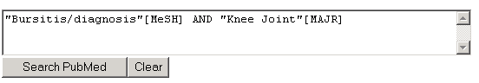

NOTES

Practice Exercises: Searching with MeSH

Try using the MeSH database to build your searches that require the use of MeSH headings.

- Find articles discussing prostate cancer as the main focus of the article. Use the MeSH Database to begin your search. Restrict to studies involving treatment by leuprolide.

- Find references discussing the economics of community-acquired pneumonia.

Suggested Answers: Searching with MeSH

- Find articles discussing prostate cancer as the main focus of the article. Use the MeSH Database to begin your search. Restrict to studies involving treatment by leuprolide.

MeSH Database Summary display for a search of prostate cancer:
Click term to reach Full display. | 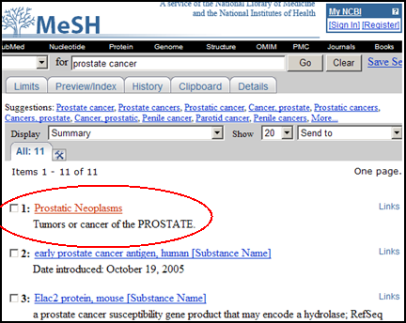

Restricting to Major Topic and adding the term to your search:

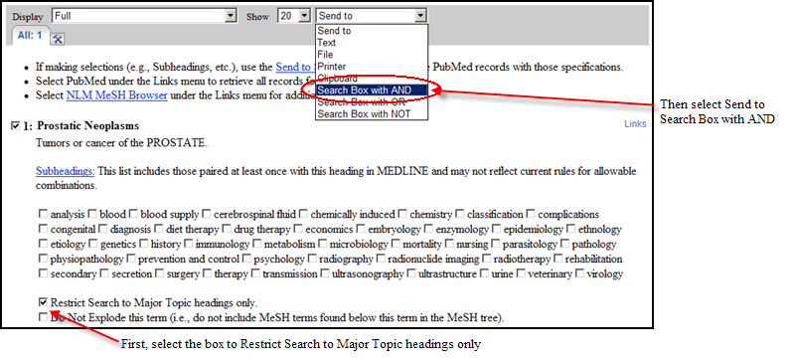

With “Prostatic Neoplasms”[Majr] in the MeSH Database Search Box, find the record for leuprolide and select the therapeutic use subheading. Send to Search Box with AND.
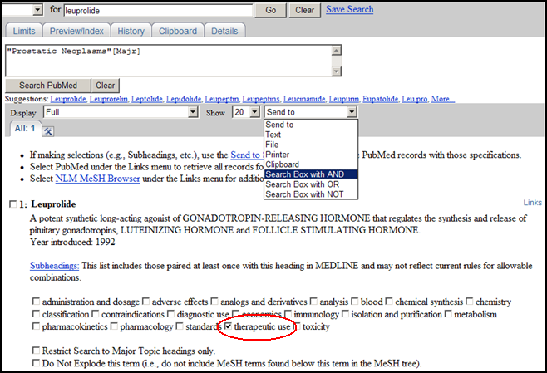

Once satisfied with the search strategy, click Search PubMed:

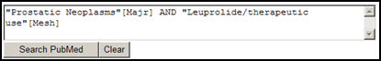

- Find references discussing the economics of community-acquired pneumonia.

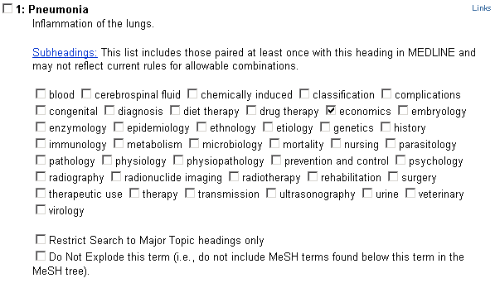
Selecting the subheading of economics to attach to the MeSH heading, pneumonia from the Full display in the MeSH database:

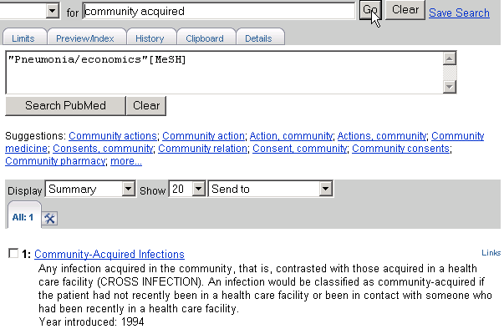
Searching for the next term:

Read the Scope Note. If relevant, click on the term to see the Full Display for more information including subheadings.

Final strategy ready to send to PubMed:

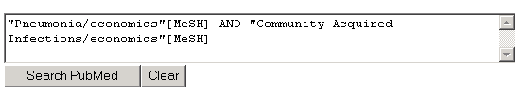

Single Citation Matcher

The Single Citation Matcher allows you to:
- find a citation or an issue of a journal using information such as a journal name, volume, issue, page number, publication date, title words, and author name
- search for the first or last author of an article

How to Get There

Click on Single Citation Matcher on the PubMed homepage.

Example: Biometals, 2001, one author is Gaither

- Enter as much information as you know; only one field is required.
- Click on Go.

- The Journal search box includes an autocomplete feature. This feature will suggest titles as you enter a title abbreviation or full title.
- When you see the title you are looking for, you can stop entering and select the title.
- Titles displayed by the autocomplete menu are in a ranked order based on the number of citations in PubMed.

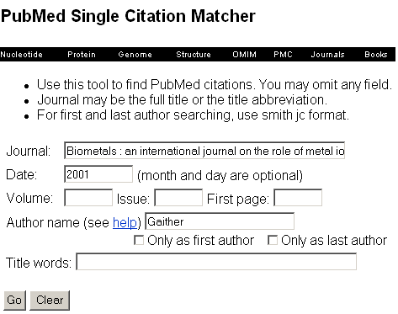
Result:
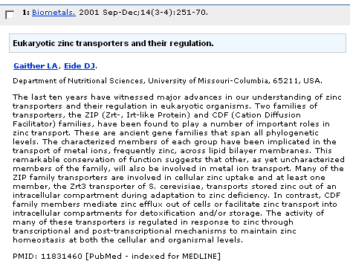

If you know four or more significant words from the title -- that is often all that is needed to locate a reference.

Example: You are looking for the citation for an article entitled,"Where does it hurt? Pain localization in osteoarthritis in the knee."

- Enter significant words from the title.
- Click Go.
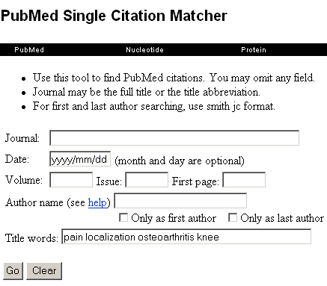
Result:
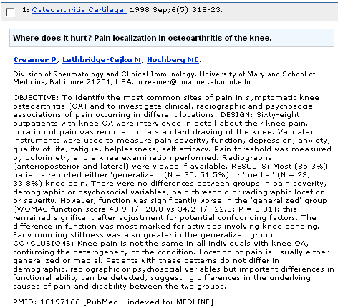

First & Last Author Searching via the Single Citation Matcher

Use the lastname + initial(s) format. Notice the autocomplete feature.  Click the check box, "Only as first author." | 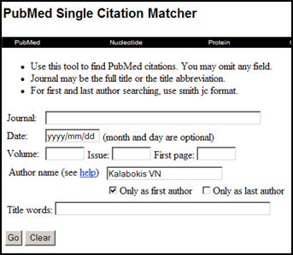

Result:
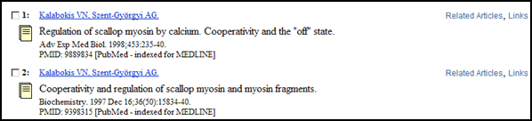

The Single Citation Matcher can also be used to get a "Table of Contents" listing of items from a particular issue of a journal in PubMed.

See the Retrieving Citations from a Journal Issue Quick Tour at http://www.nlm.nih.gov/bsd/disted/pubmed.html.
The Batch Citation Matcher allows you to retrieve the PubMed IDs for many articles all at once.

The Batch Citation Matcher is primarily a tool used by publishers to check their electronic submissions and links.

Journals Database

The PubMed Journals database allows you to look up information about a PubMed journal and search for that title. You can search for a journal using:

- journal title
- MEDLINE/PubMed title abbreviation
- NLM ID (NLM's unique journal identifier)
- ISO (International Organization for Standardization) abbreviation
- print and electronic International Standard Serial Numbers (pISSNs and eISSNs)
- subject terms (see page 89 of this workbook)

How to get there:
- Clicking on the Journals Database link from the database selection menu takes you to Journals Database screen:
Type your term(s) in the query box. | 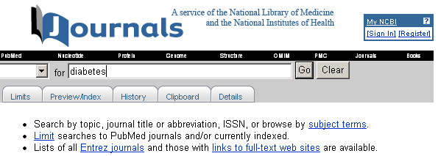

Result:
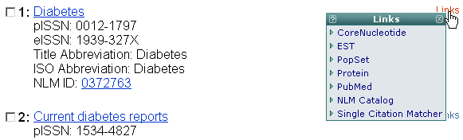 | Use the NLM ID to link to the NLM Catalog for further information about the journal.  Use the PubMed link from the Links pull-down to retrieve citations for an individual journal in PubMed.  Use the Single Citation Matcher link to place the journal title in the journal title box of the Single Citation Matcher.

Retrieval display order is alphabetical, except if term has an exact match, which will display first.

- Click on the hyperlinked journal title or choose the Full display format to see more information about the title:

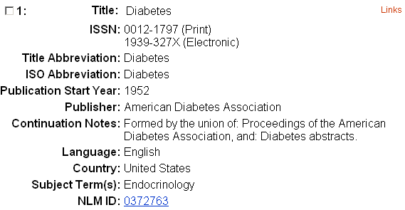

Limit to currently indexed titles

Click on Limits tab.  Use the checkbox to limit your search to currently indexed MEDLINE journal titles. | 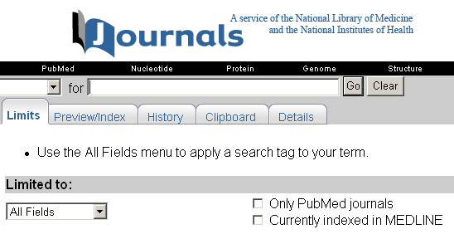

The Journals database includes journals in all Entrez databases (e.g., PubMed, Nucleotide, Protein).

Use the Only PubMed journals option on the Limits page to limit to journals in PubMed.
Subject Term [st]

- Subject terms are assigned by NLM to describe the overall scope of MEDLINE-indexed journals.
- Subject terms will display in the Full display format.
- Use the [st] tag.

Example: pediatrics [st]

Searching for non-tagged terms, e.g., pediatrics in the Journals database, will retrieve all journals that include the word pediatrics in the title as well as journals with the Subject Term, Pediatrics

The complete list of terms is available at the Journal Subject Terms Web page (http://www.nlm.nih.gov/bsd/journals/subjects.html).

Building a PubMed query for multiple journals

Click in the checkbox to the left of desired journal title.  Choose Search Box with OR from the Send to menu.  Once finished building your search, click Search PubMed button. | 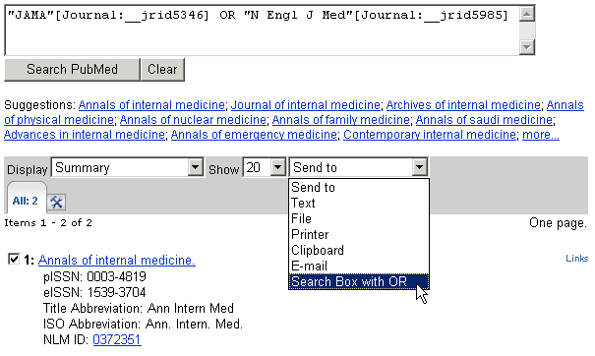
Use Save Search and My NCBI to facilitate the task of limiting searches to a specific group of journals.

See the E-mail Alerts for Articles from Your Favorite Journals Quick Tour at http://www.nlm.nih.gov/bsd/disted/pubmed.html.

Journals Lists

- On the Journals database screen, click on links to full-text web sites for a list of full-text journals available on the Web to which PubMed is currently linked.

Some journals may require that you register, subscribe, or pay a fee in order to view the full-text of an article.

Contact the journal publishers as noted on their individual Web sites for specific access information.

- Click on Entrez journals to FTP a list of all journals that are included in PubMed in the GNU Zip, Uncompressed, UNIX Compress, or PKZIP format.

Using the Search Indexes and Search Tags

Index

Viewing and selecting terms from the Index to develop search strategies

- Use the Index button to view and select terms from the Index and to add them to your search strategy.
- The Index allows you to view a listing of searchable terms within a search field.
- You may also select terms to build a search strategy using Boolean operators.

Selecting a field and entering a term to look up in the Index

Example: Use the Index function to find citations to articles about gene expression with an affiliation of Princeton University.

On the Preview/Index screen enter gene expression in the PubMed query box:

- Select affiliation from the pull-down menu, type princeton university and click the Index button.

PubMed displays a portion of the alphabetical list of available terms for the selected search field. Scroll up and down this window using the scroll bar. | 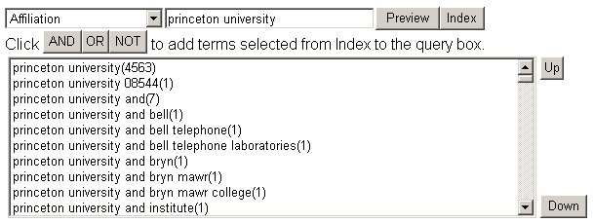
The number of citations that contain the term appears in parentheses to the right of the term.
To scroll up or down the entire Index for the field, click the Up or Down buttons.

Selecting a term from the Index

- Click on the term to highlight it.
- Then click on AND, OR or NOT to add the term to your search.

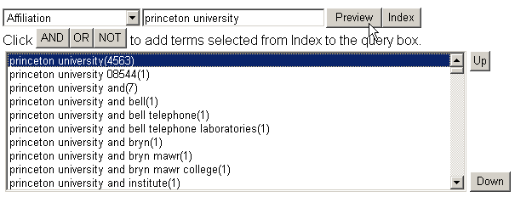

- Continue viewing, selecting, and adding search terms until your strategy is complete. Then click Go.

Query box shows the search term and the search field. | 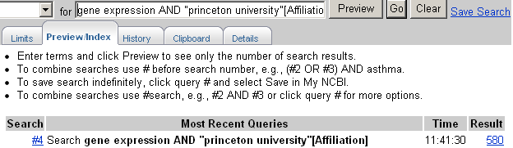
Result column shows the number of citations.

To OR together multiple terms from an Index display and then add (i.e., AND) them to your search, click on each term while holding down the Ctrl-key (PC) or the Command-key (Mac). When all the terms you want are highlighted, click the connector AND to add the terms (OR’ed together) to the query.

Search Field Descriptions

- Search fields can be specified using PubMed’s search field tags. A list of the field names and searching information is found in PubMed Help: Search Field Descriptions and Tags (http://www.ncbi.nlm.nih.gov/books/bv.fcgi?rid=helppubmed.section.pubmedhelp.Search_Field_Descrip). Not all searchable fields are included in this workbook section.

- For further information on the data found in the fields found on the MEDLINE display format, see MEDLINE®/PubMed® Data Element (Field) Descriptions (http://www.nlm.nih.gov/bsd/mms/medlineelements.html)

Rules
- Each search term should be followed with the appropriate search field tag, which indicates which field will be searched. The search field tag must follow the term.
Correct entry: aromatherapy [mh]
Incorrect entry: [mh] aromatherapy
- Search field tags must be enclosed in square brackets.
- Case and spacing do not matter: ice [mh] = Ice[mh] = ICE [MH]

Terms entered with a search tag (e.g., [mh]; [majr]; [tw]) will not generate the “Did you mean” message (PubMed’s spell check feature).

MeSH headings [mh]

- MeSH headings can be searched using two search field tags:
[mh] to search a MeSH heading
[majr] to search a MeSH heading that is a major topic of an article

- PubMed automatically searches the MeSH heading as well as the more specific terms beneath that heading in the MeSH hierarchy; i.e., the term is exploded.

- To turn off automatic explosion of MeSH headings, use one of the following tags:
[mh:noexp] or [majr:noexp]

Example: thromboembolism [majr:noexp]
Alternatively, consider using the “Do not explode” selection from the Detailed Display in the MeSH Database.
Searching with MeSH headings will exclude in process and publisher-supplied citations, as they are not indexed with MeSH.

Subheadings [sh]

- You can directly attach subheadings to MeSH headings using the format MeSH heading/subheading.

- Two letter abbreviations for subheadings or the full subheading name may be used.

Examples: thromboembolism/pc
thromboembolism/prevention and control
toes/in [majr]
toes/injuries [majr]

- Only one subheading may be attached to a MeSH heading at a time. To attach multiple subheadings, combine each MeSH/subheading combination with the OR connector or use the MeSH Browser.

Example: thromboembolism/pc [majr] OR thromboembolism/di [majr]

- For a MeSH/subheading combination, PubMed always explodes the MeSH term and also searches the subheading and its grouping if there is one.

In the example below, the subheading therapy or members of the therapy grouping (e.g., diet therapy) will be attached to the MeSH term (hypertension) or one of its indentions (e.g., hypertension, malignant).

Example: hypertension/th

Hypertension with its indentions: | Subheading grouping for therapy:
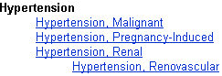 | 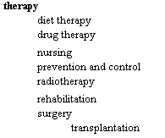

A list of subheadings and subheading groupings appears in PubMed’s Help.

To turn off both the MeSH heading explosion and subheading groupings, you would enter:

hypertension/th [mh:noexp]
hypertension/th [majr:noexp]

These search for only the subheading therapy attached to only the MeSH term hypertension (with “majr,” only as the main point).

- You may also choose to “free-float” a subheading with a MeSH heading using the Boolean AND and the subheading field tag of [sh]. This is typically done when you want to search for a subheading that cannot be applied to the MeSH heading you are also searching.

Example: hypertension [mh] AND toxicity [sh]

To turn off the subheading grouping, use the tag [sh:noexp]. You may only do this when “free-floating” a subheading.

Text Words [tw]

Terms or numbers that are searched with the Text Words [tw] field tag will be searched in the following fields:

- Title
- Abstract
- MeSH headings, Subheadings, Publication Types (includes single words and phrases)
- Other Terms field
- Chemical Names of Substances
- Secondary Source Identifier (The SI field identifies other data sources, databanks and accession numbers of molecular sequences discussed in MEDLINE articles.)
- Personal Name as Subject

Transliterated/Vernacular Title Word Searching [tt]
- This field contains the title of each item originally published in a non-English language, in that language.
- Non-Roman alphabet language titles were transliterated through 2004 publication date.
- Enter significant title words followed by the [TT] search field tag.
- Words should be combined with the AND operator.

Example: perfusion [tt] AND myocardique [tt]

Corporate Author [cn]

- Use the [cn] tag to search for corporate authorship of an article. Search the whole name or individual words from the name.

Examples: american dental association [cn]
american [cn] AND dental [cn] AND association [cn]

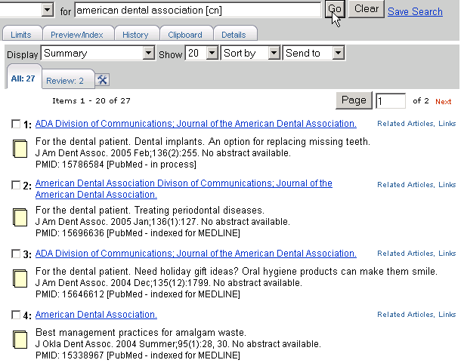

From May 2006 forward, corporate authors are displayed in the order found in the byline of the published article. From 2000 – April 2006, corporate authors are always displayed last in the list of authors.

This field was added in 2001; however this field may be added to some older records retrospectively. Citations indexed pre-2000 and some citations indexed in 2000-2001 display corporate authors at the end of the title field. For comprehensive searches, consider including terms and/or words searched in the title field.
Example: american dental association [cn] OR
american dental association [ti]

Personal Name as Subject [ps]

- Use the [ps] tag to search for citations to articles about a named individual. The name is searched in the conventional author searching format: lastname + initial(s)

The Personal Name as Subject field is not available from the Search Field pull-down menu in Limits.

Example: lincoln a [ps]

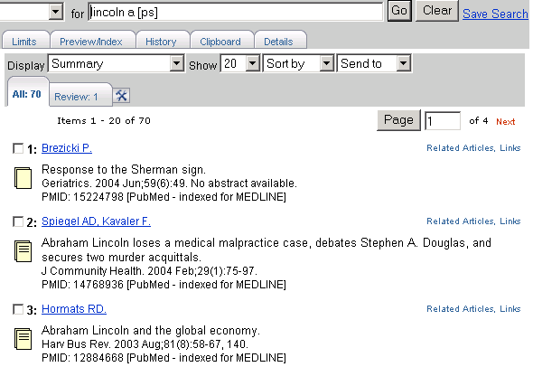

Date Ranging [edat] & [dp]

- The colon (:) is used between ranging values.
- To search on Publication Date from 1993 to 1997, enter:

1993:1997 [dp]

- To search on a date, use the format YYYY/MM/DD

The Published in the Last Date fill-in-the-blank selection on the Limits page makes searching and ranging the Publication Date easy.

Place of Publication [pl]

- This field indicates the cited journal’s country of publication.
- Use the [pl] tag.

Example: aids AND nigeria [pl]

Geographic Place of Publication regions are not searchable. In order to retrieve records for all countries in a region (e.g., North America), it is necessary to OR together the countries of interest.

Secondary Source Identifier [si]

- Identifies a secondary source that supplies information, e.g., other data sources, databanks and accession numbers of molecular sequences
Examples of Data Sources:
GenBank
GEO (NLM’s Gene Expression Omnibus) – beginning in February 2006
ClinicalTrials.gov identifier numbers – beginning in July 2005
International Standard Randomised Controlled Trial Number (ISRCTN) – beginning in mid-2006)
Reference Sequence (RefSeq) collection accession numbers
PubChem databases identifiers – beginning in January 2007

- Use the [si] search tag.

Examples: | genbank/af113832 [si]  clinicaltrials.gov/nct00000419 [si]  clinicaltrials.gov [si]
The field is composed of a source followed by a slash followed by an accession number.

Unique Identifier Searching [pmid]

- To search using the PubMed Unique Identifier (PMID), type in the number with or without the search field tag [pmid].

Example: 11073054

- You can search for several Unique Identifier numbers by entering each number in the query box separated by a space, PubMed will OR them together. Do not enter the OR connector.

Example: 7715939 11073054

Unique Identifiers  as entered in the  query box.  PubMed finds the 2 citations. | 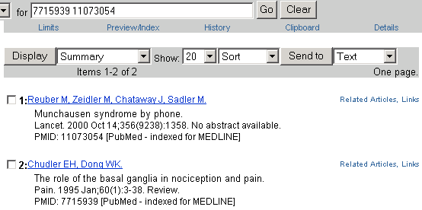

Affiliation [ad]

- May include the institutional affiliation and address (including e-mail address) of the first author of the article as it appears in the journal.
- Use the [ad] search tag.
- This field can be used to search for work done at specific institutions.
- The data is how it appears in the original journal article. It is not standardized, therefore the same institution may appear in variant forms.

Example: cleveland [ad] AND clinic [ad]

Grant Number [gr]

- Research grant numbers, contract numbers, or both that designates financial support by:
  - an agency of the US PHS (Public Health Service)
  - the Howard Hughes Medical Institute, or
  - eight funding sources from the United Kingdom

- The number is followed by the country name and organization (the Institute acronym for Public Health Services agencies, and the full name for other sources.)

Examples: LM05545/LM/United States NLM
GR072308/United Kingdom Wellcome Trust
United Kingdom Wellcome Trust

- Use the [gr] search tag.

Example: lm05545/lm/united states nlm [gr]

The four pieces of the grant number (e.g., LM05545 – number; LM – acronym; United Sates – funding country and NLM – institute mnemonic) are each individually searchable using the [gr] tag.

Examples: lm05545 [gr]
nlm [gr]
wellcome trust [gr]
united kingdom [gr]

PubMed’s online Help links to a Web page detailing Grant Number Information Found in the GR Field in MEDLINE/PubMed (http://www.nlm.nih.gov/bsd/grant_acronym.html).

NOTES

Practice Exercises: Search Tags

Use search field tags when doing these exercises. Remember you can use the History feature to obtain search statement numbers to combine searches.

- Find references to articles written by the author Singh who was affiliated with Harvard at the time of publication.
(Notice that you will only retrieve affiliation information for the first author.)

- Find references to articles about Winston Churchill.

Suggested Answers: Search Tags

- Find references to articles written by the author Singh who is affiliated with Harvard.
(Notice that you will only retrieve affiliation information for the first author.)

- Find references to articles about Winston Churchill.

Managing the Results

Display Options

Summary Format
Multiple PubMed citations are initially displayed in the Summary format.

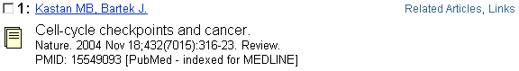

The Summary format may include the following:

- Author Name(s): All authors from the record are displayed with search links.
- Corporate Author: Identifies the corporate authorship of an article.
- Links: Available links such as Related Articles, Protein, Nucleotide, LinkOut, Books, etc.
- Title of the article: Most foreign language titles will be translated into English and placed within brackets.
- Source: Includes journal title abbreviation, date of publication, volume, issue, and pagination. Mouseover of journal title abbreviation displays full journal title.
- Abstract/Free Full text icons: Note the following icons to the right of the retrieved abstracts:

Citation includes no abstract.
Citation includes an abstract.
An icon with an orange and green banner indicates free full text is available from PubMed Central (PMC), NLM’s free digital archive of life sciences journal literature.

An icon with a green banner indicates there is a link to full text and no payment or subscription is required.

- May also include language (for non-English articles) and Publication Type if the article is a review or retracted publication. Articles without abstracts will display the notation: “No abstract available” and the No Abstract icon.
- Annotations to associated citations (e.g., Errata).
- PubMed Unique Identifier (PMID).
- A status tag: [PubMed - as supplied by publisher], [PubMed - in process], [PubMed - indexed for MEDLINE], [PubMed - OLDMEDLINE] or [PubMed]

Other Display Formats

The Display pull-down allows the user to select available display formats:
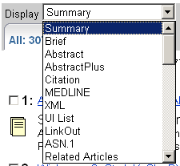

Abstract Format
Summary, Abstract, AbstractPlus, Citation, MEDLINE, and Related Articles are the most appropriate display selections for bibliographic information.
May include the following information:

- Source (journal title abbreviation - mouseover for full title and link for search options; date of publication; volume; issue; and pagination)  - Title  - On non-English language articles, [Article in language] tag  - Author(s) with author names displayed as "search links" to author searches.  - Corporate Author  - Affiliation (address) of first author |  | - Abstract (if present) from published article  - Publication Types (except for “Journal Article”) with search links  - Annotations to associated citations (e.g., errata)  - PMID  - Status tag  - Links
Click on the journal title link for search options.  Click on the linked name to run a search for that author name.  Click on link for search options. | 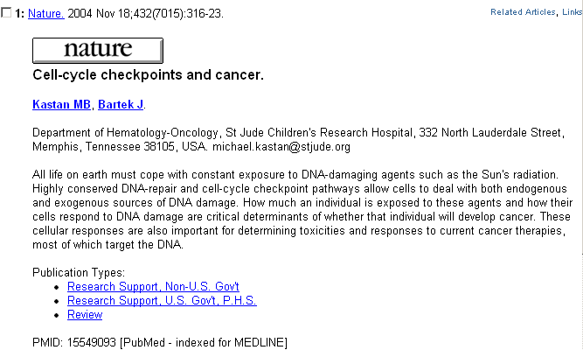

AbstractPlus Format
May include the following additional information:
    - Related Links including the first 5 Related Articles
    - Related Reviews
    - Patient Drug information links

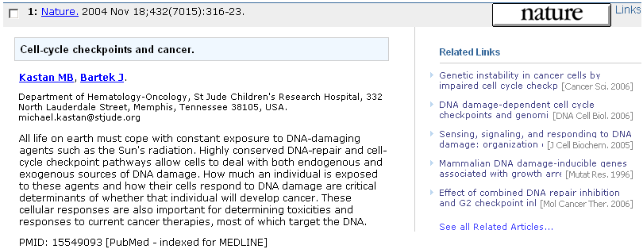

AbstractPlus is the default format when a single citation is retrieved. See My NCBI User Preferences to change your default format.

Citation Format
May include the following additional information:
- MeSH Terms with search links
- Personal Name as Subject (if present)
- Chemical substances (if present) with search links
- Grant numbers (if present) with search links
- ClinicalTrials.gov identifier number with search links

Click on the journal title link for search options.  Click on the linked name to run a search for that author name.  Click on links for search options. | 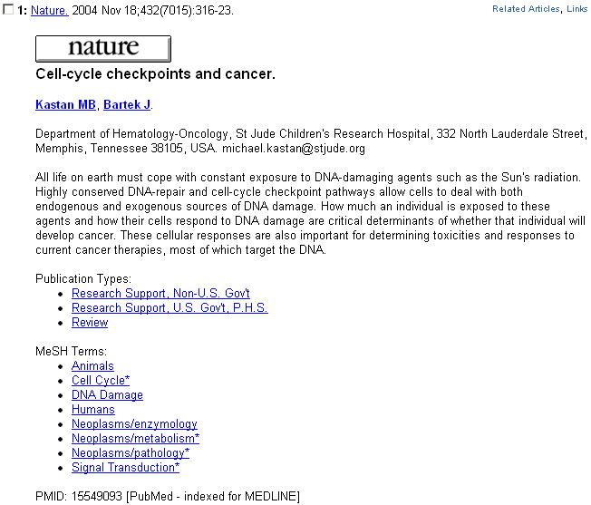

MEDLINE Format
Two- to four-character tagged field format displaying all fields of the PubMed record.
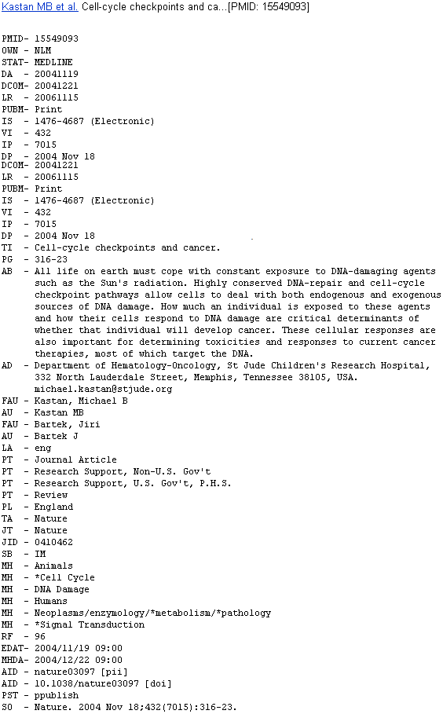
Use this format for downloading records into bibliographic management software programs.

For further information on the data found in the fields found on the MEDLINE display format, see MEDLINE®/PubMed® Data Element (Field) Descriptions (http://www.nlm.nih.gov/bsd/mms/medlineelements.html)

Show…

- PubMed initially displays search results in batches of 20 citations per page.

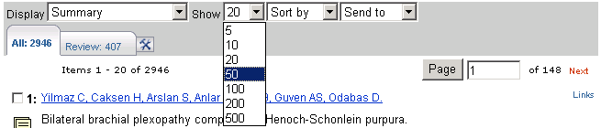

- Click on the Show pull-down menu to select a higher/lower number.
- PubMed redisplays the citations based on your selection.

Sort by…
- To sort items by author, journal, article title, or publication date, click on the Sort by pull-down menu to select a sort field.
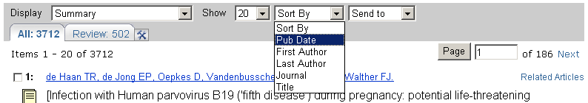

You can sort directly from the results screen, or you can collect citations on the Clipboard and sort the items there.

Send to…

Send to Text
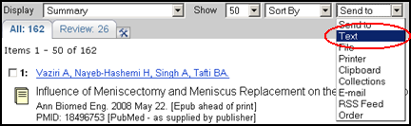
- Use Text to redisplay citations omitting the Web or HTML components.
- Text will display either selected citations, or if no citations are selected, all the citations on the page.
- Before using the Text option, consider changing the display format and the number of items displayed on each page.
- Select Text from the Send to pull-down menu. When finished with the Text display, use your Web browser’s Back button to return to your results in the regular format.

Send to File
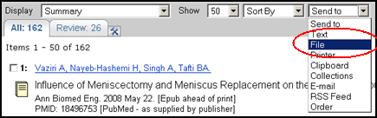

- To save and send your entire set of search results to a file, use the Display pull-down menu to select the desired format. Then select File from the Send to menu. This saves the results in the display format selected.
- To mark selected citations to save and send to a file, click on the check-box to the left of the item number as you go through each page of your retrieval. After you have finished selecting citations, choose a display format. Then select File from the Send to menu.

Send to Printer
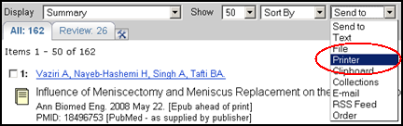
- Use the Printer option under the Send to menu to print search results.
- Choose the items you want to print and the display format before using the Send to Printer option. If you do not make any selections, the "print page" that is created will include the items in the display format currently shown on the search results screen.
- The Send to Printer option creates a printer-friendly page. Click the Print this page button.
- Use the Print dialog box of your operating system to choose your printer and print. Click the Go Back button to return to your search results after printing.
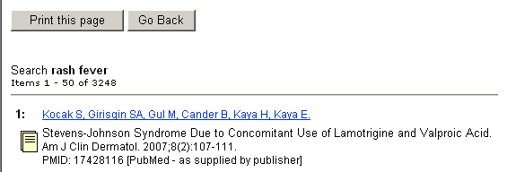

Send to Clipboard

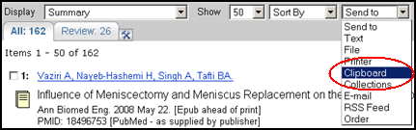
- The Clipboard allows you to collect selected citations from one search or several searches that you may want to print, save, or order.
- The maximum number of items that can be placed in the Clipboard is 500.
- To place an item in the Clipboard, click on the box to the left of the citation and select Clipboard from the Send to menu.
- Once you have added a citation to the Clipboard, the item number color will change and an asterisk will appear on the Clipboard tab.

An asterisk appears on the Clipboard tab.  A mouseover of the Clipboard tab displays the number of items collected in the Clipboard. | 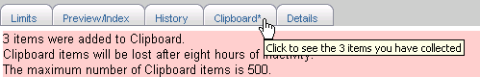
- Once the citations are added to the Clipboard, the citation item number color changes.

Clipboard Tips:

- If you send items to the Clipboard without selecting citations using the check-box, PubMed will add up to 500 citations from your retrieval to the clipboard.
- The maximum number of items that can be added to the clipboard is 500.
- The clipboard will be lost after 8 hours of inactivity.

Using the Clipboard
- To view the contents of your clipboard, click on Clipboard from the Feature tabs. 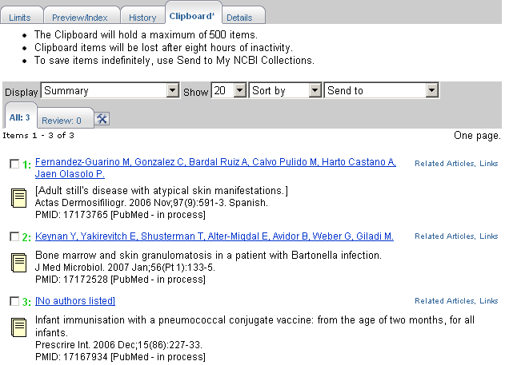
- You can sort, print, save, order, or send to My NCBI collections the citations on the Clipboard.

Deleting citations from the Clipboard

- To delete citations on the Clipboard, click on the check-box to the left of the item number, and then select Clip Remove from the Send to menu.
- To empty the Clipboard, select Clip Remove from the Send to menu.

Citations on the Clipboard may be incorporated into a search statement using #0. For example, limit the items on the Clipboard to English language citations using the following search:

#0 AND english [la]

This does not affect or replace the Clipboard contents.

Send to E-mail

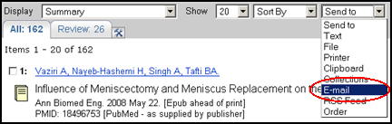

- Select E-mail from the Send to menu.
- You are brought to an options screen:
Settings on the options screen reflect selections on the Results page and can be modified if desired. We have modified the format to Abstract.  Add a message if you wish.  Enter e-mail address.  Click Mail button. | 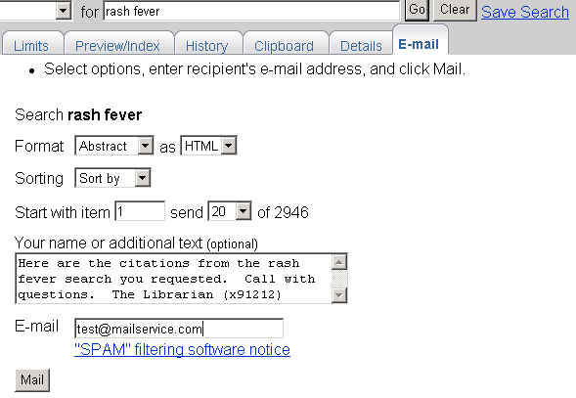

E-mail Tips:
- You may E-mail up to 500 items.
- The HTML option allows the PubMed e-mail messages to display as a results page with hyperlinks to Related Articles, LinkOut, etc. The recipient's e-mail service must be set for HTML view to allow for proper display.
- A default E-mail address may be stored via My NCBI User Preferences.

Send to Collections: See page 116
Send to RSS Feed: See page 122
Send to Order: See page 127

My NCBI Collections | 

My NCBI Features
- Saved Searches: save search strategies to get updates - including automatic e-mailed updates.
- Filters: group your retrieval by topics of interest to you.
- Collections: save search results.

If your Web browser is set to block pop-ups, you will need to allow pop-ups from NCBI Web pages to use My NCBI.

Getting to My NCBI

- PubMed's banner will display links to My NCBI.  - The My NCBI link goes to the My NCBI home page.  - Sign In links to the Sign In page.  - Register links to the My NCBI registration page. | 

Registering for My NCBI
- To use My NCBI you need to register for an account.
- If you choose to include an e-mail address, you will receive a confirmation e-mail
(see page 120 for details).

Sign In: Session-Only or Automatic
The check box, "Keep me signed in unless I sign out" is un-checked as the default.  This means that My NCBI features will be available for your current session.  Check the box if you want My NCBI features to be available from that computer without signing in again. This is done by use of a permanent cookie which remains on the computer.  Click About automatic sign in for more information about this feature. | 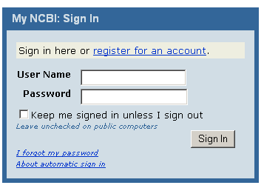

Collections

- Use Collections to save search results within My NCBI.

Create a Collection

Step 1: Select search result items you wish to save  Step 2: Choose Send to Collections from the Send to menu.  If you are not already signed into My NCBI, you will be prompted to do so. | 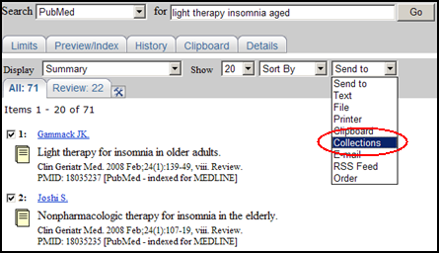

If you do not select items, all items (up to 500) will be saved to the collection you are creating.

Step 3:  Choose to create a new collection.  Rename your collection.  You may wish to remove all the saved items from the Clipboard.  Click OK. | 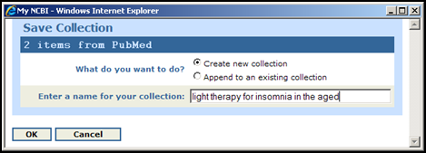

Append to a collection

- Choose Append to an existing collection from the Save Collection pop-up window.
- Choose the collection to which you want to add items and click OK.

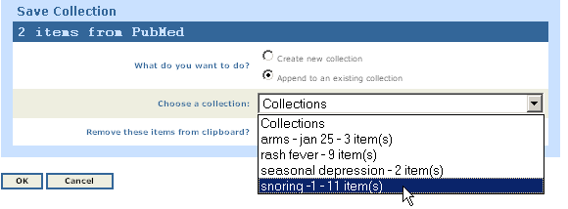

 | You can add up to a maximum of 1500 items to a collection.
Edit a collection
From the My NCBI Collections page you may:  - Merge collections.  - Delete collections.  - Sort by column using the up and down arrows.  - View the collection in a PubMed results screen to print, save or e-mail.  - Edit collections. |  | 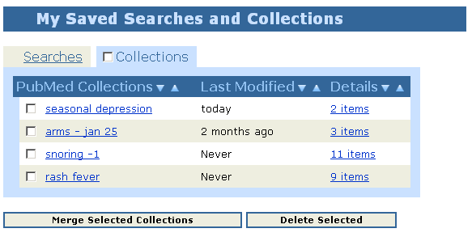

Saving the Search

Saving Searches with My NCBI

- Run your PubMed search.
- From the Results page, click on the Save Search link to the right of the query box.

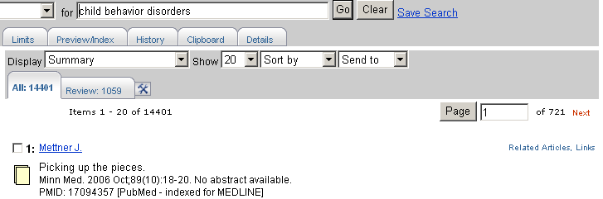 | Click  here.

- PubMed will open a separate window in your browser to start the saving process. (If you are not already signed into My NCBI, you will be prompted to do so).

- Be aware that the default search name does not include any Boolean operators, search statement numbers or search tags, if entered. This name does not affect the strategy, so it is advisable to edit it to something short, yet meaningful.

You can edit the name of the search.  This name will be part of the Subject line of automatic e-mail updates. | 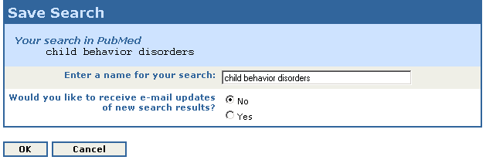

- Next, indicate whether or not you want to have the updates automatically e-mailed.

- If you leave the setting as No, the search is saved and you can update it at your convenience.

- If you select the Yes button, the window will extend to display additional options for customizing the update:
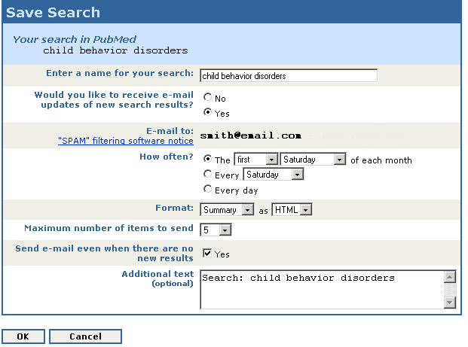

Setting Up Automatic Updating

Searches saved for automatic updating require that additional details be supplied.

- If the e-mail box is blank, enter an e-mail address for the account. All automatic updates will be sent to that address following confirmation.
- Select How often you want to get updates - monthly, weekly, or daily.
- Select the format (Summary, Abstract, etc.), and either an HTML or text e-mail.
- Select the maximum number of items to be sent with each update. Don’t worry about picking a number that is too low. You can use a link in the e-mail that takes you to the total update results in PubMed.
- If you want to know when an update retrieved no citations, select, Send e-mail when there are no new results.
- The Additional text box will default to the search name. You can replace this text, keeping in mind that this text will display on each e-mail update as “Sender’s message” and the strategy is also displayed in the e-mail message. Many users will prefer not to include additional text.

Partial e-mail update results:

Click on the word, “here” to view the complete results. For this example, to see all 10 citations. | 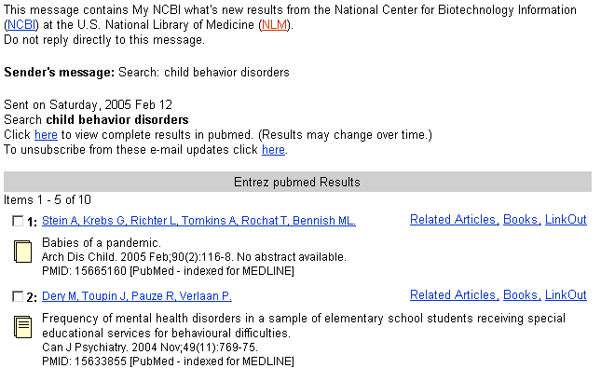

Important Facts about the E-mail for My NCBI Account
- Each My NCBI account can have only one e-mail address that will be used for all automatic e-mail updates saved in that account.
- If, at a later time, you change the e-mail address for your account, the new e-mail address will be used for all automatic updates following confirmation (see below).
- To change the e-mail address on an account, go to User Preferences on the My NCBI sidebar.

The address for PubMed’s Send to E-mail feature can be changed for individual e-mails on the Send to E-mail page without affecting the e-mail address used for the My NCBI account.

The Confirmation E-mail
- The first time an automatic e-mail update is created for an account, or if the e-mail is changed in User Preferences, a confirmation e-mail will be sent to that address.
- No automatic updates will be sent to an address until it has been confirmed.

Manually Updating Searches

- To manually update a search, go to your saved searches in My NCBI.
- Check the box to the left of the search to be updated and click What’s New for Selected at the bottom of the page.
- My NCBI will indicate if there are any new citations retrieved by the strategy since your last update.
- If you link to the results, i.e., complete the update, your saved search list will reflect the date and time of the update.

About the Updates

- The update strategies used for My NCBI are detailed in PubMed’s Help.
- New or modified searches can be generated no sooner than the next day. For example, this morning, you changed the frequency for an update from Monthly to Daily. The first update will be sent tomorrow.

Additional Functions available from My Saved Searches page

Saved searches can be run to retrieve total results, i.e., not limited to new citations. Click on the name of the search. (This will not affect future updates.) | 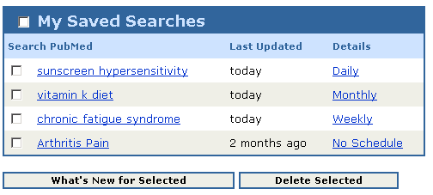 | In the Details column click on the frequency (Daily, Weekly, Monthly) to go to the Search Details page where you can make changes.  Hold your cursor over the data in the Last Updated column to show the date the next e-mail update will be sent, or in the case of No Schedule, you will see the date you last manually generated new citations.
Modifying a Strategy: Save a New One and Delete the Old

- Saved search strategies cannot be edited. To modify a strategy, re-save it with your changes.
- To delete a search, select the search using the check box and click on the Delete Selected button at the bottom of the page.
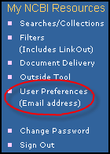
Changing the E-mail Address for an Account

- User Preferences is accessible via a link on the My NCBI sidebar. You can change the e-mail address for your My NCBI account here.
- Keep in mind, anytime you change the e-mail for an account, all automatic updates will be sent to that address following confirmation.

Send to RSS Feed
 | RSS feeds bring content (like news items) from multiple online sources into one reader or Web page. The feeds are dynamically updated as new items are added from each source. An RSS reader is required and many are available to download free from the Web. Each RSS reader behaves and displays data differently.
Select RSS Feed from the Send to menu. |  | 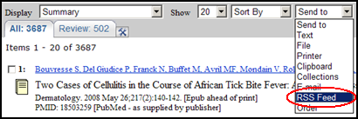
- You are brought to an options screen:
Change these selections if needed.  Click Create Feed button. | 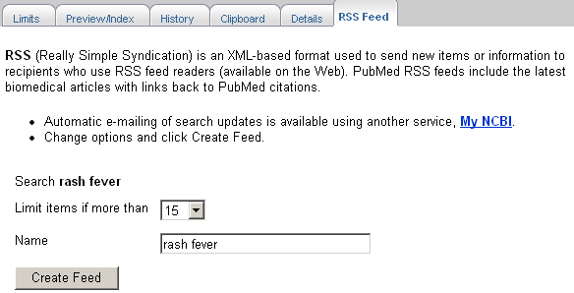
Click the XML icon to display a screen of XML. You don't need the code, just the URL from the address line. |  | 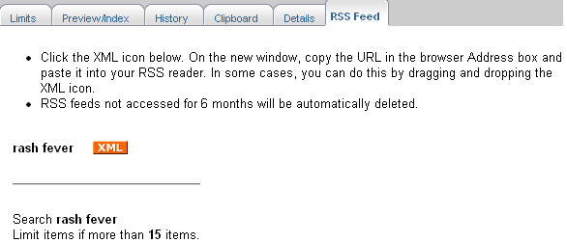

Copy and paste the URL into the "subscribe" form in your RSS reader. | 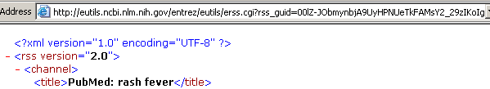

Practice Exercises: Managing the Results and Saving the Search

- Create a My NCBI account and sign in (or sign in to your existing account).

- Find English-language review articles published in the last ten years on using light therapy to treat seasonal depression. Show all results in Citation format on one page. Select three or four citations and save them in a Collection.

- Save your light therapy search and set up weekly automatic updates in AbstractPlus format.

Suggested Answers: Managing the Results and Saving the Search

Instructions for #1 and #3 are on pages 115-116 and 118.

- Find English-language review articles published in the last ten years on using light therapy to treat seasonal depression. Show all results in Citation format on one page. Select three or four citations and save them in a Collection.

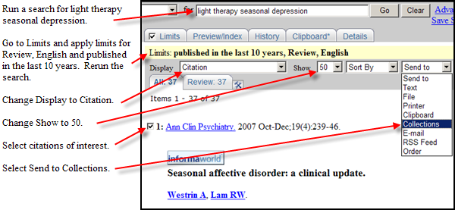

Getting the Articles
PubMed does not include copies of journal articles. However, PubMed does offer links to the full text of journal articles when links are available. Access to some articles will be free. Access to others will require payment.

LinkOut
- Links to full text resources from PubMed are available through a service called LinkOut.
- When you click on LinkOut icons or links in the LinkOut display in PubMed, you leave PubMed and are directed to the full text at an external site.
- The National Library of Medicine does not hold the copyright to this material, and cannot give permission for its use. Users should review all copyright restrictions set forth by the full text provider before reproducing, redistributing, or making commercial use of material accessed through LinkOut.
- LinkOut provides links from PubMed and other Entrez databases to a wide variety of relevant web-accessible online resources including full-text publications.
- Look for icon links to full text resources on the Abstract, AbstractPlus or Citation display formats.

The icon link to full-text from the AbstractPlusformat. | 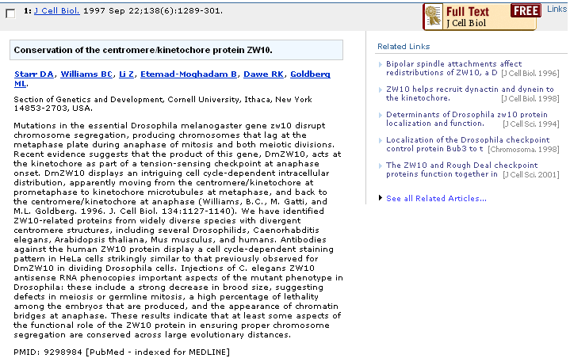

To see the full list of web accessible online resources for an item, select LinkOut from the Links pull-down menu. | 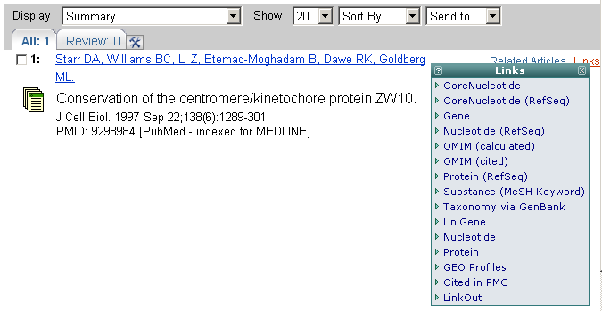

Click on icon to view a legend of icon displays.  LinkOut Libraries after“J” was selected. | 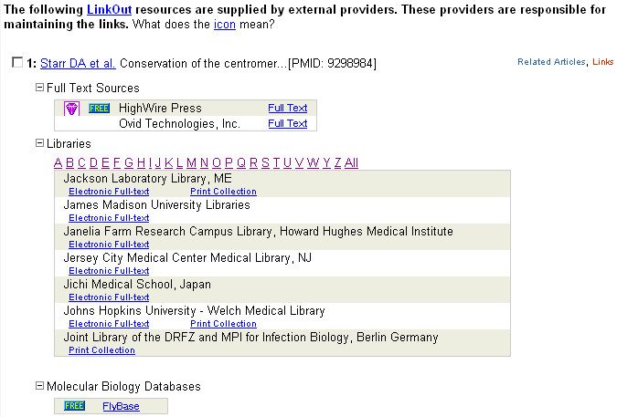

Send to Order

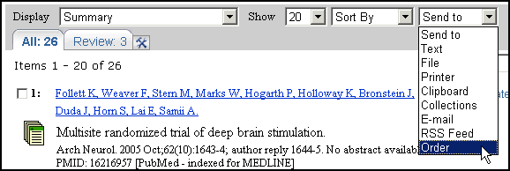

- Select Order from the Send to menu to use an automated document ordering program called Loansome Doc.
- You can also Order directly from the Clipboard.

What is Loansome Doc?

The Loansome Doc feature allows you to order the full-text of an article from a Loansome Doc participating library. Prior to using this feature, you need to establish an agreement with a Loansome Doc participating library. Your Loansome Doc library will provide you with their Library ID, which is needed when setting up the service within PubMed or the NLM Gateway.

What does it cost?

The library providing you this service will explain their ordering fees, if any. This service is generally not free.

What library can provide me with this kind of service?

Call your Regional Medical Library at 1-800-338-7657 Monday-Friday, 8:30 A.M. – 5:00 P.M. in all time zones to find out which medical library in your area can set you up with the Loansome Doc ordering service. Or visit http://www.nlm.nih.gov/pubs/factsheets/loansome_doc.html to find out more about Loansome Doc.
To order articles, select the citations for the articles by clicking on the check-box to the left of each item.

- Select Order from the Send to menu.
- You are brought to the page shown below:

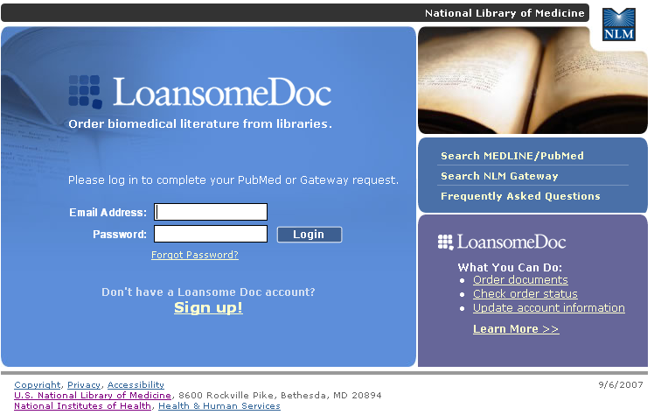

On this page you can:
- log into Loansome Doc using your Email address
- obtain a status report of your orders
- update your Loansome Doc account information
- sign up for a Loansome Doc account
- link to FAQs
- learn more about Loansome Doc

For more information about obtaining full text articles, see the tri-fold handout, Full Text and PubMed at http://nnlm.gov/training/resources/fulltexttri.pdf.

Additional Tools

Filters
- My NCBI includes a Filters feature which groups search results by areas of interest.
- You can have up to five active filters using My NCBI.

Default Tabs
- “All” tab shows the total retrieval for the search. “Review” tab shows the total retrieval for review articles.
The All tab shows the total retrieval for the search. The Review tab shows the total retrieval for review articles.  To the right of the “Review” tab, the hammer and wrench icon  links you to My NCBI where you can add or modify your filter choices. | 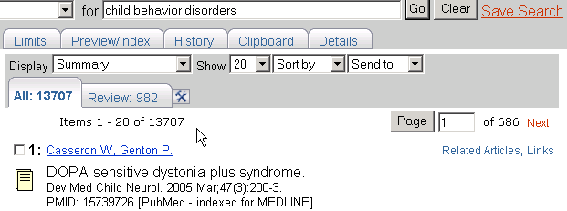

Adding Filters
- Use the icon to link to the Quick Pick list of commonly-requested filters (you must sign in to My NCBI if not already signed in):
Click in the checkboxes to select or deselect filters. | 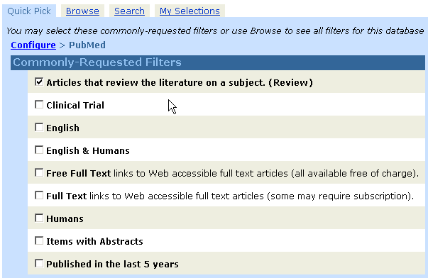

Browse
- Click on Browse to see additional options for PubMed filters.
- On the Browse page there are three categories:
- LinkOut
- Links
- Properties
- Users interested in subject-related filters for their searches should look at Properties.

There are over 70 filter options under Properties. | 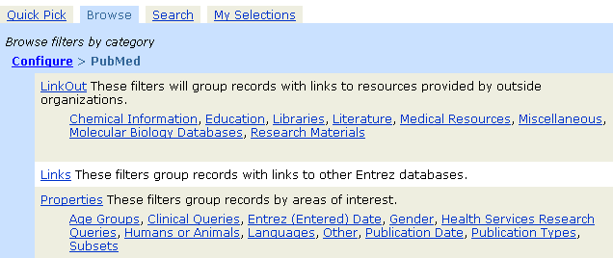

Under Properties, use the links to see the available filters for each sub-category. Here’s the one for Publication Types:

Use the link for the desired filter to go to a page where you can select that filter. | 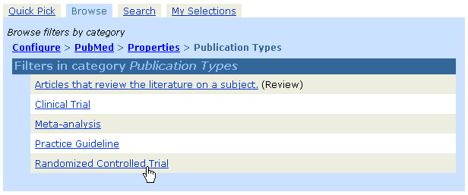

Click in the checkbox to select the filter. | 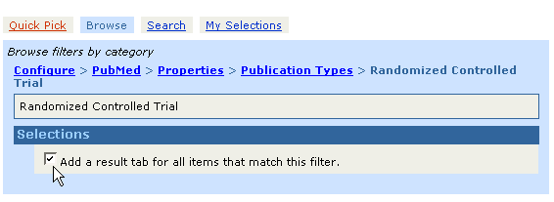

LinkOut Filters
- Filters in this category group results by full text providers, libraries, and other outside resources.

Adding your library’s holdings as a filter

- From the PubMed “Browse” filters page:

Click on Libraries link. | 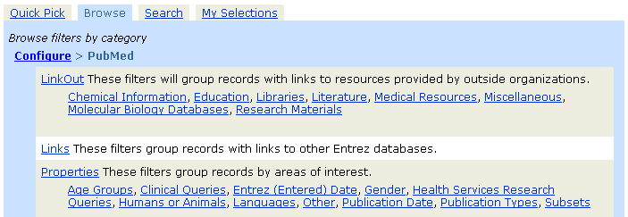

This will bring up a page with all of the LinkOut-participating libraries.
- Use your browser’s Find feature to locate your library.
- Click on the desired library link.
- Then click on the checkboxes to add a result tab and/or display the library’s icon:

Notice the use of “breadcumbs” on the Filters pages.  Each breadcrumb for a higher level is a link to that page.  Click in the checkboxes to add these selections. | 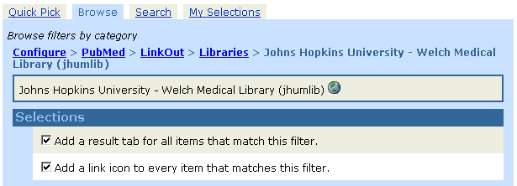

- Results tabs for LinkOut providers display the LinkOut user name.
- Place your cursor over this ID to see the name of the provider.
- Users who connect to PubMed with a URL that includes a library's holdings parameter will continue to see their library icon even if they do not select their library in My NCBI. Users should select their library filter if they want to see a filter tab for their library in the search results.

My Selections
- Click on My Selections at any time to check on the filters selected:
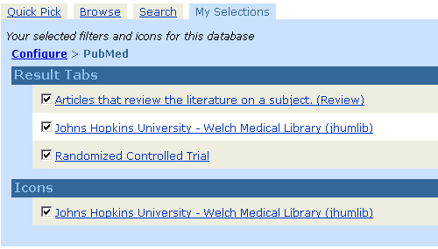

Using the Filter Tabs

- Click on a filter tab to go to the citations for a particular filter. Select any display format you wish.

- When you click on the filter name (tab) to see the results for a filter, a tack symbol will appear in the tab:

Clicking on the  icon "tacks" that filter onto the search query box. | 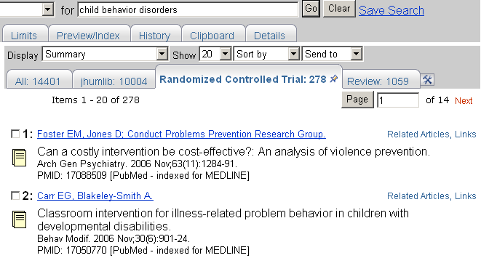

- Filters added using the tack icon will display in the query box with the [Filter] tag.

- If you want to save this search, click on Save Search.

- Many filter topics can be added to the search via the Limits page. Either way will yield the same results.

My NCBI User Preferences

- Available from My NCBI sidebar.
- Change the display format for the Links menu on your search results screen.
- Save an e-mail address for Send to E-mail as well as automatic e-mail updates.
- Choose to highlight PubMed search words in retrieval when you are signed into My NCBI.
- Change single citation display default from AbstractPlus format to another format.

Activating Highlighting Feature & changing default for single citation display:

Selecting a color and clicking OK activates the highlighting feature.  Use the pull-down menu to select your default single citation display format. | 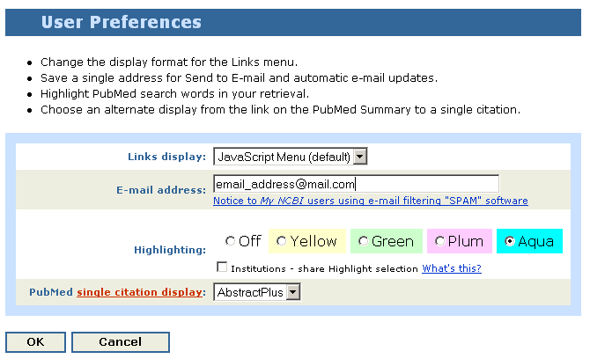

Several brief animated tutorials with audio called Quick Tours are available about using My NCBI with PubMed. Click on Quick Tours from the My NCBI home page or go directly to:

http://www.nlm.nih.gov/bsd/disted/myncbi.html

Clinical Queries

- Available on PubMed’s sidebar
- There are 3 search filters available from this page:
Search by Clinical Study Category
Find Systematic Reviews
Medical Genetics Searches

Search by Clinical Study Category
- This specialized search query is intended for clinicians and has built-in search "filters" based on research done by R. Brian Haynes, M.D., Ph.D. at McMaster University in Canada.

Five study categories or filters are provided:
- etiology
- diagnosis
- therapy
- prognosis
- clinical prediction guidelines

Two emphasis categories or filters are provided:
- narrow, specific search -- will get more precise, relevant citations but less retrieval
- broad, sensitive search -- includes relevant citations but probably some less relevant; will get more retrieval

Example: Find citations on having a rash with a fever using the defaults of therapy and narrow, specific search.

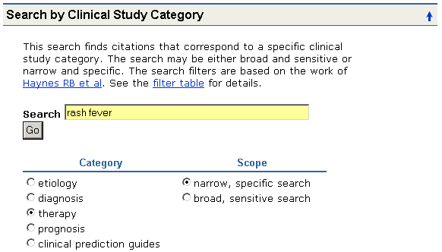

Find Systematic Reviews

- This feature is provided to help clinicians locate systematic reviews and similar articles.
- It retrieves systematic reviews, meta-analyses, reviews of clinical trials, evidence-based medicine, consensus development conferences, and guidelines. Citations from journals specializing in clinical review studies are also included.

Example: Find Systematic Reviews on inhalation therapy for pneumonia.

Enter search terms in the query box. |  | 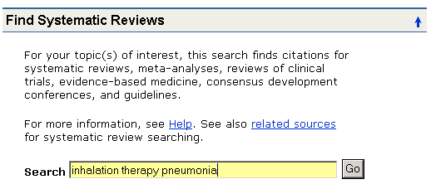
This subset can be combined directly with other search terms using AND systematic [sb]. For example, lyme disease AND systematic [sb].

Alternatively, you may select Systematic Reviews from the Subset pull-down menu on the Limits page.

Medical Genetics Searches

- Finds citations related to various topics in medical genetics.
- Default is to All topics. Click on All check box to deselect; then click on topic(s) of interest.
- Developed in conjunction with the staff of GeneReviews: Genetic Disease Online Reviews at GeneTests, University of Washington, Seattle.

Example: Find citations about sickle cell anemia using the Medical Genetics Searches categories: Genetic Counseling; Genetic Testing

Enter search terms in the query box.  Select topics of interest. | 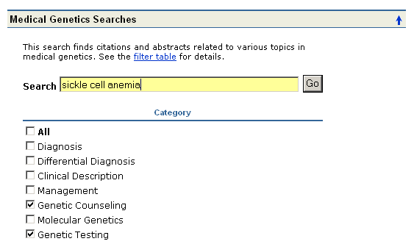

Special Queries – Health Services Research (HSR) Queries

Why?
- Provides a search interface to find PubMed citations relating to health care quality and health care costs

Where?
- Click on Special Queries from PubMed’s sidebar
- Click on Health Services Research (HSR) Queries from the Special Queries page

Click on “definitions” to display helpful explanations of the HSR categories.  Enter search terms here.  Choose appropriate category and scope. | 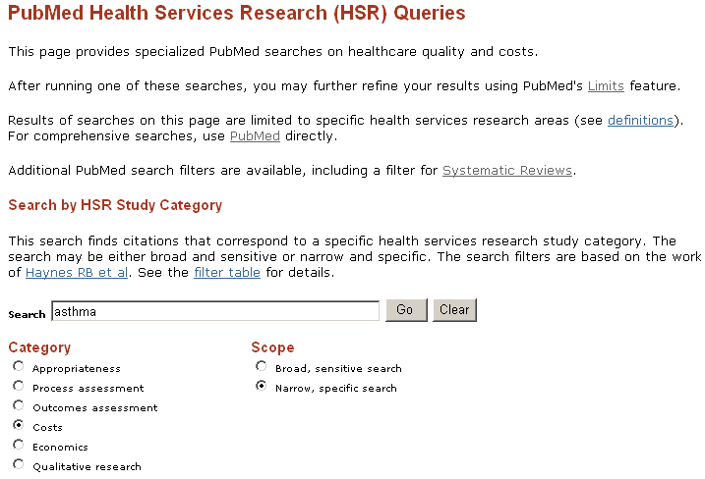

Linking to PubMed

Creating Links to PubMed Citations and Searches
To create a link to PubMed citations for use in a bookmark, Web page, or e-mail message, create or generate a customized URL. With this URL, you can link to specific citations or link to the current results of your PubMed search strategy.
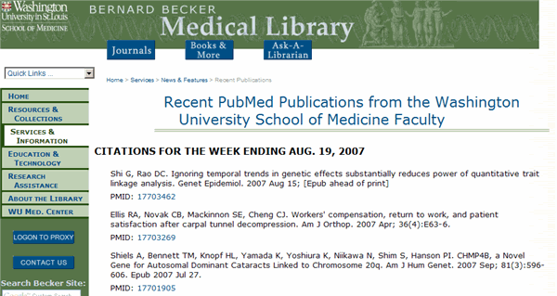
Recent publications from the Washington University School of Medicine faculty (Bernard Becker Medical Library). The PMID number links to the citation in PubMed in AbstractPlus format.

To create a link to a single citation in PubMed:
- View the citation in the Summary format
- Click the author link to display the AbstractPlus format
- Bookmark this page, or copy the URL from the browser’s address bar to paste as a link in a Web page or e-mail message

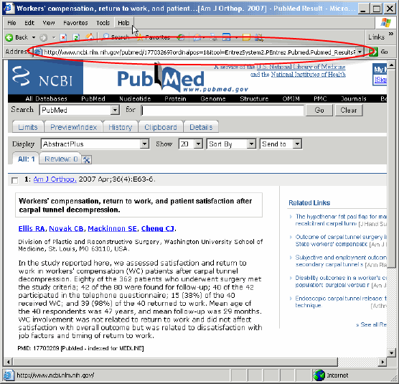

Copy the URL from the address bar when viewing a single citation in the AbstractPlus display.
To create a customized link to one or more citations in your preferred format:

Use the base URL for PubMed:

http://www.ncbi.nlm.nih.gov/pubmed/

then add the PMID. For multiple PMIDs, use commas (but no spaces) between each number, as follows:

18235850,17701905

Add ?&report= followed by your preferred display format (docsum, brief, abstract, abstractplus, citation, medline, xml, asn1 or externallink – see PubMed Help at http://www.ncbi.nlm.nih.gov/books/bv.fcgi?rid=helppubmed.table.pubmedhelp.T40 for descriptions), as follows:

?&report=citation

Strung together, your URL now looks like:

http://www.ncbi.nlm.nih.gov/pubmed/18235850,17701905?&report=citation

Note that there are no spaces.

To create a link to the results for a short PubMed search (e.g., an author’s name):

- Run the search
- Go to the Details tab
- Click on the URL button, below the search details
- Bookmark this page, or copy the URL from the browser’s address bar
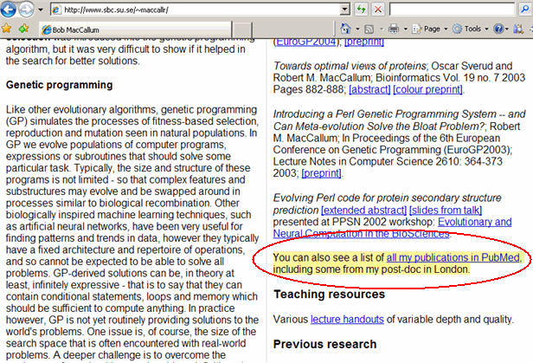
A personal home page with a link that runs a search for the author’s citations in PubMed.

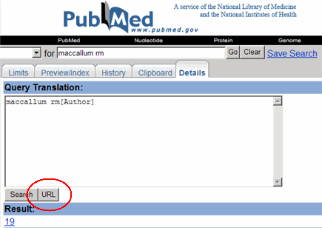
Click on the URL button on the Details page to create a link to a PubMed search.

Note: Some browsers have a size limit for URLs in the address bar. If your link doesn’t work, the search string may be too long for your browser. Use the “customized link” method, described below.

To create a customized link to PubMed search results:

A customized search link allows you to select the display format and number of citations in the PubMed results page.

Use the base URL for a PubMed “search” function:

http://www.ncbi.nlm.nih.gov/pubmed?term=

Add your search terms. Use the “+” sign between terms instead of spaces, as follows:

gastrointestinal+stromal+tumors

To use specific search fields, use the field tag (see Search Field Descriptions and Tags http://www.ncbi.nlm.nih.gov/books/bv.fcgi?rid=helppubmed.section.pubmedhelp.Search_Field_Descrip). For example, to limit the above search to articles published in the last ten years, use the [dp] tag, as follows:

+AND+”last+10+years”[dp]

Optionally, add &report= followed by your preferred display format (docsum, brief, abstract, abstractplus, citation, medline, xml, asn1 or externallink), as follows:

&report=abstract

Add &dispmax= followed by the number of items to display on each page, as follows:

&dispmax=100

Your finished URL will look like:

http://www.ncbi.nlm.nih.gov/pubmed?term=gastrointestinal+stromal+tumors+AND+”last+10+years”[dp]&report=abstract&dispmax=100

Note that there are “&” symbols between each element, and there are no spaces.

Troubleshooting:
If your URL isn’t working, the special characters may not be interpreted properly by PubMed. Try the following substitutions:
- Use &amp; instead of &
- Use %20 instead of +
- Use %5B instead of [
- Use %5D instead of ]
- Use %22 instead of “

For more details on creating links to PubMed or other Entrez databases, see Creating a Web Link to the Entrez Databases at http://www.ncbi.nlm.nih.gov/books/bv.fcgi?rid=helplinks.chapter.linkshelp

E-Utilities

- E-Utilities provide access to Entrez data outside of the regular web query interface.

Why use E-Utilities?
- E-Utilities are useful for retrieving large sets of PMIDs or records, or counts of records, matching a search strategy.

There are specific instructions and requirements for using E-Utilities in order to manage the workload on NCBI servers. See the E-Utilities documentation on the PubMed sidebar. You may consider asking your institution’s IT staff for technical support.

NOTES

Review Exercises

Choose one or two of the below case studies to review what you’ve learned about PubMed. Use My NCBI Save Search and Collections features to save your work.

- Emergency department physicians are concerned about the number of patients who leave the department without being seen (usually because they feel they have waited too long). Find articles about this phenomena using PubMed.

- Locate information on the Pelizaeus-Merzbacher Disease. Please search back 20 years. Do the Clinical Queries help you find information on etiology?

- What are the economic effects of breast cancer on a community? Consider using MeSH subheadings and/or the Health Services Research (HSR) Queries (follow the link to Special Queries on the PubMed homepage).

- Find the latest review articles on Edwards Syndrome.

- A woman presents with dementia and the neuropathological findings suggest a prominent contribution by Cerebrovascular disease. Find information on diagnosis and treatment. Try the Clinical Queries, Search by Clinical Study Category.

- Explore the ethical issues raised by the deaf community regarding cochlear implants. Consider using a subset, or looking specifically at audiology journals (see the broad subject term in the Journals Database).

- Find systematic reviews for accidents caused by sleep deprivation.

Review Exercises: Suggested Answers

- Emergency department physicians are concerned about the number of patients who leave the department without being seen (usually because they feel they have waited too long). Find articles about this phenomena using PubMed.

One approach:

emergency service, hospital AND patient dropouts AND time factors

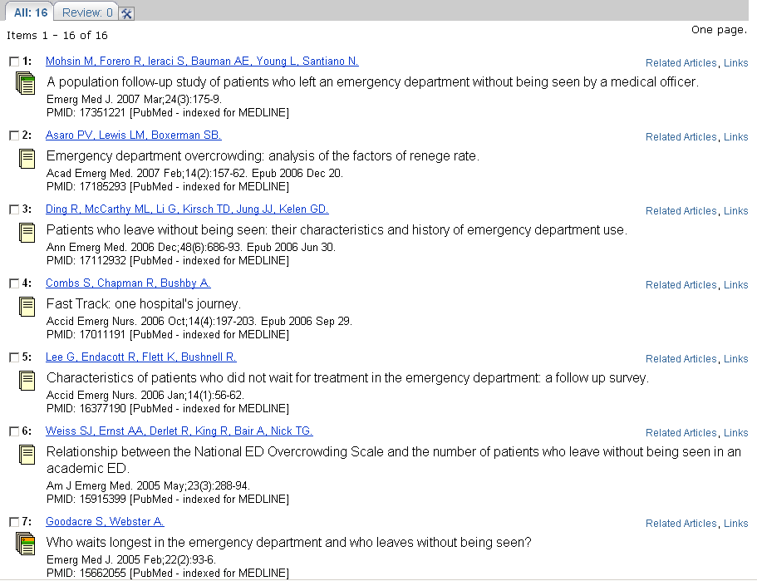

Use natural language to begin your search and then review MeSH headings used to index relevant articles to determine patterns of indexing for pertinent articles.

- Locate information on the Pelizaeus-Merzbacher Disease. Please search back 20 years. Do the Clinical Queries help you find information on etiology?

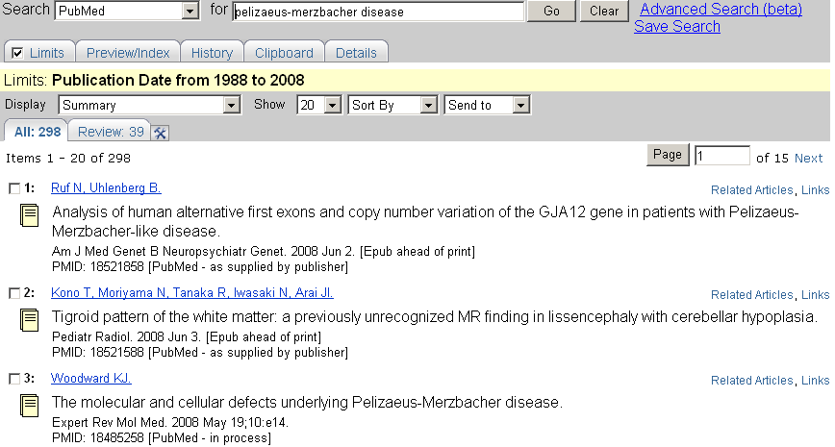

Using Clinical Queries (Search by Clinical Study Category) to locate etiology information:

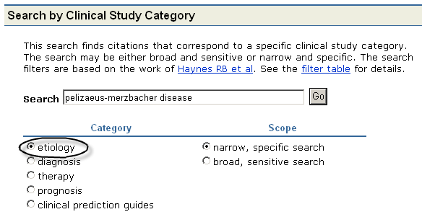

- What are the economic effects of breast cancer on a community? Consider using MeSH subheadings and/or the Health Services Research (HSR) Queries (follow the link to Special Queries on the PubMed homepage).

Possible strategy using MeSH/subheadings:
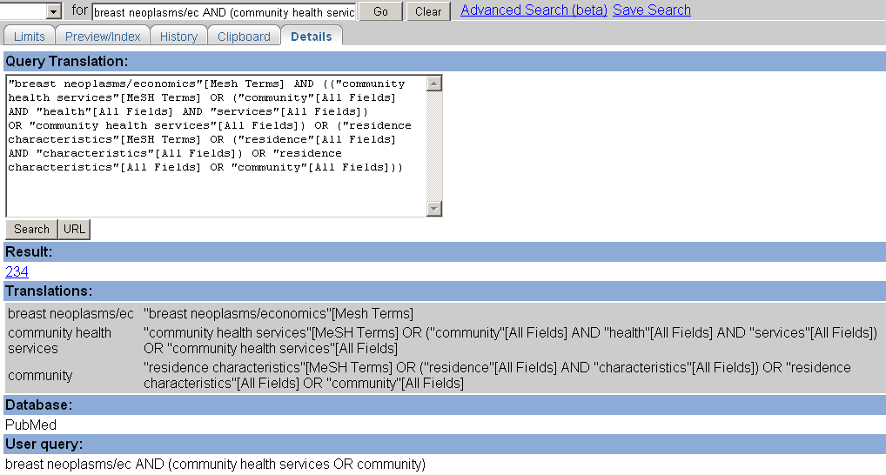

Using Health Services Research Queries from the Special Queries page:
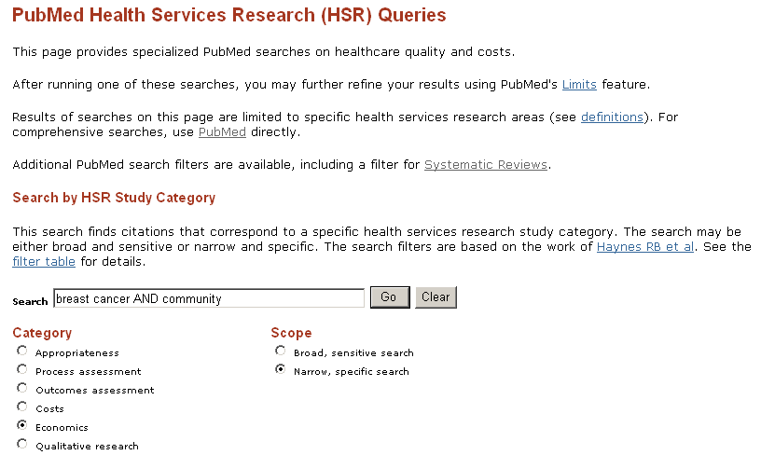
- Find review articles on Edwards Syndrome.

- Search: “edwards syndrome” as a phrase so PubMed’s automatic term mapping does not break it apart.
- Then review the citations and the MeSH headings used to index the citations to figure out what Edward Syndrome is. From that review, you should ascertain that Edwards Syndrome is a Trisomy, specifically Trisomy 18.
- If you check the MeSH Database, you will find that Trisomy 18 is not a MeSH heading.
- When you continue to review relevant citations, you will find the indexing pattern using the two MeSH Headings of Trisomy and Chromosomes, Human, Pair 18 for Edwards Syndrome.
- Therefore, a recommended search strategy could be:

(trisomy [mh] AND chromosomes, Human, Pair 18 [mh])

- Click on the Review tab to view the Review articles subset of this retrieval.

- A woman presents with dementia and the neuropathological findings suggest a prominent contribution by Cerebrovascular disease. Find information on diagnosis and treatment. Try the Clinical Queries, Search by Clinical Study Category.

Because you can only select one Clinical Study Category at a time, you must run 2 separate searches from the Clinical Queries page and then using PubMed’s History feature combine those searches together for your final result.

Clinical Study Category search for the diagnosis focus:
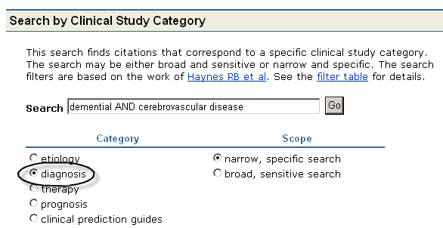

Clinical Study Category search for the treatment or “therapy” focus:
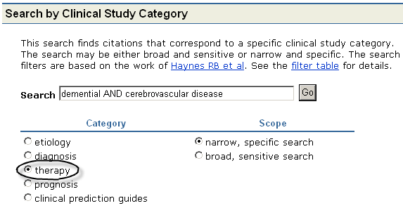

Using the History function, combine the two separate searches using the Boolean connector OR:
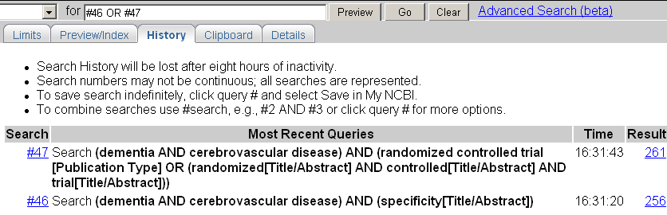

- Explore the ethical issues raised by the deaf community regarding cochlear implants. Consider using a subset, or looking specifically at audiology journals (use the broad subject term in the Journals Database).

Using the Bioethics Subset Limit:
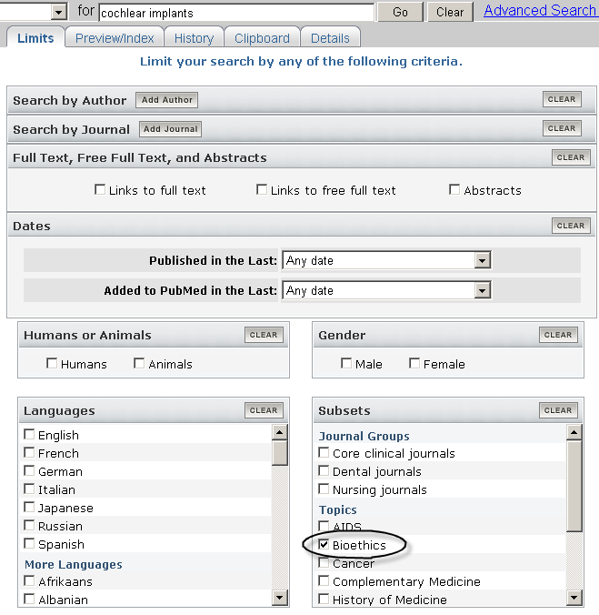
If you wish, you may limit this search to audiology journals:
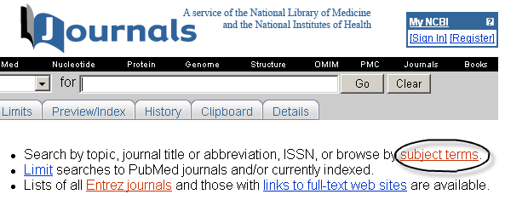

Click on Audiology:
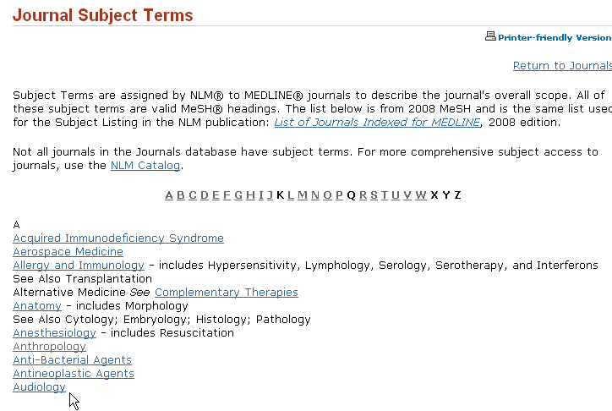

Go to Limits and select currently indexed PubMed journals:
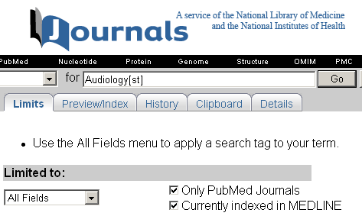

Now select the Audiology journals of interest to you and select “Send to: Search Box with OR.”

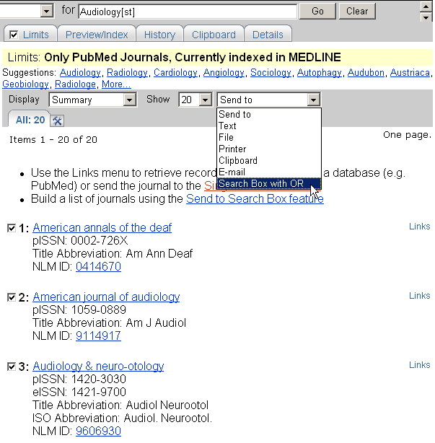
Then click the Search PubMed button under the larger query box.

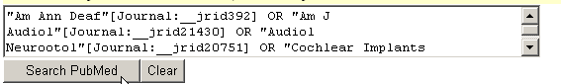

Alternatively, select PubMed Links from the Display pull-down – this option selects all the journal titles displayed and searches them in PubMed.

Now go to History and combine the two searches:

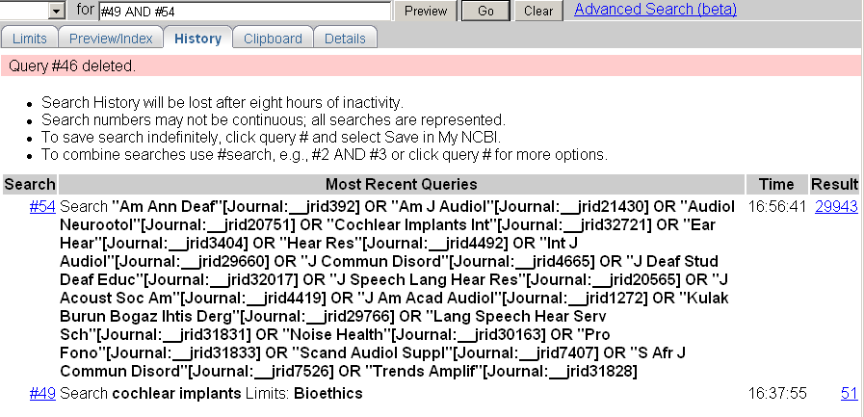

- Find systematic reviews for accidents caused by sleep deprivation.

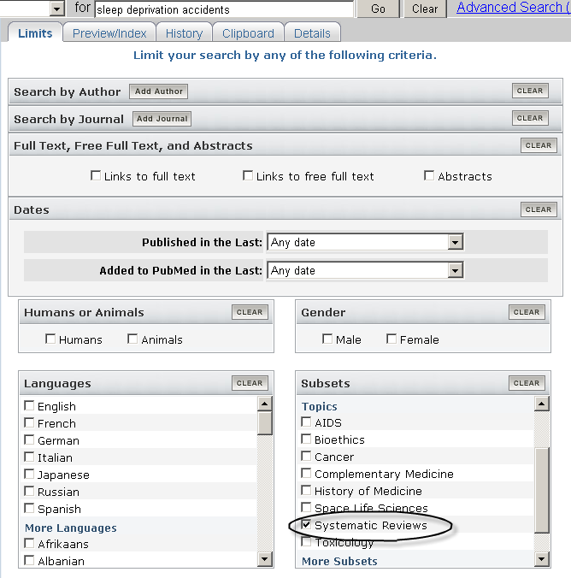
NOTES

