 | NLM® Training:  NLM Gateway and ClinicalTrials.gov

MEDLARS Management Section
U.S. National Library of Medicine®
National Institutes of Health
Department of Health and Human Services
Bethesda, Maryland
March 2008

N O T E S
NLM Training: NLM Gateway & ClinicalTrials.gov

Table of Contents

Table of Contents i
Introduction to Gateway 1
Boolean Operators 3
Searching by Fields 3
Search Results 7
Results Summary 7
Results Display 8
E-mail 10
Download 11
Put in Locker 11
Order Documents 12
Gateway Sidebar 13
Practice Exercises 15
Features 27
Term Finder 27
Limits/Settings 30
Search Details 34
History 35
My Locker 36
Practice Exercises 39
About ClinicalTrials.gov 49
Menu & Search bar 50
The Footnote 50
ClinicalTrials.gov Home Page 51
Resources 51
Investigator Instructions 51
Background Information 51
Search for Clinical Trials 52
Basic Search 52
Working with Results 52
Display Options Menu 56
Advanced Search 57
Studies by Topic 58
Studies on Map 60
Refining your Search 62
Refine Search 63
Results by Topic 65
Results on Map 69
ClinicalTrials.gov Identifier Number & PubMed 71
Practice Exercises 73

N O T E S

NLM Training: NLM Gateway & ClinicalTrials.gov

Agenda

8:30 – 8:45 | Welcome
8:45 – 10:00 | NLM Gateway
 | Background
 | Searching
 | Functions
Download/Display
Send via e-mail
 | Order documents
 | Practice Exercises
10:00 – 10:15 | BREAK
10:15 – 11:00 | Features
 | Term Finder
Limits/Settings
Search Details
 | History
 | Locker
 | Practice Exercises
11:00 – 12:00 | ClinicalTrials.gov
 | Basic Search
 | Working with Results
 | Display Options Menu
 | Advanced Search
Studies by Topic
Studies by Map
Refining your Search
ClinicalTrials.gov & PubMed
 | Practice Exercises

N O T E S


(http://gateway.nlm.nih.gov)
Introduction to Gateway
What?
- The NLM Gateway allows you to search simultaneously in multiple NLM retrieval systems using a single search interface.
- The Gateway was developed by the Lister Hill National Center for Biomedical Communications (LHNCBC) at the National Library of Medicine (NLM).
- Currently the Gateway searches:

- MEDLINE/PubMed  - TOXLINE Subset  - NLM Catalog  - Bookshelf– full text biomedical books  - DART: Developmental and  Reproductive Toxicology  - Meeting Abstracts:  HIV/AIDS-related, Health Services  Research-related, and Space Life  Sciences  - MedlinePlus:  Health Topics  Drug Information  Medical Encyclopedia  Current Health News  Other Resources  - Household Products Database | - ClinicalTrials.gov  - Genetics Home Reference  - DIRLINE: Directory of Health Organizations  - HSRProj: Health Services Research Projects  - OMIM: Online Mendelian Inheritance in Man  - IRIS: Integrated Risk Information System  - HSDB: Hazardous Substances Data Bank  - ITER: International Toxicity Estimates for Risk  - GENE-TOX: Genetic Toxicology Mutagenicity  - CCRIS: Chemical Carcinogenesis Research Information System  - Profiles in Science: Archival collections of Scientists
- NLM Gateway is the only search interface for the Meeting Abstracts.
- Other systems (PubMed, NLM Catalog, MedlinePlus) retain their own search interfaces.

Who?
Potential Gateway users could be:
- Users new to NLM’s online resources who do not know what type of information is available or how best to search for it.
- Users who want "one-stop searching."
- Users who want to search resources that are only in the NLM Gateway.

Where?
- On the NLM home page, click on List of NLM Databases and Resources. At the next screen, click on NLM Gateway. Or go directly to: http://gateway.nlm.nih.gov

Gateway Homepage

Beneath the Gateway banner is the Features Bar. On this bar are links to two (2) Gateway Features, Term Finder and Limits/Settings, and to information about the NLM Gateway
and its use: About Help FAQ.

In the center of the page is the search query box.

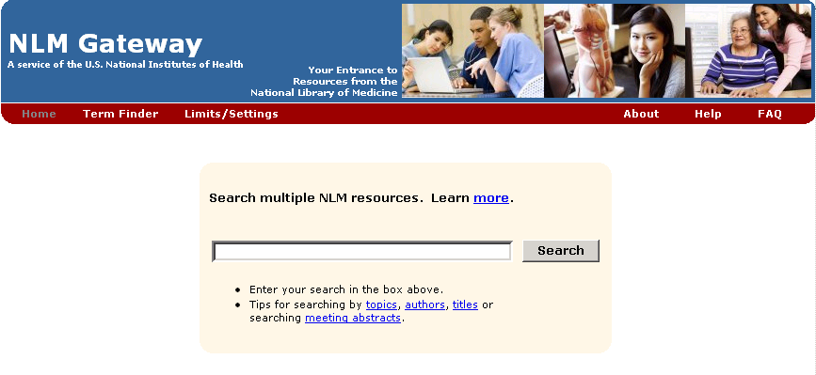

Searching
- Enter the search term(s) in the query box.
- Click on “Search” or use the Enter key.

 | The query box is also available on every screen below the features bar. You do not have to return to the homepage to enter a new search.

Searching Tips
There are links under the query box to tips on searching by topics, authors, and titles and about searching meeting abstracts. Additional helpful points to know:

- The default Gateway search is a subject search.
- You may enter one or more terms in the query box.
Example: vitamins
vitamin c aged
vitamin c aged common cold
- Multi-word search terms are searched as phrases when Gateway’s Phrase Detection function identifies them as such.
- Search terms are mapped to MeSH (Medical Subject Headings) terms. For example, if your search term is heart attack, the phrase is mapped to myocardial infarction. Myocardial infarction is searched as a MeSH term in addition to heart attack being searched as text word. This mapping helps to provide more comprehensive results.

- For terms with British and American spellings, the text word search will include both the British and the American spelling of the word.

- Search terms are automatically combined (ANDed) together.

Boolean Operators
- Use AND, OR, and NOT.
- The default Boolean operator is AND.
- Boolean operators AND, OR, and NOT must be in upper case (e.g., vitamin c OR zinc).
- The Gateway processes the AND and OR Boolean operators in a left-to-right sequence.
- The NOT operator is processed first.
- Nesting: You can change the order in which the Gateway processes the AND and OR operators in a search statement by enclosing the unit in parentheses. The terms inside the set of parentheses will be processed as a unit and then incorporated in the overall strategy.
Examples: wrinkles AND (vitamin e OR vitamin c)
hay fever AND (claritin OR zyrtec)

Searching by Fields
- Searches can be refined using qualifiers to limit the search to specific field(s).
- All field qualifiers should be entered after the search term.
Example: spanish [la]

- Field qualifiers may be in upper or lower case and must be in square brackets.
- Qualifiers may be the search field label (i.e., [Language]) or abbreviation/tag (i.e., [LA])

- N.B.: Unqualified terms should be entered after all qualified terms or should be separated with a Boolean operator (AND, OR, NOT).
Examples: lead screening [ti] children
common cold AND vitamin c [mh]

The Gateway’s Help lists all allowable search fields for every collection
And their abbreviations.

Author Name Searching
- Enter the author name in the format last name plus initials (no punctuation), followed by the field qualifier ([au] or [author]). Suffixes may be included if known.
Examples: harris mj [au]
ferris f 3rd [author]

- You may enter only the last name or the last name and the first initial if you do not know the middle initial.
Example: charron-prochownik d [au] AND siminerio [au]

The Gateway will truncate an author search for MEDLINE/PubMed, NLM Catalog, Meeting
Abstracts, HSRProj, OMIM, and TOXLINE Subset. There is no author field in the other
collections.

Note:
You may search for investigators in HSRProj and NLM Catalog collections using the author field qualifier. Investigator names in the HSRProj collection are displayed as full names but must be searched in the format last name plus initials (no punctuation).

Corporate Author Searching
- To search for a particular corporate author, enter the corporate author followed by the field qualifier [cn].
- You may search for multiple corporate authors at one time.

Examples:
international society of technology assessment in health care meeting [cn]
cochrane colloquium [cn]
conference on retroviruses and opportunistic infections [cn] AND hiv outpatient study [cn]
international conference on aids [cn] AND 2000 [dp]

 | Drop parentheses from corporate author names that contain them.  Example: International Conference on AIDS (15th : 2004 : Bangkok, Thailand)  Enter as: international conference on aids 15th : 2004 : bangkok, thailand [cn]

Title Searching
- Enter one or more title words followed by the field qualifier ([ti] or [title]).
Examples:
aids [title] sexually transmitted diseases [title]
lyme disease [ti]
quality of life [title]
managed care [ti] quality [ti]

MeSH Searching

- Enter the MeSH term followed by the field qualifier ([mh] or [mesh]).

- Subheadings may be entered in full or the two-character abbreviation may be used.

- To search for a MeSH term with one or more subheadings, enter the MeSH term, a forward slash, and one or more subheadings, followed by the field qualifier
(e.g., [mesh]).

- If multiple subheadings are entered for one MeSH term, the subheadings will be ORed together (e.g., myocardial infarction/su/dt [mh] is equivalent to myocardial infarction/su [mh] OR myocardial infarction/dt [mh]).

Examples:
melanoma [mh]
lyme disease [mh]
macular degeneration/therapy [mesh]
knee injuries/di/co [mh]

- Explosions: If a MeSH term or MeSH major topic is entered, it will be automatically exploded only in PubMed/MEDLINE and NLM Catalog.

- To turn off automatic explosion, enter the MeSH field qualifier followed by ":noexp" (e.g., [mh:noexp])

- For other collections, MeSH terms are not exploded.

Spell Check

Gateway processes search terms through a spell checker. If a spelling error is found, Gateway displays a notice.

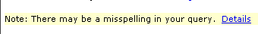

Details of the Spell Check reports the term(s) entered incorrectly and offers suggested corrections.

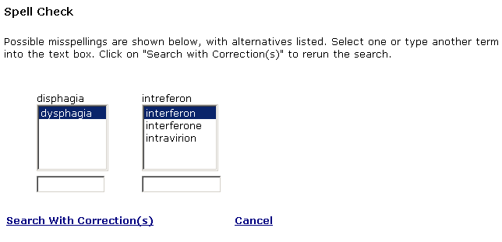

Search Results

Results Summary

When the search is completed, the Gateway displays the Results Summary: the number of Items Found in each collection.

Results Summary for “hay fever” search:

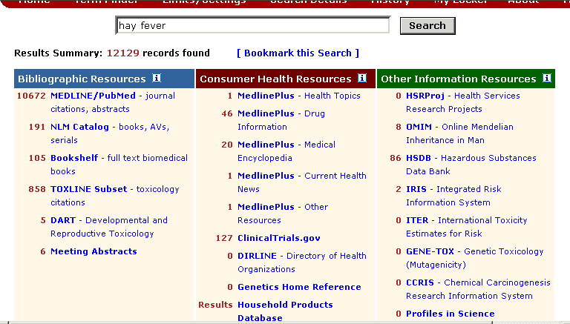

To display the results for a collection, click on the collection name or number of results.

Results Display

Example: Results for PubMed

Navigating: Use Next and Previous arrows or fill in a page number & click Page to jump to it.

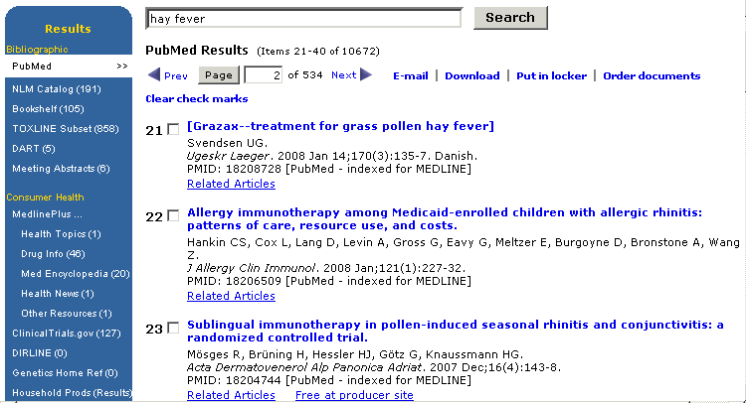

Related Articles takes you to a set of citations closely related to the selected article.
Free at producer site links to the full-text article at the producer’s web site.
Free in PMC links to the full-text article in PubMed Central.

Clicking on a title displays an expanded or fuller view of the item.

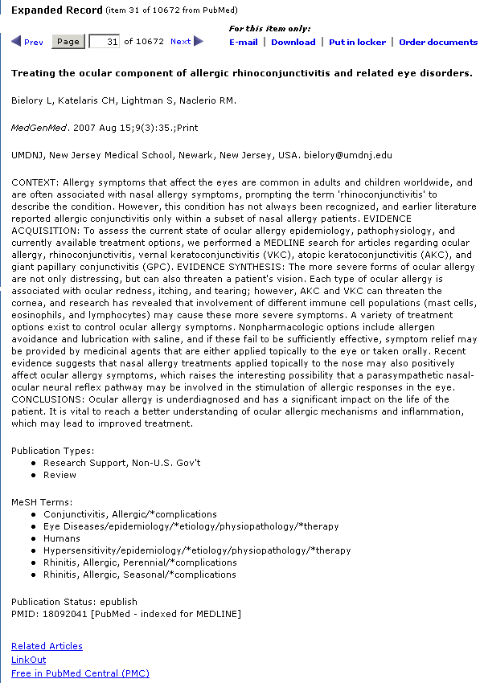

Gateway Functions
E-mail | Download | Put in locker
The Functions are at the top and bottom of each Results Page. The added function of Order documents
is available for PubMed results. Use the check boxes to select the items for a function to process. If none are selected, all on the page will be processed... Use Clear check marks to deselect.

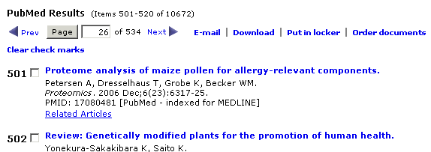

E-mail
- On the Results display, select items you wish to e-mail. (Use check boxes to select items)
- Click on E-mail. The Send via E-mail page displays.
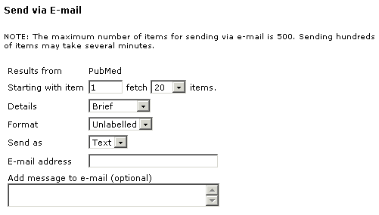
- Use the Starting with item pull-down menu to select the number of items to download or display. The maximum number of items for downloading/displaying at one time is 500.
- Use the Details pull-down menu to select the display content. Choices are Brief, Expanded, and Complete. The default details is Brief.
- Use the Format pull-down menu to select the format: the default Format is Unlabelled.
Labelled = labels each field with the full field name.
Export = labels each field with the field name abbreviation. The Export format is used for importing data into bibliographic management programs.
- Use the Send as pull-down menu to select Text or Html. The default is Text.
- Enter an e-mail address in the box provided. An accompanying message may be entered in its designated box.
- Click Send.

The email address is verified and you are notified that the data was successfully sent or when an error in the address causes the e-mail delivery to fail. The latter enables the user to correct the address and ensure delivery of the e-mail.

E-mail sent to : person@mail.nih.gov

Download
Use Download to Display multiple items in the Web browser or Save items to a file.
- On the Results display, select items you wish to download or display further.
- Click on Download.
- Make your selections from the Download or Display screen.

Note: the top five lines of the Download or Display page are the same as those on the
Send via E-mail page.

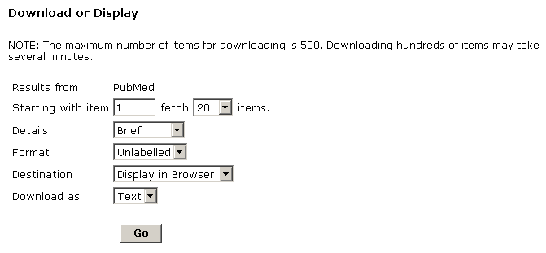

After selecting the Starting with item, the Details, and the Format,
- use the Destination pull-down menu to select the destination for the items to be downloaded or displayed. Choices are
Display in Browser
Display for Printing
Save to File.
The default destination is Display in Browser.
- Use the Download as pull-down menu to select Text or Html. The default is Text.
- Click Go.

Put in Locker
This function enables you to store items. My Locker is a place to collect selected search items for printing, downloading, e-mailing or ordering. For details on using the locker, see My Locker in the Features section (p. 36).

Order Documents

To order items from PubMed results of your current search, select the Order Documents function. Order Documents enables you to order documents directly from the Results Display page.

- Please note that items may only be ordered from PubMed
- On the Results display, select citations you wish to order.
- Click on Order Documents.
- The Gateway Document Ordering page will be displayed, containing your selected items.
Note: articles that have Free full text in PubMed Central or at the producer’s web site
are flagged with a link to the full-text and do not need to be ordered.

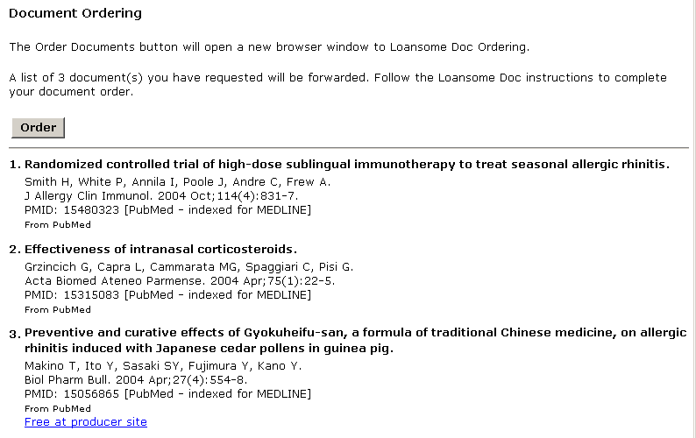

- Review your choices.
[Note: for Free full text, you may go to the articles in PubMed Central or the producer’s site at this time or later. To continue with the ordering process for the other articles: Return to the selections on the Results Display and “uncheck” those that are Free in PubMed Central. Click "Order Documents" on the display page once more].

- Click the "Order Documents" button on the Ordering Page.

- The Loansome Doc Ordering page will open in a separate browser window.

- You can also order documents through My Locker and its ‘Order Documents’ function. (See the section on My Locker.)
Gateway Sidebar
On the left side of each page displaying a collection’s results is a list of all of the collections that Gateway searches and the number of results found in each for the current search. Click on a collection to go directly to the 1st results page of that collection.

Example: Click on NLM Catalog to view the results from that collection.
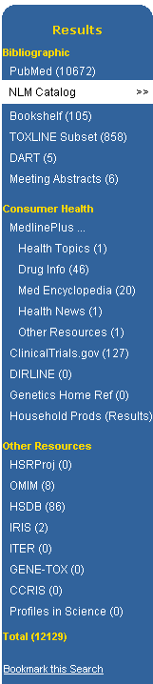 | 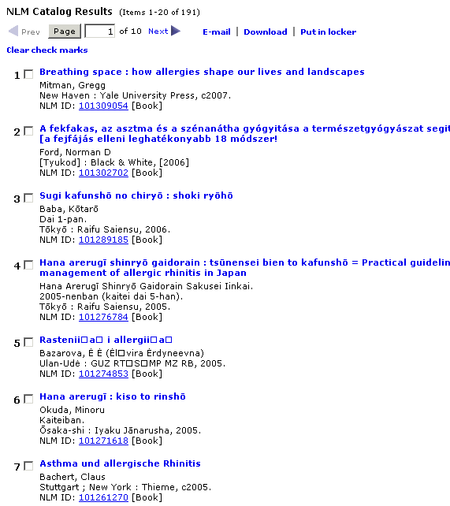
Click Bookmark this search to save the search strategy. Then click Create storable search page. A new browser window will open with the Results Summary page for the search. Use the browser’s Bookmarks or Favorites feature to save the search. Then close the browser window. Use the browser’s Back button to return to the previous page.

Click on Results on the sidebar to go to the Results Summary Page.
N O T E S
Practice Exercises

- Locate information on acupuncture and arthritis. How many clinical trials are currently recruiting volunteers (i.e., “Status: Recruiting”)?

- Locate information on alternative medicine and back pain. Review abstracts from papers presented at meetings. Identify the earliest paper. What organization held the meeting at which it was presented?

- Find organizations where I can obtain information about Sleep Apnea. How many were retrieved?

- Find information in the German language that discusses liver cancer. [Remember: Gateway supports Searching by Fields] Select several NLM Catalog results and, using a Gateway function, display the selected items in the Expanded and Labelled format.

- Search on Agent Orange. How many articles are found in TOXLINE Subset? Send 10 articles to your email address. Add a message/comment and signature to your email.

- Are there any items by Michael E. DeBakey in NLM Catalog? Are there any videorecordings about surgery? What type of surgery is the topic?

- Search photic sneeze reflex. From citations or genetic information (i.e., OMIM collection) determine the syndrome name by which it is known.

- Search for information about genetics and testing of newborns. From the Results:
Locate information in Genetics Home Reference about types of tests done in the United
States. What are the 2 disorders all states test for?

In Bookshelf, select the National Library of Medicine’s HSTAT publication. What 2 diseases
are discussed?

What former Johns Hopkins lecturer in medical genetics impacted newborn testing world-wide?
(Hint: see NLM’s archival collection, Profiles in Science)
What assessment method is their legacy?

Suggested Answers

- Locate information on acupuncture and arthritis. How many clinical trials are currently recruiting volunteers (i.e., “Status: Recruiting”)?

Step 1. Type the search terms in the query box. Use the Enter key or click on the Search button.

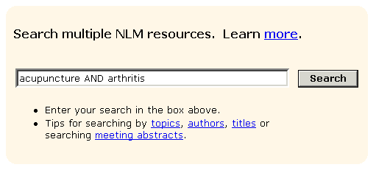

Step 2. Display Results for ClinicalTrials.gov. Note those that are currently recruiting.

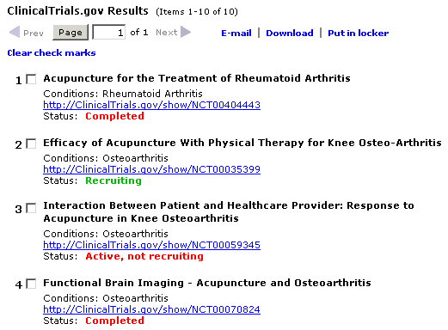
2. .Locate information on alternative medicine and back pain. Review abstracts from papers presented at meetings. Identify the earliest paper. What organization held the meeting at which it was presented?

Step 1: Type the search terms in the query box. Use the Enter key or click on the Search button.

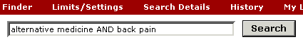

Step 2: Display Results for Meeting Abstracts. Note name of organization.

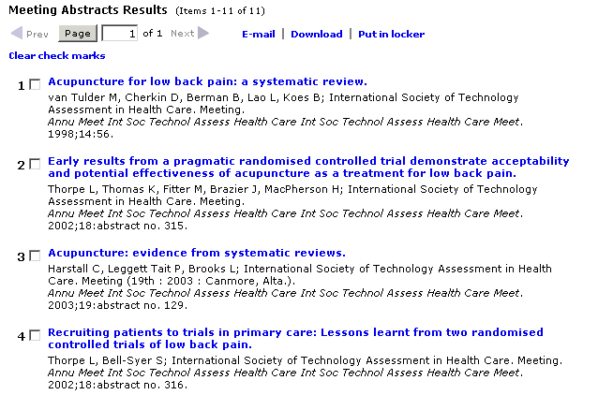

3. Find organizations where I can obtain information about Sleep Apnea. How many
were retrieved?

Step 1: Type the search terms in the query box. Use the Enter key or click on the Search button.

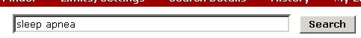

Step 2: Note number of results for DIRLINE - Directory of Health Organizations.

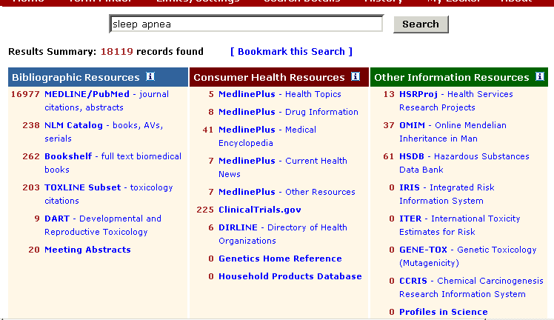

4. Find information in the German language that discusses liver cancer. [Remember: Gateway supports Searching by Fields] Select several NLM Catalog results and, using a Gateway function, display the selected items in the Expanded and Labelled format.

Step 1: Type the search terms in the query box, qualifying German by Language [la].
(Note: you can use the full name of the language or the 3-letter code, e.g., ger) Use the Enter key or click on the Search button.

OR

Step 2. Select NLM Catalog results.
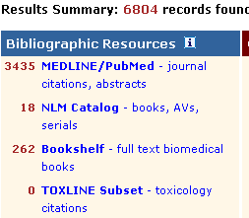

Step 3: Choose several results from NLM Catalog. Select the Download function.
(Note check marks)
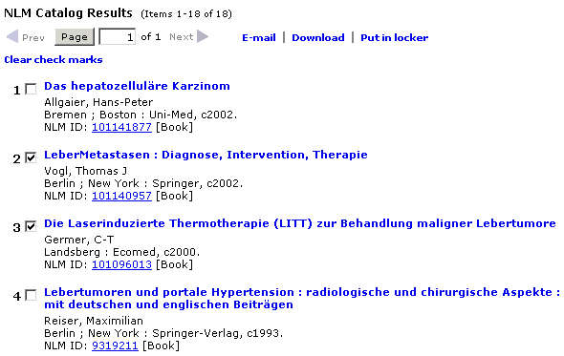

Step 4: Select Expanded Details and Labelled Format. Click Go.

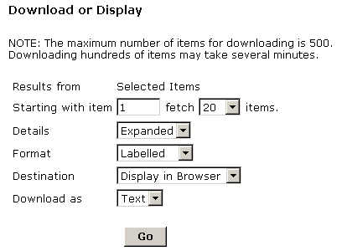

Step 5: View displayed records.

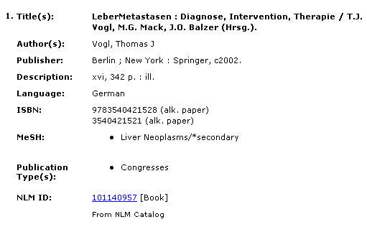

5. Search on Agent Orange. How many articles are found in TOXLINE Subset? Send 10
articles to your email address. Add a message/comment and signature to your email.

Step 1: Type the search terms in the query box. Use the Enter key or click on the Search button.
Display results for TOXLINE Subset. Select 10 citations. Click the E-mail Function.

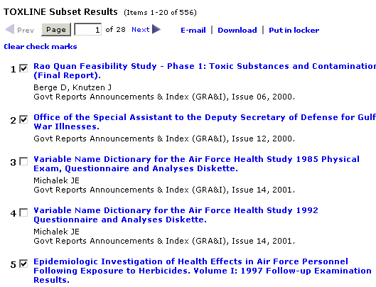

Step 2: Enter E-mail address and message. Click Send.

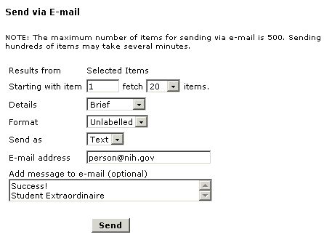

6. Are there any items by Michael E. DeBakey in NLM Catalog? Are there any videorecordings about surgery? What type of surgery is the topic?

Step 1: Type the search in the query box, using the ‘author’ field qualifier [author] or [au]. Use the Enter key or click on the Search button

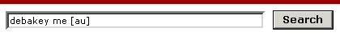

Step 2: Display results for NLM Catalog.

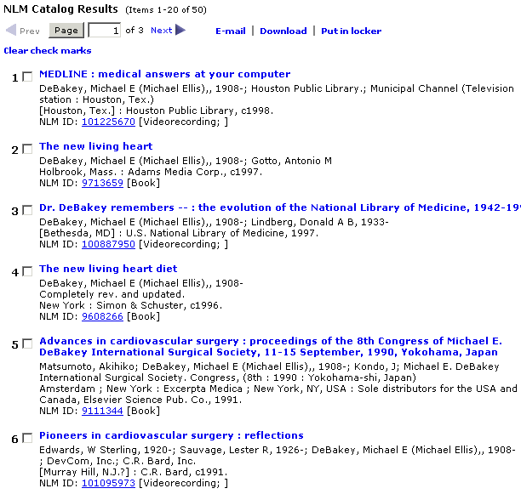

7. Search photic sneeze reflex. From citations or genetic information (i.e., OMIM collection) determine the syndrome name by which it is known.

Step 1: Type the search terms in the query box. Use the Enter key or click on the Search button. For citations, display PubMed results. Use sidebar to go to OMIM results.

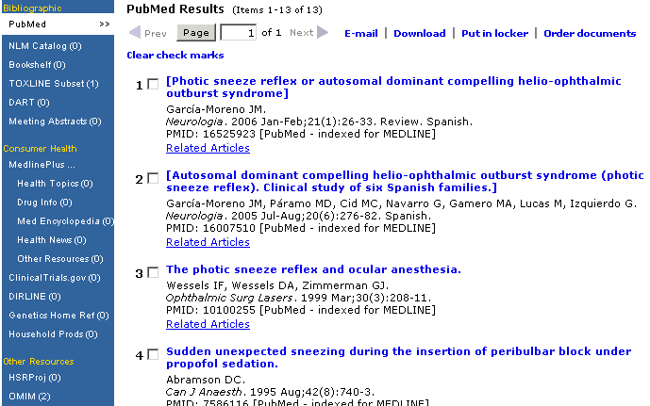

Step 2: Note syndrome name in displayed OMIM results.

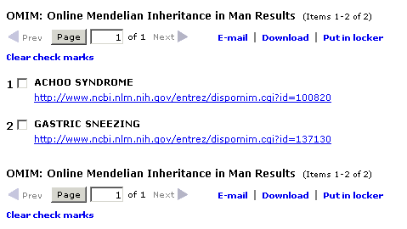

- Search for information about genetics and testing of newborns. Locate information in Genetics Home Reference about types of tests done in the United States. What are the 2 genetic disorders all states test for?

In Bookshelf, select the National Library of Medicine’s HSTAT publication. What 2 diseases
are discussed?

What former Johns Hopkins lecturer in medical genetics impacted newborn testing world-wide?
(Hint: see NLM’s archival collection, Profiles in Science)
What assessment method is their legacy?

Step 1. Enter the search terms in the query box. Use the Enter key or click on the Search button. Display Genetics Home Reference results. Click on a relevant link.
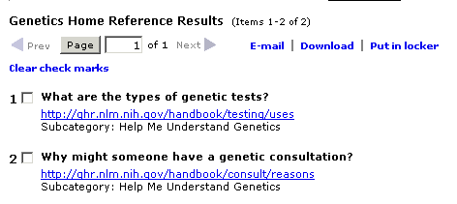

Step 2. Note the 2 disorders all states currently test infants for.
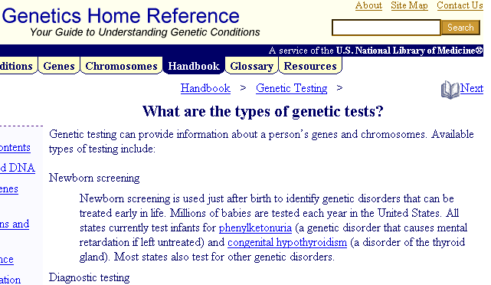
Step 3. Close Genetics Home Reference page. Use sidebar on the Results Page to go to Bookshelf.

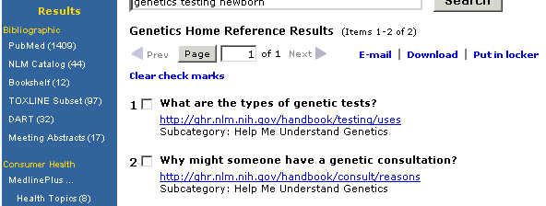

Display Bookshelf results and select the HSTAT publication.
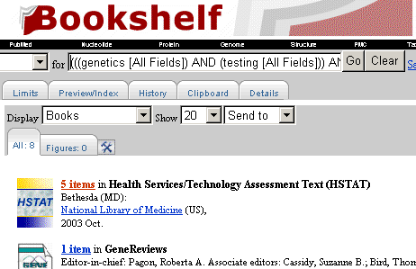

Step 4. Note the 2 diseases discussed.
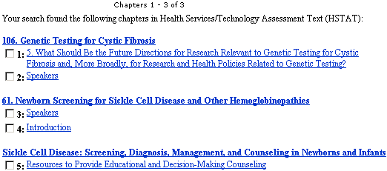

Step 4. Close Bookshelf page. Use sidebar to go to Profiles in Science results.
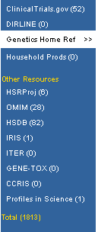

Click on link in the Profiles in Science results.
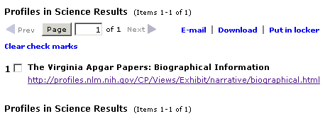

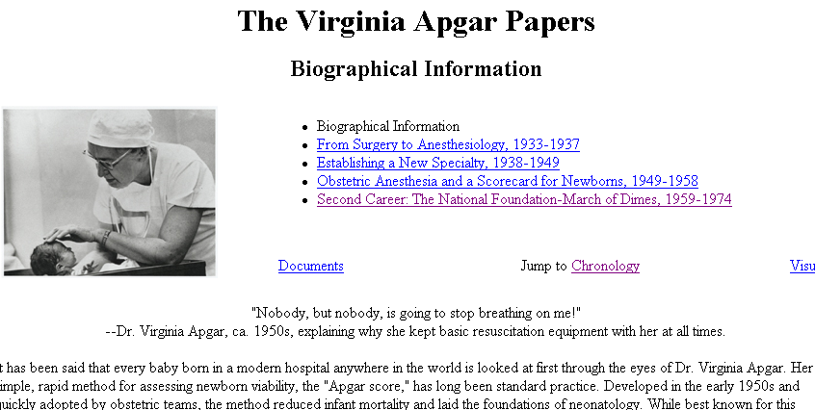

Features
Gateway’s Features enhance and/or refine search and display operations.
The Features Bar is located under the banner.



Term Finder

- Use Term Finder to select search terms from the MeSH vocabulary and the Unified Medical Language System (UMLS) metathesaurus.

- Click on Term Finder on the Features Bar.

On the initial Term Finder screen, type the term you want to find, e.g., shingles.

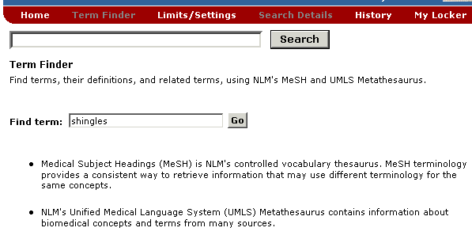

After clicking on Go, you will see a graphic similar to that on the next page.

Note the definition.  Click on Related Concepts to see other related terms.  Click on View MeSH Information for additional details about the term.  Use the Add to Search button and the Connector pull-down to add this term to your search strategy.  Use the Main point of item checkbox to limit the term to the main point of the item.  Use the Do not explode this term checkbox to turn off automatic explosion in PubMed and NLM Catalog.  Click on Subheading Definitions if you need to check a subheading definition.  Select subheading(s) to attach to your term by clicking on the checkbox(s).  Note the MeSH hierarchical tree structure(s) where the term is found. | 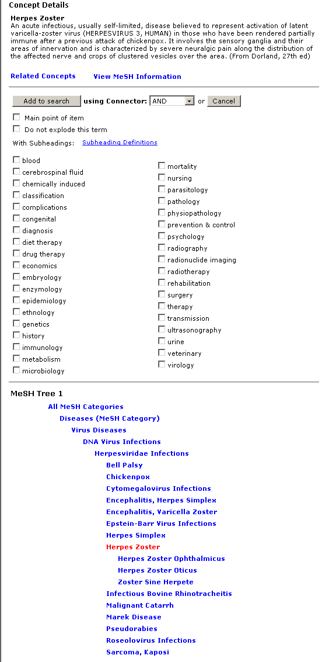

- Adjust the ‘shingles’ search by selecting the subheading complications.
- Click on the Add to Search button. If there is no term already in the query box, the default connector AND will be ignored.

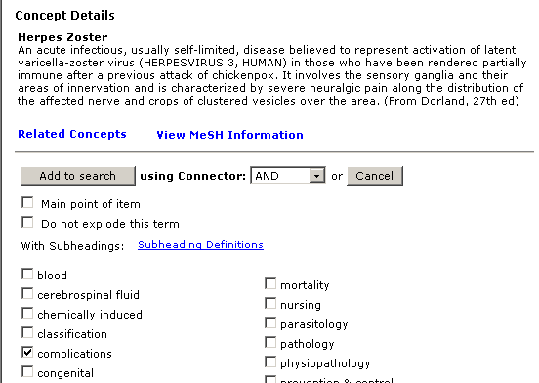

The selected term is entered in the search query box.

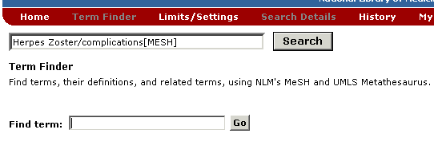

Use the Enter key or click on the Search button to have the Gateway run your search.

Limits/Settings
- Enter your search term in the query box. Click on Limits/Settings on the Features Bar.

Customize your search by using Search Limits:

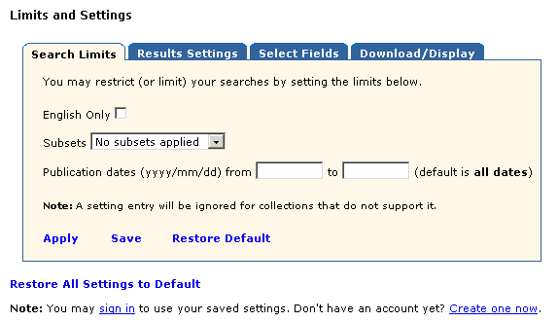

English Only Limit
- Searching all languages is the default.
- Click in the box to select English Only and limit your search to English language items only.
This limit is ignored in the collections in Consumer Health Resources and in the HSDB collection.

Subsets
- Use the Subsets pulldown menu to select the subset to limit retrieval to particular items.
- You may apply no subsets or one subset.

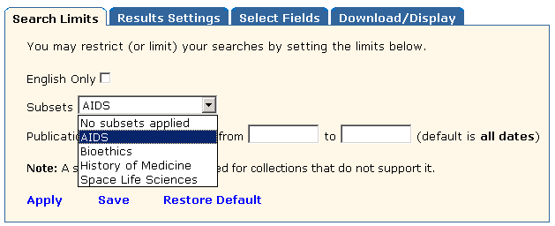

Publication Date Limit
- Searching all years is the default.
- Use the from/to boxes to limit your search to specific publication dates.
- One publication date or a date range may be searched.
- A publication date or date range may be searched using the format YYYY/MM/DD (e.g., from 1998/02/02 to 2000/12/31). Months and days are optional and will be used only in searching PubMed. All other collections will be searched for the publication year only.

This limit is ignored in Bookshelf, the Consumer Health Resources, and in the HSDB, IRIS, ITER, GENE-TOX, CCRIS, and Profiles in Science collections.

- Click on Apply to apply the selections only to your current Gateway session.
- Click on Save to apply the selections to your current and future Gateway sessions.
- Click on Restore Default to return settings for the selected Limits/Settings tab to the Gateway default settings.
- Click on Restore All Settings to Default to return all settings to the Gateway default settings

To Save your settings, you are required to sign in with a User ID and Password.
Registration is free.

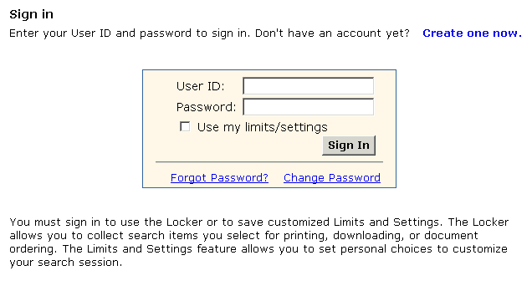

Gateway displays the verification: User preferences saved.

When you are signed in, use the Sign Out button that now appears on the Features Bar to
exit your settings.
Customize your results display by using Results Settings:
- Use the Items per Page pull-down menu to select the number of items displayed on the
Results Display page.
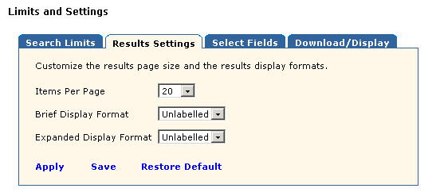

- Use the “ … Display Format” pull-down menus to customize the display formats.

Further customize your results display by using Select Fields:

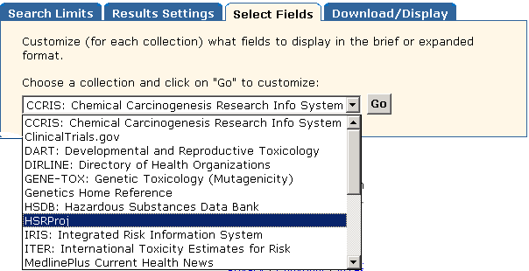

Select a collection and click Go.

The graphic on this page shows the HSRProj field selection screen.
- The check marks represent the default field selections for the Brief and Expanded display formats.
- Add or remove check marks to customize the formats to display the fields you want to display.

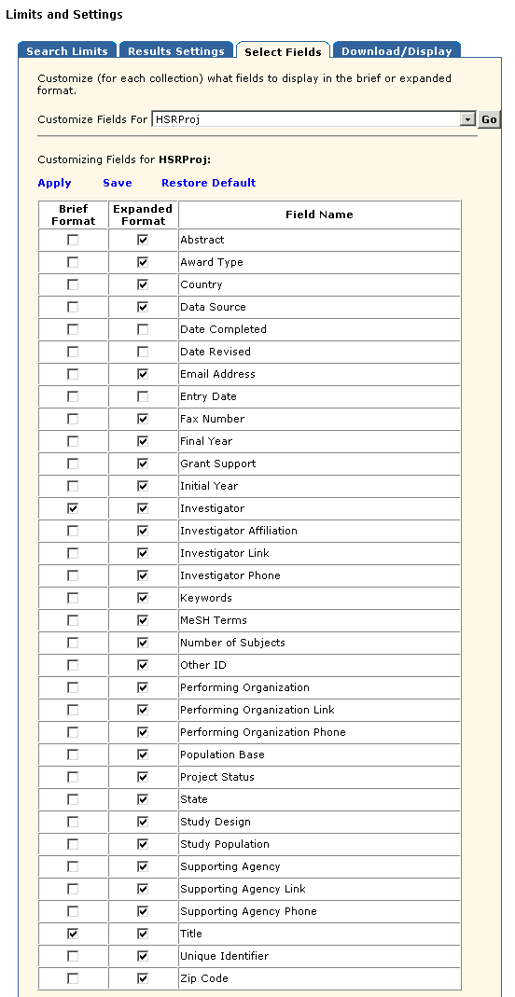

Customize the settings for Download/Display and for e-mailing results.
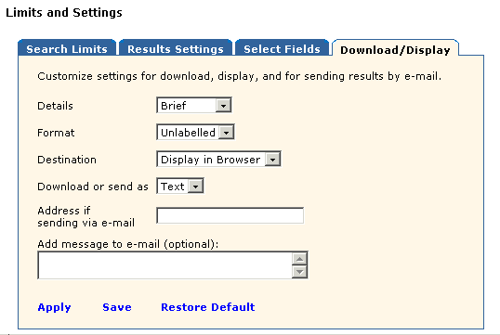

Search Details

- Search Details lets you view your search strategy as it was translated using the Gateway’s automatic term mapping and search rules and syntax. Click Search Details on the Results Summary page and view the search strategies for all of the collections..

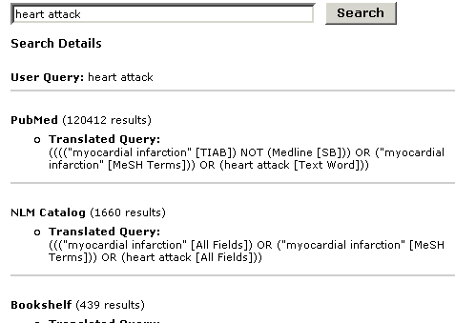

Clicking Search Details on the Results Display page of a collection displays the search
strategy for that collection. There is also a link to Details of Search for all of the collections.

- Details of Search can also contain warning and error messages. If a search fails, check Search Details.

History
- Click on History on the Features Bar to view your search history.

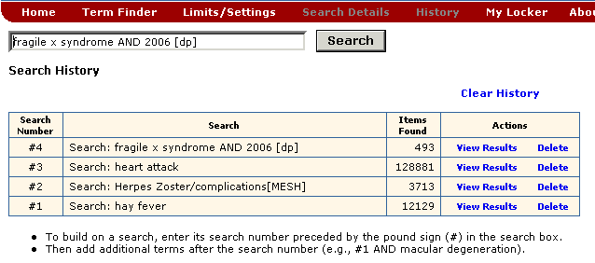

- Search strategies and results for as many as the last 25 searches will be displayed.
- Once the maximum number of searches (25) has been reached, Gateway will remove the
oldest search from the History to add the most current search.
- You can use the Search Number(s) in a subsequent search. You can build on a search by
adding terms (e.g., #1 AND circulation)
- You can also combine searches, using search numbers and Boolean operators
(e.g., #1 AND #2).
- Your Search History will be lost when you close your web browser.
My Locker
- My Locker is a place to collect selected search items for printing, downloading,
e-mailing or ordering.

Marking and putting items in your Locker
- Perform a search and select a collection from the Results Summary.
- In the Results Display, use the check boxes to select items you wish to store in your locker.
- Click on Put in locker.

You must Sign in to use the Locker (unless you have already signed in to ‘Save’ your Limits/Settings). User ID and password is required. Registration is free.

Note: you can elect to Sign in using your limits/settings.

- Gateway confirms that the items have been added to your Locker.

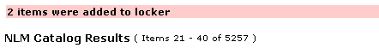

- Click on My Locker on the Features Bar to see the contents of your Locker.

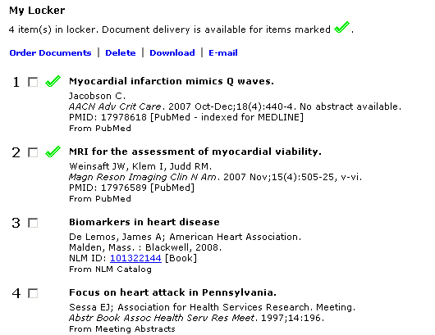

Note: the Sign Out button now appears on the Features Bar.

Locker Tips:

- If an item is already in your locker, it will not be added again.
- Contents of My Locker are grouped by collection.
- Gateway functions are available in your locker.
- Locker items remain until you delete them.
- There is a limit of 500 items that may be stored in your locker.
N O T E S
Practice Exercises

- Search for information on breast cancer where tamoxifen is the treatment. How many meeting abstracts were retrieved? Select those related to cost-effectiveness and put them in your locker. (You will most likely need to create a User ID and Password) View the contents in your Locker.

- Delete term(s) in search query box.. Search for information about Food Allergies, using the Term Finder feature to find and use the correct MeSH term for your search query.

- Using Gateway’s Limits feature, locate information published between 2000 and 2004 on crystal methamphetamine and HIV. Is free full text of a journal article available online for any of the results? From what journal

- Delete term(s) in search query box, uncheck Limits under the query box, and customize the Brief format display for the HSRProj collection. Using the Limits/Settings feature, click on Select Fields tab to customize the Brief format display for HSRProj to include 2 fields: Project Status & Supporting Agency. Then, find the following information:
Are there any ongoing health services research projects (‘Project Status: Ongoing’) on drug abuse treatment outcomes whose ‘Supporting Agency’ is National Institute on Drug Abuse (NIDA)?

- Using the History feature, re-search the search query for exercise #2 above, refining it by adding ‘AND child’ Are there any items in the NLM Catalog related specifically to toddlers?
Suggested Answers

- Search for articles on breast cancer where tamoxifen is the treatment. How many meeting abstracts were retrieved? Select those related to cost-effectiveness and put them in your locker. (You will most likely need to create a User ID and Password). View the contents in your Locker.

Step 1: Type the search terms in the query box. Use the Enter key or click on the Search button.

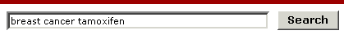

Step 2: Display the results for Meetings Abstracts. Select those about cost-effectiveness.
Click on Put in locker.

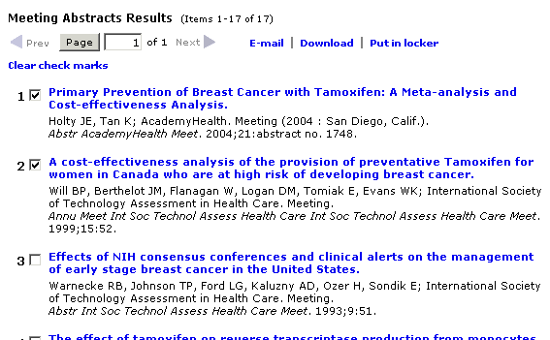

Step 3: Sign into your Locker (You will most likely need to create a User ID and Password)

Step 4: Note: confirmation of number of items added to the Locker. Click on My Locker on the
Features Bar to view the contents in your Locker.

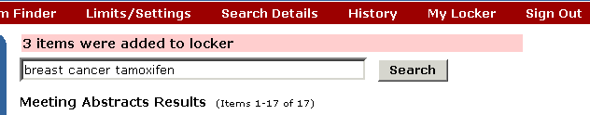

2. Delete term(s) in search query box. Search for information about Food Allergies, using the Term Finder feature to find and use the correct MeSH term for your search query.

Step 1: Delete term(s) in search query box. Click on Term Finder on the features bar.
Type in the term and click the Go button to find the correct MeSH term.

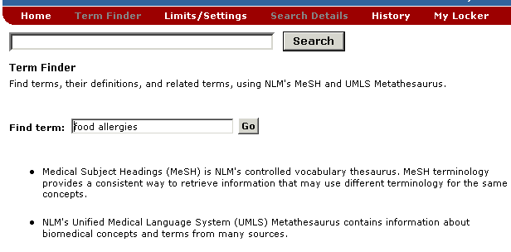

Step 2: Click on Add to Search button to add the MeSH term for Food Allergies in your
search query.
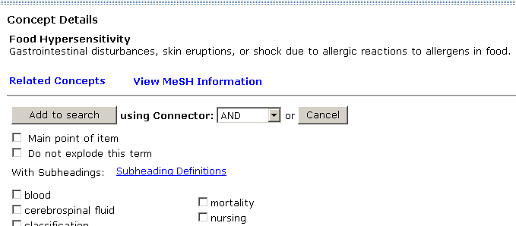

Step 3: Click on Search next to the search query box to run your search.

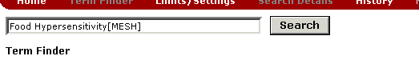

3. Using Gateway’s Limits feature, locate information published between 2000 and 2004 on crystal methamphetamine and HIV. Is free full text of a journal article available online for any of the results? From what journal(s)?

Step 1: Type the search terms in the query box. Click on Limits/Settings on the features bar. On Search Limits tab, add Publication Dates: [from] 2000 [to] 2004. Click on Apply to apply the Limit to the current session. Click on Search next to the search query box.

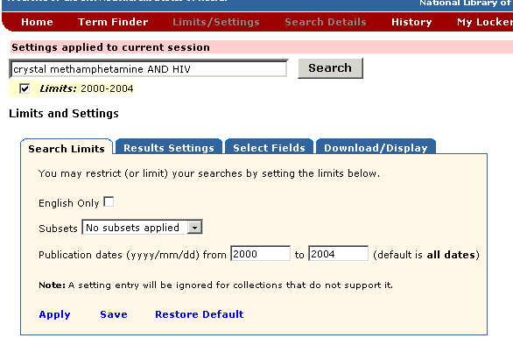

Step 2.: Display the results for MEDLINE/PubMed. Note link(s) to Free full text.
Note journal’s Title Abbreviation.

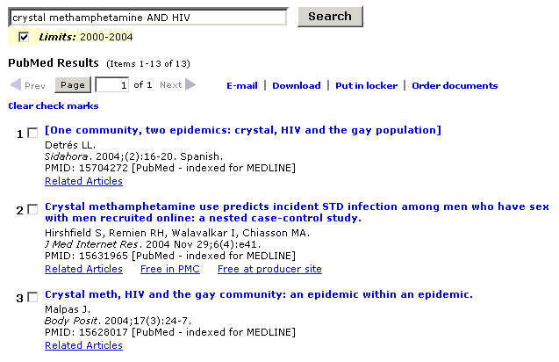

- Delete term(s) in search query box, uncheck Limits under the query box, and customize the Brief format display for the HSRProj collection. Using the Limits/Settings feature, click on Select Fields tab to customize the Brief format display for HSRProj to include 2 fields: Project Status & Supporting Agency.

Then, find the following information:
Are there any ongoing health services research projects (‘Project Status: Ongoing’) on drug abuse treatment outcomes whose ‘Supporting Agency’ is National Institute on Drug Abuse (NIDA)?

Step 1: . Delete term(s) in search query box and uncheck Limits under the query box.
Click on Limits/Settings on the features bar directly. Go to the Select Fields tab.
Select HSRProj from the pull–down menu and click on Go.

Step 2: Add the 2 fields to the Brief Format, Project Status and Supporting Agency.
Click on Apply.

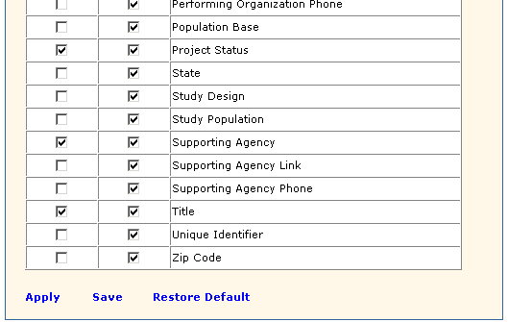

Step 3: Type the search terms in the query box. Use the Enter key or click on the Search button.

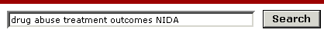

Step 4: View HSRProj results. Note items which have
‘Supporting Agency: National Institute on Drug Abuse (NIDA)’
‘Project Status: Ongoing’

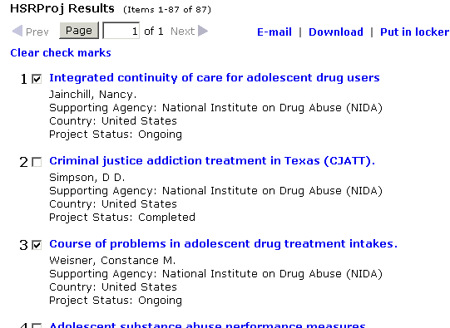

5. Using the History feature, re-search the search query for exercise #2, refining it by adding ‘AND child.’ Are there any items in the NLM Catalog related specifically to toddlers?

Step 1: Click on History on the features bar. Enter #2 in the search query box. Add AND child to the query. Use the Enter key or click on the Search button.

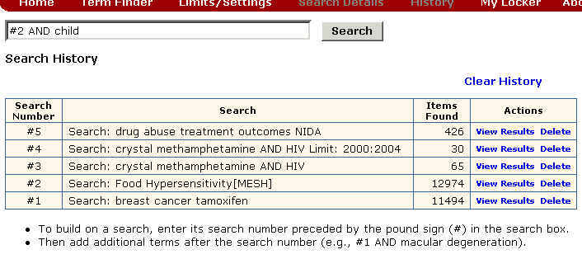

Step 2: Display the results for NLM Catalog. Note toddler-related item(s).

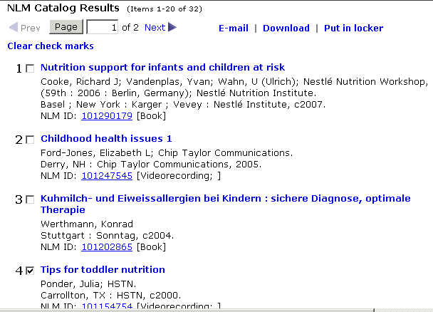
N O T E S


About ClinicalTrials.gov

- A clinical trial is a research study in human volunteers to answer specific health questions.

- Interventional trials determine whether experimental treatments or new ways of using known therapies are safe and effective under controlled environments.

- Observational trials address health issues in large groups of people or populations in natural settings.

- ClinicalTrials.gov offers up-to-date information for locating federally and privately supported clinical trials for a wide range of diseases and conditions.

- Studies listed in the database are conducted in 50 states and in over 150 countries.

- ClinicalTrials.gov receives over 10 million page views per month and hosts approximately 30,000 visitors daily.

- Available at clinicaltrials.gov; alternatively, from NLM’s home page (www.nlm.nih.gov), click on Health Information, and then click on the link to ClinicalTrials.gov from that page.

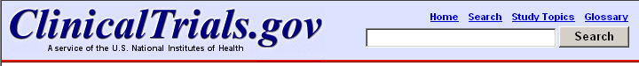

Menu & Search bar

- Appears as logo banner on all pages.
- Facilitates navigation.
- Search box provides an easy method to send a search from any page.
- Click on Home to return to the home page of ClinicalTrials.gov.
- Search returns to the Basic Search query page.
- Use Study Topics to view studies in four main categories of Conditions, Drug Interventions, Sponsors, and Locations (discussed later in this workbook).
- Use Glossary to become familiar with many of the common terms used in clinical trials.

The Footnote



- Click U.S. National Library of Medicine to reach NLM's home page.
- Click Contact NLM Customer Service to send a customer service inquiry.
- Click U.S. National Institutes of Health to reach its home page.
- Click U.S. Department of Health & Human Services to reach its home page.
- Click USA.gov to reach its home page.
- Click Copyright to reach NLM’s copyright information.
- Click Privacy to reach NLM’s privacy policy.
- Click Accessibility to reach NLM’s accessibility statement.
- Click Freedom of Information Act (FOIA) to reach the NIH FOIA Office home page.
ClinicalTrials.gov Home Page

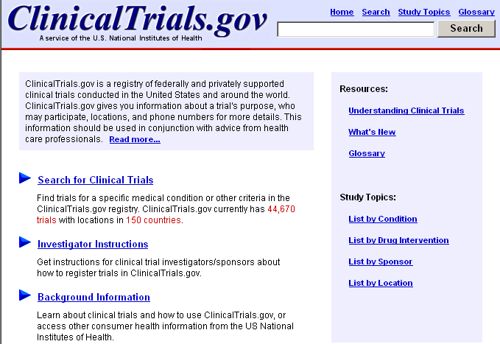

Resources
Helpful information for patients and families
- Understanding Clinical Trials in a question/answer format
- What’s New to view the most recently added trials
- Glossary to become familiar with the most common terms used in clinical trials

Investigator Instructions
- Links to the system for investigators/sponsors to register trials in ClinicalTrials.gov

Background Information
- Resources links also included here
- Links to Help; Glossary; and other consumer health-oriented resources
Search for Clinical Trials

Basic Search
- Use Basic Search query box to find information broadly.

Type search terms.  Click Search button. | 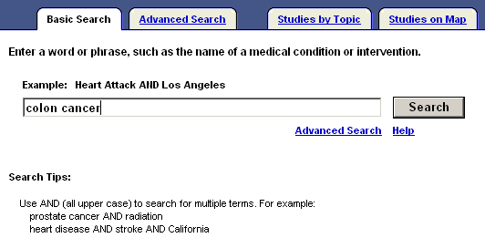

Some misspelled words can be recognized and suggestions are provided through the automatic spell check feature.

Working with Results

- Results of your search are displayed under the List Results tab.
- The current status of the trial (e.g., recruiting), title, condition(s), and interventions are shown for each clinical trial.

 | The display default is for all trials. Click on the Hide studies which are not seeking new volunteers link to narrow your results to only studies recruiting new volunteers (see example on next page).

List Results (partial display):

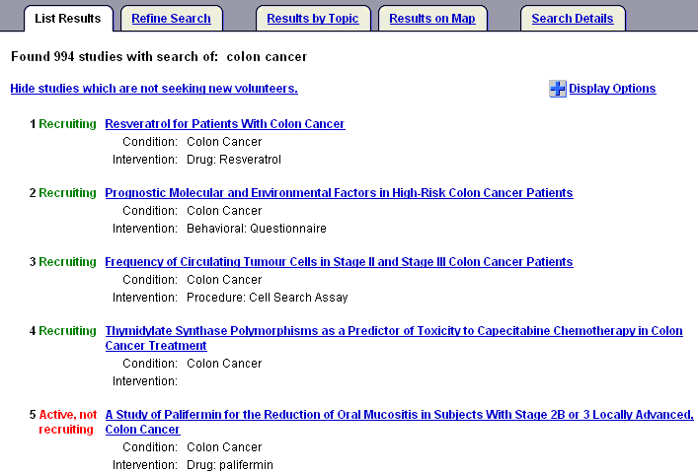

Click on the clinical trial title to see the full text view that may include:
- Brief Title | - Official Title
- Name of Sponsoring Institute | - Detailed Description
- Purpose | - Eligibility Information
- Name of Disease or Condition | - Dates of the study
- Name of the Treatment or Intervention | - Location and Contact Information
- Phase | - More Information Supplied by Sponsoring Organization
- Links to related MedlinePlus and Genetics Home Reference topics | - References
- Study Type and Design

See next page for a partial view of a fuller record.
Full Text View (partial display):
1  2  3 | 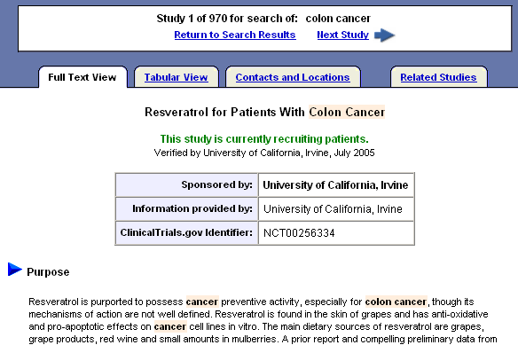

Legend:
1 Navigational area | Use the Next Study or Previous Study or arrows to navigate through your retrieval.  Use Return to Search Results to get back to your full retrieval in the short format.
2 Tabs | Tabular View: displays the fuller record in a tabular/table format  Contacts and Locations: displays the complete list of contacts and locations for that specific clinical trial  Related Studies: method to find related studies by searching for the conditions, interventions, and sponsors found in that specific clinical trial
3 Highlighting | Searched terms are highlighted in a pale pink.  Synonyms of those terms are highlighted in a pale yellow.

At the bottom of the List Results brief display page there are options for an RSS Feed and download options:
4  5 |  | 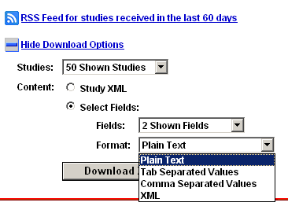
Legend:
4 RSS Feed | Set up an RSS Feed for studies received in the last 60 days for a particular search.
5 Download Options | Click Download Options to select options to download studies to a zip file.
Tabular View (partial display):
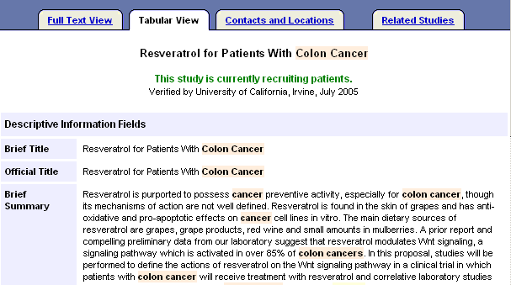

Contacts and Locations:
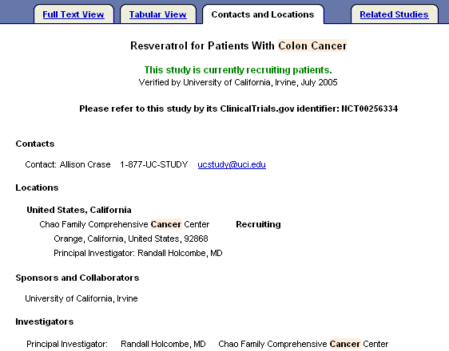

Contact and Location information is also included in the fuller record of the complete study.
Related Studies (partial display):
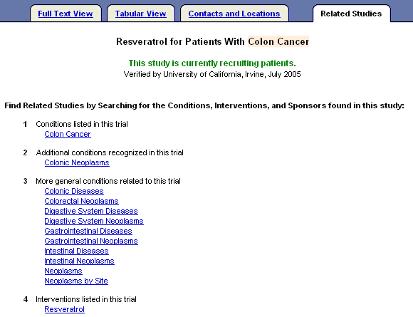

Display Options Menu

To customize your display, on the List Results page of your search retrieval, click on the Display Options icon or link. Then, check the fields you want to display. Note the fields are added/deleted as you click in the field.

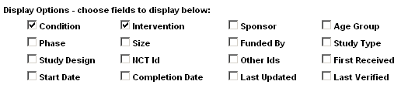

To hide the Display Options, click on the Hide Display Options icon or link:


Advanced Search
- From the Basic Search page, click on the Advanced Search link or tab.
- Use this page to conduct a more structured and targeted search.
- The labels to the left of each box are links to further information about each field.
- It is not necessary to fill in all the fields.

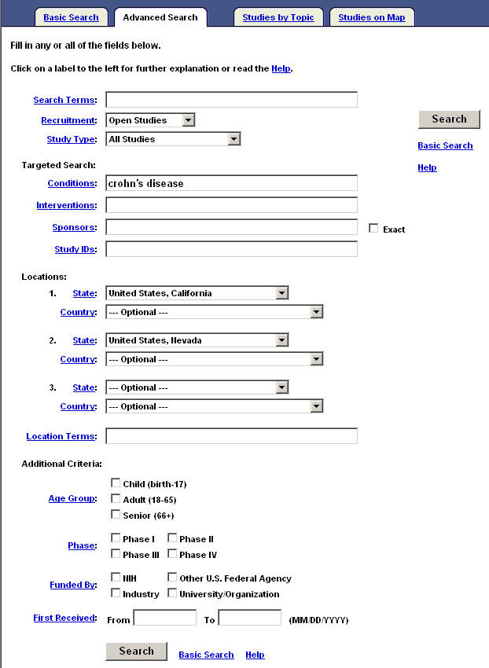
When selecting more than 1 location, they will be ORed together.
Use this box to search for a specific city or facility name.
Studies by Topic
- Easy way to search by selecting options from lists.

Example: Click on Conditions by Category
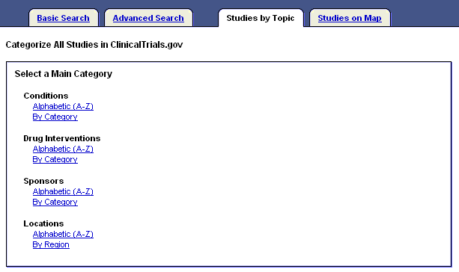
Select a Main Category.

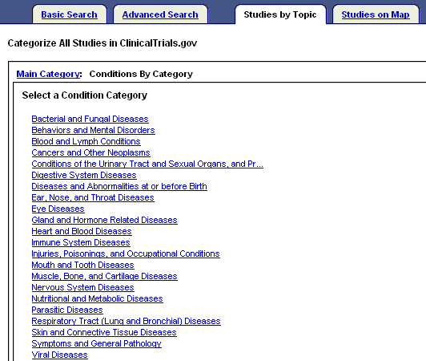
Select a Condition.

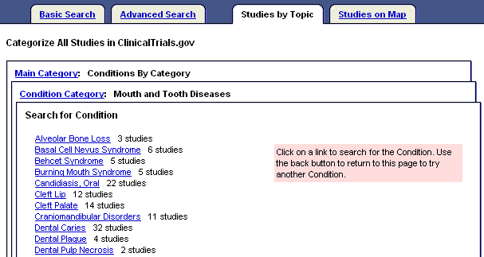
Refine the Condition.

List Results for “Cleft Palate” studies (partial display):

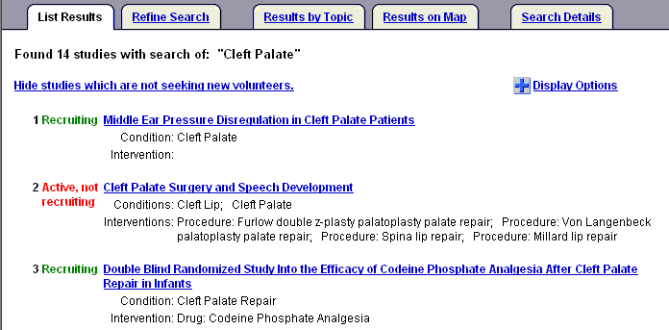
Studies on Map

- Easy way to search for clinical trials by location.

Example: Click on United States.

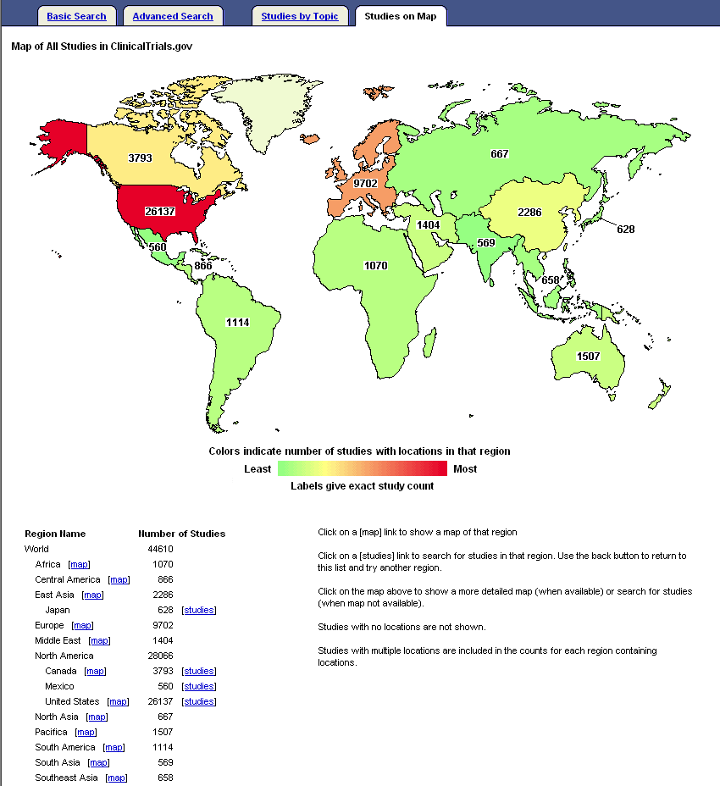
Click on the map links or the text links in the list.

Click on the state of Maine:

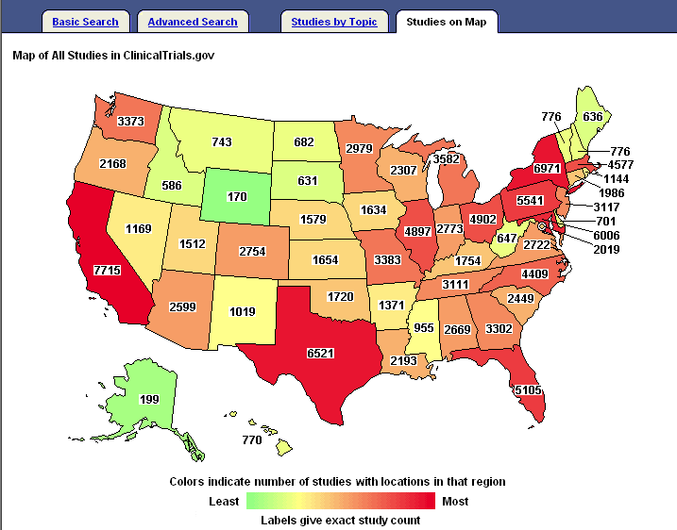

Partial display of retrieval:

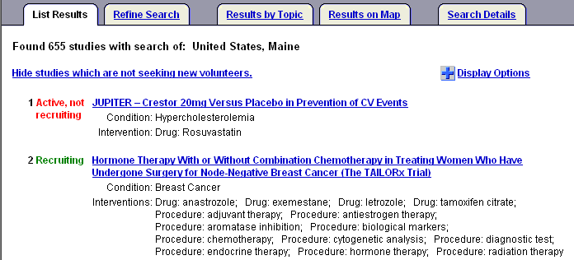
Refining your Search

Example: Start with a search for lymphoma from the Basic Search page:

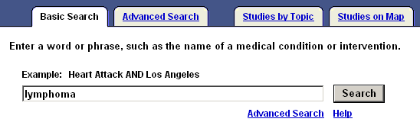

- Use the various tabs from the List Results to refine or further limit your search:

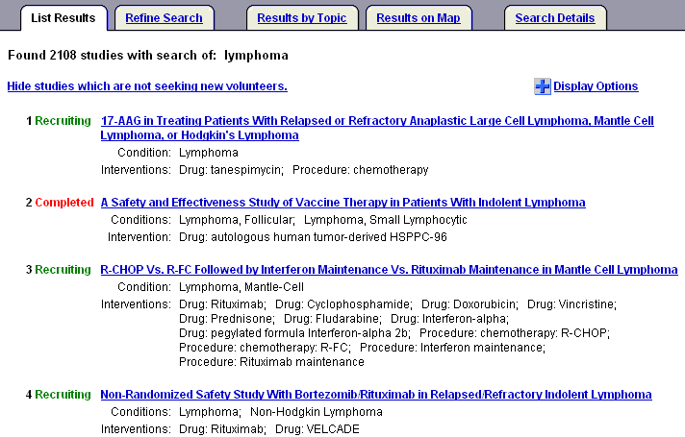
Refine Search

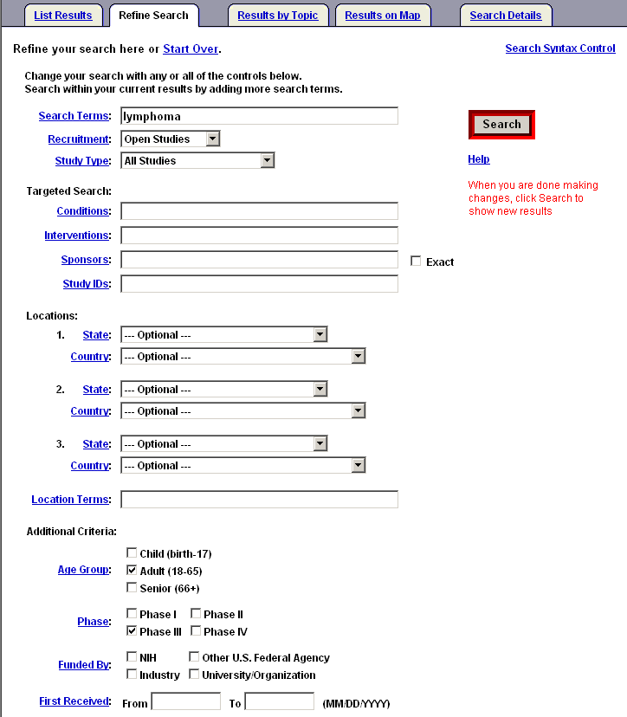
Lymphoma is retained as the search term.

Notice that the Refine Search page is the Advanced Search page with your previous search criteria retained for your convenience.

Results of Refine Search (partial display):

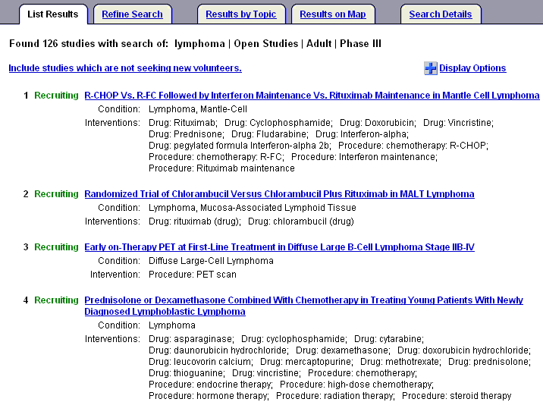

Results by Topic

- Narrow your results by selecting specific topical categories.

Example: Use Results by Topic to narrow your original retrieval by Drug Intervention:

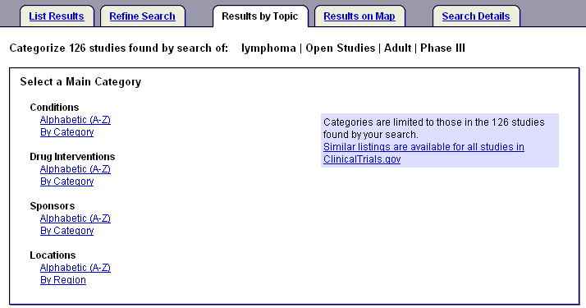

Then limit to Antineoplastic Agents:

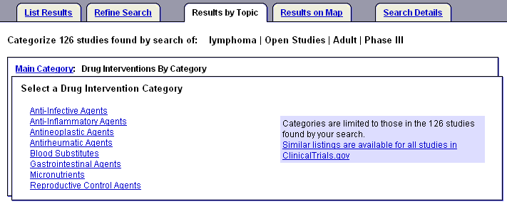

Next you reach a page with an alphabetic list of Antineoplastic Agents to choose from (partial display):

Let’s choose Cyclophosphamide:
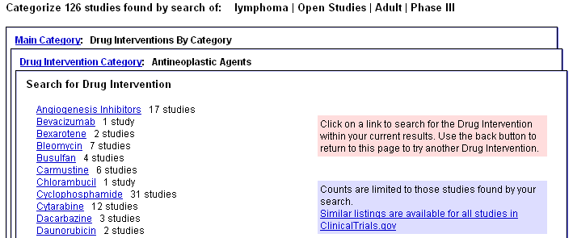

Results of search (partial display):

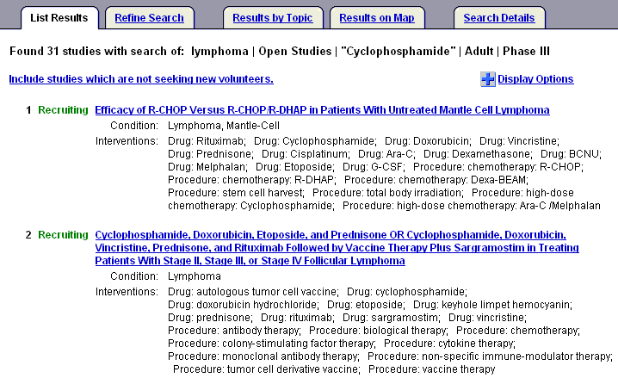

Example: Use Results by Topic to narrow retrieval to a specific location - Connecticut

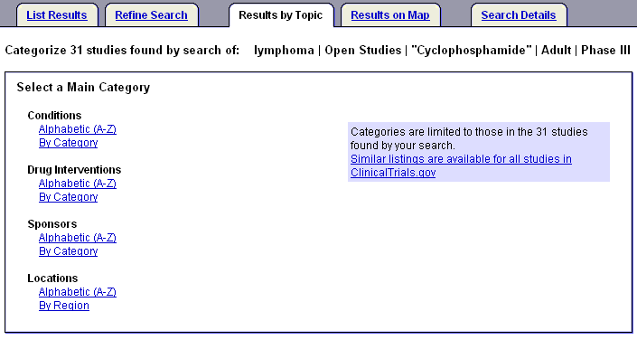

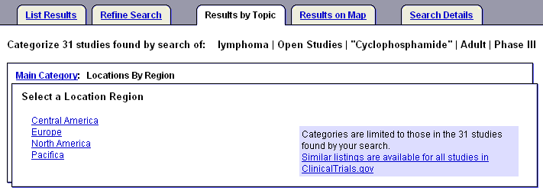

Next, is a listing of states (partial display):
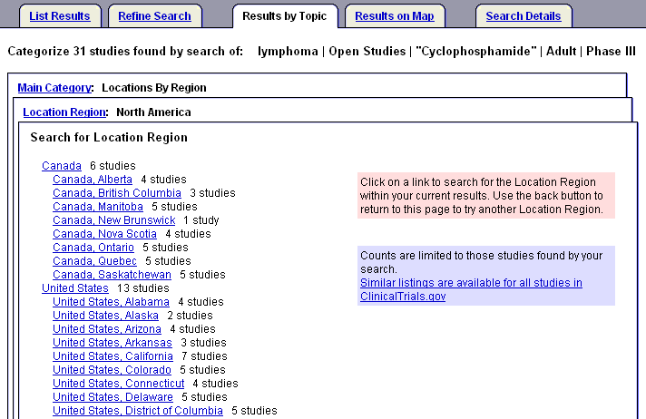

List Results (partial display):
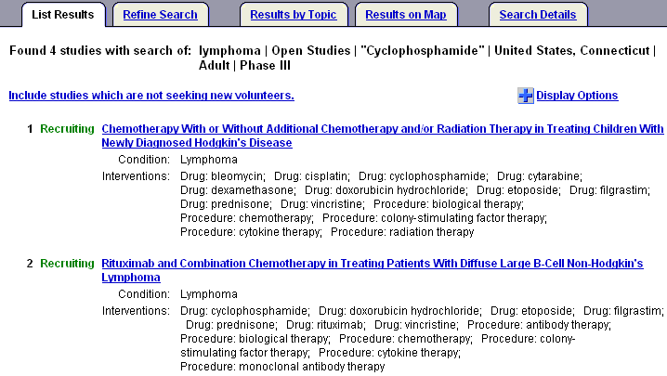
Results on Map

Click geographic region to get fuller information.

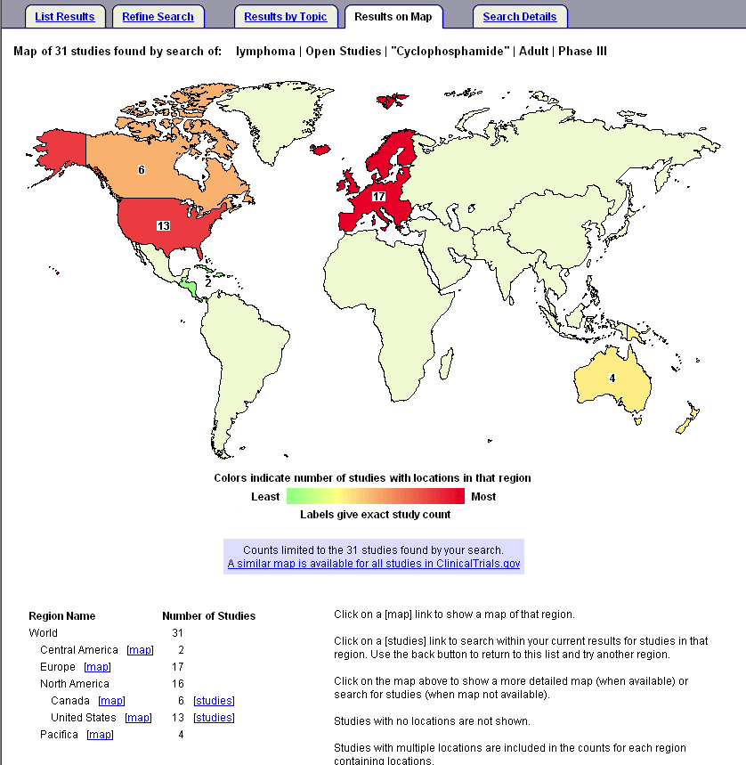
Click on United States.
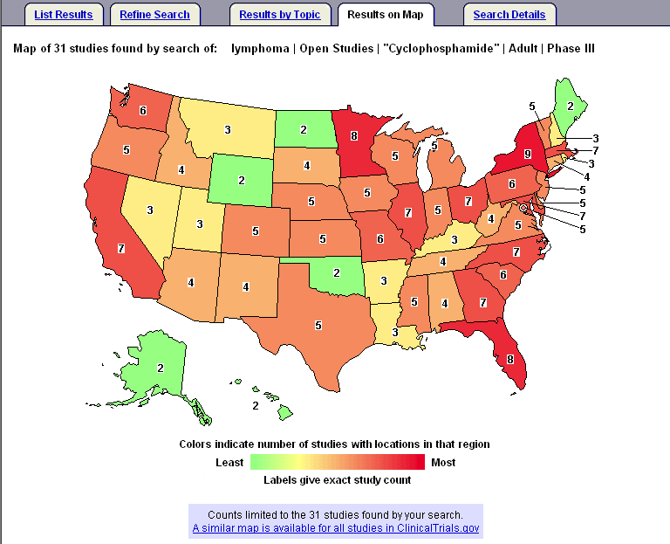
Click on Florida.
List Results (partial display):
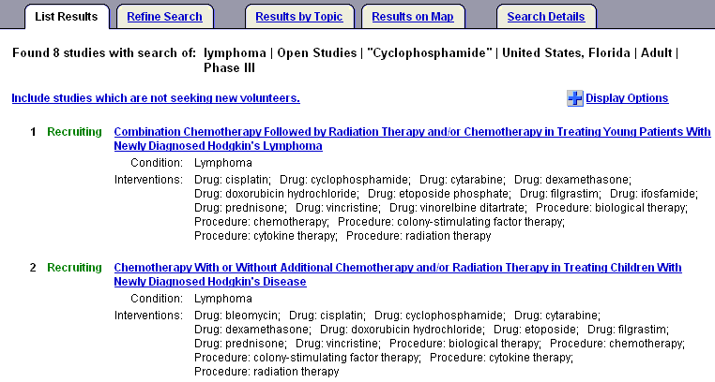
ClinicalTrials.gov Identifier Number & PubMed

- In July 2005 NLM began including the ClinicalTrials.gov identifier number in MEDLINE records, when the article is devoted solely and entirely to announcing or reporting the results of the clinical trial.
- The data displays in the Secondary Source ID field [SI] in the Citation and MEDLINE display formats. For additional information, see the May-June 2005 NLM Technical Bulletin article at http://www.nlm.nih.gov/pubs/techbull/mj05/mj05_ct.html.
- Use clinicaltrials.gov [si] in PubMed to retrieve these citations.

PubMed’s Citation format displays links for ClinicalTrials.gov identifier numbers that link you directly to the record in ClinicalTrials.gov | 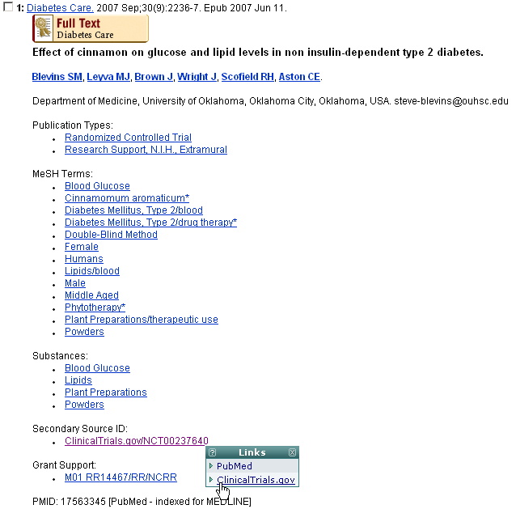

N O T E S
Practice Exercises

- Are there any clinical trials studying acupuncture? From the List Results page, hide the studies that are not seeking new volunteers.

- Find Phase III clinical trials for bladder cancer for an adult living in Texas who wants to get into a trial. (Hint: Use Advanced Search).

- Using the Studies by Topic tab, retrieve the clinical trials studying Cataracts. Once you have your retrieval, use the Results on Map tab to see the U.S. states where these studies are located.
Suggested Answers

1. Are there any clinical trials studying acupuncture? From the List Results page, hide the studies that are not seeking new volunteers.

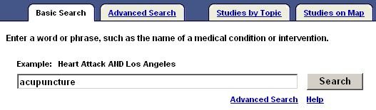

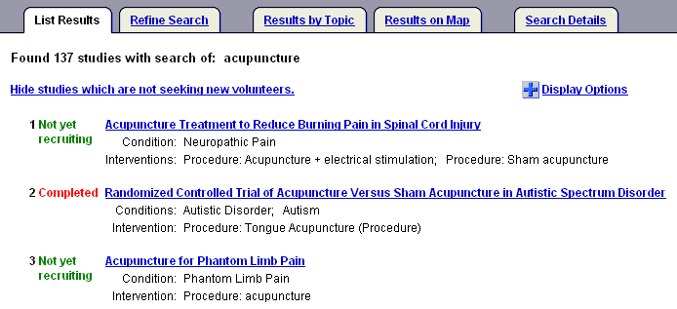
Click here.

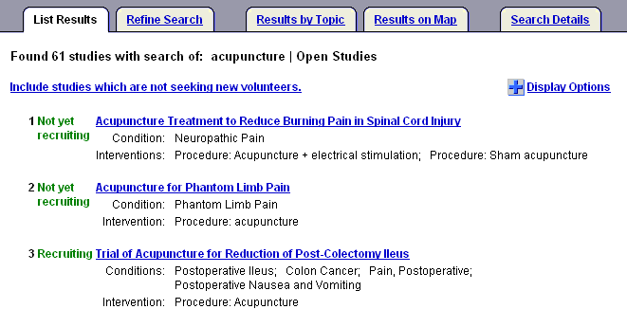
2. Find Phase III clinical trials for bladder cancer for an adult living in Texas who wants to get into a trial. (Hint: Use Advanced Search).

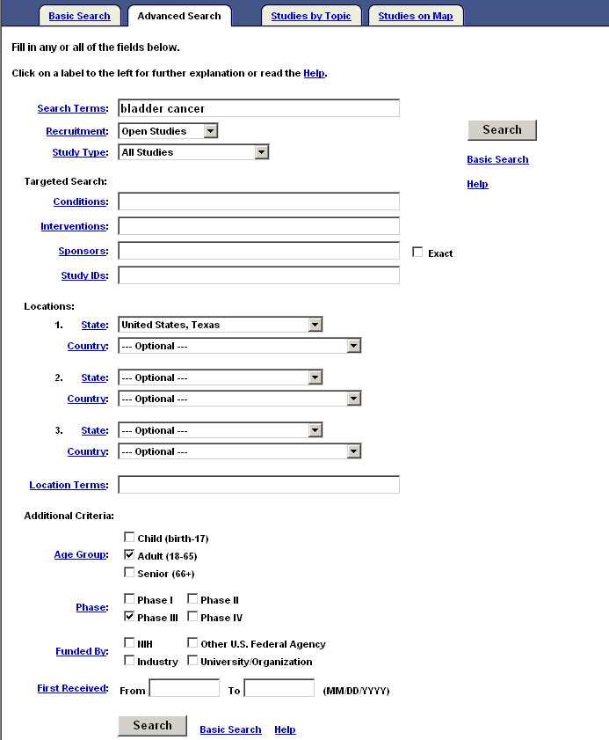
3. Using the Studies by Topic tab, retrieve the clinical trials studying Cataracts. Once you have your retrieval, use the Results on Map tab to see the U.S. states where these studies are located.

You can select the Studies by Topic tab from the Basic Search page:
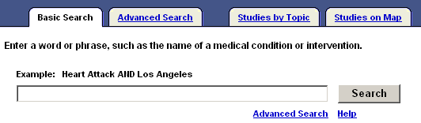

OR

Click on Study Topics from the top menu bar

OR

From the home page you can click on List by Condition under Study Topics:

Then select Eye Diseases from the Conditions by Category list:

Select Cataract from the next list (partial display):
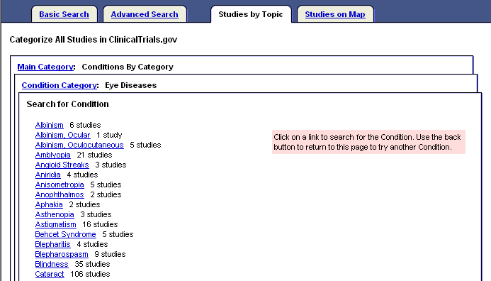
Once you’ve reached the list of Cataract studies, click the Results on Map tab:
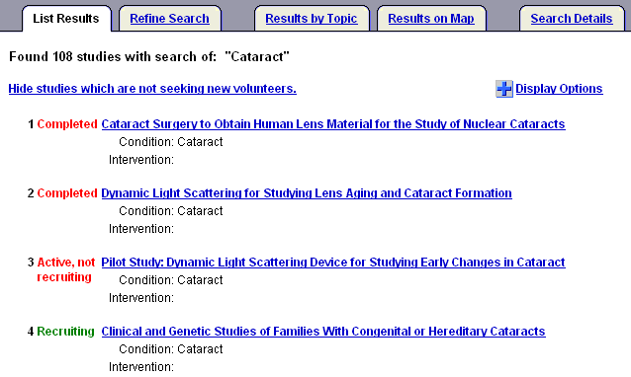

From World Map, click on United States:
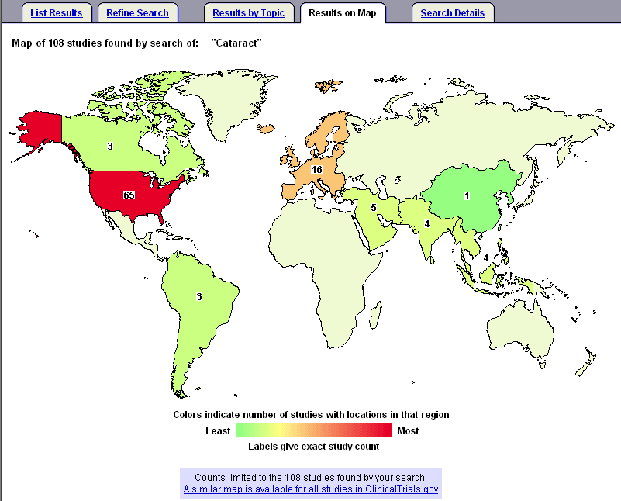
Map of United States for the cataract studies is below. Please note that if you scroll down further on the Results on Map page, you will see a textual version of this same information.
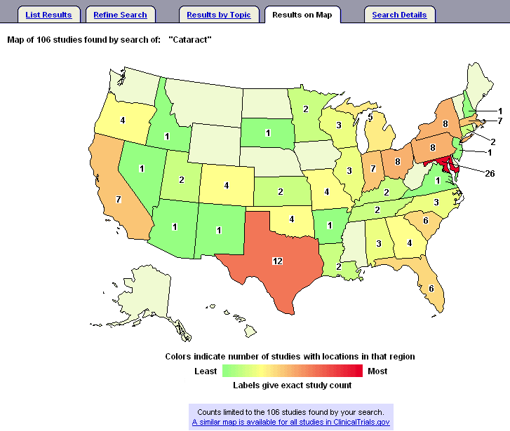
N O T E S

