Fourth Meeting of the
Cross Polar Trans East Air Traffic Management Providers’ Working Group

(Edmonton, Alberta, 18-20 September 2007)

Agenda Item 3: Report on Relevant Outcomes from Other Pertinent Meetings

Implementation of the Reduced Vertical Separation Minimum (RVSM) in Sovereign Chinese Airspace

(Presented by the United States)

SUMMARY

The Air Traffic Management Bureau of the General Administration of Civil Aviation of China intends to implement the Reduced Vertical Separation Minimum (RVSM) on 22 November 2007 in all sovereign Chinese airspace. This marks the first use of RVSM in airspace where the meter is the unit of altitude. Planning has involved adaptation of existing global RVSM procedures to this metric-altitude airspace, development of a flight level allocation scheme which recognizes that most aircraft can only fly at altitudes defined in feet, and coordination with the U.S. Federal Aviation Administration. Application of the RVSM in Chinese airspace has potential importance for the overall planning process undertaken by the Trans-Polar Working Group.

Action by the Meeting is at section 4.

1. Introduction

1.1 At the November 2006 Meeting of the Directors General of Civil Aviation in the Asia and Pacific Region, Wang Liya, Deputy Director General of the General Administration of Civil Aviation’s AI Traffic Management Bureau (CAAC ATMB), announced that China would introduce the Reduced Vertical Separation Minimum (RVSM) into its sovereign airspace in 2007. In presenting this decision, Mr. Wang noted that civil traffic in China’s airspace was increasing at a significant annual rate and that, if this rate were sustained into the foreseeable future, annual operations would soon be second only to those in the U.S. among all International Civil Aviation Organization (ICAO) Contracting States. He noted the demonstrable high-altitude airspace capacity increase associated with RVSM application and cited the need to accommodate increased civil aviation operations expected as a consequence of the Olympic Games to be hosted by China in 2008.

1.2 At this meeting, China requested help with implementation from States in the
Region and asked ICAO to activate the Region’s RVSM Implementation Task Force (RVSM/TF) toward that end.

1.3 China also proposed that work to assist RVSM implementation be the top-priority 2007 task of the Joint Air Traffic Control Steering Group (JATSG), an ongoing cooperative effort between the ATMB and the U.S. Federal Aviation Administration’s Air Traffic Organization (FAA ATO). This proposal was adopted and planned RVSM-related JATSG work was accelerated.

1.4 Refinements to China’s planning led to identification of November 22, 2007 as the intended date for RVSM implementation.

1.5 The purpose of this information paper is to present the recent developments, current status and near-term planning associated with implementation of the RVSM in sovereign Chinese airspace.

2. Background

2.1 The RVSM/TF held its Thirtieth Meeting during March at the ICAO Asia Pacific Office in Bangkok. At this meeting, it was agreed that States from the Region, as well as several ICAO European Region States, would cooperate with China in the RVSM implementation. The Meeting developed a list of non-Chinese flight information regions which would be affected by the implementation and outlined plans for changing associated letters of agreement (LOAs) to reflect the use of RVSM in China and for establishing transition procedures.

2.2 In May, a Special Coordination Meeting among States was held in Beijing to advance LOA development and to receive an update on China’s RVSM implementation planning.

2.3 In late-July 31/early-August, RVSM/TF/31 was held in Bangkok. During the Meeting, China presented its draft Aeronautical Information Publication (AIP) supplement (SUP) covering RVSM and also provided preliminary readiness and safety assessments. The AIP SUP identified the domain of China RVSM as being all airspace between metric flight levels S890 (8 900 meters) and S1250 (12 500 meters) within the sovereign airspace of all Chinese FIRs, as shown in Attachment A. The Meeting concluded that the implementation program had made significant progress and that preliminary readiness and safety assessments showed promise. The Meeting called on China to finalize all LOAs prior to RVSM/TF/32, scheduled for 18 – 21 September in Beijing.

2.4 In parallel, the ATMB and FAA ATO developed and carried out a series of activities.

2.5 A group of senior air traffic specialists spent a week at Chinese area control centers during April in order to review implementation planning and share experience.

2.6 In June, approximately 30 air traffic managers and controllers representing a cross-section of service-provision facilities in China spent a week at the FAA’s Forth Worth Air Route Traffic Control Center observing RVSM operations, receiving instruction in FAA RVSM procedures and conducting simulation-based RVSM training using Fort Worth’s facilities. Based on feedback and information sharing, both ATMB and FAA specialists agreed that the one-week session was very valuable and that the ATMB controllers had developed considerable familiarity with application of the RVSM.

2.7 In January, a group of five ATMB specialists visited the FAA Technical Center for familiarization and training in the establishment and operation of a regional monitoring agency (RMA), as called for in ICAO RVSM guidance material. Building on previous sessions in Beijing and at the Technical Center in 2005 and 2006, the week afforded the opportunity for in-depth discussions of various RMA functions. Among topics covered were establishing and maintaining a database of State RVSM approvals, assessing the approval-readiness of operators and aircraft for RVSM implementation, monitoring aircraft height keeping performance, and conducting an assessment of the safety of RVSM implementation – including estimation of safety risk and comparison to the internationally applied safety criterion, the Target Level of Safety (TLS).

2.8 In June, a group of Technical Center specialists held a session with Chinese colleagues in Beijing in order to review readiness-assessment topics and the treatment of large height deviations observed during pre-implementation safety oversight activities.

2.9 Chinese specialists spent the week of 20 August at the Technical Center to conduct a review of the draft readiness and safety assessments prepared for RVSM/TF/32. During this period, FAA participants provided constructive criticism of the draft material and, where possible, conducted independent checks of results shown in the documents.

2.10 The next section of this information paper will describe the novel flight level allocation scheme (FLAS) which will accompany introduction of the RVSM into sovereign Chinese airspace, and will present the current status of implementation tasks.

3. Discussion

3.1 Chinese RVSM FLAS

As noted previously, introduction of the RVSM in China will mark the first use of the vertical standard in airspace where the meter is the unit of altitude. A June 2007 system-wide sample of traffic operating in Chinese airspace has indicated that aircraft types manufactured in Europe and the Americas account for more than 98 percent of the operations. Such aircraft types actually determine and maintain altitude using the foot as the unit of vertical position, with crews using conversion tables to translate an ATC-assigned metric flight level into an equivalent foot-based altitude. This conversion process does not result in a commanded altitude exactly equal to the foot-equivalent of the metric flight level, since commanded altitude may be selected only in increments of 100 feet.

In recognition of the aircraft-type profile described in the previous paragraph, the draft AIP SUP presented by China at RVSM/TF/31 requires that all operations in Chinese airspace where the RVSM will be applied will be flown using the foot as the unit of altitude.

The draft AIP SUP provides a conversion table of metric flight levels to foot-based flight levels which is mandatory for use by all aircraft which will operate in China RVSM airspace. The AIP SUP also describes the manner in which these levels will be allocated by direction-of-flight.

Attachment B presents a diagram of this FLAS, showing the metric flight levels which will be used when China implements the RVSM and the corresponding mandated foot-based flight levels which all aircraft will use.

Attachment C presents the same information in more readable tabular form.

As will be noted from the table in Attachment C, the practical effect of requiring all operations to be conducted in feet using the published meter-foot flight level conversions is that 1000 feet is the planned vertical separation between aircraft at adjacent flight levels in China RVSM airspace.

Status of Tasks Required To Be Completed Prior to RVSM Implementation

As noted, RVSM/TF/32 will meet in Beijing during the period 18 – 21 September. The intent of the meeting is to review progress and endorse a decision to implement RVSM as planned on 22 November or to delay if conditions warrant.

The Meeting will review analysis of the readiness of operators, where such readiness refers to having State approval for RVSM operations. The readiness goal established by the ATMB is that 90 percent of the operations currently operating in the altitude band within which the RVSM will be applied will have State RVSM approval by 22 November. Results published in advance of the Meeting indicate that this goal will be met.

The Meeting will also review the results of a safety assessment conducted by the ATMB. The goal of this assessment is demonstration that a quantitative safety criterion, the TLS, will be satisfied, as called for in relevant ICAO RVSM guidance material. Again, results published in advance of the meeting indicate that this goal will be met.

It was agreed at RVSM/TF/31 that China should endeavor to complete LOAs with all adjacent FIRs by the opening of RVSM/TF/32. No information is available at this time on the status of LOAs.

China has already informed the ICAO Asia Pacific RVSM Implementation Task Force that necessary controller training, update of aeronautical publications and related items will have been accomplished in a timely manner before 22 November.

China has scheduled coordination meetings with relevant segments of the civil aviation industry in advance of the planned implementation date.

4. Recommendation

4.1 The Meeting is invited to review the contents of this information paper as a means of updating itself regarding the plan for implementation of the RVSM in sovereign Chinese airspace on 22 November 2007.

Attachment A

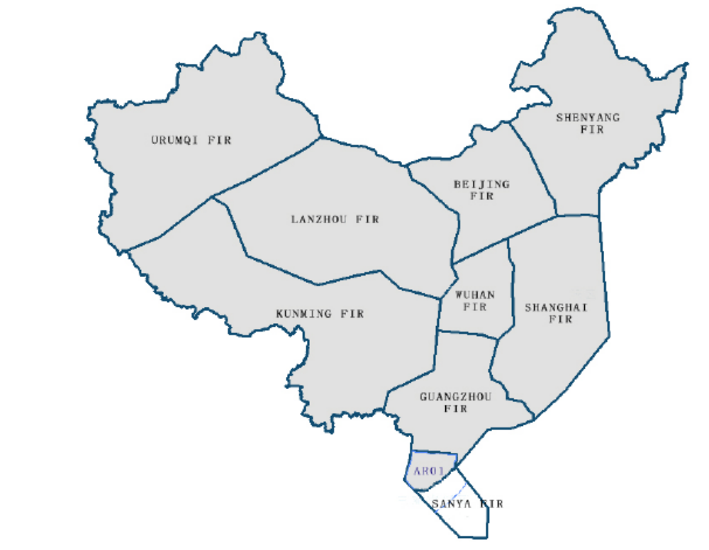

Figure A. Chinese Flight Information Regions With Shaded Area Showing Sovereign Chinese Airspace Where the Reduced Vertical Separation Minimum Will Be Introduced
Attachment B

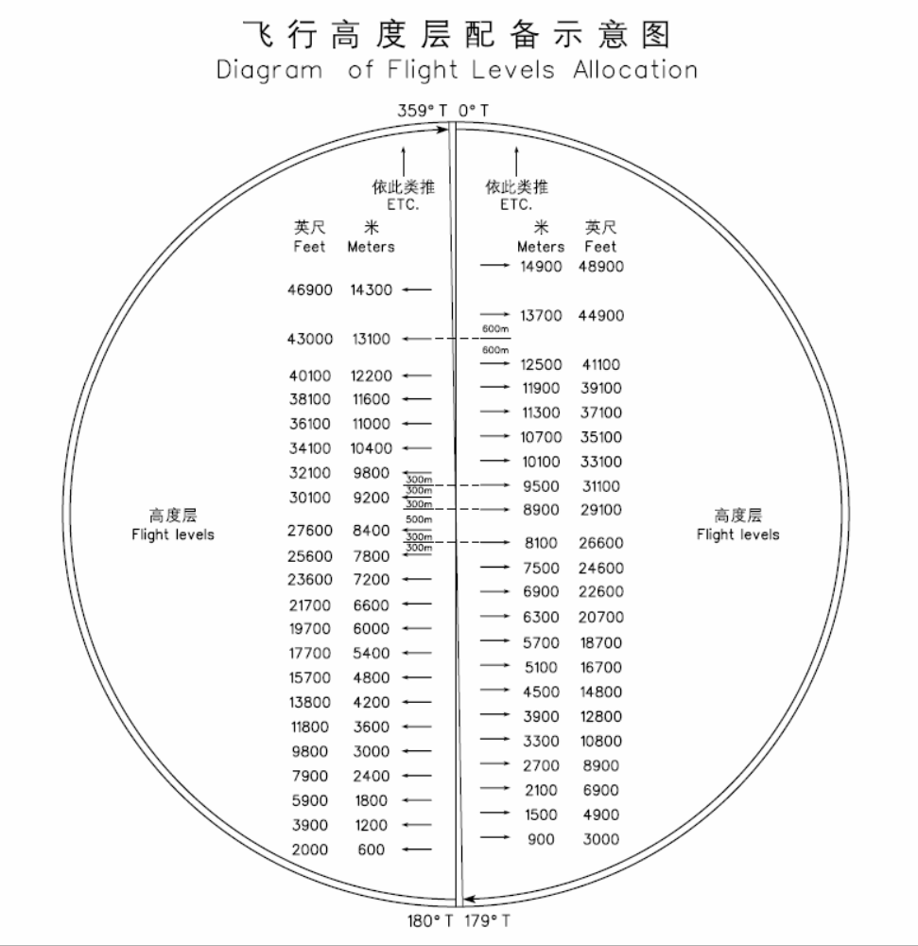

Flight Level Allocation Scheme To Be Applied In Sovereign Chinese Airspace After Implementation of the Reduced Vertical Separation Minimum Shown in Both Meters and Feet

Attachment C

000º – 179º T |  | 180º – 359º T
Flight Levels |  | Flight Levels
m | ft | m | ft
ETC.  ↑  14900  13700  12500  11900  11300  10700  10100  9500  8900  8100  7500  6900  6300  5700  5100  4500  3900  3300  2700  2100  1500  900  － | ETC.  ↑  48900  44900  41100  39100  37100  35100  33100  31100  29100  26600  24600  22600  20700  18700  16700  14800  12800  10800  8900  6900  4900  3000  － | ETC.  ↑  15500  14300  13100  12200  11600  11000  10400  9800  9200  8400  7800  7200  6600  6000  5400  4800  4200  3600  3000  2400  1800  1200  600 | ETC.  ↑  50900  46900  43000  40100  38100  36100  34100  32100  30100  27600  25600  23600  21700  19700  17700  15700  13800  11800  9800  7900  5900  3900  2000
m | ft | m | ft

Table for Conversion of Metric to Imperial Flight Levels Mandated for Use After Implementation of Reduced Vertical Separation Minimum in Sovereign Chinese Airspace

